Project 2-2: Internet Measurement

Name: Nan Ding 4671340

Date: Apr,12.2025-Apr,25.2025

Report: You must submit a clearly written report that contains the following:
(a) The goal of this project (introduction)
(b) The methodology for your measurements (report on step 1)
(c) The metrics you picked for your data analysis, the reason you picked these metrics, and the actual results (report on step 2)
(d) Your conclusions about path and delay stability based on your analysis results
----------------------------------------------------------------------------------------
1 The goal of this project (introduction)

In this project, my goal is to analyze internet routing behavior using traceroute, a network diagnostic tool that traces the path packets take from a source machine to a destination IP address. By collecting measurements over time, I aim to :
- Identify routing paths between my source and 3 different destinations,
- Analyze path stability, check routes consistency, will the routes change due to load balancing, failures or CDN redirections,
- Measure latency and packet loss at each hop to assess network performance,
- Observe ISP peering relationships based on AS(autonomous system) information.

Final submission files:

Report: 1 word project 2-2 report

Script file: 1 python script folder with 10 scripts

Data log folder: 1 traceroute_logs folder with raw traceroute files and AS_table files. From 04-13 to 04-24, there are 153 raw traceroute_logs ( 51 raw traceroute_logs per destination) and 153 AS table files ( 51 AS table files per destination) .

Other materials: CSV data folder including 3 dataset; reports folder including 3 statistics reports.

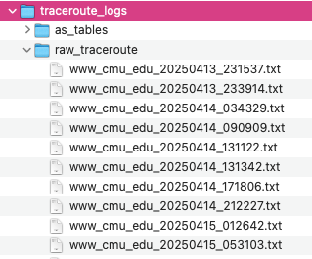

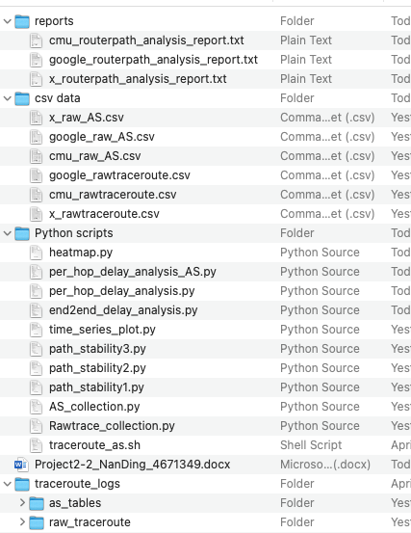

----------------------------------------------------------------------------------------
2 Data Measurement and Collection
The methodology for your measurements (report on step 1)
- Setup and tools
  - Source machine: home laptop, Wi-Fi
  - Traceroute Tool: macOS: traceroute in Terminal
  - A small traceroute_as.sh script to run the autonomous measurement and AS translation and log storage.

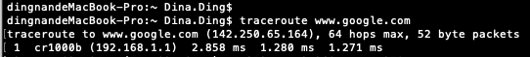



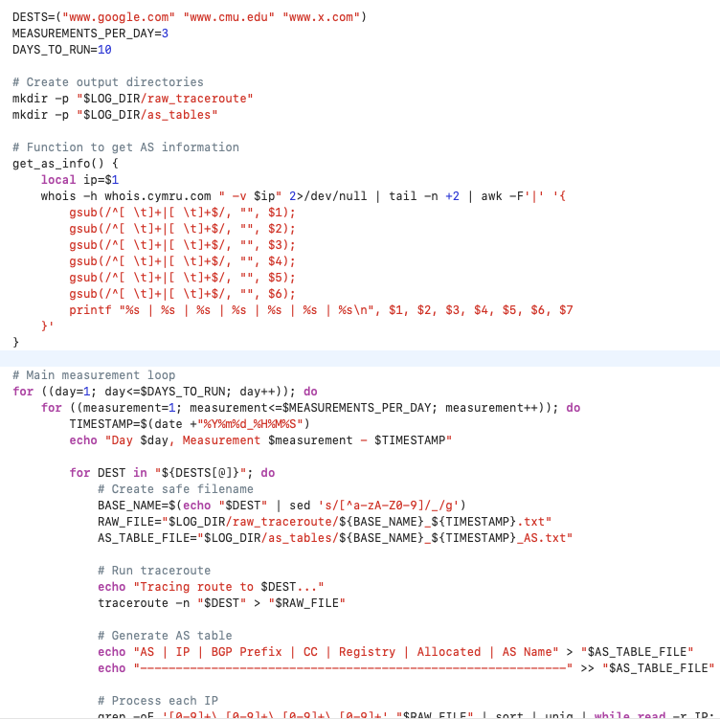
- Destination selection
  - 3 destinations I chosen to represent diverse routing paths:
    - www.google.com
    - www.x.com
    - www.cmu.edu
- Data Selection(Granularity of measurement)
  - Frequency & Duration :
    - x=at least 4 traceroutes per destination per day (sometime test 5 times a day)
    - y =12 days (Apr,13.2025-Apr,24.2025)
    - total 51 total measurements per destination
    - total 153 screenshots for all raw traceroutes.
  - Timing:
    - Measurements spaced 4- 5 times per day, 1 in the morning (around 7-10 am), 1 in the afternoon (around 3-5 pm), 1 in the evening ( around 8-10 pm), 1 in the night (10-12 pm)
- Data Recorded per Traceroute

By using the traceroute_as.sh script, the measurement data logs are stored in the folder below:

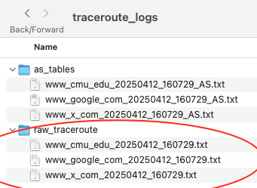

Raw router-level path of www.google.com

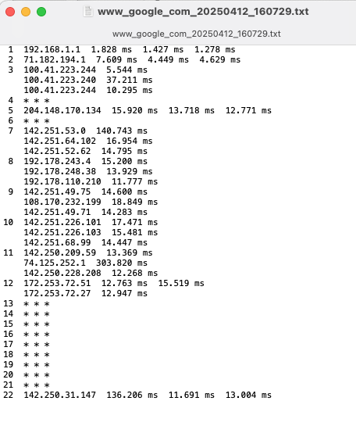

Raw router-level path of www.cmu.edu

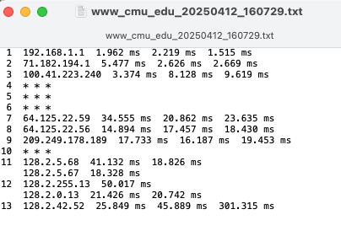

Raw router-level path of www.x.com

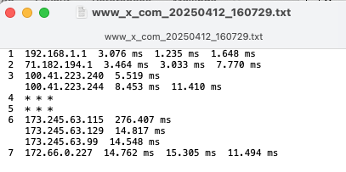

----------------------------------------------------------------------------------------
3 Data Analysis
The metrics you picked for your data analysis, the reason you picked these metrics, and the actual results (report on step 2)

- Translate each router-level path to an autonomous system-level path using whois tool

By using the traceroute_as.sh script, the measurement data logs has been automatedly transferred into AS level path and the new transferred AS logs are stored in the folder:

Before running traceroute_as.sh script in terminal, run chmod +x /../traceroute_as.sh command firstly.



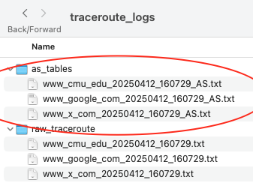

AS level path of destination www.google.com

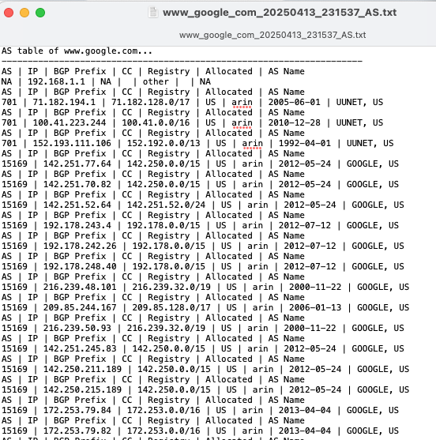

AS level path of destination www.cmu.edu

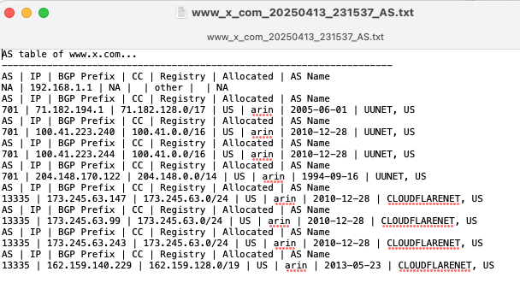

AS level path of destination www.x.com


- Path Stability Analysis at Router level and AS level
Answer to questions:
What is the most common path ?
how often do paths change ?
which part of the path changes most ?

1: Most Common paths:

Metric: Mode(most frequent path) or histogram of path occurrences

For destination www.google.com:

Most common router path (appeared 1 times):

('192.168.1.1', '71.182.194.1', '100.41.223.244', 'NA', '152.193.111.106', 'NA', '142.251.77.64', '142.251.70.82', '142.251.52.64', '192.178.243.4', '192.178.242.26', '192.178.248.40', '216.239.48.101', '209.85.244.167', '216.239.50.93', '142.251.245.83', '142.250.211.189', '142.250.215.189', '172.253.79.84', '172.253.79.82', '172.253.72.202', '172.253.66.161', '172.253.66.151', '172.253.66.161', 'NA', 'NA', 'NA', 'NA', 'NA', 'NA', 'NA', 'NA', 'NA', '172.253.115.103')

Most common AS path (appeared 6 times):

('NA', 701.0, 701.0, 'NA', 'NA', 'NA', 'NA', 'NA', 'NA', 'NA', 'NA', 'NA', 'NA', 'NA', 'NA', 'NA', 'NA', 'NA', 'NA', 'NA', 'NA', 'NA', 'NA', 'NA', 'NA', 'NA', 'NA', 'NA', 'NA', 'NA', 'NA', 'NA', 'NA')

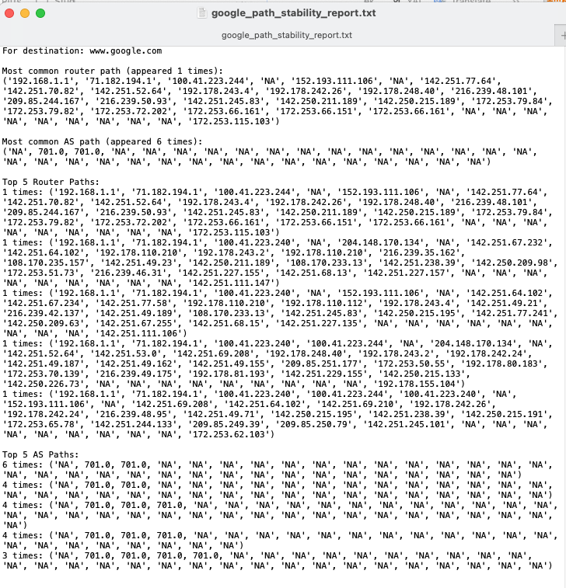

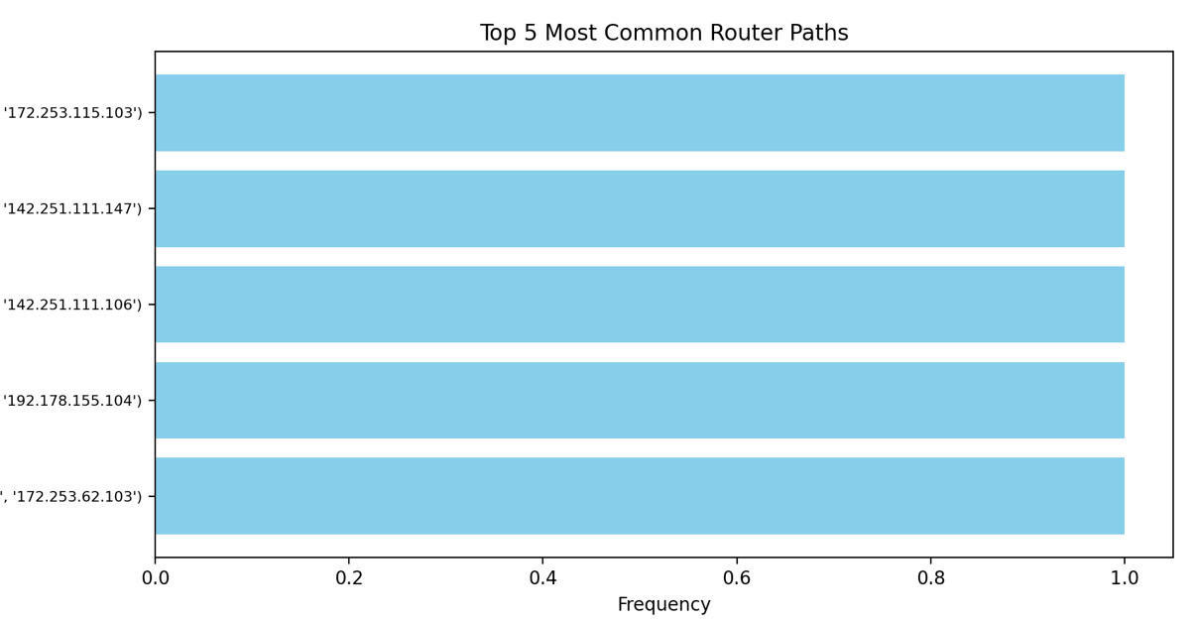

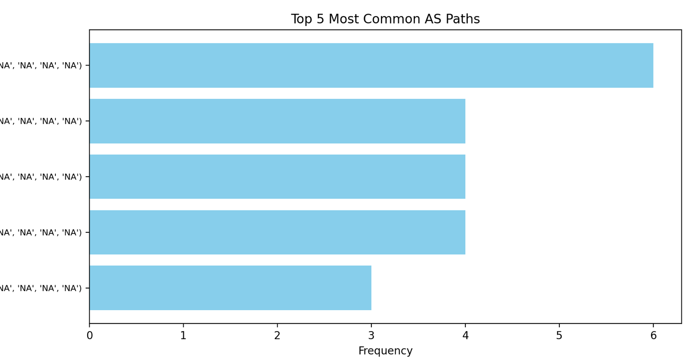

For destination: www.cmu.edu:

Most common router path (appeared 2 times):

('192.168.1.1', '71.182.194.1', '100.41.223.240', '100.41.223.244', 'NA', 'NA', 'NA', '64.125.22.59', '64.125.22.56', '209.249.178.189', 'NA', '128.2.5.67', '128.2.5.68', '128.2.5.67', '128.2.255.13', '128.2.0.13', '128.2.255.15', '128.2.42.52')

Most common AS path (appeared 8 times):

('NA', 701.0, 701.0, 701.0, 'NA', 'NA', 'NA', 6461.0, 6461.0, 6461.0, 'NA', 9.0, 9.0, 9.0, 9.0, 9.0, 9.0)

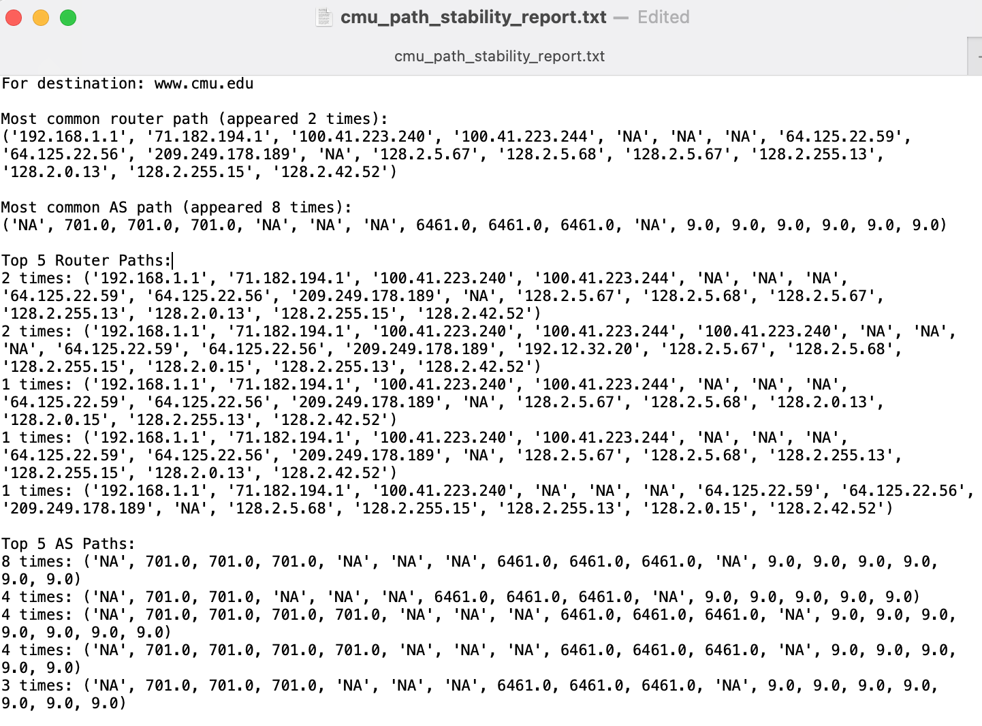

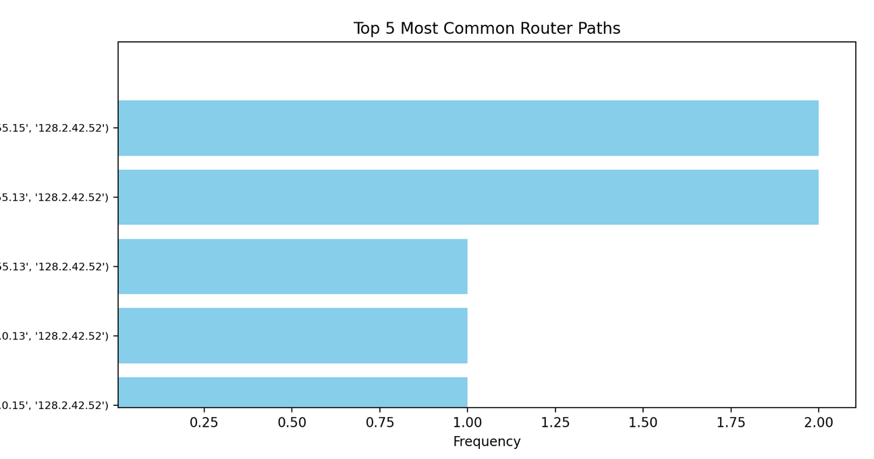

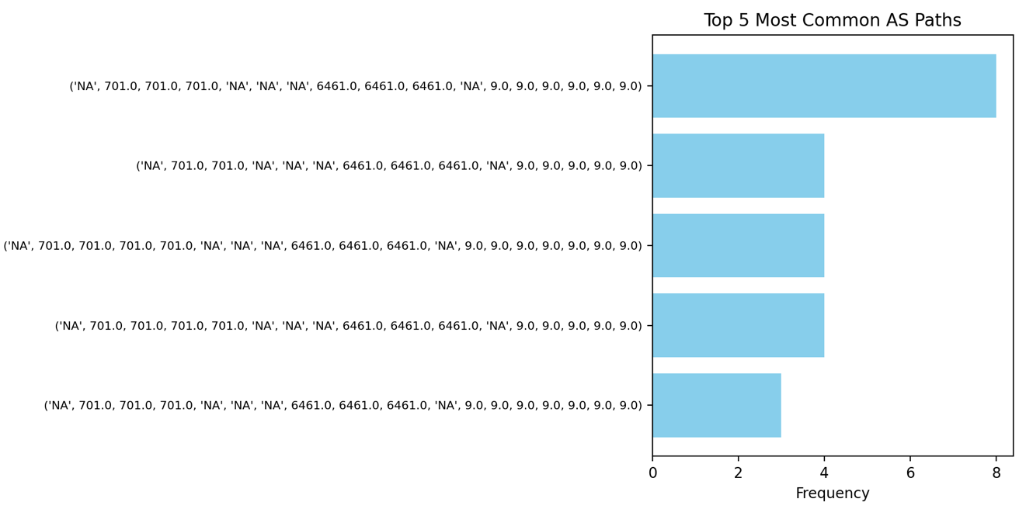

For destination www.x.com:

Most common router path (appeared 1 times):

('192.168.1.1', '71.182.194.1', '100.41.223.240', '100.41.223.244', 'NA', '204.148.170.122', '173.245.63.147', '173.245.63.99', '173.245.63.243', '162.159.140.229')

Most common AS path (appeared 13 times):

('NA', 701.0, 701.0, 701.0, 'NA', 'NA', 'NA', 'NA', 'NA', 'NA')

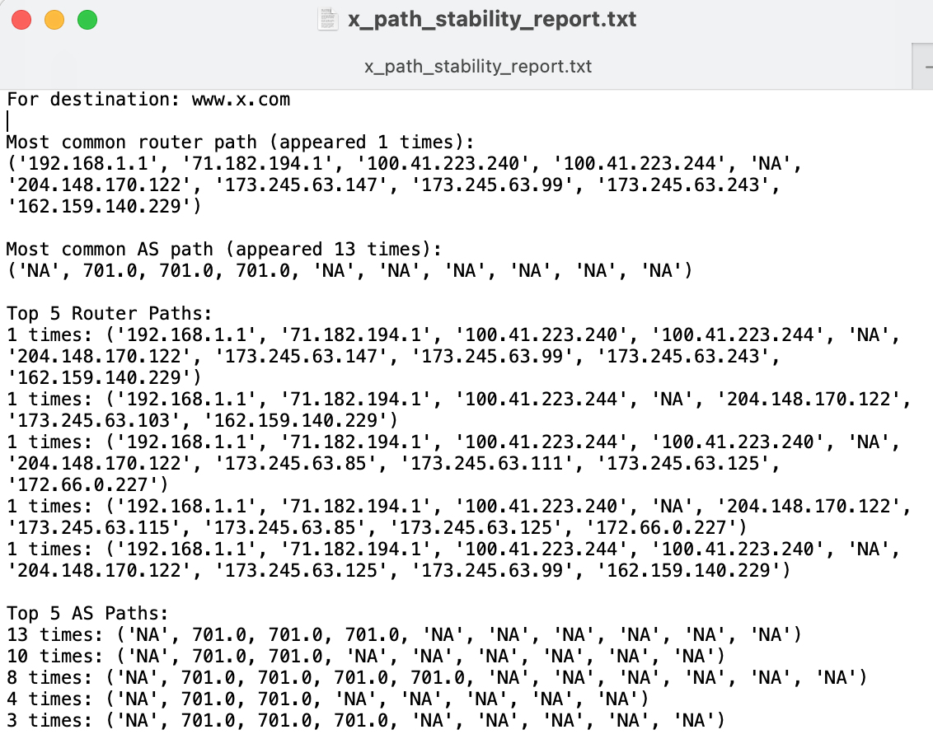

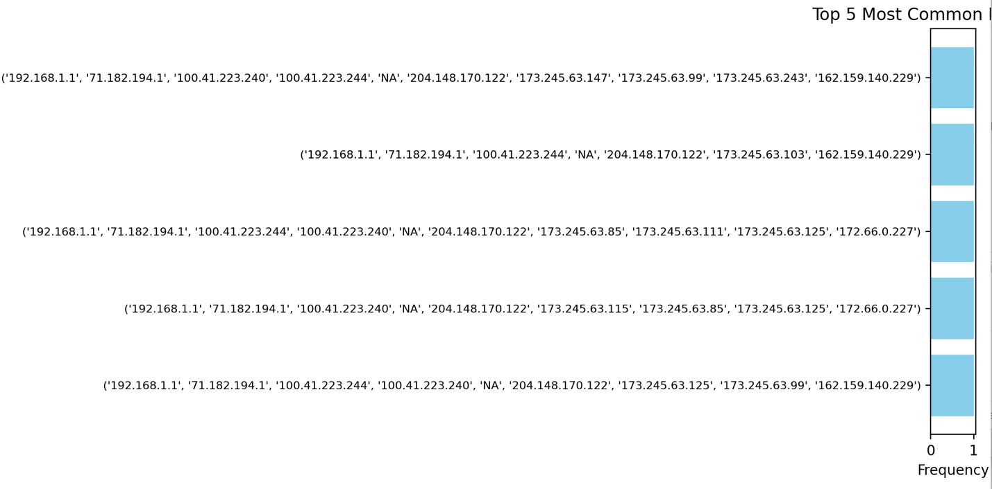

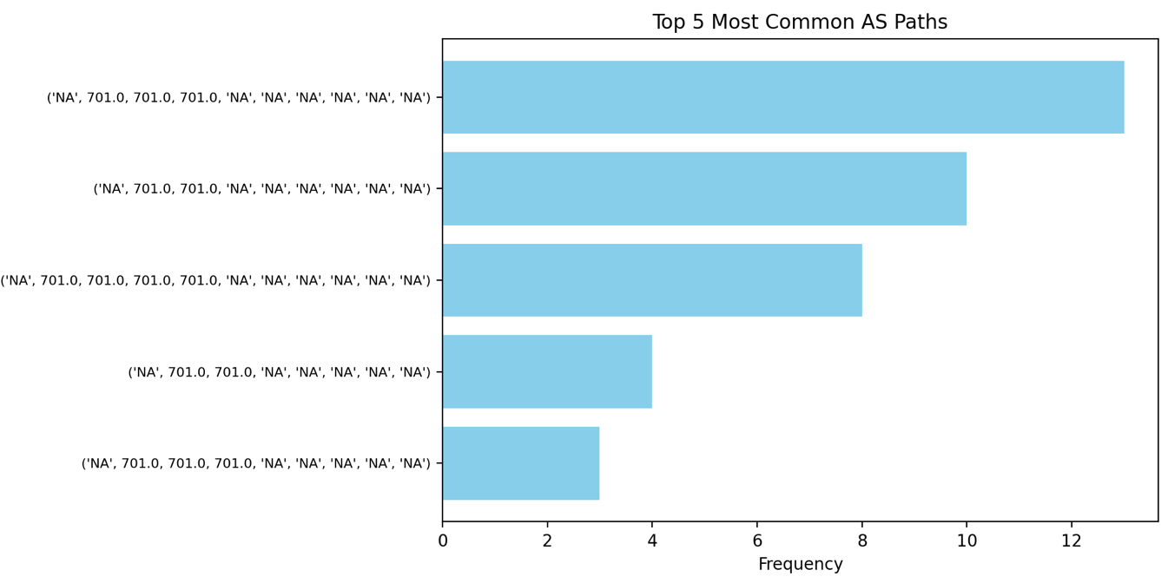

2: Path change frequency

Metric: % of measurements where the path changed from the previous sample

For destination google:

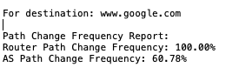

For destination cmu:

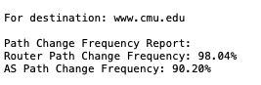

For destination x:

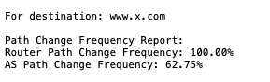

3: Most volatile hops/ASes:

Metric: for each hop/AS, compute the % of the measurements where it differed from the prior observation.

When calculating hops volatility, I did not consider the change from Na- value – Na, I just counting valid comparisons(non-NaN to non-NaN), so if a particular AS or router hop is always the same or mostly missing, its volatility = 0%.

For destination google:

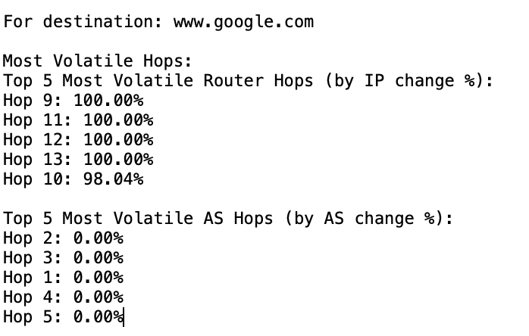

For destination cmu:

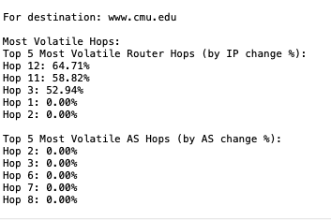

For destination x:

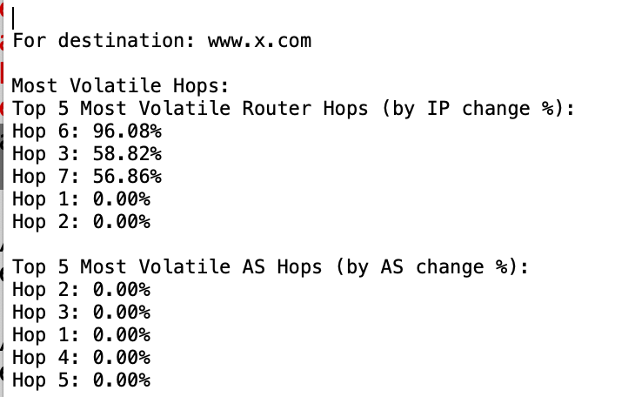

- Delay Stability Analysis

For end-to-end delay stability:
- Average delay:

Mean, median, and range (min/max) across all measurements.
- Jitter:

Standard deviation(SD) of latency, how much the end-to-end RTT fluctuates over time, lower SD = more stable delay
- Max/Min RTT range:

Max RTT - Min RTT, simple way to see the total spread of delay variation.
- Packet Loss Rate:

% of traceroutes with * * * at a hop. Count how many times the final hop is missing or timed out.
- Peak vs. Off-Peak Latency:

Compare daytime vs. nighttime RTTs.

For destination google:

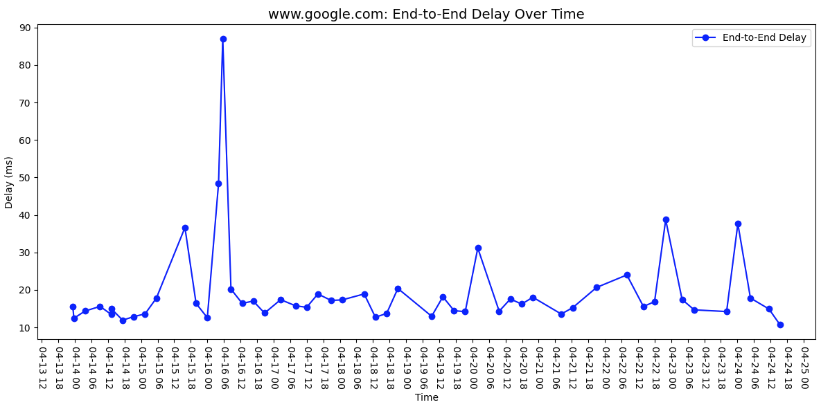

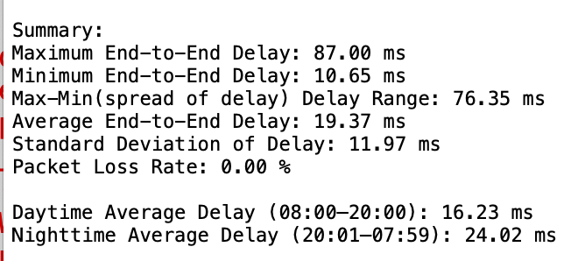

For destination cmu:

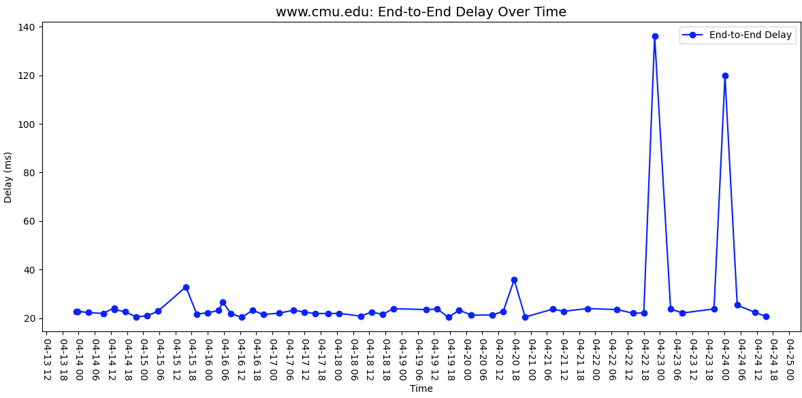

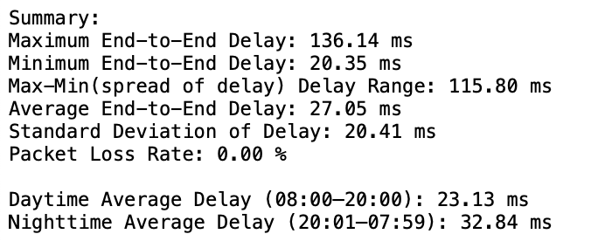

For destination x:

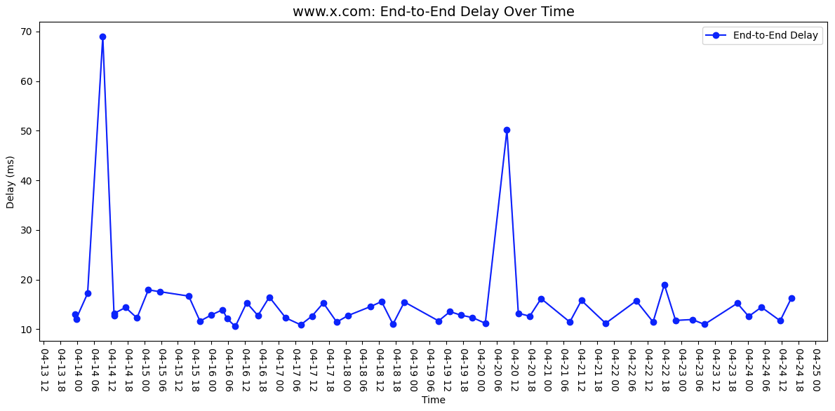

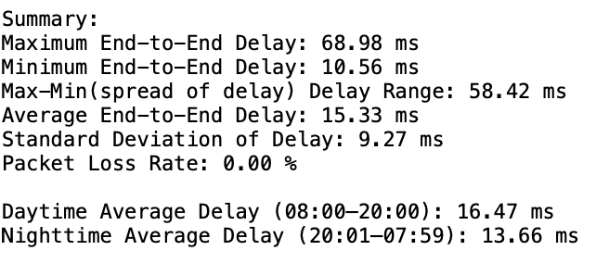

For per-hop delay stability:

(Consistent Hops: Focus on hops with stable IP addresses across measurements.)
- Hop-Specific Trends:
  - Mean delay and variability per hop (router/AS).

Mean, median, and range (min/max) across all measurements.
  - Correlation between hop delay and end-to-end delay (e.g., is one hop a bottleneck?).

For destination google:

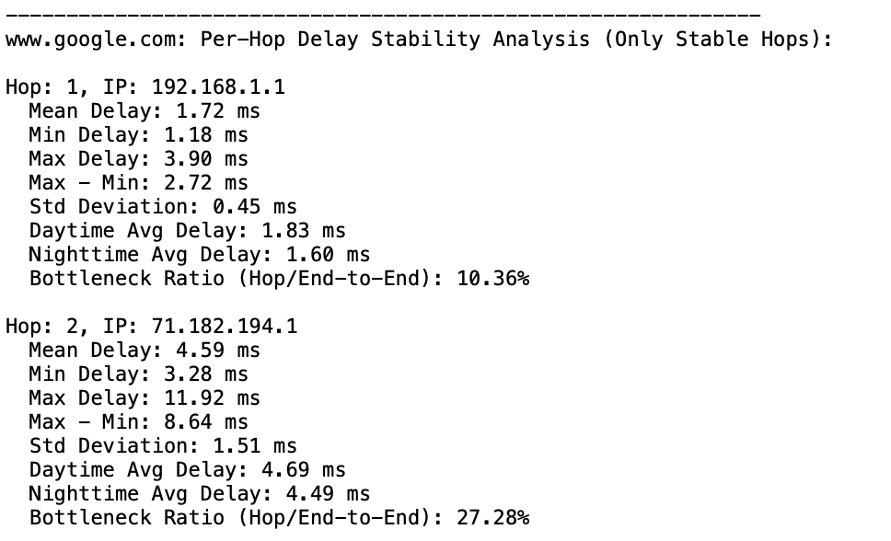

For destination cmu:

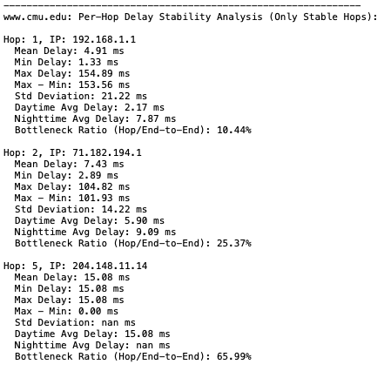

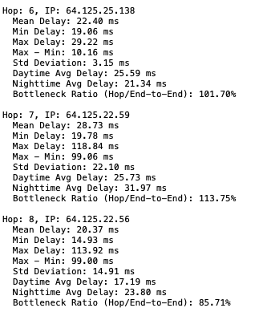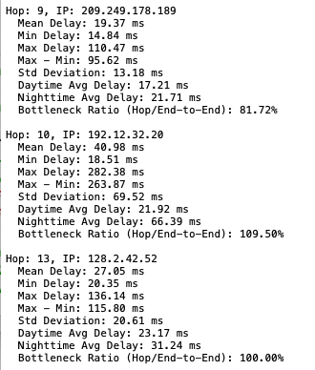

For destination x:

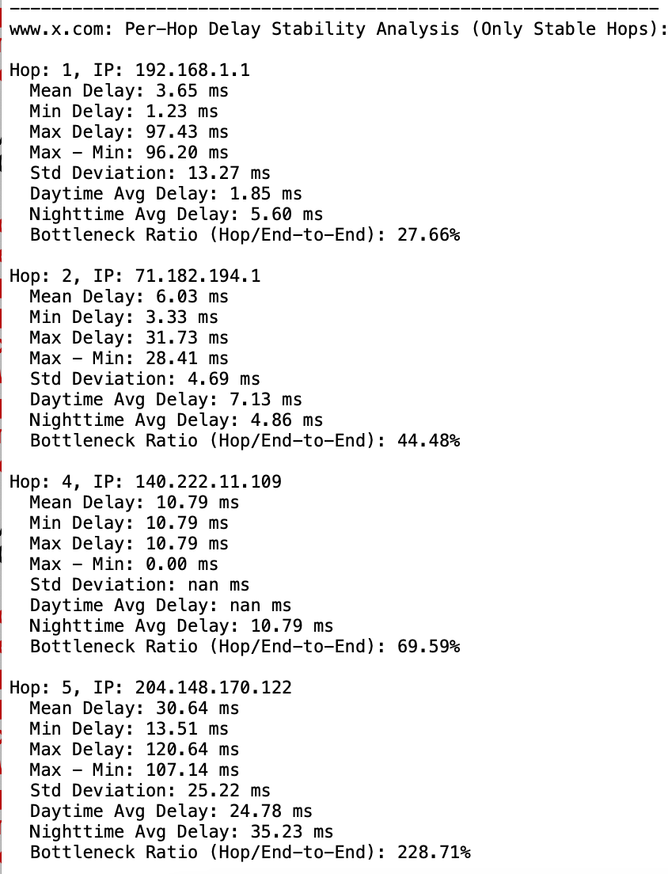

- AS-Level Delay Shifts:
  - Compare delays for the same AS in different router-level positions (e.g., does delay increase at peering points?).

For destination google:

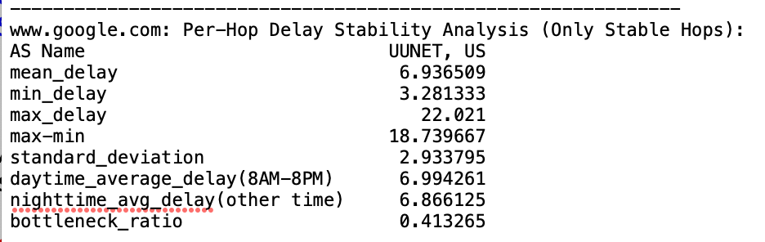

For destination cmu:

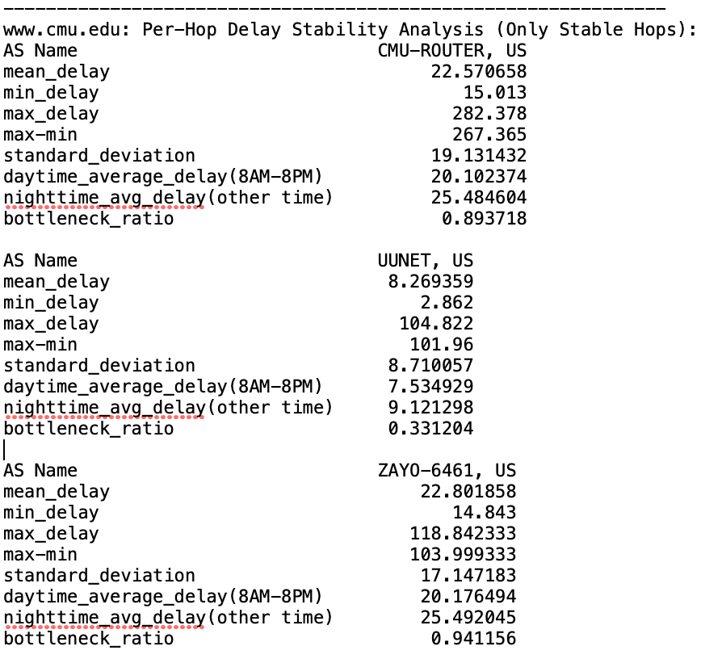

For destination x:
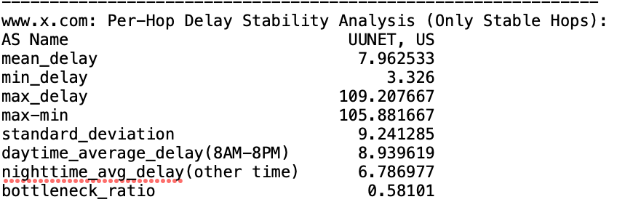

----------------------------------------------------------------------------------------
4 Conclusion
Visualizations:
- Time-series plots of path changes (router vs. AS).
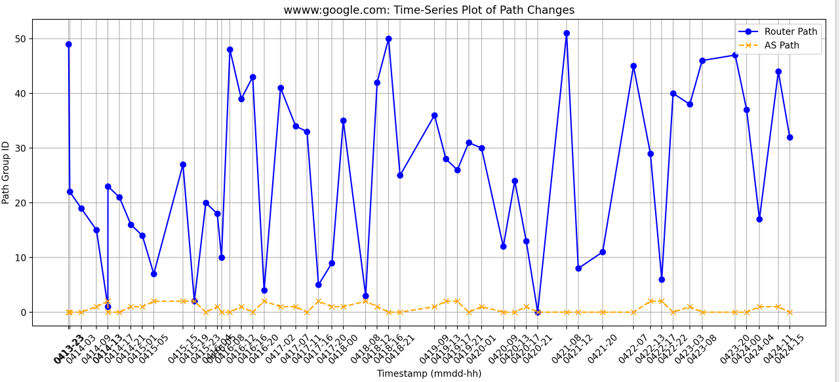

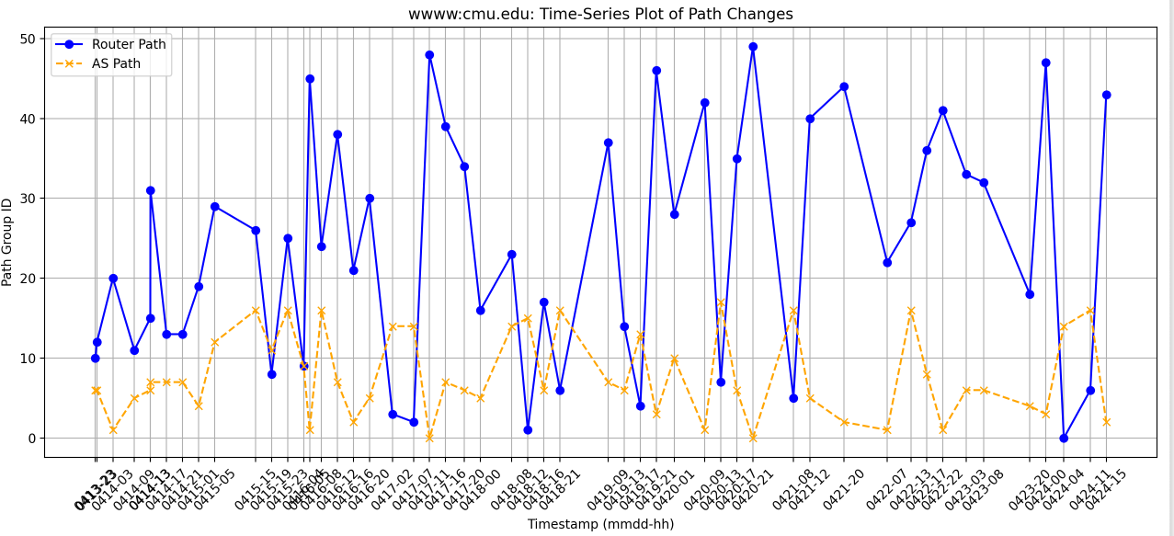
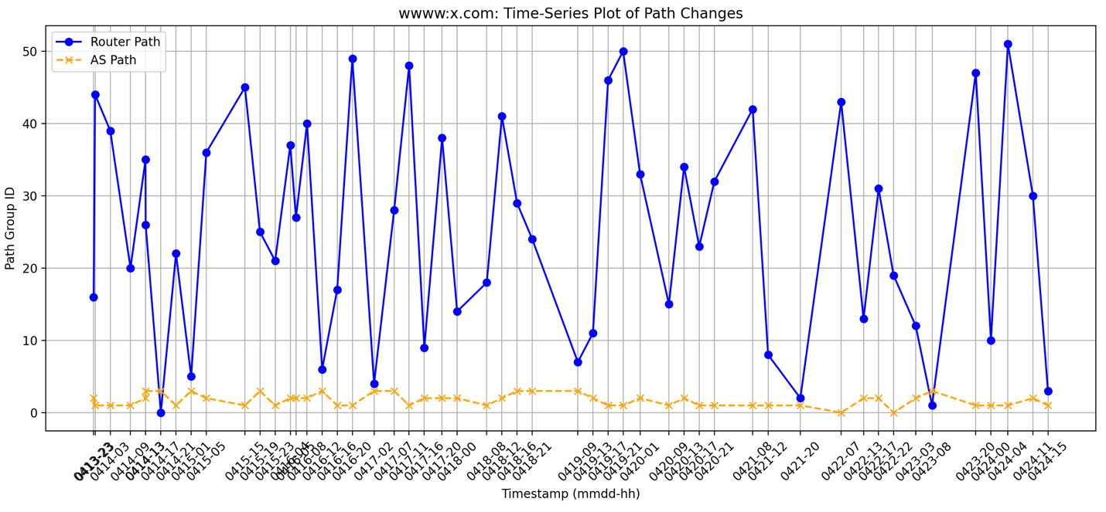

For most frequent router’s paths and AS paths:

Conclusion:

From 3 destination’s most frequent router’s paths and AS paths , we find compare to routers path, AS path is more stable:

www.google.com the most common router path appeared 1 times, but AS path appeared 6 times;

www.cmu.com the most common router path appeared 2 times, but AS path appeared 8 times;

www.x.com the most common router path appeared 1 times, but AS path appeared 13 times;

For path change frequency:

Conclusion:

From 3 destination’s most router path change frequency and AS path change frequency results , we find: compared to AS path, router path change frequency is very high (nearly 100 %) which means, when we visit these websites, its router path changes every time.

For most volatile hops /ASes

Conclusion:

From 3 destination’s most router path and AS path most volatile hops results , we find:
- compared to AS path, all 3 destination’s router paths show a very high volatility (google:100%, cmu:64.7%, x:96%) .
- Compared to google and x, CMU shows a moderate volatility, which means IP path to CMU is more stable.
- All top AS hops show 0% volatility which means they keep same ( or mostly missing ,by my calculation definition). So compared to IP-level paths vary, AS-level routing is consistent.

Summarized Interpretation:
- AS-level paths are more stable (BGP policies change less frequently than router-level paths).
- Google’s path varies due to CDN load balancing, while CMU’s path is stable (single hosting).

For end-to-end delay

Conclusion:
- Delay Performance Ranking: Twitter (X) performs the best overall, while CMU has the worst latency. CMU’s higher delays suggest potential network congestion, longer routing paths, or less optimized peering.
- Delay Variability: Google: Moderate variability (Std Dev = 11.97 ms), CMU: High variability (Std Dev = 20.41 ms), Twitter (X): Lowest variability (Std Dev = 9.27 ms)
- Most of time, daytime delay is smaller than nighttime delay, Google & CMU: Higher delays at night, Reduced off-peak routing optimizations. Twitter (X): Faster at night, Possible use of dynamic routing.

For per hop delay at router level and AS level

Conclusion:
- Per hop delay at router level and AS level are different, per hop delay at router level can be affected by various factors like congestion at each hop, routing decisions, and physical distance between the hops, but AS level per hop delay aggregates delay measurements across the entire AS path. So basically, AS level ‘s delay is smaller than router level delay.
- Compared to google and x, CMU has more consistent hops which shows CMU has a well-maintained network infrastructure. CMU even has its own local network, the hops within the CMU network are likely geographically closer and less affected by the global internet traffic variations.

Appendix A)
All python scripts and sh scripts used in this project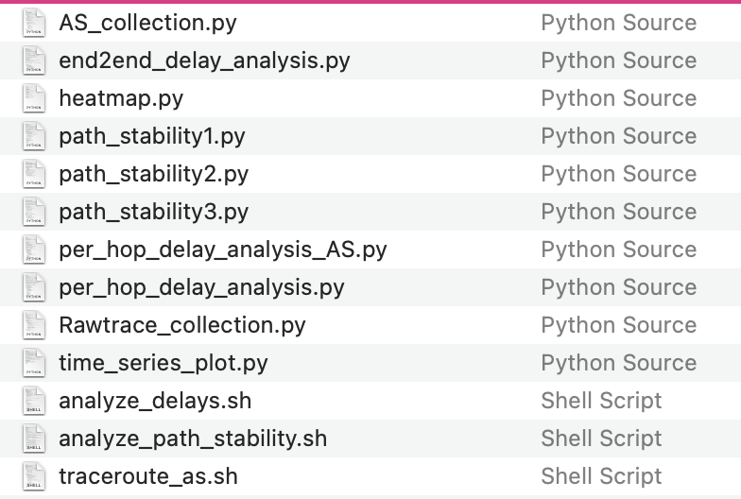

Appendix B) 3 reports of google, CMU and X
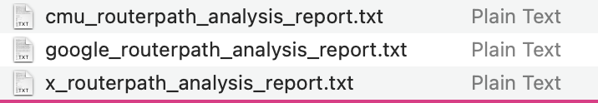

google routerpath_analysis_report.txt
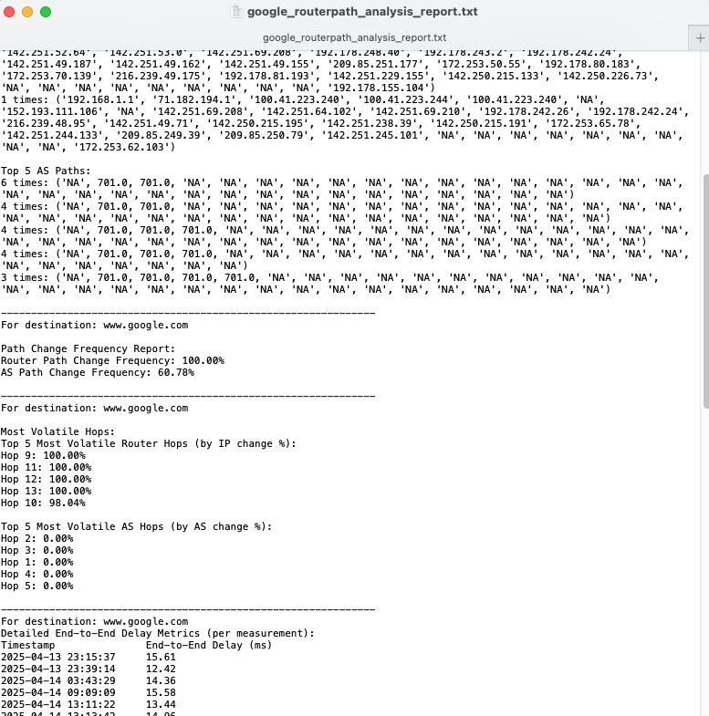

Appendix c) python script : raw_traceroute_transfer.py
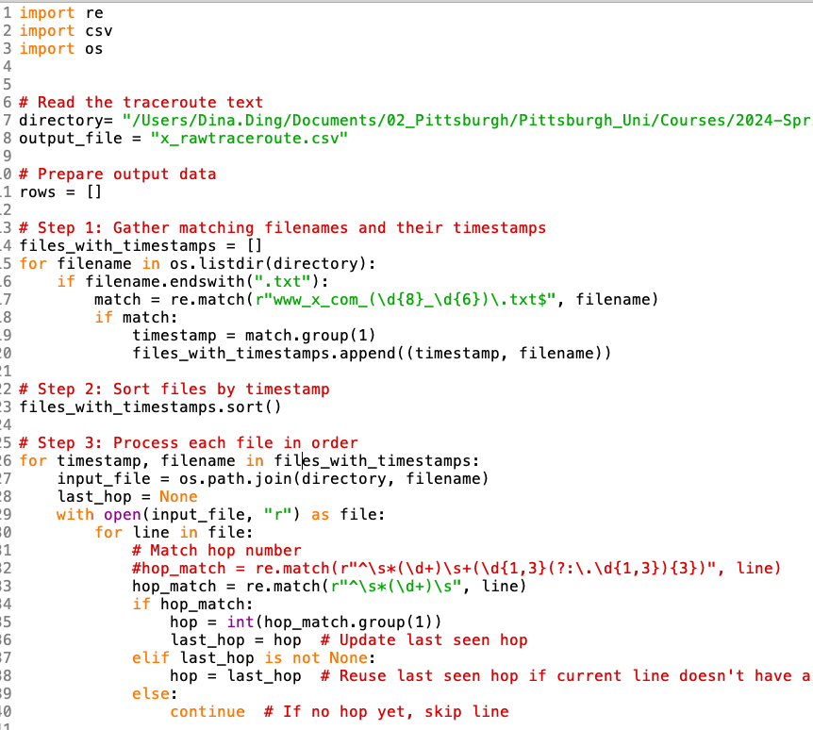
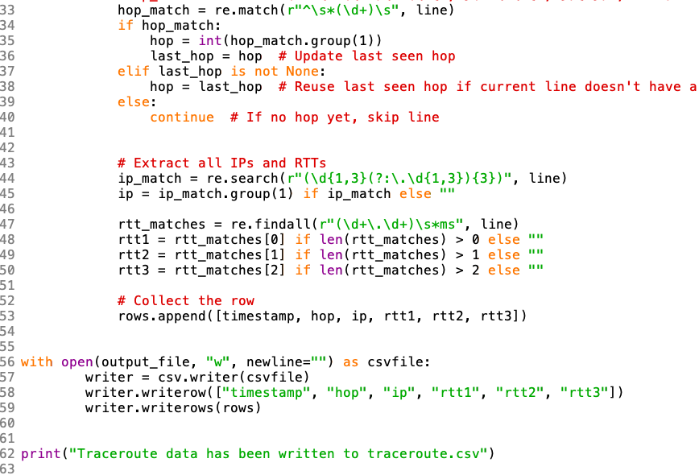

Appendix d) AS_collection.py
