# **Facial Emotion Recognition (FER) Proposal**

List of Team Members:  
  
Tianxingjian Ding, Haowen Pan, Qiyue Xu

# **Project Description and Goals**

## **Project Description**

The FER project is designed to harness the power of the Residual Masking Network, a novel neural architecture that has demonstrated promising results in the realm of facial emotion recognition. The network consists of four Residual Masking Blocks, each composed of a Residual Layer and a Masking Block. These blocks work in tandem to transform input features into refined outputs, capable of identifying seven different facial expression states, encompassing six emotions and one neutral state.

## **Goals**

**Fundamental Emotion Detection**: Ensure the system can reliably detect basic emotions using CNN-based models, establishing a solid foundation for more complex emotion recognition tasks.

**Datasets Development and Utilization**: Assemble and utilize diverse datasets for training and testing, focusing on the inclusion of facial expressions and micro-expressions, in line with the datasets highlighted in the article.

**Prototype with Emotion Prediction**: Develop a prototype that incorporates the key components of an ANN-based FER system, including face detection, feature extraction, and emotion prediction, mirroring the structure outlined in the review.

***If possible*: Emotion Spectrum and Intensity**: Develop the system to recognize not only the basic emotions identified by Ekman and Friesen, such as anger, fear, sadness, happiness, surprise, and disgust but also to discern their intensities and derivations through sophisticated image analysis.

## **Resources**

## **Datasets**

**AffectNet database:** The AffectNet database contains 456,349 images of facial emotions obtained from three search engines, Google, Bing and Yahoo. The images were labeled with the following 11 emotions: neutrality, happiness, sadness, surprise, fear, disgust, anger, contempt, none, uncertain, and nonface.

Figure 1: Image categories in AffectNet Database

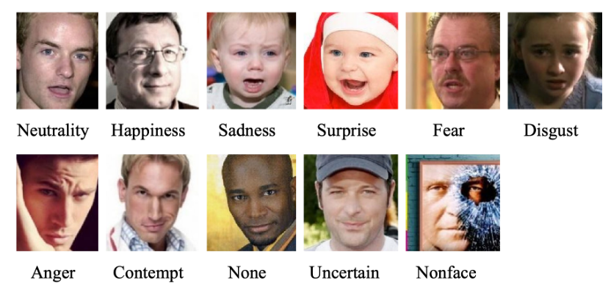

**Real-World Affective Faces Database:** The RAF-DB consists of more than 300,000 facial images sourced from the internet, which are classified into seven categories: surprise, fear, disgust, anger, sadness, happiness and neutrality.

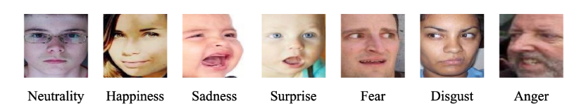

## **Code**

Figure 2: Image categories in RAF Database

**Residual Masking Network:**

The Residual Masking Network (ResMaskNet) is a neural network architecture devised to enhance the capabilities of convolutional neural networks (CNNs) for the task of facial emotion recognition by integrating feature refinement mechanisms within the network layers.

## **Implementation Platform**

1. Programming Language: Python
2. Frameworks and Libraries: TensorFlow, PyTorch, OpenCV
3. Development Environment: Jupyter Notebooks, PyCharm, Visual Studio Code

## **Reservation**

## **Datasets Selection and Labeling**

Dataset quality is important for the model training and results. We need to find a dataset with a wide range of emotions, ethnicities, ages, lighting conditions, and angles. Compiling this dataset is difficult as emotions are often ambiguously expressed and can overlap (e.g., a smile might indicate both happiness and sadness). And since determining facial emotion expressions is a very subjective judgment, Accurate labels are also important. If needed, we could also try to collect and label some of the data.

## **Model Architecture Design and Training**

Model design and training is the core part of the project and directly affects the accuracy rate. Constructing and training the model for emotion detection could be challenging and complicated, due to the complexities of human expressions and their contextual subtleties. We should choose the platform and library we want to use and design the model. Refinement of the model is also an iterative and resource-intensive process, with the constant need to tune hyperparameters and possibly restructure the model to improve performance. It also has requirements for hardware devices.

## **Final Stage Accuracy Enhancement**

After successfully implementing the whole application, which is our basic goal, we need to increase the accuracy for better performance. It involves a lot of parts and is complicated. Potential methods are using diverse and high-quality validation datasets, using data augmentation, using transfer learning and fine-tuning for the pre-trained models, using Large Language Models and so on.

# **Member Roles**

**Tianxingjian Ding:**

1. Model Architecture and Implementation
2. Documentation and Reporting

**Qiyue Xu:**

1. Model Training and Optimization
2. Integration, Testing, and Prototyping

**Haowen Pan:**

1. Model Evaluation and Refinement
2. Data Management and Preprocessing

# **Relation of Background**

**Qiyue Xu:**

I have taken machine learning and introduction to AI courses, and worked with and have implemented algorithms like DFS, BFS, greedy algorithms, and NLP, I have a solid grounding in the fundamentals. My experience with license plate recognition using SVM has familiarized me with image processing and classification tasks, although I have not yet ventured into CNNs or face recognition technology. This new project, focusing on facial emotion recognition, is a thrilling step forward for me. It will involve implementing and training new models, extending my existing knowledge into a more complex domain of image analysis. I'm particularly excited to explore the potential applications in AI and human-computer interaction.

**Tianxingjian Ding:**

Having studied machine learning and AI, and worked with algorithms like DFS, BFS, and greedy algorithms, my foundation in AI is solid. I've also gained practical experience with image classification through a project on license plate recognition using SVM, which gave me a good grasp of image processing tasks. Additionally, I have some understanding of computer vision. I've worked with feature extraction algorithms like SIFT and SURF before, which will be useful in this new project. I'm looking forward to seeing how this knowledge will help in AI and how we interact with computers. With this new project, I'm stepping into a new area with a project on facial emotion recognition, which will push my skills further into the realm of image analysis. I've not worked with CNNs or face recognition before, so this is an exciting challenge.

**Haowen Pan:**

I have taken ECE448 AI and I have experience with CV projects like image classification and face recognition with neural networks. I will leverage what I know into this Facial Emotion Recognition project.