AERO1005 MATLAB Coursework 2

Author: Yixin Ding
Student ID: 20719599
Date of report: 2026.4.27

Task 1
a) Thermistor Circuit Implementation with Arduino UNO:
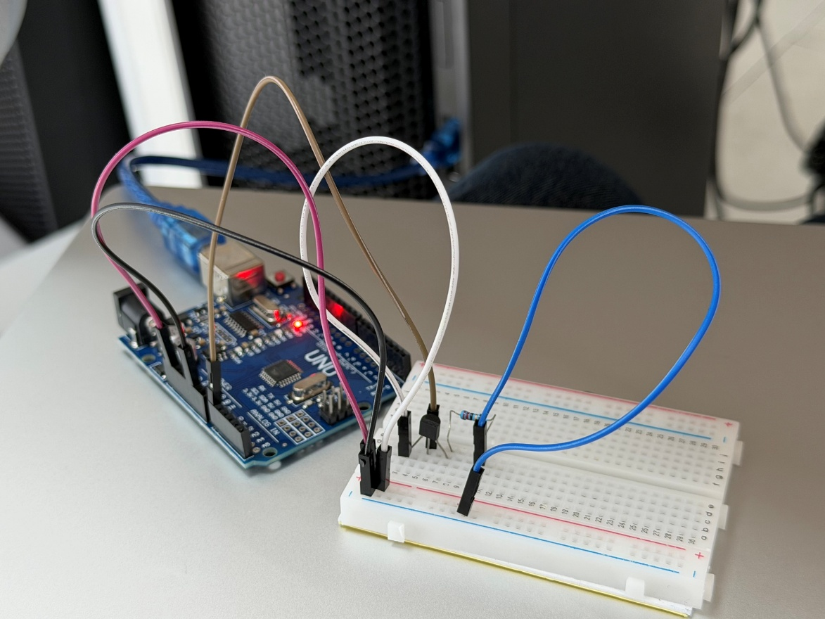
c) Temperature Variation Over Time:
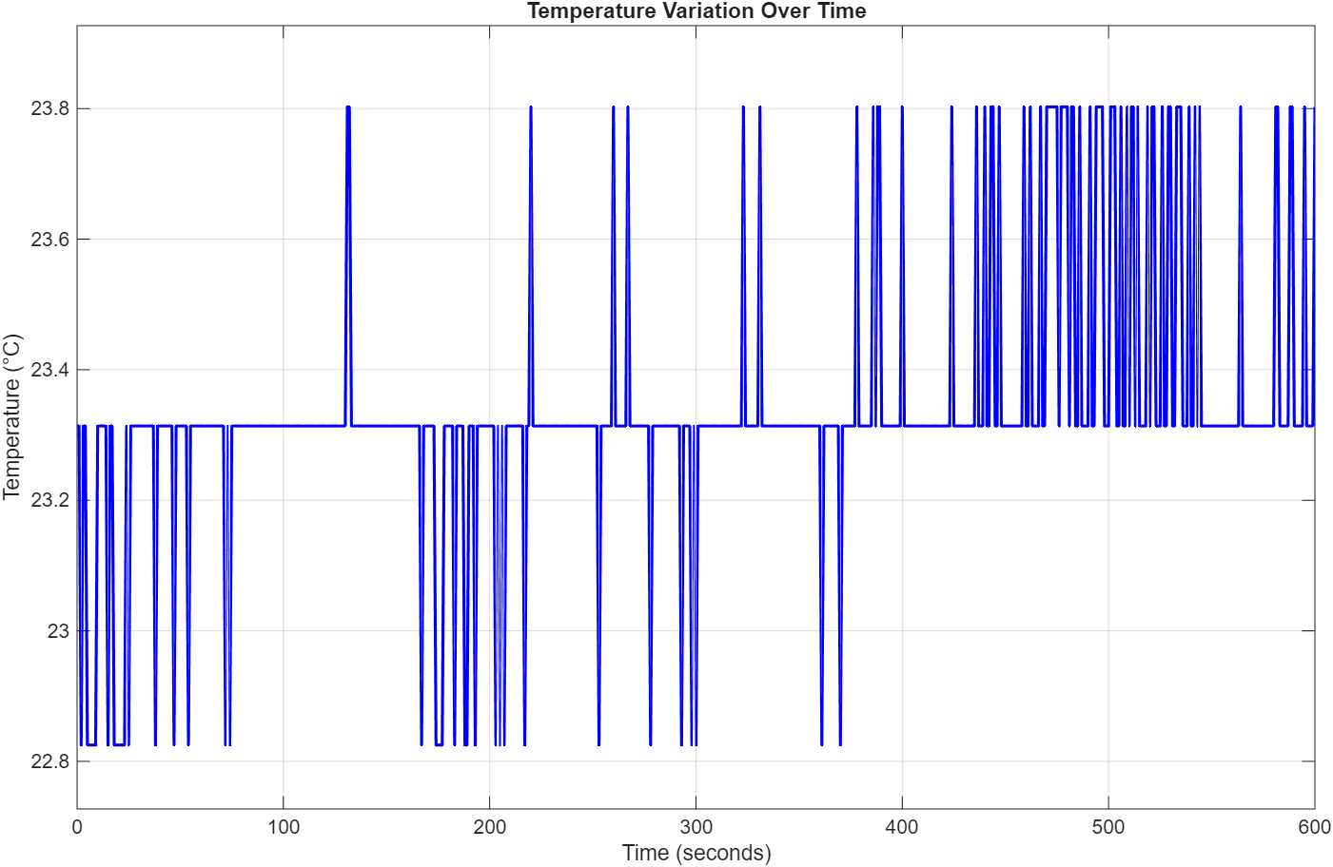
Task 2
f) Connection diagram of three LED sensors with Arduino:
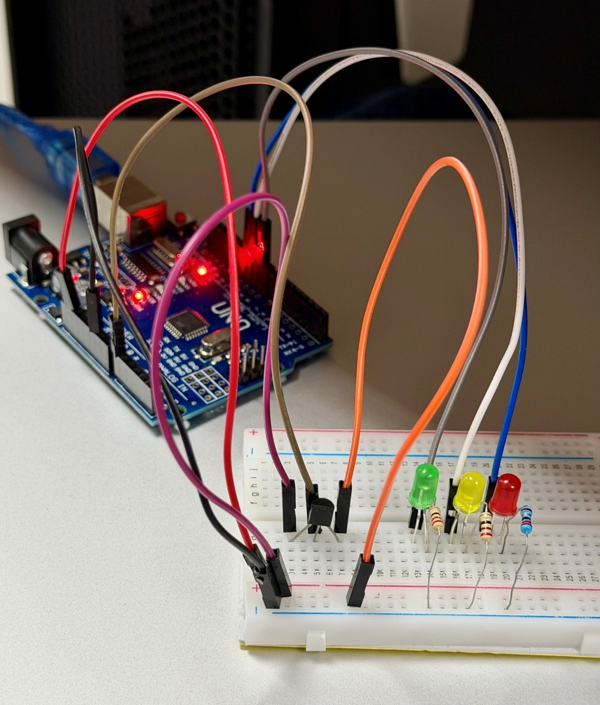

g) Flowchart:
Start

Connect the three LEDs and temperature sensor to the Arduino on the breadboard.

Set green/yellow/red pins as OUTPUT, and turn all LEDs OFF.

Infinite While loop start

Read current temperature
No
Is the temperature in the range 18-24 °C?
Yes

Turn on green LED constantly and turn off yellow and red LEDs.
No
Is the temperature below 18 °C?
Yes

Yellow LED blinks every 0.5s and turn off green and red LEDs.

Is the temperature above 24 °C?
Yes

Red LED blinks every 0.25s and turn off green and yellow LEDs.
i)The Live Temperature Monitoring Graph:
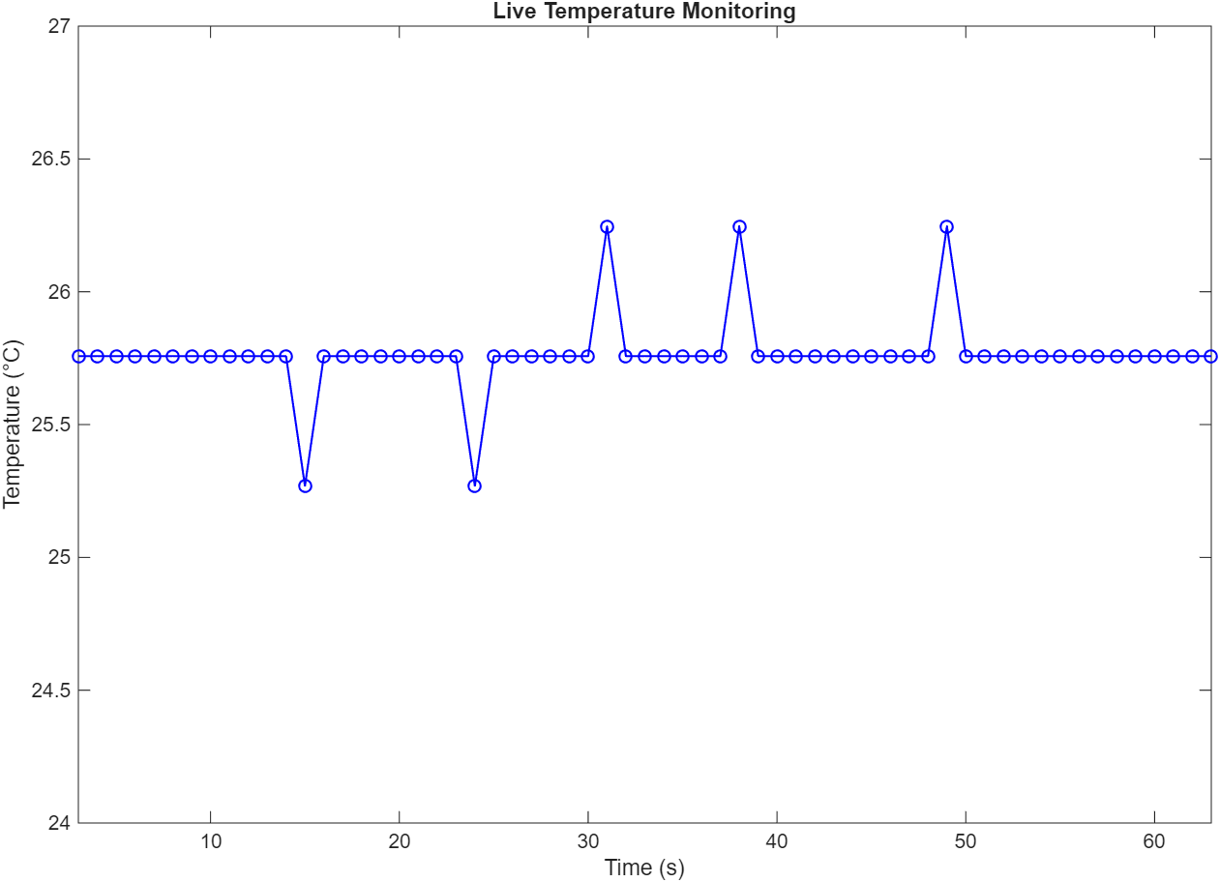
g) Second, updated Flowchart:
Start

Create a function temp_monitor.m.

Connect green LED (D9), yellow LED (D10), red LED (D11),
and temperature sensor to the Arduino on the breadboard.

Turn all LEDs OFF.

Initialize 60 second rolling live plot: title, labels, grid, xlim [0,60], ylim [24,27].

Infinite While loop start.

Read voltage from A0, convert to temperature.

Update time counter t, append time/temp data.

If t > 60: trim data to last 60s, update xlim([t-60, t]).

Update live plot with new data (drawnow), maintain 1 second sampling interval.
No
Is the temperature in the range 18-24 °C?
Yes

Turn on green LED constantly and turn off yellow and red LEDs.
No
Is the temperature below 18 °C?
Yes

Yellow LED blinks every 0.5s and turn off green and red LEDs.

Is the temperature above 24 °C?
Yes

Red LED blinks every 0.25s and turn off green and yellow LEDs.

Task 3
a) Flowchart:
Start

Create a function temp_prediction.m.

Connect green LED (D9), yellow LED (D10), red LED (D11),
and temperature sensor to the Arduino on the breadboard.

Turn all LEDs OFF.

Infinite While loop start.

Read voltage from A0, convert to temperature.

Apply median filter to smooth temperature data.

Calculate temperature rate of change (derivative):
Rate (°C/s) = ΔT / Time Interval (1 s)

Print current temperature, smoothed temperature and rate of change.

Predict temperature in 5 minutes:
Rate (°C/min) = Rate (°C/s) × 60
Predicted Temp = Current Temp + (Rate × 5)

Print 5-minute prediction.

Is the temperature rate greater than +4°C/min?
No
Yes

Turn on red LED constantly and turn off off green and yellow LEDs.
No
Is temperature rate less than -4°C/min?
Yes

Turn on yellow LED constantly and turn off green and red LEDs.

Is the temperature in the range 18-24 °C?
Yes

Turn on green LED constantly and turn off yellow and red LEDs.

Turn off all LEDs.

Pause for sample interval (1 seconds).

Task 4 reflective statement
Challenges

Strength
Limitations
Suggested future improvement

