The durability test results below show that over time, the response time grows in leaps and bounds, in parallel increasing the number of server errors.

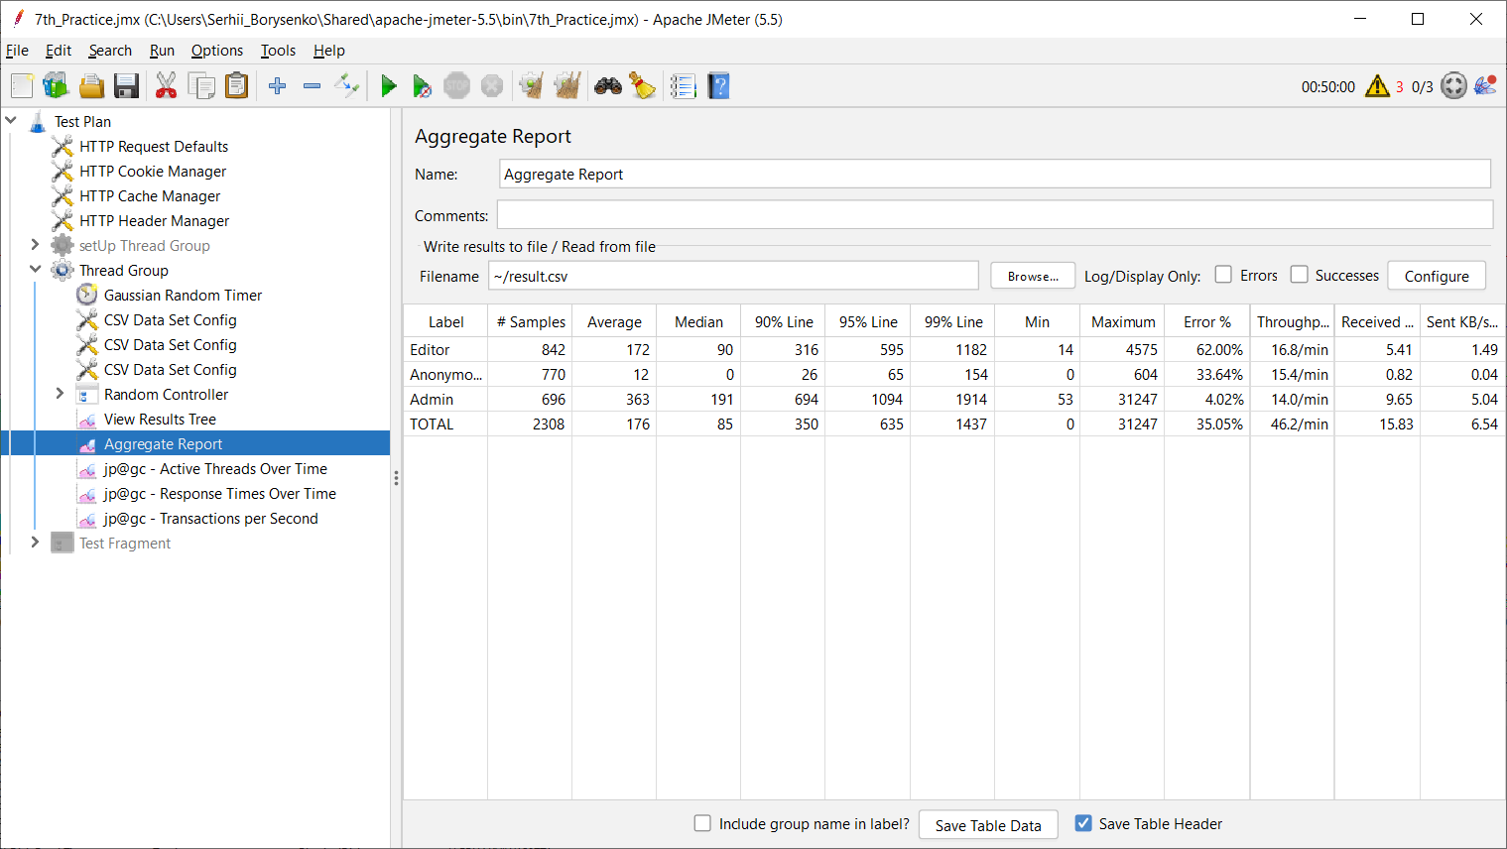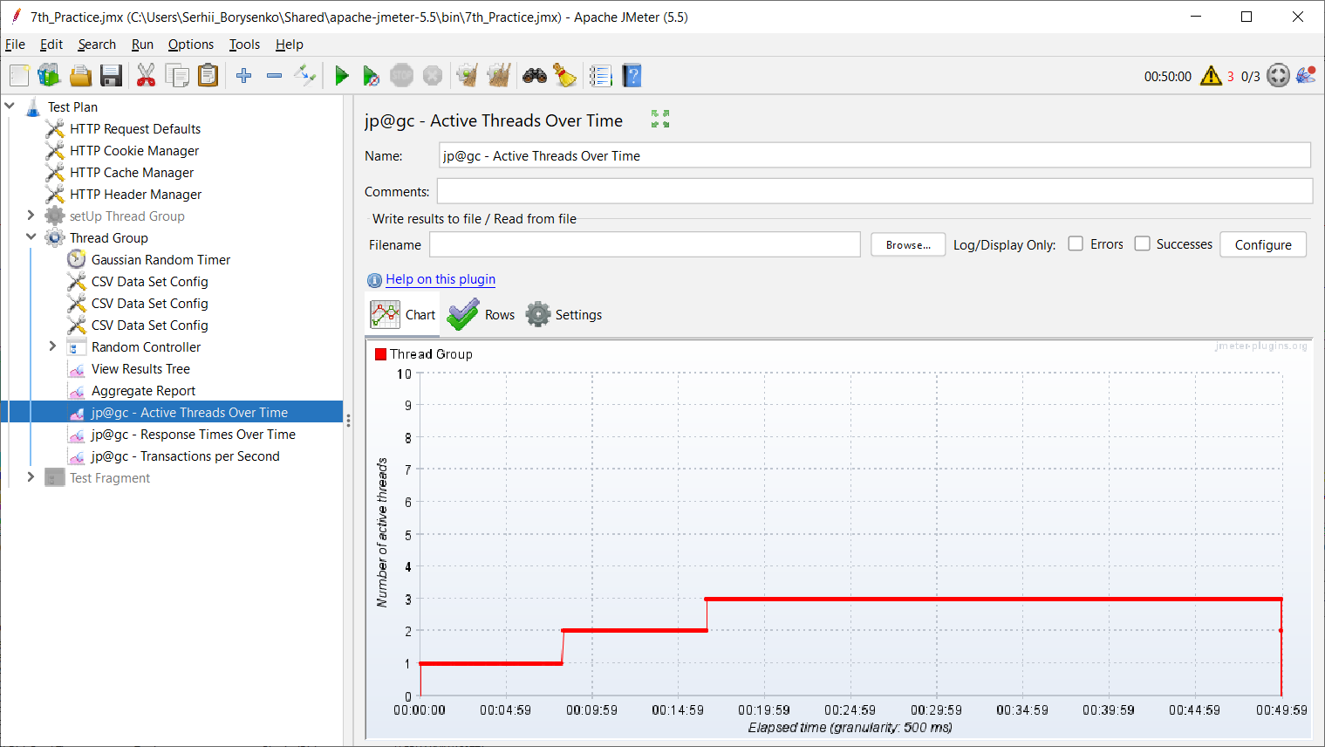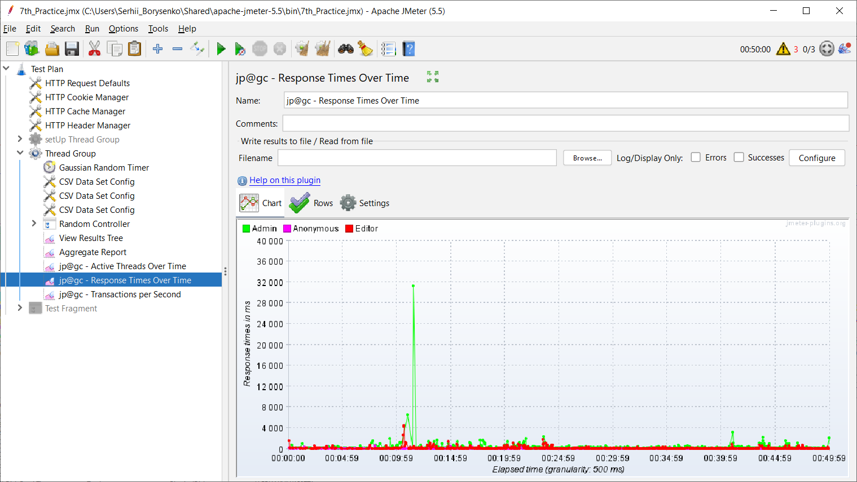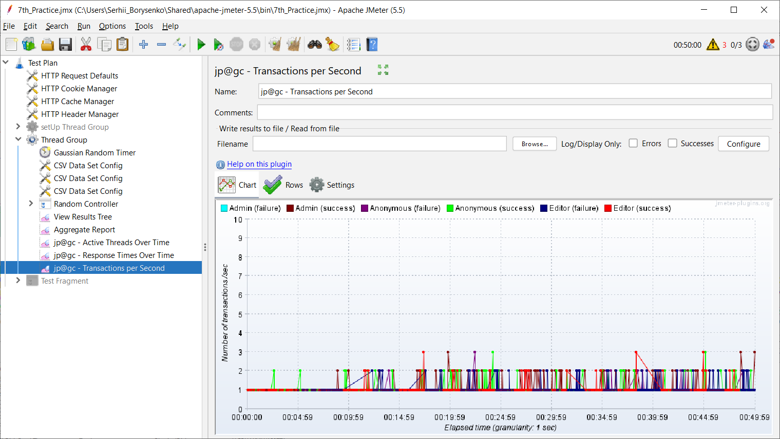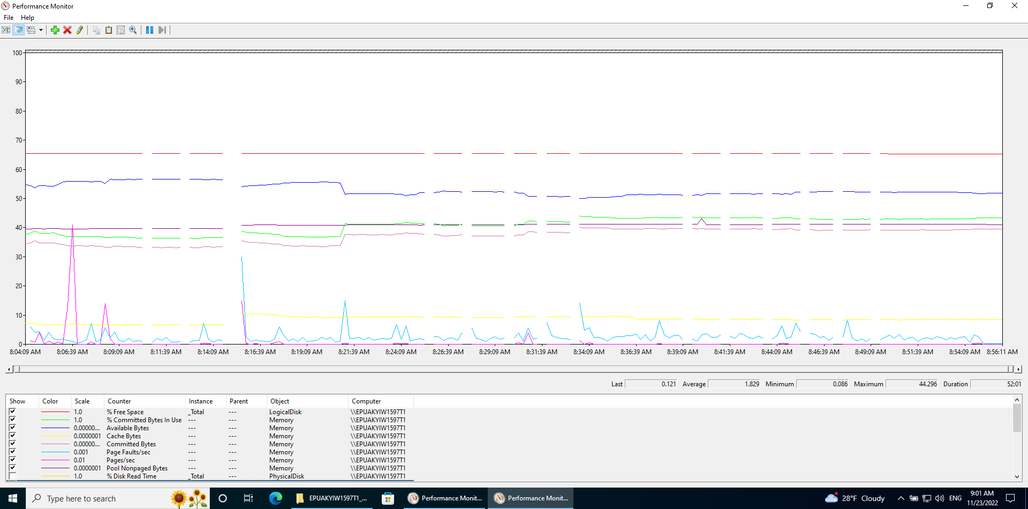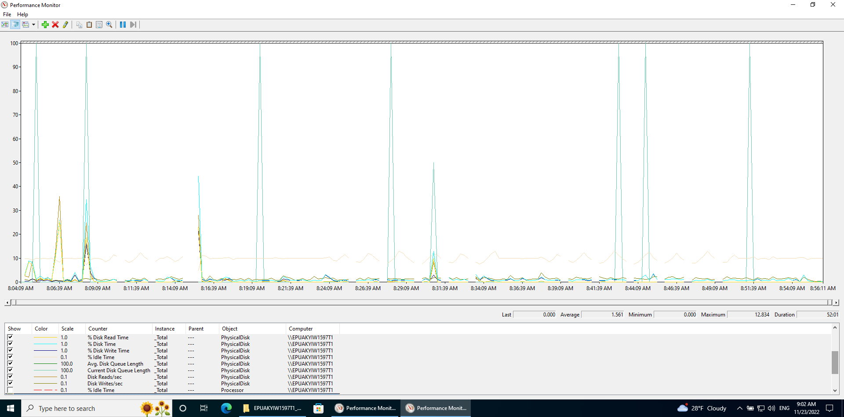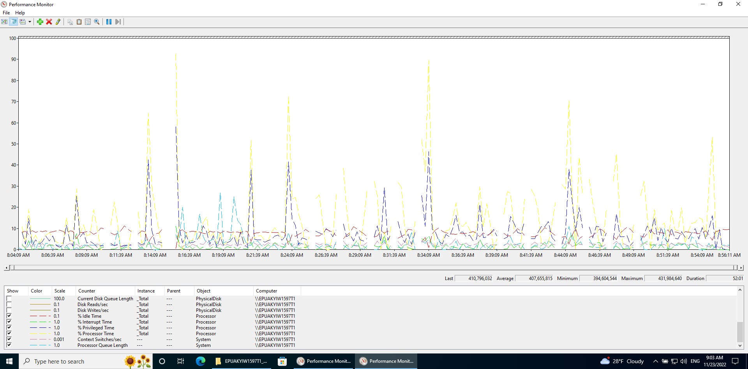

|  |  |  |  |  |  |  |  |  |  |  |  |  |
| --- | --- | --- | --- | --- | --- | --- | --- | --- | --- | --- | --- | --- |
|  | Samples | Average | Median | 90% Line | 95% Line | 99% Line | Min | Max | Error % | Throughput | Received KB/sec | Sent KB/sec |
| 1CPU; 8GB RAM | 84 | 310 | 130 | 415 | 570 | 3679 | 0 | 4318 | 0.00% | 44.1/min | 33.62 | 7.49 |
| Durability test(1hour) | 2308 | 176 | 85 | 350 | 635 | 1437 | 0 | 31247 | 35.05% | 46.2/min | 15.83 | 6.54 |
| difference |  |  |  |  |  |  |  |  | 35.05% | +4.76% | -52.91% | -12.68% |

Summary report on durability testing:

According to the presented results, it can be seen that with an increase in the duration of the test, the throughput significantly deteriorates (by 79%), while the response time and the number of errors increase (by 35%).

In conclusion, we can say that this system is not ready to work over a long period of time and needs to be improved.