1. Main results from test run

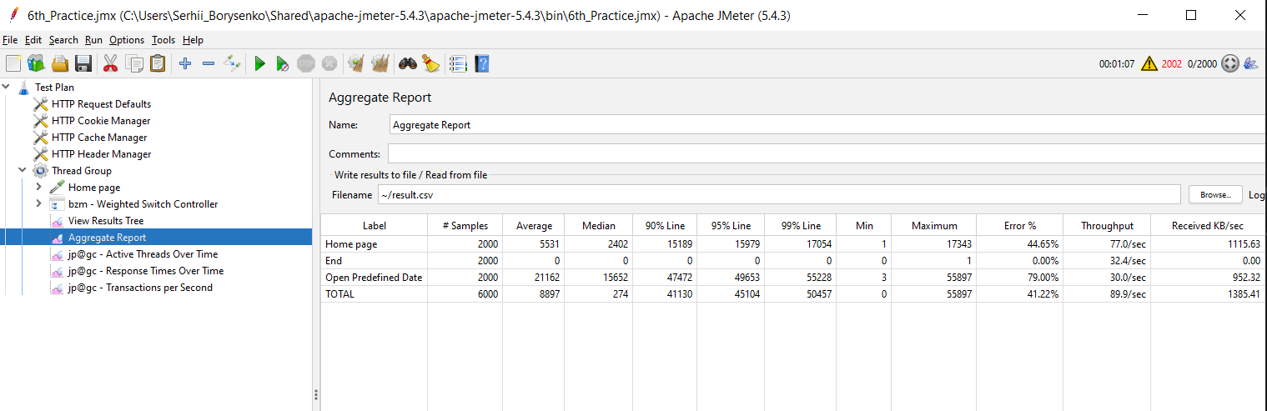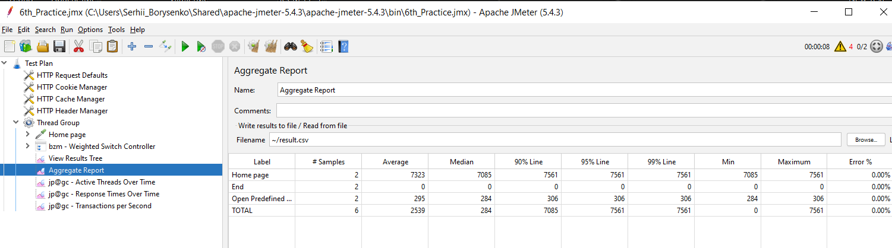

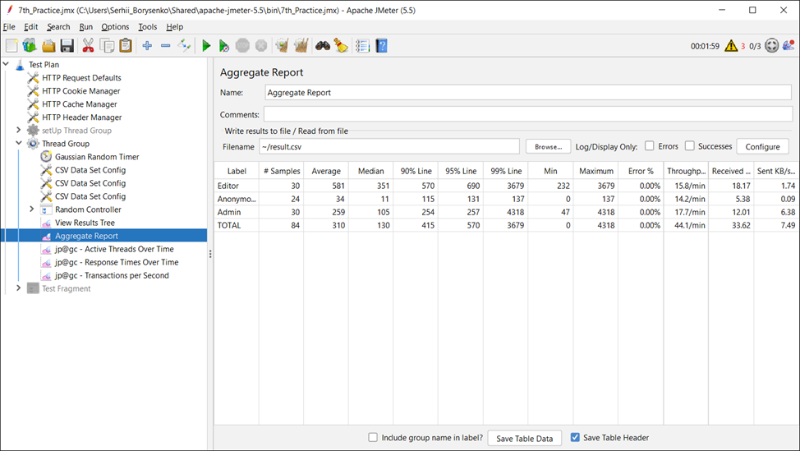

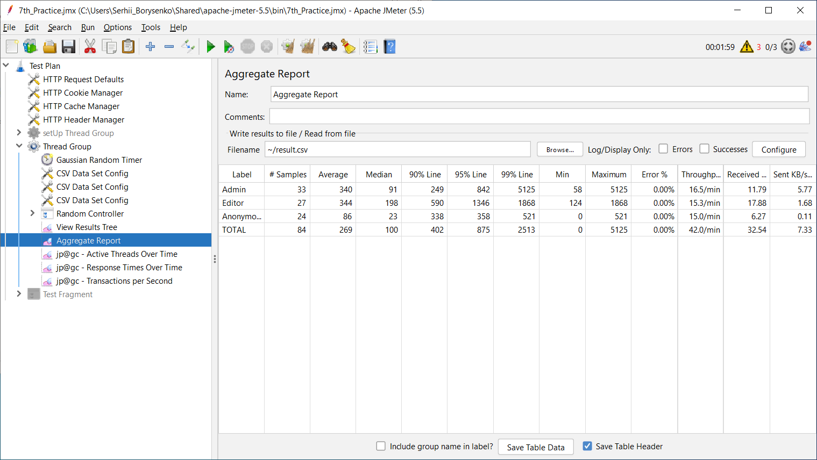

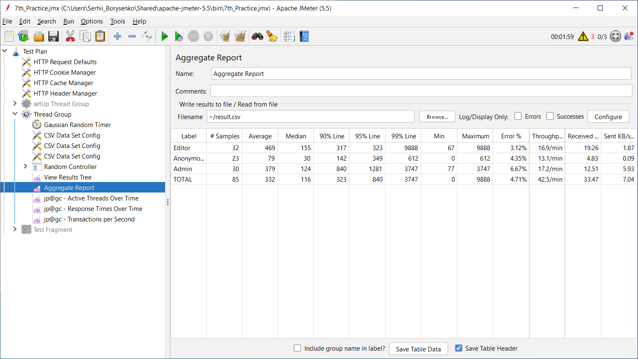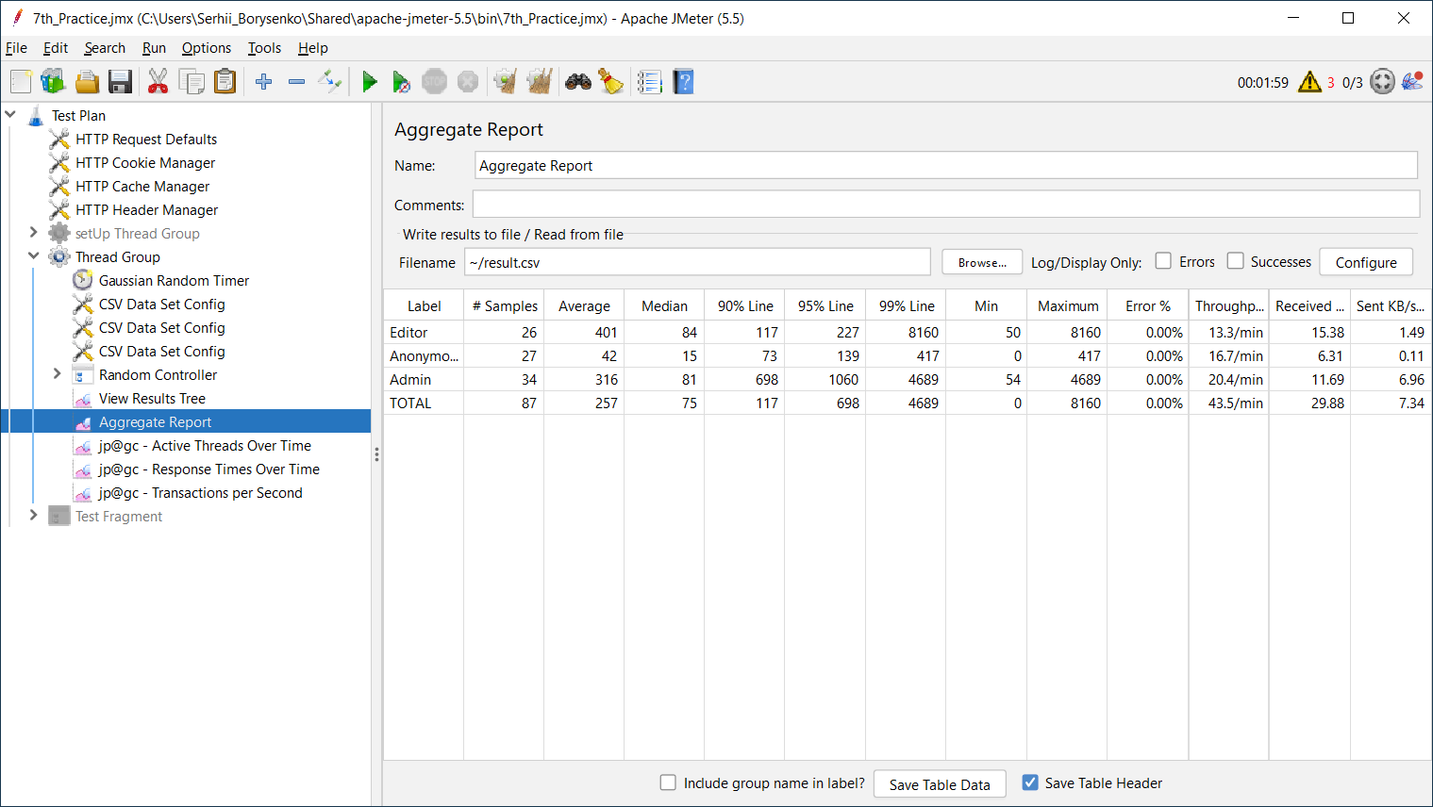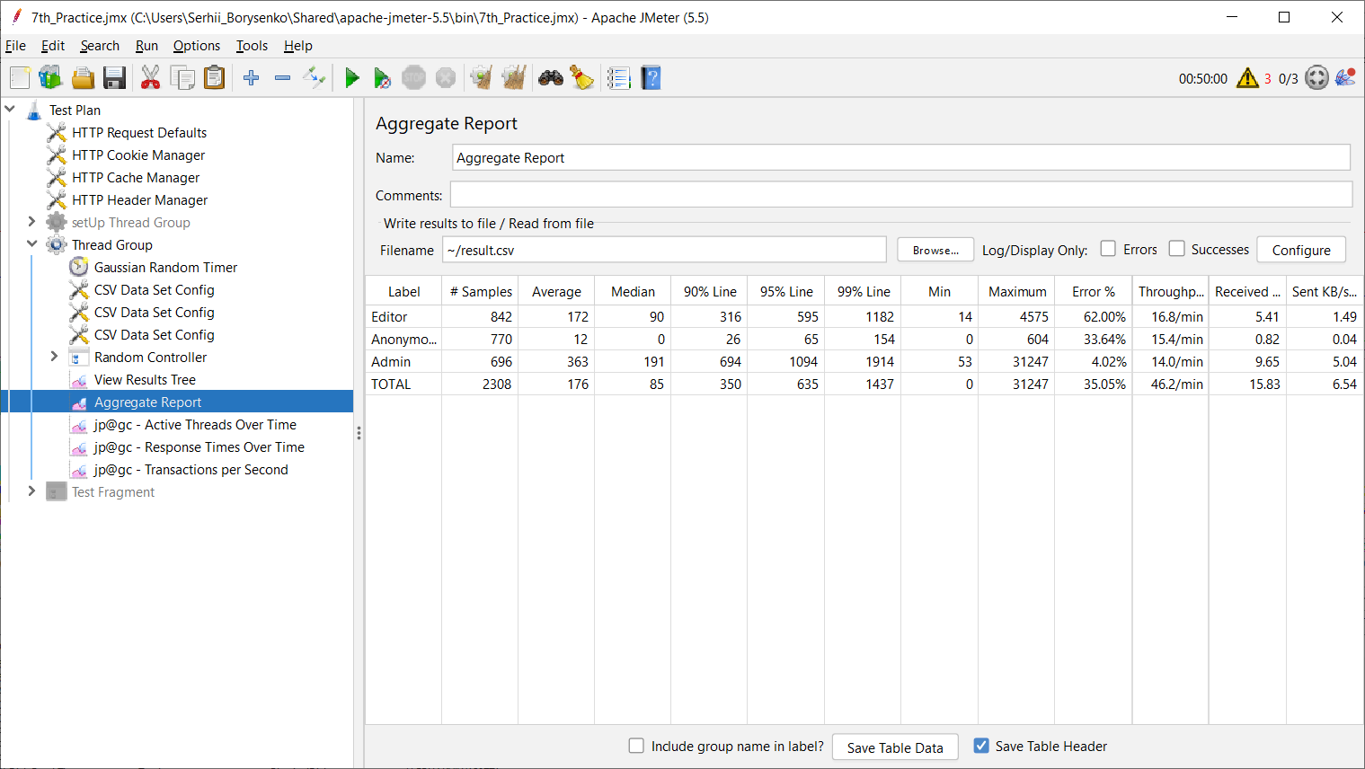

2. Conclusion:

Having completed all the planned test cases and after analyzing, we can conclude that practical knowledge and a stable understanding of the main types of performance testing (Capacity, Regression, Volumetric, Combined, Scalability, Durability/Longevity/Stability, Configuration) have been obtained.

Gained experience in preparing test data and the skill of creating a data generator. Acquired the skill of developing an anonymous, administrative, design editor and their combined scripts. Gained experience in determining the regular load and the definition and calculation of KPI.

Also, experience was gained in determining the load parameters for long-term testing and the skill was acquired to identify bottlenecks and possible problems for long-running systems.

Complex testing was studied during the migration of test data to a new platform and complex analysis.