Task 6

Test Setup

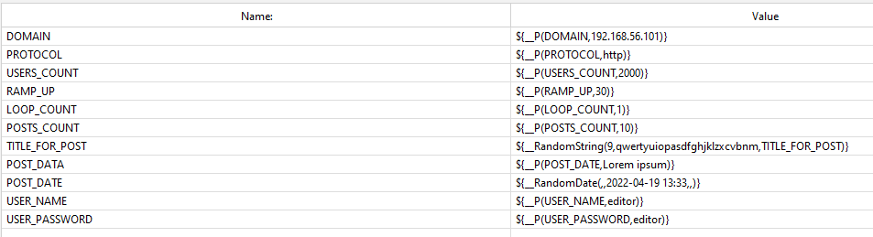

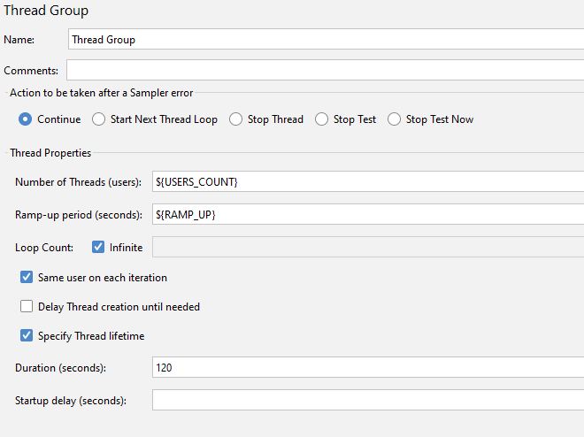

Test Summary

Capacity testing was done with the same load but using two different logic controllers to gain experience with their use and compare the results and changes in behavior. In this case, testing was carried out with two sets of generated messages (100 and 1000).

Task 3 and Task 6: 100 posts

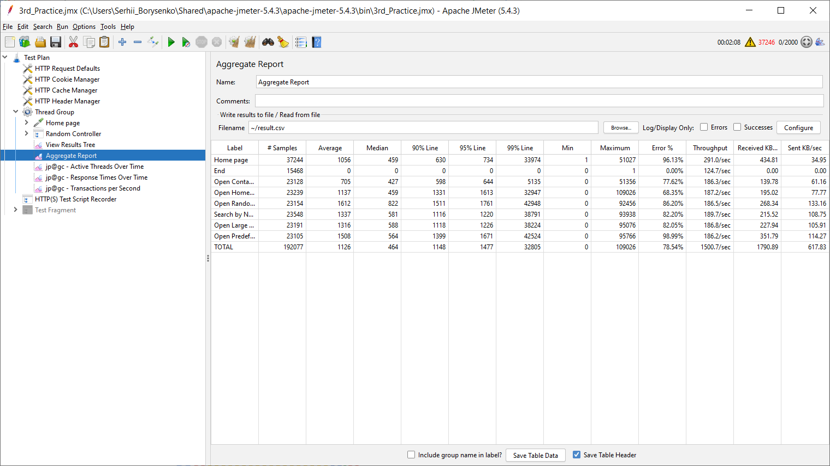

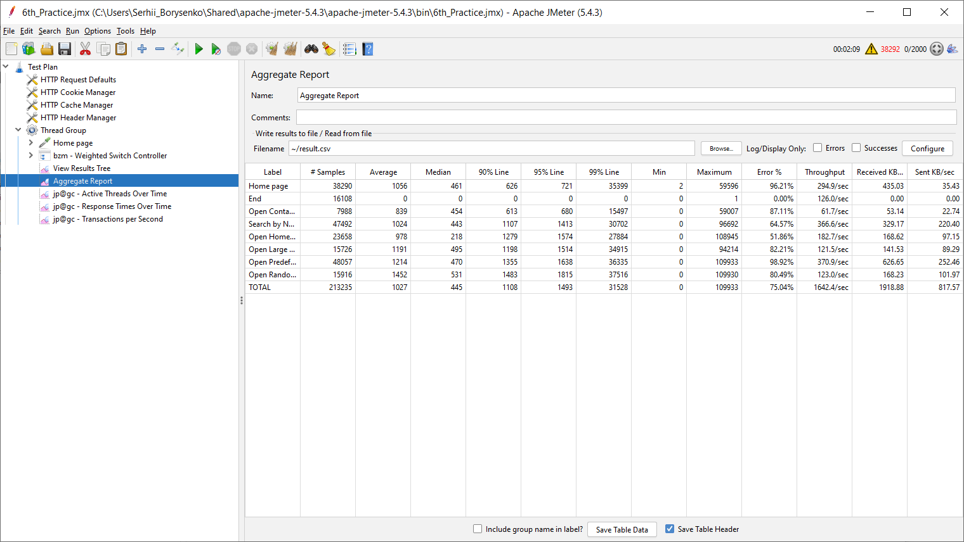

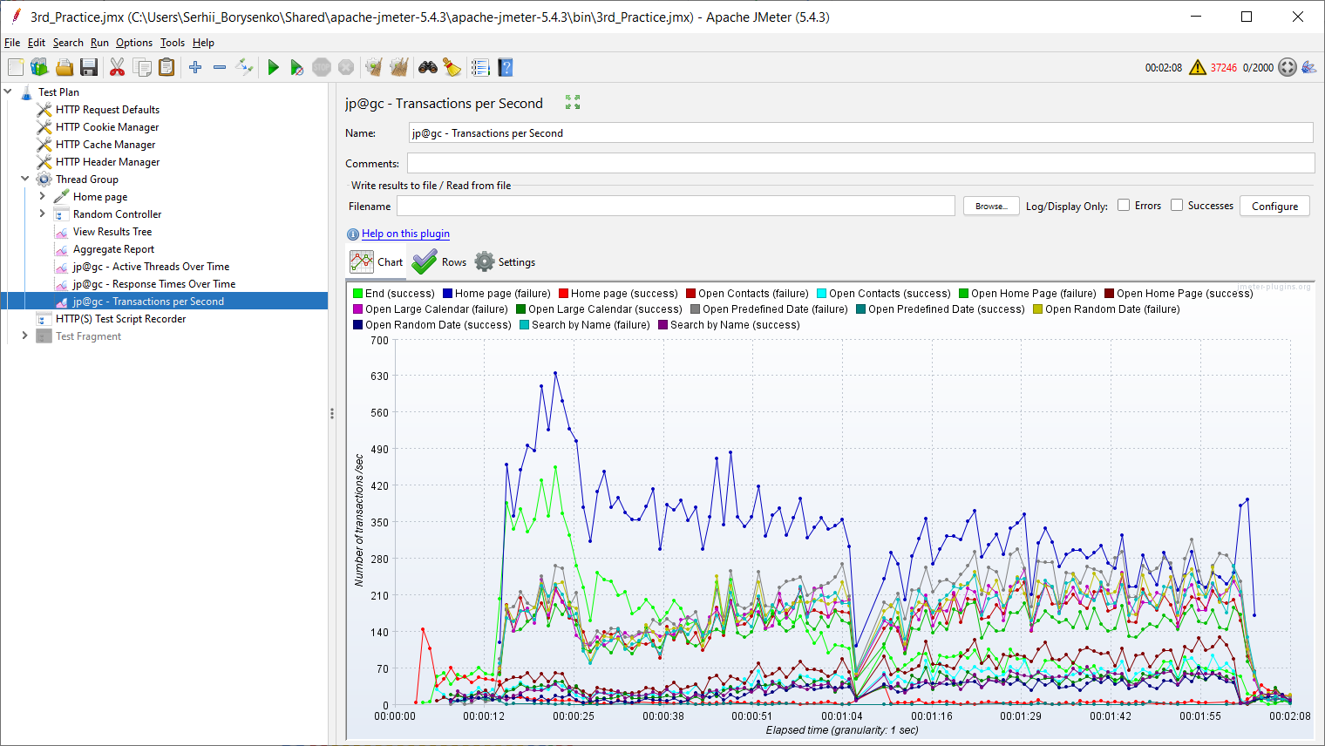

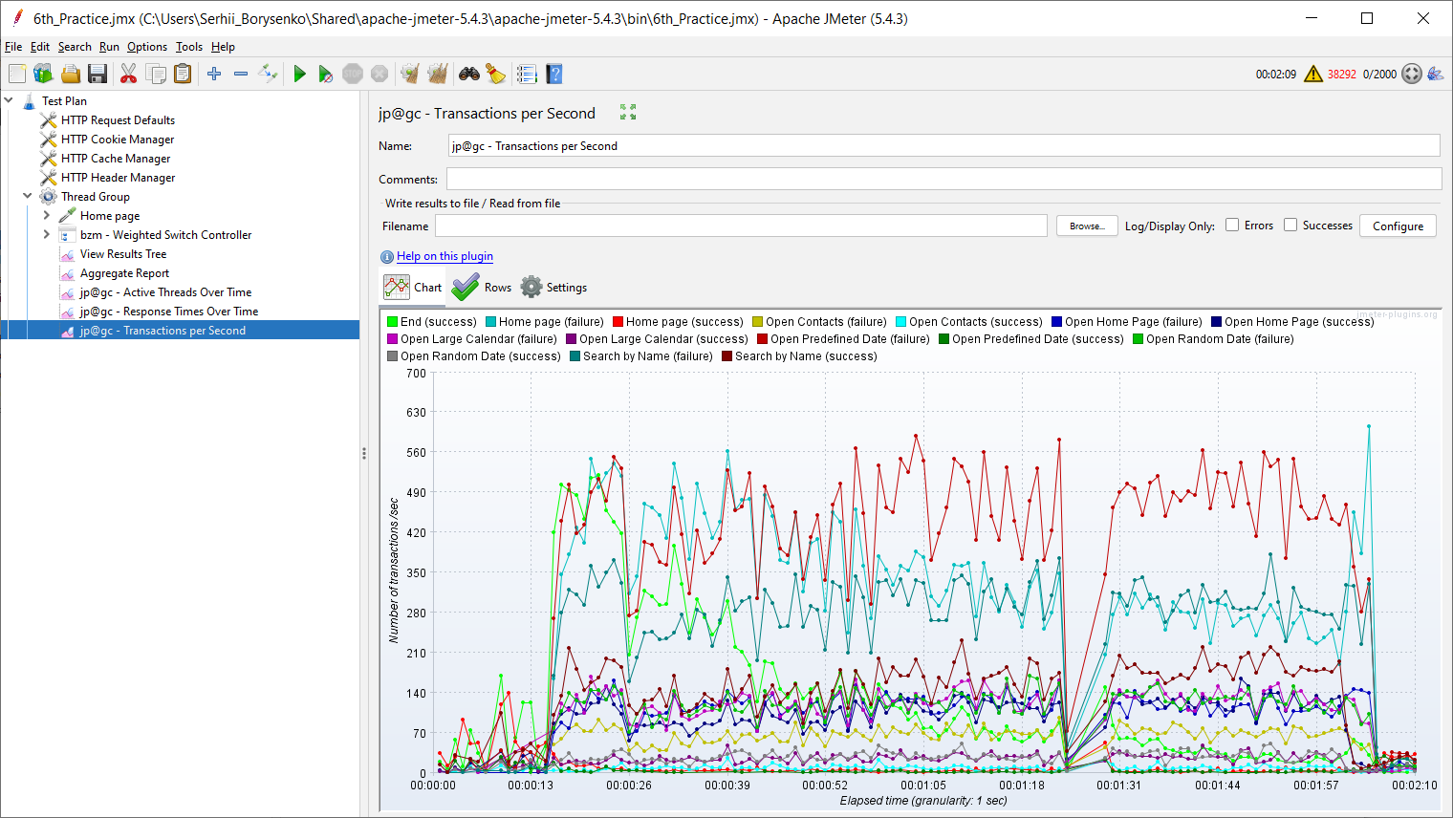

Task 3 and Task 6: 1000 posts

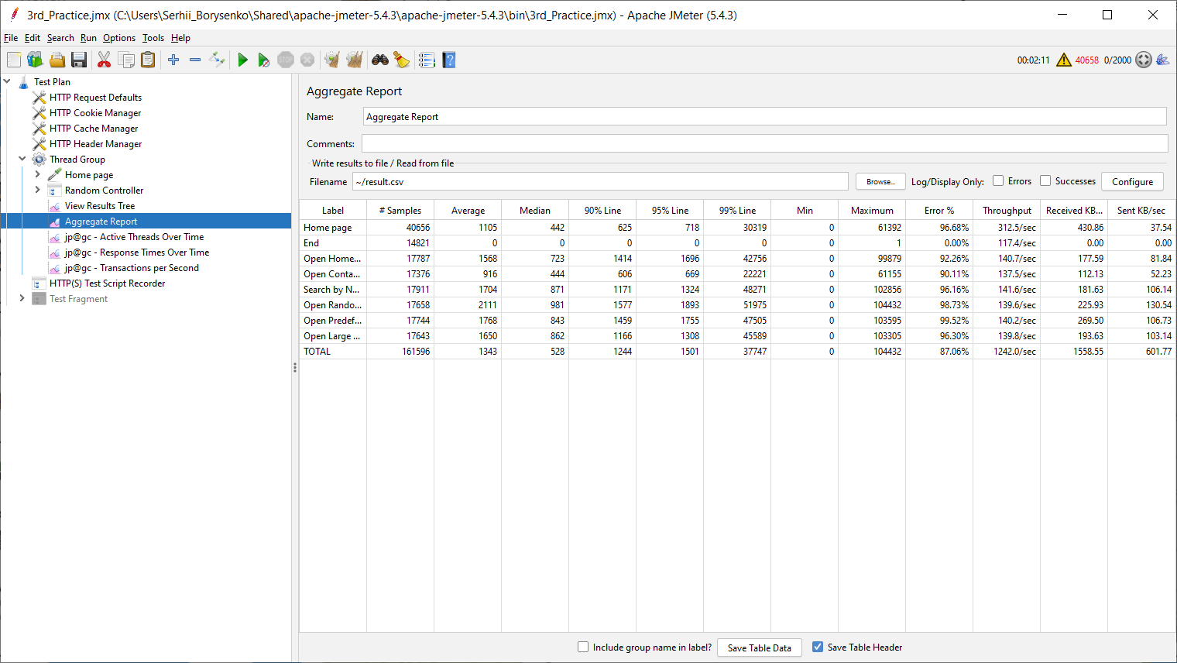

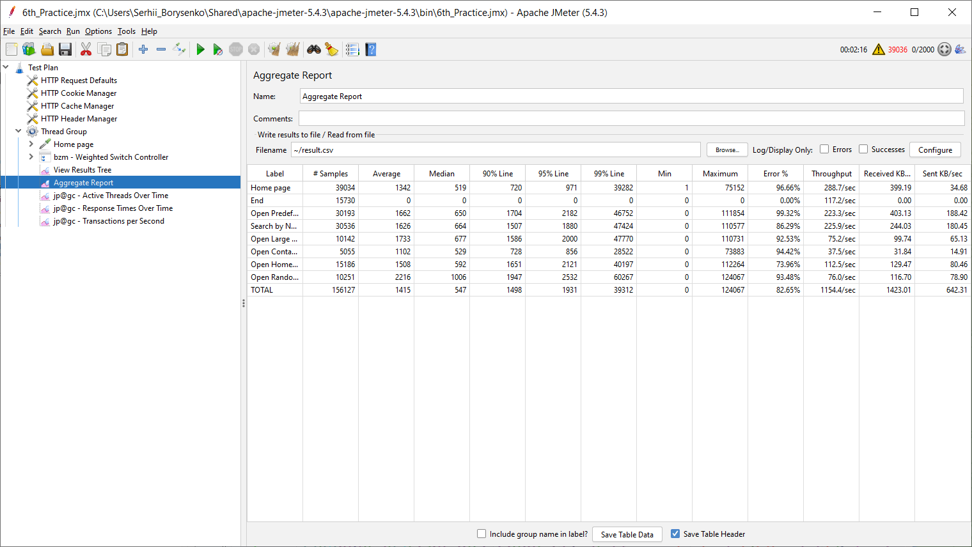

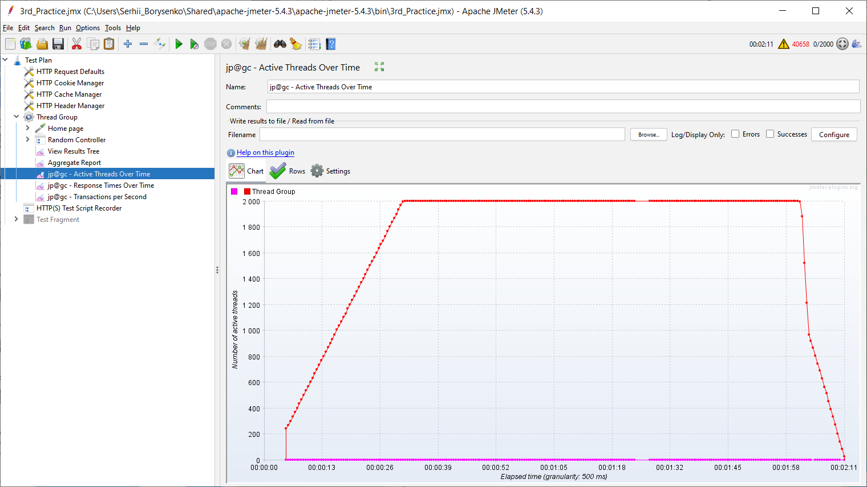

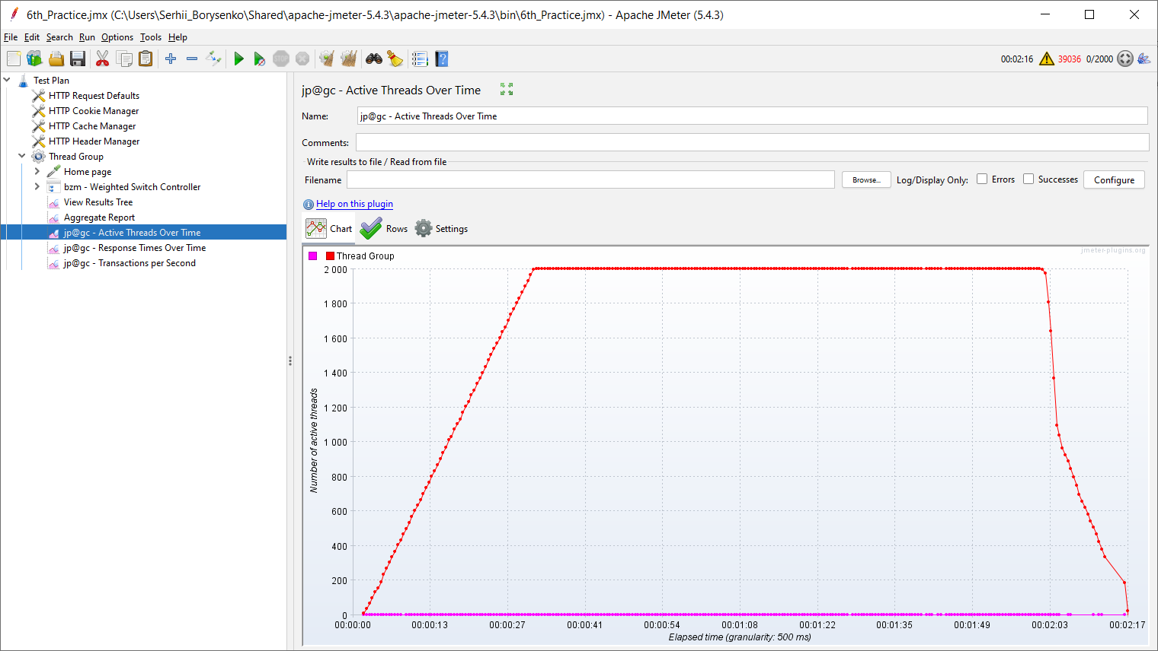

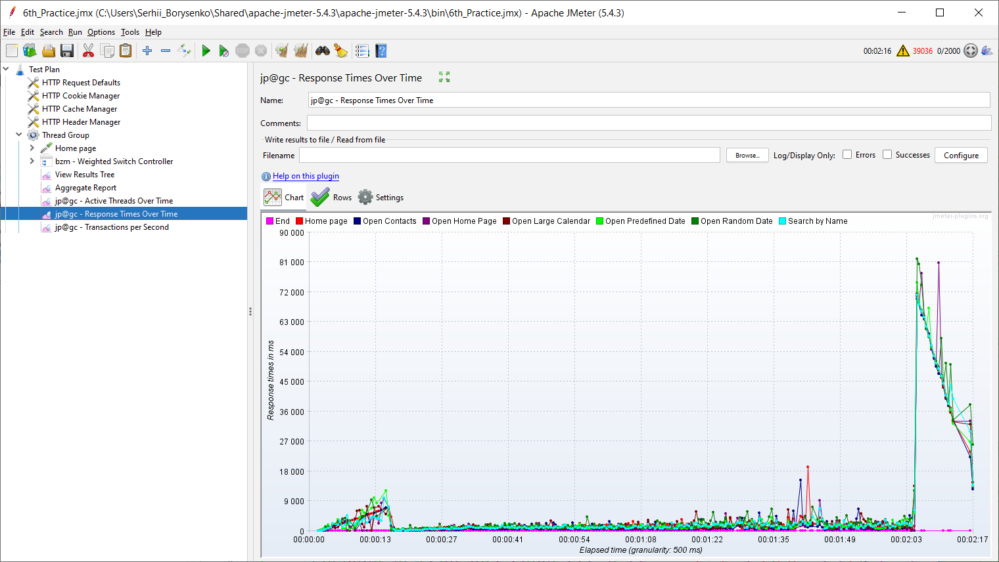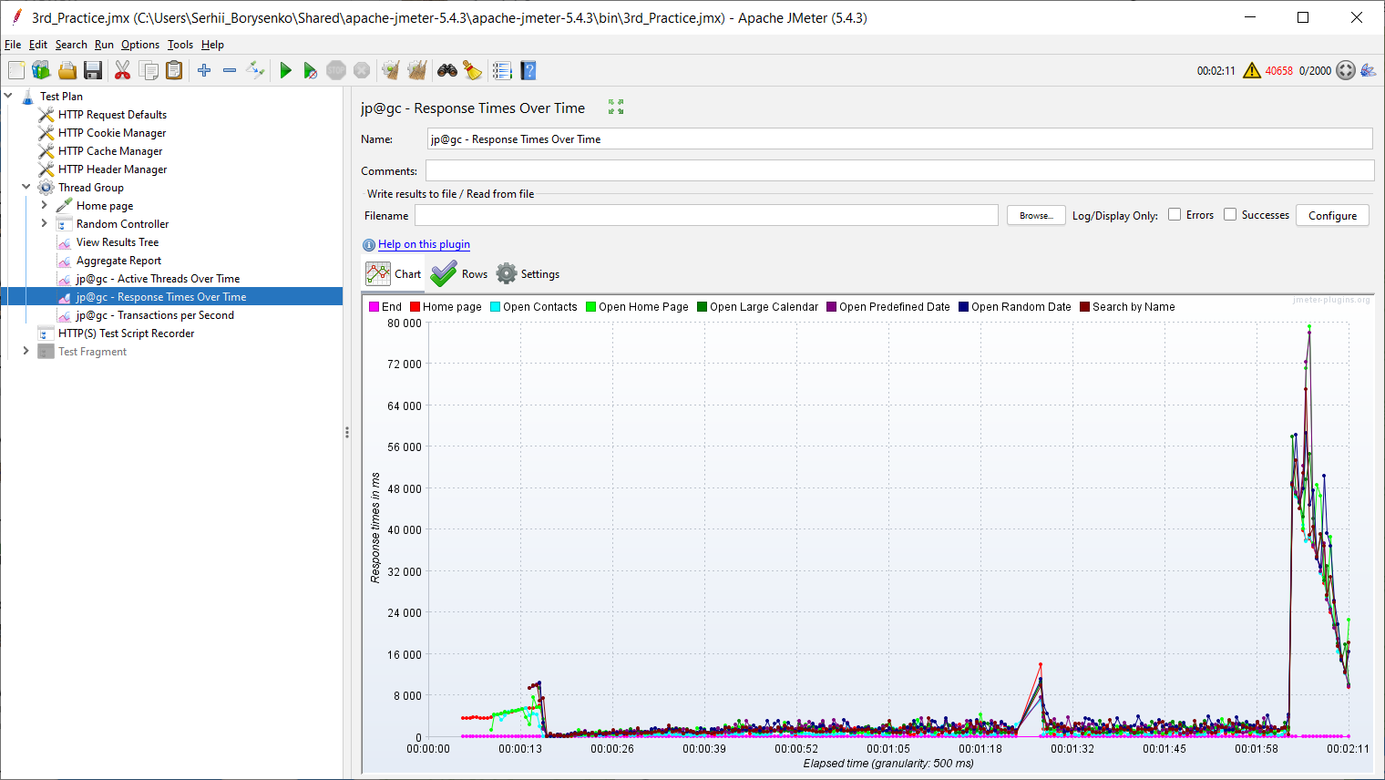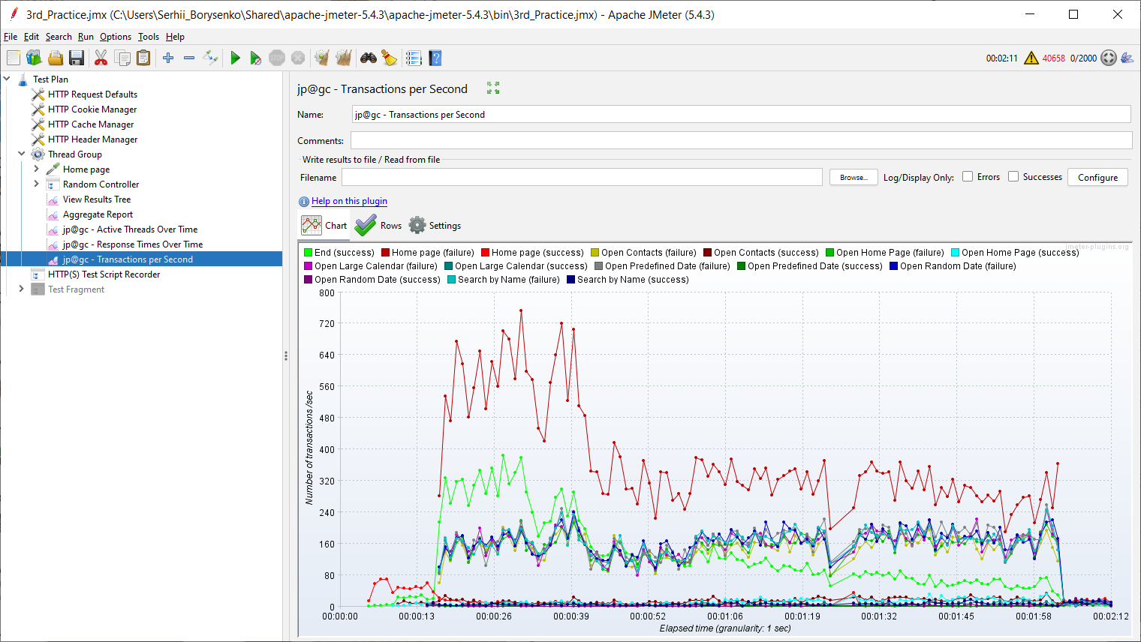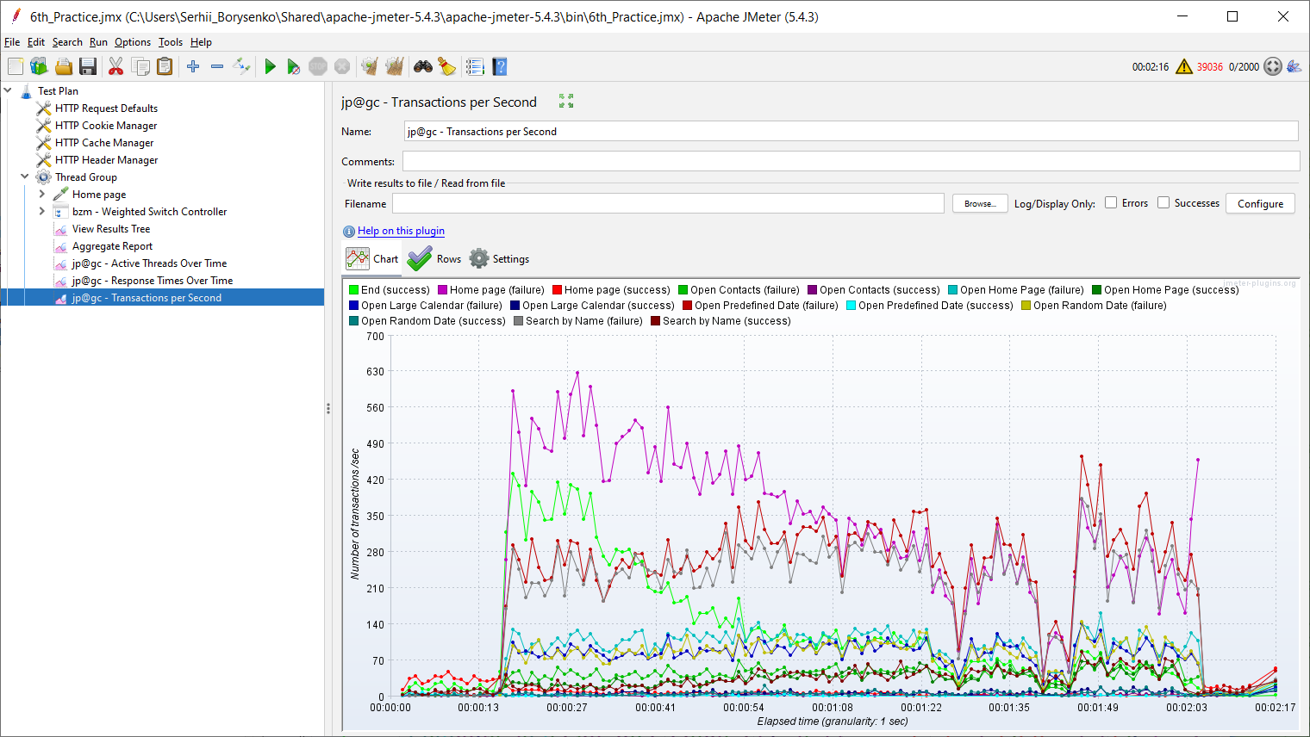

Task 6: 100 and 1000 posts





