1. Using the results of task 7, the following regular load was determined(1CPU; 8Gb RAM):

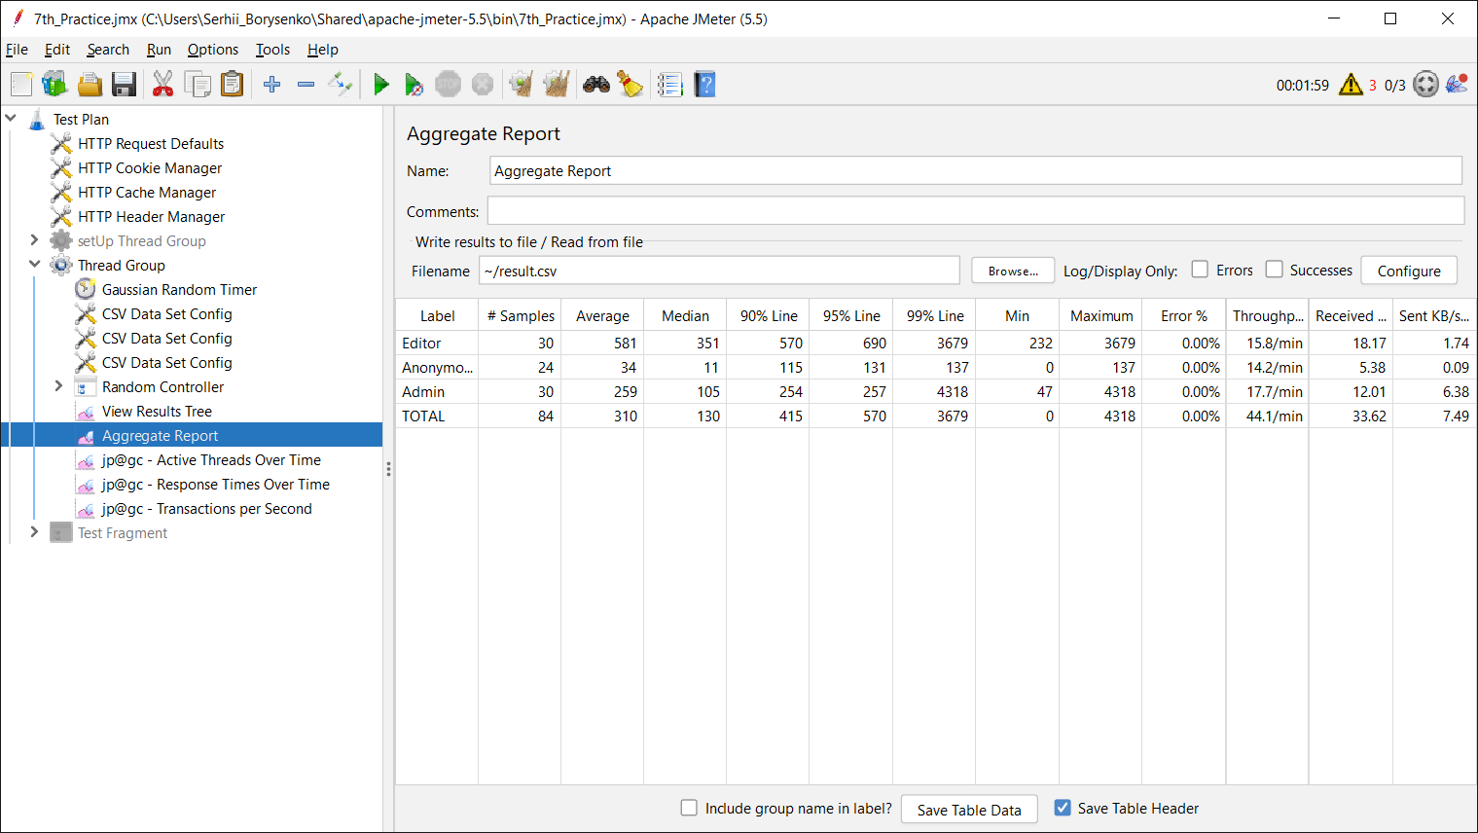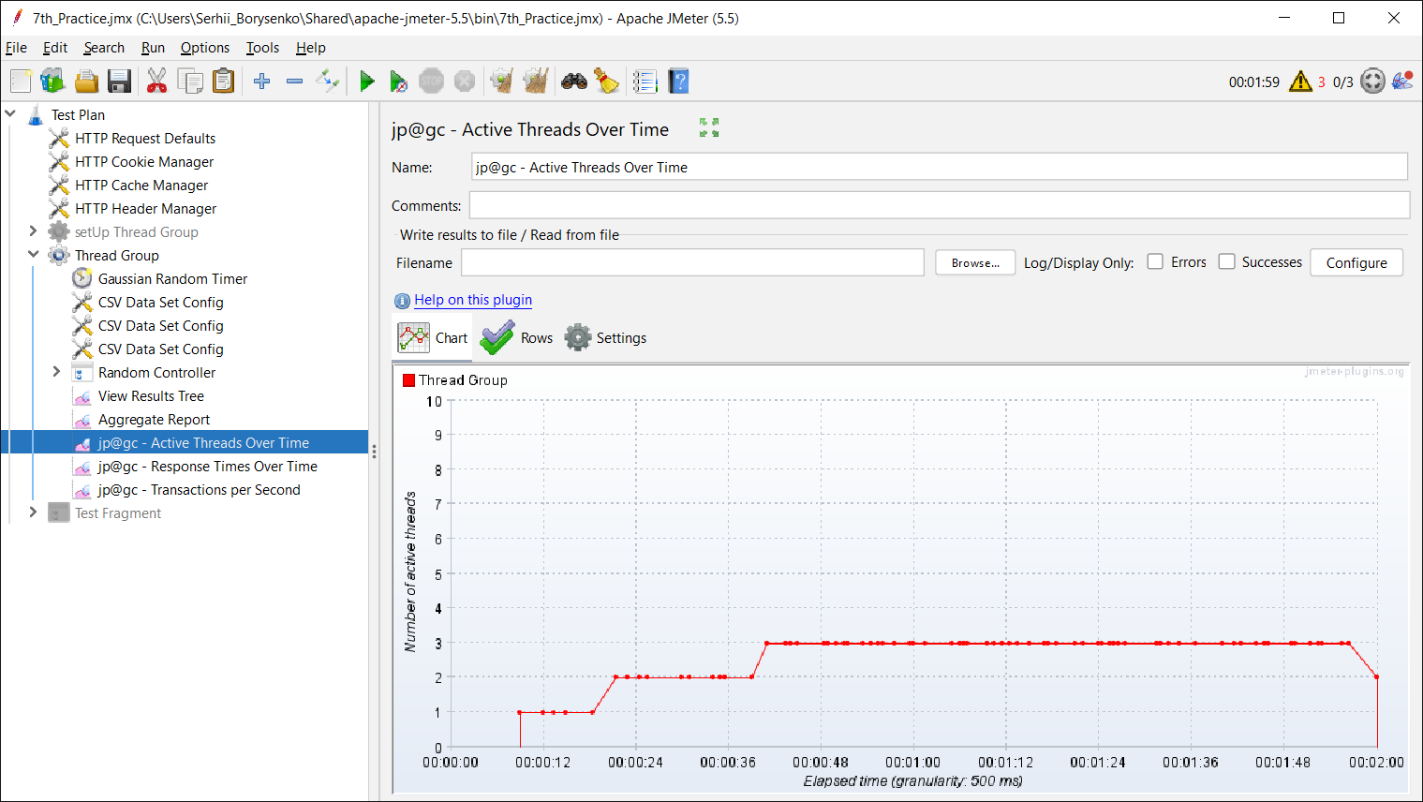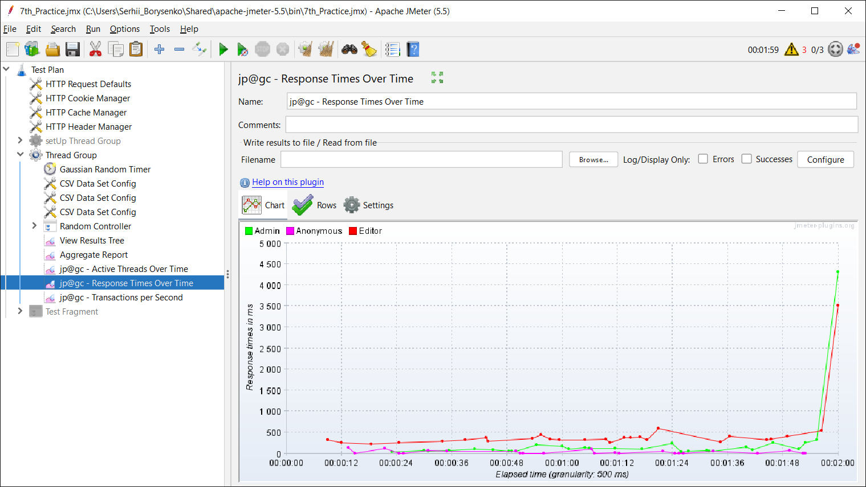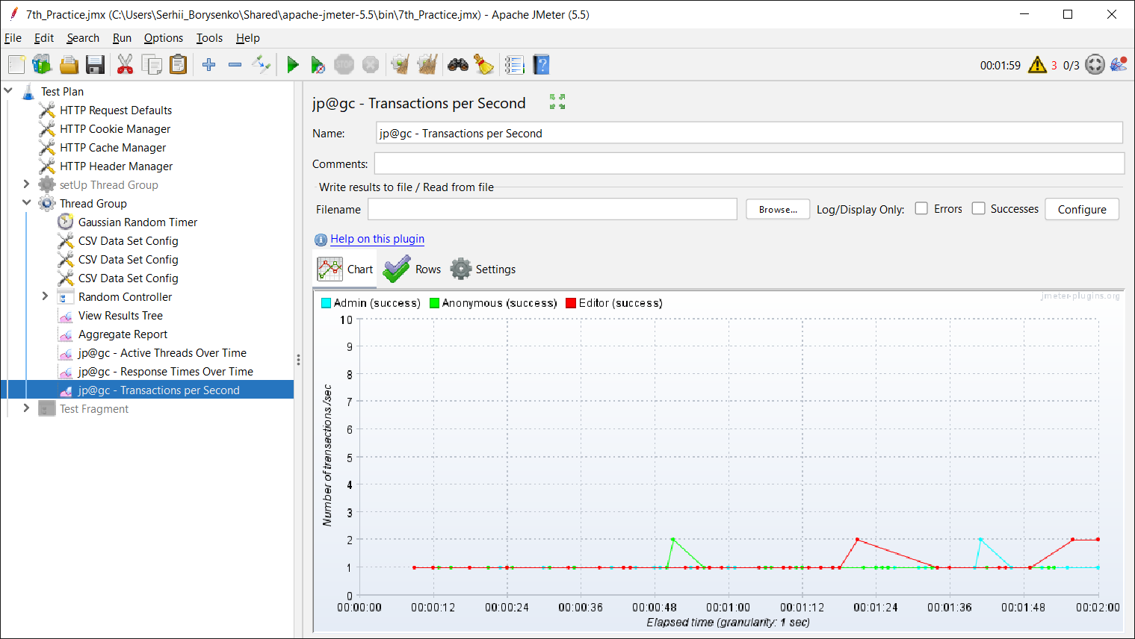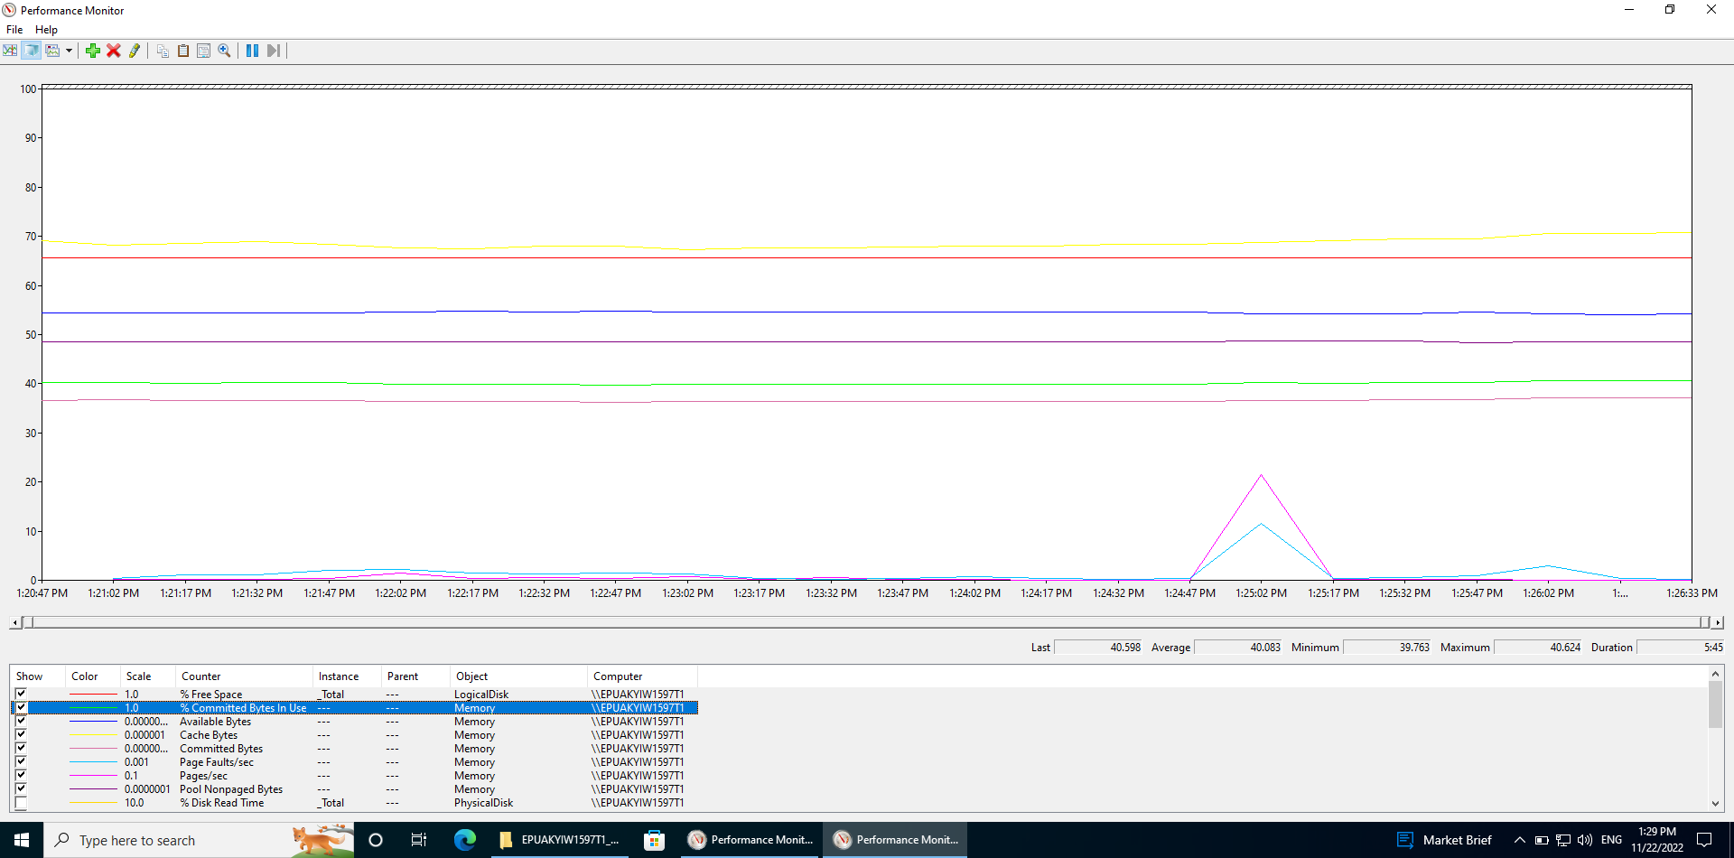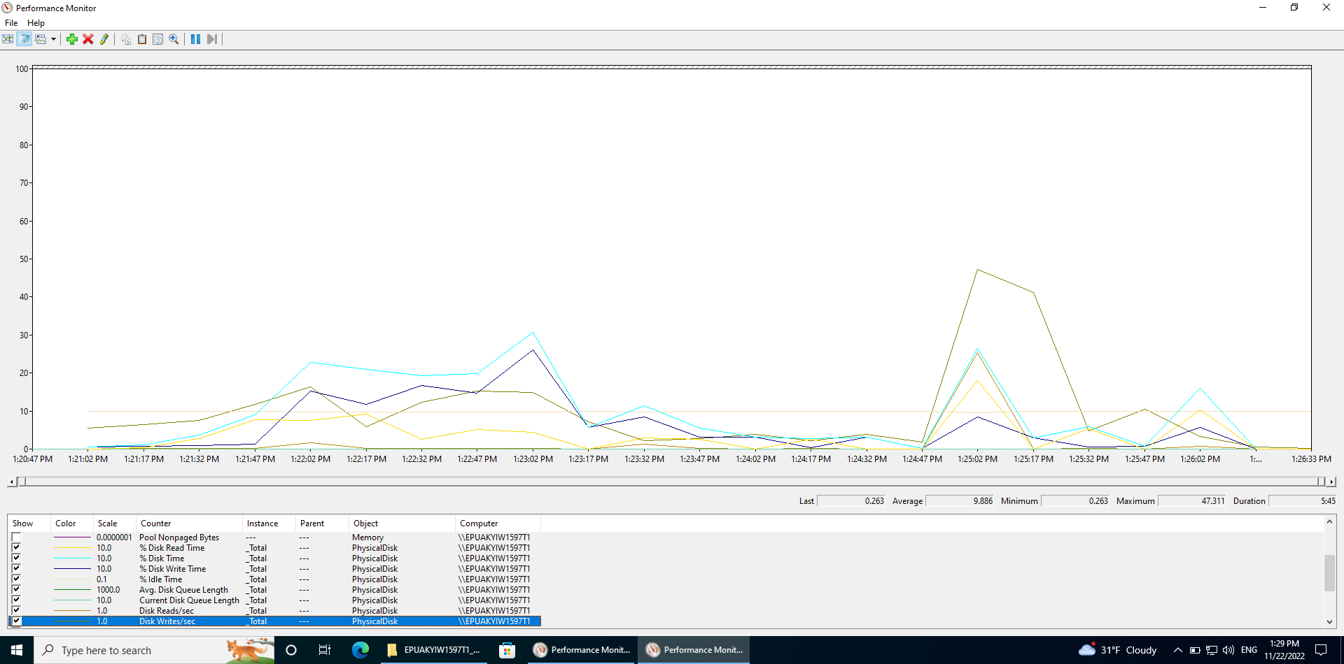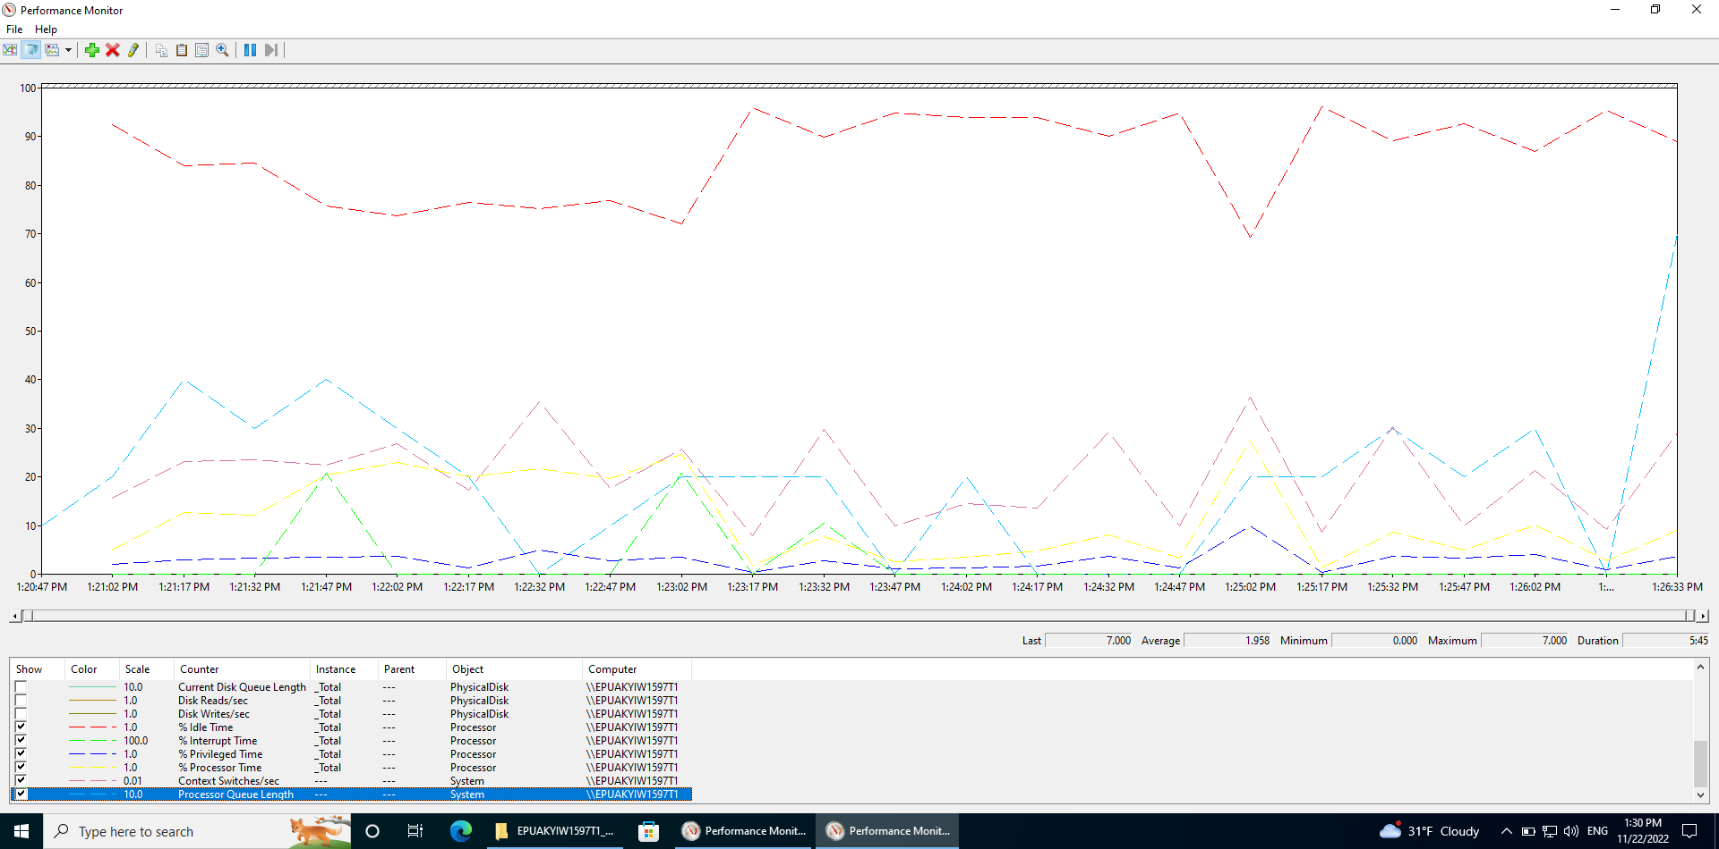

1. Scaling CPU:

* 2 CPU:

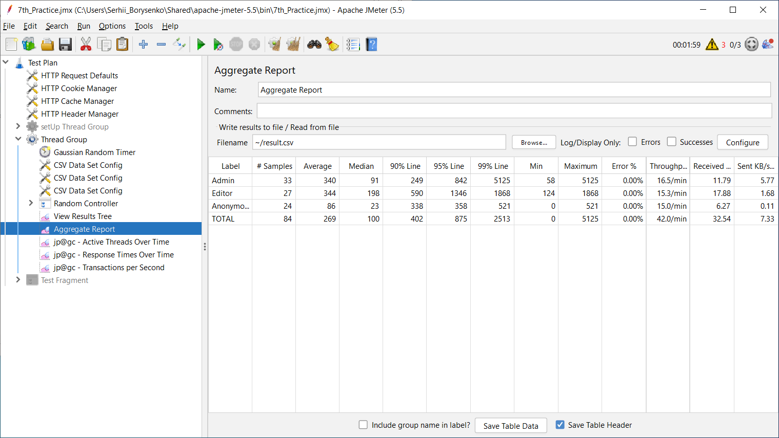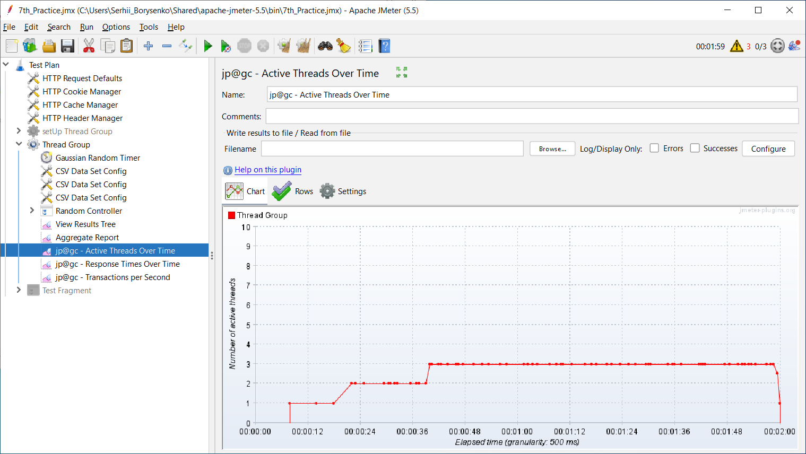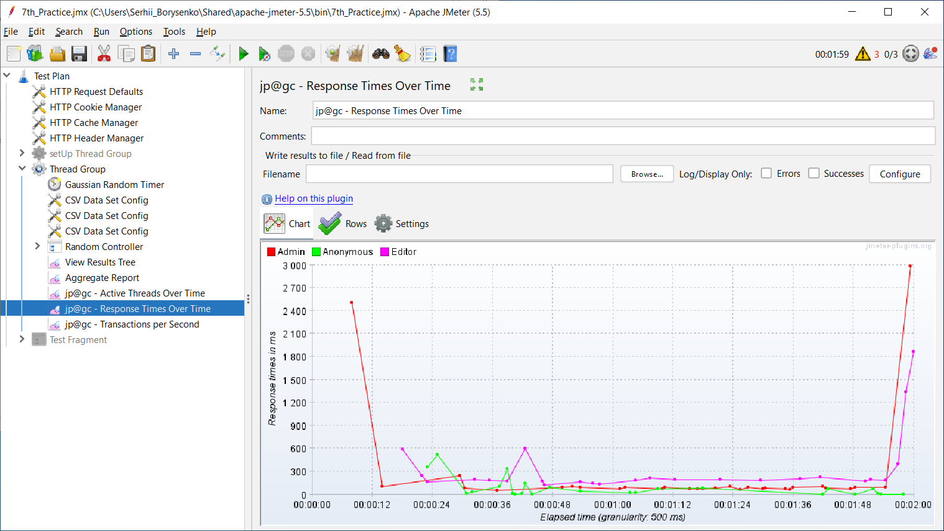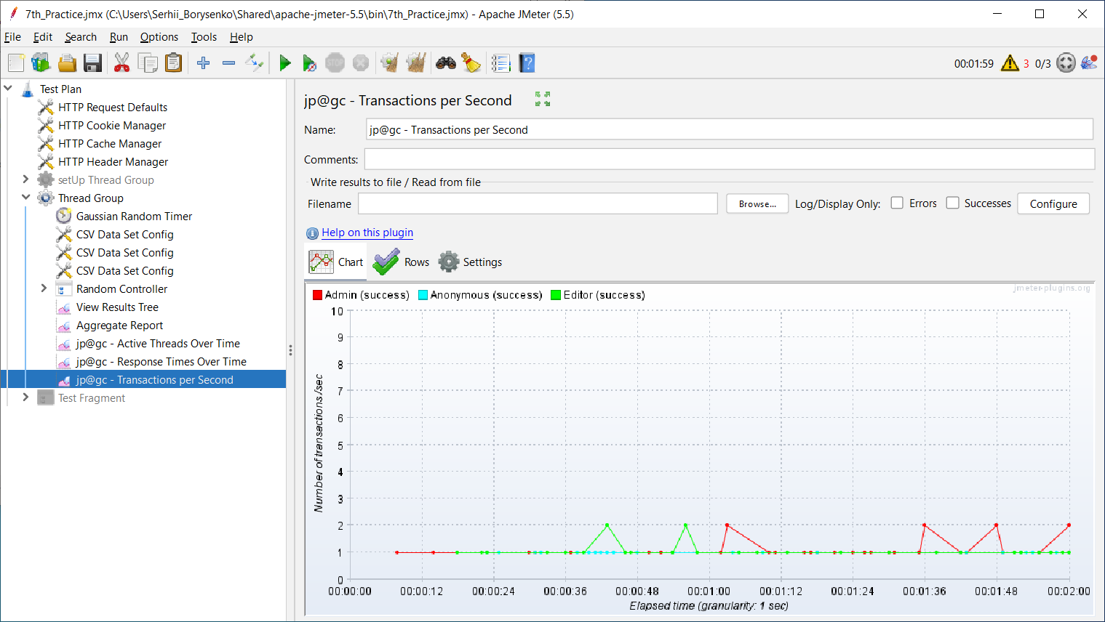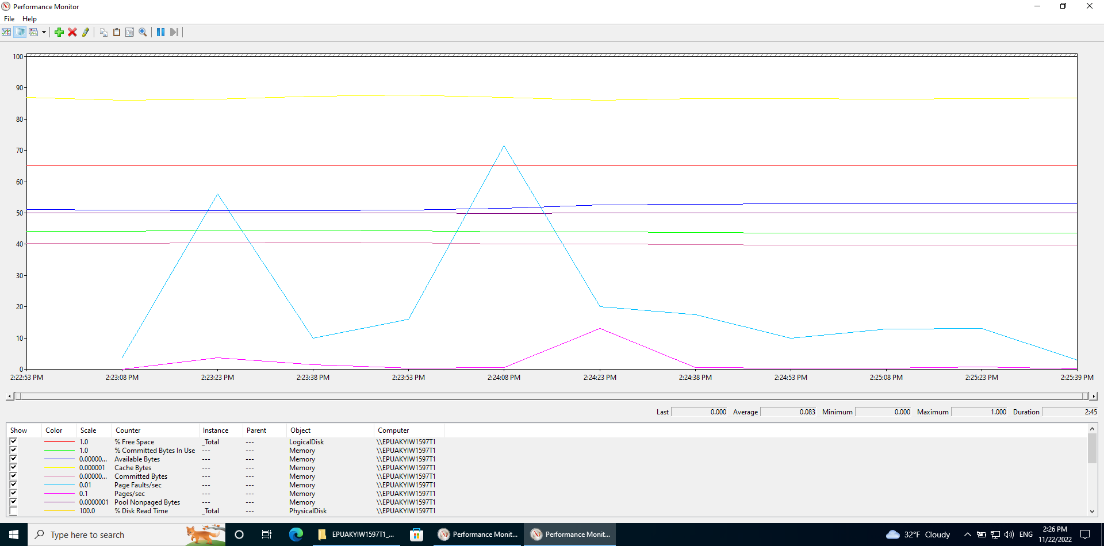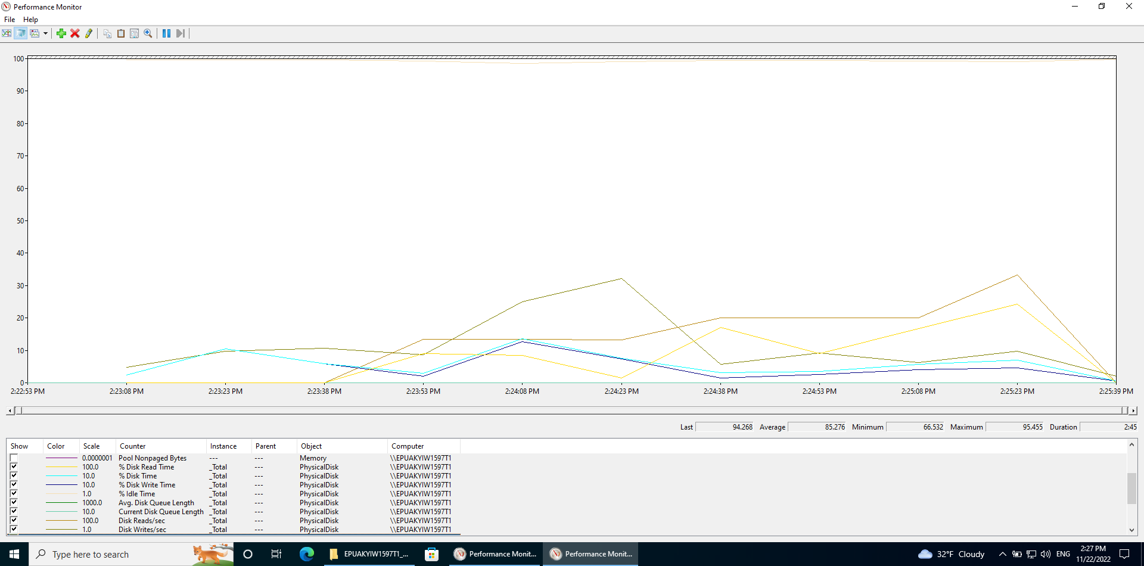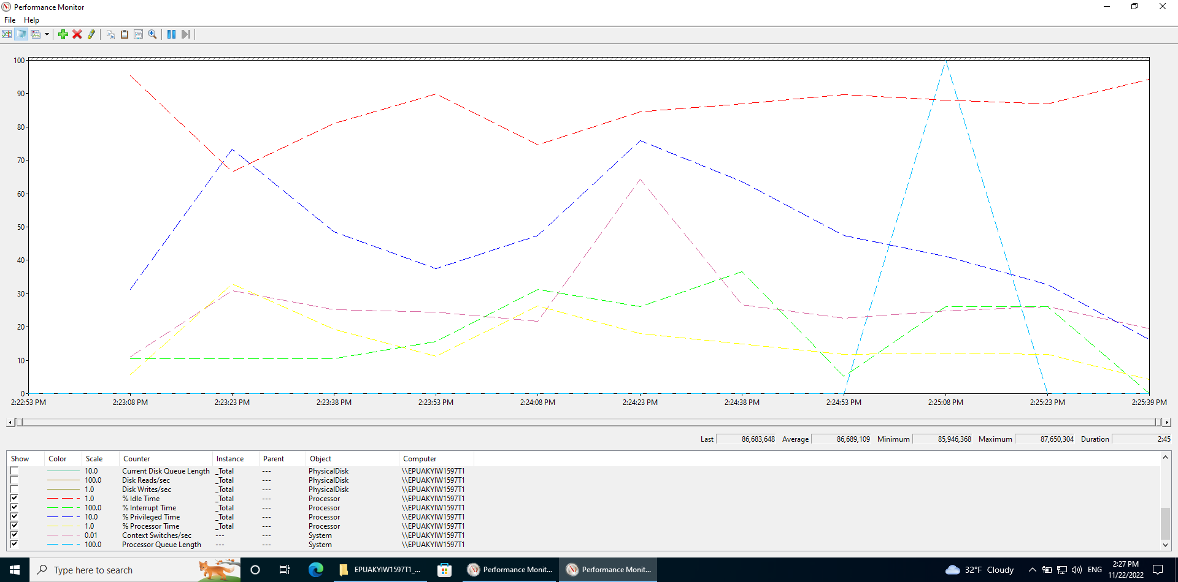

* 4 CPU:

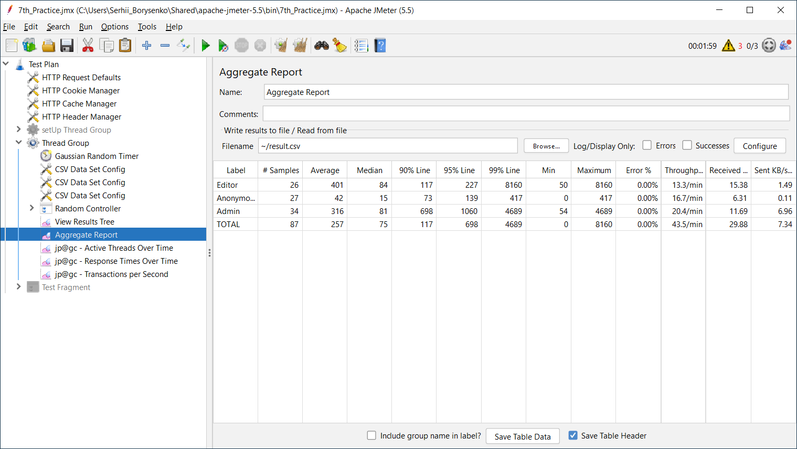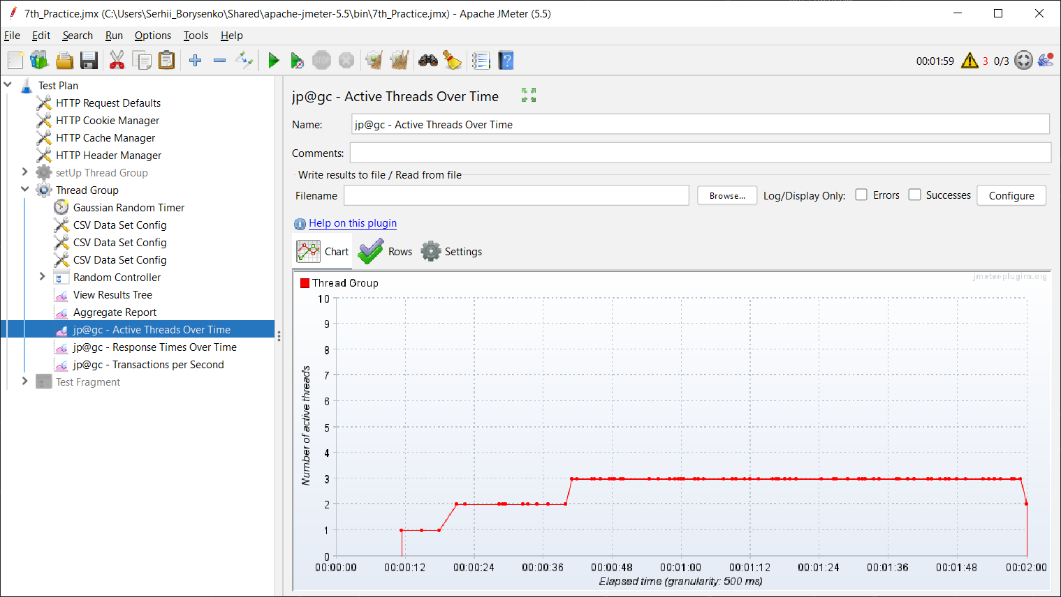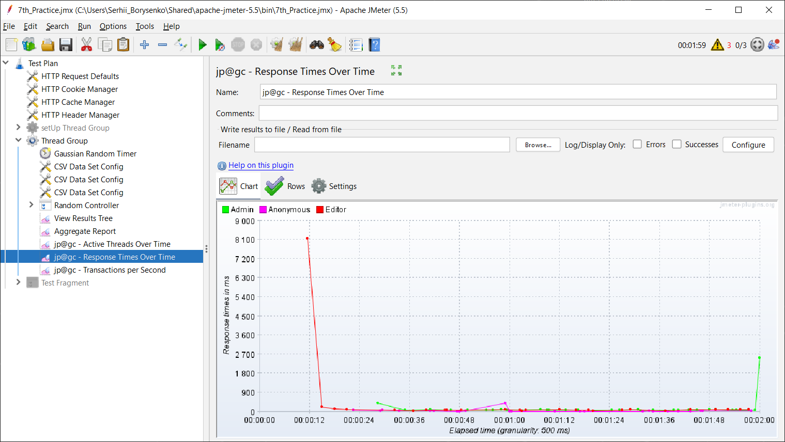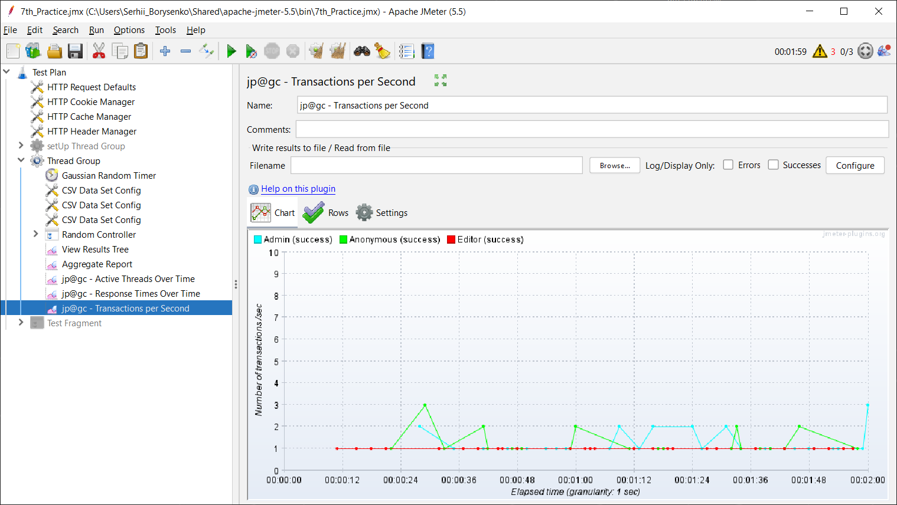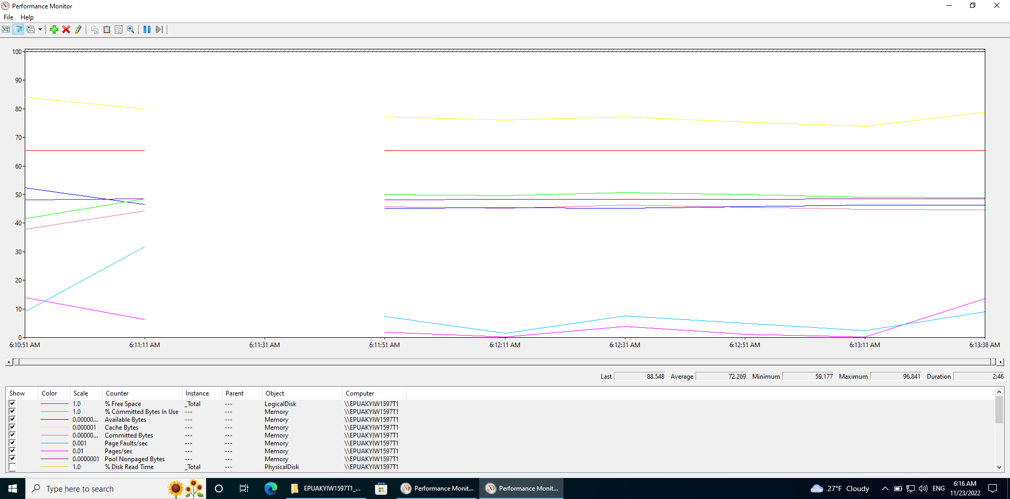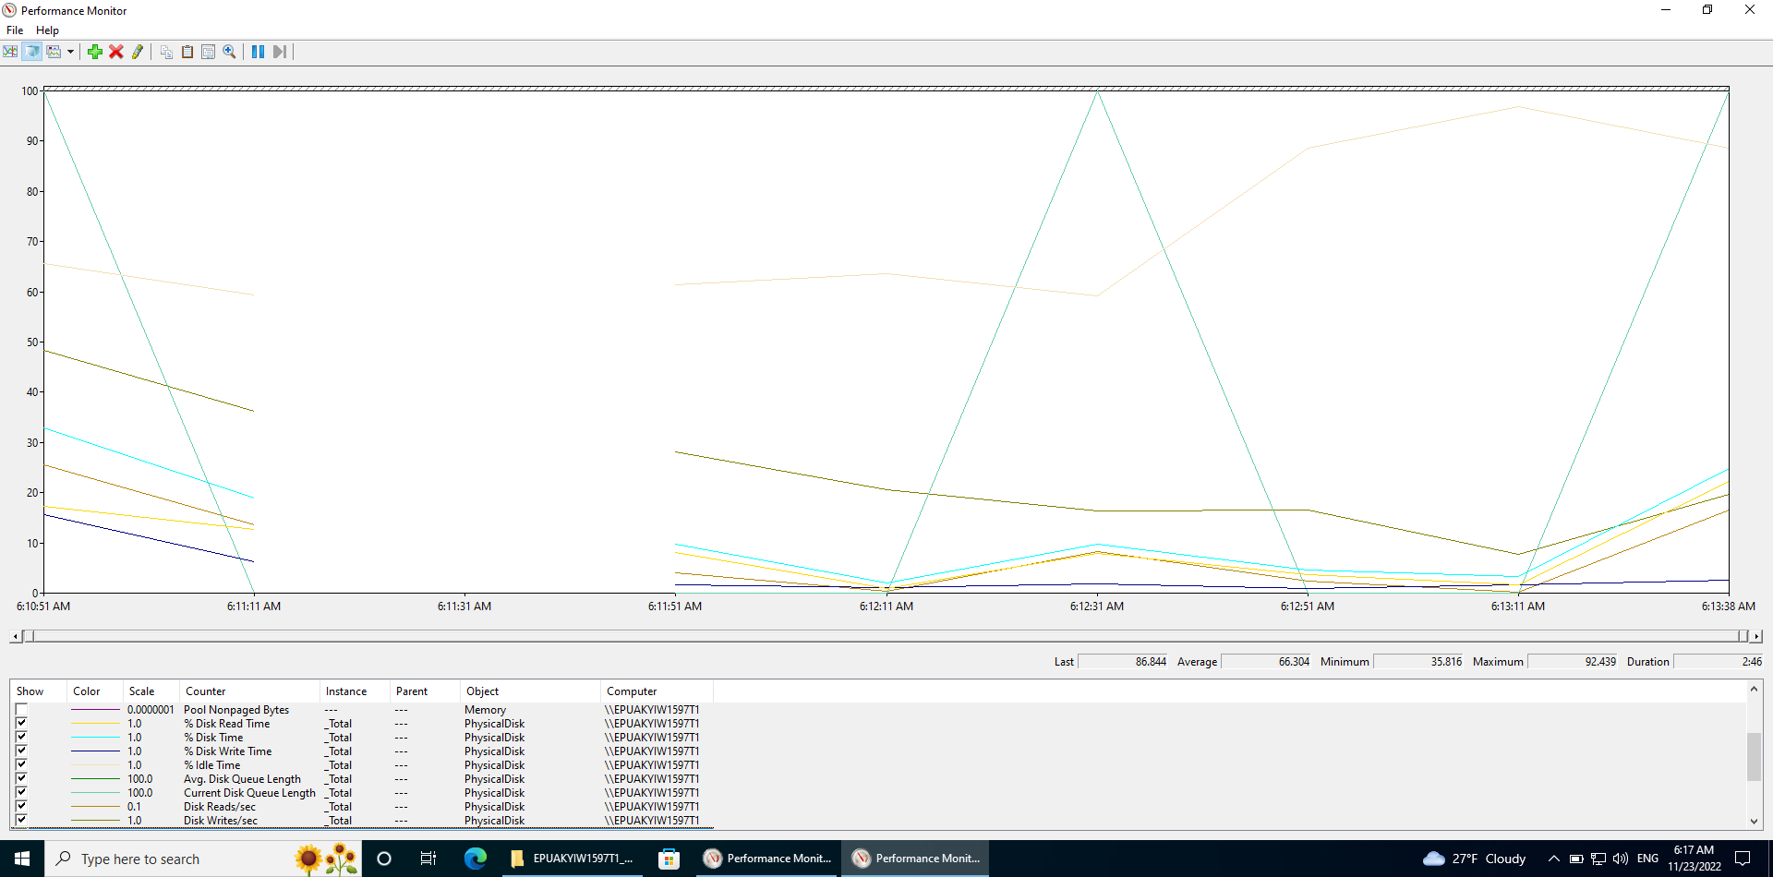

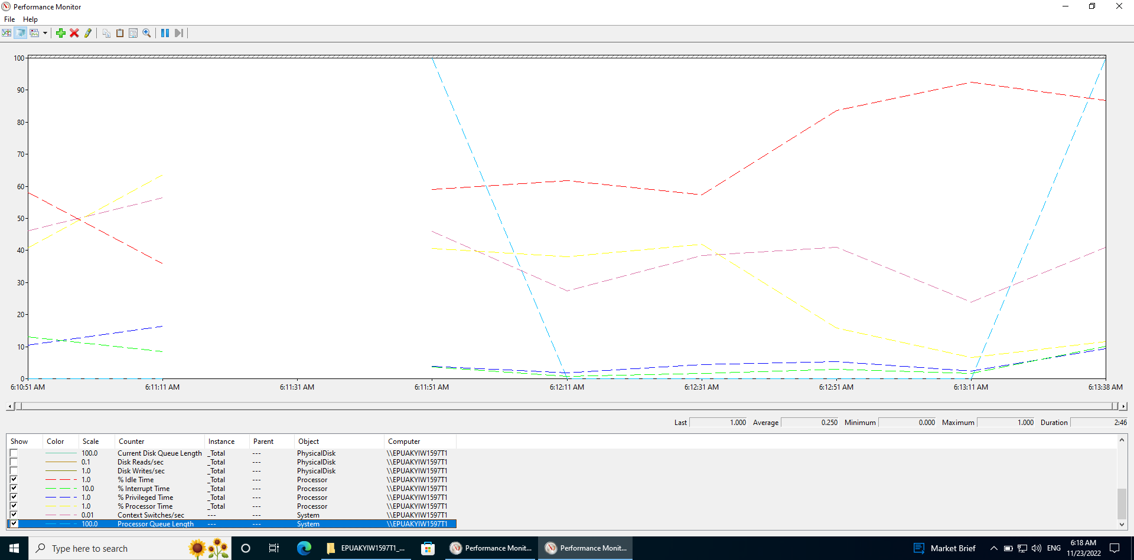

1. Scaling RAM:

* 4Gb RAM:

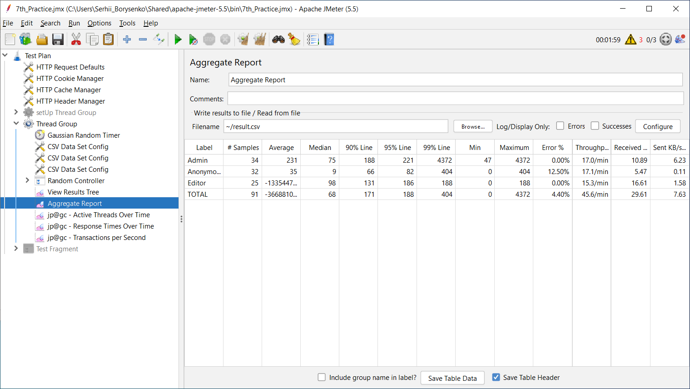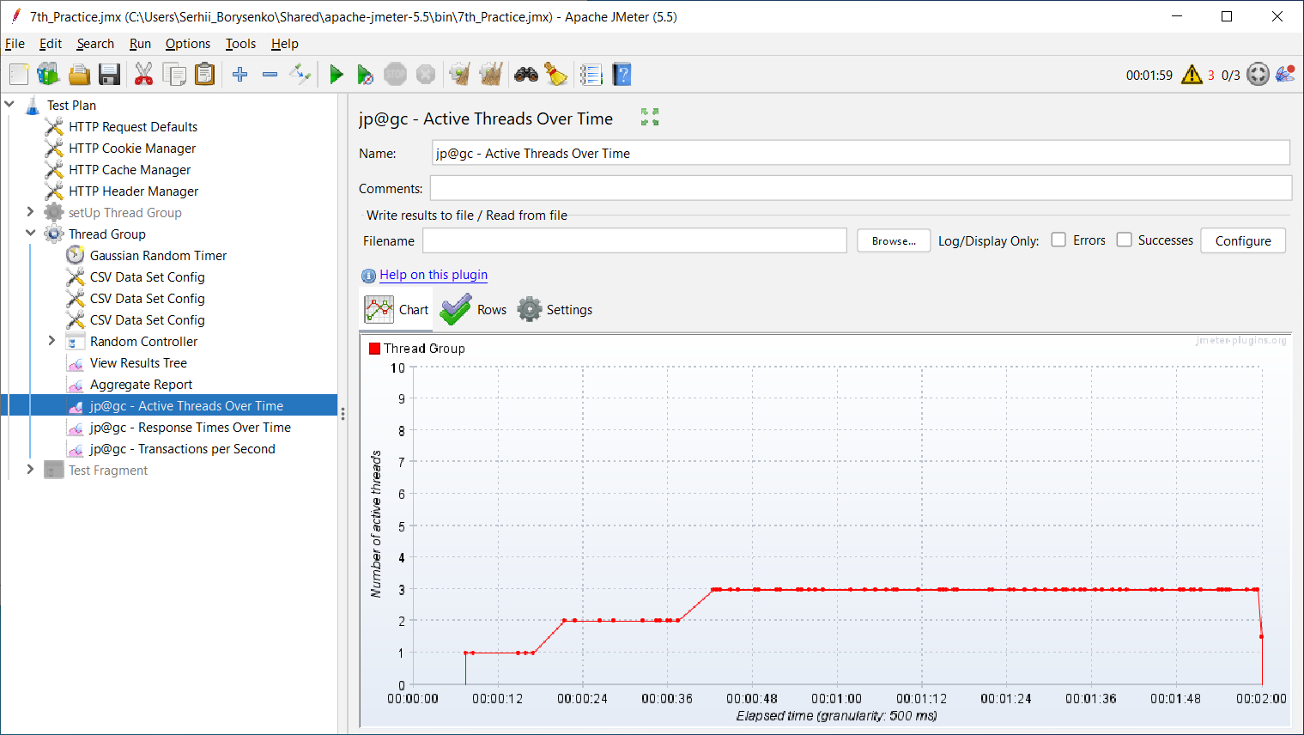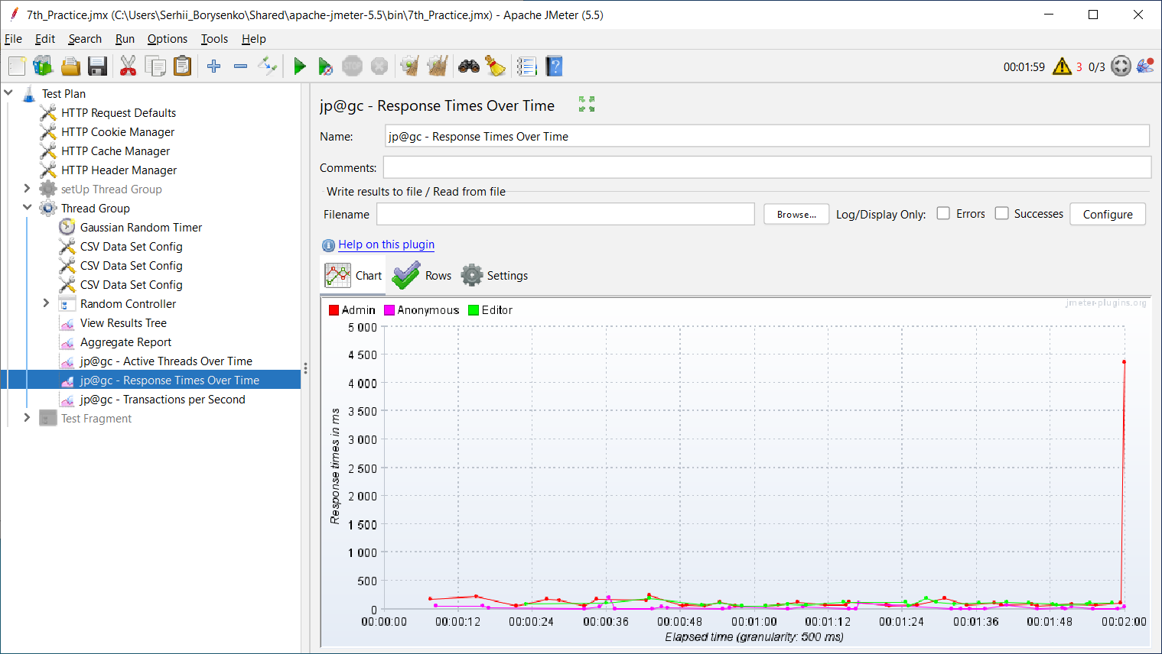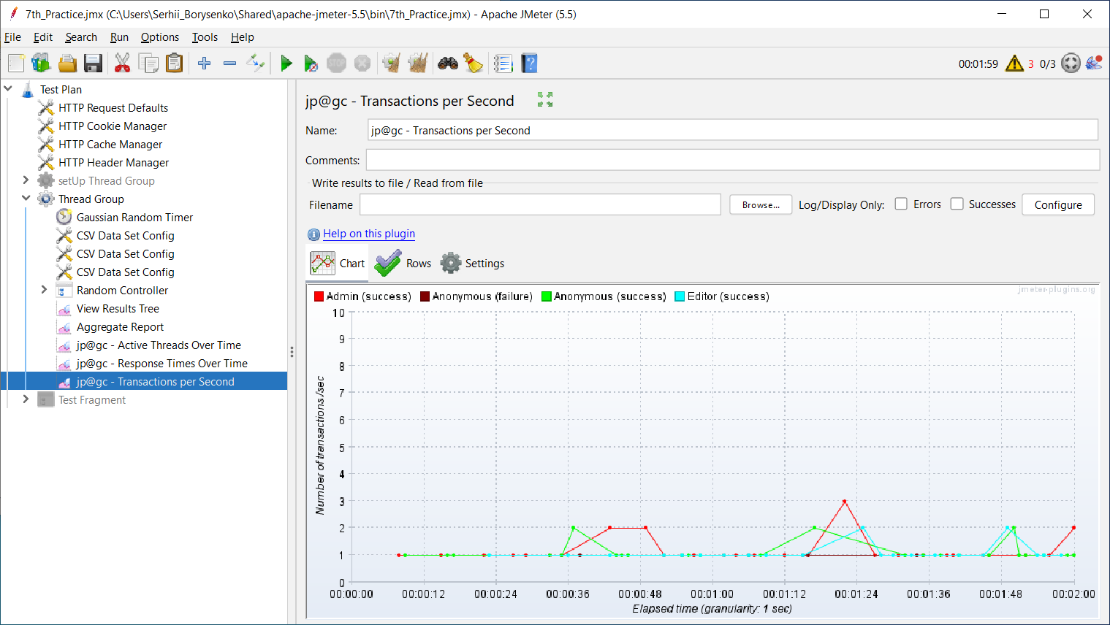

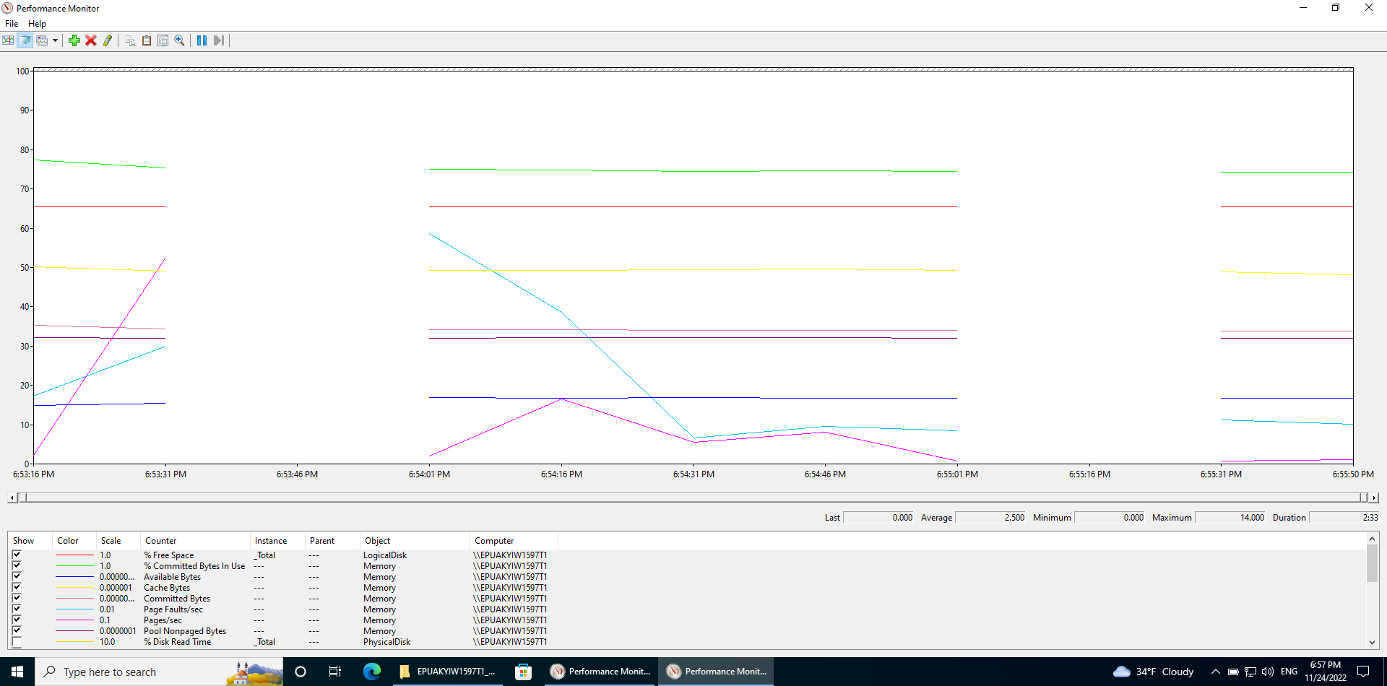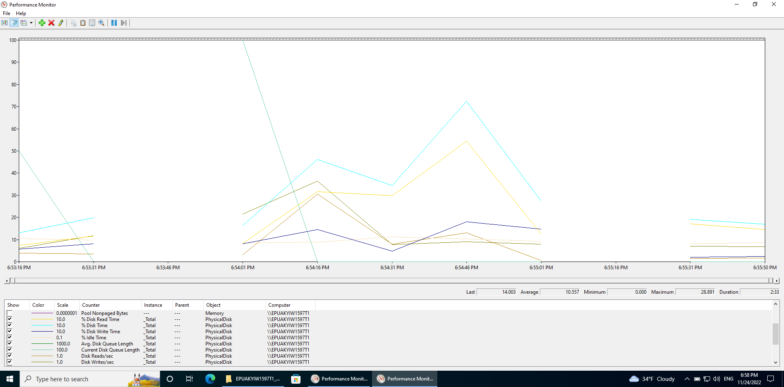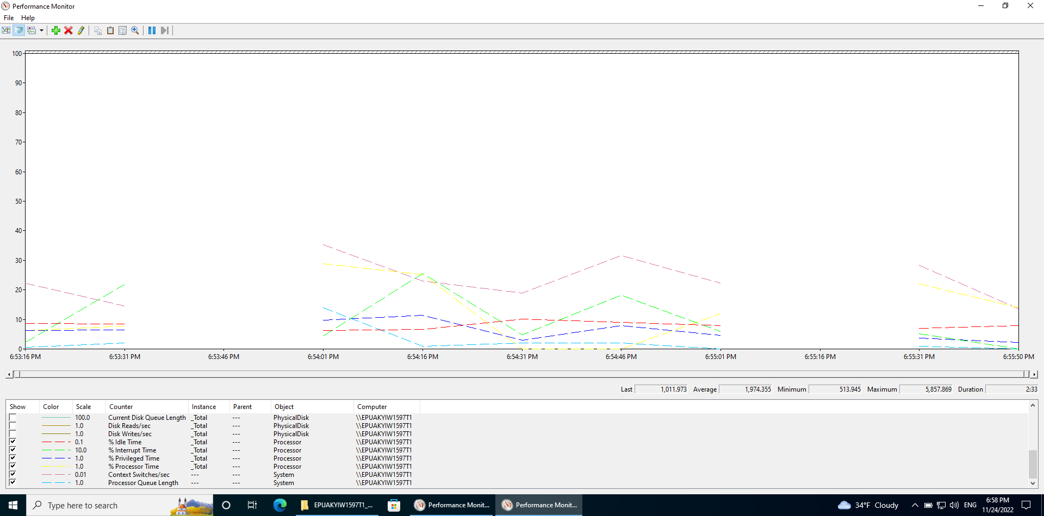

* 6Gb RAM:

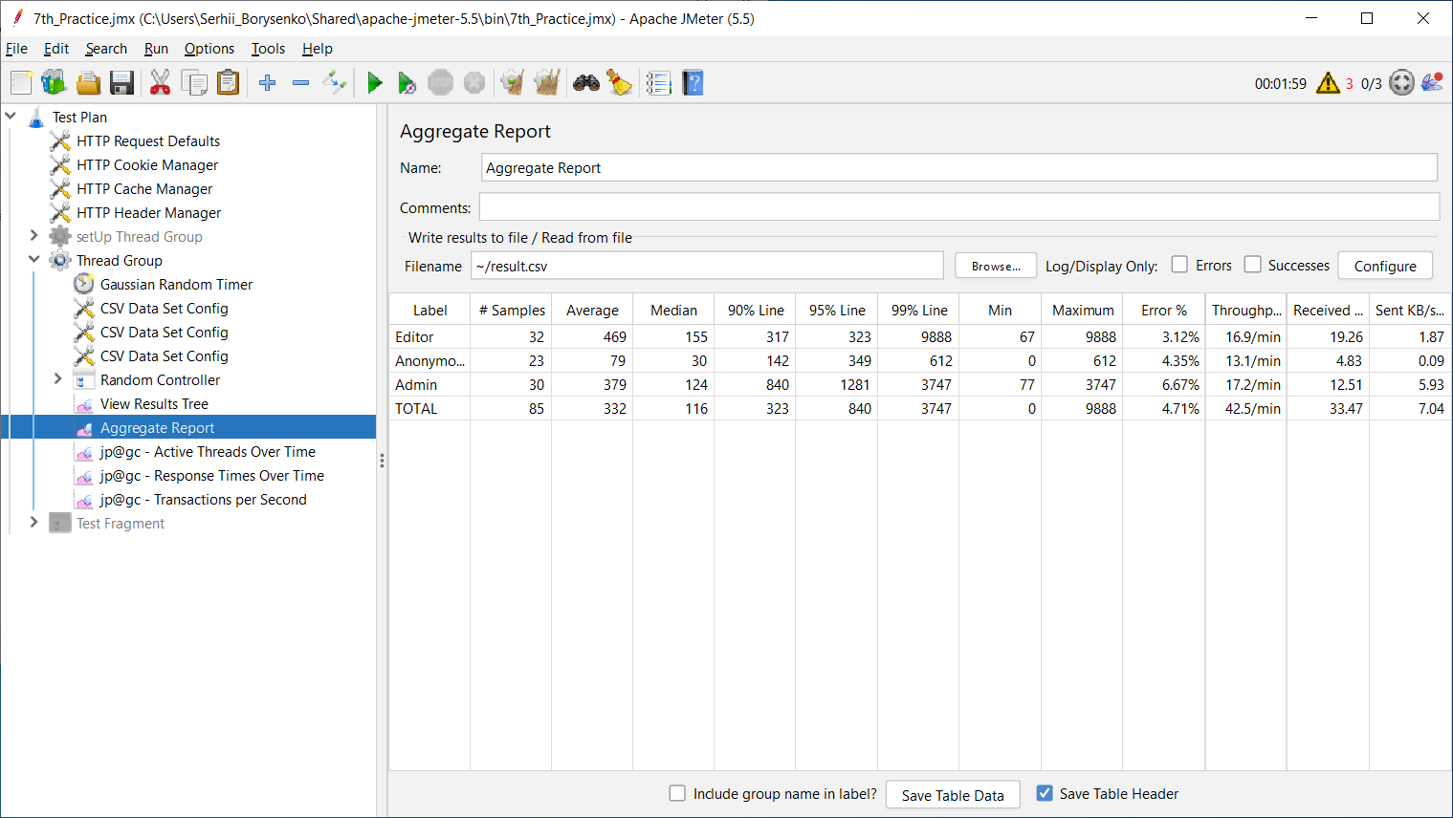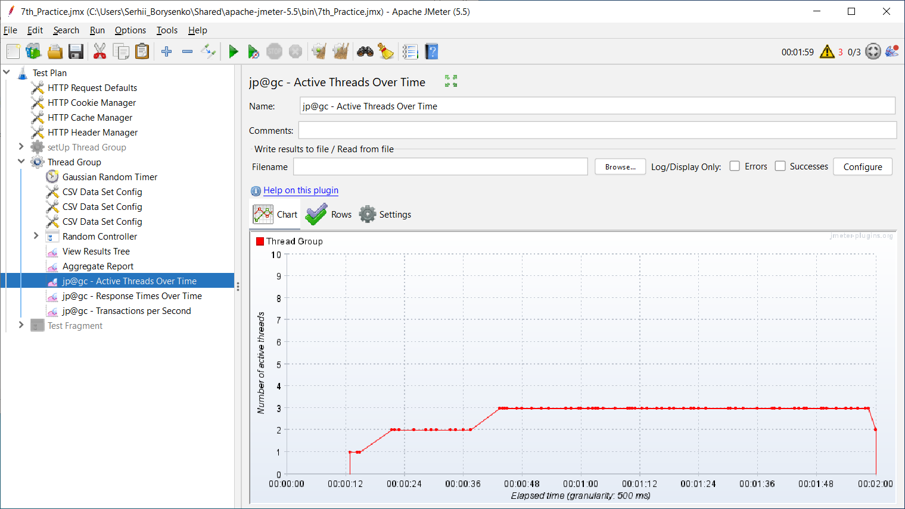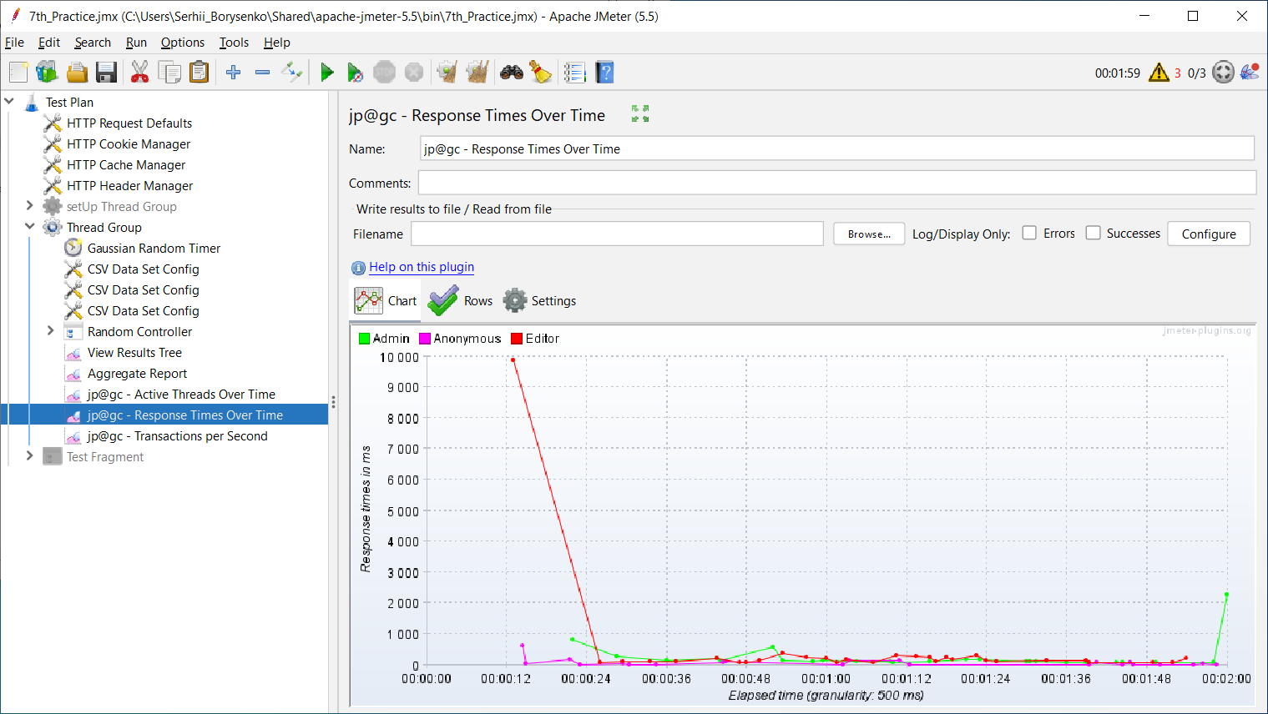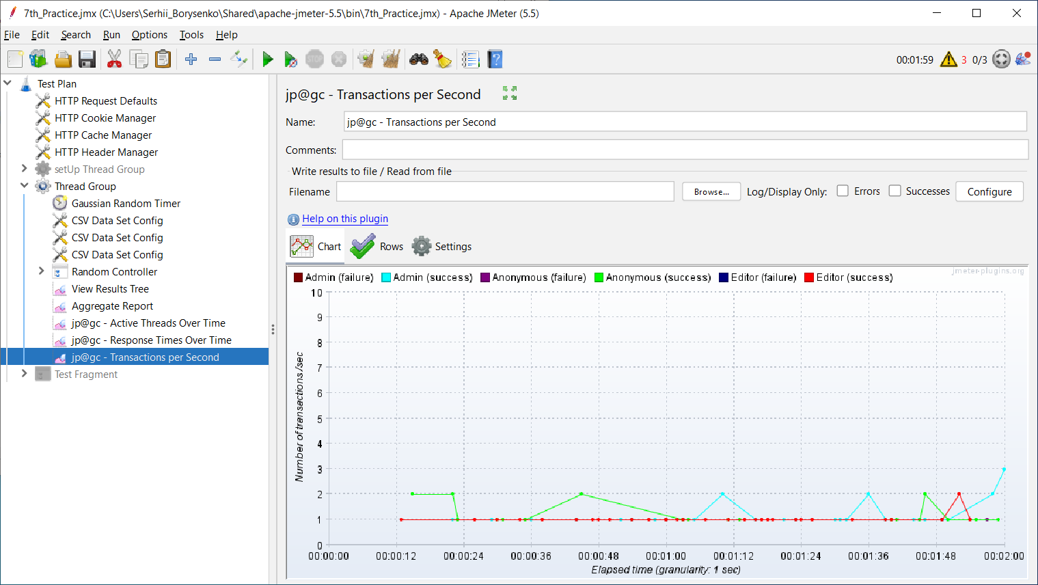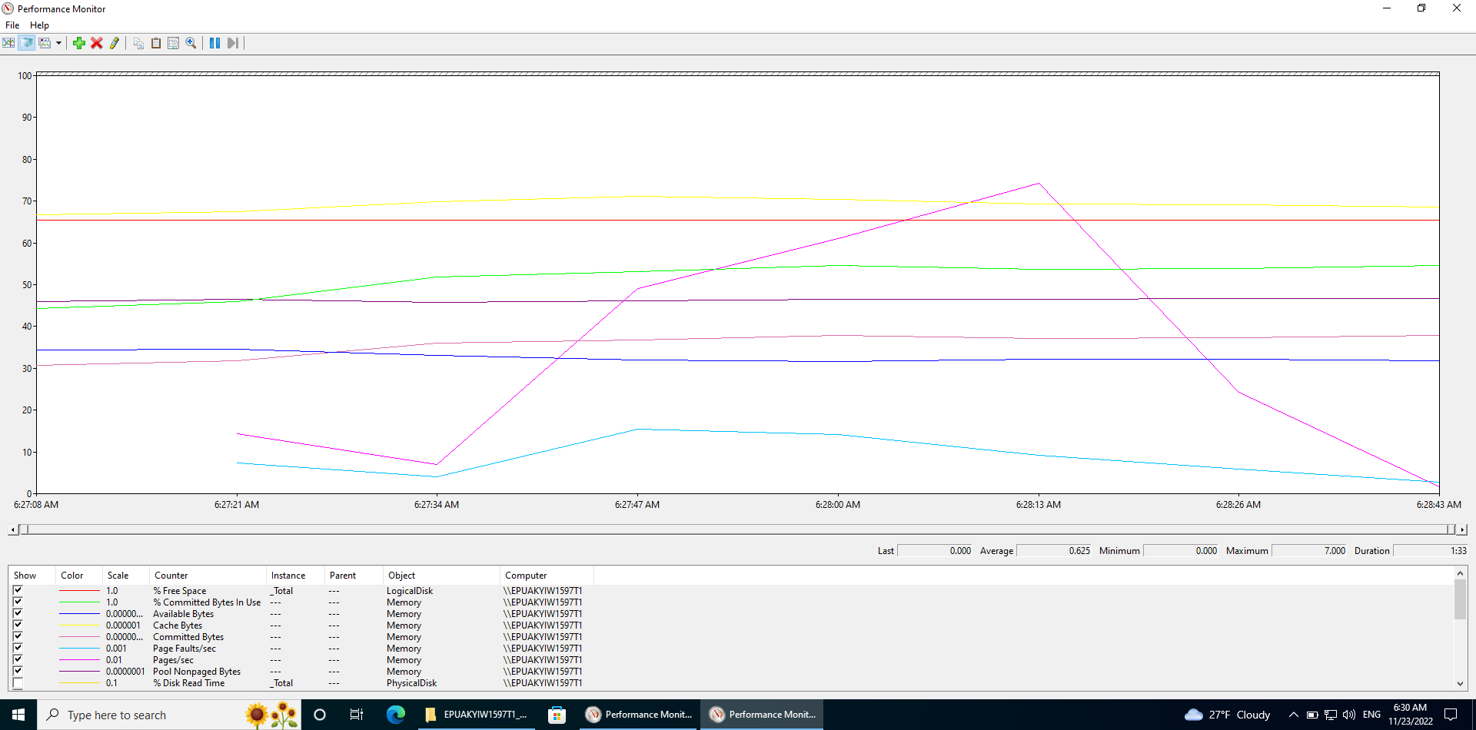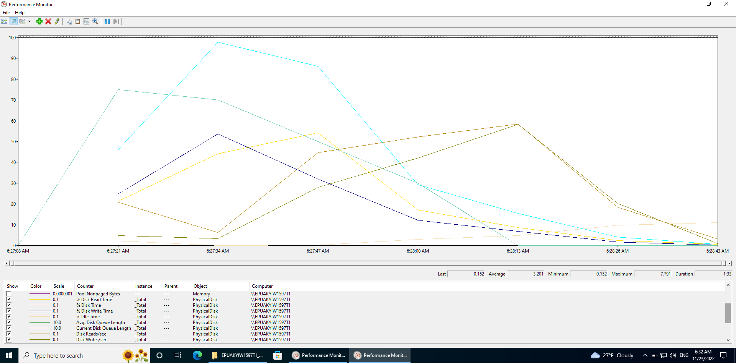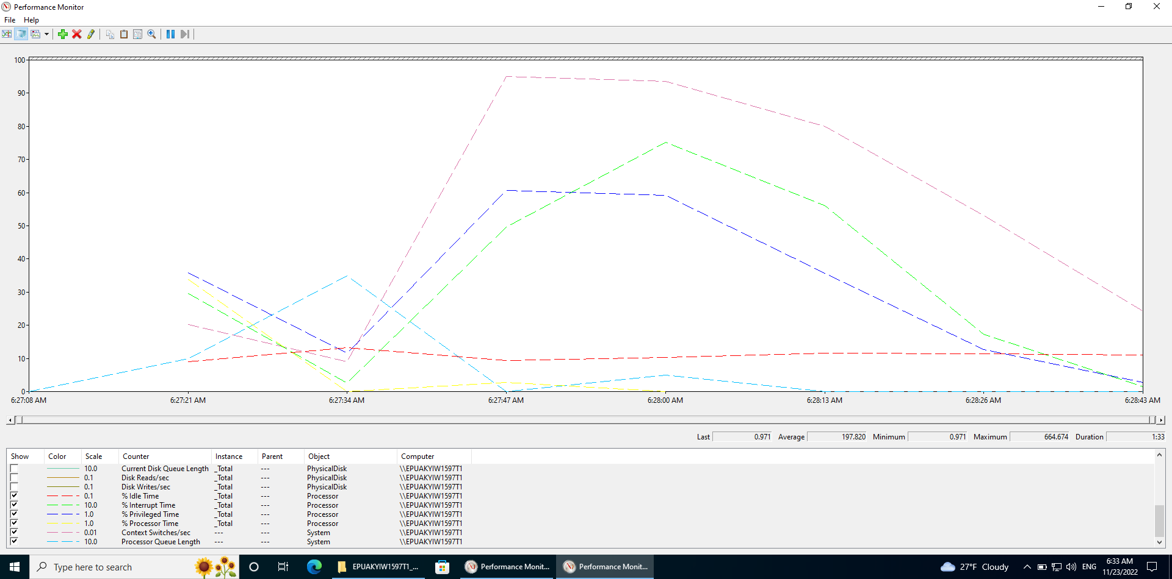

|  |  |  |  |  |  |  |  |  |  |  |  |  |
| --- | --- | --- | --- | --- | --- | --- | --- | --- | --- | --- | --- | --- |
|  | Samples | Average | Median | 90% Line | 95% Line | 99% Line | Min | Max | Error % | Throughput | Received KB/sec | Sent KB/sec |
| 1CPU; 8GB RAM | 84 | 310 | 130 | 415 | 570 | 3679 | 0 | 4318 | 0.00% | 44.1/min | 33.62 | 7.49 |
| 2CPU; 8GB RAM | 84 | 269 | 100 | 402 | 875 | 2513 | 0 | 5125 | 0.00% | 42.0/min | 32.54 | 7.33 |
| 4CPU; 8GB RAM | 87 | 257 | 75 | 117 | 698 | 4689 | 0 | 8160 | 0.00% | 43.5/min | 29.88 | 7.34 |
| 1CPU; 4GB RAM | 91 | -3668810… | 68 | 171 | 188 | 404 | 0 | 4372 | 4.40% | 45.6/min | 29.61 | 7.63 |
| 1CPU; 6GB RAM | 85 | 332 | 116 | 323 | 840 | 3747 | 0 | 9888 | 4.71% | 42.5/min | 33.47 | 7.07 |

**Summary report on scalability testing:**

According to the presented results, it can be seen that with an increase in the number of CPUs and RAM, the throughput increases, while the response time and the number of errors decrease.

In conclusion, we can say that 4CPU; 8GB RAM is the most optimal option