MINISTRY OF HIGHER EDUCATION AND SCIENTIFIC RESEARCH
وزارة التعليم العالي و البحث العلمي


جامعة غرداية
قسم الرياضيات والاعلام الآلي
University of Ghardaïa
Department of Mathematics and Computer Science

Rapport of Mini-Project Clustering

Realized by : Reviewed by : GUERBOUZ Mohammed Alaa Eddine Dr. MOUSSAOUI Abdelouahab

2025/2024
Table of Content
Clustering 3
Introduction 3
Overview about the dataset 3
Clustering with DBSCAN 4
Cluster Visualization 5
Analysis of Results 6
Conclusion 8

Clustering

Introduction
In this Rapport we will explore and see how to implement and analyze the habits of a Citi Bike Data in New York model using spatial clustering techniques , The data used comes from downloadable Citi Bike files, which contain information about trips made by users. We will apply the DBSCAN algorithm to group departure stations based on their geographic location and compare the results with other clustering models such as K-means and HCA.

Overview about the dataset
The data was downloaded from the Citi Bike website (https://s3.amazonaws.com/tripdata/index.html). The chosen file is JC-201906-citibike-tripdata.csv, which contains information about trips made in June 2019.
It has 15 parameter based on that we will do the process

We will try to upload the dataset using the python
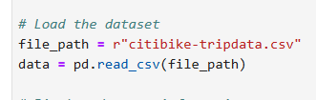
Display the head of the dataset
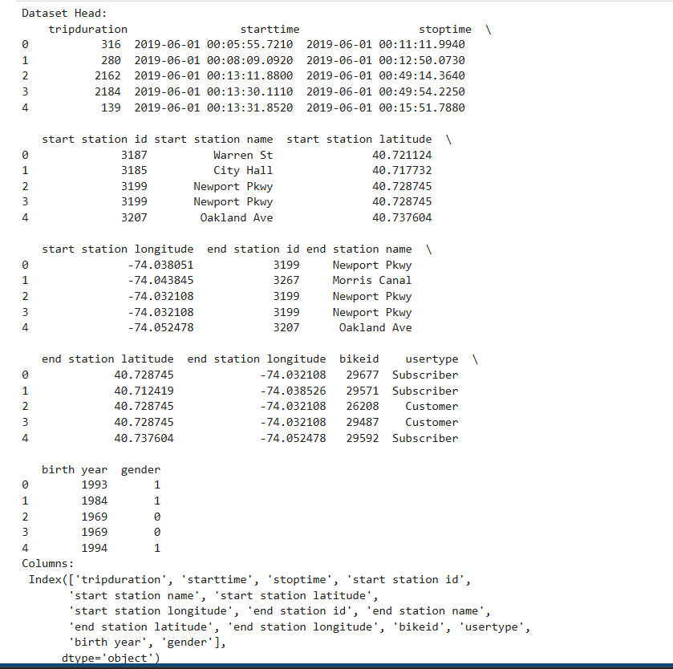

Clustering with DBSCAN
The DBSCAN algorithm was chosen to group departure stations based on their geographic location. The parameters eps and min_samples were adjusted to obtain meaningful clusters.
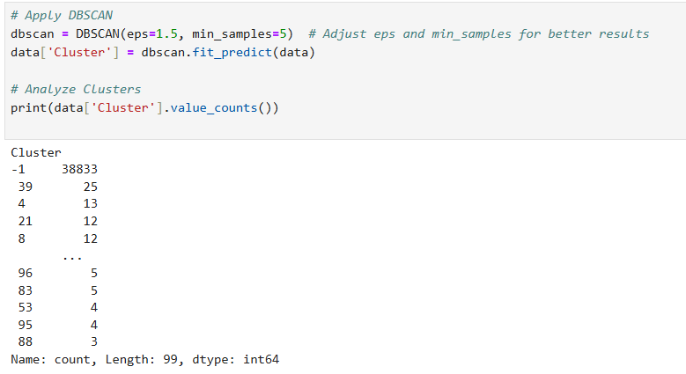

Cluster Visualization
The clusters were visualized using the geographic coordinates of the departure stations. The colored points represent the different clusters, while the gray points represent outliers.
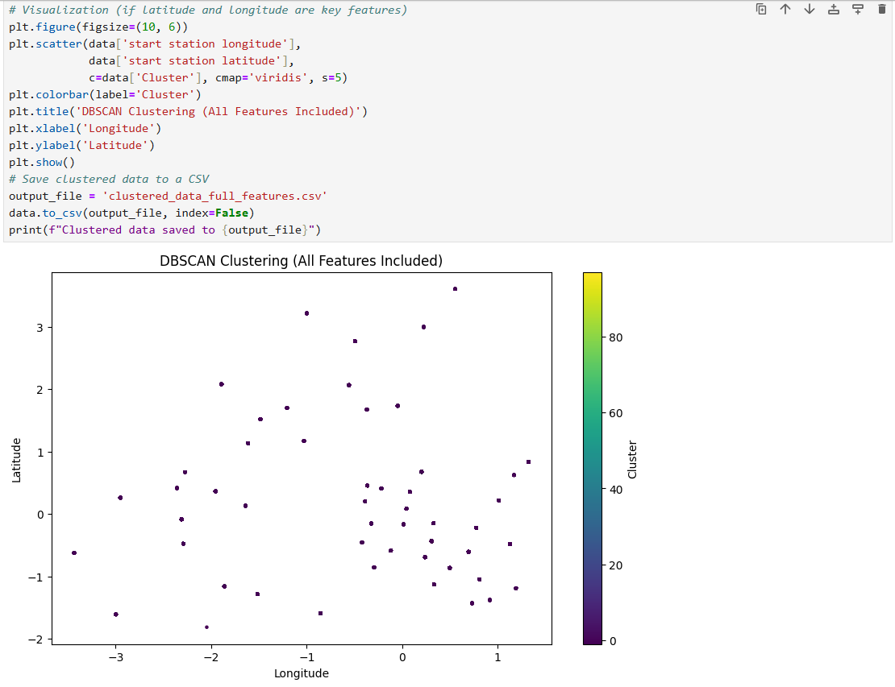

Analysis of Results
- DBSCAN: Effectively identified dense clusters and detected outliers. However, the choice of eps and min_samples parameters is crucial for meaningful results.
- K-means: Produced more regular clusters but requires specifying the number of clusters in advance.
- HCA: Allowed visualization of cluster hierarchy but is more computationally expensive for large datasets.
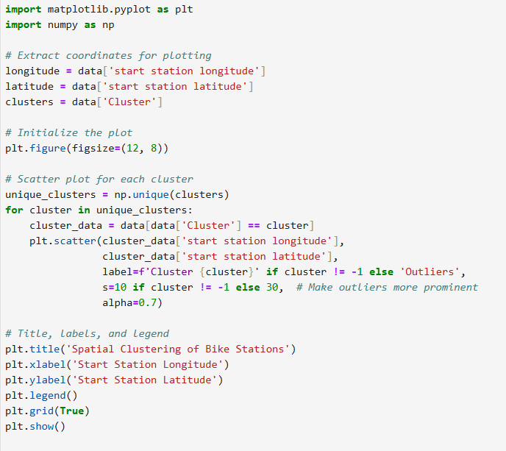
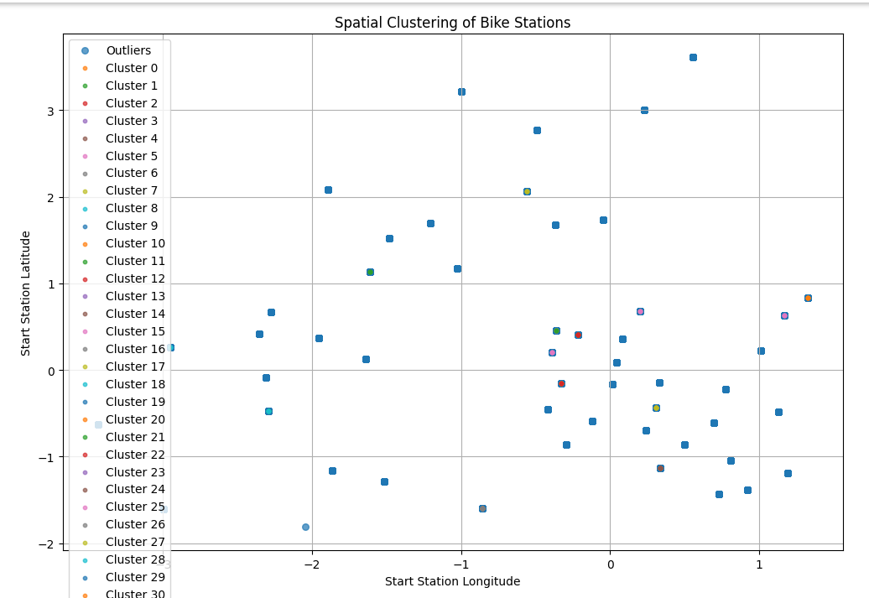

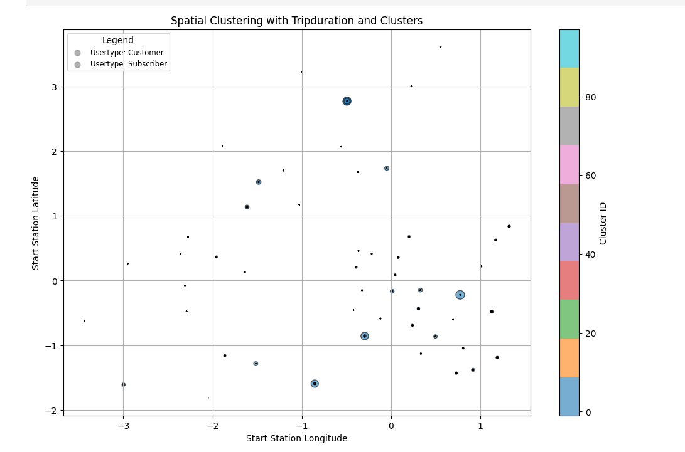

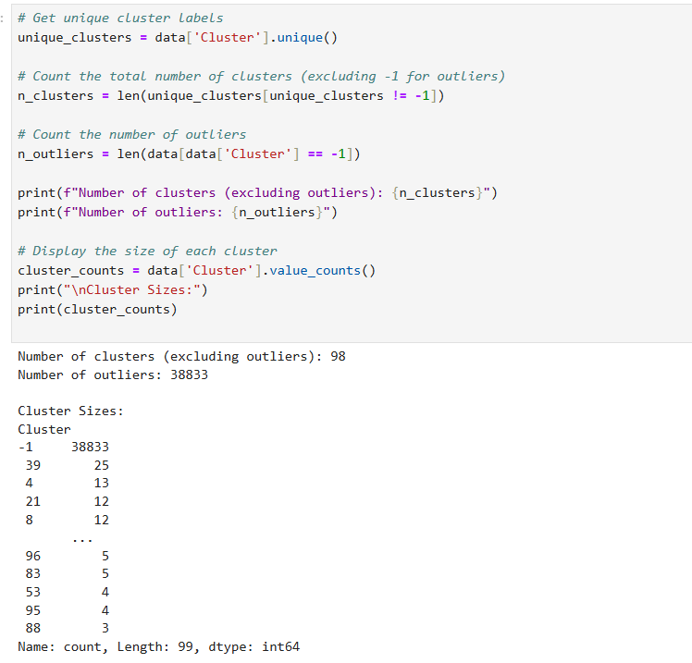

Conclusion
The project aimed to analyze the habits of Citi Bike users in New York City by applying spatial clustering techniques to trip data. Using the DBSCAN algorithm, we successfully grouped departure stations based on their geographic locations and identified patterns in user behavior. Additionally, we compared DBSCAN with other clustering algorithms like K-means and Hierarchical Clustering Analysis (HCA) to evaluate their effectiveness in this context. Below is a detailed conclusion summarizing the findings, challenges, and potential future work.

