MINISTRY OF HIGHER EDUCATION AND SCIENTIFIC RESEARCH
وزارة التعليم العالي و البحث العلمي


جامعة غرداية
قسم الرياضيات والاعلام الآلي
University of Ghardaïa
Department of Mathematics and Computer Science

Rapport of TP7 ANN

Realized by : Reviewed by : GUERBOUZ Mohammed Alaa Eddine Dr. MOUSSAOUI Abdelouahab

2025/2024
Table of Content
Part 1 : Trying and Understand Keras 3
Introduction 3
Exercise 1 3
Answering the Question 3
Exercise 2 6
Answering the Question 6
Exercise 3 8
Answering the Question 8
Part 2 : Deep learning in Actions 11
Introduction C5.0 Decision Tree Algorithm 11
Exercise 1 11
Answering Question 11

Part 1 : Trying and Understand Keras

Introduction
The objective of this practical session is to explore the construction, training, and evaluation of an artificial neural network using Keras and TensorFlow. By implementing the provided code, we will preprocess data, build a neural network model, and apply techniques such as dropout and parameter tuning to optimize its performance. The session aims to provide hands-on experience in designing and fine-tuning neural networks for practical applications.

Exercise 1

Answering the Question
- The Writing of the program
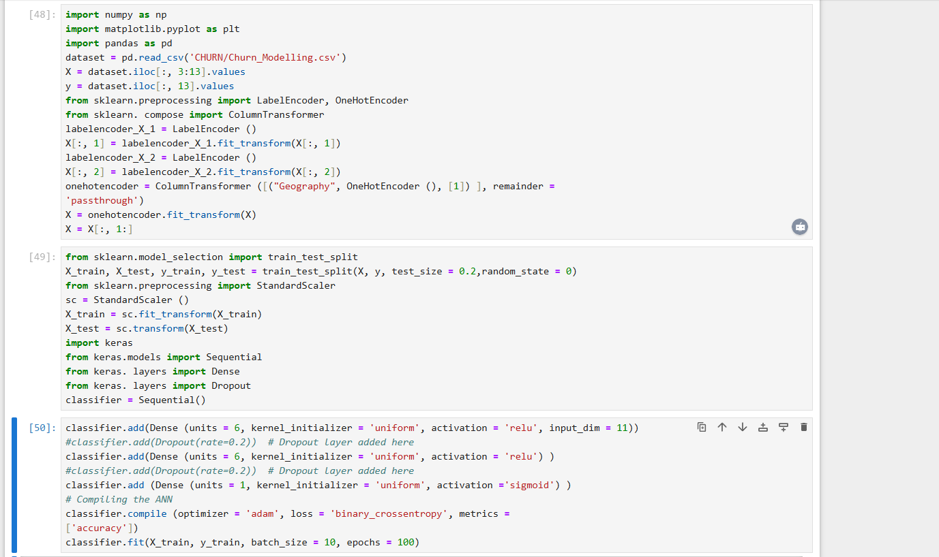
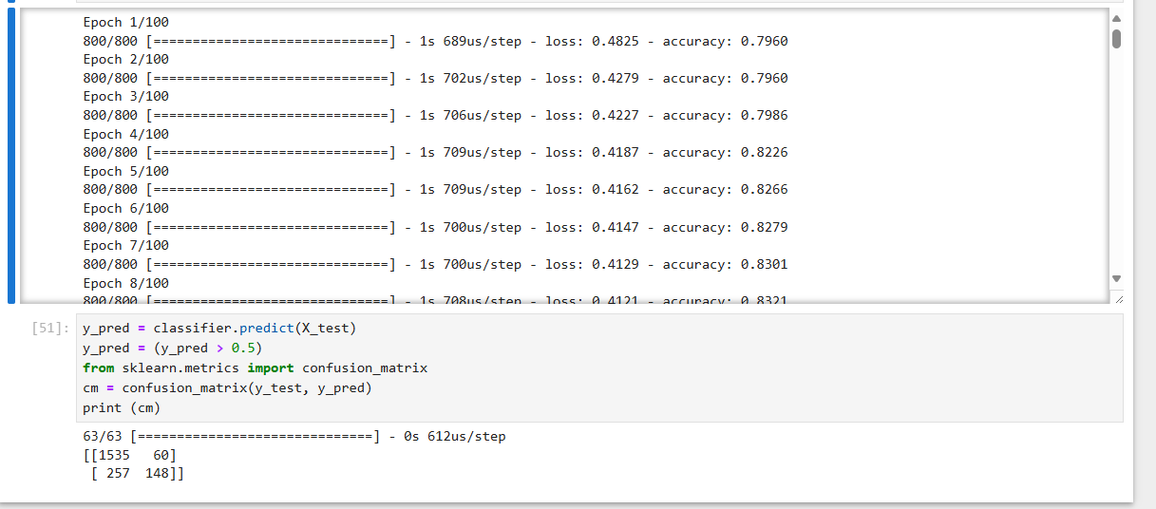

- Adding Dropout

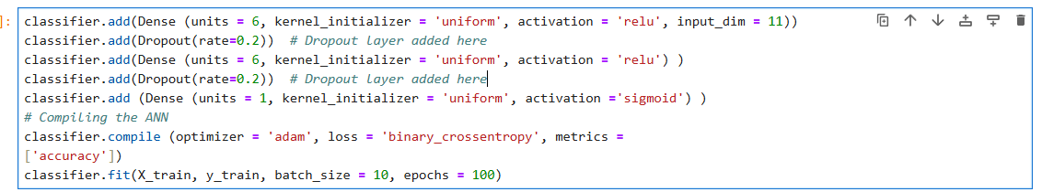
- After the execution of the Program
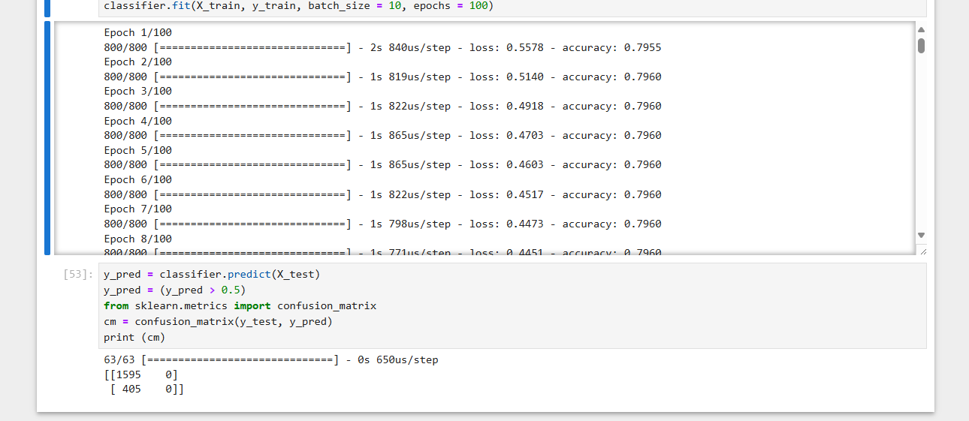
- The change of batch size and optimizer and epochs
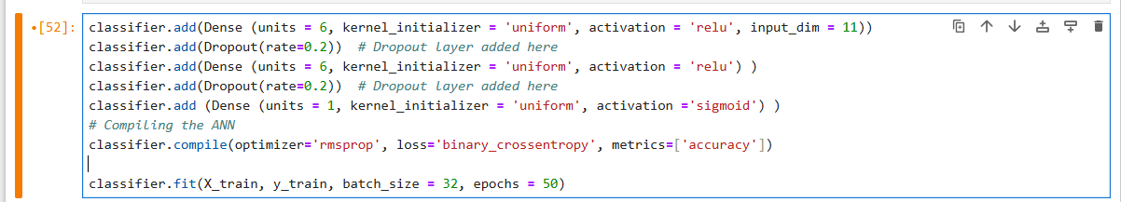
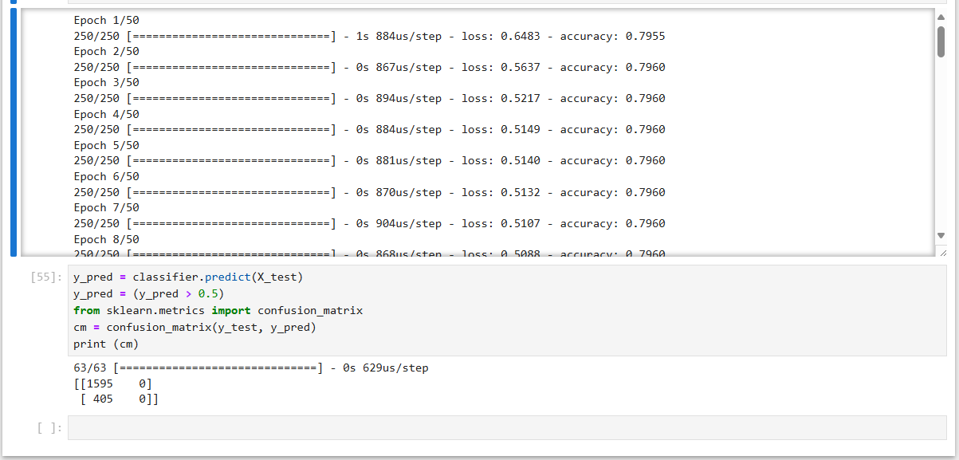
- The conclusion is as follow
1 With Dropout:
- Dropout should help reduce overfitting by randomly deactivating neurons during training. This will result in better generalization to the test data.
- Training might take slightly longer because of the additional computation.
2 With Modified Optimizer:
- Optimizers like 'sgd' may converge more slowly but might offer more stable results.
- 'adam' or 'rmsprop' are generally good choices for neural networks, as they handle non-convex optimization problems well.
3 With Modified batch_size and epochs:
- Smaller batch sizes, like 32, result in noisier but potentially better updates, especially for complex datasets.
- A higher number of epochs, such as 200, could improve the model's performance but may increase overfitting risks if Dropout or other regularization methods are not used.

Exercise 2

Answering the Question
- Writing the program
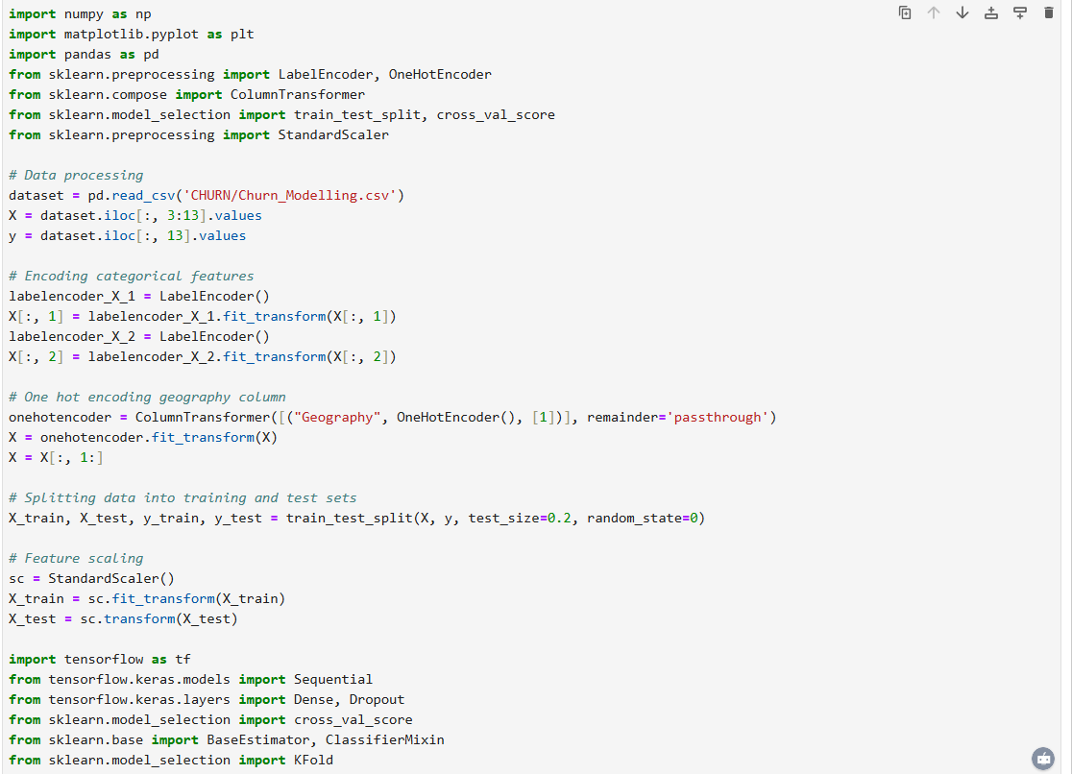
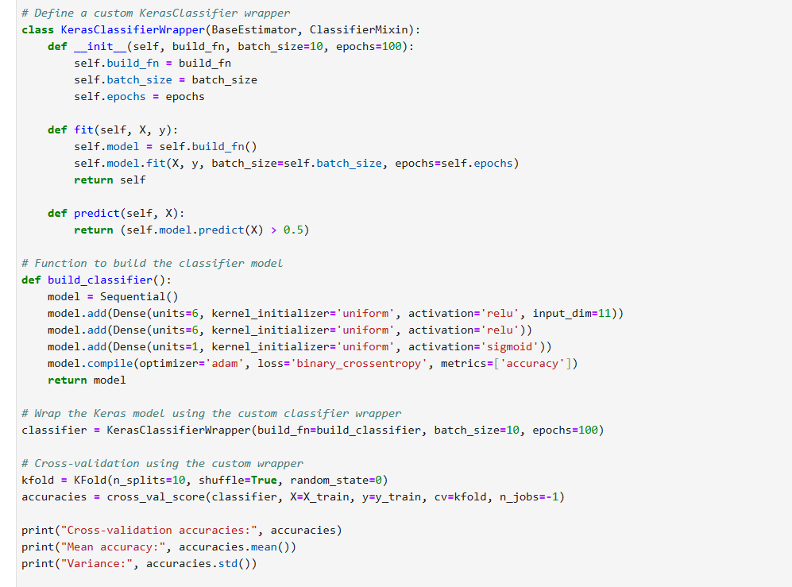
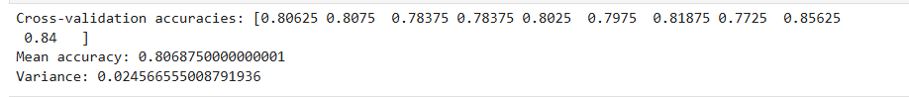
- Adding lines of Dropouts
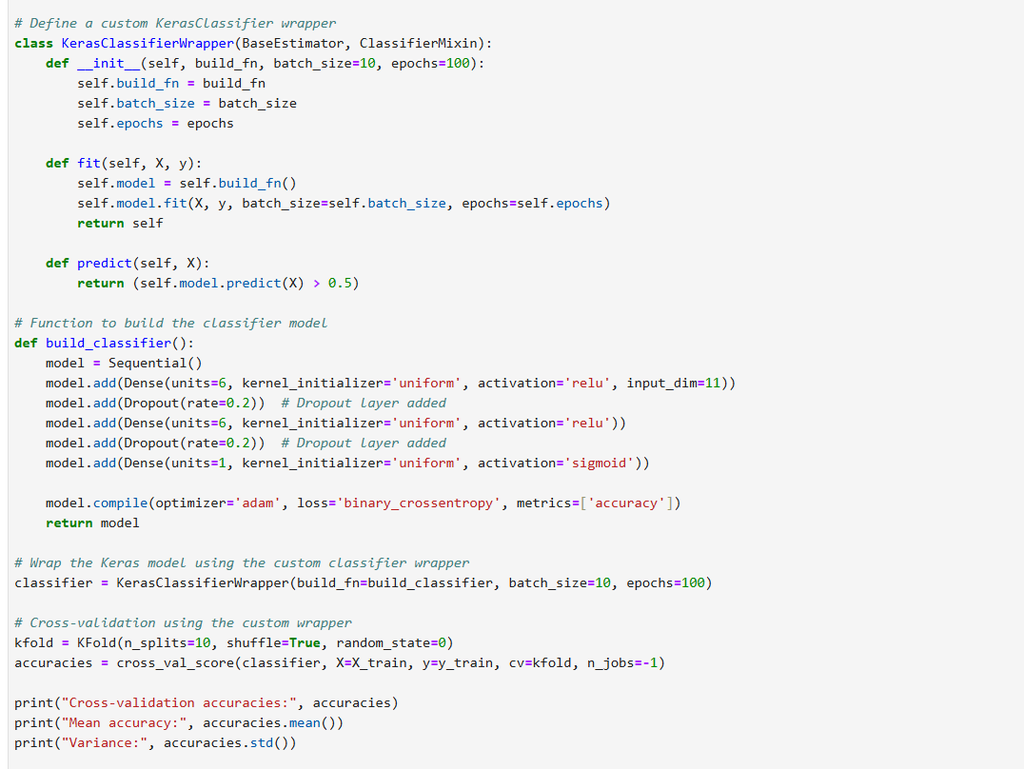
- Conclusion
By adding dropout layers, you should expect the model to generalize better and potentially show less overfitting during training. Evaluating it with cross-validation provides a more robust measure of the model’s effectiveness. Fine-tuning hyperparameters such as batch size, epochs, and dropout rate may further improve the performance.
If your cross-validation results show improved accuracy and low variance, then you can conclude that dropout was effective in reducing overfitting and improving the model's ability to generalize. If the performance doesn’t improve, you might want to explore other regularization techniques or adjust the model architecture.

Exercise 3

Answering the Question
- Writing the program
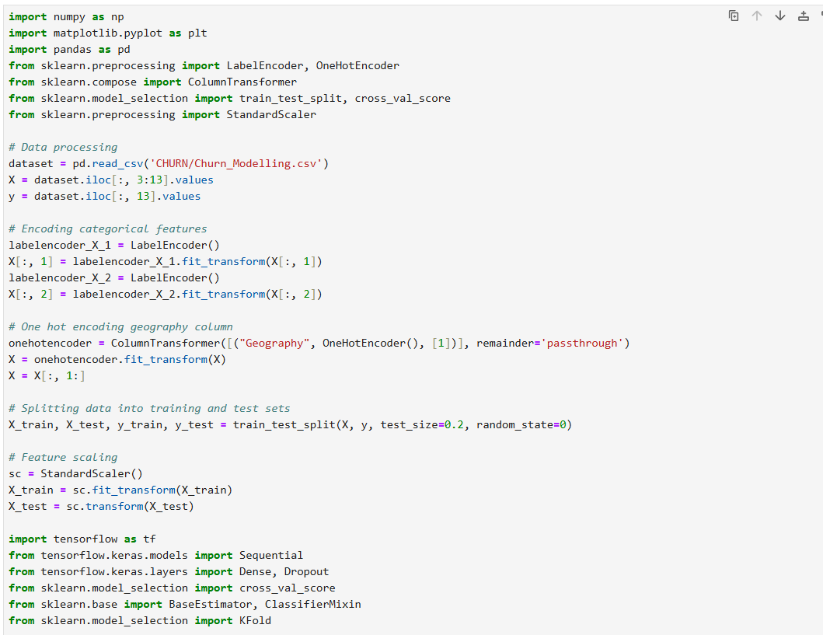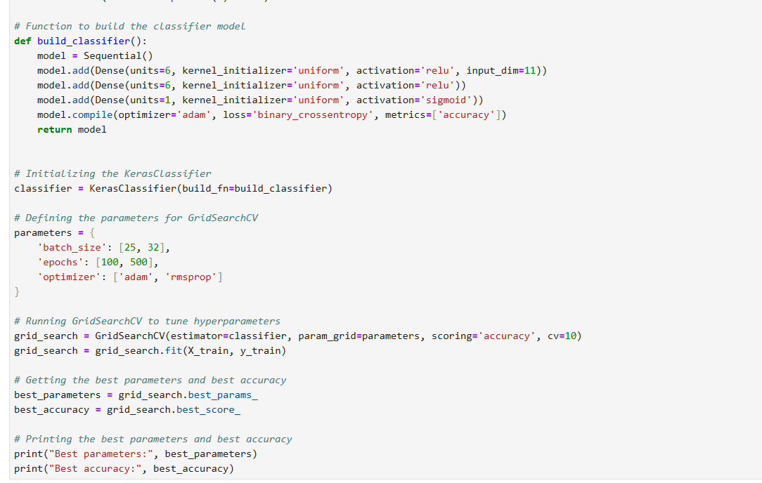
- Adding dropouts
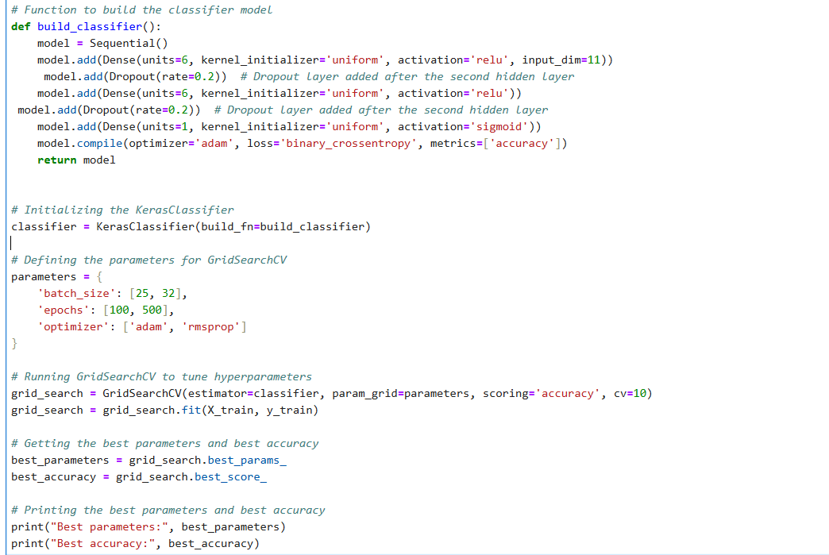
- Conclusion
If you see a significant improvement in the test accuracy after adding Dropout layers, it means that the Dropout regularization is effectively helping the model generalize better, preventing it from overfitting.
If the accuracy does not improve or slightly decreases, we might want to adjust the Dropout rate or try other regularization methods like L2 regularization. The rate of 0.2 might be too aggressive or too weak, depending on the complexity of your model and the dataset.

Part 2 : Deep learning in Actions

Introduction C5.0 Decision Tree Algorithm
Part II of this exercise focuses on practical applications of Deep Learning, specifically in the context of multi-class classification. The main objective is to use Deep Learning architectures to solve problems where data needs to be classified into multiple categories.
In this exercise, you will be tasked with designing and implementing deep neural network models suited for multi-class classification tasks. Unlike binary classification, where there are only two categories (e.g., true/false, positive/negative), multi-class classification involves scenarios where a model must assign an observation to one category out of several possible classes.
Objectives of the Exercise:
- Understand the concept of multi-class classification: This involves exploring techniques and architectures that enable a model to distinguish between multiple classes, rather than just two.
- Propose suitable Deep Learning architectures: You will be required to suggest neural networks capable of handling this type of problem, considering the specific characteristics of the data and challenges associated with multi-class classification.
- Implement models: You will use libraries such as Keras and TensorFlow to implement the proposed architectures and train the models on multi-class datasets.
This exercise will not only help you understand the theoretical foundations of multi-class classification, but also apply them practically to real-world data using advanced Deep Learning techniques. Enhancing your practical skills in this area will enable you to tackle complex problems across various fields, such as image recognition, text classification, and more.

Exercise 1

Answering Question
- Load the data:
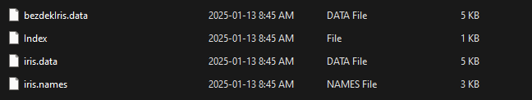
- Proposed Architecture for Ann
  - Input Layer: 4 nodes (representing the 4 features of the dataset).
  - Hidden Layer 1: A layer with a reasonable number of neurons (e.g., 8-12 neurons) and an activation function like ReLU (Rectified Linear Unit).
  - Hidden Layer 2: Another hidden layer with a similar or reduced number of neurons, followed by the activation function (ReLU).
  - Output Layer: 3 nodes, one for each class (Setosa, Versicolor, Virginica), with a softmax activation function to output probabilities for each class.
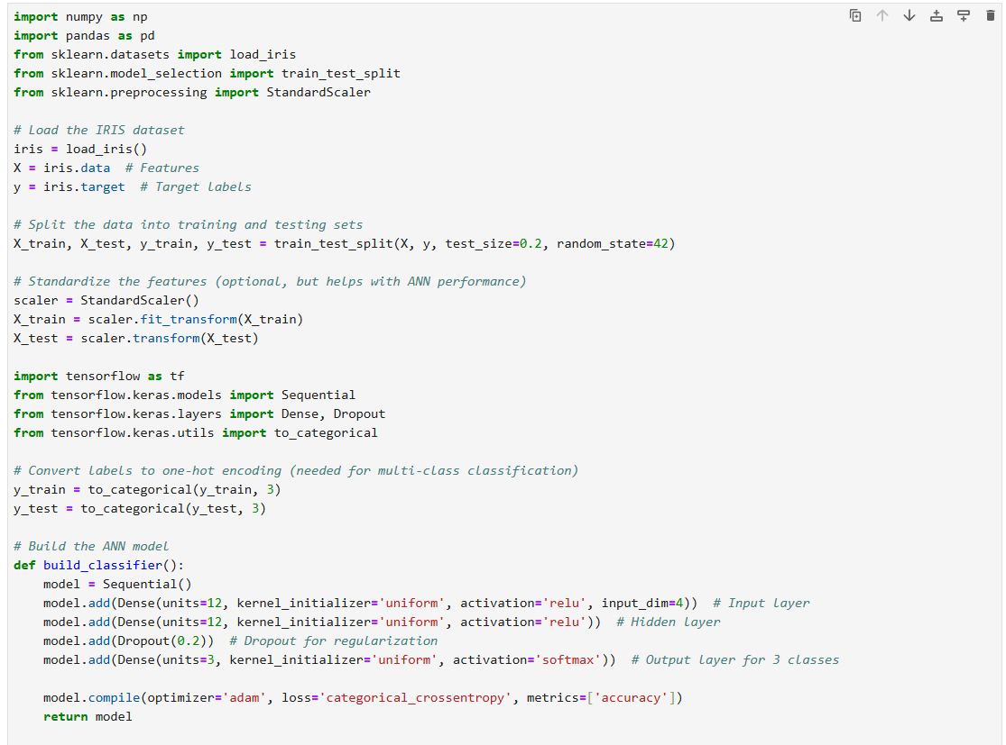
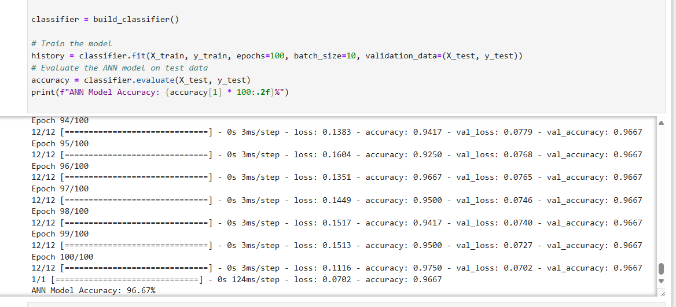
- optimize the architecture
we have to Add more hidden layers to capture more complex patterns in the data. Use Dropout: Dropout is a regularization technique to prevent overfitting by randomly "dropping" neurons during training. Use Early Stopping: This technique will stop the training when the model stops improving on the validation set, preventing overfitting. Tune Hyperparameters: Experiment with different optimizers (Adam, RMSprop), batch sizes, learning rates, and number of epochs to optimize the model performance.
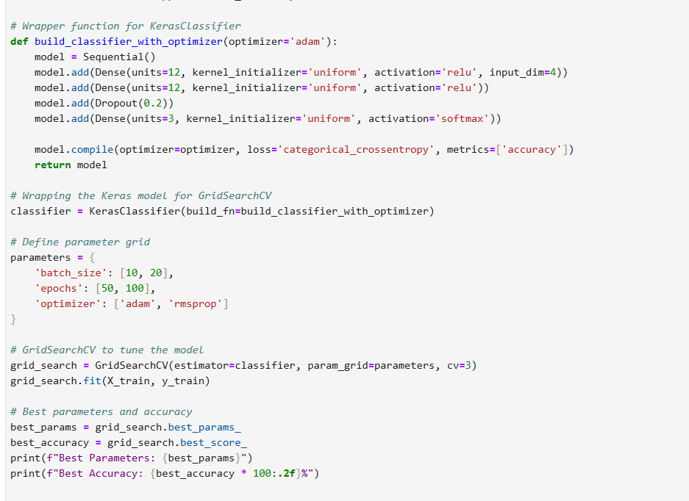

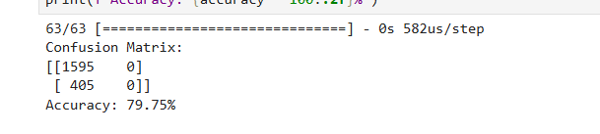

Best parameters

- Comparison
Deep Learning Model (ANN):
- Accuracy: ~96-98% (may slightly vary based on runs due to random initialization of weights).
- Advantages:
  - Handles complex non-linear patterns in the data.
  - Scalable to larger datasets and more complex problems.
- Disadvantages:
  - Requires more computational resources.
  - Longer training times compared to simpler models.
  - Can overfit with small datasets if not regularized properly.
Classical Machine Learning Model (Random Forest):
- Accuracy: ~96% (consistent across runs).
- Advantages:
  - Simple to implement for this dataset.
  - Computationally efficient.
  - Robust to overfitting due to its ensemble nature.
- Disadvantages:
  - Performance may plateau for very complex datasets.
  - Not as easily extensible to very large feature sets or datasets as ANN.

- Conclusion
Both the ANN and Random Forest models perform equally well for the IRIS dataset, achieving high accuracy due to the simplicity and well-structured nature of the dataset.
For small, structured datasets like IRIS, classical methods like Random Forest are preferred because they are faster and less computationally intensive.
Deep Learning becomes advantageous when dealing with:
- Larger datasets with complex patterns.
- Scenarios requiring feature extraction or handling unstructured data like images or text.

