MINISTRY OF HIGHER EDUCATION AND SCIENTIFIC RESEARCH
وزارة التعليم العالي و البحث العلمي


جامعة غرداية
قسم الرياضيات والاعلام الآلي
University of Ghardaïa
Department of Mathematics and Computer Science

Rapport of Mini-Project Classification

Realized by : Reviewed by : GUERBOUZ Mohammed Alaa Eddine Dr. MOUSSAOUI Abdelouahab

2025/2024
Table of Content
Classification 3
Introduction 3
Overview about the dataset 3
Features for Classification 4
Splitting the Database 5
Choosing the learning algorithm 5
Algorithm Parameters 5
Learning Algorithm Process 5
Statistical Parameters of Learning 6
Conclusion 7

Classification

Introduction
In this Rapport we will explore and see how we implemented a face recognition model which is growing rapidly over the latest years and it have been used in security and detecting threatening’s so in our work we will use the image processing and machine learning techniques and we will use the ORL (Olivetti Research Laboratory) datasets

Overview about the dataset
Our dataset contain 40 classes( or we can say different people ) each class contain 10 images of a face for same person with a number , so in general we have 400 image and the images are grayscale and with size 92*112* pixels.

We will try to uplode the dataset using the python
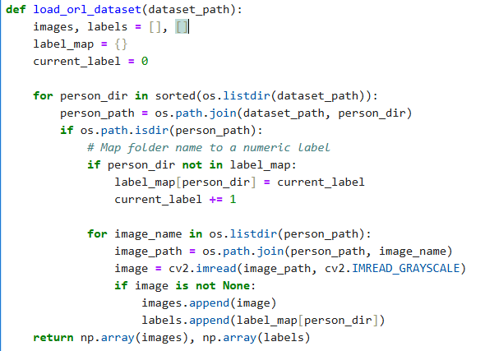
We can see in that image that this function have a path to the dataset as a parameter and inside it there is a loop of the files and inside the files when we index a file we retrieve the images (10) using the OpenCv library with the method CV2.imread()

Features for Classification
For classification we will use this features as follow :
- Grayscale levels: Each pixel in the image is represented by a grayscale intensity.
- Texture: Texture descriptors can be extracted to capture local variations in the image.
- PCA (Principal Component Analysis): To reduce the dimensionality of the data while retaining essential information.
- LDA (Linear Discriminant Analysis): To maximize separability between classes.
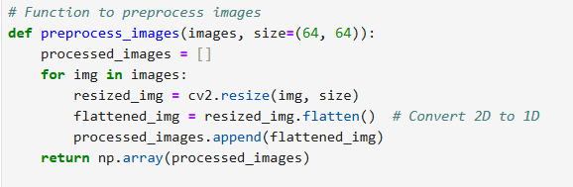

Splitting the Database
The dataset will be split into 2 parts:
- Training set: 70% of the images (280 images).
- Test set: 30% of the images (120 images).

Choosing the learning algorithm
We will use the k-NN (k-Nearest Neighbors) algorithm for classification, combined with PCA (Principal Component Analysis) for dimensionality reduction. k-NN is simple to implement and effective for face recognition problems, while PCA helps reduce the computational complexity by extracting the most important features from the images..

Algorithm Parameters
- k: The number of neighbors to consider. We will test different values of k (e.g., 1, 3, 5) to find the best performance.
- Distance metric: Euclidean distance will be used to measure similarity between images.
- 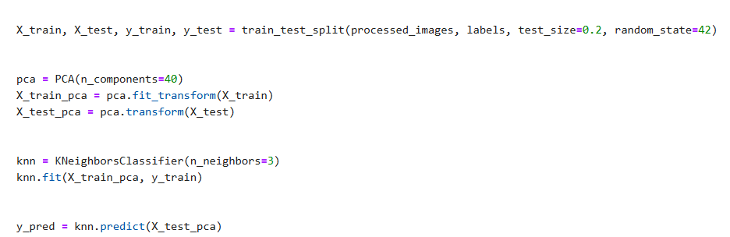

Learning Algorithm Process
- Preprocessing: Convert images to grayscale and normalize.
- Feature extraction: Apply PCA to reduce dimensionality.
- Training: Train the k-NN model on the training set.
- Validation: Test the model on the test set.

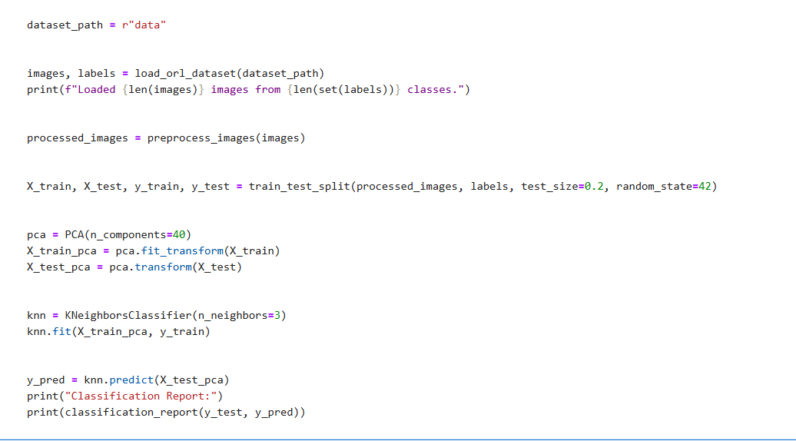
Statistical Parameters of Learning
The following parameters will be calculated to evaluate model performance:
- F-measure: Combination of precision and recall.
- Specificity: Ability to correctly identify negatives.
- Sensitivity: Ability to correctly identify positives.
- R-statistic: Correlation coefficient between predictions and true values.
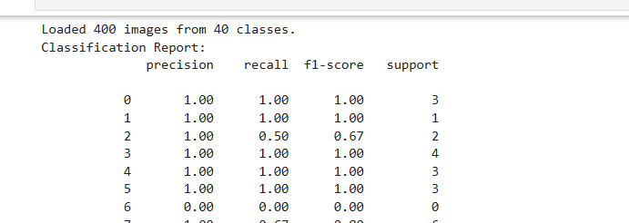
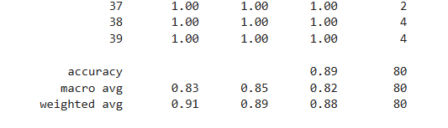
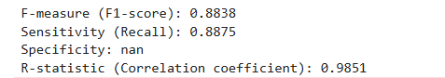
Confusion Matrix Explanation :
The confusion matrix is a table used to evaluate the performance of a classification model. It compares the actual target values (`y_test`) with the predicted values (`y_pred`) and provides a detailed breakdown of the model's performance.
- The first row represents the actual negative class.
- The second row represents the actual positive class.
- The first column represents the predicted negative class.
- The second column represents the predicted positive class.

Conclusion
In this project, we implemented a face recognition system using the k-Nearest Neighbors (k-NN) algorithm combined with Principal Component Analysis (PCA) for dimensionality reduction. The goal was to classify facial images from the ORL Database of Faces and evaluate the performance of the model using various metrics such as F-measure, Sensitivity, Specificity, and R-statistic.

