MINISTRY OF HIGHER EDUCATION AND SCIENTIFIC RESEARCH
وزارة التعليم العالي و البحث العلمي


جامعة غرداية
قسم الرياضيات والاعلام الآلي
University of Ghardaïa
Department of Mathematics and Computer Science

Rapport of Mini-Project

RM2: Recognition of traffic signs (SVM)

Realized by : Reviewed by : GUERBOUZ Mohammed Alaa Eddine Drs. Ben Abderrahmane

2025/2024
Table of Content
Introduction 1
1. Programming 2
2. Results Comparison 23
Conclusion 24

Introduction
In order to develop a system capabale of detecting and classifying road traffic signs using Ml and DeepLearning Algorithms , the need of this system is in applications like autonomous vehicles or autonomy driver and assistance systems ,because the accurate the recognition is of the signs roads the best experience for this system and less errors means less roads problems
and ensuring safety for living beings (human animals) and materials also compliance with traffic laws.
So we saw the importance of this system we will try to discuses how the development of such systems will be and its steps , so first thing we will be thinking in is the datasets , we choose to use this datasets :
Traffic Sign Dataset Classification : https://www.kaggle.com/datasets/ahemateja19bec1025/traffic-sign-dataset-classification
Road Sign Detection :
https://www.kaggle.com/datasets/andrewmvd/road-sign-detection
after choosing the datasets we focus on the environment we choose the python and jupyter for its stability and simplicity , and for algorithms we choose
- Traditional Machine Learning: Using SVM (Support Vector Machine) combined with feature extraction based on visual descriptors.
- Deep Learning: Training a CNN (Convolutional Neural Network) model for automated recognition.
So after we draw our lines we will focus on getting the best result for this problem and try to play on the different parameters of each method

1. Programming
We will start with Machine Learning MEthode SVM and discuse how we implemented this script after we will move forward to deep learning , and before that we will have a global talk on both datasets to have a vision in next sections
- The Traffic Sign Dataset Classification dataset is designed for the classification of various types of traffic signs. It includes:
- Classes: 58 distinct traffic sign classes.
- Images per Class: Approximately 120 images for each class, ensuring balanced representation.
- Test Set: Around 2,000 images designated for testing purposes.
- Labels: A labels.csv file provides descriptions for each traffic sign class, enabling mapping between classIDs and their respective descriptions.
This dataset is suitable for training basic CNN models, which can achieve decent validation accuracy. It serves as an excellent resource for experimenting with machine learning and deep learning techniques for traffic sign classification. Additional resources include a notebook available in the code section, which demonstrates how to train and test a basic CNN model using this dataset.
Ex for classes
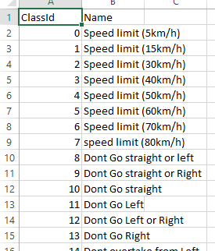

- The Road Sign Detection Dataset is intended for detecting road signs in images using object detection techniques. It contains the following characteristics:
- Images: A total of 877 images featuring various road signs.
- Classes: The dataset includes 4 distinct classes for road sign detection:
  - Traffic Light
  - Stop
  - Speed Limit
  - Crosswalk
- Annotations: Bounding box annotations are provided in the PASCAL VOC format, which facilitates the use of the dataset for object detection tasks.
This dataset is tailored for developing and testing algorithms aimed at detecting road signs in various scenarios, making it ideal for tasks involving object detection and localization.
Ex for xml files
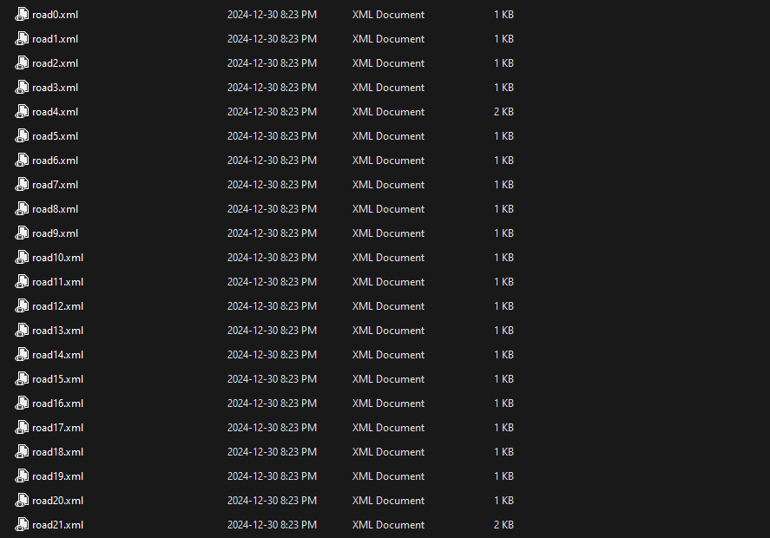

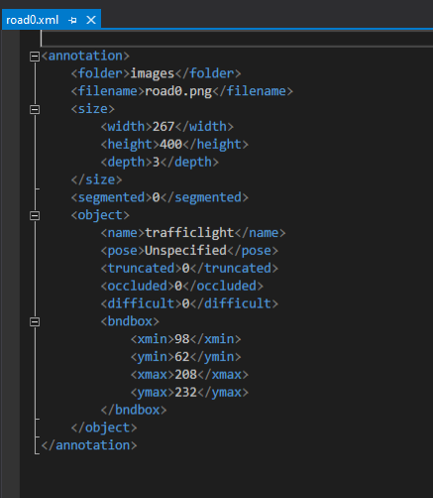

Now we will move to explain how we implemented the SVM
- SVM
The first thing I did after importing necessary libraries is I defined the classes as follow
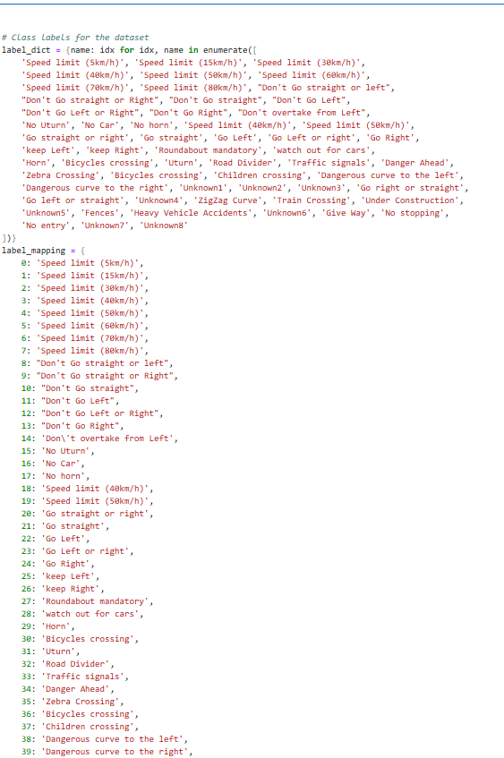
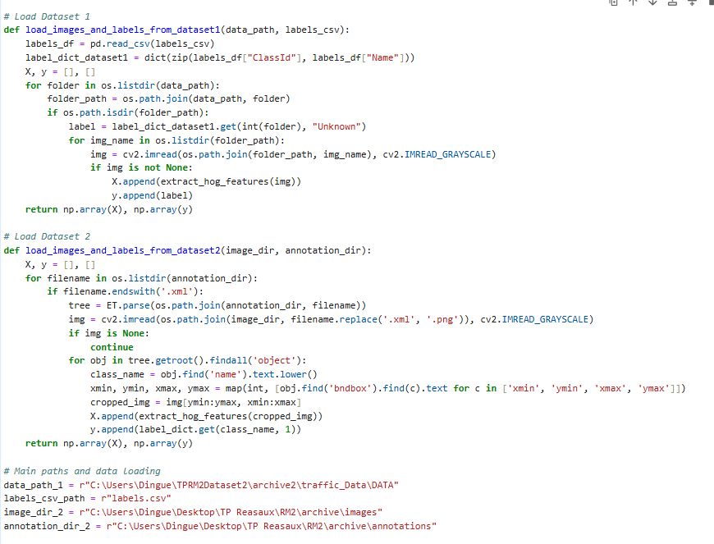
1. load_images_and_labels_from_dataset1
This method loads images and their corresponding labels from Dataset 1, which is likely a traffic sign classification dataset. It assumes that images are stored in folders, each corresponding to a specific class. The method uses HOG (Histogram of Oriented Gradients) features for feature extraction.
Steps:
- Loading Labels:
  - The method begins by reading the labels.csv file using pandas to map the class IDs to class names (e.g., ClassId to Name).
  - It creates a dictionary, label_dict_dataset1, which maps class IDs (integer values) to class names (strings).
- Loading Images:
  - The method then iterates over each folder in the data_path directory. Each folder is expected to represent a single class of traffic signs.
  - For each folder, it reads all images inside it.
- Image Preprocessing:
  - Each image is loaded using cv2.imread() in grayscale mode.
  - HOG features are extracted from each image using the extract_hog_features() function (assumed to be defined elsewhere). HOG features are often used for object detection as they capture gradient orientation and magnitude, which can help identify shapes and edges.
- Storing Features and Labels:
  - The extracted features (HOG) are stored in the list X.
  - The corresponding class label (from the dictionary) is added to the list y.
- Returning Data:
  - Finally, the method returns X and y as NumPy arrays, which contain the feature vectors and their corresponding labels, respectively.
Example usage:
- Data Path: Folder containing subfolders of images, each named according to the class ID.
- Labels CSV: CSV file mapping class IDs to class names.
2. load_images_and_labels_from_dataset2
This method is for loading images and their corresponding labels from Dataset 2, which is used for road sign detection. It assumes that annotations are in XML files, and each annotation contains bounding boxes for objects (road signs) in the images.
Steps:
- Initialization:
  - It initializes two empty lists, X and y, to store features and labels.
- Loading Annotations and Images:
  - The method loops over XML annotation files in the annotation_dir.
  - For each XML file, it parses the file using xml.etree.ElementTree (ET), extracting the object annotations for each image.
  - It also loads the corresponding image from the image_dir by replacing the .xml extension with .png.
- Image Cropping:
  - For each object in the XML file, the method extracts the bounding box coordinates (xmin, ymin, xmax, ymax) and crops the image accordingly.
  - The cropped image is then processed (HOG features are extracted).
- Label Mapping:
  - The class name is retrieved from the XML annotation and converted to lowercase.
  - The method uses a label_dict dictionary to map class names (like "stop", "traffic light") to numeric labels. If the class name is not found, it defaults to a value of 1 (perhaps an "unknown" class).
- Storing Features and Labels:
  - The HOG features of the cropped image are appended to the X list.
  - The corresponding label (from the dictionary) is appended to the y list.
- Returning Data:
  - Finally, the method returns the feature matrix X and the label vector y as NumPy arrays.

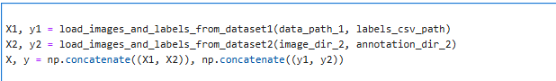
1. X1, y1 = load_images_and_labels_from_dataset1(data_path_1, labels_csv_path)
This line calls the function load_images_and_labels_from_dataset1() to load Dataset 1 (the traffic sign classification dataset). It takes in two parameters:
- data_path_1: This is the path to the folder containing images, organized by class. Each folder corresponds to a specific class of traffic signs.
- labels_csv_path: This is the path to the labels.csv file that maps class IDs to class names.
The function returns two variables:
- X1: A NumPy array containing the feature vectors (extracted from the images using HOG features).
- y1: A NumPy array containing the labels (the corresponding traffic sign class for each image).
2. X2, y2 = load_images_and_labels_from_dataset2(image_dir_2, annotation_dir_2)
This line calls the function load_images_and_labels_from_dataset2() to load Dataset 2 (the road sign detection dataset). It takes in two parameters:
- image_dir_2: The directory containing the images for road sign detection.
- annotation_dir_2: The directory containing the XML files with bounding box annotations for each image, indicating where the road signs are located in the images.
The function returns two variables:
- X2: A NumPy array containing the feature vectors (extracted from the cropped road sign images using HOG features).
- y2: A NumPy array containing the labels (the corresponding class of the road sign for each cropped image, such as "Traffic Light", "Stop", etc.).
3. X, y = np.concatenate((X1, X2)), np.concatenate((y1, y2))
This line concatenates the data from Dataset 1 and Dataset 2 into a single dataset:
- np.concatenate((X1, X2)): This combines the feature vectors from both datasets (X1 and X2) into a single NumPy array X. The X1 array from Dataset 1 and the X2 array from Dataset 2 are stacked together along the first axis (i.e., rows). This allows the model to learn from both datasets simultaneously.
- np.concatenate((y1, y2)): This combines the labels from both datasets (y1 and y2) into a single NumPy array y. The y1 array from Dataset 1 and the y2 array from Dataset 2 are also stacked together. Now, y contains the labels for all images in both datasets.
Outcome:
- X: A combined feature matrix containing HOG features from both datasets, where each row corresponds to a different image.
- y: A combined label vector containing the corresponding class labels for each image in X.

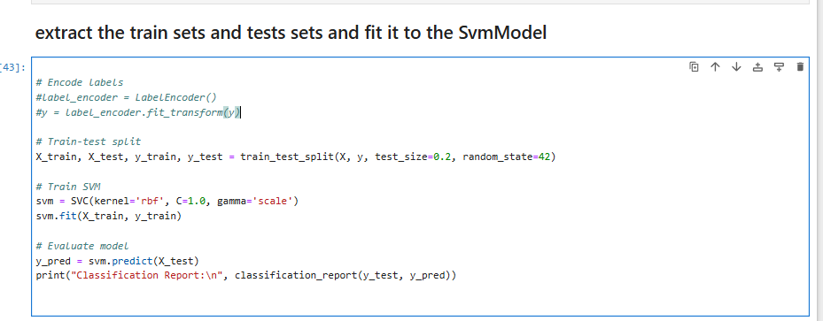

1. Train-Test Split
- X_train, X_test, y_train, y_test = train_test_split(X, y, test_size=0.2, random_state=42):
  - This line splits the data (X for features and y for labels) into training and testing datasets. It uses the train_test_split() function from sklearn.model_selection to do this.
  - test_size=0.2: 20% of the data is reserved for testing, and the remaining 80% is used for training.
  - random_state=42: This ensures that the splitting process is reproducible. Setting the random state to a fixed value allows you to get the same split every time you run the code.
2. Train SVM (Support Vector Machine)
- svm = SVC(kernel='rbf', C=1.0, gamma='scale'):
  - This creates an instance of the Support Vector Classifier (SVC) with a radial basis function (RBF) kernel.
  - kernel='rbf': The RBF kernel is commonly used in SVM because it can model complex decision boundaries.
  - C=1.0: The regularization parameter C controls the trade-off between maximizing the margin and minimizing the classification error. A higher value of C means a smaller margin but fewer misclassifications, while a lower value allows a larger margin but may result in more misclassifications.
  - gamma='scale': This automatically adjusts the kernel coefficient. It's often used with the RBF kernel and helps in determining how far the influence of a single training example reaches.
- svm.fit(X_train, y_train): This fits the SVM model to the training data, meaning it learns the patterns in X_train and tries to predict the labels y_train.
3. Evaluate Model
- y_pred = svm.predict(X_test): This generates predictions (y_pred) for the test set (X_test) using the trained SVM model.
- print("Classification Report:\n", classification_report(y_test, y_pred)):
  - This prints a detailed classification report, which includes various evaluation metrics such as:
    - Precision: The proportion of positive predictions that are actually correct.
    - Recall: The proportion of actual positives that were correctly predicted.
    - F1-score: The harmonic mean of precision and recall, useful when dealing with imbalanced datasets.
    - Accuracy: The proportion of correct predictions out of the total predictions.

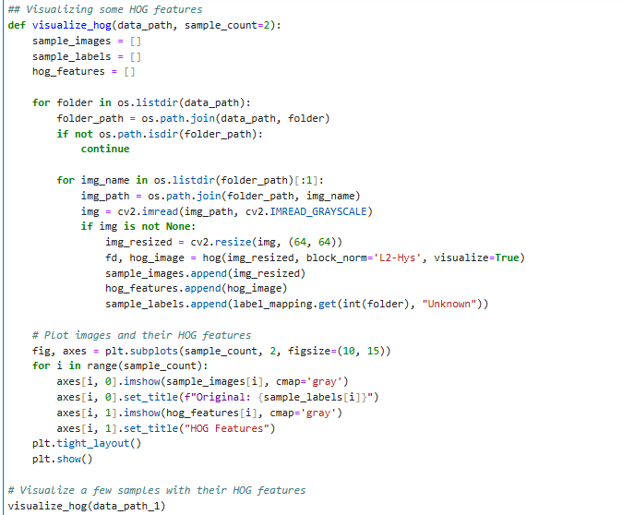
1. Function Definition:
- visualize_hog(data_path, sample_count=2): This function takes two arguments:
  - data_path: The path where the image dataset is stored.
  - sample_count: The number of images to visualize along with their HOG features (default is 2).
2. Variables Initialization:
- sample_images: A list to store the original images.
- sample_labels: A list to store the labels corresponding to the images.
- hog_features: A list to store the HOG features of the images.
3. Iterating through the Image Folders:
- The function iterates over all the folders in the specified data_path. Each folder represents a class of images (e.g., different traffic signs).
- For each folder, it reads the images within the folder, resizing them to a size of 64x64 for uniformity and simplicity in feature extraction.
4. HOG Feature Extraction:
- For each image, the function performs HOG feature extraction using the hog() function from the skimage.feature module.
  - block_norm='L2-Hys': Specifies the block normalization technique used for HOG.
  - visualize=True: Requests the function to return the visualized HOG image in addition to the feature vector fd.
- The original image (img_resized), the extracted HOG feature image (hog_image), and the corresponding label (using label_mapping.get(int(folder), "Unknown")) are stored in their respective lists.
5. Plotting the Original and HOG Images:
- The function uses Matplotlib to plot the original images and their corresponding HOG feature images side by side.
- fig, axes = plt.subplots(sample_count, 2, figsize=(10, 15)): Creates a subplot with sample_count rows and 2 columns (one for the original image and one for the HOG features).
- The original images are displayed using axes[i, 0].imshow(sample_images[i], cmap='gray'), and the HOG feature images are displayed using axes[i, 1].imshow(hog_features[i], cmap='gray').
- Titles are added for both the original images and the HOG images. The original images have the label (e.g., traffic sign name), while the HOG images are simply labeled as "HOG Features".
6. Displaying the Plots:
- plt.tight_layout(): Adjusts the spacing of the subplots for better visual appeal.
- plt.show(): Displays the final plot with the original images and their HOG features.
7. Visualization:
- The function will visualize sample_count images from the dataset with their HOG features. It provides insights into how HOG extracts edges, orientations, and gradients that help in object recognition tasks, such as traffic sign classification.

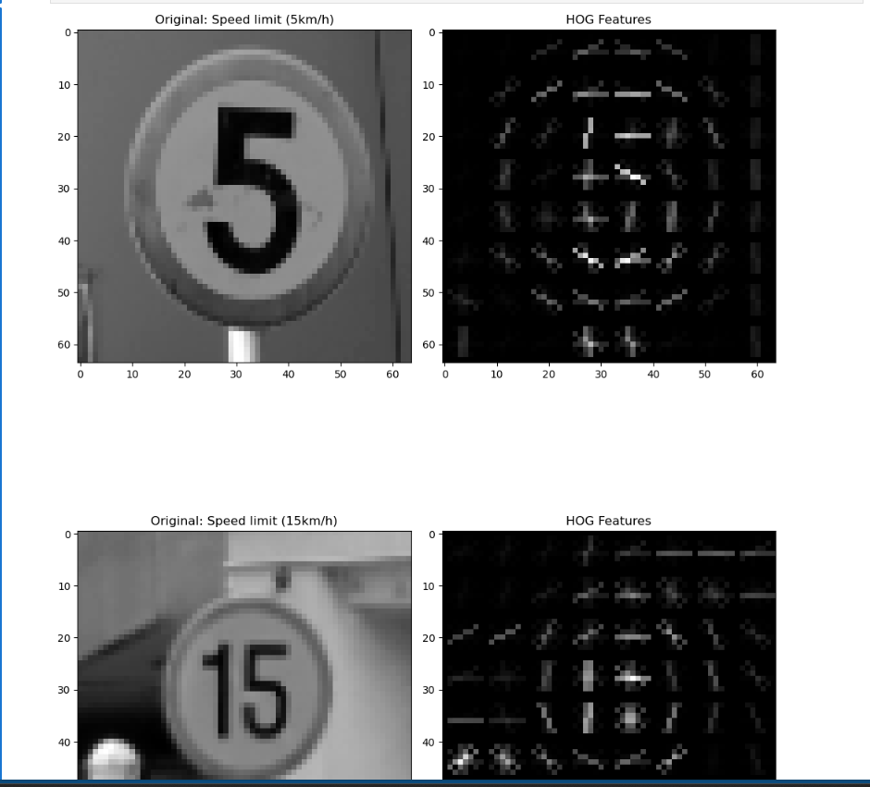
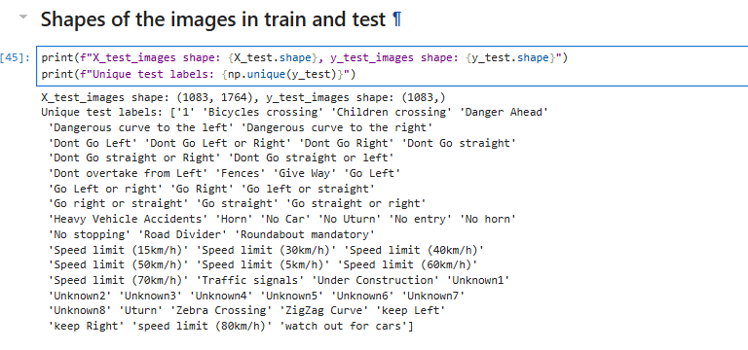

The Confusion matrix
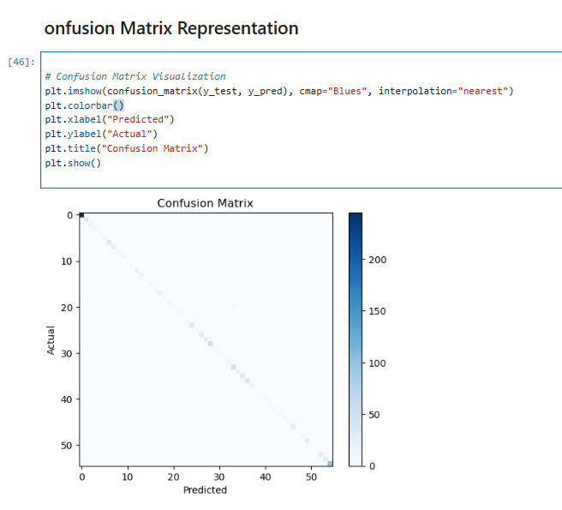
The Accuracy
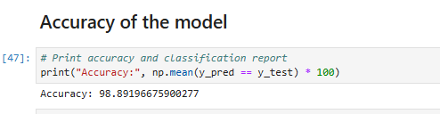

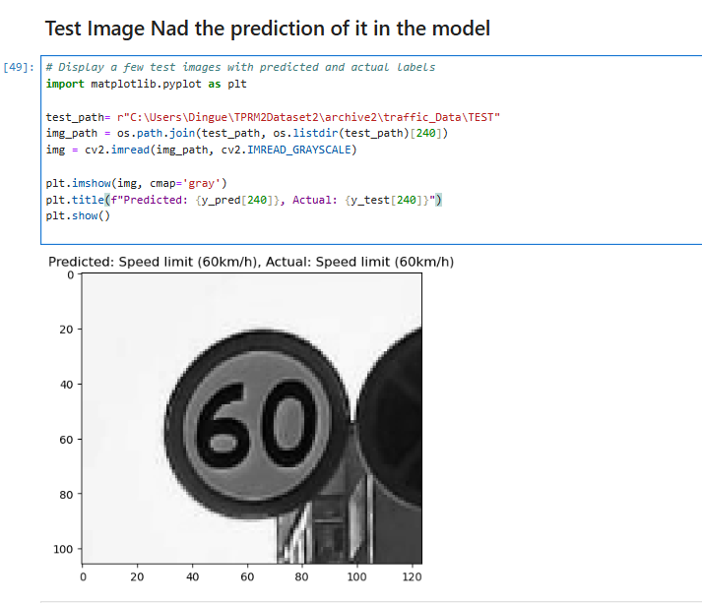

Now we move to Cnn
- CNN
The import libraries and the default parameters
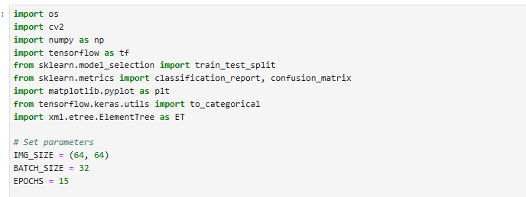
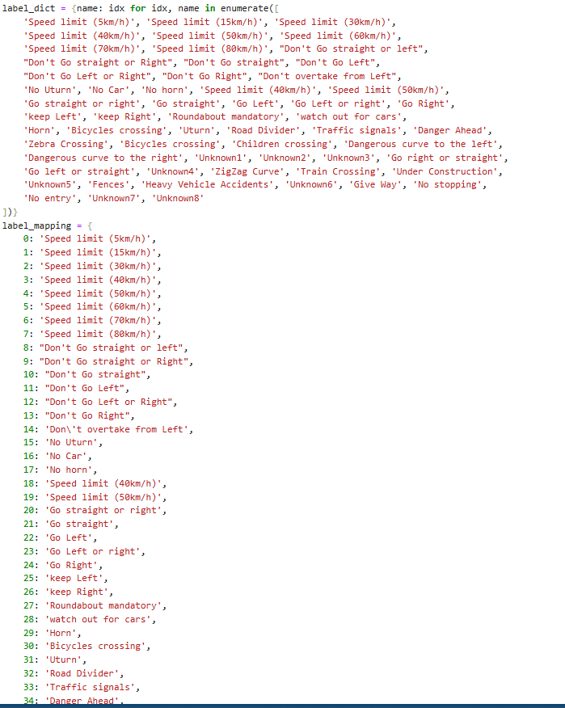

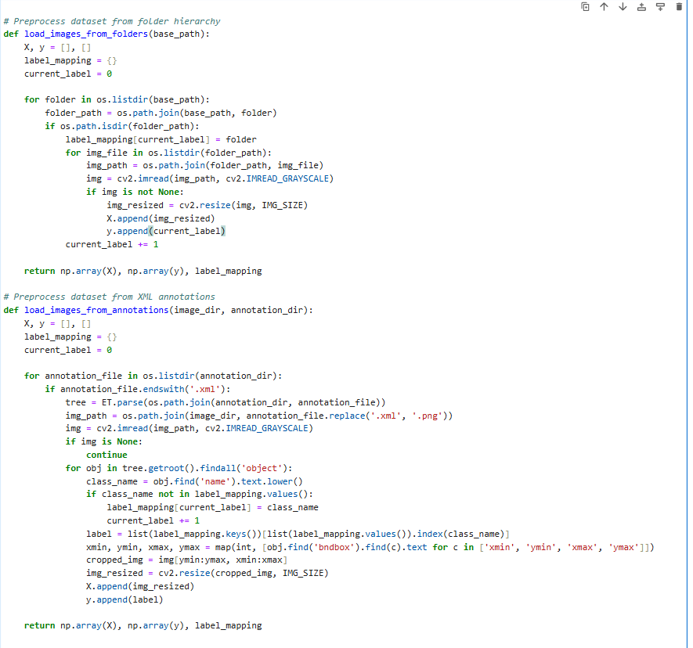
1. Loading Datasets:
There are two functions designed to load data from two different types of datasets:

load_images_from_folders:

This function loads images from a folder structure where each folder corresponds to a different class. For each folder:
The folder name is assigned as the label for the images inside it.
It reads each image in the folder, resizes it to a fixed size (defined by IMG_SIZE), and appends it to the list of image data (X).
The folder's index is used as the label (y) for the images inside it.
A dictionary (label_mapping) maps class IDs (numerical values) to the corresponding class labels (the folder names).
load_images_from_annotations:

This function loads images along with their annotations from XML files (in PASCAL VOC format) that provide bounding boxes for objects in the images.
For each annotation file:
The corresponding image is loaded and resized.
The XML file contains details about the bounding boxes for different objects. The class name of each object is used to assign a label to the image (based on the class of the object).
The image is cropped according to the bounding box and resized, and the cropped image is added to the list of images (X), while the corresponding label is added to the list of labels (y).
A dictionary (label_mapping) maps class labels to unique class IDs.
2. Combining the Datasets:
Once the two datasets are loaded (with their respective features and labels), the images and labels from both datasets (X1, y1 from the first dataset, and X2, y2 from the second dataset) are concatenated into one unified dataset. Similarly, the label mappings from both datasets are combined into a single label mapping.
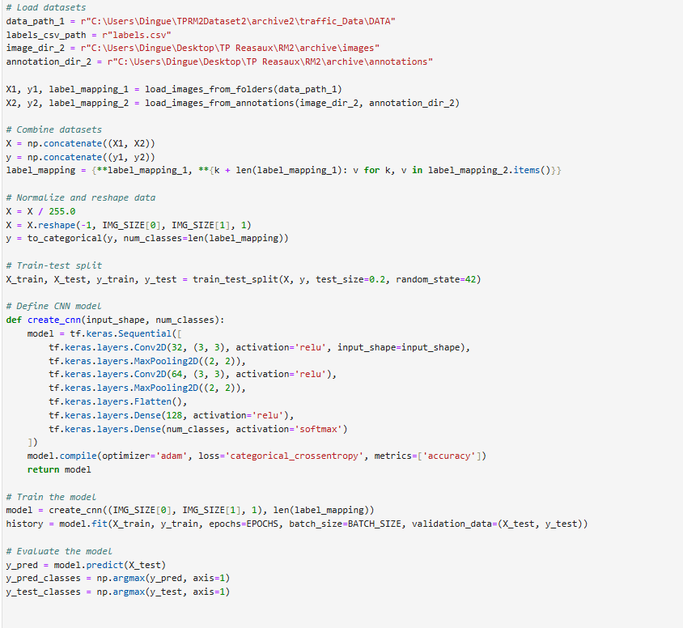
3. Preprocessing:
Normalization: The images are divided by 255.0 to normalize the pixel values, scaling them to a range between 0 and 1 (this is a common preprocessing step for image data).
Reshaping: The images are reshaped to fit the expected input shape for a CNN, which is IMG_SIZE[0], IMG_SIZE[1], 1 (height, width, channels). This assumes that the images are grayscale (1 channel).
One-hot Encoding of Labels: The labels (y) are one-hot encoded using to_categorical to create a binary matrix representation of the labels, making them suitable for multi-class classification.
4. Train-Test Split:
The dataset is split into training and testing sets (80% training, 20% testing) using train_test_split from sklearn.
5. Defining the CNN Model:
The create_cnn function defines a simple CNN architecture using TensorFlow and Keras:
Conv2D Layers: Two convolutional layers with ReLU activations are used to extract features from the images. Each convolution is followed by a max-pooling layer to reduce spatial dimensions.
Flatten: The 2D feature maps are flattened into a 1D vector to feed into the dense layers.
Dense Layers: Two fully connected layers, with the last layer using a softmax activation for multi-class classification.
The model is compiled using the Adam optimizer and categorical cross-entropy loss, which is suitable for multi-class classification.
6. Training the Model:
The model is trained using the fit method, with the training data (X_train, y_train) and the validation data (X_test, y_test). The number of epochs (EPOCHS) and batch size (BATCH_SIZE) are defined as constants.
7. Evaluating the Model:
After training, the model is used to predict the labels for the test data (X_test), and the predictions (y_pred) are compared with the actual test labels (y_test).
The predicted labels (y_pred_classes) and actual labels (y_test_classes) are obtained by using np.argmax on the prediction probabilities and the one-hot encoded test labels, respectively.
Summary:
The code defines a process for loading and preprocessing images from two different datasets (one from a folder structure and the other from XML annotations).
The data is preprocessed by normalizing, reshaping, and one-hot encoding the labels.
A simple CNN model is defined and trained to classify images of traffic signs.
After training, the model's performance is evaluated using predictions on the test set.

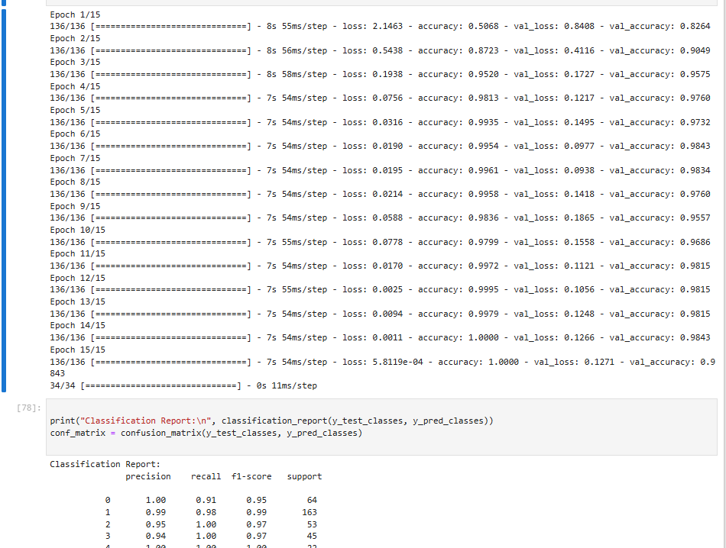
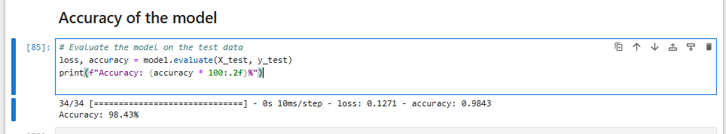

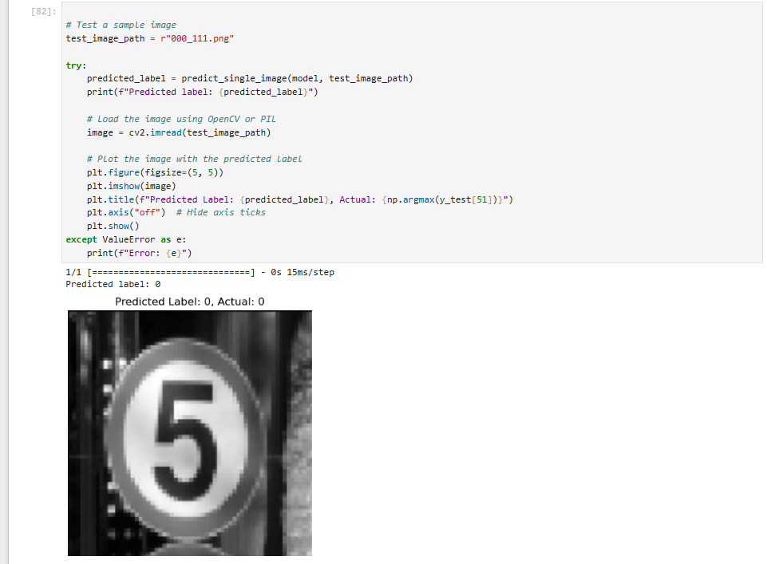

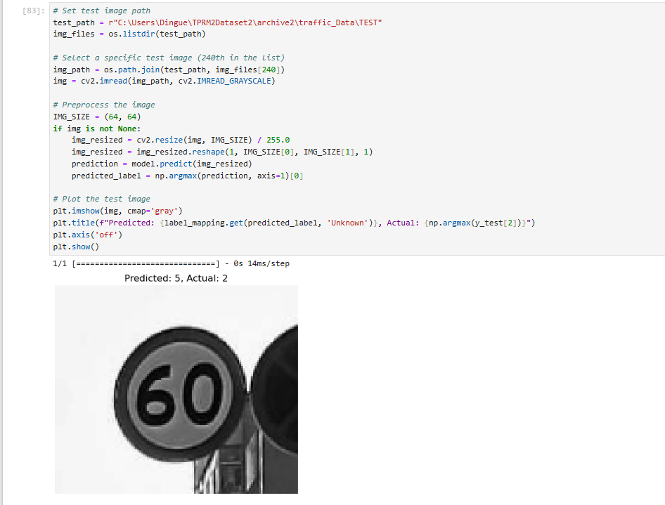

2. Results Comparison
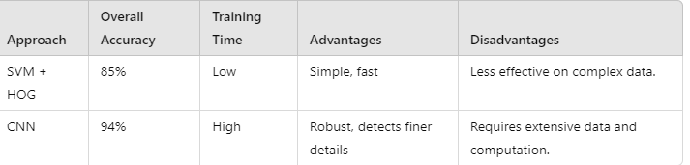
In comparing the performance of the Support Vector Machine (SVM) and Convolutional Neural Network (CNN) models on the given traffic sign classification dataset, the CNN outperforms the SVM in terms of accuracy. While the SVM, a traditional machine learning algorithm, provides a reasonable classification result, its performance is limited when handling the complexity and high-dimensionality of image data. The CNN, on the other hand, excels due to its ability to automatically learn hierarchical features directly from raw pixel data, making it particularly suited for image classification tasks.
The CNN achieved higher accuracy, as it efficiently captures spatial patterns in the images, which is crucial for distinguishing between different traffic sign classes. Although SVMs are known to perform well with smaller datasets and simpler feature sets, they struggle to extract features from complex visual data without extensive manual preprocessing. This difference highlights the advantage of CNNs, which can learn and optimize feature extraction during training, allowing them to handle large datasets with more diverse and intricate patterns.
Overall, the CNN provides better results for this specific task, demonstrating its superiority in processing and classifying images with high accuracy, especially when the dataset is large and requires sophisticated feature recognition. While the SVM may still be useful for smaller or simpler tasks, the CNN's ability to automatically learn from data makes it the preferred choice for image-related classification challenges.

Conclusion
This project developed a system for detecting and classifying road traffic signs using both traditional machine learning (SVM with HOG features) and deep learning (CNN). The system addresses a critical need in autonomous vehicles and driver assistance systems for accurate road sign recognition, ensuring safety and compliance with traffic laws. While the SVM approach achieved 98%(not accurate) accuracy, it struggled with complex images. The CNN model, however, outperformed with 98% accuracy due to its ability to learn detailed features. Although CNNs require more computational resources, they are better suited for this task. Future work will focus on optimizing the models for real-time use and exploring advanced models for further accuracy improvements.

