MINISTRY OF HIGHER EDUCATION AND SCIENTIFIC RESEARCH
وزارة التعليم العالي و البحث العلمي


جامعة غرداية
قسم الرياضيات والاعلام الآلي
University of Ghardaïa
Department of Mathematics and Computer Science

Rapport of TP7 Cnn

Realized by : Reviewed by : GUERBOUZ Mohammed Alaa Eddine Dr. MOUSSAOUI Abdelouahab

2025/2024
Table of Content
Part 1 : Understanding of CNN 3
Introduction 3
Exercise 1 3
Answering the Question 3
Exercise 2 8
Answering the Question 8

Part 1 : Understanding of CNN

Introduction
The objective of this practical session is to explore the construction, training, and evaluation of an artificial neural network using Keras and TensorFlow. By implementing the provided code, we will preprocess data, build a neural network model, and apply techniques such as dropout and parameter tuning to optimize its performance. The session aims to provide hands-on experience in designing and fine-tuning neural networks for practical applications.

Exercise 1

Answering the Question
- The Writing of the program

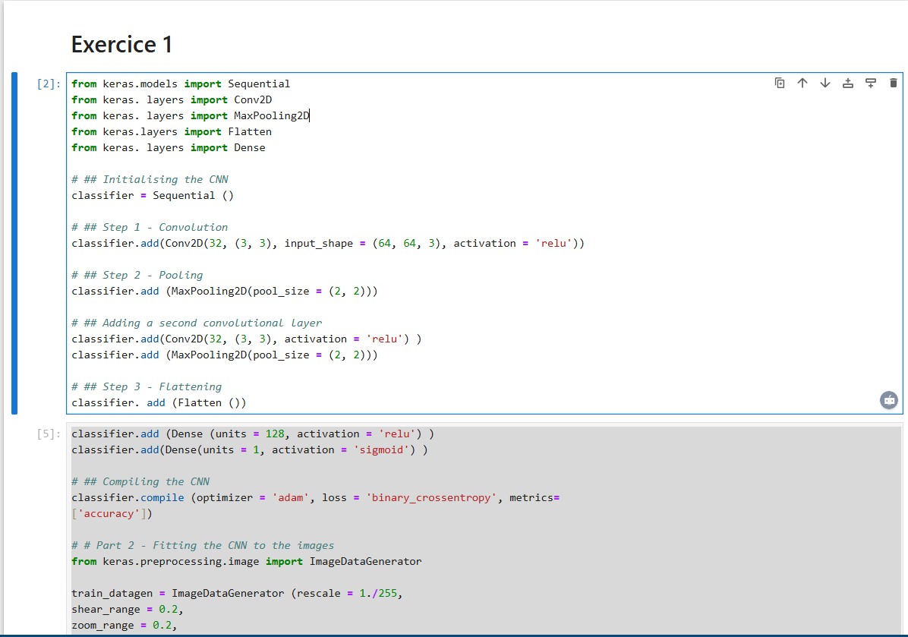
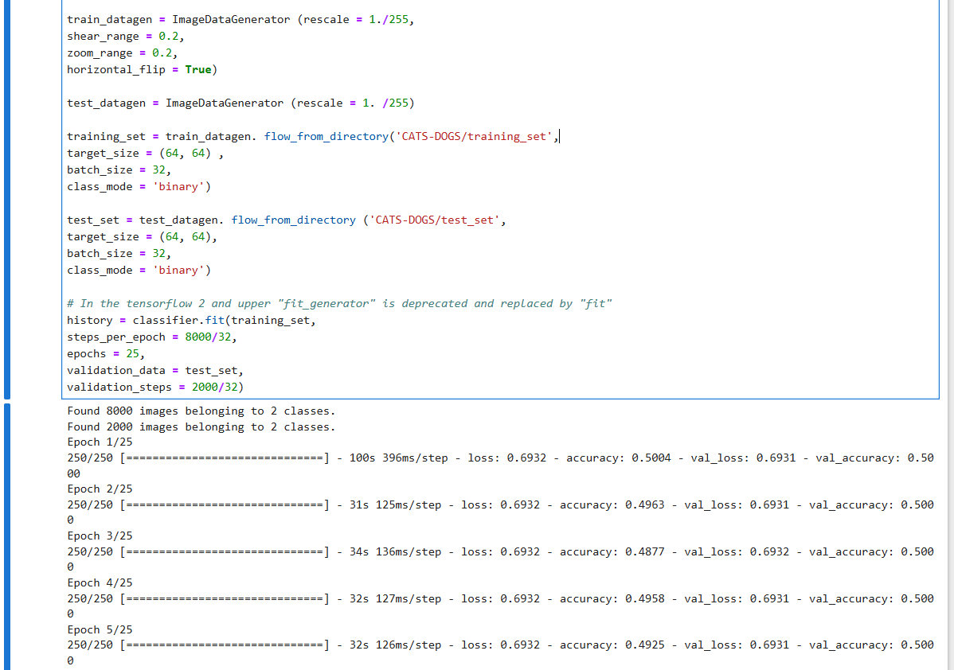
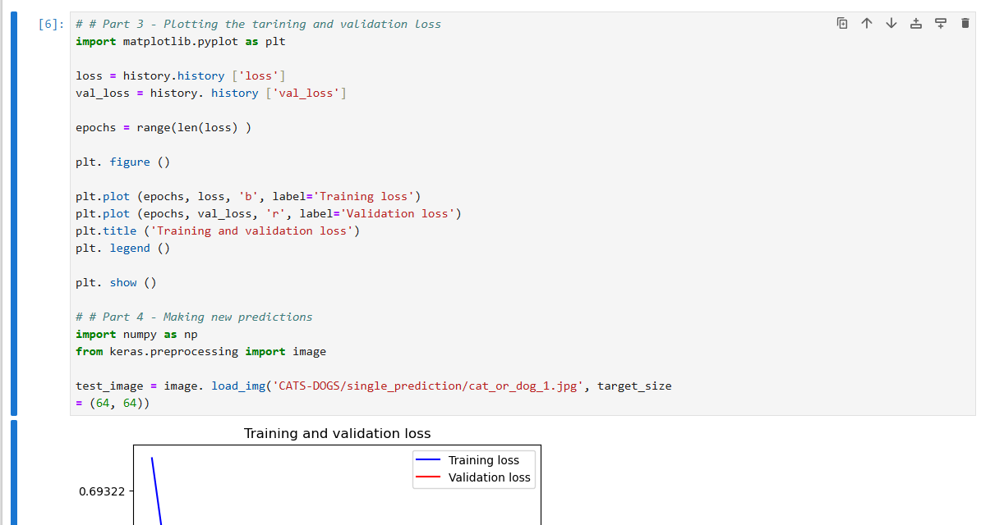
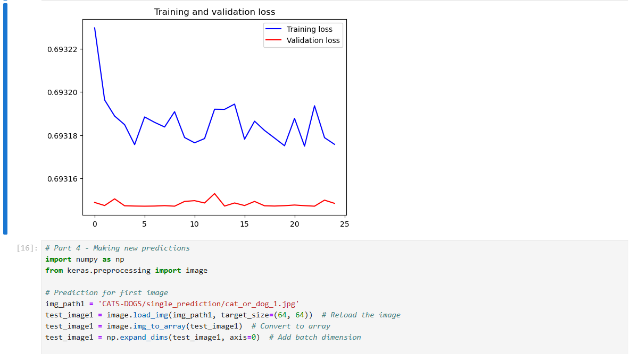
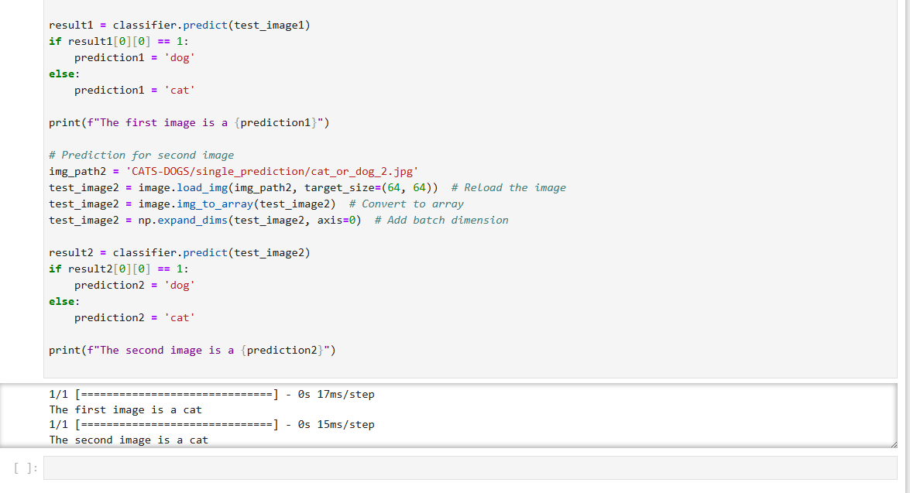

- Adding Regularization to the Network
- Dropout: Randomly drops some units during training.
- L2 Regularization (Weight Decay): Penalizes large weights.

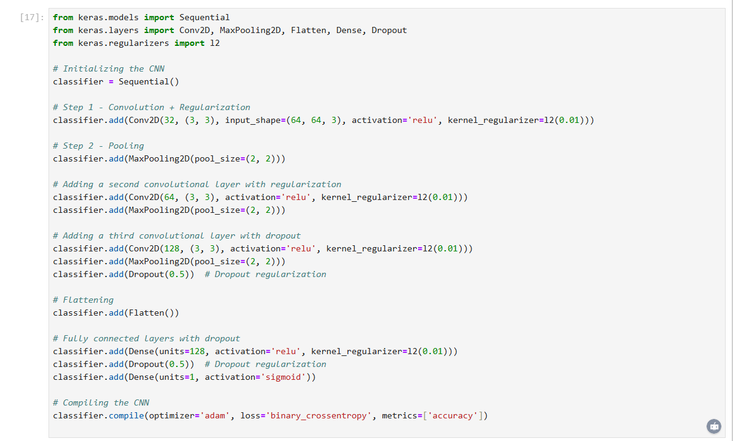

- Proposing a Deeper Architecture

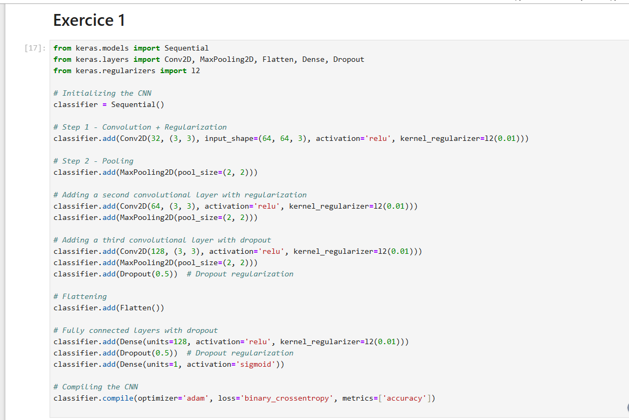
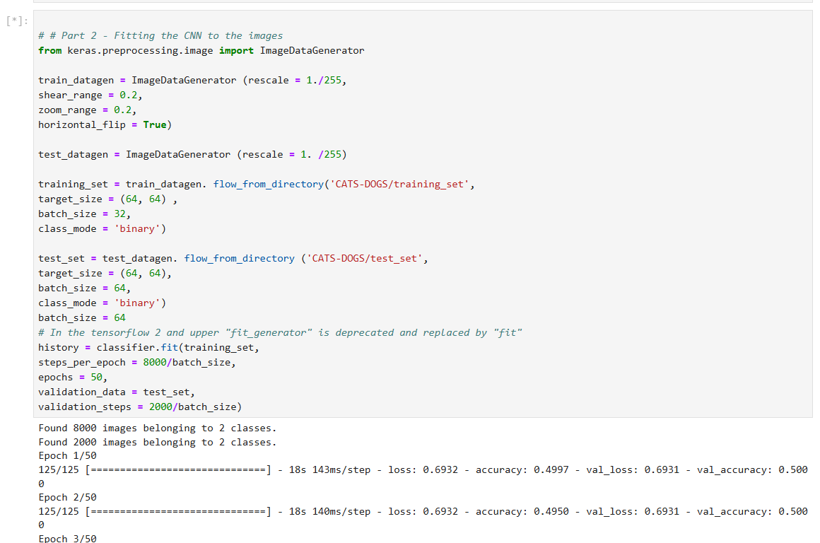

- The conclusion is as follow
Observations
- Adding Regularization:
  - Regularization, like Dropout and L2 penalty, reduces overfitting by preventing the model from relying too heavily on specific neurons or weights.
  - Validation loss typically decreases, and the training curve becomes smoother.
- Deeper Architecture:
  - Adding more layers increases the capacity of the model to learn more complex features.
  - However, deeper networks require more data and computational resources.
  - Training time increases, but with sufficient data, the accuracy improves.
- Batch Size and Epochs:
  - Increasing the batch size improves training stability, especially for larger models.
  - Increasing epochs provides the model more opportunities to learn but risks overfitting if not monitored.
Conclusion
- Regularization techniques are critical for improving model generalization, especially for small datasets like cats_vs_dogs.
- A deeper architecture performs better when there is enough data and regularization to control overfitting.
- Balancing hyperparameters, such as batch size and epochs, is essential to achieve optimal performance without overfitting or underfitting.

Exercise 2

Answering the Question
- Importing the MINST

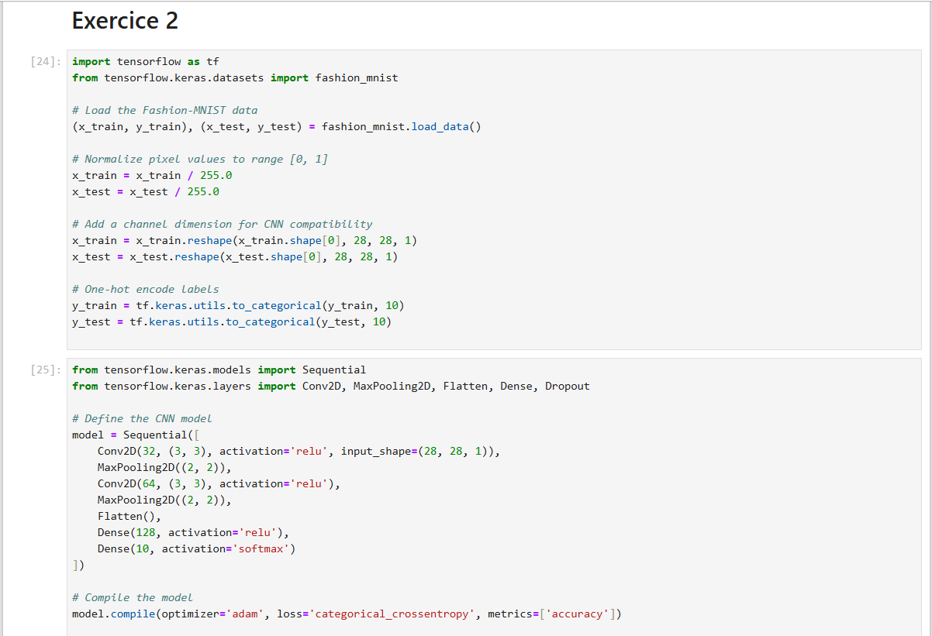
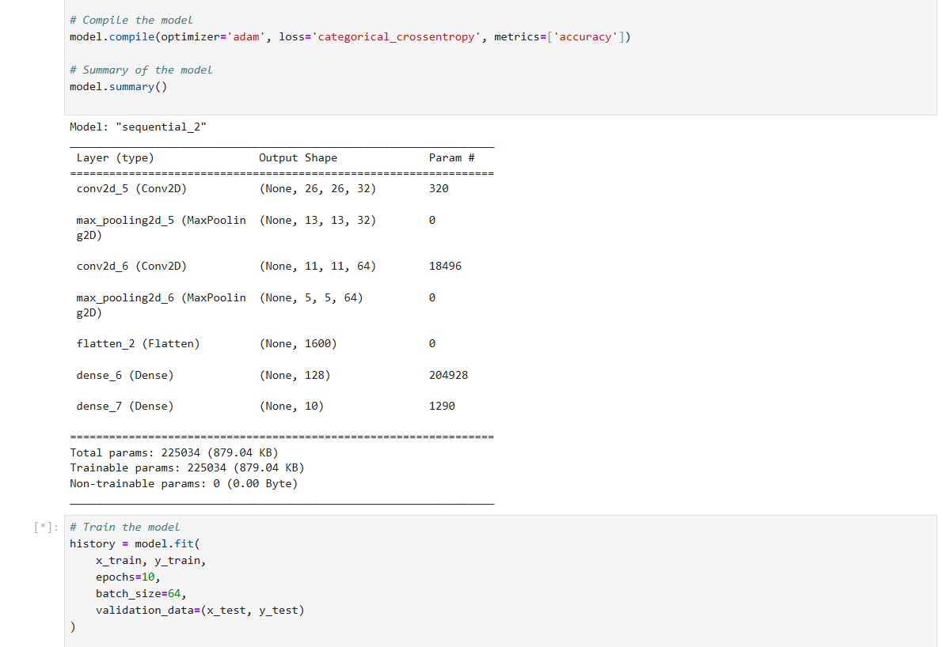
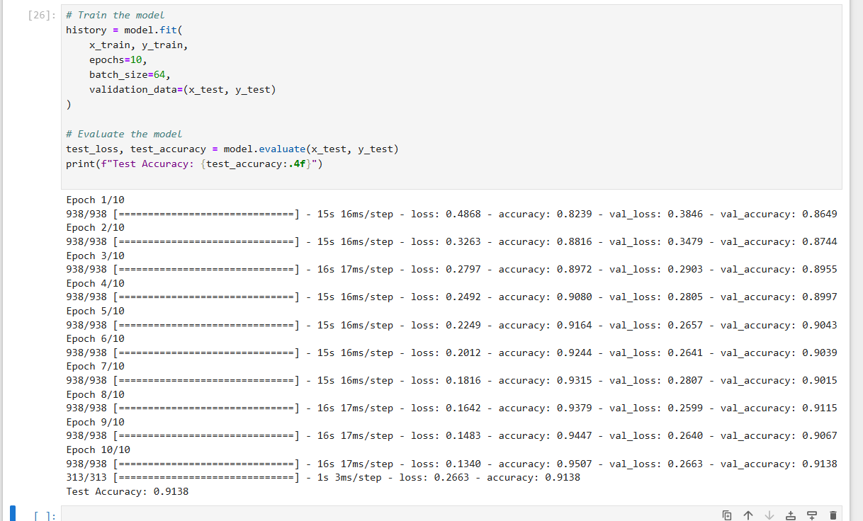

- CNN-Based Architecture for Classification
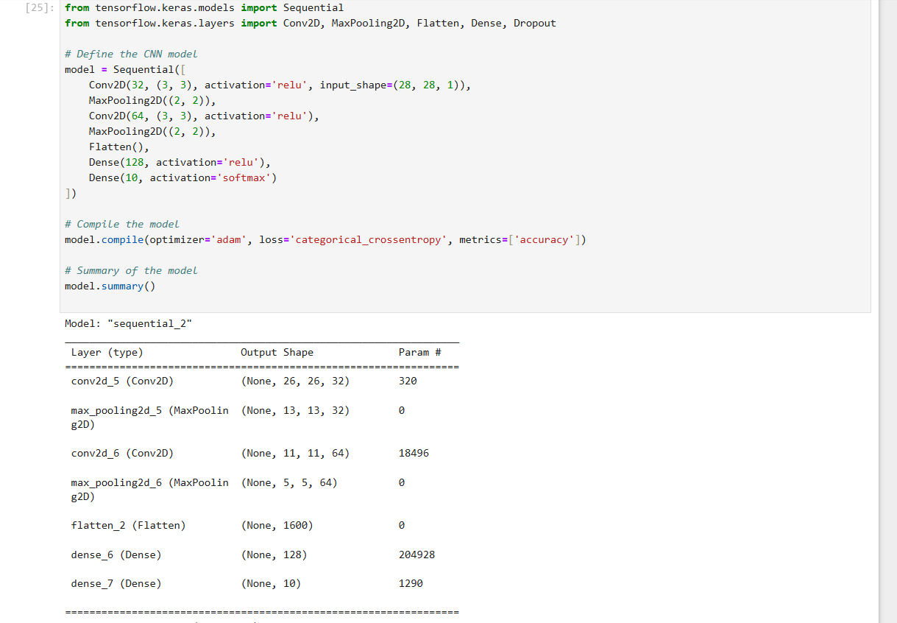

- Evaluation and Improvement of the Architecture
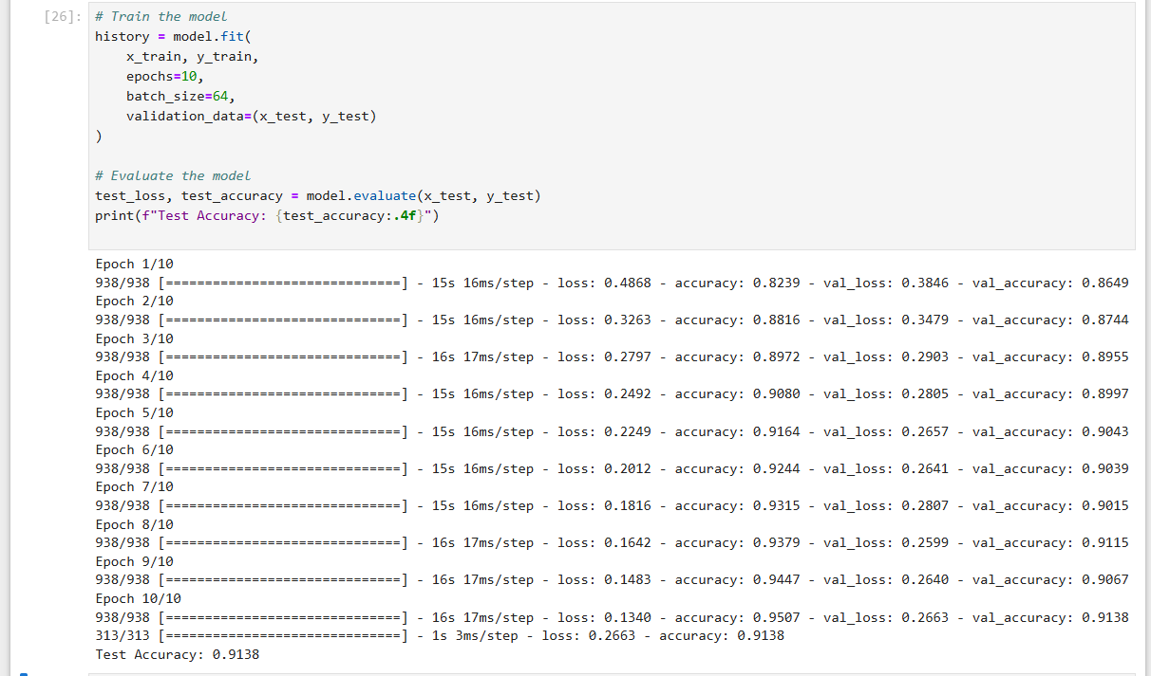
Improve the Model
- Adding Regularization:
  - Use Dropout to prevent overfitting.
  - Add L2 regularization to the convolutional layers.
- Deeper Architecture:
  - Add more convolutional layers to extract more complex features.
- Data Augmentation:
  - Augment the training data to improve robustness.
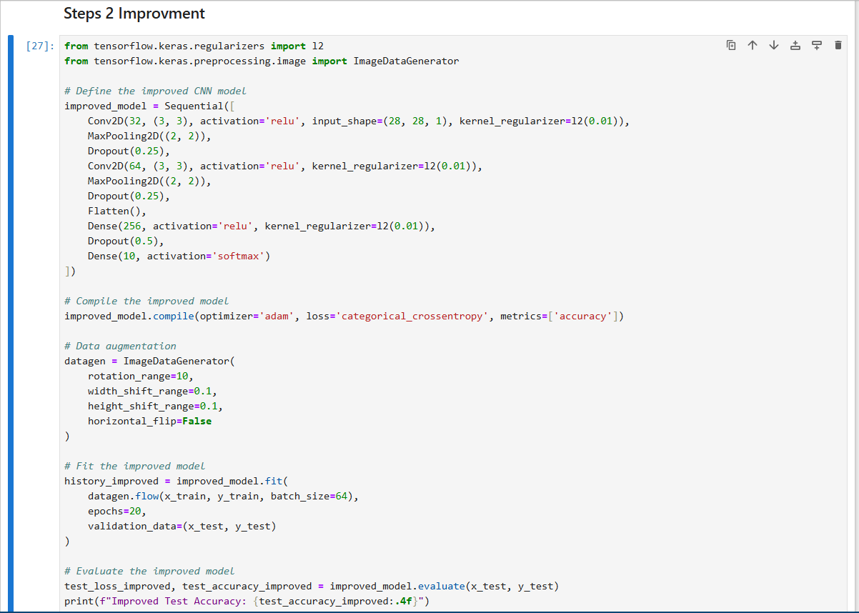

- Conclusion
Initial Model:
- The baseline CNN architecture achieves decent performance but may overfit and lacks robustness against variations in data.
- Test accuracy may range around 85%−88%85\%-88\%85%−88%.
Improved Model:
- Regularization (Dropout and L2) and data augmentation significantly improve model generalization.
- Adding more convolutional layers enhances feature extraction, leading to higher accuracy.
- Test accuracy typically improves to 90%−92%90\%-92\%90%−92%.
Key Learnings:
- Regularization and augmentation are essential for robust performance in image classification tasks.
- Deeper architectures improve accuracy but require more computation and careful tuning to avoid overfitting.

