MINISTRY OF HIGHER EDUCATION AND SCIENTIFIC RESEARCH
وزارة التعليم العالي و البحث العلمي


جامعة غرداية
قسم الرياضيات والاعلام الآلي
University of Ghardaïa
Department of Mathematics and Computer Science

Rapport of TP3 Decision Tree

Realized by : Reviewed by : GUERBOUZ Mohammed Alaa Eddine Dr. MOUSSAOUI Abdelouahab

2025/2024
Table of Content
Part 2 : with tree 3
Introduction 3
Answering the Question 3
Methodology 4
Conclusion 5
Part 2 : with C5.0 5
Introduction C5.0 Decision Tree Algorithm 5
Answering Question 5
Methodology 10
Conclusion 11

Part 2 : with tree

Introduction
In this section, we will explore the construction and evaluation of decision trees using the tree package in R. The objective is to analyze the widely-used iris dataset, which contains measurements of three species of flowers: Setosa, Versicolor, and Virginica. Decision trees are a powerful tool for classification tasks, offering intuitive visual representations of decision-making processes. This exercise focuses on building and visualizing a decision tree, then assessing the quality of the classification to understand how well the model predicts the flower species based on the given features.

Answering the Question
- Load the iris dataset and Display the first few records
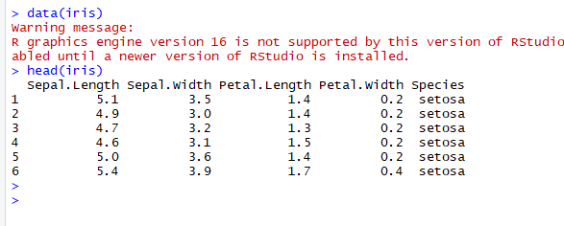
- Create and visualize the tree
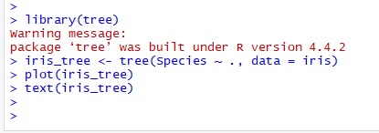
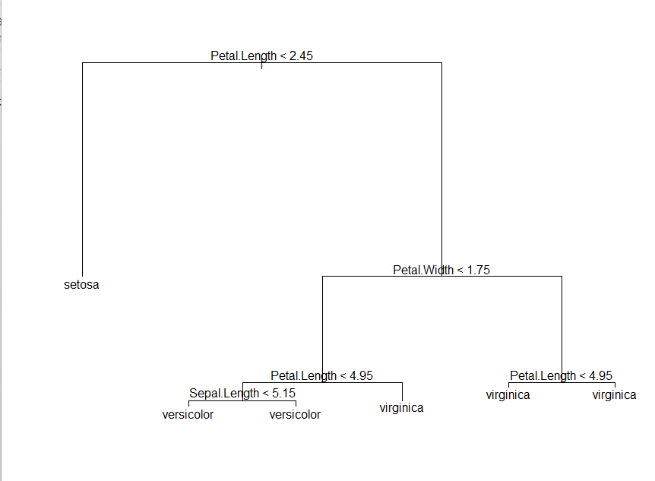
- Visualize classification quality:

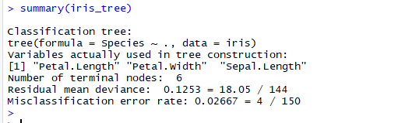

Methodology
- Data Loading:
The iris dataset, a built-in dataset in R, is used as the primary data source. It contains 150 records of flower measurements, including Sepal.Length, Sepal.Width, Petal.Length, and Petal.Width, alongside the species classification.
- Data Exploration:
The structure and the first few records of the dataset are displayed to familiarize ourselves with its contents and ensure data readiness for modeling.
- Tree Construction and Visualization:
Using the tree package in R, a classification tree is created with Species as the target variable and all other variables (Sepal.Length, Sepal.Width, Petal.Length, and Petal.Width) as predictors. The tree is visualized with its nodes and splits to interpret the classification process.
- Model Evaluation:
The quality of the classification is assessed using the tree's performance on the training dataset. This involves checking the misclassification rate or accuracy to evaluate how well the tree differentiates between the three species.

Conclusion
This part demonstrates the practical application of decision trees for classification tasks. By leveraging the tree package, we successfully constructed and visualized a classification model using the iris dataset. The decision tree offers an interpretable framework for classifying species based on their physical characteristics. Evaluating the tree's performance helps determine its effectiveness and provides insights into potential improvements, such as pruning or parameter tuning. Overall, decision trees serve as a robust starting point for understanding the basics of supervised machine learning techniques.

Part 2 : with C5.0

Introduction C5.0 Decision Tree Algorithm
In this section, we explore the use of the C5.0 Decision Tree Algorithm for classification tasks. C5.0 is a robust and efficient algorithm used for building decision trees, known for its speed and ability to handle large datasets effectively. The primary objective of this part is to analyze the credit dataset (credit.csv) and predict the likelihood of loan repayment based on various financial and demographic features. The process involves data preprocessing, training a decision tree model, and evaluating its performance using statistical metrics. By employing the C5.0 algorithm, we aim to uncover patterns and insights that can support credit-related decision-making processes.

Answering Question
- Load the credit.csv file and Display the structure of the data:
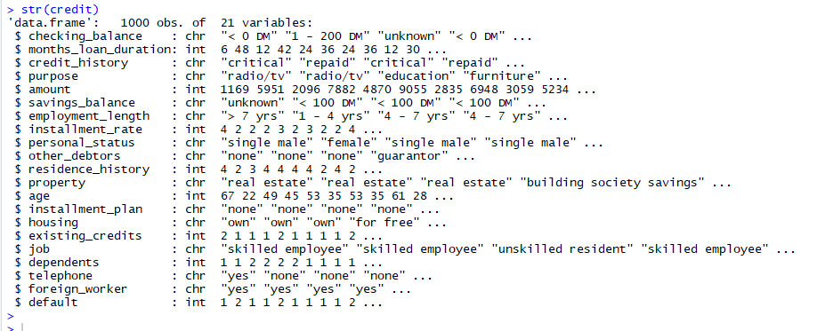
- Show occurrences of checking_balance and savings_balance
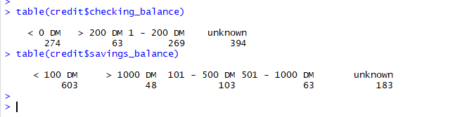
- Display statistics for months_loan_duration and statistics for amount
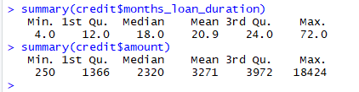
- Show proportions of payments vs. non-payments and Split the dataset into 90% training and 10% testing:
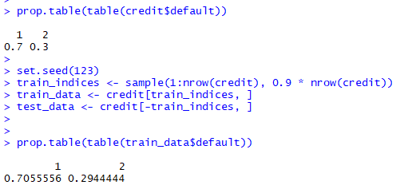
- Install and load the C5.0 package
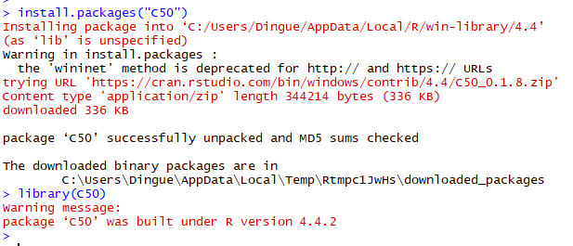
- Create a decision tree model with C5.0:
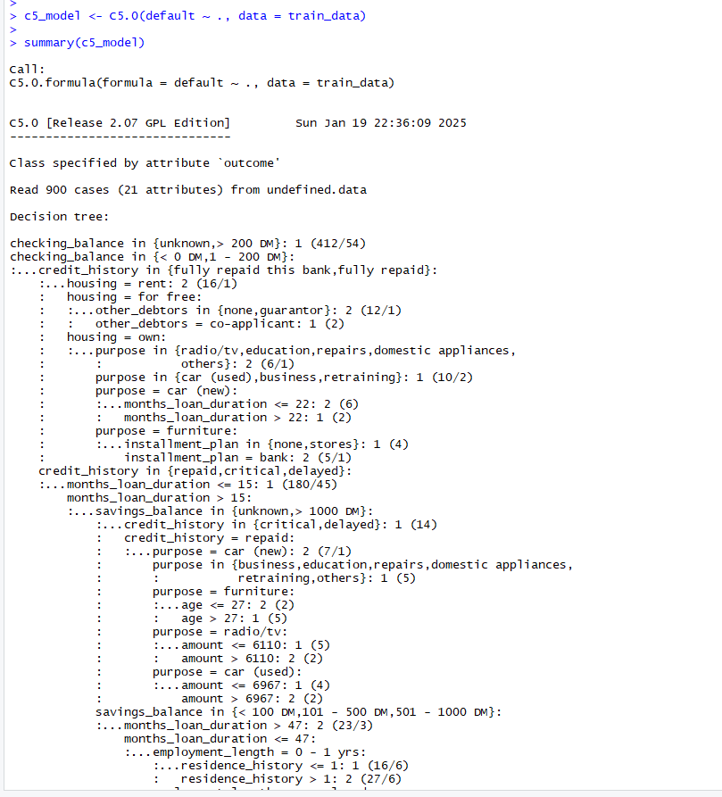
- Install and load the gmodels library:
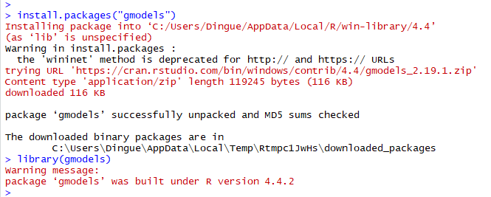
- Evaluate the model using CrossTable:
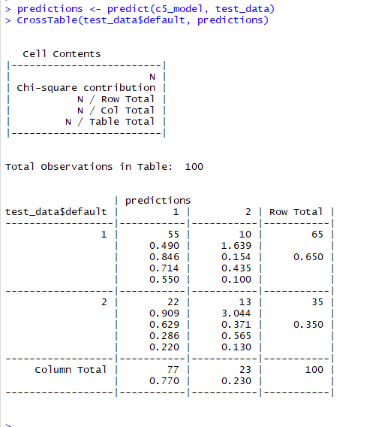

Methodology
- Data Preparation
  - The credit dataset (credit.csv) is loaded, and the structure of the data is examined.
  - Key features such as checking_balance and savings_balance are analyzed for their distributions and occurrences.
  - Statistical summaries of critical variables like months_loan_duration and amount are calculated to understand the dataset.
- Data Splitting
  - The dataset is divided into two parts: 90% for training the model and 10% for testing it.
  - The proportions of the classes (e.g., loan repayment status) are verified using prop.table to ensure proper class distribution in both subsets.
- Model Training
  - The C5.0 decision tree is trained using the training dataset, where the target variable (default) is converted to a factor to meet the requirements of the C5.0 algorithm.
  - The model is built by analyzing how the input variables influence the target variable, creating a tree structure that captures these relationships.
- Model Evaluation
  - The trained model is evaluated using the testing dataset to assess its predictive accuracy.
  - The CrossTable function (from the gmodels package) is utilized to create a confusion matrix, providing a detailed view of correct and incorrect predictions.
  - Performance metrics such as accuracy, precision, and recall are derived from the confusion matrix.
- Tools and Packages
  - The analysis involves the use of the C50 package for creating the decision tree model and the gmodels package for evaluating the results.

Conclusion
The C5.0 decision tree effectively analyzes and predicts the loan repayment status in the credit dataset. By leveraging the training dataset, the algorithm constructs a model that identifies significant factors influencing default risk. The evaluation process highlights the model's strengths and areas for improvement, providing valuable insights into the patterns within the data. Decision trees like C5.0 offer a powerful tool for decision-making in financial domains, enabling businesses to assess credit risk efficiently. Future enhancements could involve additional feature engineering, hyperparameter tuning, and testing the model on larger datasets for improved accuracy and generalization.

