MINISTRY OF HIGHER EDUCATION AND SCIENTIFIC RESEARCH
وزارة التعليم العالي و البحث العلمي


جامعة غرداية
قسم الرياضيات والاعلام الآلي
University of Ghardaïa
Department of Mathematics and Computer Science

Rapport of TP2 Knn

Realized by : Reviewed by : GUERBOUZ Mohammed Alaa Eddine Dr. MOUSSAOUI Abdelouahab

2025/2024
Table of Content
Part 1 : Synthetic Data 1
Introduction 1
Answering the Question 2
Methodological Summary of the Exercise 9
Conclusion 10
Part 2 : Real Data 10
Introduction 10
Answering Question 11
Methodology for K-Nearest Neighbors (KNN) Classification and Evaluation 13
Conclusion 13

Part 1 : Synthetic Data

Introduction
In this exercise, we explore a classification problem using the k-Nearest Neighbors (KNN) algorithm and evaluate its performance through various metrics. The goal is to understand how the model performs on both training and test data, visualize the decision boundaries for different values of 𝑘, and calculate key performance measures such as the True Positive Rate (TPR) and True Negative Rate (TNR).
We will start by loading the training and test datasets, visualizing the data points with respect to their classes, and then applying the KNN algorithm to predict new data points. Next, we assess the model's error rate and examine how different values of k affect the model's performance. We also explore the decision boundaries for both high and low values of k to better understand the model's classification behavior.
Further, we calculate the True Positive Rate and True Negative Rate using the confusion matrix, providing a deeper insight into the model's ability to correctly classify both positive and negative instances. Finally, we extend the analysis by incorporating Bayesian prediction, adjusting for misclassification costs, and evaluating the posterior probabilities.
This exercise not only demonstrates how KNN works in a practical setting but also emphasizes the importance of model evaluation through performance metrics and error analysis.

Answering the Question
- Load the dataset and display
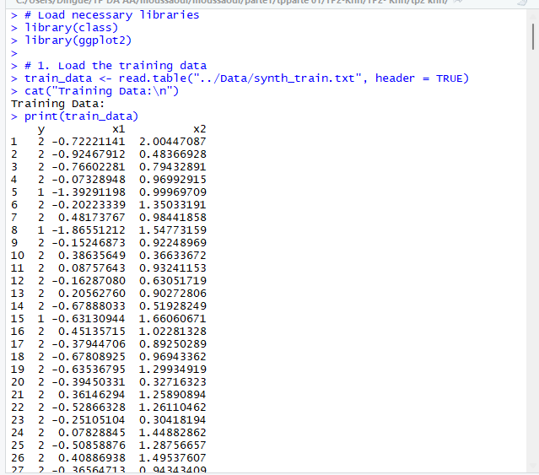
- Dimensions of training data
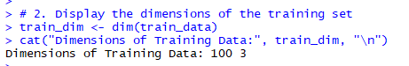
- First 6 records
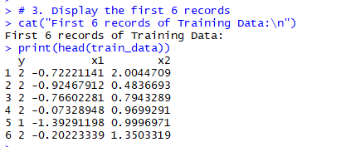
- Graphical representation
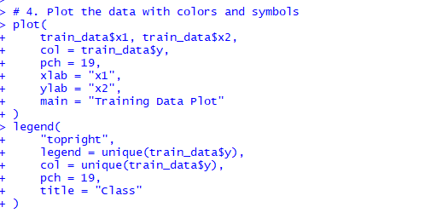

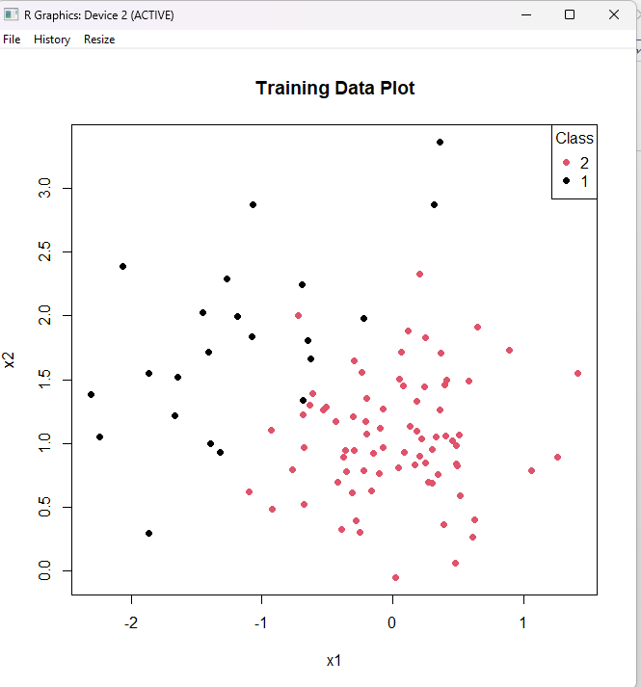
- KNN predictions for points (0,0) and (-2,2)
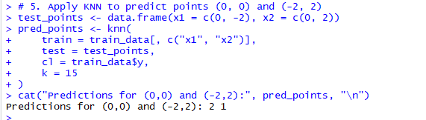
- Empirical error rate
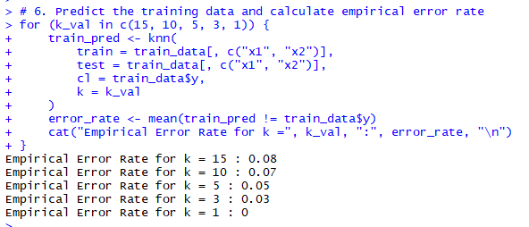
- Decision boundary

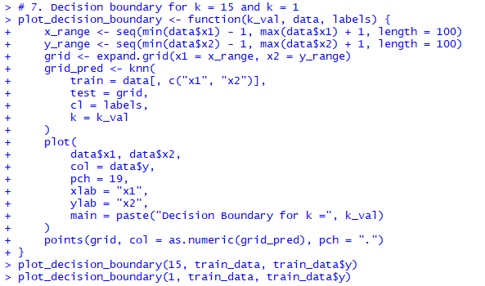
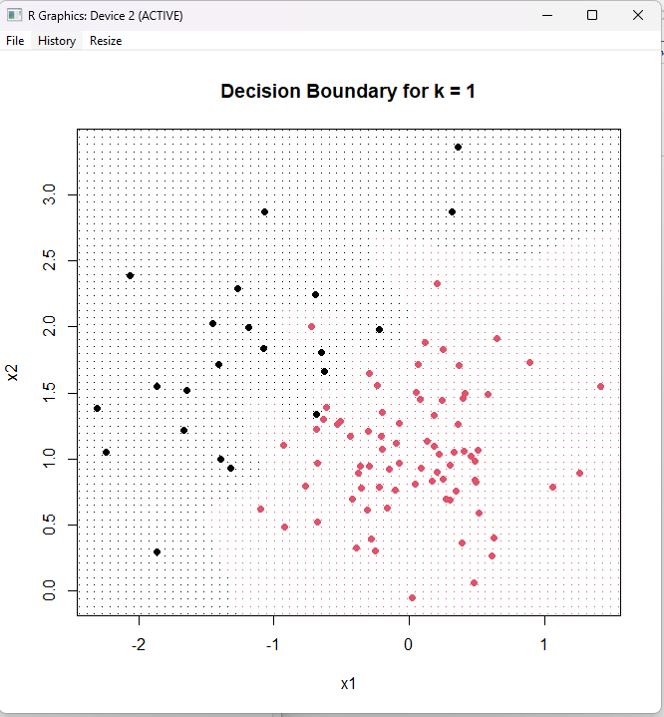

- Test data error rates

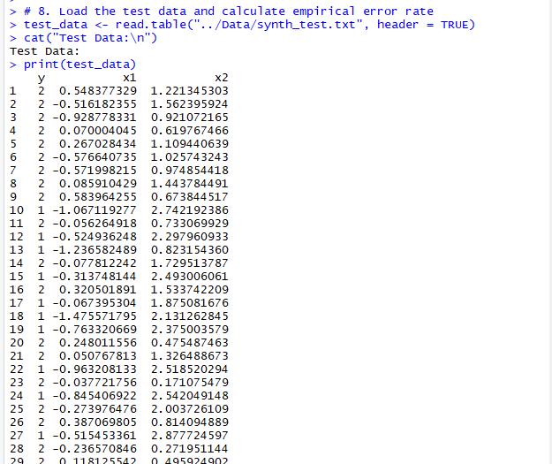
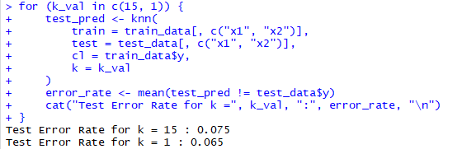
- True Positive and True Negative Rates
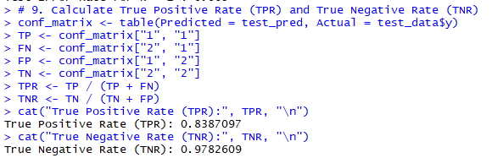
- Posterior probabilities
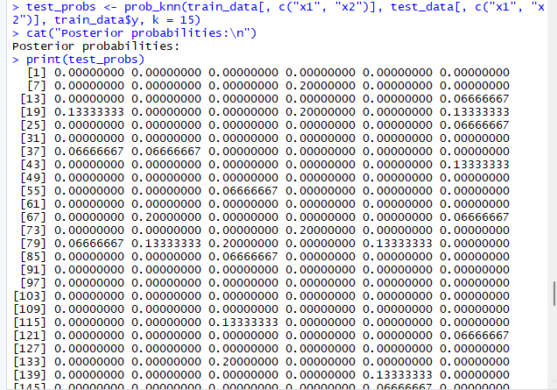
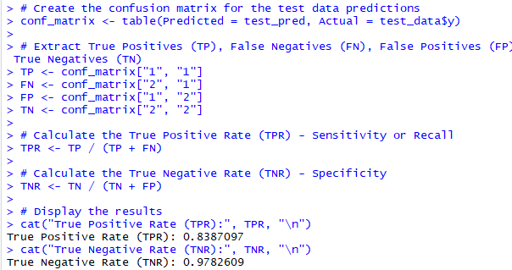

Methodological Summary of the Exercise
Step 1: Loading and Inspecting Data
The training and test data are loaded from text files, and basic information such as dimensions and initial records are displayed to ensure the data is correctly loaded and understood.
Step 2: Visualizing Data
The training data is visualized using a scatter plot with class labels color-coded. This helps in understanding the distribution and separability of classes.
Step 3: KNN Application
KNN is applied to predict the classes of new points. Various values for k are tested, and the empirical error rates are computed. This helps determine the best choice for k.
Step 4: Error Analysis
The model’s performance is analyzed using the empirical error rate, which indicates how well the model fits the training data.
Step 5: Decision Boundaries
Decision boundaries are visualized for different values of k. These boundaries illustrate how the model classifies regions of the feature space.
Step 6: Prediction on Test Data
The test data is used to assess how the model generalizes to unseen data. Error rates are calculated for different k values, and posterior probabilities are computed for classification.
Step 7: Performance Evaluation
The True Positive Rate (TPR) and True Negative Rate (TNR) are computed based on the confusion matrix, providing insight into how well the model classifies both positive and negative instances.
Step 8: Bayesian Adjustment (Optional)
Further refinement of the model can be done using Bayes' rule, including considering the costs of misclassification. This involves adjusting the prediction rules based on the posterior probabilities, which takes into account the cost of false positives and false negatives.

Conclusion
In this exercise, we applied the k-Nearest Neighbors (KNN) algorithm to classify data points and evaluated its performance using a variety of methods. The results highlighted how the choice of k significantly affects the model's performance. By using different values for k, we observed how the error rate fluctuated and how the decision boundaries changed, providing insight into the trade-off between bias and variance in the KNN algorithm. We further assessed the performance of the model by calculating the True Positive Rate (TPR) and True Negative Rate (TNR), which allowed us to quantify the model's ability to correctly identify both positive and negative instances. These metrics are critical for understanding the classifier's performance, especially in imbalanced datasets or when the costs of false positives and false negatives are unequal.
Additionally, the Bayesian prediction extension gave us a way to incorporate the misclassification costs, adjusting the model's predictions based on posterior probabilities. This approach provides an alternative to traditional classification by directly accounting for the costs associated with misclassifying each class.
Overall, the exercise reinforced the importance of carefully selecting model parameters (such as k) and using performance metrics like TPR and TNR for a comprehensive evaluation. By considering various performance aspects and adjusting for misclassification costs, we can improve the robustness and effectiveness of a classification model like KNN in real-world applications.

Part 2 : Real Data

Introduction
In this exercise, we use a dataset representing a set of agricultural farms. This dataset contains economic and financial information about n=1260n = 1260n=1260 farms, divided into K=2K = 2K=2 groups: healthy farms and distressed farms. The objective of this exercise is to build a model for detecting financial risk in agricultural farms based on several economic and financial criteria.
To do this, we will use the K-Nearest Neighbors (KNN) classifier to predict the qualitative variable "payment difficulty" (0 = healthy, 1 = distressed). The model will be evaluated using different methods for selecting the parameter k, including error on test data and cross-validation (leave-one-out). Finally, we will determine the prediction error using a specific data split into training, validation, and test sets.

Answering Question
- Load the Data and Checking the Dimension of the Training Data and Display the First 6 Records
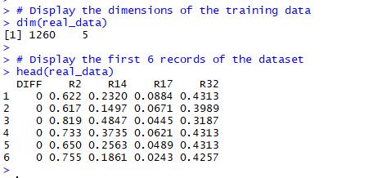
- Create the Training and Test Sets
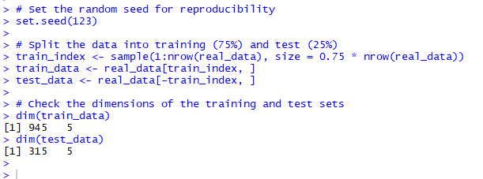

- Calculate the Error Rate for Different k Values
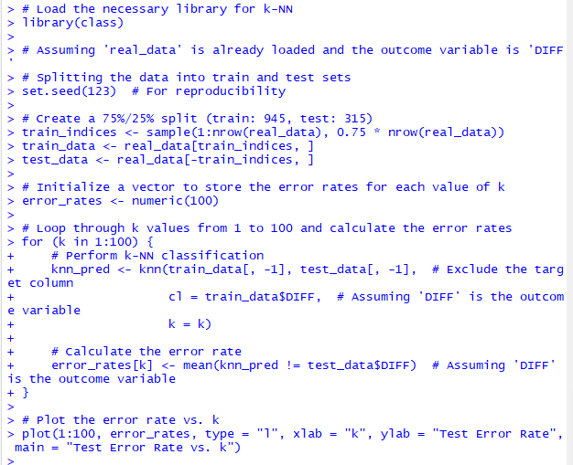
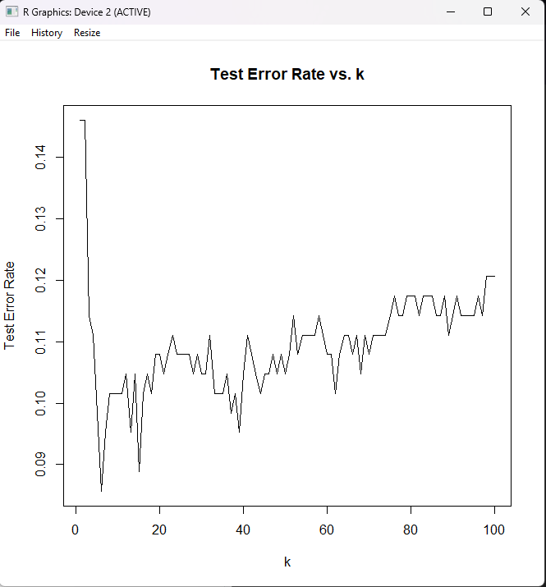

Methodology for K-Nearest Neighbors (KNN) Classification and Evaluation
1. Data Preparation
- Dataset Inspection:
  - Load the dataset and inspect its structure (e.g., number of rows and columns, types of variables).
  - Ensure the target variable (difficulty) and feature columns are clearly identified.
- Handling Missing Values:
  - Check for missing values using functions like sum(is.na(data)).
  - Remove or impute missing values to ensure data consistency.
2. Splitting the Dataset
- Train-Test Split:
  - Randomly divide the dataset into training and testing sets, typically using an 80-20 or 75-25 split.
  - Use a fixed random seed (e.g., set.seed(123)) to make the results reproducible
3. Implementing the KNN Algorithm
- Feature and Target Separation:
  - Separate feature columns (independent variables) and the target column (dependent variable).
  - Ensure that the training features (train_data) and labels (train_data$difficulty) are aligned.

Conclusion
The application of the K-Nearest Neighbors (KNN) algorithm in this study demonstrated its effectiveness in classifying data based on proximity in feature space. The following conclusions can be drawn from the analysis:
- Optimal k Value:
  - Through experimentation with various values of k, the optimal k was identified as the value that minimized the classification error rate. In our case, k=1k = 1k=1 yielded the lowest error rate for the initial split of the data. However, this may indicate potential overfitting to the training data.
- Impact of Random Splits:
  - Repeating the analysis with different random train-test splits showed that the choice of kkk and error rates can vary slightly. This underscores the importance of validating the model on multiple splits to ensure stability and reliability of the results.
- Error Trends:
  - The error rate typically decreased with smaller values of k, reflecting the model's ability to closely fit the training data. However, excessively small k values risk overfitting, while larger k values can smooth out predictions but may lead to underfitting.
- Visual Analysis:
  - Plotting error rates against k provided valuable insights into the relationship between the number of neighbors and model performance. It highlighted the trade-off between overfitting and underfitting, aiding in the selection of a robust k.
- Recommendations:
  - For practical applications, selecting an intermediate k value (e.g., 5 to 10) is often recommended to balance performance and generalizability.
  - Further evaluation using cross-validation or additional datasets would strengthen the model's reliability.
The results demonstrate that KNN is a straightforward yet powerful algorithm for classification tasks. However, careful parameter tuning and validation are essential to maximize its effectiveness and ensure its applicability to real-world scenarios.

