7、
#include<iostream>
using namespace std;
int max(int a, int b, int c)
{
int t;
if (a > b) t = a;
else t = b;
if (c > t) t = c;
return t;
}
int main()
{
int a, b, c;
cin >> a >> b >> c;
cout << "max(a, b, c)=" << max(a, b, c) << endl;
cout << "max(a,b)=" << max(a, b) << endl;
return 0;
}
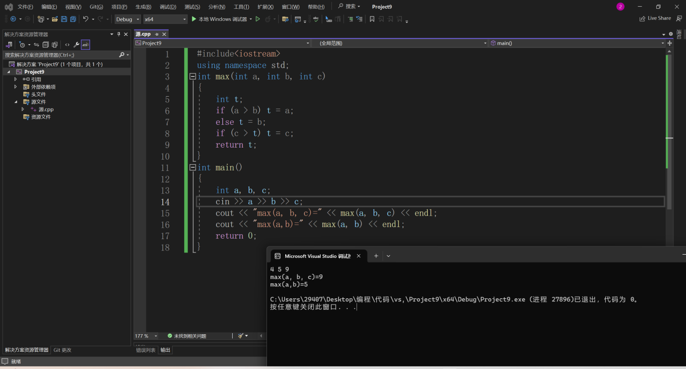

9、
#include<iostream>
using namespace std;
void sort(int& a, int& b, int& c)
{
int t;
if (b > a){ t = b; b = a; a = t;}
if (c > a){t = c;c = a;a = t;}
if (c > b){t = c;c = b;b = t;}
}
int main()
{
int a, b, c;
cin >> a >> b >> c;
sort(a, b, c);
cout << a <<" " << b<<" " << c;
return 0;
}
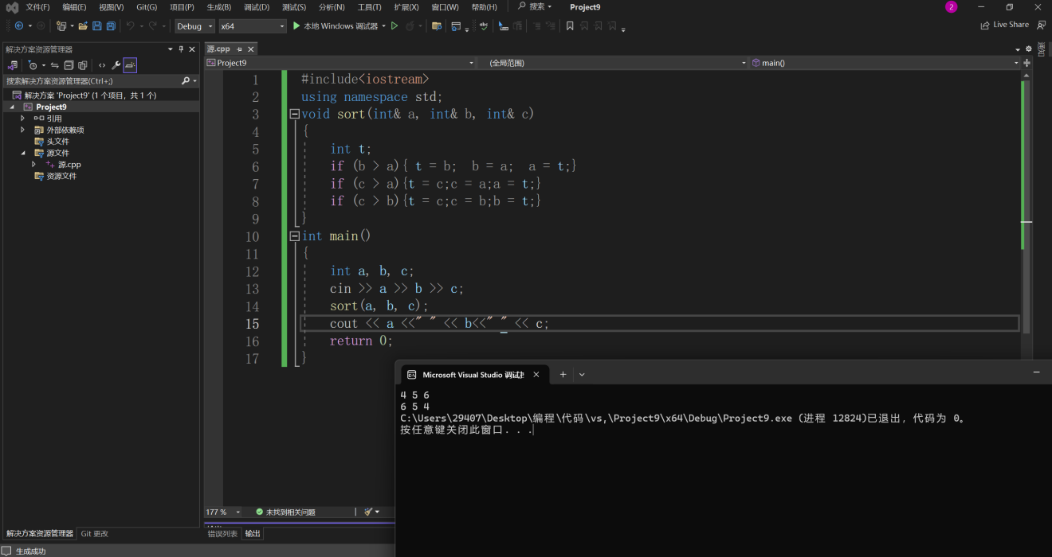
11、
#include<iostream>
#include<string>
using namespace std;
int main()
{
string str;
int i, n;
char temp;
cin >> str;
n = str.size();
for (i = 0; i < n / 2; i++)
{
temp = str[i];
str[i] = str[n - i - 1];
str[n - i - 1] = temp;
}
cout << str << endl;
return 0;
}
