|  |  |
| --- | --- |
|  |  |

Undergraduate Project Report

2015/16

**[Design and Implementation of 3D Model Retrieval System based on hand-drawn Sketches]**

|  |  |
| --- | --- |
| Name: | [Cui Dingyue] |
| Programme: | [Telecommunications with Management] |
| Class: | [2012215103] |
| QM Student No. | [ 120721186 ] |
| BUPT Student No. | [2012212853] |
| Project No. | [ IM_2853 ] |

**Date** [**16th May, 2016]**

Table of Contents

Abstract 4

Chapter 1: Introduction 6

1.1 Research Motivation 6

1.2 Research Content and Achievement 7

1.3 Technical Context 8

1.4 Functionality Realised 9

Chapter 2: Background 10

2.1 Research Background 10

2.2 Research Status and Analysis 11

2.2.1 Retrieval Based on Text or Specific Command Symbol 11

2.2.2 Retrieval Based on Pictures or 3D Models 11

2.2.3 Retrieval Based on Hand-drawn Sketches 11

Chapter 3: Design and Implementation 12

3.1 Basic Framework of the Retrieval System 12

3.2 Pre-processing of Hand-drawn Sketches 14

3.2.1 Source of Hand-drawn Sketch 14

3.2.2 Sketch Pre-processing 16

3.3 Projecting of Three Dimensional Models 17

3.3.1 Source of Three Dimensional Model 17

3.3.2 Projection with Platonic Solids (Icosahedron) 18

3.4 Extracting of the Contours 20

3.4.1 Contour Tracking Arithmetic 20

3.4.2 Result and Analysis of Contour Extraction 21

3.5 Processing of Contours 21

3.5.1 Polygonal approximation algorithm 21

3.5.2 Result and Analysis of Polygonal Approximation 22

3.6 Extracting and Matching of Contour Feature 23

3.6.1 Hu Moment Calculation 23

3.6.2 Matching Ratio Calculation 25

3.6.3 Sorting of Matching ratios 25

3.7 System Prototype Implementation 26

3.7.1 MFC for system implementation 26

3.7.2 Appearance of Retrieval System Prototype 26

3.7.3 Instruction of using the system 27

Chapter 4: Results and Discussion 28

4.1 Precision Ratio of the Retrieval System 28

4.2 Recall Ratio of the Retrieval System 28

4.3 System Analysis 29

Chapter 5: Conclusion and Further Work 30

5.1 Further work 30

5.1.1 Adding User Feedback 30

5.1.2 Adding 3D Demonstration of Retrieved Model 30

References 31

Acknowledgement 32

Appendix 33

Risk Assessment 39

Environmental Impact Assessment 40

# Abstract

This project develops a 3D model retrieval system with hand-drawn sketches as query. By the means of 3D model projection, sketch pre-processing and contour pro-processing, the system could obtain more standard contours to extract feature. And by comparing with the similarity of these features, the system could find the most matching 3D models corresponding to retrieval sketch.

On the basis of the above steps, this project completes the design and implementation of system prototype which could support the basic retrieval functions of this system.

The main researches are:

1. Pre-processing of Hand-drawn Sketches and 3D Models

Sketch pre-processing is achieved by dilating strokes of hand-drawn sketches. With dilating, the number of nonstandard strokes would be remarkably decreased, thus standard sketches whose main regions are nearly closed would be obtained.

3D model pre-processing is realized by projection with icosahedron, a regular 20-face object. Firstly, the system places 3D model at centre of an icosahedron. Then it uses 12 vertex of this polyhedron as viewpoints to get projections from diversified views.

1. Extracting and Pro-processing of Contours

Contour extracting is achieved with contour tracking algorithm, which is able to find contours of processed sketches and projection graphs. And contour pro-processing is realized with polygonal approximation method, aiming at reducing the amount of contour vertex to approximate the contour into polygonal shape.

1. Extracting and Matching of Contour Features

This part is implemented by calculating Hu Moments of the object contours. And, by figuring up the similarity of sketch’s moments and projection’s moments, the system would get the matching ratio and select the most matching models corresponding to retrieval hand-drawn sketches.

摘要 (Chinese translation of the Abstract)

本项目开发了以手绘草图作为检索输入的三维模型检索系统。通过对三维模型的投影，手绘图的预处理，提取轮廓的再处理，该检索系统可得到更标准的轮廓图来提取轮廓特征。通过比较轮廓特征间的相似度，针对手绘图的三维模型的匹配可以被实现。在上述步骤的基础上，本项目系统原型的设计和实现。

1. 手绘草图和三维模型的预处理

手绘草图的预处理是由膨胀算法实现。通过膨胀，将草图中的非标准笔画消除，以得到较标准且接近封闭的草图 。三维模型的预处理是由正二十面体实现， 将模型放置在二十面体中心，以其十二个顶点为视点来得到视角不同的多样化的投影图。

1. 轮廓提取和处理

通过轮廓跟踪算法来实现手绘图和投影图轮廓的提取。对提取得到的轮廓进行多边形拟合，减少轮廓中顶点的数量从而使曲线轮廓逼近多边形。

1. 轮廓特种的提取和匹配

计算轮廓的不变矩，并计算得到草图轮廓和投影图轮廓不变矩的相似度。通过排序得到最接近草图的三维模型。

# Introduction

This project develops a 3D model retrieval system with hand-drawn sketches as query. By the means of 3D model projection and sketch pre-processing, the system could obtain more standard graphs to extract feature. And by comparing with the similarity calculations of contour features from both hand-drawn sketches and 3D model projections, this system could achieve the three dimensional model retrieval function on the basis of hand-drawn sketches.

With the steps above, this project reaches a system framework which presents the technological process of the whole system. Beyond that, the system completes design and implementation of system prototype which could support the basic retrieval functions of this system.

## Research Motivation

With a rapid popularization of 3D objects in both networking and daily life, a convenient, reliable and efficient 3D model retrieval method is greatly in need. Comparing to exiting interactive retrieval methods, using hand-drawn sketches as query has the following several superiorities [1].

1. Hand-drawn interactions imitate the traditional ‘paper-pen’ mode, which has long been utilized in human life. Thus, such kind of interaction confirms to human custom, and makes users easy to accept. In addition to that, since people have been in touch with such ‘paper-pen’ mode, hand-drawn interactions would be easy to apply and become populated rapidly.
2. Hand-drawn sketches express concept in visual field. This kind of representation could convey users’ obscure ideas and retrieval objectives explicitly and directly, and it is superior to traditional three dimensional retrieval using artificially selected texts or symbols as index query. Therefore, by the means of utilizing hand-drawn sketches, efficiency of human-computer interaction is capable to be improved notably.
3. Universal use of touch screen increases preponderance of hand-drawn sketches as well. A great amount of touch screen equipment has occupied people’s daily life, such like smart phones, pads, and tablets. With these products, people could create hand-drawn sketches much easier and more conveniently, that means the three dimensional retrieval system using hand-drawn sketches already has the basis for realizing, and would possess a broad applying prospect.

## Research Content and Achievement

1. **Pre-processing of Hand-drawn Sketches**

The sketch pre-processing part is achieved mainly by dilating strokes of these hand-drawn sketches. With dilating, the number of nonstandard strokes would be remarkably decreased, and thus standard sketches whose main regions are nearly closed would be obtained.

1. **Improved Projection Methods of 3D Model**

The projection part is realized with icosahedron, a regular 20-face object. Firstly, the system places three dimensional model at centre of an icosahedron. Then it uses 12 vertex of this object as viewpoints to get projections of diversified views.

1. **Contour Extracting**

The contour finding part is achieved with contour tracking algorithm to find contours of processed sketches and projection graphs.

1. **Contour Pro-processing**

Contour pro-processing part is realized with method of polygonal approximation. Since the contour extracted was saved in vertex, this method aims at reducing the amount of vertex to approximate the contour into polygonal shape.

1. **Feature Extracting and Matching**

The feature extraction part is implemented by calculating Hu Moments of the object contours. And by figuring up the similarity of sketch’s moments and projection’s moments, the system would get the matching ratio. By comparing with the matching ratio, the system would be capable to select the most matching models corresponding to retrieval hand-drawn sketches.

1. **System Framework and Prototype Implementation**

On the basis of the above steps, this project reaches a retrieval system framework. The framework presents the technological process of the whole system, and conveys the relationship of these steps at the same time.

Beyond that, this project completes the design and implementation of system prototype as well. The prototype realizes basic retrieval functions of this system, and adds several additional functions, such like manipulation of those retrieved three dimensional models.

## Technical Context

1. Hand-drawn Sketches

Hand-drawn sketches here represent computer used hand-drawn graphs which could be produced by scanning paper-based sketches, drawing with painting software on computer or drawing on computer connected Wacom.

1. Dilation:

Dilating is a process that adding pixels conjoining with object to object pixels. By the means of dilation, the edge of the object could expand, disconnected strokes would link up and those redundant strokes would blend into contour strokes.

1. Projection

Projecting is a process that transfer the three dimensional models into two dimensional projection graphs. Because three dimensional models cannot match directly with two dimensional hand-drawn sketches, the projection process is indispensable.

1. Icosahedron

Icosahedron is a platonic solid, which is constituted with congruent polygonal faces. These faces are all regular, thus the polyhedron is regular. Every vertex of the polyhedron converges the same number of faces.

1. Contour Tracking Algorithm

Contour is the edge pixels of an object. It contains lots of useful information which can be utilized to express features of an object.

The basic idea of tracking algorithm is using information of preceding edge pixel as index to find next pixel and judge whether it is an edge pixel. By iterating this process, an integrated contour would be find out.

1. Feature of Contour

Feature of contour is an extracted representation which contains lots of information of the contour and could express the contour in a simple and easy-used form.

1. Moment of Contour:

Moment is the integral of every points on contours. It could be consider as a feature of contour.

## Functionality Realised

The system allows users to select a hand-drawn sketch from directory and send that sketch as query to retrieve. Then it would output several two dimensional projection graphs which are projected by the most matching three dimensional models. By clicking the projection, those corresponding 3D models would be shown to users.

Beyond that, this project completes the design and implementation of system prototype as well. The prototype realizes basic retrieval functions of this system, and adds several additional functions, such like manipulation (including rotating, scaling and changing presentation modes) of those retrieved three dimensional models.

In addition to that, the system supports basic operations of the retrieved 3D models, including rotating, scaling and changing presentation modes (point, line, face). This additional function could let users check the retrieval results more comprehensively.

The system is implemented in MFC frame, in Windows 7 style, which is familiar and comfortable to most users. In the prototype, interactions could be realised easily by mouse clicking operations.

# Background



## Research Background

With the rapid growing of multimedia technologies and computer graph hardwires, three dimensional model gradually becomes the fourth multimedia data type, which is ranked after sound, graph and video. Because of its multi-dimensional features and capability of subtly expression, three dimensional models are applied in more and more fields, such like industrial design, 3D game, Movie editing, medical research and simulating.

In order to storage and manage these 3D models, most applied fields build their own model dataset. And more and more people start to use existing models from these dataset, for this could reduce creation of redundant models and decrease the cost. For example, designers turn to use three dimensional models by extracting, modifying and re-combining existing models from dataset, instead of building new models. Therefore, a reliable, convenient and efficient three dimensional retrieval system is in great need.

Being a special kind of expression in symbol system, hand-drawn sketch is obscure in semantic, logic and grammar. It could express abstract ideas and concepts in visual field. This kind of representation could convey users’ obscure ideas and retrieval objectives explicitly and directly. Hand-drawn sketches could also convey multi-dimensional information in consecutive way, which obviously reduce impediments in human-computer interactions.

Beyond that, hand-drawn interactions imitate the traditional ‘paper-pen’ mode, which confirms to human custom, making users easy to accept and apply. Universal use of touch screen increases preponderance of hand-drawn sketches as well. People now are able to create their own computer-using hand-drawn sketches much easier and more conveniently.

In recent days, three dimensional models and hand-drawn sketches have been paid more and more attention, and their combination has made a great amount of achievements at the same time, such like sketched-based three dimensional retrieval. With the merits of hand-drawn sketch, it is becoming the first choice of three dimensional model retrieval system.

## Research Status and Analysis

### Retrieval Based on Text or Specific Command Symbol

Retrieval based on text retrieves according to the matching rate between users’ input text and model’s text label, such as retrieval engine of Google’s 3D Warehouse.

Retrieval based on specific command symbol [2] expresses basic objects with defined strokes or stroke combination. For example, using ‘⊙’ to represent a three dimensional sphere.

These two methods are supposed to label every 3D models, which may cost great amount of time and manpower, and manual label is subjective and incomplete to some extent, which could lead to non-uniform label standard. Beyond that, retrieval based on specific command symbol only fits to retrieval for several basic object, since it is unpractical for users to remember a great deal of command symbols.

### Retrieval Based on Pictures or 3D Models

Retrieval based on pictures [3] or 3D models [4] works by inputting pictures of the model or the model itself as query to retrieve corresponding 3D model.

The method above requires that user possess pictures or 3D models of the aiming models, which also limits the applying.

### Retrieval Based on Hand-drawn Sketches

This method use 2D hand-drawn sketch as query to retrieve 3D models in dataset.

In comparison with above methods, retrieval based on sketches is more convenient and feasible. Because hand-drawn interaction imitates traditional ‘paper - pen’ mode, which confirms to human custom. Sketch expresses concept in visual ways, which could convey obscure ideas explicitly and present user’s objective directly. Therefore, efficiency of human-computer interaction is capable to be improved notably. Beyond that, universal use of touch screen increase preponderance as well, because it makes creation of computer using hand-drawn sketches easier and more convenient.

# Design and Implementation

This part mainly explains technological processes of system realization, which was constructed by system framework designing, sketch pre-processing, three dimensional model projecting, contour extracting, contour processing and feature matching. Beyond that, this part also demonstrates user interface of this retrieval system.



## Basic Framework of the Retrieval System

Main parts of this sketch-based retrieval system composes by sketch pre-processing part, 3D model projection part, contour finding part, contour pro-processing part and features extraction part. On the basis of these parts, this project reaches a retrieval system framework. It presents technological process of the whole system, and conveys the relationship of those parts at the same time. Figure 1 shows framework of this retrieval system.

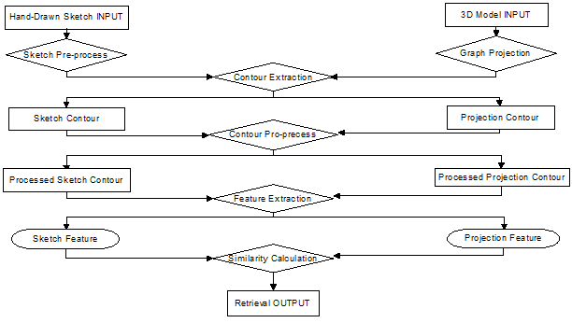

Figure 1 Framework of the retrieval system

1. **Pre-processing of Hand-drawn Sketches**

This sketch pre-processing part is used to reduce obstructs produced by nonstandard drawing, such as crossing, discontinuous and redundant strokes. This part is achieved mainly by dilating the strokes of these hand-drawn sketches. With dilating, the number of nonstandard strokes would be remarkably decreased, thus standard sketches whose main regions are nearly closed would be obtained. After this step, sketch contour is capable to be extracted accurately from these standard sketches.

1. **Projection of 3D Model**

The projection part is realized with icosahedron, a regular 20-face object. Firstly, the system places three dimensional model at centre of an icosahedron. Then it uses 12 vertex of this object as viewpoints to get projections of diversified views.

This part is used to obtain multi-view projection graphs of three dimensional model. Since different people have different understanding of these 3D models and they have their own drawing habits. Thus we need distinctive projection graphs from as much as possible different views of a 3D model to cover people’s various kinds of expressions of this model. By using this icosahedron projection method, the system would obtain twelve different-view project graphs.

1. **Contours Extracting**

This contour finding part is achieved with contour tracking algorithm to find contours of processed sketches and projection graphs.

This step is applied to extract contour of the retrieval object from the whole graph. The object contour contains lots of useful information, which could be used to express the feature of the object. Thus, this part is a preparing part for the further feature extraction works.

1. **Contour Pro-processing**

Contour pro-processing part is realized with method of polygonal approximation. Since the contour extracted was saved in vertex, this method aims at reducing the amount of vertex to approximate the contour into polygonal shape.

This purpose of this step is decreasing redundant details on contours extracted. Contour processing makes it possible to express a contour more efficiently and eliminate interference brought by those useless details.

1. **Feature Extracting and Matching**

The feature extraction part is implemented by calculating Hu Moments of the object contours. And by figuring up the similarity of sketch’s moments and projection’s moments, the system would get the matching ratio. By comparing with the matching ratio, the system would be capable to select the most matching models corresponding to retrieval hand-drawn sketches.

Hu Moment is a sort of contour characteristic, which could be used to express the contour. At the same time, Hu Moment has several merits making it superior to other contour features, such as simple calculation, less time cost, rotating invariance, shifting invariance, and scaling invariance. In addition to that, the similarity comparison of Hu Moments is easy to be achieved and calculation saved. And that is why the system choose Hu Moment to express contour characteristics.

1. **System Prototype Implementation**

Beyond that, this project completes the design and implementation of system prototype as well. The prototype realizes basic retrieval functions of this system, and adds several additional functions, such like manipulation of those retrieved three dimensional models.

## Pre-processing of Hand-drawn Sketches

This part is an important components of this sketch-based retrieval system. Since most users are amateurish in drawing, their input sketches may exist some adverse factors, such as breaking points, overlapping strokes or jittering paints, which could obviously influence the effects of contour extraction, and the final results of retrieving.

### Source of Hand-drawn Sketch

The first step of sketch pre-processing is sketch recognition. In order to simulating and revealing how human drawing, this project selects two sources of sketch input, which are SHREC shape benchmark and user’s hand-made input.

#### SHREC Shape Benchmark

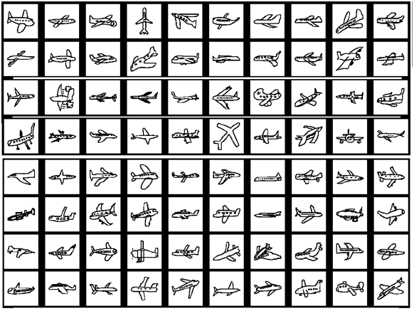In this project, one source of hand-drawn sketches is SHREC. This 2D sketch benchmark contains more than 7200 sketches corresponding to models in PSB [5]. Sketches in SHREC are selected from Eitz et al.’s [6] hand-drawn sketch dataset, which is specially built for human sketch recognition. Figure 2 shows human sketches within a class of Eitz et al’s sketch database.

Figure 2 Demonstration of hand-drawn sketch set in one class of Eitz et al human sketch dataset.

Princeton Shape Benchmark (PSB) is the most widely used three dimensional shape benchmark, which has over 1800 models covering the most commonly occurring objects. It is designed to be a publicly available polygonal models dataset specially used for three dimensional shapes matching tests. Figure 3 shows several three dimensional models in Princeton shape benchmark.

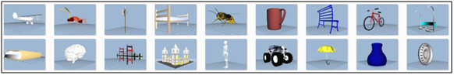

Figure 3 Example of several 3D models in PSB benchmark

In order to learn habits of human drawing and how human sketch was recognised, Eitz et al collected over 20,000 hand-drawn sketches, in 250 categories [6].This dataset promotes the occurring of three dimensional model retrieval benchmarks on the basis of sketches, including the SHREC benchmark used in this project.

Main achievement of SHREC shape benchmark is linking three dimensional models from PSB with sketches from Eitz et al.’s database. By filtering over-amount sketches and selecting appropriate models with sketches, SHREC benchmark could alleviate side effect of non-uniform category distribution in PSB. That means every 3D model has uniform number of corresponding hand-drawn sketches, which could guarantee the fairness and rationality of 3D retrieval.

Figure 4 shows above PSB model’s relating sketches in SHREC shape benchmark.

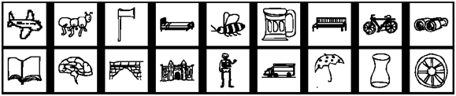

Figure 4 2D hand-drawn sketches in SHREC’s sketch dataset corresponding to models in PSB

In the system, users are able to select any one of SHREC’s sketch to be a retrieval query, simplify from file directories on computer.

#### Other Source of Hand-drawn sketch

In addition to using hand-drawn sketches from SHREC shape benchmark as retrieval query, users are also allowed to use other existing sketches on computer. (Bitmap format). Beyond that, users could create their own hand-drawn sketches with painting software which could produce computer used sketches. (Bitmap format).

### Sketch Pre-processing

Most users of this system are not professional at painting, which means the sketches they produced would exist irrelevant or nonstandard strokes, such as breaking points, overlapping strokes or jittering paints, which may have side effect on users’ retrieval intention expression. Even professional painters could generate such sketches with the limit of painting equipment. One example showing nonstandard strokes of sketch input is demonstrated in Figure 5.

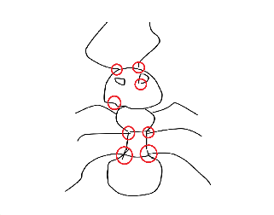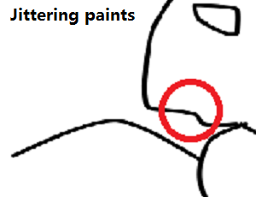 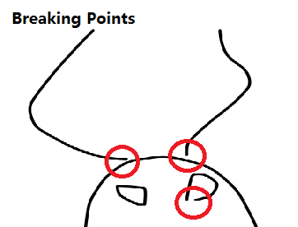 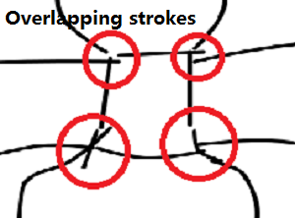

Figure 5 Example shows nonstandard strokes of sketch input

#### Dilation in Pre-processing

Sketch pre-processing part, mainly achieved by dilating arithmetic, which is aiming at extracting key elements of one sketch, and reducing nonstandard strokes talked above. With this method, veracity and validity of sketch recognition can be insured.

#### Principle of Dilating Arithmetic

Dilation is a process that adding pixels to the edge of an object. Structuring element is a designed structure which could determine how many pixels will be added to the object’s boundaries. Common form of structuring element is a 3*3 pixel square, pixel in the centre is used to match with the pixel going to be detected, and other pixels surrounding the centre is called neighbouring pixels. The state of pixel detected in the output image is determined by a rule of calculation to the pixel itself and its neighbouring pixels in the input image [7].

In the dilation operation, A represents a binary image, and B represents the structuring element. The centre of B is moving along with every pixel of Image A. When the centre of structuring element is coincide with pixel which is going to be detected in image A, the arithmetic would make an ‘AND’ operation. The calculation result of this detected point is the maximum value of all the pixels in the detected pixel's neighbourhood. In other words, if any result of neighbouring pixels equals to 1, then the detected pixel will be set to 1.

The principle of the arithmetic is demonstrated in the above figure 6 [8].

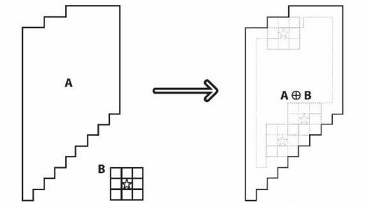

Figure 6 Demonstration of dilating arithmetic

The principle can also be expressed with the following formula.

 (1)

is the image after dilating, is the original image and B is the structuring element.

#### Result and Analysis of Sketch Pre-processing

With the dilating arithmetic, irrelevant strokes would blend into useful strokes obviously. Beyond that, gaps of two adjacent strokes are closed. The whole sketch becomes integrated and consecutive, which is a benefit to further contour extracting and feature matching work. Figure 7 shows result of an 8-time iteration dilating.

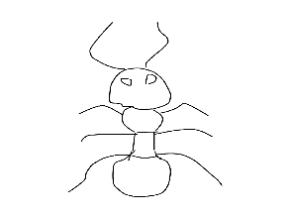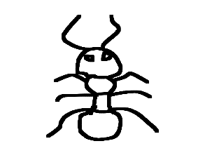

Figure 7 Output sketch of dilating arithmetic

## Projecting of Three Dimensional Models

Hand-drawn sketch expresses ones retrieval intention in two dimension, which means contour features extracted from hand-drawn sketches cannot compare with descriptors extracted directly from 3D models. Therefore, this project choose to make project theses 3D models to obtain 2D features. This step builds a mapping relation from 3D models to 2D contour features.

### Source of Three Dimensional Model

This project imports 3D models from Princeton Shape Benchmark (PSB).

Models in PSB are saved in object format file (‘off ’) format, which is used to represent model geometry by defining the model’s surface. Files in PSB accord with the following standard. ASCII files, beginning with the keyword ‘OFF’, has a second line stating the amount of vertices, faces and edges. Then the vertices are listed with x, y, z coordinates, and the faces are listed with the number of vertices of each face, followed by index of the vertices in the vertices list.

Loading of three dimensional models can be implemented with OpenGL, which is a cross-language, cross-platform API aiming at 2D and 3D model rendering [9].

The result of .off 3D model loading is demonstrated in Figure 8.

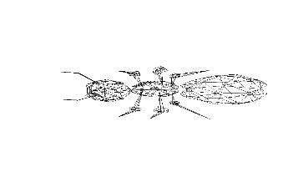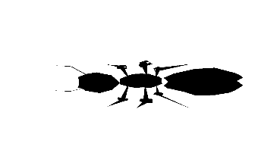

Figure 8 loading result of an ‘.off’ model file (lines and faces)

### Projection with Platonic Solids (Icosahedron)

Platonic solid is a sort of polyhedron, constituted with congruent polygonal faces. These faces are all regular, thus the polyhedron is regular. Every vertex of the polyhedron converges the same number of faces. Platonic Solids have perfect symmetry characters, and they are regular and congruent, which means they are especially suitable for projection assistance.

Since every user may produce their hand-drawn sketch of 3D model in random view, it is beneficial to get as many as possible view of projection graphs for one model. However, the amount of calculation and time cost also needs to be traded off. Therefore, this project determine to use Icosahedron (twenty congruent regular triangles, twelve vertices), which could generate enough and appropriate number of projection graphs.

#### Pre-processing of Projection

1. Generate the Icosahedron

Since 3D models in PSB have been normalized, the size of encircling icosahedron was settled. Put icosahedron center at point (0, 0, 0) at world coordinate system, then every vertex of the icosahedron was fixed and can be calculated and easily rendered.

1. Put 3D model into the icosahedron

In order to get correct projection, 3D model needs to be inside and at the center of icosahedron. With the vertex information in model file, the maximum and minimum coordinates in x, y, z axis can be confirmed. The average of these coordinates can be seen as the center of 3D model. Notice that model center may be outside of itself. Set 3D model at the center of icosahedron. Result of this step is demonstrated in Figure 9.

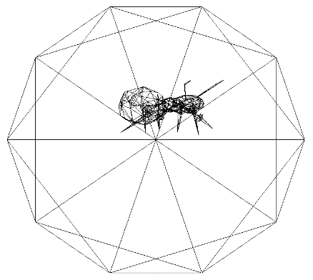

Figure 9 Three dimensional model in the icosahedron

#### Projecting from Every Vertex of the Icosahedron

1. Using cuboid to produce orthogonal parallel projection.

Create a cuboid with appropriate size, which could cover the whole model in it. Then set the camera at every vertex of the icosahedron, 12 orthogonal projections of the model have been produced. Notice that, the projections now are still three dimensional, for the projection was made in a cuboid other than a plane.

Projection results are shown in Figure 10.

|  |
| --- |
|  |
|  |

Figure 10 Twelve orthogonal projections of the example model

1. Select useful projections

Since the icosahedron is perfectly symmetrical, projection of symmetrical models can produce some alike results. Even the model is not completely symmetric, those slightly difference cannot influence the retrieval results. Thus, the system removes projections which are almost the same. At last 7 projections will be reserved. This step obviously reduces time cost in further retrieval work.

Example of selection results are shown in Figure 11.

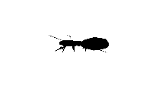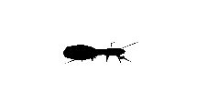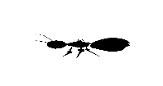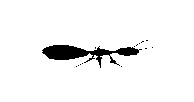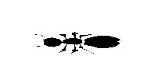

Figure 11 Seven selected projections of the example model

1. Read pixels from the screen and create projection graph

After the projection, pixels in window can be read into buffer and restored in a format of bitmap. With this step, three dimensional model would totally be projected into two dimensional plane.

## Extracting of the Contours

Main function of this part is tracking contours of processed graphs, and eliminating irrelevant inner contour to obtain a closed external contour. These external contours would be used to extract contour features.

### Contour Tracking Arithmetic

Contour tracking arithmetic is a method which is able to acquire contours of binary graphs using the following directional detecting criteria.

If the top, bottom, left and right adjacent pixels of one point is black (pixel value is 0), then it is not a contour point. If any of these four pixels is white (pixel value is 1), then it would be judged as contour point, except for the condition that adjacent pixels are all white.

The whole tracking process is demonstrated in Figure 12.

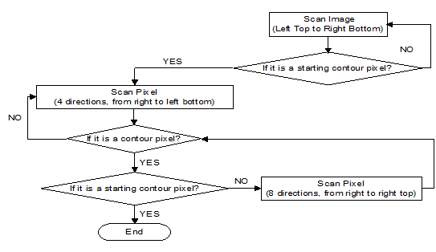

Figure 12 Flow chart of contour tacking arithmetic

1. Scan the image from top left to bottom right (clockwise), when the pixel’s value equal to 0, this pixel would be set as starting contour pixel, it can be called as point A, and the system will log its position.
2. Then the system will scan four adjacent pixels (from right to bottom-right, clockwise) of point A, and judge if it is a contour pixel with the above criteria. Since A is the left-top contour pixel of the image, there must be a contour pixel in these four directions of point A. This new contour pixel can be called as point B, and the system will log its position.
3. After finding point B, the system would scan all eight adjacent pixels in the order from right to right top, and judge if it is a contour pixel. Set this new contour pixel as point C, and the system will log its position.
4. If point C is point A, it means that it is the end of the contour tracking. Else, this tracking will go on until point C back to point A.

### Result and Analysis of Contour Extraction

With the contour tracking arithmetic, the system could output a consecutive external contour, whose inner details are mostly dropped. Hand-drawn sketches and projection graphs are both processed in this method. Figure 13 shows the contour extraction results of sketches and projection graphs.

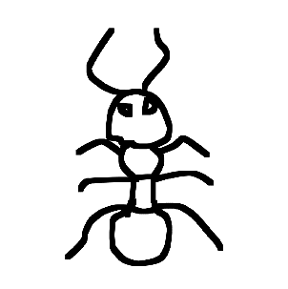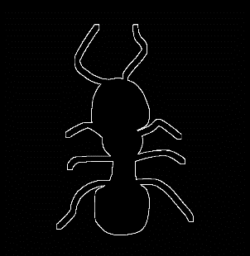 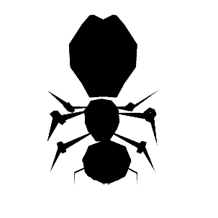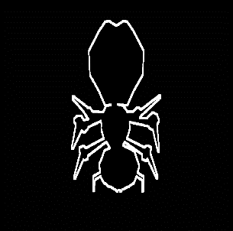

Figure 13 Contour extraction results of sketch and projection graphs (Dilating, Contour)

## Processing of Contours

Contour extracted in previous step is curved, in order to improve the retrieval efficiency, the system needs reduce those redundant details, which means approximating this contour into a nearly straight expression. Polygonal approximation algorithm is designed to realize this idea.

### Polygonal approximation algorithm

Polygonal approximation algorithm aims at reducing vertices on contour and approximating curves into polygons. This algorithm is realized by iterating. The whole process is shown in Figure 14.

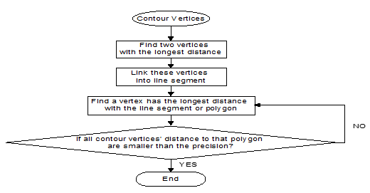

Figure 14 Process of polygonal approximation

1. The system firstly rules a precision and finds two contour vertices which has the longest distance on this contour, and connects these two vertices into line segment.
2. Then the system will find out one vertex who has the longest distance with the line segment above, and links this vertex along with vertices found before into a polygon.
3. After that, the system would test if all contour vertices’ distance to that polygon are smaller than the precision set, if yes, the polygon is the approximated polygon, if not, and the system would iterate step 2 until it finds an appropriate polygon.

### Result and Analysis of Polygonal Approximation

With the polygonal approximation arithmetic, the system would get a polygonal contour. The result contour markedly reduces number of vertices, and thus decreases time cost in contour extraction. Beyond that, by dropping those redundant details, such like jittering strokes, their side effects on retrieval results would be avoided efficiently.

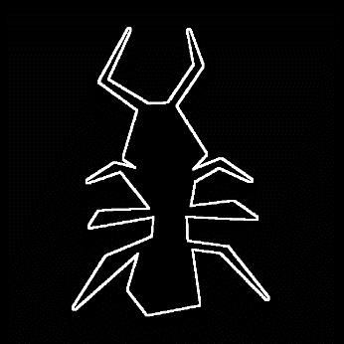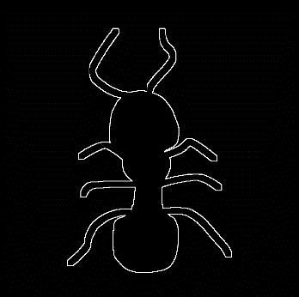Result of polygonal approximation was shown in Figure 15. The result shows that curves are efficiently replaces with line segments. Main details, such like the overall shape, distinguished details (number of tentacles of the object), are retained well. The polygonal contour is still distinctive but further calculation would remarkably decrease.

Figure 15 Result of polygonal approximation

## Extracting and Matching of Contour Feature

Since contours cannot be used to do the matching work directly, the system needs to import features of contours, which can be used to compare simply. There are many kinds of contour features which are able to represent contours’ distinctions. In this project, Hu Moment was imported as the contour feature [11].

### Hu Moment Calculation

Different people have different painting habits, that is to say hand-drawn sketches from various sources were obviously distinguished. Even if every user sketches the same model at the same viewport, they would still produce different sketches in different size or direction. That means a feature with shifting, rotating, scaling invariance is of great need. Hu Moment (Contour Moment) used in this system is of this kind of characteristic.

#### Moment of Contour

Contour moment is the integral of every pints on a contour, it is able to reveal the rough features of a contour. Formula (2) shows the calculation of (p + q) orders contour moment.

 (2)

In the formula, f (x, y) is the image function, value of pixel (x, y). N means height of the image while M represents the width, p, and q are the order of moment corresponding to coordinate x and y.

Zero order moment (m00) equals the number of vertices on contour. For binary image, m00 is the area of a contour. Order one moment (m01, m10) means the average or centre of a contour. Order two moment (m02, m11, m20) represents the variance, which means the direction of an object shape. Order three moment (m03, m12, m21, m30) expresses the deviation degree of a contour, which is very sensitive to subtle differences on contour. That is to say, moments are able to be on behalf of some important contour features. Hu moment only takes use of the first four orders of moment.

#### Central Moment

Central moment is a processed moment, which shifts origin of the coordinates to the centre of contour. Formula (3) and (4) are the calculation of (p + q) order central moment.

  (3)

 (4)

In the formula,  and  are the centroid of the image.

#### Normalized Central Moment

In order to make the contour comparison invariant, normalized central moment is imported. It is invariant to shifting and scaling, however it is still sensitive to rotating. Formula (5) and (6) show the calculation of (p + q) order normalized central moment.

 (5)

 (6)

#### Hu Moment

Hu Moment also called as invariant moment, is the Linear combination of normalized 2-order and 3-order central moments. It is invariant to shifting, scaling and rotating. When image changed, those moments above would change immediately, while values of Hu Moment set would stay invariant. Since it is impossible for users to create normalized and standard sketches, this advantage of Hu moment ensures the correctness to some extent of retrieval with different-standard sketches.

 (7)

 (8)

 (9)

 (10)



(11)

 (12)

 (13)

The following 7 formulas indicates the calculation of Hu moment set.

### Matching Ratio Calculation

After calculation of Hu moment set, the system is able to calculate the matching ratio of two contours. Using formula (14) and (15), matching ratio can be figure out with simple calculations. This matching calculation has less computational works and time costing, which means it is suitable for retrieval work with large amount of data.

 (14)

 (15)

In formula (14),  and  means Hu moments of two contours.

In formula (15), ‘matching’ represents matching ratio of contour A and B. It is ranged between 0 and 1. The smaller the ‘matching’ value is, the higher matching degree of two contours is. By iterating, matching ratios of all projection graphs corresponding to the retrieval sketch are able to obtain.

### Sorting of Matching ratios

After getting matching ratios, the next step is sorting these data in an order from small to larger. The system applies Half-Insert sorting arithmetic to realize this function.

Half-Insert sorting is the improved version of Insertion sorting. It improves method on finding the inserting position of the sorted number. After sorting, the system is able to come out the 3D model’s rank of matching degree. Whole process of Half-insert sorting is shown in Figure 16.

Figure 16 Process of Half-insert sorting

## System Prototype Implementation

### MFC for system implementation

MFC, Microsoft Foundation Classes, is a class library encapsulated win32 API, based on C++ language. Since MFC applies Windows style, it is comfortable for users to accept system designed in format. Beyond that, MFC is convenient to developer, which means it could help developers design a better interface.

### Appearance of Retrieval System Prototype

Figure 17 shows the initial status of retrieval system, Figure 18 shows the result status of retrieval system.

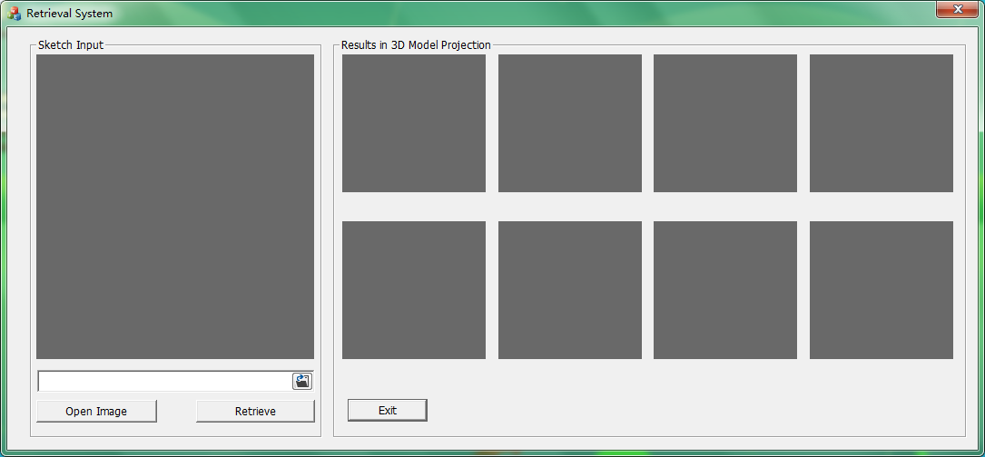

Figure 17 Initial State of the system prototype

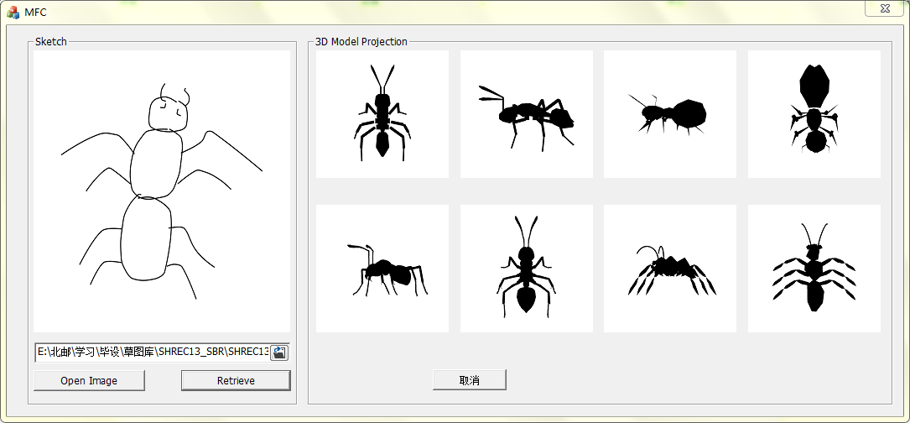

Figure 18 Result State of this system prototype

### Instruction of using the system

Figure 19 shows instructions of using this retrieval system.

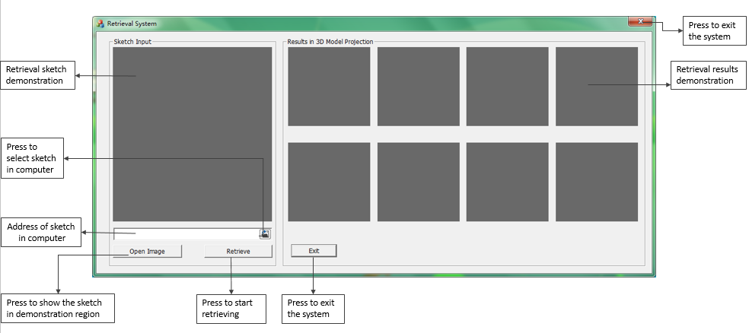

Figure 19 Instructions of using the retrieval system

# Results and Discussion



## Precision Ratio of the Retrieval System

Precision ratio is a standard to measure the accuracy of retrieval. Precision ratio was figured out via dividing the number of relevant results by total results.

The project using 25 three dimensional models to obtain the results of precision ratio. These models are selected form 5 categories, which means each category has 5 models. Categories selected are obviously distinguished in shape, which helps the system to tell apart each model accurately. Then, choose 5 sketches for each category’s retrieval to see the precision value.

Every time the system would output 8 results, which means the number of total results is 8. The outcomes of precision ratio was shown in Table 1.

Table 1: Table of Precision Ratio

|  |  |  |  |  |  |
| --- | --- | --- | --- | --- | --- |
|  | Category 1  Ant | Category 2  Butterfly | Category 3  Duck | Category 4  Fish | Category 5  Dog |
| Sketch 1 | 62.5% | 50.0% | 87.5% | 75.0% | 75.0% |
| Sketch 2 | 50.0% | 75.0% | 50.0% | 87.5% | 75.0% |
| Sketch 3 | 62.5% | 87.5% | 87.5% | 62.5% | 75.0% |
| Sketch 4 | 75.0% | 62.5% | 62.5% | 87.5% | 62.5% |
| Sketch 5 | 62.5% | 75.0% | 75.0% | 87.5% | 75.0% |

Thus, the overall precision ratio of the retrieval system is 71.5%, it shows that the system is able to find target model according to corresponding sketch.

## Recall Ratio of the Retrieval System

Recall ratio is a standard that measures the collecting capability of a retrieval system. Recall ratio was figured out via dividing the number of relevant results by total relevant information in database.

Every category has 5 models to retrieve, which means the number of total relevant information is 5. The outcomes of precision ratio was shown in Table 2.

Table 2: Table of Recall Ratio

|  |  |  |  |  |  |
| --- | --- | --- | --- | --- | --- |
|  | Category 1  Ant | Category 2  Butterfly | Category 3  Duck | Category 4  Fish | Category 5  Dog |
| Sketch 1 | 40% | 60% | 100% | 80% | 80% |
| Sketch 2 | 60% | 60% | 60% | 80% | 80% |
| Sketch 3 | 60% | 80% | 100% | 60% | 60% |
| Sketch 4 | 80% | 60% | 60% | 100% | 60% |
| Sketch 5 | 80% | 80% | 80% | 100% | 80% |

Thus, the overall recall ratio of the retrieval system is 72%, it shows that the system could find out most of the relevant models to the input sketch.

## System Analysis

With the precision and recall ratio calculated, it can be revealed that this system is able to realize the retrieval function. Even if not all relevant model can be retrieved out, the system could output most of the corresponding models. Beyond that, correct models could be shown to users, which means with a further feedback work, precision of retrieval could be obviously improved.

However, the results are still not ideal, some irrelevant results are still shown in the system. This encourages some further works, such like the feedback function talked above, to be imported in the system in the future.

# Conclusion and Further Work

This project successfully implements a three dimensional retrieval system prototype using hand-drawn sketches as query. The system is designed in mainly five parts, which are sketch pre-processing, 3D model projecting, contour extracting and processing, feature extracting and matching and prototype implementing.

Every part of the system has its theoretical foundation, and achieves its preconceived effects. The system creatively improves the three dimensional model projection part using icosahedron, which obtains good results. Beyond that, it combines dilating, polygonal approximating and contour moment matching together to promote retrieval accuracy and reduce time cost, and it receives good effects.



## Further work

### Adding User Feedback

Since matching results still have errors, adding user feedback would significantly improves retrieval accuracy. When users firstly get their retrieval results, they are able to select the least accurate results. With their selection feedback, the system would be trained to exclude some models which are similar in shape but in wrong classification. After several times of iteration, this system would be capable to output accurate results.

### Adding 3D Demonstration of Retrieved Model

In order to have a better user experience, the system could implement three dimensional demonstration of those retrieved model. In the demonstration, users are able to observe the models in all directions and scales. With this function, users can get a more clear judgement about the correctness of retrieval results.

References

[1] XIE Xiaohua (2015). Journal of Integration Technology. *Three Dimensional Shape Retrieval Based on Two Dimensional Sketches, 4,* no.2, 391-41.

[2] Zeleznik, R. C., Herndon, K. P., & Hughes, J. F. (2007, August). SKETCH: an interface for sketching 3D scenes. In ACM SIGGRAPH 2007 courses (p. 19). ACM.

[3] Aono, M., & Iwabuchi, H. (2012, December). 3D shape retrieval from a 2D image as query. In Signal & Information Processing Association Annual Summit and Conference (APSIPA ASC), 2012 Asia-Pacific (pp. 1-10). IEEE.

[4] Funkhouser, T., Min, P., Kazhdan, M., Chen, J., Halderman, A., Dobkin, D., & Jacobs, D. (2003). A search engine for 3D models. ACM Transactions on Graphics (TOG), 22(1), 83-105.

[5] Lei, H., Li, Y., Chen, H., Lin, S., Zheng, G., & Luo, X. (2015). A novel sketch-based 3D model retrieval method by integrating skeleton graph and contour feature. Journal of Advanced Mechanical Design, Systems, and Manufacturing, 9(4), JAMDSM0049-JAMDSM0049.

[6] Li, B., Lu, Y., Li, C., Godil, A., Schreck, T., Aono, M., ... & Fu, H. (2015). A comparison of 3D shape retrieval methods based on a large-scale benchmark supporting multimodal queries. Computer Vision and Image Understanding, 131, 1-27.

[7] Haralick, R. M., Sternberg, S. R., & Zhuang, X. (1987). Image analysis using mathematical morphology. Pattern Analysis and Machine Intelligence, IEEE Transactions on, (4), 532-550.

[8] Serra, J. (1986). Introduction to mathematical morphology. Computer vision, graphics, and image processing, 35(3), 283-305

[9] Kronlachner, M. Spatial Transformations for the Alteration of Ambisonic Recordings.

[10] YUAN, W., DONG, Q., & SANG, H. (2010). Hand shape contour tracking method based on directional gradient extremum. Optics and Precision Engineering, 18(7), 1675-1683.

[11] Hu, M. K. (1962). Visual pattern recognition by moment invariants. information Theory, IRE Transactions on, 8(2), 179-187.

Acknowledgement

This project starts form October, 2015, the whole process lasts for over eight months. During the process, lots of people gave me generous help. Here, I would like to express my sincere gratitude to them.

First I would like to thank my supervisor. During the project, he guided my project progress responsibly, gave my constructive advices patiently and avoids me from taking redundant courses. Without his help, this project cannot have today’s achievements. Next I would like to appreciate my friend Ding. He tutored me a lot with code works, and helped me overcome programme cash down for many times. Thanks for his patience and selflessness. At last I would like to express my gratitude to my parents, their unlimited supporting gave me lots of courage to conquer difficulties in the process.

With the helps received in the process, this project is able to reach today’s achievements. Thanks again for their bountiful assistance.

Appendix



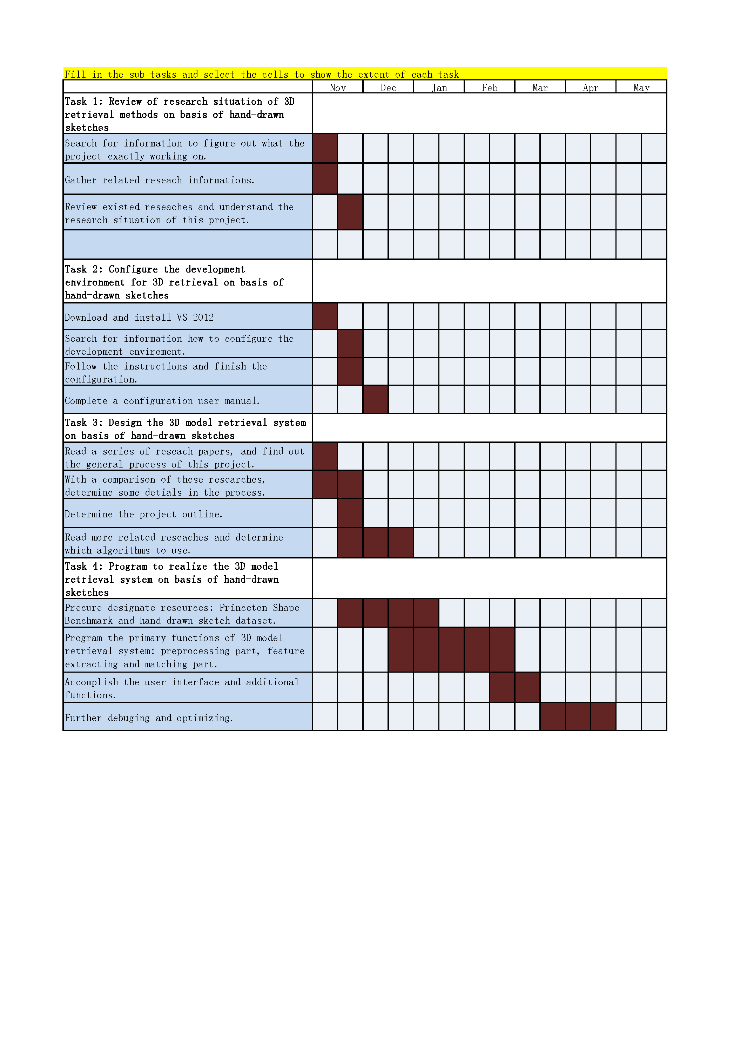







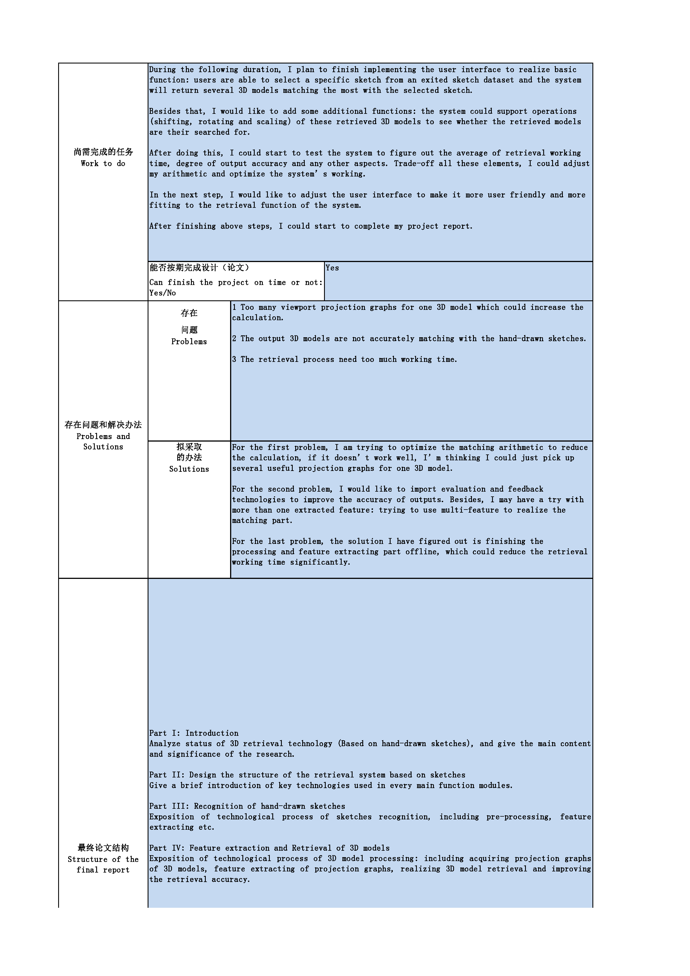



Risk Assessment

The system allows users to select a hand-drawn sketch from directory and send that sketch as query to retrieve. Then it would output several two dimensional projection graphs which are projected by the most matching three dimensional models. By clicking the projection, those corresponding 3D models would be shown to users.

|  |  |  |  |  |
| --- | --- | --- | --- | --- |
| **Description of Risks** | **Description of Impact** | **Likelihood Rating** | **Impact Rating** | **Preventative Actions** |
| **Users have no sketch dataset to input their retrieval query.** | Users need to find another source of sketch input. | 4 | 0 | Users could use sketches they created. |
| **Wrong format input of sketch query** | Retrieval results would be extremely inaccurate | 2 | 2 | Sketch inputs are required as the format of bitmap. Add this attention to users before their retrieving |
| **Wrong environment setting of the system** | System crash down | 1 | 4 | Adding notice to users to ensure their correct environmental configuration. |

Environmental Impact Assessment

This project develops a 3D model retrieval system with hand-drawn sketches as query. By the means of 3D model projection, sketch pre-processing and contour pro-processing, the system could obtain more standard contours to extract feature. And by comparing with the similarity of these features, the system could find the most matching 3D models corresponding to retrieval sketch.

This project has environmental impact to some extent. For 3D project designers, this retrieval system assist them to find target 3D object components, which means they are able to use existing models to build their new model, instead of creating a totally new model. This could not only save users time but also reduce the waste of redundant designing elements.