There are 4 things you should notice.

1. Import project to your IDE.
2. Prepare data for testing.
3. How to run test case.
4. How to check report.

**Import project to your IDE.**

After you donwload the source file from git you will get the project like below

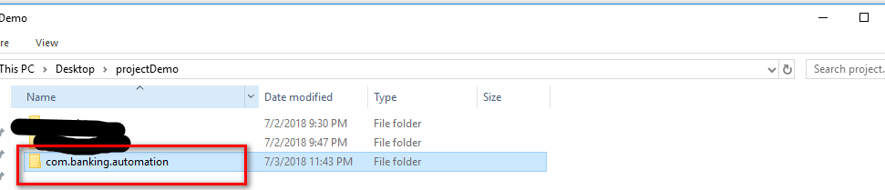

Check the location of pom.xml file

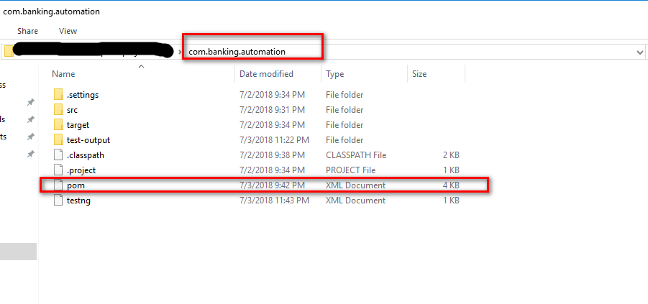

Open the ide and import existing maven project. This project is written in maven project.

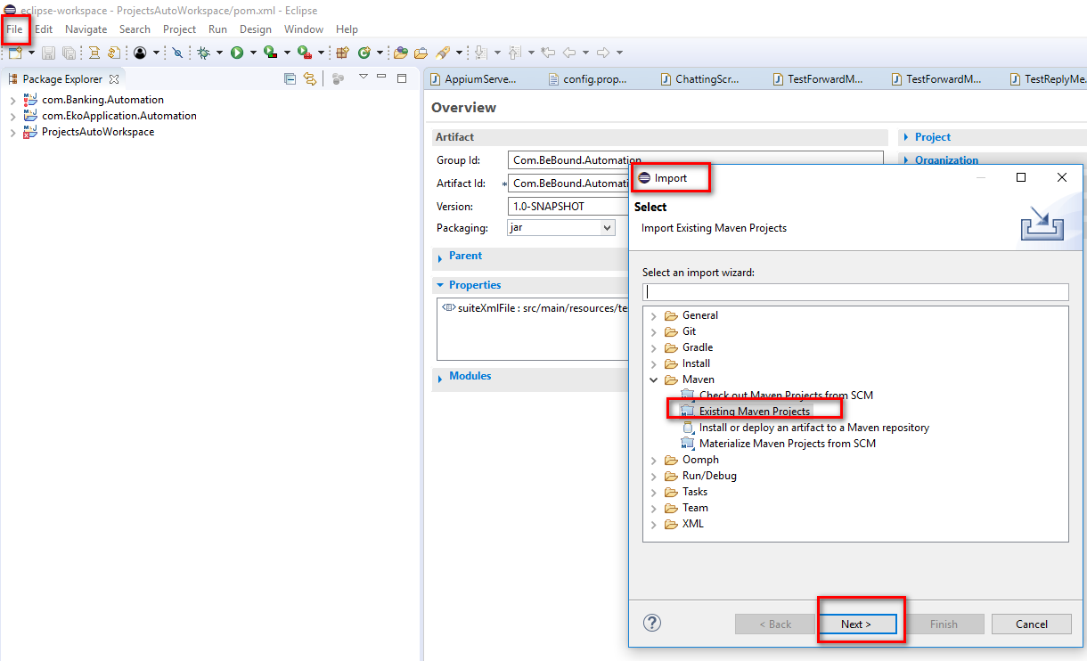

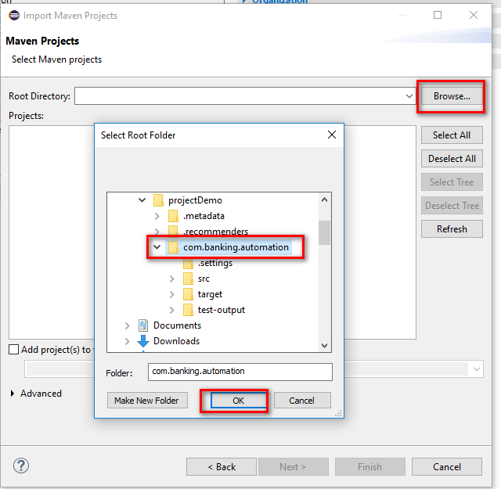

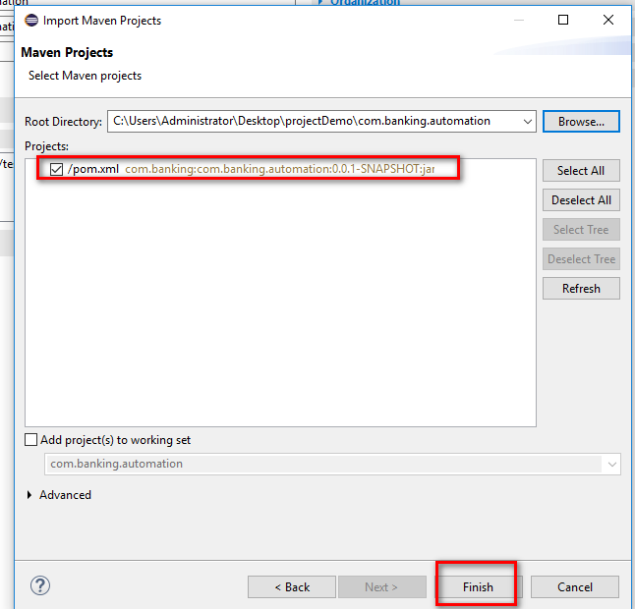

**Prepare data for testing.**

Data for testing will be place in excel file.

Where to find the data excel file:

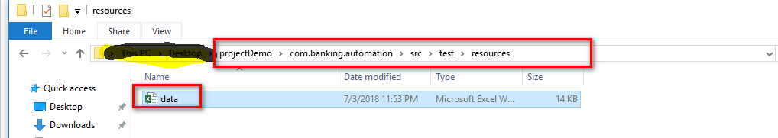

There are 3 main tab:

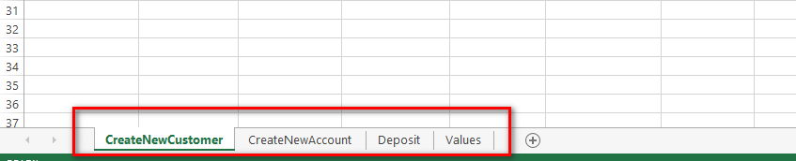

CreateNewCustomer: this tab is used for testing create new customer function.

CreateNewAccount: this tab is used for testing create new account function.

Deposit: this tab is used for testing deposit function.

You can edit test data in these tab for your own testing.

The rest tab is used for another purpose. Just a resource data for other tabs. So dont remove or edit them.

**How to run test case**

The easiest way to run test case is : select class and run as testng.

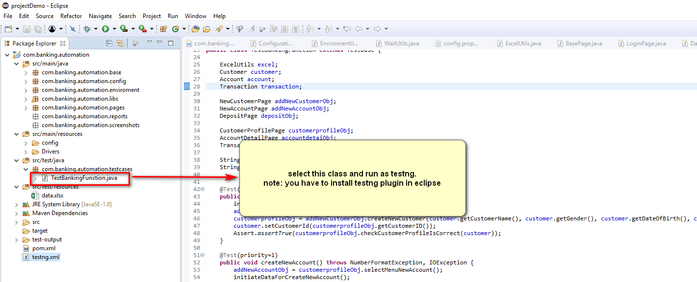

**How to check report.**

After you run the test case. You can check the report in the location

