1. Prepare data for testing

Before you run the test. You have to prepare data for testing.

* 1. What is data file?

“data file” is the file which you input data for testing. Example, for the test case of search a string. You will input the string you want to search in the excel file. When the test runs it will read this file and get the string and input in application.

* 1. Where to find it.

It is located in below path : (your project location)/src/main/resource/Data

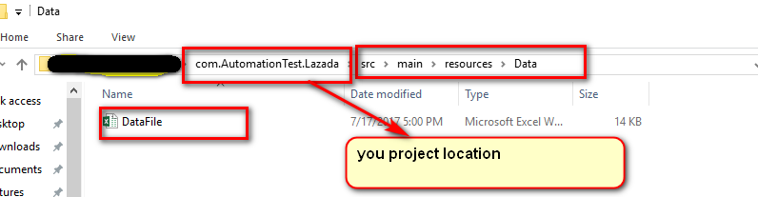

* 1. How to edit the file

1. For test case “search”

You will edit the sheet name “DataSearchProduct”

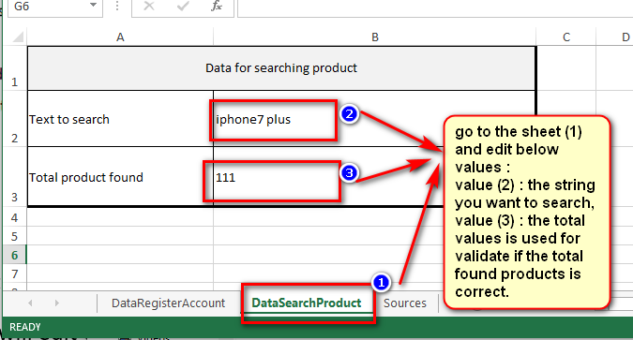

1. For test case “create account”

You will edit the sheet name “DataRegisterAccount”

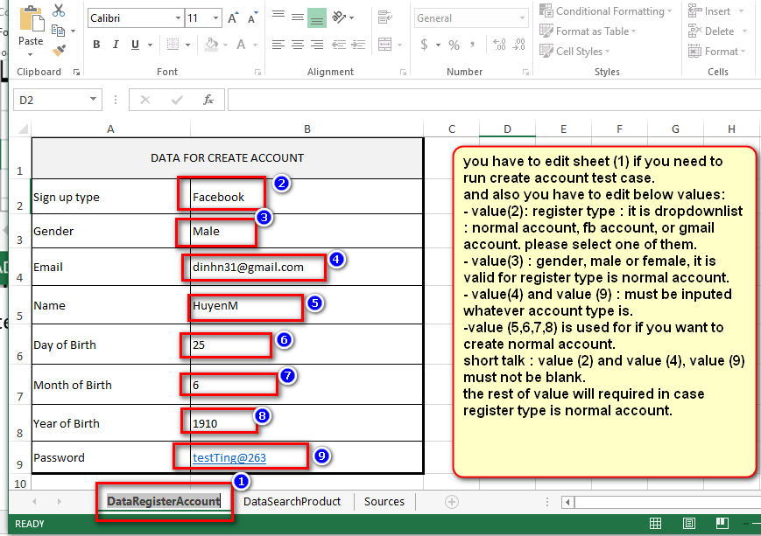

One note

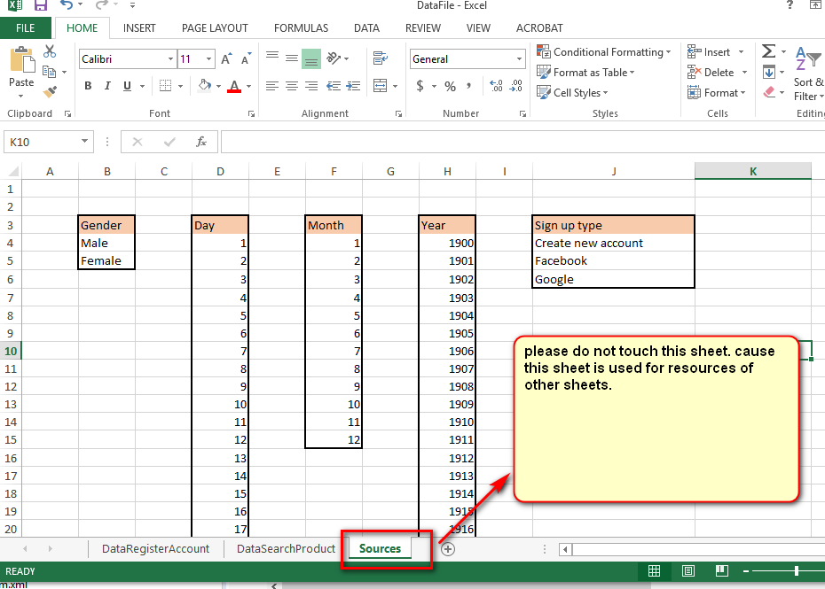

1. How to run test case

After you edit the data file, the next step is run the test case.

1. Import the project to your IDE, it will look like below

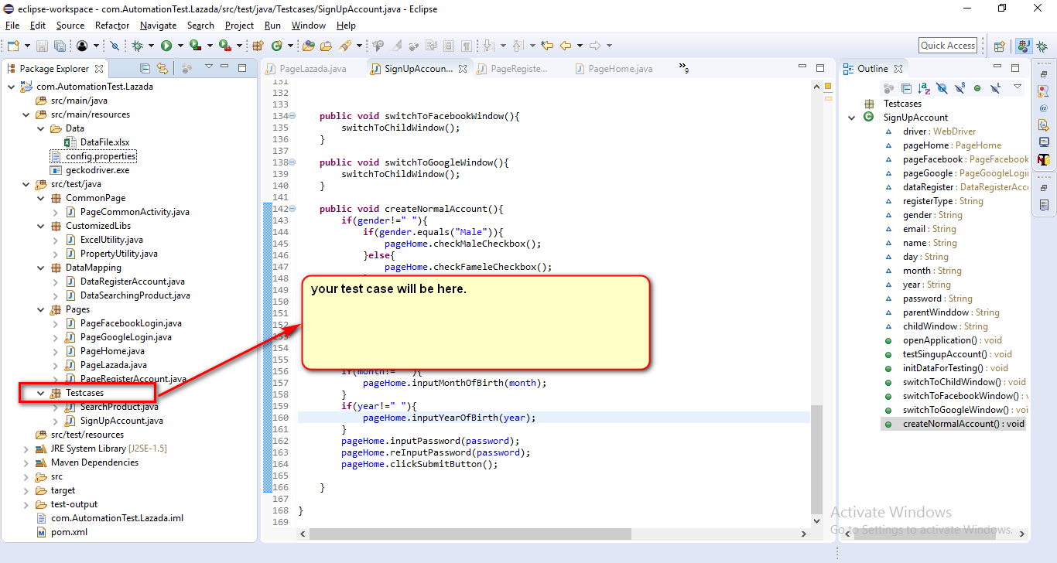

1. Run test case search

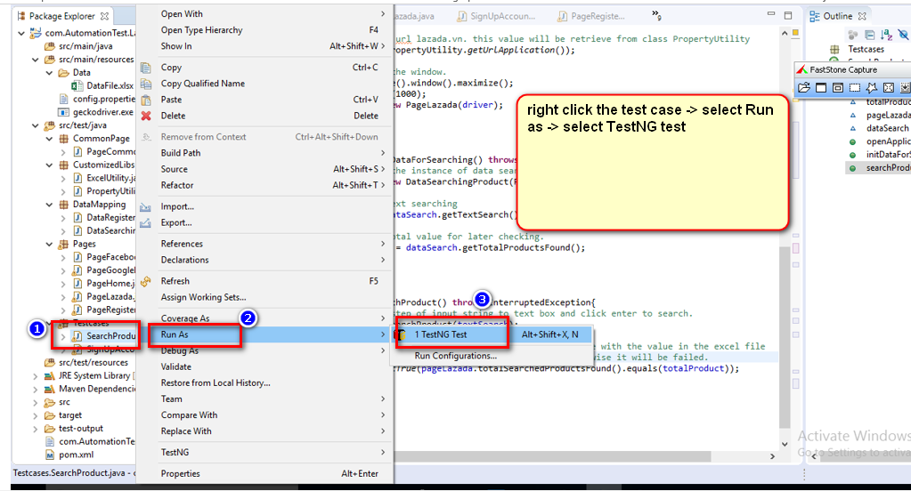

The same case if you want to run test case of create account.

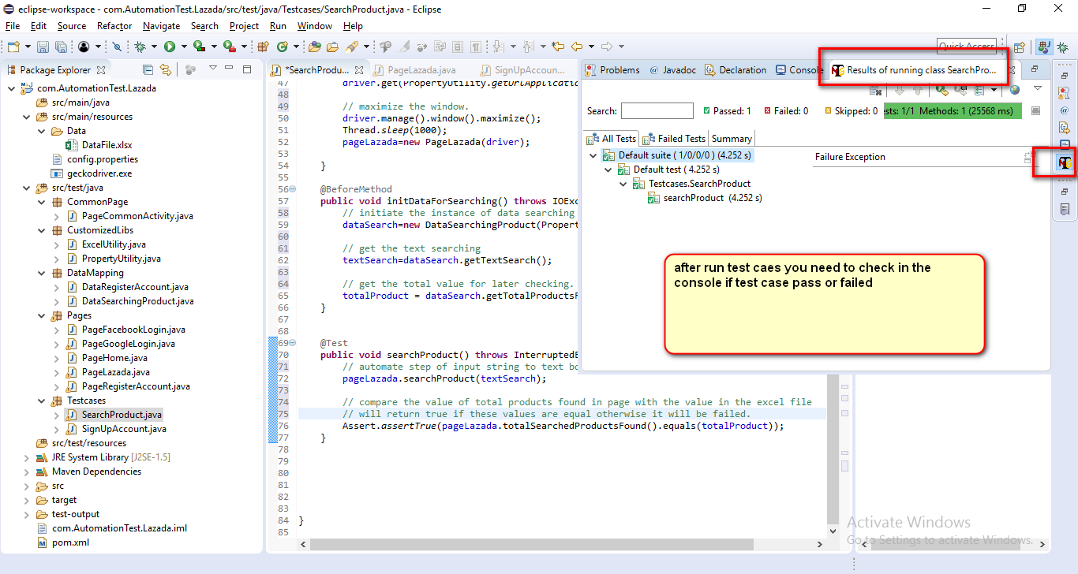

1. Note

For this version of script, truly speaking, there is 1 issue with create account with Facebook, I can not still find the issue yet. The rest of script works well.

The issue is: when we click button to create account via facebook, driver will switch to facebook window, after log in facebook successfully, the driver can not be back the main window. The same step with google account creation. But not sure: the issue does not happen with google account. For google account it works fine. I am still navigating the issue or trying to find some solution to work around