**LAB 8**

Họ tên: Đặng Đình An

Lớp: 11_THMT

MSSV: 1150080001

Bài 1+2:

**AndroidManifest.xml**

<?xml version="1.0" encoding="utf-8"?>  
<manifest xmlns:android="http://schemas.android.com/apk/res/android"  
 xmlns:tools="http://schemas.android.com/tools">  
  
 <application  
 android:allowBackup="true"  
 android:dataExtractionRules="@xml/data_extraction_rules"  
 android:fullBackupContent="@xml/backup_rules"  
 android:icon="@mipmap/ic_launcher"  
 android:label="@string/app_name"  
 android:roundIcon="@mipmap/ic_launcher_round"  
 android:supportsRtl="true"  
 android:theme="@style/Theme.Animalsound">  
  
 <activity  
 android:name=".MainActivity"  
 android:exported="true">  
 <intent-filter>  
 <action android:name="android.intent.action.MAIN" />  
 <category android:name="android.intent.category.LAUNCHER" />  
 </intent-filter>  
 </activity>  
  
  
 <activity  
 android:name=".M000ActSplash"  
 android:exported="false"  
 android:theme="@style/Theme.MaterialComponents.DayNight.NoActionBar" />  
  
 <activity  
 android:name=".ProfileActivity"  
 android:exported="false"  
 android:theme="@style/Theme.MaterialComponents.DayNight.NoActionBar" />  
  
 <activity  
 android:name=".HomeActivity"  
 android:exported="false"  
 android:theme="@style/Theme.MaterialComponents.DayNight.NoActionBar" />  
  
 </application>  
  
</manifest>

**MainActivity.java**

package com.example.animalsound;  
  
import android.content.Intent;  
import android.os.Bundle;  
import android.widget.Button;  
import androidx.appcompat.app.AppCompatActivity;  
  
public class HomeActivity extends AppCompatActivity {  
 @Override  
 protected void onCreate(Bundle savedInstanceState) {  
 super.onCreate(savedInstanceState);  
 setContentView(R.layout.*activity_home*);  
  
 Button btnSplash = findViewById(R.id.*btnSplash*);  
 Button btnProfile = findViewById(R.id.*btnProfile*);  
  
 btnSplash.setOnClickListener(v -> startActivity(new Intent(this, M000ActSplash.class)));  
 btnProfile.setOnClickListener(v -> startActivity(new Intent(this, ProfileActivity.class)));  
 }  
}

**activity_main**

<?xml version="1.0" encoding="utf-8"?>  
<FrameLayout xmlns:android="http://schemas.android.com/apk/res/android"  
 android:id="@+id/main"  
 android:layout_width="match_parent"  
 android:layout_height="match_parent"  
 android:background="@android:color/black">  
  
 <!-- Giao diện chính là Splash -->  
 <include layout="@layout/activity_splash" />  
  
 <!-- Giao diện loading đè lên (hiển thị trong lúc load) -->  
 <include layout="@layout/item_loading" />  
  
</FrameLayout>

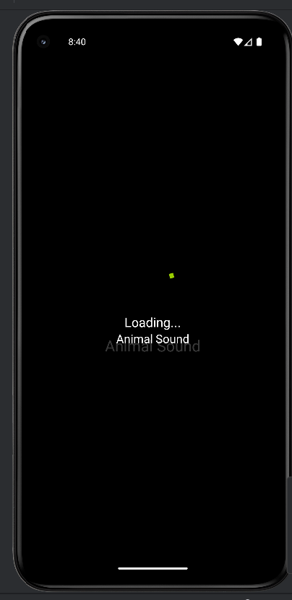

Bài 3: Giao diện profile