Bài thực hành lab3
Họ và tên : Đặng Đình An
Lớp :11_THMT
MSSV: 1150080001
1.Khởi tạo LinearLayout bằng code
package com.example.demoapp;
import android.os.Bundle;
import android.widget.LinearLayout;
import android.widget.TextView;
import androidx.activity.EdgeToEdge;
import androidx.appcompat.app.AppCompatActivity;
import androidx.core.graphics.Insets;
import androidx.core.view.ViewCompat;
import androidx.core.view.WindowInsetsCompat;
public class MainActivity extends AppCompatActivity {
private LinearLayout llNameContainer, llAddressContainer, llParentContainer;
// Tạo LinearLayout chứa Name
private void createNameContainer() {
llNameContainer = new LinearLayout(this);
llNameContainer.setLayoutParams(new LinearLayout.LayoutParams(
LinearLayout.LayoutParams.MATCH_PARENT,
LinearLayout.LayoutParams.WRAP_CONTENT));
llNameContainer.setOrientation(LinearLayout.HORIZONTAL);
TextView tvName = new TextView(this);
tvName.setText("Name: ");
llNameContainer.addView(tvName);
TextView tvNameValue = new TextView(this);
tvNameValue.setText("John Doe");
llNameContainer.addView(tvNameValue);
}
// Tạo LinearLayout chứa Address
private void createAddressContainer() {
llAddressContainer = new LinearLayout(this);
llAddressContainer.setLayoutParams(new LinearLayout.LayoutParams(
LinearLayout.LayoutParams.MATCH_PARENT,
LinearLayout.LayoutParams.WRAP_CONTENT));
llAddressContainer.setOrientation(LinearLayout.HORIZONTAL);
TextView tvAddress = new TextView(this);
tvAddress.setText("Address: ");
llAddressContainer.addView(tvAddress);
TextView tvAddressValue = new TextView(this);
tvAddressValue.setText("911 Hollywood Blvd");
llAddressContainer.addView(tvAddressValue);
}
// Tạo LinearLayout cha chứa tất cả
private void createParentContainer() {
llParentContainer = new LinearLayout(this);
llParentContainer.setLayoutParams(new LinearLayout.LayoutParams(
LinearLayout.LayoutParams.MATCH_PARENT,
LinearLayout.LayoutParams.MATCH_PARENT));
llParentContainer.setOrientation(LinearLayout.VERTICAL);
llParentContainer.addView(llNameContainer);
llParentContainer.addView(llAddressContainer);
}
@Override
protected void onCreate(Bundle savedInstanceState) {
super.onCreate(savedInstanceState);
// Nếu muốn dùng hoàn toàn code -> bỏ activity_main.xml
// EdgeToEdge.enable(this);
createNameContainer();
createAddressContainer();
createParentContainer();
setContentView(llParentContainer);
// Nếu muốn dùng activity_main.xml thì thay vì trên,
// dùng setContentView(R.layout.activity_main);
// và ánh xạ view bằng findViewById()
}
}
Kết quả
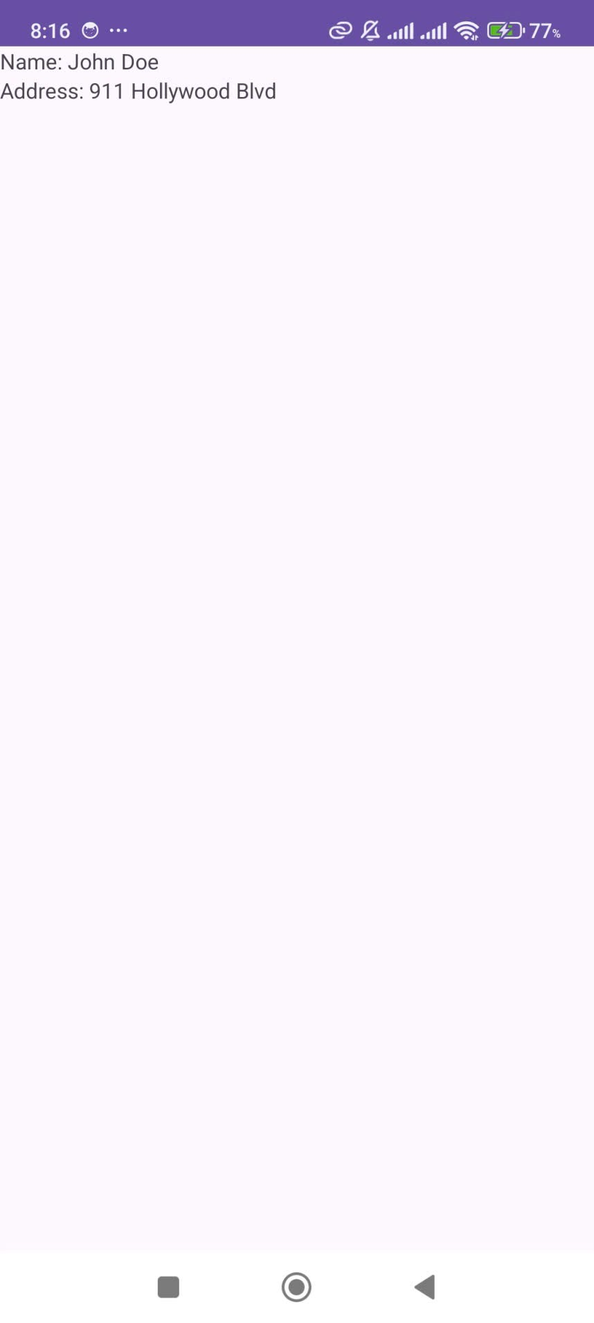
Câu 2:Sử dụng LinearLayout trong file xml
<?xml version="1.0" encoding="utf-8"?>
<resources>
<color name="color0">#FFECB3</color> <!-- ví dụ vàng nhạt -->
<color name="color1">#BBDEFB</color> <!-- xanh dương -->
<color name="color2">#C8E6C9</color> <!-- xanh lá -->
<color name="color3">#FFCDD2</color> <!-- đỏ nhạt -->
</resources>
MainActivity.java
package com.example.demoapp;
import android.os.Bundle;
import android.widget.LinearLayout;
import android.widget.TextView;
import androidx.activity.EdgeToEdge;
import androidx.appcompat.app.AppCompatActivity;
import androidx.core.graphics.Insets;
import androidx.core.view.ViewCompat;
import androidx.core.view.WindowInsetsCompat;
public class MainActivity extends AppCompatActivity {
private LinearLayout llNameContainer, llAddressContainer, llParentContainer;
// Tạo LinearLayout chứa Name
private void createNameContainer() {
llNameContainer = new LinearLayout(this);
llNameContainer.setLayoutParams(new LinearLayout.LayoutParams(
LinearLayout.LayoutParams.MATCH_PARENT,
LinearLayout.LayoutParams.WRAP_CONTENT));
llNameContainer.setOrientation(LinearLayout.HORIZONTAL);
TextView tvName = new TextView(this);
tvName.setText("Name: ");
llNameContainer.addView(tvName);
TextView tvNameValue = new TextView(this);
tvNameValue.setText("John Doe");
llNameContainer.addView(tvNameValue);
}
// Tạo LinearLayout chứa Address
private void createAddressContainer() {
llAddressContainer = new LinearLayout(this);
llAddressContainer.setLayoutParams(new LinearLayout.LayoutParams(
LinearLayout.LayoutParams.MATCH_PARENT,
LinearLayout.LayoutParams.WRAP_CONTENT));
llAddressContainer.setOrientation(LinearLayout.HORIZONTAL);
TextView tvAddress = new TextView(this);
tvAddress.setText("Address: ");
llAddressContainer.addView(tvAddress);
TextView tvAddressValue = new TextView(this);
tvAddressValue.setText("911 Hollywood Blvd");
llAddressContainer.addView(tvAddressValue);
}
// Tạo LinearLayout cha chứa tất cả
private void createParentContainer() {
llParentContainer = new LinearLayout(this);
llParentContainer.setLayoutParams(new LinearLayout.LayoutParams(
LinearLayout.LayoutParams.MATCH_PARENT,
LinearLayout.LayoutParams.MATCH_PARENT));
llParentContainer.setOrientation(LinearLayout.VERTICAL);
llParentContainer.addView(llNameContainer);
llParentContainer.addView(llAddressContainer);
}
@Override
protected void onCreate(Bundle savedInstanceState) {
super.onCreate(savedInstanceState);
// Nếu muốn dùng hoàn toàn code -> bỏ activity_main.xml
// EdgeToEdge.enable(this);
createNameContainer();
createAddressContainer();
createParentContainer();
setContentView(llParentContainer);
// Nếu muốn dùng activity_main.xml thì thay vì trên,
// dùng setContentView(R.layout.activity_main);
// và ánh xạ view bằng findViewById()
}
}
Kết quả
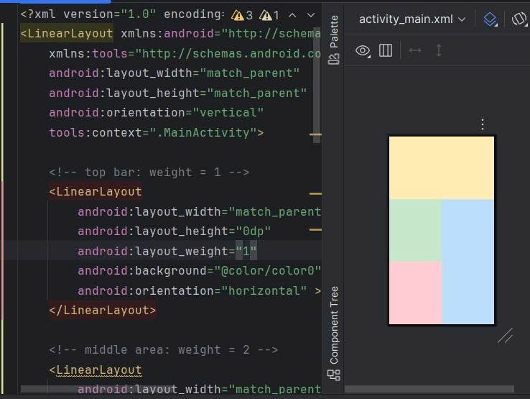

Câu 3: Giao diện đăng nhập
strings.xml
<resources>
<string name="app_name">demoapp</string>
<string name="sign_in">Sign in</string>
<string name="username">Username: </string>
<string name="password">Password: </string>
<string name="signup">Sign up</string>
</resources>
dimens.xml
<?xml version="1.0" encoding="utf-8"?>
<resources>
<dimen name="activity_horizontal_margin">16dp</dimen>
<dimen name="activity_vertical_margin">16dp</dimen>
<dimen name="margin_base">5dp</dimen>
<dimen name="margin_basex2">10dp</dimen>
<dimen name="margin_basex3">15dp</dimen>
<dimen name="margin_basex4">20dp</dimen>
<dimen name="text_small">16sp</dimen>
<dimen name="text_medium">18sp</dimen>
<dimen name="text_large">20sp</dimen>
</resources>

Activity_login.xml
<?xml version="1.0" encoding="utf-8"?>
<RelativeLayout xmlns:android="http://schemas.android.com/apk/res/android"
android:layout_width="match_parent"
android:layout_height="match_parent"
android:paddingLeft="@dimen/activity_horizontal_margin"
android:paddingRight="@dimen/activity_horizontal_margin">
<!-- Tiêu đề -->
<TextView
android:id="@+id/tv_sign_in"
android:layout_width="wrap_content"
android:layout_height="wrap_content"
android:text="@string/sign_in"
android:textAllCaps="true"
android:layout_centerHorizontal="true"
android:layout_marginTop="@dimen/margin_basex4"
android:textSize="@dimen/text_large" />
<!-- Label Username -->
<TextView
android:id="@+id/tv_user_name"
android:layout_width="100dp"
android:layout_height="wrap_content"
android:text="@string/username"
android:layout_below="@id/tv_sign_in"
android:layout_alignParentLeft="true"
android:layout_marginTop="@dimen/margin_basex4" />
<!-- EditText Username -->
<EditText
android:id="@+id/et_username"
android:layout_width="match_parent"
android:layout_height="wrap_content"
android:hint="name@gmail.com"
android:layout_toRightOf="@id/tv_user_name"
android:layout_alignTop="@id/tv_user_name" />
<!-- Label Password -->
<TextView
android:id="@+id/tv_password"
android:layout_width="100dp"
android:layout_height="wrap_content"
android:text="@string/password"
android:layout_below="@id/et_username"
android:layout_alignParentLeft="true"
android:layout_marginTop="@dimen/margin_base" />
<!-- EditText Password -->
<EditText
android:id="@+id/et_password"
android:layout_width="match_parent"
android:layout_height="wrap_content"
android:hint="******"
android:inputType="textPassword"
android:layout_alignTop="@id/tv_password"
android:layout_toRightOf="@id/tv_password" />
<!-- Button Sign in -->
<Button
android:id="@+id/btn_sign_in"
android:layout_width="wrap_content"
android:layout_height="wrap_content"
android:padding="@dimen/margin_base"
android:text="@string/sign_in"
android:layout_below="@id/et_password"
android:layout_alignParentRight="true"
android:layout_marginTop="@dimen/margin_base" />
</RelativeLayout>

loginactivity
package com.example.demoapp;
import android.os.Bundle;
import androidx.appcompat.app.AppCompatActivity;
public class LoginActivity extends AppCompatActivity {
@Override
protected void onCreate(Bundle savedInstanceState) {
super.onCreate(savedInstanceState);
setContentView(R.layout.activity_login); // nhớ tạo activity_login.xml
}
}
kết quả
