Overview
QSOC is a 32-bit RISC-V microcontroller, a training project at Quy Nhon Semiconductors: single core, on-chip memory only, AXI4 system bus, APB4 peripheral bus, fourteen peripheral slaves out to forty pins.
Two constraints shape the design, both from the project's tool licences, not from a product requirement. No flash: the application is downloaded into RAM over a serial port after every reset and run from there. No phase-locked loop (PLL): the whole chip runs from one external clock.
Open-source IP is used wherever a suitable block exists: the core, the buses, the memory controllers, most peripherals. In-house RTL covers only the clock and reset controller, the debug block, and adapters between IPs of different protocols. Each block has an owner and its own spec; this document is the system view.

Features
Technology:
– SMIC 28nm, 20MHz
Core: 32-bit RV32IMC RISC-V CPU (lowRISC Ibex), 20 MHz
– Two-stage pipeline, in-order, machine mode; no branch predictor, 1 cycle penalty on a taken branch
– 1 cycle for add, subtract, shift, logic and compare; 3 for multiply, 4 for the high-half forms, 37 for divide and remainder (upstream figures) [TBD: not confirmed by simulation for this build]
– 32 x 32-bit register file in flip-flops
Memory: 98 Kbytes on chip, no external memory interface
– 2 Kbytes ROM holding the serial bootloader, read-only
– 64 Kbytes instruction RAM: 4 Kbytes debug entry code plus 60 Kbytes application
– 32 Kbytes data RAM, split into ISRAM and DSRAM
Reset and supply
– Active-low reset, 3 sources: power-on, watchdog and software
– Sticky reset cause register; SYSCSR only reset by Power-on reset to keep the value of register
Clock: one external input on a dedicated pad
– One frequency for the whole chip
– Clock gating is allowed for peripherals only, never for the CPU, the buses or the memories
Bootloader preloaded in ROM
– Serial download after every reset: one frame of header, payload and CRC32
– Bootloader fits the 2 Kbyte ROM; Table 13-4 carries the size estimate
– The ROM loads the debug program over UART0 together with the application; the debug interface halts the core into it and does not load the image
Debug over JTAG: halt, resume, memory access without the CPU
– In-house block, control registers reachable only over JTAG and deliberately off the system bus
– 2 hardware breakpoints (they also work in ROM); software ebreak for RAM code. Debug entry code uses the first 4 KiB of ISRAM: no separate debug memory, no program buffer. One master port serves memory access, run control and register reads.
40 pins in four sides of ten, 30 carrying peripheral functions
– Each muxed pin selects one of 4 functions through a two-bit field, all defaulting to the first after reset
– 24 general-purpose I/O in 3 blocks of 8, one interrupt per block; 8 power and ground pins; 2 dedicated for clock and reset; no unused pins in the 40-pin package
Interrupts: 26 sources on 12 wires to the core
– INTMAP is an OR tree: one OR gate per peripheral
– The core identifies the source from mcause, so no register read is needed. Table 8-1 gives the mapping
– The watchdog bark is the one non-maskable interrupt and bypasses INTMAP
– Eleven sources are pulses. Each peripheral records its own event, so none is lost

11 peripheral instances on the peripheral bus
– 2x serial port (UART0/1); UART0 carries the boot download
– 1x SPI master and 1x SPI target sharing one pin group
– 1x I2C, controller or target
– 3x 8-pin GPIO
– TIMER0 and TIMER1: apb_timer_unit, two compare outputs each. TIMER0 chains them into one 64-bit counter, so it raises 1 interrupt; TIMER1 raises 2
– PWM: a separate apb_adv_timer, 16 channels, 8 to pads, 4 event lines, 4 external triggers
– Watchdog: bark interrupt at the first threshold, bite reset at the second. Disabled after reset, lockable. Largest window 3.58 minutes

Block diagram
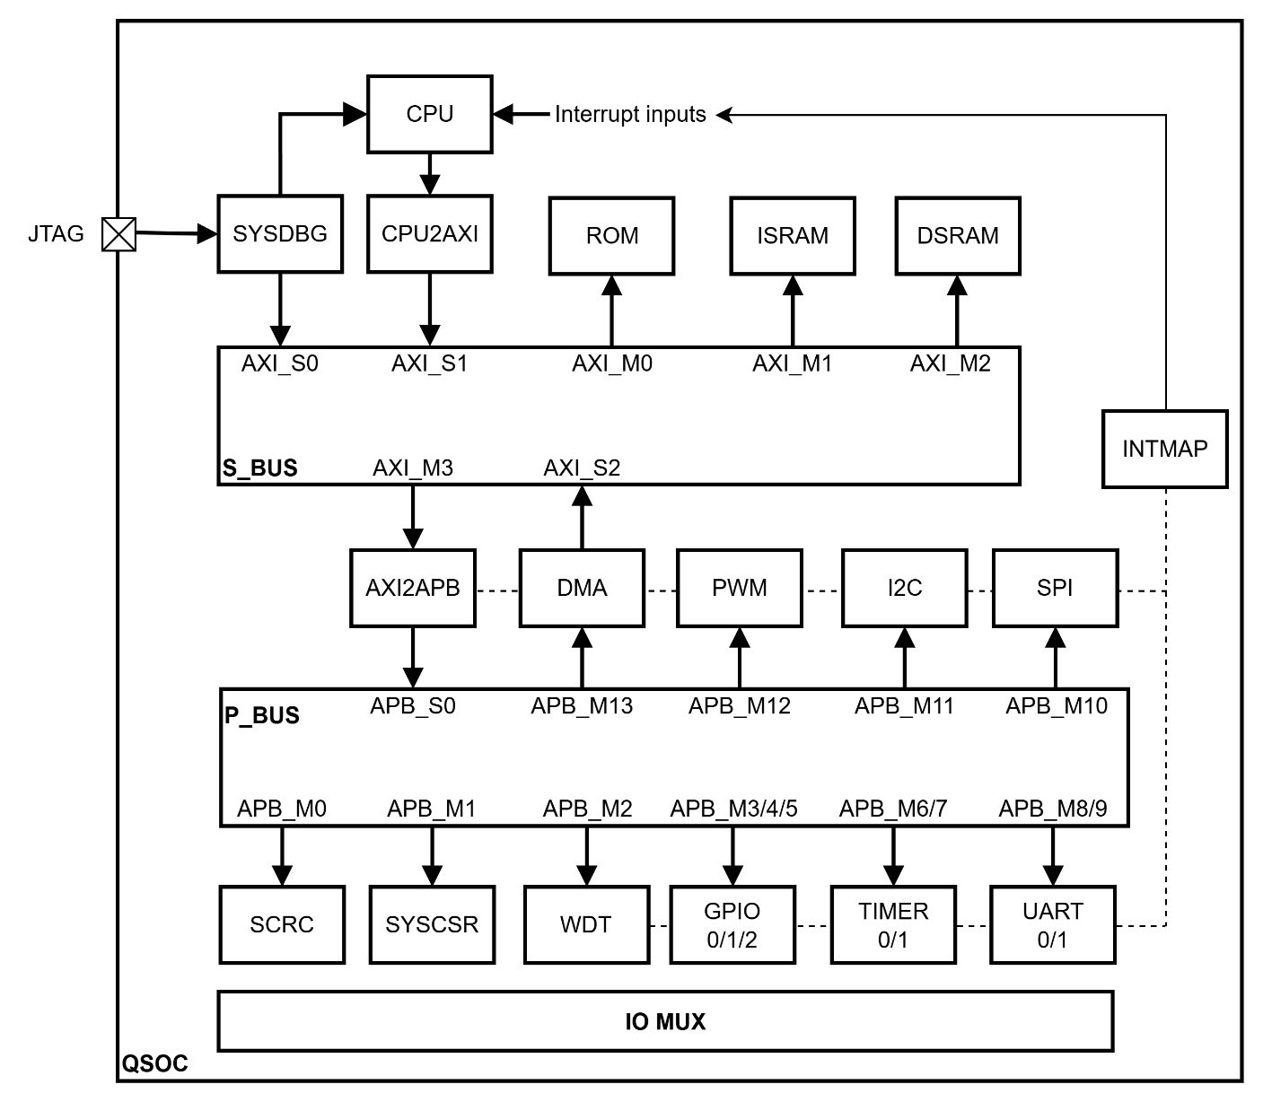

Ibex core
– Executes the program. Provides two memory-style ports, one for instruction fetch and one for data, plus eleven fast interrupt inputs and one non-maskable interrupt input wired in this chip
CPU2AXI
– Converts each core port to the system bus protocol and merges them into one bus port, so the core takes one slave port instead of two
SYSDBG
– The debug block. Takes JTAG, halts and resumes the core, reads and writes memory over its own bus port without involving the core
– Its control registers respond only over JTAG and are not on the system bus, so software on the core cannot grant itself debug access
S_BUS
– The AXI4 crossbar. Routes three access sources to four destinations by address
– Returns a decode error for every unmapped address, which the memories themselves cannot do
ROM
– Holds the bootloader. Its content is fixed when the design is built, and it is made read-only by tying its write channel to the idle state
ISRAM
– Instruction memory. Holds the debug entry code in the first 4 Kbytes and the downloaded application in the upper part
DSRAM
– Data memory. Being separate from the instruction memory means a stack overflow cannot overwrite the running program
AXI2APB
– The bridge between the two buses, built as two modules in series: full AXI4 to the lite version of AXI, then lite AXI to APB
– Also splits bursts, which only the DMA generates and the peripheral protocol does not support
P_BUS
– The APB4 router. Subtracts each target's base address before forwarding, so every peripheral sees its registers starting at 0
– Answers an unmapped address itself in the same cycle, so the bus never hangs
SCRC (System Clock Reset Control)
– Takes the single external clock, merges the three reset sources, and distributes gated clocks and synchronised resets to every domain
– Two register windows on the peripheral bus: control registers at APB_M0, status registers (SYSCSR) at APB_M1. The clock and reset logic itself is not addressable
SYSCSR
– The status half of SCRC: reset cause, domains held in reset, chip ID, debug-boot gate and CPU crash information. Mostly read-only; every control bit (clock gating, software reset) is in the control window at APB_M0
INTMAP
– An OR tree combining 25 sources onto the eleven fast interrupt lines irq_fast_i[10:0]. Not a bus slave: no registers, no address, no flip-flops, so it adds no cycle between a peripheral and the core
– Written in-house: an OR tree and a concatenation with no state and no status register, which removes the bus port and releases AXI_M4
IO MUX
– Selects which peripheral signal reaches each pad, and holds the select registers
– A wide combinational select network with no clock or reset, plus the registers that control it
WDT
– The watchdog. Raises an early warning interrupt at the first threshold and a reset request at the second
TIMER0 and TIMER1
– Two apb_timer_unit instances, two compare outputs each, no channel pin. TIMER0 in 64-bit mode gives 1 interrupt source; TIMER1 as two 32-bit units gives 2. The interrupt is a pulse when periodic, a held level in one-shot. TIMER0's clock gate is open out of reset (timebase); TIMER1's starts closed.
PWM
– One apb_adv_timer: four independent 16-bit modules, four channels each, sixteen channel outputs. Eight reach pads as PWM_0–PWM_7 (modules 0 and 1), giving two independent base frequencies. Four event lines to INTMAP, each a one-cycle pulse selecting one of the sixteen channels.
– Different IP from TIMER0/1; the four modules inside apb_adv_timer are also called Timer0–Timer3. TIM_EXT0–TIM_EXT3 go to ext_sig_i[3:0], upper 28 bits tied 0. Closing the PWM clock gate freezes the outputs at their current level, which is not a safe state for a power stage.
UART0 and UART1
– 16550-compatible serial ports. The first port carries the boot download
SPI master and SPI target
– Two separate IPs sharing one peripheral port and one pin group, so only one role is active at a time
I2C
– The two-wire bus controller. Needs three signals per line and open-drain pads with external pull-up resistors
GPIO0 to GPIO2
– Eight pins per block, with direction control, input synchronisation and interrupt generation
DMA
– Moves blocks of data between the memories without the core. Configured over the peripheral bus, moves the data on the system bus

Clock and Reset

Clock List
One root buffer takes the pin clock and drives 18 domain controllers, one per domain. Each controller holds one library clock gate and one reset synchroniser, and the clock gate is the only cell on a clock path after the root buffer. Seven domains are never gated. That is a design rule, not a default: their gate enables are tied active, so no register value can stop them.
Table 4-1. Clock gating rule
Domain group | Gate | Why
CPU, System BUS, Peripheral BUS, ROM, RAM, SYSDBG, WDT | Tied on, no register controls it | Gating any of these removes the agent that would have to re-enable them, or the watchdog that supervises the firmware. Nothing would be left awake to recover
Peripherals: TIMER0/1, UART0/1, SPI (SPI Host and SPI Device share one domain), I2C, GPIO0/1/2, DMA (configuration port), PWM: 11 domains | Requested through CLK_EN in SCRC, applied by the SCRC MCPU | These are the only blocks whose clock can be stopped for power without stranding the system

A gated peripheral must still answer the bus. Each of the 11 gateable APB slaves sits behind an APB guard. The guard is designed with SCRC but instantiated in the chip top, and it runs on the peripheral bus clock, which is never gated. The guard follows APB_BLK, not CLK_EN. APB_BLK is written only by the SCRC MCPU, which closes the guard and waits until no transfer is in progress before it stops the clock. When it starts the clock again, it reopens the guard only after the clock runs. A transfer to a blocked slave completes with PSLVERR, which reaches Ibex as a load or store access fault. Nothing restarts the clock automatically and nothing retries: software writes CLK_EN, then repeats the access itself.

Reset List
Reset is built in two stages. The first stage makes one chip reset:
– Power-on passes a glitch filter and a synchroniser built from library cells.
– The watchdog request passes a 2-FF synchroniser and goes into the Reset Request Controller (RRC), together with the software request.
– The RRC latches either request and holds the chip reset for exactly 16 cycles. A plain OR is not enough, because both requests would be cleared by the very reset they cause.
The second stage gives every domain its own synchroniser, clocked by that domain and released under SCRC control (RST_REL).
Table 4-2. Reset sources
Source | Path | Note
Power-on reset | Filter and synchroniser | Resets everything, SYSCSR and SYSDBG included. No stretch: every domain stays in reset until the SCRC power-up sequence releases it
Watchdog bite | Synchronised into the RRC | Chip reset of 16 cycles. Resets every domain, CPU included, except SYSDBG and SYSCSR
Software reset | SW_RST bit in SCRC, into the RRC | Same path and same effect as the watchdog bite: the whole chip, CPU included. Firmware reads RESET_CAUSE after the restart

There are three sources, not five: the external reset pin and the debugger request were both removed in the design review of 18/09/2026. There is no priority between the sources. If two requests coincide, both cause bits are captured, so RESET_CAUSE can show more than one bit. SYSCSR is reset only by power-on, so the cause survives a watchdog or software reset and can be read after the restart.
There is no per-peripheral reset. No IP can report that it is hung, so recovery has a single level: a chip reset (the watchdog bite, or firmware writing SW_RST). SYSDBG can halt the CPU with the debug request, but that is not a reset source and sets no cause bit.
Two ordering constraints are mandatory, and neither can be verified by simulating a block on its own:
– The debug block must leave reset before the CPU, so that a debug request can reach the core as soon as it runs ROM code. The SCRC power-up sequence releases the CPU last.
– The debug block's core must sit outside every reset tree except power-on. If a system reset dropped it too, issuing that reset would kill the JTAG link at the moment it is needed, and the host would see the target disappear with no explanation. Only SYSDBG's system-bus side follows the system-bus reset, so that a watchdog or software reset leaves no half-finished bus handshake.

Clock Relationship
Every domain derives from the same root, so all domains are synchronous to each other and no clock-domain crossing is needed anywhere in the functional path. Inside SCRC, only the watchdog request is synchronised. The only real crossings belong to the debug block: the JTAG TAP runs on the adapter's own clock, which is free to stop between commands, and the system side runs on the chip clock. Neither side may wait on an edge of the other.

SCRC sequencing
SCRC is not a hard-wired state machine. Its sequencing is software, run by a small MCU (MCPU): a MRV-CPU RV32I core with a 13-instruction subset, its own program ROM, and an APB master port. MCPU is the only agent that opens a clock gate, releases a domain reset or opens an APB guard. Ibex only writes requests: SW_RST and CLK_EN.
MCPU's program has two parts:
– Power-up sequence, which runs after every chip reset:
a. Enable the clocks requested in CLK_EN.
b. Release every domain except the CPU in one write.
c. Open the guards of the running peripherals.
d. Release the CPU last.
– Idle loop. MCPU polls CLK_EN, compares it with the state it has applied, and stops or starts each domain that changed:
– stop: close the guard, wait until idle, gate the clock;
– start: ungate the clock, wait 3 cycles, open the guard.
MCPU polls and does not use an interrupt, and only the last value written to CLK_EN matters, so firmware may write CLK_EN back to back. SW_RST does not go through MCPU at all: it goes straight to the RRC.

BUS
QSOC has two buses joined by a bridge. The system bus carries the heavy traffic - instruction fetch, data reads and writes, debug accesses, DMA transfers. The peripheral bus carries register accesses, which are sparse and not worth a dedicated AXI port per block.

S_BUS
Table 5-1. S_BUS configuration
Item | Value | Reason
Protocol | AXI4 full | -
Address width | 32 bits | Matches the CPU core
Data width | 32 bits | Matches the CPU core and the memories
Slave ports | 3 | SYSDBG, CPU core, DMA
Master ports | 4 | ROM, ISRAM, DSRAM, AXI2APB bridge
Identifier width | 1 bit at the slave ports, 3 at the master ports | The crossbar adds log2(number of slave ports) bits so IDs stay unique after merging
Outstanding transactions | 4 per slave port, 8 write-order depth per master port | Transactions allowed in flight awaiting a response
Register stage | None (NO_LATENCY) | No spill register on any channel; not needed at 20 MHz (50 ns per cycle)
Connectivity | Every slave port reaches every master port, except the DMA (AXI_S2), which cannot reach ROM or ISRAM | The DMA only accesses data RAM and peripherals. A blocked access gets DECERR from the crossbar and never reaches the memory. The matrix blocks read and write together.
AxiIdUsedSlvPorts | 1 | Number of low ID bits the demultiplexer compares. Equal to the slave-port ID width (1 bit).
AtopsEnable | 1'b0 | AXI5 atomic operations off. The core has no A extension and the DMA sends no atomics.
Fall-through | 1'b0 | Off, so the AW and W channels do not form a long combinational path.
Pipeline stages | 0 | None; not needed at 20 MHz (50 ns per cycle).
Unique IDs | 1'b0 | Off, because the CPU2AXI bridge does not issue unique IDs.
Number of address rules | 4 | Matches the 4 master ports. With 5, a rule would route the removed PLIC window to a port that no longer exists instead of raising an error.

Table 5-2. S_BUS ports
Port | Connects to | Note
AXI_S0 | SYSDBG | SYSDBG's AXI4 manager drives this port directly; no adapter needed
AXI_S1 | CPU2AXI | Converts both of the core's memory ports and merges them onto one slave port
AXI_S2 | DMA | DMA. [TBD: DMA owner]
AXI_M0 | ROM | 0x0000_0000 to 0x0000_07FF
AXI_M1 | ISRAM | 0x2000_0000 to 0x2000_FFFF
AXI_M2 | DSRAM | 0x3000_0000 to 0x3000_7FFF
AXI_M3 | AXI2APB bridge | 0x8000_0000 to 0x8003_7FFF

The two buses use opposite end-address conventions. The crossbar treats the end address as exclusive: a rule takes the table value plus one, otherwise the last byte of every region raises a decode error. The peripheral bus treats it as inclusive. The crossbar overlap check exists only in simulation. The AXI_M3 window is 224 KiB (the 14 populated P_BUS slots); the two spare slots, 0x8003_8000 to 0x8003_FFFF, are outside it, so an access there gets DECERR from the crossbar and never reaches P_BUS.

P_BUS
Table 5-3. P_BUS configuration
Item | Value | Reason
Protocol | APB4 | Most peripheral IP exposes an APB slave
Address width | 18 bits in, 14 bits out to each peripheral | Sixteen 16 KiB slots need 18 bits at the input. Each peripheral receives only the 14-bit offset.
Data width | 32 bits | Matches the system bus
Slave ports | 14 used, 2 spare, 16 KiB each | A uniform stride lets the decoder compare a fixed field. The 14 peripherals are packed from APB_M0; the two empty slots, APB_M14 and APB_M15, are at the top. They are outside the 224 KiB AXI_M3 window, so S_BUS answers DECERR first; if the window is ever widened, the router's default branch returns an error in the same cycle.
Byte strobe | Present on the bus | Needed for byte writes; two peripherals do not implement it and need a wrapper
End address convention | Inclusive (<=) | The system bus uses the opposite (exclusive) convention; see the note after Table 5-2.
Address rebase | Offset truncated to the slave's address width: 14 bits per 16 KiB slot | The router emits o_paddr = N'(i_paddr - base). Each slot is 16 KiB, so 14 bits lose nothing. Whether registers repeat inside a slot is up to the peripheral.
Sequential logic | 0 flip-flops | With a single master (the AXI2APB bridge) the router is plain combinational logic, so no cycle is added. A timeout is therefore not possible.
Error response | Yes | Used by the router for unmapped addresses. A gated peripheral would never return PREADY and would stall the CPU; SCRC's APB guard, one per gateable slave, answers a blocked access with PSLVERR in the same cycle.

Table 5-4. Slave allocation on P_BUS
Port | Block | Base address
APB_M0 | SCRC | 0x8000_0000
APB_M1 | SYSCSR | 0x8000_4000
APB_M2 | WDT | 0x8000_8000
APB_M3 | GPIO0 | 0x8000_C000
APB_M4 | GPIO1 | 0x8001_0000
APB_M5 | GPIO2 | 0x8001_4000
APB_M6 | TIMER0 | 0x8001_8000
APB_M7 | TIMER1 | 0x8001_C000
APB_M8 | UART0 | 0x8002_0000
APB_M9 | UART1 | 0x8002_4000
APB_M10 | SPI wrapper | 0x8002_8000
APB_M11 | I2C | 0x8002_C000
APB_M12 | PWM | 0x8003_0000
APB_M13 | DMA configuration | 0x8003_4000
APB_M14 | Unused, outside the AXI_M3 window (S_BUS returns DECERR) | 0x8003_8000
APB_M15 | Unused, outside the AXI_M3 window (S_BUS returns DECERR) | 0x8003_C000

Protocol Adapter
Some IP does not speak the protocol of the bus it attaches to, so an adapter is needed: the CPU core emits no AXI; two peripheral blocks use a different register bus protocol [pending confirmation with the bus owner]; the DMA adapter is [TBD: DMA owner]. Most of the adapter logic already exists in the IP families the project uses.
The four debug parameters (DmBaseAddr, DmAddrMask, DmHaltAddr, DmExceptionAddr) are core parameters, not bus adapters; see Table 6-4 rows 19 and 20.
Table 5-6. Mandatory protocol conversions
Location | From | To | Why it cannot be skipped
S_BUS slave port AXI_S1 (CPU2AXI) | Ibex req/gnt/rvalid memory interface, two ports | AXI4 full, one port | The core's two memory ports use a req/gnt/rvalid handshake with no channels, IDs or bursts. Each port is converted with axi_from_mem and the two are merged with axi_mux. The Ibex RTL never uses the string OBI; axi_from_mem calls this interface mem.
S_BUS slave port AXI_S2 | [TBD: DMA owner] | [TBD: DMA owner] | [TBD: depends on the DMA IP]
P_BUS port APB_M2 (WDT) | APB4 | TL-UL | The watchdog is a TileLink Uncached Lightweight slave, not APB. It has registers only and one outstanding transfer, so no queue or burst handling is needed
Inside APB_M10 (SPI master) | APB4 | TL-UL | Also a TileLink slave: one register block six address bits wide, no buffer window, so the adapter only converts register accesses

CPU

CPU Block Diagram
Two stages: IF and ID/EX. IF generates the program counter, fetches and expands compressed instructions. ID/EX decodes, reads the register file, executes, does the memory access and writes back; there is no separate writeback stage. A prefetch buffer keeps the fetch port busy; with no branch predictor a taken branch discards the prefetch and costs at least one cycle [TBD: upstream documentation gives two cycles in this configuration; not confirmed by simulation for this build].
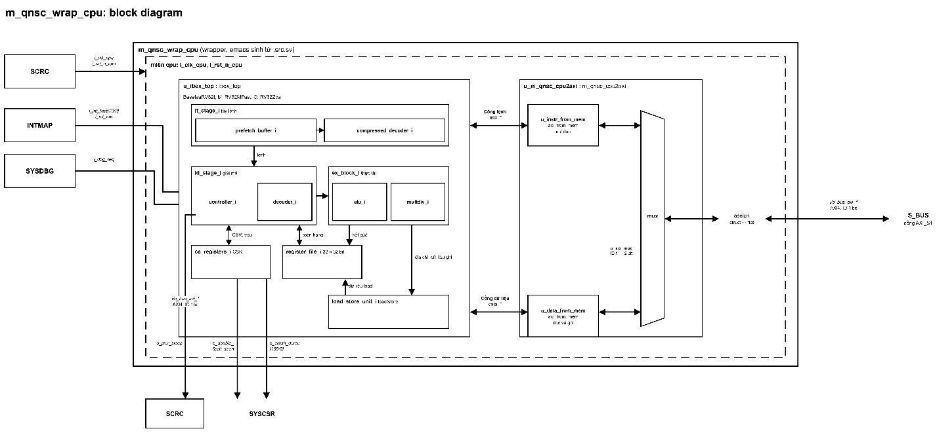

Interfaces
Table 6-1. Interface groups
Group | Signal count | Data direction | Purpose
Instruction | 6 | Read only | Instruction fetch. Request and address go out; grant, valid, data and error come back. No write path
Data | 9 | Read and write | Data reads and writes: the same handshake plus write enable, write data and four byte enables
Interrupts | 5 signals, 19 wires | In | Software, timer and external interrupt (tied 0), fifteen fast interrupts (eleven wired, four tied 0), one non-maskable interrupt
Debug | 1 | In | Request to enter debug mode
Clock, reset, boot and status | 8 | Both directions | Clock, active-low reset, boot address, hart ID, sleep status output, fetch enable, test_en_i, scan_rst_ni. In the QSOC wrapper only the clock, reset, debug request and sleep status are ports; the rest are tied to constants

The core has two memory ports with a request-and-grant handshake and the system bus is AXI4, so the adapter translates and merges them into one slave port. Table 6-2 lists what it must get right.
Table 6-2. Requirements on CPU2AXI
No. | Requirement | How it is done | If it is missing
1 | Choose between the two ports when both request in the same cycle | Round-robin in the axi_mux that merges the two ports. A data access can wait one cycle behind an instruction fetch; accepted so the bridge is built from stock IP | One of the two requests is dropped
2 | Keep the byte enables on a write | The byte enables from the data port are passed straight to the bus. The instruction port has no write path | A single-byte write rewrites the whole word
3 | Return each response to the port that asked | axi_mux puts the port index in the top ID bit and routes each response back by it; one port always uses the same ID, so responses return in order. Each axi_from_mem allows two requests in flight (MaxRequests = 2), matching the two outstanding fetches of the prefetch buffer | An instruction response returned on the data path corrupts data with no error
4 | Never drive a write from the instruction port | Instruction requests take the read path only | A write would be issued on a port that has no write path
5 | Transfer one word at a time | Every access is a single beat of four bytes; only the DMA bursts | A burst would have to be split again at the peripheral bridge
6 | Report a bus error to the core | The bus response is wired to the core's error inputs on both ports | A failed access looks like a successful one
7 | Give the two ports different identifiers so their transactions can overlap | axi_mux: the port index becomes the top ID bit, so instruction and data never share an ID | Responses of overlapping transactions with one ID cannot be told apart

CPU2AXI converts both memory ports and merges them through a round-robin axi_mux, with byte enables applied so single-byte and half-word writes do not corrupt neighbouring bytes.

CPU Operation Modes
Table 6-3 lists the core's own states; chip-level modes are in Table 12-1. After the table: how the core enters and leaves sleep.
Table 6-3. Core states
State | How it is entered | What runs | What is active
Machine mode | After reset, and after any trap | All code: bootloader, application, interrupt handlers | Everything. User mode exists in the core but is not used; machine-only is a firmware convention, not a hardware boundary
Sleep | Executing the wait-for-interrupt instruction while no enabled interrupt is pending | Nothing. The pipeline is halted and the core stops its own clock | Core clock gate closed, sleep status output high. Reopened by an enabled interrupt, the non-maskable interrupt, a debug request, being in debug mode, or single-step. The core never wakes itself
Debug mode | The debug block raises the request input, a breakpoint instruction executes, or a hardware trigger matches. The debug block never holds the core in reset; a request is useful once the ROM has loaded the debug program (the dispatch loop comes from the frame), so the host raises it after the download. | The dispatch loop and command sequences at the debug halt address | Ordinary interrupts and the non-maskable interrupt are ignored. Memory is accessed over the debug block's own bus port, no halt needed. Reading a CPU register needs the halt: the debug block writes a short instruction sequence into the debug window, the core executes it and stores the value to a known address, and the debug block reads that.
Entering sleep needs no register write. Firmware executes the wait-for-interrupt instruction; the controller drops its busy flag, stops issuing instruction requests and flushes the decode stage, then enters the sleep state. With the busy flag clear, the core's clock enable falls and the internal clock gate stops the core clock. The sleep status output is the inverse of that enable.
Sleep is left by one of five events: an enabled interrupt, the non-maskable interrupt, a debug request, being in debug mode, or single-step. The core then re-fetches and, if the interrupt is also enabled globally, takes the handler. Nothing else wakes it: there is no timer in the core and no register a host can write.
Two properties firmware depends on. The wake-up is qualified by the per-source enable only, not the global enable: with every per-source enable clear, only the non-maskable interrupt or a debug request wakes the core. Clearing the global enable still allows wake-up: the core resumes after the wait without taking the handler, the usual way to wait for an event without an interrupt routine. In debug mode and single-step, wait is a no-op.
The core stops only its own clock. The CPU domain is always on (Table 4-1), so wait does not interact with SCRC. The sleep status leaves the wrapper as o_pwr_sleep; it has no destination because QSOC has no power manager.

The CPU clock must never be gated externally: the core_busy flip-flop sits ahead of the internal clock gate, so an external gate would stop it and leave the core asleep permanently. SYSDBG does not hold the core; to halt it, SYSDBG raises debug_req.
Three firmware traps: clearing every bit in mie before wfi leaves only the non-maskable interrupt or a debug request to wake the core; dcsr.ebreakm resets to 0, so ebreak does not by itself enter debug mode; the debug resume/halted-flag range 0x2000_0000–0x2000_07FF is inside the debug window, below the dispatch loop.

Features and Configurations
Each row gives the option, QSOC's pick and the reason. Rows that differ from the published reference configuration for a core of this size say so.
Table 6-4. CPU configuration
No. | Feature | Options | QSOC | Reason: when present, and when absent
1 | Base integer instruction set | RV32I / RV32E | RV32I | RV32I has 32 registers and runs the standard compiler and prebuilt libraries unmodified. RV32E saves flip-flops but forces more register spills, which inflates code, and code size is the constrained resource because the program lives in RAM.
2 | Multiply and divide | None / slow / fast / single cycle | Fast | Multiply takes three cycles and divide iterates in hardware, per upstream documentation [TBD: not confirmed by simulation for this build]. With none, multiply costs tens of cycles in library functions, too slow for the bootloader checksum and timer maths. Single-cycle puts a wide multiplier on the critical path for a gain nothing needs.
3 | Bit manipulation | None / subsets | None | Not needed: the chosen libraries do not use it. It is not part of the base architecture, so code using it would no longer build for plain RV32I.
4 | Compressed instructions | Zca / Zca+Zcb / Zca+Zcb+Zcmp | Zca | Zca (16-bit encodings) cuts code size by about a quarter, which gives the application more space, and matches the rv32imc string the toolchain emits by default. Zcb and Zcmp compress more but enlarge the decoder and were not chosen; they deserve measurement later.
5 | Register file style | Flip-flop / latch | Flip-flop | Flip-flops synthesise everywhere, including FPGA. A latch-based file is smaller for ASIC but needs clock-gating support and does not map to FPGA.
6 | Third pipeline stage | Yes / no | No | Without it the register write happens in the second stage: smaller core, shorter branch penalty. With it, read data can be forwarded for higher throughput at the cost of area, not worth it for peripheral drivers. Consequence: with no writeback stage, every data access stalls the core until the data returns, which is why each peripheral write through the shared bridge is expensive.
7 | Branch target adder | Yes / no | No | A separate adder removes one cycle on taken branches at the cost of a second adder. The reference configuration for this size leaves it out and so does this design, since nothing measured justifies the area.
8 | Branch predictor | Yes / no | No | Without it every taken branch empties the prefetch buffer. A predictor avoids that bubble, but its storage is large for a core this small and a misprediction costs more than the bubble. At this frequency the bubble is cheap.
9 | Instruction cache | Yes / no | No | The program is in on-chip RAM a few cycles away, so a cache would only add tag memory, data memory and a fill state machine, and make fetch timing variable.
10 | Security hardening | Yes / no | No | With it the whole core is duplicated and compared every cycle, and memory error correction widens both memory interfaces from 32 to 39 bits for every memory. That is a system-wide change for a threat model this project does not have.
11 | Memory protection | Yes / no | No | Disabled (PMPEnable = 0), so the debug window is protected by convention, not hardware. Enabling it would use three of the four checkers and require the wrapper parameter to change.
12 | Number of protection regions | Up to 16 | 4, inert while row 11 is No | Inert while row 11 is No. Left at 4, the ibex_top default, so enabling protection later starts from a real number.
13 | Protection granularity | 0 and up | - | Not applicable while protection is disabled
14 | Debug support | Always present, not parameterisable | Yes | Not a choice: the core has no parameter that removes the debug part (request pin, debug mode, dcsr, dpc). Only the number of triggers is selectable (row 15). Listed to state that QSOC uses it.
15 | Hardware breakpoints | 0 and up | 2 | A trigger match needs no ebreak in memory, so it also works in code that cannot be modified, such as the ROM bootloader, and is more convenient for GDB/OpenOCD than a single trigger (leader review 2026-09-28, up from zero).
16 | Performance counters | 0 to 10 | 0 | The cycle and retired-instruction counters are always present and enough to measure load and boot time. Event counters would help tune caches and branches, which do not exist here.
17 | Privilege level | Both levels always present, not parameterisable | Software convention: machine only | Not a choice: user mode is hard-wired in misa and cannot be removed; mstatus.MPP even resets to user. Machine-only is a firmware convention, not a hardware boundary. In user mode interrupts are still taken regardless of the global enable.
18 | Boot address | Any value aligned to 256 bytes | boot_addr_i = 0x0000_0000, tied in the wrapper | boot_addr_i is a core port, not a parameter. QSOC ties it to the bottom of ROM for every boot: no boot-mode strap, no alternate vector; debug boot is handled by the ROM code (Table 13-1). The core forms its reset entry as {boot_addr_i[31:8], 8'h80}, so the first fetch is at 0x0000_0080. mtvec also resets from this port, so the vector table is in ROM until the application sets its own.
19 | Debug window base address and mask | Any window aligned to a power of two | 0x2000_0000, 4 KiB | Anchored to the bottom of instruction memory, so the value depends only on the base address; anchored to the top it would shift with every memory size change and need a core rebuild. DmBaseAddr and DmAddrMask only take effect once memory protection is enabled (not on this chip), but are set to real values so a later enable does not inherit a wrong range.
20 | Debug halt and debug exception addresses | Any address within the window | 0x2000_0800 and 0x2000_0810 | The halt address is where the core fetches when asked to stop. The exception address is 16 bytes away, not the default 8, because the resume and halted flags occupy the first 2 KiB of the window (0x2000_0000 to 0x2000_07FF) and the dispatch loop starts at 0x2000_0820; 8 bytes would leave no room for the exception entry.
21 | Hart identifier | Any value | 0 | Only one core, so it only needs to be unique among cores. Zero is the common convention and lets published example code run unchanged.
Table 6-4 covers the core's own build-time parameters. Seven more choices are made when the core is integrated into QSOC.
Table 6-5. Integration-level configuration
No. | Feature | Function | Options | QSOC | Reason
1 | fetch_enable_i | Allows the core to begin fetching | Gate from SCRC / tie constant | tie IbexMuBiOn (4'b0101) | Present: the core runs the moment reset releases, with no extra SCRC logic. The CPU is held in reset by SCRC and released last, not held by fetch enable. The value is 4 bits; all four are driven so enabling security hardening (row 10) needs no change.
2 | CPU bridge topology | How many bridges convert the core's two memory ports to AXI4 | One bridge / two bridges | One bridge | See Table 6-2. The axi_mux that merges the two paths arbitrates round-robin, so no custom arbiter is needed.
3 | Debug window guard | How the 4 KiB debug window stays separate from the 60 KiB application region when PMP gives no hardware check | Separate master port / enable PMP / accept the risk | Accept the risk | No hardware cost and the design stays on the small configuration. Nothing stops firmware writing into the debug window or past its own region. A separate master port would cost an extra crossbar port; enabling PMP would add four comparators.
4 | AXI identifier at the CPU boundary | Whether the two CPU paths need telling apart by an AXI ID | Shared ID / separate ID | No action needed | The axi_mux that merges the two ports adds a port-select bit to the ID: a 1-bit leaf ID on each port becomes 2 bits in the bridge, and the wrapper keeps only the port-select bit, giving the 1-bit ID of AXI_S1. The two paths are distinguished by construction; the hardcoded ID = 0 in axi_lite_to_axi is harmless.
5 | ATOPs on the crossbar | Whether the bus carries AXI5 atomic read-modify-write operations | 1'b0 / 1'b1 | 1'b0 | Set once for the whole crossbar (Table 5-1); repeated here because it also governs what the CPU boundary must support.
6 | CsrMvendorId / CsrMimpId | Two read-only core identification registers | Any 32-bit value | CsrMvendorId=0, CsrMimpId=1 | mvendorid is a JEDEC JEP106 code with a fixed structure, so “QSOC” cannot be written here; zero is spec-legal for “not implemented or non-commercial”. The chip identity is in CHIP_ID_REV at 0x8000_4008. CsrMimpId is implementation-defined; leader review 2026-09-28 sets it to 1 so firmware can identify this core.
7 | test_en_i / scan_rst_ni | DFT bypass of every clock gate in the chip so scan chains inserted at synthesis can be shifted during production test | External pin / tie 0 / register bit | test_en_i: tied 0; scan_rst_ni: tied high | See the paragraph below the table.
DFT (row 7): test_en_i is tied 0 and scan_rst_ni high. Ibex has no scan chain of its own; the DFT tool inserts it at synthesis. test_en_i only bypasses the core's own clock gate (ibex_top.sv:333), so with it low the gate is never bypassed, and scan_rst_ni only feeds the unused lockstep branch. Consequence: scan chains cannot be shifted behind any gated clock, so those flip-flops get no scan coverage. This is the chosen trade-off.
mstatus resets with MPP = U, so a bare mret executed right after reset drops the core to U-mode; firmware must not rely on the reset value here.
The debug window and the 60 KiB application region share one ISRAM block and PMP is off, so nothing in hardware stops firmware writing into the debug window or past its region. A write into the park loop is the worst case: the program runs on and the corruption shows only when the next debug session jumps into it. The linker script is the only boundary; a link-time assertion against 0x2000_1000 and a SYSDBG reload of the debug window at each session would close the gap.

Memory map

Table of address map
Table 7-1. Complete address table
No. | Start | End | Size | Block | Description
1 | 0x0000_0000 | 0x0000_07FF | 2 KiB | ROM | Boot code, read-only, executable
2 | 0x0000_0800 | 0x1FFF_FFFF | - | Reserved | Unused
3 | 0x2000_0000 | 0x2000_0FFF | 4 KiB | ISRAM (debug) | Debug window: halt address 0x2000_0800, exception address 0x2000_0810. Firmware must not place anything here
4 | 0x2000_1000 | 0x2000_FFFF | 60 KiB | ISRAM (program) | The downloaded application program, executable
5 | 0x2001_0000 | 0x2FFF_FFFF | - | Reserved | Unused, kept for ISRAM expansion
6 | 0x3000_0000 | 0x3000_7FFF | 32 KiB | DSRAM | Stack, heap and variables
7 | 0x3000_8000 | 0x3FFF_FFFF | - | Reserved | Unused, kept for DSRAM expansion
8 | 0x4000_0000 | 0x7FFF_FFFF | - | Reserved | Unused
9 | 0x8000_0000 | 0x8000_3FFF | 16 KiB | SCRC | System clock and reset control registers
10 | 0x8000_4000 | 0x8000_7FFF | 16 KiB | SYSCSR | System status registers
11 | 0x8000_8000 | 0x8000_BFFF | 16 KiB | WDT | Watchdog timer
12 | 0x8000_C000 | 0x8000_FFFF | 16 KiB | GPIO0 | General purpose IO port 0
13 | 0x8001_0000 | 0x8001_3FFF | 16 KiB | GPIO1 | General purpose IO port 1
14 | 0x8001_4000 | 0x8001_7FFF | 16 KiB | GPIO2 | General purpose IO port 2
15 | 0x8001_8000 | 0x8001_BFFF | 16 KiB | TIMER0 | Plain counter, an apb_timer_unit instance
16 | 0x8001_C000 | 0x8001_FFFF | 16 KiB | TIMER1 | Plain counter, an apb_timer_unit instance
17 | 0x8002_0000 | 0x8002_3FFF | 16 KiB | UART0 | Serial port essential for boot
18 | 0x8002_4000 | 0x8002_7FFF | 16 KiB | UART1 | General purpose serial port
19 | 0x8002_8000 | 0x8002_BFFF | 16 KiB | SPI wrapper | SPI master at wrapper offset 0x0000-0x0FFF, reserved 0x1000-0x1FFF, SPI slave at 0x2000-0x3FFF
20 | 0x8002_C000 | 0x8002_FFFF | 16 KiB | I2C | I2C controller
21 | 0x8003_0000 | 0x8003_3FFF | 16 KiB | PWM | Advanced timer instance used for the PWM outputs
22 | 0x8003_4000 | 0x8003_7FFF | 16 KiB | DMA config | Register interface of the DMA
23 | 0x8003_8000 | 0x8003_BFFF | 16 KiB | Reserved | P_BUS spare slot, APB_M14; outside the AXI_M3 window, S_BUS returns DECERR
24 | 0x8003_C000 | 0x8003_FFFF | 16 KiB | Reserved | P_BUS spare slot, APB_M15; outside the AXI_M3 window, S_BUS returns DECERR
25 | 0x8004_0000 | 0xFFFF_FFFF | - | Reserved | Unused
26 | - | - | - | INTMAP | Combinational interrupt logic. No address, no registers, not a bus slave

Interrupt map
INTMAP connects 26 interrupt sources from 8 peripheral blocks to the Ibex core: 25 maskable sources form 11 groups, each driving one fast line irq_fast_i[n] through an OR gate (or a wire for a single source); the watchdog bark goes to the non-maskable input. No clock, reset or registers, not a bus slave. The core resolves priority among the fast lines, lowest first.
Table 8-1. Interrupt line assignment
Line | mcause | Source
irq_fast_i[0] | 16 | DMA
irq_fast_i[1] | 17 | SPI device (8 sources ORed)
irq_fast_i[2] | 18 | SPI host (2 sources ORed)
irq_fast_i[3] | 19 | I2C
irq_fast_i[4] | 20 | UART0
irq_fast_i[5] | 21 | UART1
irq_fast_i[6] | 22 | TIMER1 (lo and hi counters ORed)
irq_fast_i[7] | 23 | PWM (4 event lines ORed)
irq_fast_i[8] | 24 | WDT wake-up
irq_fast_i[9] | 25 | GPIO0-2 (3 ports ORed)
irq_fast_i[10] | 26 | TIMER0 (64-bit mode)
irq_fast_i[14:11] | 27-30 | tied 0, spare
irq_nm_i | 31 | WDT bark — bypasses mie and mstatus.MIE
irq_software_i, irq_timer_i and irq_external_i (mcause 3, 7 and 11) are tied to 0: QSOC has no CLINT and no PLIC.

System (SYS) CSR
SYSCSR is an APB slave on P_BUS (base 0x8000_4000, 16 KiB) with read-mostly registers: last reset cause, domains held in reset, chip ID, the debug-boot gate and CPU crash information. Reset by power-on only, so RESET_CAUSE survives a watchdog or software reset.
Table 9-1. SYSCSR register map (base 0x8000_4000)
Offset | Register | Access | Reset | Description
0x0000 | RESET_CAUSE | R/W1C | 0x1 | Sticky cause of the last reset(s): bit 0 POR, bit 1 WDT, bit 2 SOFT. Write 1 to clear a bit; more than one can be set at once.
0x0004 | DOMAIN_RST_STATUS | RO | - | Live reset state of every SCRC domain (1 = held in reset), same bit map as SCRC's own control registers; bit 31 = CPU.
0x0008 | CHIP_ID_REV | RO | 0x5153_4F43 | ASCII “QSOC”, tied off at integration; no revision field.
0x000C | DBG_BOOT | bit 0 RO, bit 1 R/W | 0x0 | bit 0 DBG_EN: the DBG_EN pin through two synchronizer flip-flops, forced to 0 while bit 1 is set. bit 1 DBG_EN_MASK: JTAG sets it to make the ROM polling loop exit.
[TBD] | [TBD: SYSCSR owner] | RO | - | Sticky double-fault flag and the captured CPU words (see below). Names, offsets and clear mechanism are left to the SYSCSR owner.
A DOMAIN_RST_STATUS bit follows the reset synchronizer output, not the clock: a domain whose clock is gated keeps reading 1 after its soft reset is released, until its clock runs again.
[TBD: SYSCSR owner] The CPU diagnostic outputs o_double_fault_seen (a one-cycle pulse) and o_crash_dump (five 32-bit words: current_pc, next_pc, last_data_addr, exception_pc, exception_addr) are latched here: on the pulse SYSCSR sets a sticky double-fault flag and captures the words. Only exception_pc and exception_addr keep their value after the event; the other three are meaningful only if captured on that cycle. These registers belong to the power-on-only reset domain and can be read through JTAG over SYSDBG.

DMA
[TBD: to be added by the DMA owner]

IO PAD

Function Select Encoding
Each multiplexed pin has a 2-bit field in the IOMUX register selecting one of up to four functions; a code with no function drives Hi-Z. Each pin resets to b00, so JTAG (PIN_5 to PIN_9) and the UART0 boot port (PIN_10, PIN_11) work right after reset. OSCIN, RSTN and the eight power and ground pins are not multiplexed.

Pad List
The package has 40 pins: 24 GPIO across three 8-pin banks (GPIO0-2), six shared with SPI, I2C, PWM and timer-trigger functions, two dedicated to the remaining JTAG signals, five dedicated to clock, reset and the UART0 boot port, and eight for power and ground. SPI Host and SPI Device share the same six pads; only one role drives a given pad at a time.
Table 11-1. Pad list (40-pin package)
Pin | Group | Pin name | Type | Default | b00 | b01 | b10 | b11
1 | Left | PIN_1 | DIG | OSCIN | - | - | - | -
2 | Left | PIN_2 | DIG | RSTN | - | - | - | -
3 | Left | PIN_3 | Source | VDDIO_0 | - | - | - | -
4 | Left | PIN_4 | Ground | VSS_0 | - | - | - | -
5 | Left | PIN_5 | DIG | TCK | TCK | GPIO0_7 | - | -
6 | Left | PIN_6 | DIG | TMS | TMS | GPIO0_6 | - | -
7 | Left | PIN_7 | DIG | TDI | TDI | GPIO0_5 | - | -
8 | Left | PIN_8 | DIG | TDO | TDO | GPIO0_4 | - | -
9 | Left | PIN_9 | DIG | TRSTN | TRSTN | GPIO0_3 | - | -
10 | Left | PIN_10 | DIG | UART0_TX | UART0_TX | GPIO0_2 | - | -
11 | Bottom | PIN_11 | DIG | UART0_RX | UART0_RX | GPIO0_1 | - | -
12 | Bottom | PIN_12 | DIG | GPIO0_0 | GPIO0_0 | UART1_TX | - | -
13 | Bottom | PIN_13 | DIG | GPIO1_7 | GPIO1_7 | UART1_RX | SPI_SCK | -
14 | Bottom | PIN_14 | Source | VDDIO_1 | - | - | - | -
15 | Bottom | PIN_15 | Ground | VSS_1 | - | - | - | -
16 | Bottom | PIN_16 | DIG | GPIO1_6 | GPIO1_6 | SPI_CSB | - | -
17 | Bottom | PIN_17 | DIG | GPIO1_5 | GPIO1_5 | SPI_SD0 | - | -
18 | Bottom | PIN_18 | DIG | GPIO1_4 | GPIO1_4 | SPI_SD1 | - | -
19 | Bottom | PIN_19 | DIG | GPIO1_3 | GPIO1_3 | SPI_SD2 | - | -
20 | Bottom | PIN_20 | DIG | GPIO1_2 | GPIO1_2 | SPI_SD3 | - | -
21 | Right | PIN_21 | DIG | Hi-Z | Hi-Z | I2C_SCL | - | -
22 | Right | PIN_22 | DIG | Hi-Z | Hi-Z | I2C_SDA | - | -
23 | Right | PIN_23 | DIG | GPIO1_1 | GPIO1_1 | PWM_0 | - | -
24 | Right | PIN_24 | DIG | GPIO1_0 | GPIO1_0 | PWM_1 | - | -
25 | Right | PIN_25 | DIG | GPIO2_7 | GPIO2_7 | PWM_2 | - | -
26 | Right | PIN_26 | DIG | GPIO2_6 | GPIO2_6 | PWM_3 | - | -
27 | Right | PIN_27 | Source | VDDIO_2 | - | - | - | -
28 | Right | PIN_28 | Ground | VSS_2 | - | - | - | -
29 | Right | PIN_29 | DIG | GPIO2_5 | GPIO2_5 | PWM_4 | - | -
30 | Right | PIN_30 | DIG | GPIO2_4 | GPIO2_4 | PWM_5 | - | -
31 | Top | PIN_31 | DIG | GPIO2_1 | GPIO2_1 | TIM_EXT0 | - | -
32 | Top | PIN_32 | DIG | GPIO2_0 | GPIO2_0 | TIM_EXT1 | - | -
33 | Top | PIN_33 | DIG | Hi-Z | Hi-Z | TIM_EXT2 | - | -
34 | Top | PIN_34 | DIG | Hi-Z | Hi-Z | TIM_EXT3 | - | -
35 | Top | PIN_35 | DIG | Hi-Z | Hi-Z | UART0_RTSN | - | -
36 | Top | PIN_36 | DIG | Hi-Z | Hi-Z | UART0_CTSN | - | -
37 | Top | PIN_37 | Source | VDDCORE | - | - | - | -
38 | Top | PIN_38 | Ground | VSS_3 | - | - | - | -
39 | Top | PIN_39 | DIG | GPIO2_3 | GPIO2_3 | PWM_6 | - | -
40 | Top | PIN_40 | DIG | GPIO2_2 | GPIO2_2 | PWM_7 | - | -
PIN_5 (TCK) and PIN_13 (SPI_SCK) must be confirmed clock-capable by the physical design library; no other pin carries a clock signal.

Operation mode
Three modes describe the chip as a whole. The core's own states (machine, sleep, debug) are in Table 6-3. Sleep is not a chip mode: QSOC has no power manager, so no domain is switched off.
Table 12-1. Operation modes
Mode | Entered by | Left by | What is running
Reset | Any of the three reset sources: power-on, watchdog bite, or the software reset bit | The clock is qualified, then SCRC releases every other domain together, opens the APB guards, and releases the CPU last | SCRC only. Every other domain is held in reset, so the buses do not respond
Normal | The first instruction fetch after the CPU's own reset is released | Any reset source, or a debug entry | The ROM bootloader, then the downloaded application. The core may stop its own clock with wait-for-interrupt without leaving this mode.
Debug | A request from the debug block over JTAG, a breakpoint instruction, or a hardware trigger match | The debug return instruction, which is only reached after the two ordered writes described below | The core executes only what the debug block places in the debug window. Peripherals and buses keep running, so an enabled watchdog still counts

Boot flow
QSOC has no Flash, so every reset re-downloads the application: SCRC brings the chip up, the ROM bootloader receives the image over UART0, and the CPU jumps to it.
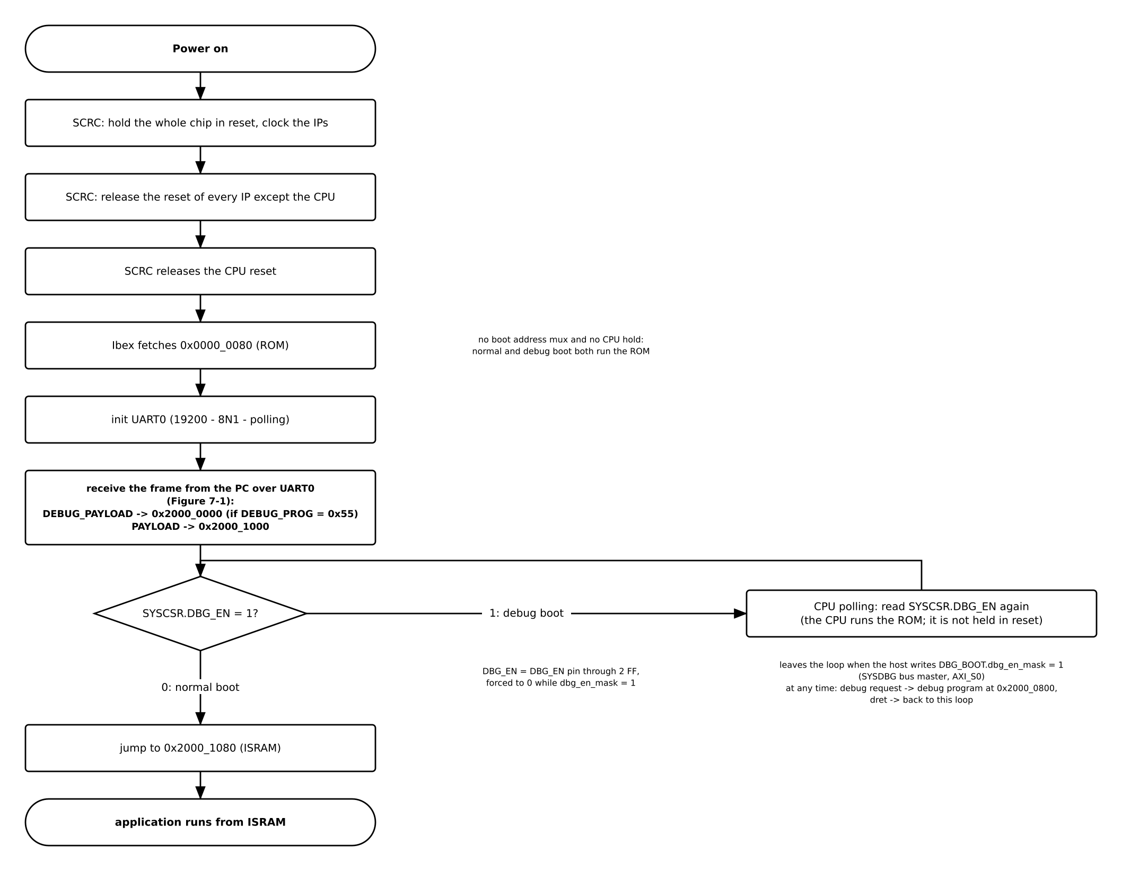
Table 13-1. Boot stages
Stage | What happens
1. Reset | POR, a watchdog bite or the software reset holds the chip in reset (the RRC stretches a watchdog or software request to 16 cycles); the cause is recorded in SYSCSR RESET_CAUSE.
2. Power-up | SCRC releases every domain except the CPU together, opens the APB guards of the peripherals it just enabled, then releases the CPU last.
3. ROM start | The boot address is always ROM: the CPU fetches its first instruction at 0x0000_0080 and configures UART0 (19200 baud nominal, 19 231 actual, 8N1). There is no boot-mode strap and no alternate vector, and SYSDBG never holds the CPU.
4. Download | The ROM code polls UART0 and receives a framed image: a 16-byte header (MAGIC, LENGTH, DEBUG_PROG, HDR_CRC), then an optional 4 KiB debug program with its own CRC (only when DEBUG_PROG = 0x55, loaded at 0x2000_0000) and the user payload (loaded at 0x2000_1000), each protected by CRC32. Each step is answered by a token: ACKH, ACKD (debug program) and ACKP. On any failure it sends a four-character error token, flushes the receiver, waits, and sends QRDY so the host resends the whole frame.
5. Debug gate | The ROM code reads SYSCSR.DBG_BOOT. While DBG_EN = 1 the CPU stays in a ROM polling loop (not held in reset). JTAG writes DBG_EN_MASK = 1 over SYSDBG, S_BUS, AXI2APB, P_BUS and SYSCSR, so DBG_EN reads 0 and the loop exits. JTAG can only clear the debug state, never set it. DBG_EN_MASK is reset by power-on only, so after a watchdog bite or software reset the mask keeps its value and the ROM does not wait again until the next power-on.
6. Jump | The CPU jumps to 0x2000_1080: the user program is loaded at 0x2000_1000, with its own 128-byte vector table and _start at +0x80.
The application is linked at 0x2000_1000 or above (the first 4 KiB of ISRAM are reserved for debug), with its own 128-byte vector table and _start at +0x80. The bootloader leaves UART0 configured and no other state to rely on.
JTAG may request debug mode at any time; the core enters debug mode at the halt address 0x2000_0800 and, on the debug return instruction, goes back to the polling loop and reads DBG_EN again. If DBG_EN = 1 but DEBUG_PROG is not 0x55 (no debug program loaded; the PC loader sends 0xAA, the ROM does not check it), the ROM keeps polling and emits no error token, and the host must not request debug mode because the dispatch loop is not there.

