**INSTRUCTION FOR RUNNING PROCESS MINING TOOL ON JAVA ENVIRONMENT**

**I. System requirements:**

* Java JDK 8. Download it from here: <https://www.oracle.com/kr/java/technologies/javase/javase-jdk8-downloads.html>

(You will need to register an account to download the package)

**II. Setup Java JDK 8 and the environment:**

**1. Microsoft Windows OS**

- Download and install Java 8 on your computer. Remember the Java installed location. You will need it in the next step.

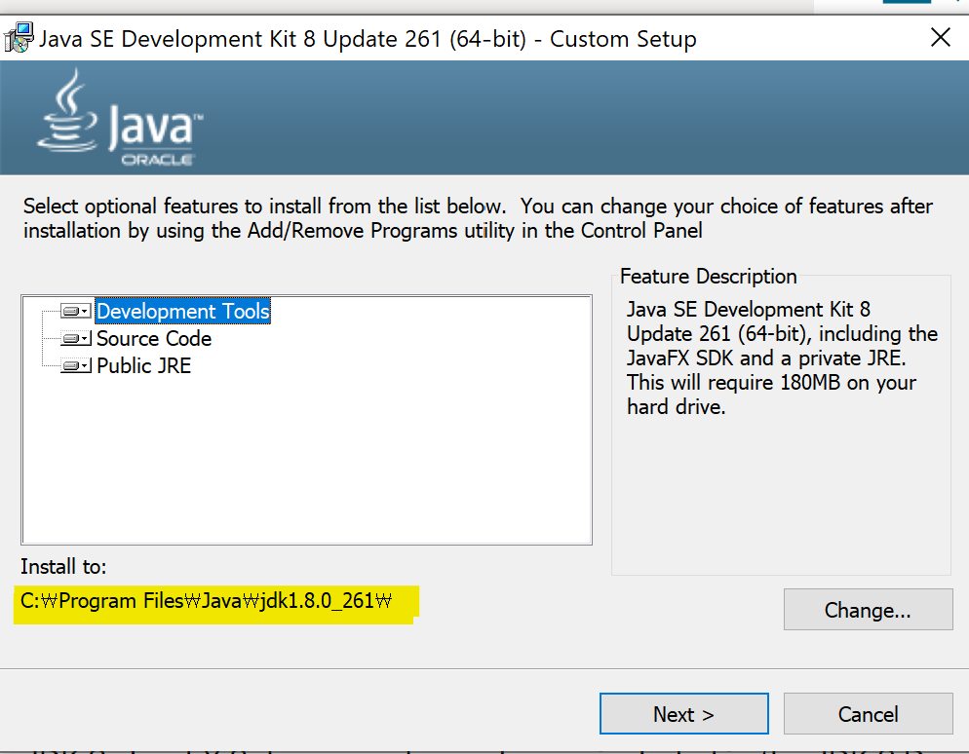

- Setup the JAVA_HOME invironment by following the instruction in this website: <https://javatutorial.net/set-java-home-windows-10>

(Remember to put the correct variable value. The path looks like “c:\Program Files\Java\jdk1.8.0_261” in the previous step).

- Open Command Prompt in the Windows OS, run this command:***javac –version****.* This will print out the version of the java compiler in your computer. You can only run the tool whenever you can run this command successfully.

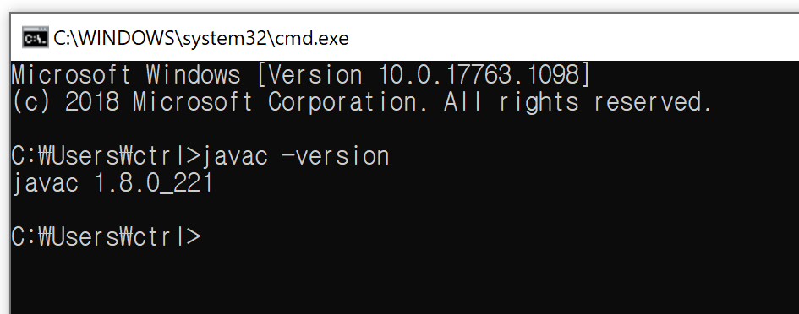

**2. Mac OS**

- Download and install Java 8 on your computer. Remember the Java installed location. You will need it in the next step.



- Setup the JAVA_HOME invironment by following the instruction in this website: <http://www.sajeconsultants.com/how-to-set-java_home-on-mac-os-x/?utm_source=rss&utm_medium=rss&utm_campaign=how-to-set-java_home-on-mac-os-x>

- Open the Terminal on MAC, run this command:**java -version***.* This will print out the version of the java compiler in your computer. You can only run the tool whenever you can run this command successfully.

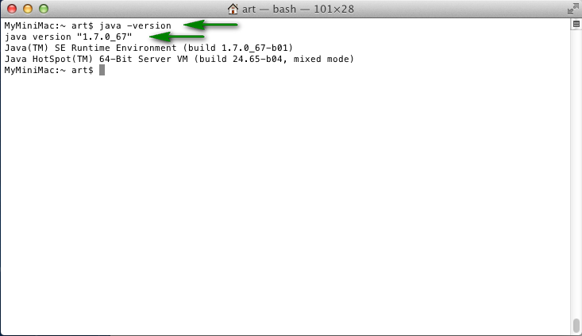

**II. Run the tool:**

Double click to run the file “runtool (MS Windows)” on MS Windows.

Double click to run the file “runtool (Mac OS)” on MS Windows.

**III. Download data set:**

Large bank transaction: <https://data.4tu.nl/articles/dataset/Large_Bank_Transaction_Process/12714395>

Review example large: <https://data.4tu.nl/articles/dataset/Synthetic_event_logs_-_review_example_large_xes_gz/12716609>