⋉

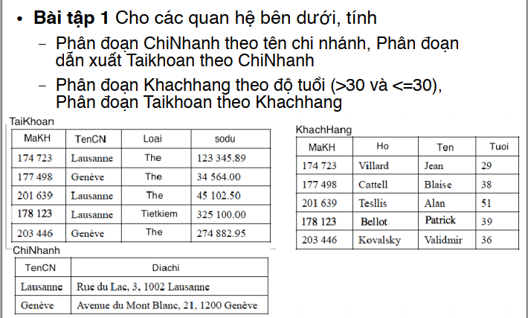

**ChiNhanh = {ChiNhanh1, ChiNhanh2} theo tên chi nhánh**

TaiKhoan1 = TaiKhoan ⋉ ChiNhanh1

TaiKhoan2 =TaiKhoan ⋉ ChiNhanh2

Vớii

ChiNhanh1 = σTenCN = ‘Lausanne’

ChiNhanh2 = σTenCN <> ‘Lausanne’

TaiKhoan1

|  |  |  |  |
| --- | --- | --- | --- |
| MaKH | TenCN | Loai | Sodu |
| 174 723 | Lausanne | The | 123 345.89 |
| 201 639 | Lausanne | The | 45 102.50 |
| 178 123 | Lausanne | Tietkiem | 325 100.00 |

TaiKhoan2

|  |  |  |  |
| --- | --- | --- | --- |
| MaKH | TenCN | Loai | Sodu |
| 177 498 | Genève | The | 34 564.00 |
| 203 446 | Genève | The | 274 882.95 |

**KhachHang = {KhachHang1, KhachHang2} theo tuổi**

TaiKhoan1 = TaiKhoan ⋉ KhachHang1

TaiKhoan2 =TaiKhoan ⋉ KhachHang2

Với

KhachHang1 = σTuoi > 30

KhachHang2 = σTuoi ≤ 30

TaiKhoan1

|  |  |  |  |
| --- | --- | --- | --- |
| MaKH | TenCN | Loai | Sodu |
| 177 498 | Genève | The | 34 564.00 |
| 201 639 | Lausanne | The | 45 102.50 |
| 178 123 | Lausanne | Tietkiem | 325 100.00 |
| 203 446 | Genève | The | 274 882.95 |

TaiKhoan2

|  |  |  |  |
| --- | --- | --- | --- |
| MaKH | TenCN | Loai | Sodu |
| 174 723 | Lausanne | The | 123 345.89 |

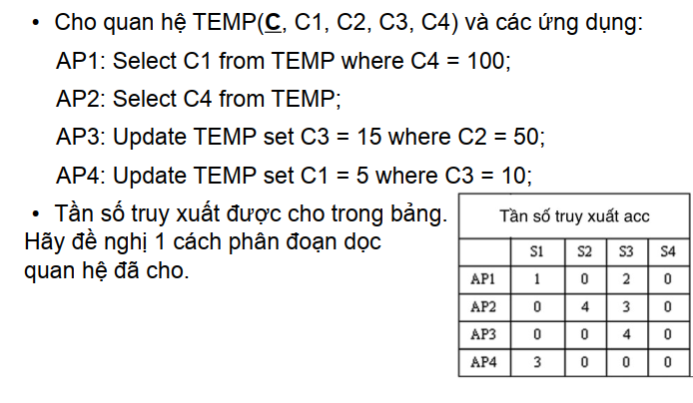

Ma trận AU Tần số truy xuất

|  |  |  |  |  |
| --- | --- | --- | --- | --- |
|  | C1 | C2 | C3 | C4 |
| AP1 | 1 | 0 | 0 | 1 |
| AP2 | 0 | 0 | 0 | 1 |
| AP3 | 0 | 1 | 1 | 0 |
| AP4 | 1 | 0 | 1 | 0 |

|  |  |  |  |  |
| --- | --- | --- | --- | --- |
|  | S1 | S2 | S3 | S4 |
| AP1 | 1 | 0 | 2 | 0 |
| AP2 | 0 | 4 | 3 | 0 |
| AP3 | 0 | 0 | 4 | 0 |
| AP4 | 3 | 0 | 0 | 0 |

Ma Trận AA

|  |  |  |  |  |
| --- | --- | --- | --- | --- |
|  | C1 | C2 | C3 | C4 |
| C1 | 6 | 0 | 3 | 3 |
| C2 | 0 | 4 | 4 | 0 |
| C3 | 3 | 4 | 7 | 0 |
| C4 | 3 | 0 | 0 | 10 |

Ma Trận CA

|  |  |  |  |  |
| --- | --- | --- | --- | --- |
|  | C1 | C2 | C3 | C4 |
| C1 | 6 | 0 |  |  |
| C2 | 0 | 4 |  |  |
| C3 | 3 | 4 |  |  |
| C4 | 3 | 0 |  |  |

C3 có 3 cách đặt: Trước cột C1, giữa C1 &C2, sau C2

Cont(C0, C3, C1) = 2bond(C0,C3) + 2bond (C3,C1) – 2bond (C0, C1)

= 2bond(C3,C1) = 2*(18+21) = 78

Cont(C1, C3, C2) = 2bond(C1,C3) +2bond(C3,C2) – 2bond(C1,C2)

= 2*39 + 2*44 – 2*12 = 142

Cont(C2, C3, Cn) = 2bond(C2,C3) + 2bond(C3,Cn) -2bond(C2,Cn)

= 2*44 = 88

* C3 Đặt ở giữa C1&C2

Ma Trận CA cột C3

|  |  |  |  |  |
| --- | --- | --- | --- | --- |
|  | C1 | C3 | C2 | C4 |
| C1 | 6 | 3 | 0 |  |
| C2 | 0 | 4 | 4 |  |
| C3 | 3 | 7 | 4 |  |
| C4 | 3 | 0 | 0 |  |

C4 có 4 cách đặt: trước C1, giữa C1&C3, giữa C3&C2, sau C2

Cont(C0, C4, C1) = 2bond(C0,C4) + 2 bond(C4,C1) – 2bond(C0,C1)

= 2bond(C4,C1)

= 2*48 = 96

Cont(C1, C4, C3) = 2bond(C1,C4) + 2bond(C4,C3) – 2bond(C1,C3)

= 96 + 18 – 78 = 36

Cont(C3, C4, C2) = 2bond(C3,C4) + 2bond(C4,C2) – 2bond(C3,C2)

= 18+ 0 – 88 = -70

Cont(C2, C4, Cn) = 2bond(C2,C4) +2bond(C4,Cn) – 2bond(C2,Cn)

= 2bond(C2, C4)= 0

* Đặt C4 ở trước C1

|  |  |  |  |  |
| --- | --- | --- | --- | --- |
|  | C4 | C1 | C3 | C2 |
| C1 | 3 | 6 | 3 | 0 |
| C2 | 0 | 0 | 4 | 4 |
| C3 | 0 | 3 | 7 | 4 |
| C4 | 10 | 3 | 0 | 0 |