|  |
| --- |
| #!/bit/bash  Assignment Shell Programming  Đinh Văn Độ  #Assignment: Shell Programming  #Class ID: SE1705  #Student ID: HE161048  #Student Name: Dinh Van Do  #Source File: dinhdando_HE161048_ShellProgramming.sh  while :  do  echo "**************************************************"  echo "Please choose from the following options; type the option number and hit the <Enter> key."  echo  echo "a or A To display the current directory"  echo "b or B To list names of the files in a given directory"  echo "c or C To display today's date and time"  echo "d or D To display whether a file is a simple file or directory "  echo "e or E To execute a command line."  echo "q or Q To exit the program."  echo "**************************************************"  echo -n "Enter your choice and hit <Enter>: "  read choice  case "$choice" in  a|A)  pwd  echo -n "Hit <Enter> to continue. "  read a  echo `clear`  ;;  b|B)  echo -n "Enter the directory path: "  read chon  ls -l $chon  echo "Hit <Enter> to continue."  read a  echo `clear`  ;;  c|C)  echo `date`  echo "Hit <Enter> to continue."  read a  echo `clear`  ;;  d|D)  echo "Enter the file name: "  read kt  if [ -d "${kt}" ] ; then  echo "$kt is a directory.";  else  if [ -f "${kt}" ]; then  echo "${kt} is an ordinary file";  else  echo "${kt} does not exist, or it is neither an ordinary file not a directory.";  fi  fi  echo "Hit <Enter> to continue."  read a  echo `clear`  ;;  e|E)  echo -n "Please enter a command to be executed: "  read cm  echo `$cm`  echo "Hit <Enter> to continue."  read a  echo `clear`  ;;  q|Q)  echo "Bye now!"  break  ;;  esac |

Enter a

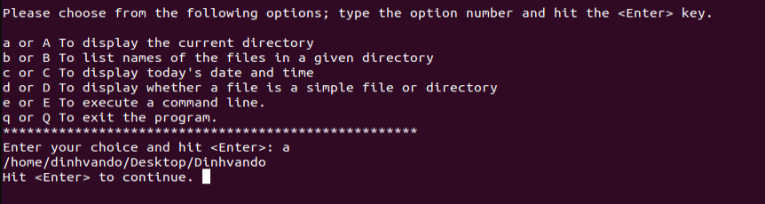

Enter b

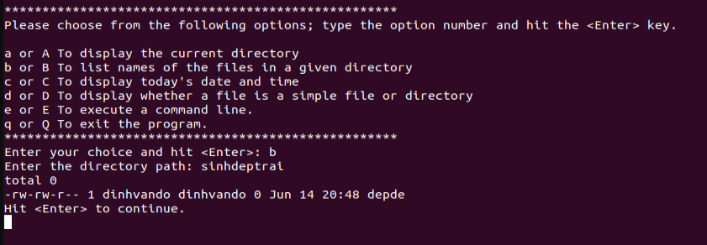

Enter c

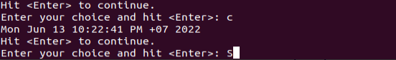

Enter d

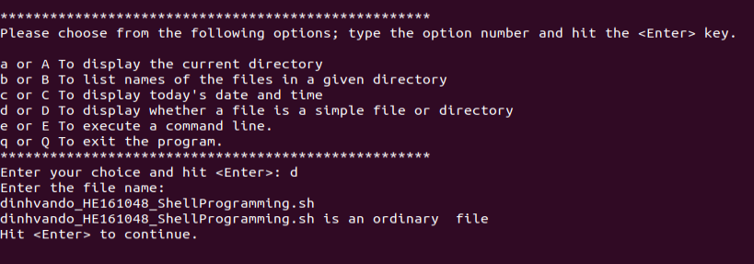

Enter e

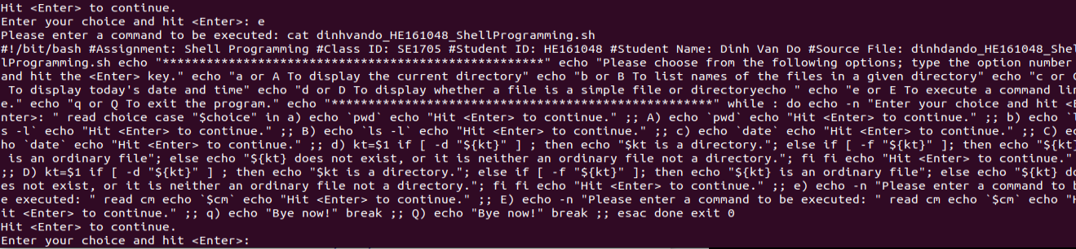

Enter Q

