Smart Parking Platform — Project Document
Prepared by: $oftware ¢orp.
Course: CIS 4374 — Software Project Management
Author: Dinh Pham
Document version: 1.3
Date: October 1, 2026

Document Control
Version | Date | Author | Summary of changes
1.0 | 2026-09-10 | D. Pham | Initial release. Added existing software landscape, Vision & Scope, and first SRS draft with 22 use cases.
1.1 | 2026-09-17 | D. Pham | Added Work Breakdown Structure (Section 5) and draft project timeline with Gantt chart (Section 6), scheduled within the Fall 2026 semester constraint.
Table of Contents
Document Control 1
1. Introduction 4
2. Existing Software Landscape (Research) 4
2.1 Purpose of the Research 4
2.2 Market Overview 4
2.3 Competitor Analysis 4
2.4 Common Weaknesses in Current Solutions 5
2.5 How Our Platform Will Be Different 6
3. Vision and Scope 6
3.1 About $oftware ¢orp. 6
3.2 How This Project Was Acquired 7
3.3 Business Need 7
3.4 Vision Statement 7
3.5 Business Objectives and Success Metrics 7
3.6 Project Overview 8
3.7 Scope — In and Out 8
3.8 Stakeholders 9
3.9 Constraints and Assumptions 9
4. Software Requirements Specification (Draft) 10
4.1 Purpose and Scope of the SRS 10
4.2 Definitions and Acronyms 10
4.3 Actors 10
4.4 Use Cases 10
4.5 Non-Functional Requirements 14
4.6 External Interfaces 15
4.7 Open Items for Future Versions 15
5. Work Breakdown Structure 16
5.1 Purpose and Approach 16
5.2 WBS Structure 16
5.3 WBS Dictionary (Level 2) 19
5.4 Decomposition Notes 19
6. Draft Project Timeline 20
6.1 Scheduling Approach and Assumptions 20
6.2 Phase Schedule 20
6.3 Milestones 21
6.4 Gantt Chart 22
6.5 Critical Path 23
6.6 Open Scheduling Items 23
7. Product Backlog and Sprint 1 Plan 24
7.1 Approach 24
7.2 Epic Overview 24
7.3 Backlog — Login and Accounts 24
7.4 Backlog — User Interface 25
7.5 Backlog — Backend Processes 26
7.6 Backlog — Reporting and Analytics 27
7.7 Sprint 1 Plan 28
7.8 Product Backlog Board 29
7.9 Open Backlog Items 30
8. Risk Management and Communication Plan 30
8.1 Risk Management Approach 30
8.2 Risk Identification by Category 31
8.3 Risk Register 33
8.4 Probability and Impact Matrix 35
8.5 Communication Plan 35
8.6 Open Risk Management Items 37
9. Next Steps 37
10. References 37

1. Introduction
This document is the living project document for the Smart Parking Platform. It is updated every week as the course moves through the project management life cycle. Version 1.0 covers three things: research into what already exists, the first draft of the Vision and Scope, and the first draft of the Software Requirements Specification (SRS).
The Smart Parking Platform is a web and mobile system that helps drivers find, reserve, and pay for parking spaces in parking garages in real time. It also gives parking operators tools to monitor occupancy, set pricing, and report on how their assets are used.

2. Existing Software Landscape (Research)

2.1 Purpose of the Research
Before writing requirements, we need to know what is already on the market. This tells us three things: which features drivers already expect, which problems are still unsolved, and where we can build something better. Everything in this section feeds into the differentiation strategy in Section 2.5 and the scope decisions in Section 3.7.

2.2 Market Overview
Smart parking is an established and growing market, not an empty one. Industry estimates put the smart parking platform market at roughly $3.9 billion in 2024, growing at about 12% per year. The named leaders in that research are ParkMobile, PayByPhone, SpotHero, ParkWhiz, INRIX, Passport, Flowbird, and hardware-side vendors such as Siemens, Bosch, and Cleverciti.
The market splits into four rough groups:
Group | What they do | Examples
Garage reservation apps | Book and prepay an off-street space in advance | SpotHero, ParkWhiz
Meter and session payment apps | Pay for on-street or municipal parking by the hour | ParkMobile, PayByPhone, Passport
Parking information and mapping | Show prices, rules, and locations without booking | Parkopedia, SpotAngels, BestParking
Operator-side management software | Gate control, occupancy tracking, revenue reporting | TIBA, Flowbird, Arivo, Parking.com
The key finding is that no single product covers all four groups well. Drivers who want to reserve a garage use one app, drivers who want to pay a meter use another, and the garage operator often runs a third system that does not talk to either.

2.3 Competitor Analysis
Competitor | Main strength | Main weakness | Gap we can use
SpotHero | Strongest brand in garage reservations; wide US coverage; clear prepay pricing; no separate booking fee | Prices carry a hidden margin; users report surge pricing gaps and garage access-code problems at the gate | Reliable, verified gate entry and transparent pricing
ParkWhiz (owned by Arrive) | Strong at venue, airport, and event parking; good prepay discounts | Users report reservations not honored at the garage and slow refunds | Guaranteed-space enforcement backed by live inventory
ParkMobile (owned by EasyPark Group) | Largest US footprint by zone coverage; very high app store rating volume | Focused on meter sessions, not garage reservation; per-transaction convenience fee; “phantom session” complaints | Combined reserve-and-pay in one flow, no per-transaction fee
PayByPhone | Official meter partner in many cities; simple session model | City-specific outages; late expiration alerts; almost no reservation capability | Dependable notification engine and session extension
Passport | Deep in smaller cities and university campuses | Crashes during payment; confusing zone numbering | Simpler, map-first space selection instead of zone codes
Parkopedia / SpotAngels | Very large database of prices and street rules; strong free-parking discovery | Information only — you generally cannot reserve or guarantee a space | Turn information into a guaranteed booking
Operator software (TIBA, Flowbird, Arivo) | Real gate hardware integration, occupancy counting, revenue reports | Sold to operators, not to drivers; little to no consumer-facing demand generation | One platform serving both sides with shared live data

2.4 Common Weaknesses in Current Solutions
Reading across the competitor set, five problems repeat:
- Availability is predicted, not proven. Most consumer apps sell a spot based on an allocation the operator gave them, not on a live count of cars in the garage. This is the root cause of the “reservation not honored” complaint pattern.
- The two sides are disconnected. The driver app and the operator’s garage system are usually separate products from separate vendors. Data has to be reconciled manually.
- Pricing is not transparent. Convenience fees, dynamic markups, and drive-up-versus-prepay differences make it hard for a driver to know the real total.
- Entry at the gate is fragile. Access codes, QR codes, and license plate reading fail often enough that it is a top complaint category.
- Operators get reports, not insight. Occupancy numbers are common; pricing recommendations and demand forecasting are rare.

2.5 How Our Platform Will Be Different
Our platform is not trying to out-market SpotHero. It is trying to remove the root causes above. Four points of differentiation:
1. One platform, both sides, one source of truth. Competitors serve either drivers or operators. We serve both on shared live data. When a car enters a garage, the count changes for the operator dashboard and the driver map at the same instant. This directly attacks weakness 1 and 2.
2. Verified availability, not estimated availability. Availability comes from the operator’s live occupancy feed and from our own reservation ledger, not from a static block of spaces. If we show a space, it exists. Any reservation we cannot honor triggers an automatic refund plus a comparable alternate space nearby.
3. Honest total pricing. The price shown on the map is the price charged. Taxes and any operator fees are itemized before the user confirms. No separate per-transaction convenience fee.
4. Reservation and payment in one flow, with reliable entry. One flow covers search, reserve, pay, navigate, and enter. Entry supports both a dynamic QR pass and license plate recognition as a fallback, so a single failure does not strand the driver at the gate.
A fifth, longer-term differentiator is analytics that recommend, not just report — suggesting price changes to operators based on observed demand. This is planned but out of scope for the first release (see Section 3.7).

3. Vision and Scope

3.1 About $oftware ¢orp.
$oftware ¢orp. is a software development studio that builds platform products for the transportation and mobility sector. The studio works in cross-functional delivery teams and takes projects from requirements gathering through release and support. For this engagement the studio has committed six teams: Mobile Application, Web Application, Backend/API, Mapping & Location Services, Payment Integration, and Quality Assurance & Testing.
For the purposes of this course, $oftware ¢orp. is a fictitious company operating with an unlimited theoretical development budget. This removes cost as a constraint but does not remove the schedule constraint — the semester timeline is fixed.

3.2 How This Project Was Acquired
A regional parking operator group, together with a municipal transportation department, issued a request for proposal for a real-time parking reservation and management platform. Their existing setup used three separate vendors: one consumer booking app, one gate and access control system, and one spreadsheet-based revenue reporting process. The three did not share data, which caused oversold garages and monthly reconciliation work.
$oftware ¢orp. was invited to bid based on prior mobility platform work. Our proposal argued that the real problem was not a missing app but a missing single source of truth between the driver and the garage. The client accepted that framing, and the contract was awarded to $oftware ¢orp. as a full platform build covering both the driver-facing product and the operator-facing product.
The client’s stated priorities, in their order: 1. Never sell a space that is not actually available. 2. Give operators live visibility into occupancy and revenue. 3. Make the driver experience fast enough that it beats circling the block.

3.3 Business Need
Drivers spend a large share of their trip time searching for parking. That searching creates traffic congestion, wasted fuel, driver frustration, and lost productivity. On the other side, parking operators cannot see their own occupancy in real time, so they cannot price dynamically, cannot plan for events, and cannot tell which assets are underused.
Both problems come from the same missing piece: there is no shared, live, trusted picture of which spaces are open right now.

3.4 Vision Statement
For drivers and parking facility operators who waste time and revenue because parking availability is unknown until you arrive, the Smart Parking Platform is a web and mobile parking reservation and management platform that shows verified real-time availability, guarantees the reserved space, and gives operators live occupancy and pricing control. Unlike SpotHero, ParkWhiz, and ParkMobile, which serve only the driver and rely on allocated blocks of spaces, our product runs both sides of the transaction on one live inventory, so what the driver sees is what the operator actually has.

3.5 Business Objectives and Success Metrics
ID | Objective | Success metric (target for first release)
BO-1 | Cut the time drivers spend searching for parking | Median search-to-reserved time under 90 seconds
BO-2 | Eliminate unhonored reservations | Fewer than 0.5% of reservations fail at the gate
BO-3 | Increase garage utilization for operators | 10% increase in average occupancy at participating garages
BO-4 | Give operators live visibility | Occupancy dashboard reflects gate events within 30 seconds
BO-5 | Build driver trust in pricing | Zero difference between quoted total and charged total

3.6 Project Overview
The platform has four parts:
- Mobile application (iOS and Android) — the main driver experience: map, search, reserve, pay, navigate, enter.
- Web application — the same driver features in a browser, plus the operator dashboard.
- Backend / API — accounts, inventory, reservations, pricing, notifications, and the shared source of truth.
- Integrations — mapping and navigation services, payment processors, and garage gate/occupancy hardware.

3.7 Scope — In and Out
In scope for the first release
- User registration, authentication, and vehicle profiles
- Real-time garage availability on an interactive map
- Search, filter, and compare garages by price, distance, and availability
- Reservation creation, extension, and cancellation
- Digital payment processing and refunds
- Digital entry pass (QR) with license plate recognition fallback
- Reservation history and downloadable receipts
- Push and email notifications and alerts
- Operator dashboard: listings, capacity, pricing, live occupancy
- Occupancy and revenue reporting for operators
- Integration with external mapping and navigation services
- Administrative tools for user management and dispute resolution
Out of scope for the first release (candidates for later releases)
- On-street and metered parking (garages only for now)
- Peer-to-peer or residential driveway rental
- Automated dynamic pricing recommendations
- EV charging reservation and billing
- Valet services
- Monthly and corporate permit management
- Transit ticketing bundles
Scope decisions in this section are provisional and will be refined during stakeholder analysis.

3.8 Stakeholders
Stakeholder | Interest in the project | Influence
Drivers / vehicle owners | Find and guarantee parking quickly at a fair price | High (end users)
Parking facility operators | Higher utilization, live occupancy, pricing control | High (paying client)
City transportation departments | Less congestion, compliance with city ordinance | Medium (regulatory)
System administrators | Stable operations, manageable support load | Medium
Finance and billing personnel | Accurate payouts, reconciliation, tax handling | Medium
Mobile application users | Fast, reliable app that works at the gate | High
Third-party payment providers | Compliant, low-fraud transaction volume | Medium (external dependency)
$oftware ¢orp. delivery teams | Clear requirements, workable schedule | High (delivery)

3.9 Constraints and Assumptions
Constraints
- C-1: Unlimited theoretical development budget, but a fixed semester timeline.
- C-2: The platform depends on third-party services and APIs (mapping, payments, gate hardware) that we do not control.
- C-3: The system must comply with security and privacy requirements, city ordinances, and applicable laws.
- C-4: Payment handling must meet PCI DSS requirements.
Assumptions
- A-1: Participating garages can supply a live occupancy signal, or will accept our sensor/gate integration.
- A-2: Operators will keep their listing and pricing data current.
- A-3: Drivers have a smartphone with data service and location access at the time of booking.
- A-4: Mapping and payment providers will remain available under commercial terms.

4. Software Requirements Specification (Draft)
Status: Draft, version 1.0. This SRS will grow through the semester. Use cases here are written at a summary level; detailed flows, alternate flows, and acceptance criteria will be expanded in later versions.

4.1 Purpose and Scope of the SRS
This SRS describes what the Smart Parking Platform must do. It is written for the $oftware ¢orp. delivery teams, the QA team, and the client stakeholders who will approve the requirements. It covers the driver-facing web and mobile applications, the operator dashboard, and the backend services that support them.

4.2 Definitions and Acronyms
Term | Meaning
Driver | An end user who searches for, reserves, and pays for parking
Operator | A person or company that manages one or more parking garages
Space | An individual parking spot inside a garage
Reservation | A confirmed, paid claim on a space for a defined time window
Entry pass | The credential used to open the gate (QR code or license plate)
LPR | License Plate Recognition
SRS | Software Requirements Specification
PCI DSS | Payment Card Industry Data Security Standard

4.3 Actors
Actor | Description
Guest | An unregistered visitor browsing availability
Driver | A registered end user
Operator | Manages garage listings, capacity, and pricing
Finance User | Handles payouts, refunds, and reconciliation
System Administrator | Manages accounts, permissions, and disputes
Payment Gateway | External payment processing service
Mapping Service | External mapping and navigation provider
Garage Hardware | Gate controllers, sensors, and LPR cameras

4.4 Use Cases

UC-01 — Register Account
Actor: Guest Goal: Create an account so reservations can be made and saved. Preconditions: User is not registered. Main flow: User enters email, password, and name → system validates the input → system sends a verification email → user confirms → account is created. Alternate flow: Email already in use → system offers sign-in or password reset. Postcondition: A verified Driver account exists.

UC-02 — Authenticate (Log In / Log Out)
Actor: Driver, Operator, Finance User, System Administrator Goal: Access the account securely. Preconditions: A verified account exists. Main flow: User submits credentials → system verifies → session is created with the correct role permissions. Alternate flow: Wrong credentials three times → account is temporarily locked and a reset email is offered. Postcondition: Authenticated session, or access denied.

UC-03 — Manage Vehicle Profile
Actor: Driver Goal: Save vehicle details and license plate for gate entry. Preconditions: Driver is logged in. Main flow: Driver adds vehicle make, model, and plate number → system validates the plate format → vehicle is saved and can be set as default. Alternate flow: Duplicate plate on another account → flagged for administrator review. Postcondition: Vehicle is available for LPR entry and for reservations.

UC-04 — Search for Parking Near a Destination
Actor: Guest, Driver Goal: Find garages near a chosen address, landmark, or current location. Preconditions: Location access granted, or an address entered. Main flow: User enters a destination and an arrival/departure time → system queries live inventory → results are returned with distance, price, and available space count. Alternate flow: No garages within range → system widens the radius and shows the nearest option. Postcondition: A result set is displayed.

UC-05 — View Real-Time Availability on an Interactive Map
Actor: Guest, Driver Goal: See where open spaces are, visually. Preconditions: Search results exist. Main flow: System renders garage pins on the map → each pin shows price and live open space count → counts refresh as gate events arrive. Alternate flow: Live occupancy feed is unavailable → the garage is marked “availability estimated” and cannot be reserved as guaranteed. Postcondition: Driver can compare options at a glance.

UC-06 — Filter and Sort Results
Actor: Guest, Driver Goal: Narrow results to what actually fits the driver’s needs. Preconditions: Search results exist. Main flow: User applies filters (price ceiling, walking distance, covered parking, height clearance, accessible spaces, EV-adjacent) and sorts by price or distance. Alternate flow: Filters return zero results → system suggests which filter to relax. Postcondition: A filtered, sorted result set is displayed.

UC-07 — View Garage Details
Actor: Guest, Driver Goal: See full information before committing. Preconditions: A garage is selected. Main flow: System shows photos, address, hours, clearance, entry instructions, itemized pricing, and amenities. Postcondition: Driver has enough information to decide.

UC-08 — Reserve a Parking Space
Actor: Driver Goal: Hold a specific space for a specific time window. Preconditions: Driver is logged in; the garage reports verified availability. Main flow: Driver selects garage and time window → system places a temporary hold on a space → driver confirms → system proceeds to payment (UC-09). Alternate flow: The last space is taken during the hold → system releases the flow and offers the nearest comparable garage. Postcondition: A pending reservation exists, awaiting payment.

UC-09 — Pay for a Reservation
Actor: Driver, Payment Gateway Goal: Complete payment and confirm the reservation. Preconditions: A pending reservation exists. Main flow: Driver selects a saved or new payment method → system displays the itemized total → driver confirms → system sends the charge to the payment gateway → gateway approves → reservation is confirmed. Alternate flow: Payment declined → reservation hold is kept for 5 minutes and the driver may retry with another method. Postcondition: Reservation is confirmed and paid; the space is removed from live inventory.

UC-10 — Receive Booking Confirmation and Entry Pass
Actor: Driver Goal: Get proof of the reservation and the credential needed at the gate. Preconditions: Payment succeeded. Main flow: System issues a dynamic QR entry pass and registers the driver’s plate with the garage → confirmation is delivered in-app and by email. Alternate flow: Email delivery fails → the pass remains available in the app and by SMS. Postcondition: Driver holds a valid entry credential.

UC-11 — Navigate to the Garage
Actor: Driver, Mapping Service Goal: Get turn-by-turn directions to the reserved garage entrance. Preconditions: A confirmed reservation exists. Main flow: Driver taps “Navigate” → system hands the garage entrance coordinates to the mapping service → navigation begins. Alternate flow: Mapping service unavailable → system displays written directions and the entrance address. Postcondition: Driver is routed to the correct entrance, not just the building.

UC-12 — Enter the Garage
Actor: Driver, Garage Hardware Goal: Get through the gate without friction. Preconditions: A valid, currently active reservation exists. Main flow: LPR camera reads the plate and matches it to the reservation → gate opens → entry event is recorded and occupancy updates. Alternate flow 1: LPR fails → driver scans the QR pass at the reader. Alternate flow 2: Both fail → in-app support code opens the gate and an incident is logged. Postcondition: Driver is parked; occupancy count is updated everywhere.

UC-13 — Extend an Active Reservation
Actor: Driver Goal: Stay longer without getting towed or fined. Preconditions: An active reservation is in progress. Main flow: Driver requests extra time → system checks that the space is not booked by someone else → system quotes the additional charge → driver confirms and is charged. Alternate flow: The space is reserved by another driver for the later window → extension is refused, and the system offers to move the vehicle to another available space in the same garage. Postcondition: Reservation end time is updated, or the extension is denied with a clear reason.

UC-14 — Cancel a Reservation and Receive a Refund
Actor: Driver, Payment Gateway Goal: Cancel and get money back under the stated policy. Preconditions: A confirmed reservation exists that has not yet started. Main flow: Driver cancels → system applies the cancellation policy → refund is issued through the gateway → the space returns to live inventory. Alternate flow: Cancellation is inside the no-refund window → system states the policy and asks for confirmation before cancelling without refund. Postcondition: Reservation is cancelled; inventory and finances are consistent.

UC-15 — View Reservation History and Receipts
Actor: Driver Goal: Look up past parking and download receipts for expenses. Preconditions: Driver is logged in with at least one past reservation. Main flow: Driver opens history → system lists past and upcoming reservations → driver downloads a PDF receipt. Postcondition: Receipt is downloaded or emailed.

UC-16 — Receive Notifications and Alerts
Actor: Driver Goal: Be reminded before something goes wrong. Preconditions: Notifications are enabled. Main flow: System sends reservation confirmations, arrival reminders, expiration warnings before the reservation ends, and disruption alerts if a garage becomes unavailable. Alternate flow: Push notifications are disabled → system falls back to email or SMS. Postcondition: Driver is informed in time to act.

UC-17 — Manage Garage Listing and Capacity
Actor: Operator Goal: Keep the garage’s information and inventory correct. Preconditions: Operator account is verified and linked to a garage. Main flow: Operator edits address, hours, photos, clearance, total spaces, and reservable space count → system validates and publishes the changes. Alternate flow: Capacity is reduced below the number of existing reservations → system blocks the change and lists the affected reservations. Postcondition: Listing is live and consistent with existing reservations.

UC-18 — Set and Adjust Pricing
Actor: Operator Goal: Control what the garage charges by time and demand. Preconditions: Operator manages at least one garage. Main flow: Operator defines hourly and daily rates, time-of-day rules, and event pricing → system validates against city ordinance limits → new rates apply to future reservations only. Alternate flow: A proposed rate breaks a regulatory ceiling → change is rejected with an explanation. Postcondition: Pricing is updated; already-confirmed reservations are unaffected.

UC-19 — Monitor Live Occupancy Dashboard
Actor: Operator Goal: See what is happening in the garage right now. Preconditions: Operator is logged in; the garage has a live feed. Main flow: Dashboard displays current occupancy, spaces reserved versus walk-in, entries and exits, and revenue so far today, refreshing continuously. Alternate flow: Hardware feed drops → dashboard shows a stale-data warning with the last update time. Postcondition: Operator has an accurate live picture.

UC-20 — Generate Occupancy and Revenue Reports
Actor: Operator, Finance User Goal: Analyze utilization and revenue over a period. Preconditions: Historical data exists for the selected range. Main flow: User selects a date range and garages → system generates utilization rate, peak hours, average duration, and revenue → user exports to PDF or CSV. Alternate flow: Range exceeds retention limits → system caps the range and explains why. Postcondition: Report is generated and exported.

UC-21 — Process Operator Payouts
Actor: Finance User, Payment Gateway Goal: Pay operators their share on schedule. Preconditions: Completed, settled reservations exist for the payout period. Main flow: System calculates gross revenue minus platform fee and refunds per operator → Finance User reviews and approves → payout is sent through the gateway. Alternate flow: A discrepancy is found → the payout is held and flagged for reconciliation. Postcondition: Operators are paid and the payout is recorded.

UC-22 — Manage Users and Resolve Disputes
Actor: System Administrator Goal: Keep accounts healthy and settle problems fairly. Preconditions: Administrator is logged in with elevated permissions. Main flow: Administrator searches for an account, reviews reservation and entry logs, and takes action — issue a goodwill refund, correct a record, suspend an account, or resolve a duplicate plate claim. Alternate flow: The dispute involves a failed gate entry → administrator pulls the hardware incident log before deciding. Postcondition: The dispute is resolved and every action is written to an audit trail.

4.5 Non-Functional Requirements
ID | Category | Requirement
NFR-1 | Performance | Map search results shall return within 2 seconds for 95% of requests.
NFR-2 | Performance | Availability counts shall reflect a gate event within 30 seconds.
NFR-3 | Availability | The platform shall maintain 99.9% uptime, measured monthly.
NFR-4 | Scalability | The system shall support 50,000 concurrent users without degrading NFR-1.
NFR-5 | Security | All traffic shall use TLS 1.3 or higher; passwords shall be stored hashed and salted.
NFR-6 | Security | Payment handling shall be PCI DSS compliant; the platform shall never store raw card numbers.
NFR-7 | Privacy | Location and plate data shall be retained only as long as needed and shall be deletable on user request.
NFR-8 | Usability | A first-time user shall complete search-to-reserved in under 90 seconds without help.
NFR-9 | Accessibility | Web and mobile interfaces shall meet WCAG 2.2 Level AA.
NFR-10 | Compatibility | The mobile app shall support the current and two prior major versions of iOS and Android.
NFR-11 | Reliability | A confirmed reservation that cannot be honored shall trigger an automatic refund and an alternate offer within 60 seconds.
NFR-12 | Auditability | All financial and administrative actions shall be written to an immutable audit log.

4.6 External Interfaces
Interface | Purpose | Notes
Mapping / navigation API | Geocoding, map tiles, turn-by-turn routing to the garage entrance | External dependency; needs a fallback
Payment gateway | Authorization, capture, refunds, payouts | Must be PCI DSS compliant
Garage gate controllers | Open and close gates on valid credentials | Vendor-specific; adapter layer needed
Occupancy sensors / LPR cameras | Live space counts and plate reads | Accuracy affects NFR-2 and NFR-11
Notification services | Push, email, SMS delivery | Multiple channels for fallback

4.7 Open Items for Future Versions
These are known gaps in version 1.0 and will be filled as the semester continues:
- Detailed alternate and exception flows for every use case
- Use case diagrams and sequence diagrams
- Data model and entity relationship diagram
- Acceptance criteria per requirement
- Requirements traceability matrix
- Full stakeholder analysis and elicitation notes
- Work breakdown structure, schedule, budget, and risk register

5. Work Breakdown Structure

5.1 Purpose and Approach
The Work Breakdown Structure (WBS) breaks the Smart Parking Platform into the actual pieces of work that have to be completed. It is deliverable-based, not activity-based: every item names something that gets produced, not something that gets done.
The structure is decomposed to at least three levels throughout, and to four levels where a work package needs more detail before it can be estimated. The rule used for stopping the decomposition was the 8/80 rule — a work package should be small enough to estimate in under 80 hours and large enough to be worth tracking, roughly 8 hours at minimum.
Each Level 2 branch maps to one of the six $oftware ¢orp. delivery teams named in Section 3.1, so ownership is clear before scheduling begins.

5.2 WBS Structure
1.0 Smart Parking Platform
1.1 Project Management
- 1.1.1 Project charter
- 1.1.2 Project management plan
- 1.1.3 Stakeholder register and communication plan
- 1.1.4 Weekly status reporting and stakeholder updates
- 1.1.5 Risk register and risk reviews
- 1.1.6 Change control log
- 1.1.7 Project closeout and lessons learned
1.2 Requirements and Design
- 1.2.1 Stakeholder analysis
- 1.2.2 Requirements elicitation
  - 1.2.2.1 Driver interviews and surveys
  - 1.2.2.2 Operator workshops
  - 1.2.2.3 City transportation department consultation
- 1.2.3 Software Requirements Specification
  - 1.2.3.1 Use case catalog
  - 1.2.3.2 Non-functional requirements
  - 1.2.3.3 Use case and sequence diagrams
  - 1.2.3.4 Requirements traceability matrix
- 1.2.4 UX and UI design
  - 1.2.4.1 Wireframes
  - 1.2.4.2 High-fidelity mockups
  - 1.2.4.3 Design system and component library
- 1.2.5 System architecture
  - 1.2.5.1 Architecture decision records
  - 1.2.5.2 Data model and entity relationship diagram
  - 1.2.5.3 API contract specification
1.3 Backend and API
- 1.3.1 Environment setup and CI/CD pipeline
- 1.3.2 Account and authentication service
- 1.3.3 Inventory and availability service
  - 1.3.3.1 Live occupancy ingestion
  - 1.3.3.2 Availability calculation engine
  - 1.3.3.3 Reservation ledger
- 1.3.4 Reservation service
  - 1.3.4.1 Hold and confirm logic
  - 1.3.4.2 Extension and cancellation logic
  - 1.3.4.3 Failed-reservation auto-refund handler
- 1.3.5 Pricing service
- 1.3.6 Notification service
- 1.3.7 Reporting and analytics service
1.4 Mobile Application
- 1.4.1 Application shell and navigation
- 1.4.2 Map and search screens
- 1.4.3 Reserve and pay flow
  - 1.4.3.1 Space selection
  - 1.4.3.2 Payment method handling
  - 1.4.3.3 Confirmation and entry pass
- 1.4.4 Reservation history and receipts
- 1.4.5 Push notification handling
- 1.4.6 iOS build and App Store packaging
- 1.4.7 Android build and Play Store packaging
1.5 Web Application
- 1.5.1 Driver web portal
- 1.5.2 Operator dashboard
  - 1.5.2.1 Listing and capacity management
  - 1.5.2.2 Pricing management
  - 1.5.2.3 Live occupancy view
  - 1.5.2.4 Reporting and export
- 1.5.3 Administrative console
- 1.5.4 Finance and payout screens
1.6 Mapping and Location Services
- 1.6.1 Provider selection and contract
- 1.6.2 Geocoding integration
- 1.6.3 Map rendering and garage pins
- 1.6.4 Navigation handoff to garage entrance
1.7 Payment Integration
- 1.7.1 Gateway selection and contract
- 1.7.2 Payment processing
- 1.7.3 Refund processing
- 1.7.4 Operator payout processing
- 1.7.5 PCI DSS compliance review
1.8 Garage Hardware Integration
- 1.8.1 Gate controller adapter layer
- 1.8.2 Occupancy sensor feed integration
- 1.8.3 License plate recognition integration
- 1.8.4 QR entry pass reader integration
- 1.8.5 Hardware failure and fallback handling
1.9 Quality Assurance and Testing
- 1.9.1 Master test plan
- 1.9.2 Functional testing
  - 1.9.2.1 Test case authoring
  - 1.9.2.2 Test execution and defect logging
  - 1.9.2.3 Regression suite automation
- 1.9.3 Integration testing
- 1.9.4 Performance and load testing
- 1.9.5 Security and penetration testing
- 1.9.6 Accessibility testing
- 1.9.7 User acceptance testing support
1.10 Pilot and User Acceptance
- 1.10.1 Pilot garage selection
- 1.10.2 Pilot deployment
- 1.10.3 Operator training materials
- 1.10.4 User acceptance testing and sign-off
1.11 Deployment and Launch
- 1.11.1 Production environment provisioning
- 1.11.2 App store submission and approval
- 1.11.3 Data migration and cutover
- 1.11.4 Public launch
- 1.11.5 Post-launch hypercare support

5.3 WBS Dictionary (Level 2)
ID | Work package | Key deliverable | Owning team
1.1 | Project Management | Project plan, status reports, risk register | Project Management Office
1.2 | Requirements and Design | Approved SRS, UI designs, architecture | All teams, led by PMO
1.3 | Backend and API | Deployed API services and data layer | Backend/API Team
1.4 | Mobile Application | iOS and Android apps in the stores | Mobile Application Team
1.5 | Web Application | Driver portal and operator dashboard | Web Application Team
1.6 | Mapping and Location Services | Working map, search, and navigation handoff | Mapping & Location Services Team
1.7 | Payment Integration | PCI-compliant payments, refunds, payouts | Payment Integration Team
1.8 | Garage Hardware Integration | Live gate control and occupancy feed | Backend/API Team with vendor support
1.9 | Quality Assurance and Testing | Test plan, executed suites, defect reports | QA & Testing Team
1.10 | Pilot and User Acceptance | Signed-off pilot at live garages | QA & Testing Team with PMO
1.11 | Deployment and Launch | Platform live in production | All teams

5.4 Decomposition Notes
- Branches 1.3 through 1.8 run partly in parallel, since they are owned by different teams. The dependency that controls the order is the API contract in 1.2.5.3 — no client work starts before it is signed off.
- Branch 1.8 carries the most estimating uncertainty because it depends on third-party gate hardware that varies by garage. It is decomposed further than the others for that reason.
- Branch 1.1 runs for the full duration of the project rather than as a phase, so it appears as a single continuous bar on the schedule in Section 6.

6. Draft Project Timeline

6.1 Scheduling Approach and Assumptions
The schedule below is a first draft built from the WBS in Section 5. It is constrained by the fixed semester timeline in Section 3.9: the project must be delivered by December 4, 2026. That end date is not negotiable, so the schedule was built backward from it. It will be refined once resource assignments and effort estimates are complete.
Assumptions used:
- A-5: The schedule is bounded by the fixed semester timeline named in Section 3.9. The project starts August 28, 2026 and must deliver by December 4, 2026 — a 14-week schedule.
- A-6: All six delivery teams are available for the full duration and are fully staffed from day one. Budget is not a constraint (Section 3.9), so teams work in parallel wherever dependencies allow.
- A-7: Client sign-off on requirements is time-boxed to one week and is included in the Requirements and Design phase. The compressed schedule leaves no room for a longer review.
- A-8: Third-party contracts for mapping, payments, and gate hardware are signed during the Requirements and Design phase, so integration work is not blocked by procurement.
- A-9: Durations are in calendar weeks and assume a standard five-day work week. The Thanksgiving break, November 23–27, is treated as non-working time and is absorbed inside the Deployment and Launch phase.
- A-10: Because the timeline is fixed and cannot extend, scope is the variable. The out-of-scope list in Section 3.7 is what makes a 14-week delivery possible.

6.2 Phase Schedule
WBS | Phase | Start | Finish | Duration | Depends on
1.1 | Project Management | Aug 28, 2026 | Dec 4, 2026 | 14 wk | — (runs throughout)
1.2 | Requirements and Design | Sep 4, 2026 | Oct 2, 2026 | 4 wk | 1.1.1
1.3 | Backend and API Development | Oct 2, 2026 | Oct 30, 2026 | 4 wk | 1.2.5
1.4 | Mobile Application | Oct 9, 2026 | Nov 6, 2026 | 4 wk | 1.2.4, 1.2.5.3
1.5 | Web Application | Oct 9, 2026 | Nov 6, 2026 | 4 wk | 1.2.4, 1.2.5.3
1.6 | Mapping and Location Services | Oct 16, 2026 | Oct 30, 2026 | 2 wk | 1.3.1, 1.6.1
1.7 | Payment Integration | Oct 16, 2026 | Nov 6, 2026 | 3 wk | 1.3.1, 1.7.1
1.8 | Garage Hardware Integration | Oct 23, 2026 | Nov 6, 2026 | 2 wk | 1.3.3
1.9 | Quality Assurance and Testing | Oct 30, 2026 | Nov 20, 2026 | 3 wk | 1.3, 1.4, 1.5 (rolling)
1.10 | Pilot and User Acceptance | Nov 6, 2026 | Nov 20, 2026 | 2 wk | 1.9.2, 1.8
1.11 | Deployment and Launch | Nov 20, 2026 | Dec 4, 2026 | 2 wk | 1.10.4

6.3 Milestones
ID | Milestone | Target date | Gate criteria
M1 | Project kickoff | Aug 28, 2026 | Charter approved and teams assigned
M2 | Requirements approved | Oct 2, 2026 | Client sign-off on SRS and API contract
M3 | Backend feature complete | Oct 30, 2026 | All API endpoints deployed to staging
M4 | Code complete | Nov 6, 2026 | All integrations done, feature freeze
M5 | UAT sign-off | Nov 20, 2026 | Pilot garages running with no severity-1 defects
M6 | Launch | Dec 4, 2026 | Apps approved in both stores, production live

6.4 Gantt Chart
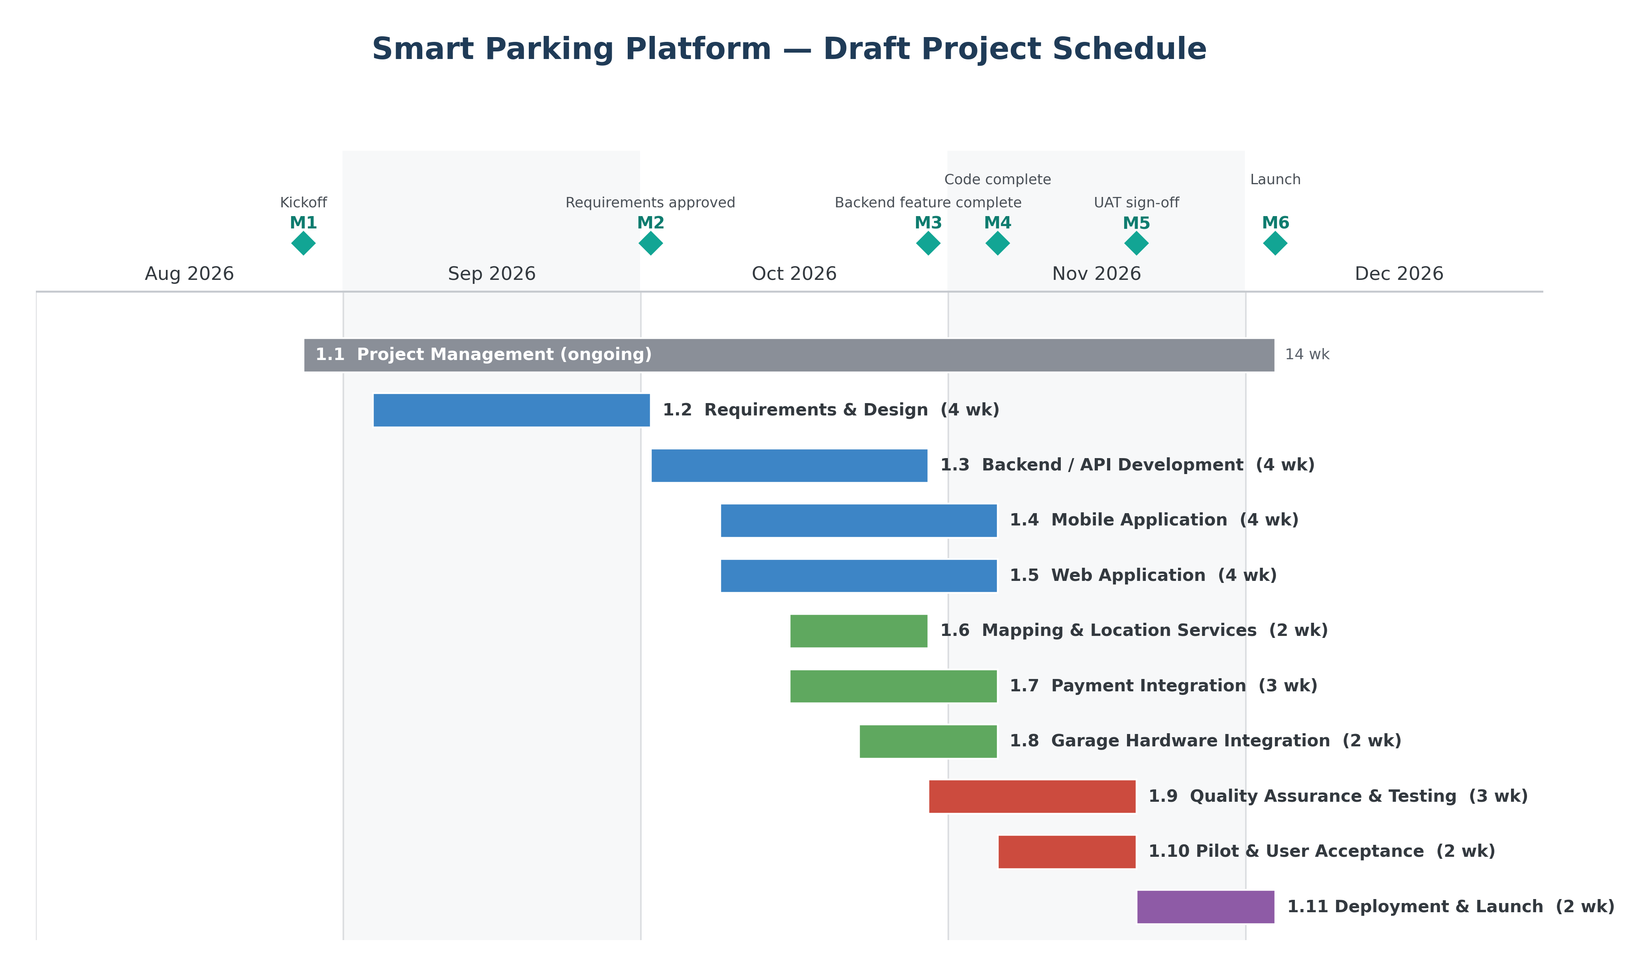
Figure 1: Draft project schedule for the Smart Parking Platform, August through December 2026. Diamonds mark the six project milestones listed in Section 6.3.

Figure 1: Draft project schedule for the Smart Parking Platform, August through December 2026. Diamonds mark the six project milestones listed in Section 6.3.

6.5 Critical Path
The longest dependent chain through the schedule is:
- 1.1.1 Project charter
- 1.2 Requirements and Design
- 1.3 Backend and API
- 1.9 Quality Assurance and Testing
- 1.10 Pilot and User Acceptance
- 1.11 Deployment and Launch
This chain has no slack. The December 4 delivery date is fixed and cannot move, so any delay in requirements sign-off (M2) has to be absorbed by cutting scope rather than by extending the schedule. Every client-side and integration branch waits on the API contract produced in the Requirements and Design phase.
The compressed timeline changes the risk profile. On a longer schedule a two-week slip is recoverable; here it consumes half a phase.
Three risks sit directly on this path and will be carried into the risk register:
- Requirements sign-off slipping past October 2. The client has three separate stakeholder groups — operators, drivers, and the city transportation department — and their priorities may conflict. Sign-off is time-boxed to one week, which is aggressive.
- Garage hardware integration (1.8) running long. It is not on the critical path today, but it feeds the pilot in 1.10, and it has only two weeks. Any vendor delay makes it critical immediately.
- Testing compressed against the Thanksgiving break. QA ends November 20 and deployment runs through a week with no working days. There is no recovery window between UAT sign-off and delivery.

6.6 Open Scheduling Items
- Effort estimates in hours per work package, which will replace the duration estimates above
- Resource leveling once team sizes are confirmed
- Buffer allocation for the critical path
- Holiday and semester-break calendar

7. Product Backlog and Sprint 1 Plan

7.1 Approach
The requirements in Section 4 describe what the system must do. This section turns them into work the teams can pull from. Every backlog item is written as a user story in the form as a [role], I want [goal], so that [benefit], so that the reason for the work stays attached to the work itself.
Items are estimated in story points on a Fibonacci scale — 1, 2, 3, 5, 8 — rather than in hours. Points measure relative size and uncertainty, not time. An 8-point item is not four times a 2-point item in hours; it is an item the team is far less certain about.
Priority uses MoSCoW: Must for items without which the first release does not work, Should for items that matter but could slip a release, Could for items that improve the product but are safe to drop under schedule pressure. Given the fixed December 4 deadline in Section 6, the Could items are the scope buffer.
The backlog is a living list. It will be re-groomed at the start of every sprint, and items will be split as the teams learn more.

7.2 Epic Overview
Epic | Prefix | Items | Points | Covers
Login and Accounts | LOG | 10 | 30 | Registration, authentication, roles, vehicle profiles
User Interface | UI | 21 | 71 | Driver app and web, operator dashboard, admin console
Backend Processes | BE | 20 | 116 | Services, availability engine, payments, hardware, integrations
Reporting and Analytics | RPT | 12 | 41 | Operator reports, finance statements, driver history
Total |  | 63 | 258

7.3 Backlog — Login and Accounts
ID | User story | Points | Priority
LOG-01 | As a driver, I want to create an account with my email and password so that I can save my reservations. | 3 | Must
LOG-02 | As a driver, I want to verify my email address so that my account is secure. | 2 | Must
LOG-03 | As a driver, I want to log in with my credentials so that I can reach my reservations. | 2 | Must
LOG-04 | As a driver, I want to reset a forgotten password so that I can get back into my account. | 3 | Must
LOG-05 | As a driver, I want to stay signed in on my phone so that I do not log in every trip. | 2 | Should
LOG-06 | As a driver, I want to sign up with Google or Apple so that registration is faster. | 5 | Could
LOG-07 | As an operator, I want to log in to the operator dashboard so that I can manage my garage. | 3 | Must
LOG-08 | As an administrator, I want role-based permissions so that each user only sees what their role allows. | 5 | Must
LOG-09 | As a driver, I want to save my vehicle and licence plate so that gate entry works automatically. | 3 | Must
LOG-10 | As a driver, I want to sign out of all devices so that I can secure a lost phone. | 2 | Should

7.4 Backlog — User Interface
Covers both sides of the platform. Items UI-01 to UI-16 are the driver experience; UI-17 to UI-21 are the operator dashboard and administrative console.
ID | User story | Points | Priority
UI-01 | As a driver, I want to see garages as pins on an interactive map so that I can find parking near me. | 5 | Must
UI-02 | As a driver, I want to search by address or landmark so that I can plan parking before I leave. | 3 | Must
UI-03 | As a driver, I want to use my current location so that I can find parking without typing. | 2 | Must
UI-04 | As a driver, I want to filter by price, walking distance, covered parking and accessible spaces so that results match my needs. | 5 | Should
UI-05 | As a driver, I want to sort results by price or distance so that I can compare options quickly. | 2 | Should
UI-06 | As a driver, I want a garage detail page with photos, hours, clearance and pricing so that I know what I am booking. | 3 | Must
UI-07 | As a driver, I want to pick my arrival and departure time so that I am quoted the right price. | 3 | Must
UI-08 | As a driver, I want to see the itemised total before I pay so that there are no surprise fees. | 3 | Must
UI-09 | As a driver, I want to reserve and pay in one flow so that booking takes under ninety seconds. | 5 | Must
UI-10 | As a driver, I want my QR entry pass in the app so that I can get through the gate. | 3 | Must
UI-11 | As a driver, I want turn-by-turn directions to the garage entrance so that I do not circle the building. | 3 | Should
UI-12 | As a driver, I want to see upcoming and past reservations so that I can keep track of my parking. | 3 | Must
UI-13 | As a driver, I want to download a receipt so that I can claim the expense. | 2 | Should
UI-14 | As a driver, I want to extend an active reservation from the app so that I am not rushed back to my car. | 3 | Should
UI-15 | As a driver, I want to cancel a reservation and see the refund policy first so that I know what I get back. | 3 | Must
UI-16 | As a driver, I want to control which notifications I receive so that I am not spammed. | 2 | Could
UI-17 | As an operator, I want a dashboard home showing live occupancy so that I know my garage status at a glance. | 5 | Must
UI-18 | As an operator, I want to edit my listing details and photos so that drivers see accurate information. | 3 | Must
UI-19 | As an operator, I want to set hourly, daily and event pricing rules so that I can price by demand. | 5 | Must
UI-20 | As an operator, I want to see the reservation list for my garage so that I can plan staffing. | 3 | Should
UI-21 | As an administrator, I want a console to look up users and resolve disputes so that I can handle support cases. | 5 | Should

7.5 Backlog — Backend Processes
These are the services behind the screens. They are written from the point of view of the person who benefits, not the person who builds them, so the value of each service stays visible. Twelve serve drivers, six serve operators, and two are shared infrastructure.
ID | User story | Points | Priority
BE-01 | As a driver, I want my account credentials kept secure so that nobody else can use my account. | 5 | Must
BE-02 | As a driver, I want to stay signed in across the app and the website so that I do not log in twice. | 5 | Must
BE-03 | As an operator, I want my garages, spaces and capacity held in one place so that every channel shows the same numbers. | 5 | Must
BE-04 | As an operator, I want my gate and sensor events sent to the platform automatically so that occupancy is always current. | 8 | Must
BE-05 | As a driver, I want availability worked out from live occupancy and existing bookings so that a space I reserve really exists. | 8 | Must
BE-06 | As an operator, I want every hold, booking and cancellation recorded so that my records reconcile at the end of the day. | 5 | Must
BE-07 | As a driver, I want my space held while I finish paying so that I do not lose it at checkout. | 5 | Must
BE-08 | As a driver, I want the system to check for later bookings before extending so that my extension is honoured. | 5 | Should
BE-09 | As a driver, I want cancellations refunded by a clear policy so that I know what I get back. | 5 | Must
BE-10 | As a driver, I want an automatic refund and an alternate space if my reservation cannot be honoured so that I am not stranded. | 8 | Must
BE-11 | As an operator, I want pricing rules applied automatically by time of day and event so that I do not reprice by hand. | 5 | Must
BE-12 | As a driver, I want my card processed securely so that my payment details are never exposed. | 8 | Must
BE-13 | As an operator, I want my share of revenue calculated each period so that I am paid accurately and on time. | 5 | Should
BE-14 | As a driver, I want alerts delivered by push, email or SMS so that I receive them on whatever I am using. | 5 | Must
BE-15 | As an operator, I want the platform to work with my existing gate hardware so that I do not have to replace equipment. | 8 | Must
BE-16 | As a driver, I want the gate to open from my licence plate so that I do not have to handle anything at entry. | 8 | Must
BE-17 | As a driver, I want a QR pass as a backup so that a failed plate read does not strand me at the gate. | 5 | Must
BE-18 | As a driver, I want addresses and routes resolved accurately so that search and navigation take me to the right entrance. | 5 | Must
BE-19 | As an administrator, I want an unchangeable log of financial and admin actions so that disputes can be investigated. | 3 | Should
BE-20 | As a developer, I want deployment pipelines and separate environments so that the team can release safely from day one. | 5 | Must

7.6 Backlog — Reporting and Analytics
Reporting serves three audiences: operators who need to understand their garages, finance users who need to reconcile payouts, and drivers who need their own parking history.
ID | User story | Points | Priority
RPT-01 | As an operator, I want a live occupancy widget so that I can see spaces used right now. | 3 | Must
RPT-02 | As an operator, I want a daily revenue summary so that I can track takings without a spreadsheet. | 3 | Must
RPT-03 | As an operator, I want a utilisation rate report for any date range so that I can see how well the garage is used. | 5 | Must
RPT-04 | As an operator, I want a peak hours report so that I can set pricing around demand. | 3 | Should
RPT-05 | As an operator, I want average parking duration so that I can plan capacity. | 3 | Should
RPT-06 | As an operator, I want a reserved versus walk-in split so that I can see what the platform is bringing in. | 3 | Should
RPT-07 | As an operator, I want to export any report to CSV or PDF so that I can share it with my finance team. | 3 | Must
RPT-08 | As a finance user, I want a payout statement per operator per period so that payouts can be reconciled. | 5 | Must
RPT-09 | As a finance user, I want a refund and dispute report so that I can spot patterns of failed reservations. | 3 | Should
RPT-10 | As an administrator, I want a failed gate entry incident report so that hardware problems are caught early. | 5 | Should
RPT-11 | As a driver, I want a summary of my parking history so that I can see where and how often I park. | 2 | Could
RPT-12 | As a driver, I want an annual expense export so that I can claim parking on my taxes. | 3 | Could

7.7 Sprint 1 Plan
Sprint 1 dates: October 2 to October 16, 2026 (two weeks)
Sprint goal: A driver can create an account, log in, and see real garages with live availability on a map.
Sprint 1 deliberately builds the spine of the product rather than the most visible features. Nothing else in the backlog can be built or demonstrated until accounts, sessions, the inventory service and the deployment pipeline exist. The map is included so the sprint ends with something a stakeholder can actually look at, which is the point of a sprint review.
ID | User story | Points
LOG-01 | As a driver, I want to create an account with my email and password so that I can save my reservations. | 3
LOG-02 | As a driver, I want to verify my email address so that my account is secure. | 2
LOG-03 | As a driver, I want to log in with my credentials so that I can reach my reservations. | 2
LOG-04 | As a driver, I want to reset a forgotten password so that I can get back into my account. | 3
UI-01 | As a driver, I want to see garages as pins on an interactive map so that I can find parking near me. | 5
UI-02 | As a driver, I want to search by address or landmark so that I can plan parking before I leave. | 3
UI-03 | As a driver, I want to use my current location so that I can find parking without typing. | 2
BE-01 | As a driver, I want my account credentials kept secure so that nobody else can use my account. | 5
BE-02 | As a driver, I want to stay signed in across the app and the website so that I do not log in twice. | 5
BE-03 | As an operator, I want my garages, spaces and capacity held in one place so that every channel shows the same numbers. | 5
BE-20 | As a developer, I want deployment pipelines and separate environments so that the team can release safely from day one. | 5
 | Sprint 1 total | 40
Why these items
- BE-20 comes first. Without pipelines and environments, nothing else can be deployed or tested.
- BE-01, BE-02, LOG-01 to LOG-04 are the account spine. Every other story assumes a logged-in user.
- BE-03 establishes garages and spaces as data. The map has nothing to draw without it.
- UI-01 to UI-03 give the sprint a visible outcome and prove the backend works end to end.
Deferred on purpose
Payments (BE-12), reservations (BE-07) and gate hardware (BE-15, BE-16) are all Must items but none belongs in Sprint 1. Each depends on the inventory and account services being stable first, and taking them early would mean building on foundations that are still moving.
Definition of done for Sprint 1
An item is done when the code is merged, unit tests pass, it is deployed to the staging environment, and it has been demonstrated against the sprint goal at the review.

7.8 Product Backlog Board
The backlog is maintained as a Trello board so that the teams can move work through the sprint rather than read it from a document. The four epic lists hold the remaining backlog and the Sprint 1 list holds the committed work for the current sprint. Card titles carry the story ID, the estimate and the MoSCoW priority, so the board and Section 7.3 to 7.6 stay in step.
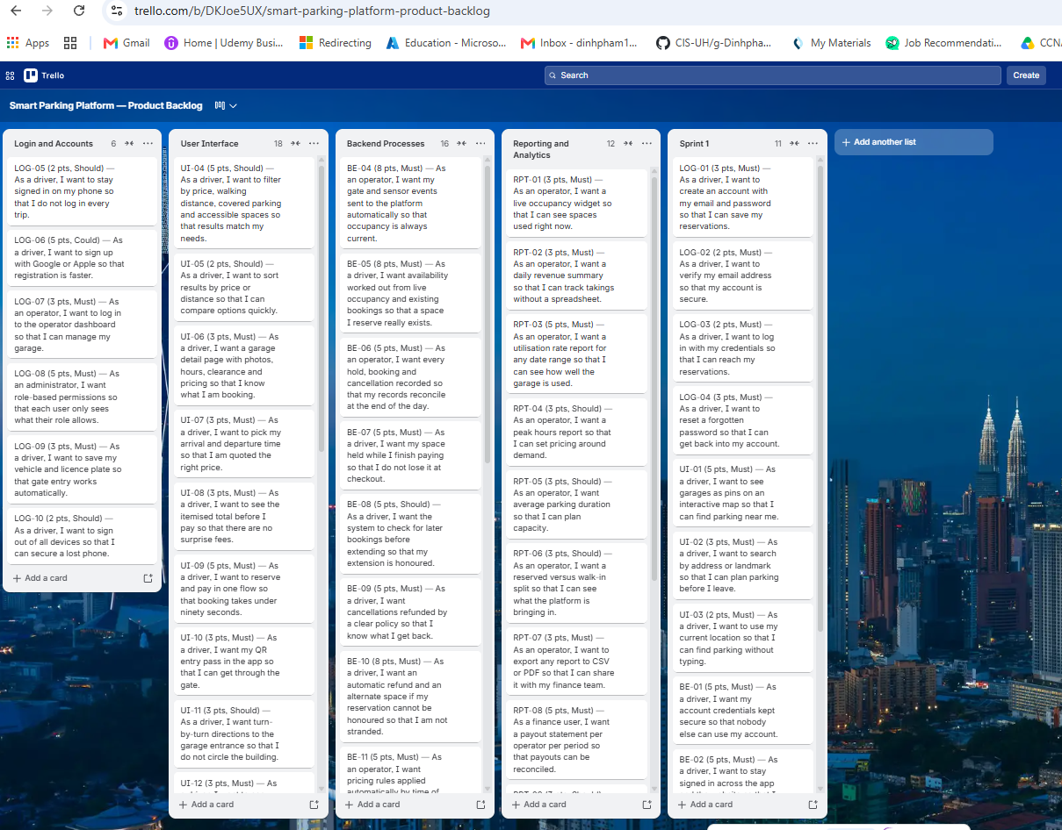
Figure 2: Product backlog board in Trello. The four epic lists hold the remaining 52 stories; the Sprint 1 list holds the 11 stories committed for the sprint beginning October 2, 2026.
As sprints progress, the board will gain the usual working columns — In Progress, In Review and Done — so that flow can be tracked. They are left off for now because Sprint 1 has not started.

7.9 Open Backlog Items
- Acceptance criteria per story, which will be written during sprint grooming
- Sprint 2 and Sprint 3 planning once Sprint 1 velocity is known
- Splitting the 8-point items, which are too large to finish inside one sprint as written
- Linking each story back to its use case in Section 4 for traceability

8. Risk Management and Communication Plan

8.1 Risk Management Approach
Risks were identified by walking the WBS in Section 5 branch by branch, the schedule in Section 6, and the assumptions in Sections 3.9 and 6.1. Every assumption is a risk in disguise: if it turns out to be false, something breaks.
Each risk is scored on two scales:
- Probability — Low (1), Medium (2), High (3): how likely it is to happen.
- Impact — Low (1), Medium (2), High (3): what it costs us if it does.
The risk score is probability multiplied by impact, so it runs from 1 to 9. Anything scoring 6 or higher gets an owner and an active response now. Anything scoring 3 or 4 is monitored. Anything at 1 or 2 is logged and reviewed monthly.
Four response strategies are used:
Strategy | What it means | When we use it
Avoid | Change the plan so the risk cannot happen | The risk would sink the project and the plan can be changed
Mitigate | Reduce the probability or the impact | Most risks land here
Transfer | Move the consequence to a third party | Insurance, vendor contracts, SLAs
Accept | Do nothing in advance; handle it if it happens | Cost of the response exceeds the cost of the risk
Because the December 4 deadline in Section 6 is fixed and cannot move, schedule risks carry more weight on this project than they would normally. When a schedule risk materialises here, the only lever available is scope.

8.2 Risk Identification by Category
Technical risks
ID | Risk
T-1 | Live occupancy feeds from garage sensors are less accurate than the 30-second target in NFR-2, so availability shown to drivers is wrong
T-2 | Gate hardware differs by vendor and the adapter layer in WBS 1.8.1 does not cover every garage in the pilot
T-3 | Licence plate recognition misreads plates in rain, at night, or on damaged plates, so drivers are stuck at the gate
T-4 | Payment integration pulls more of the system into PCI DSS scope than expected, forcing rework in the backend
T-5 | The availability engine has a race condition under load and sells the same space twice, breaking the core promise of the product
Schedule risks
ID | Risk
S-1 | Requirements sign-off slips past October 2 because three stakeholder groups cannot agree, delaying every downstream branch
S-2 | Garage hardware integration has only two weeks in the schedule and any vendor delay pushes it onto the critical path
S-3 | The Thanksgiving break, November 23 to 27, removes the only recovery window between UAT sign-off and delivery
S-4 | App store review takes longer than the three weeks allowed in WBS 1.11.2 and the public launch misses December 4
S-5 | Mobile, web and integration teams sit idle waiting on the API contract from WBS 1.2.5.3
Financial risks
ID | Risk
F-1 | Payment gateway per-transaction fees are higher than modelled, cutting the margin on every reservation
F-2 | Mapping and geocoding API costs scale with usage and become the largest running cost at launch volume
F-3 | Automatic refunds under NFR-11 create a liability we cannot forecast until occupancy feeds are proven
F-4 | Pilot garages need sensor or camera retrofits that were not in the hardware budget
F-5 | Errors in operator payout calculation create reconciliation work and damage trust with the paying client
People risks
ID | Risk
P-1 | A specialist on payments or licence plate recognition becomes unavailable and no one else can pick the work up
P-2 | Six teams working in parallel create coordination overhead that slows everyone down
P-3 | Operator stakeholders are slow to respond to questions, blocking requirements and pilot scheduling
P-4 | Drivers, operators and the city transportation department want different things, and no one has final say
P-5 | Knowledge of the availability engine sits with one person, so any absence stops the critical path

8.3 Risk Register
In the table below, P is probability and I is impact, each rated Low, Med or High. Score is the two multiplied, as described in Section 8.1. The twelve risks below scored 3 or higher and are actively managed. The remaining eight are logged as watch items and reviewed at the monthly steering meeting.
ID | Risk | P | I | Score | Owner | Response | Status
S-1 | Requirements sign-off slips past October 2 | High | High | 9 | Project Manager | Mitigate — time-box review to one week, get written sign-off criteria agreed up front, escalate to steering on day 3 | Open
S-2 | Garage hardware integration runs past its two weeks | High | Med | 6 | Backend Lead | Mitigate — start vendor technical calls during requirements, build the adapter against two vendors first | Open
T-3 | Plate recognition fails in poor conditions | High | Med | 6 | Backend Lead | Mitigate — QR pass fallback in WBS 1.8.4 plus an in-app support code; target 95% read rate, not 100% | Open
P-4 | Stakeholder groups want different things | High | Med | 6 | Project Manager | Mitigate — name a single product owner on the client side with final say before requirements start | Open
T-1 | Occupancy feeds less accurate than NFR-2 requires | Med | High | 6 | Backend Lead | Mitigate — mark garages without a verified feed as “availability estimated” and block guaranteed booking there | Open
T-5 | Availability engine double-books a space | Med | High | 6 | Backend Lead | Mitigate — pessimistic locking on the reservation ledger, load test before the pilot; auto-refund in NFR-11 as backstop | Open
S-4 | App store review delays the December 4 launch | Med | High | 6 | Mobile Lead | Mitigate — submit a review build four weeks early during UAT; prepare the web app as the launch path if stores slip | Open
T-2 | Adapter layer misses a pilot garage’s hardware | Med | Med | 4 | Backend Lead | Mitigate — survey hardware at all pilot garages before WBS 1.8 starts; choose pilot sites by hardware match | Open
F-1 | Gateway fees higher than modelled | Med | Med | 4 | Finance Lead | Transfer — fix the rate in the gateway contract signed during WBS 1.7.1 | Open
F-3 | Refund liability under NFR-11 is unforecastable | Med | Med | 4 | Finance Lead | Accept and monitor — track refund rate weekly from the pilot; revisit if it exceeds 1% of reservations | Open
S-3 | Thanksgiving break removes the recovery window | High | Low | 3 | Project Manager | Avoid — move the deployment buffer earlier so no critical work sits in that week | Open
P-1 | A payments or LPR specialist becomes unavailable | Low | High | 3 | Project Manager | Mitigate — pair every specialist area with a second engineer from week one | Open
Watch list (reviewed monthly, not actively managed): T-4, S-5, F-2, F-4, F-5, P-2, P-3, P-5.

8.4 Probability and Impact Matrix
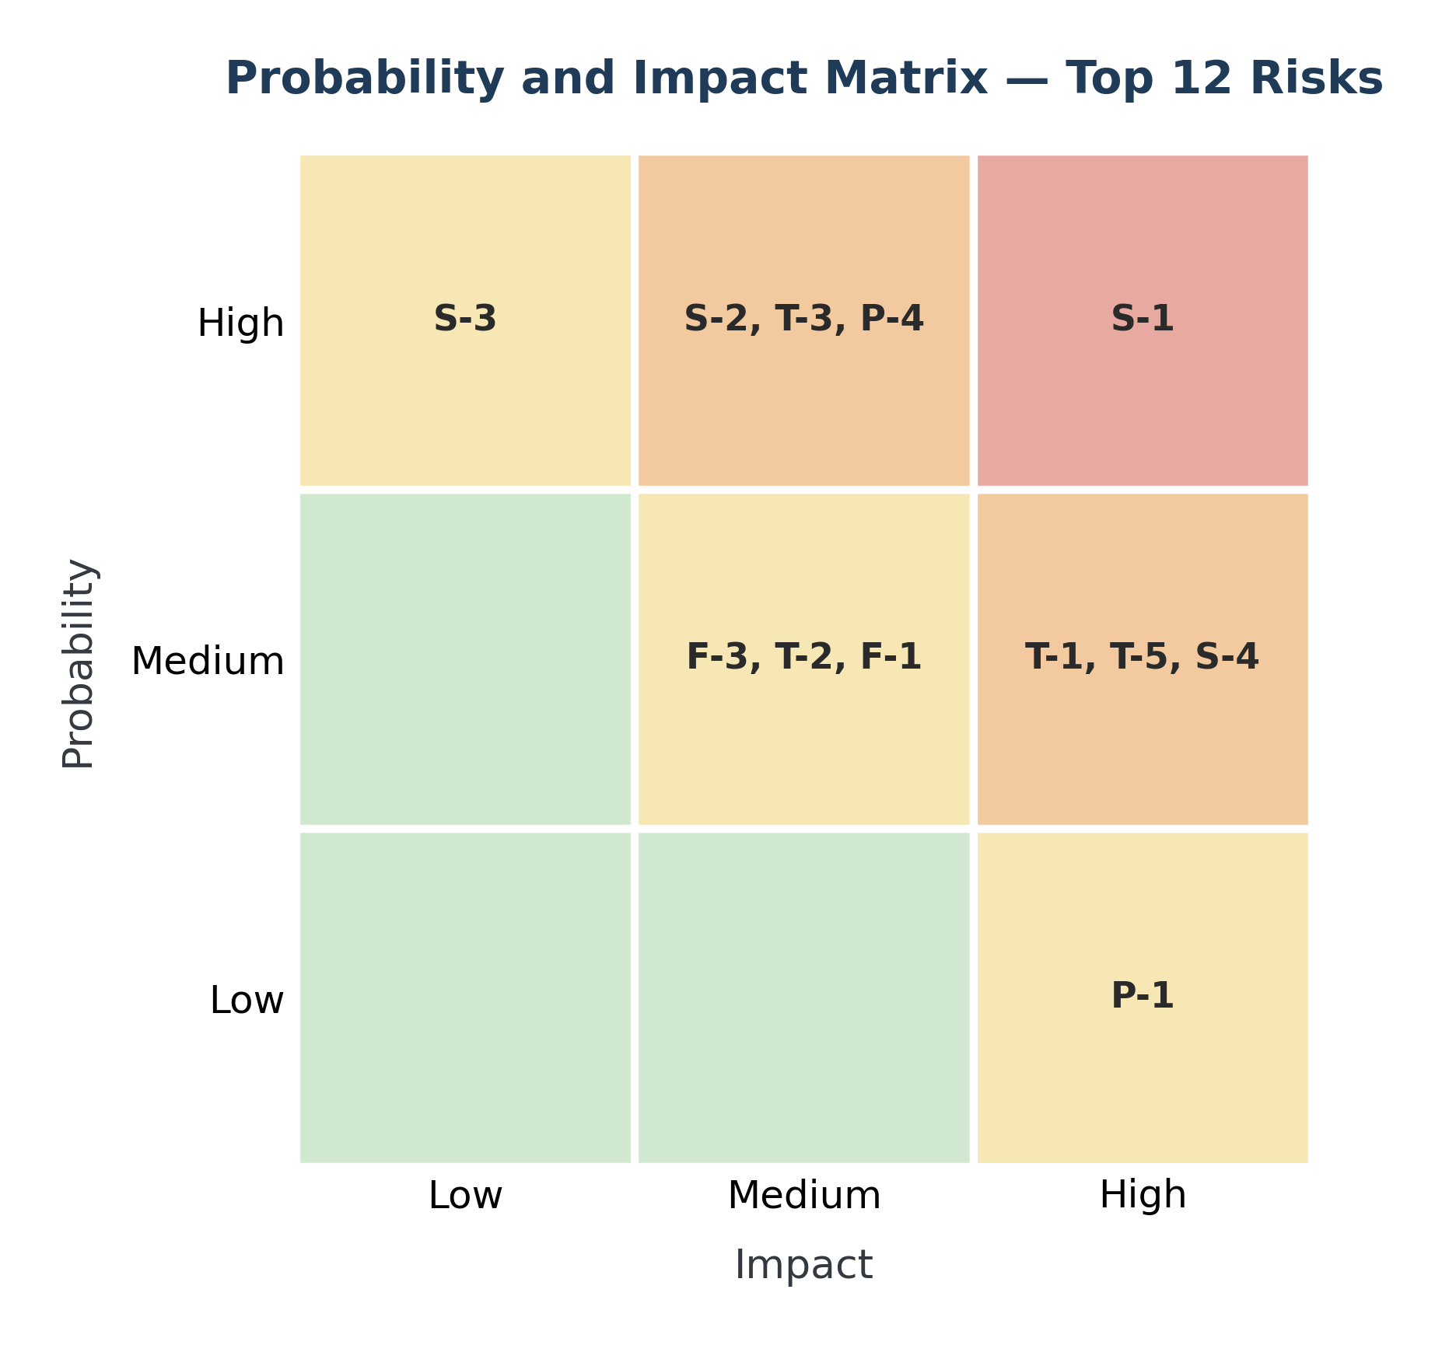
Figure 3: Probability and impact matrix for the twelve actively managed risks. Red and orange cells require an active response; yellow cells are monitored; green cells are accepted.
The matrix makes the shape of the project clear. The top-right cluster is almost entirely schedule and integration risk, which follows directly from the fixed deadline in Section 6. There is nothing in the low-probability, low-impact corner worth tracking, because those risks were filtered out during identification.

8.5 Communication Plan
Meeting cadence
Meeting | Who attends | How often | Length | Purpose
Team stand-up | Each delivery team separately | Daily, 9:15am | 15 min | What was done, what is next, what is blocked
Scrum of scrums | One lead from each of the six teams | Twice weekly, Tue and Thu | 30 min | Cross-team blockers and dependencies
Sprint planning | Delivery team plus product owner | Every two weeks, sprint start | 2 hr | Commit to the sprint backlog
Sprint review | Delivery teams, product owner, client | Every two weeks, sprint end | 1 hr | Demonstrate working software
Sprint retrospective | Each delivery team | Every two weeks, sprint end | 45 min | What to change in how we work
Stakeholder update | Project Manager to all stakeholders | Weekly, Thursday | Async video | What changed this week, what is next
Risk review | Project Manager and team leads | Every two weeks | 45 min | Re-score the register, close and open risks
Steering committee | Client sponsors, PM, delivery leads | Monthly | 1 hr | Budget, scope changes, escalated decisions
Reporting methods
Report | Audience | Format | Frequency | Owner
Sprint burndown | Delivery teams | Trello board, live | Continuous | Team leads
Weekly status update | All stakeholders | 1–2 minute recorded video | Weekly | Project Manager
Project document | All stakeholders | This document, versioned in GitHub | Weekly | Project Manager
Risk register | Steering committee, team leads | Section 8.3 of this document | Every two weeks | Project Manager
Occupancy and revenue reports | Operators, finance | Platform reports in WBS 1.5.2.4 | Daily and monthly | Operator dashboard
Defect report | QA, delivery leads | Test management tool | Daily during test phases | QA Lead
Milestone report | Client sponsors | One-page summary at each milestone | Six times (M1–M6) | Project Manager
Escalation path
- Raised in the team stand-up and handled by the team lead.
- Unresolved after one working day, raised at the scrum of scrums.
- Unresolved after three working days, or affecting the critical path, escalated to the Project Manager.
- Affecting scope, budget, or the December 4 delivery date, escalated to the steering committee within 24 hours.
Anything on the critical path in Section 6.5 skips straight to step 3. There is no slack to absorb a slow escalation.
Communication principles
- Written first. Decisions made in a meeting are recorded in this document or on the board within 24 hours.
- One source of truth. The project document in the public repository is the current state; anything else is a draft.
- Bad news early. A risk raised late costs more than a risk raised wrong.

8.6 Open Risk Management Items
- Quantitative risk analysis, including expected monetary value for the financial risks
- Contingency reserve sizing once effort estimates are complete
- Risk triggers — the specific signal that tells us a risk is becoming an issue
- A stakeholder communication matrix mapping each stakeholder to their interest and influence

9. Next Steps
- Add effort estimates in hours to each work package in Section 5, then resource-level the schedule.
- Start the risk register, beginning with the three critical-path risks named in Section 6.5 and the third-party dependency risks in Section 3.9.
- Run stakeholder analysis and requirements elicitation to confirm and extend the requirements in Section 4.
- Expand the SRS with use case and sequence diagrams and acceptance criteria.

10. References
- Market Research Intellect — Smart Parking Platform Market Size and Forecast. Market sizing and key player list.
- Similarweb — SpotHero Competitors, June 2026. Competitive set for garage reservation platforms.
- Unstar — ParkMobile vs SpotHero: 5 Parking Apps Ranked, 2026. Complaint pattern analysis for ParkMobile, SpotHero, PayByPhone, ParkWhiz, and Passport.
- StartupOG — Best ParkWhiz Alternatives & Competitors, 2026. Feature positioning across competitors.
- $oftware ¢orp. — Semester Project: Smart Parking Platform (course project brief).
End of document — version 1.1

