Credit Card Fraud Detection
EG/2021/4487 | EG/2021/4825 | EG/2021/4434

Testing the Mapper
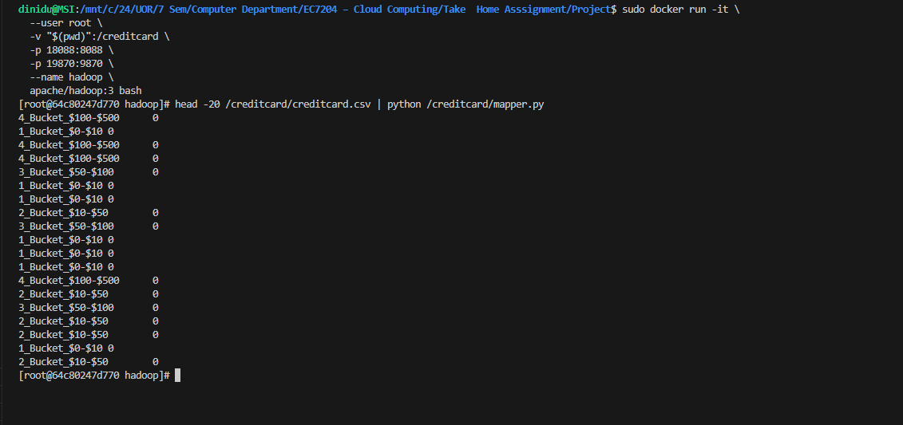

Approach

The Credit Card Fraud Detection dataset there are 284,807 transactions and 492 fraud cases is used in the MapReduce task to analyze fraud rates across six transaction amount brackets. Each CSV row is read by the mapper then extracts the Amount and Class fields and assigns the amount to a bucket as $0–$10, $10–$50, $50–$100, $100–$500, $500–$1,000, $1,000+ and outputs a key-value pair of bucket_name and class_label. Malformed rows are eliminated and the header row is identified and skipped. The reducer groups records by bucket, counts all transactions, adds up the class labels to determine the fraud count because of Class is binary and outputs a single line for each bucket that includes the following information bucket name, total transactions, fraud count, normal count, and fraud rate percentage. Python with Hadoop Streaming on Apache Hadoop 3.3.6 via Docker on WSL2 was used to complete the task.

Result Summary

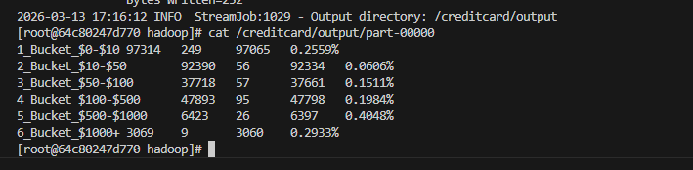

Result Interpretation

The findings show a direct correlation between transaction volume and fraud risk. Fraudsters disproportionately target high-value transactions, where each successful fraud yields greater financial gain, as evidenced by the highest fraud rate of 0.4048% in the $500–$1,000 bracket. At 0.2933%, the $1,000+ bucket comes next. Notably, despite the low individual value, the $0–$10 micro-transaction bucket also exhibits an elevated rate of 0.2559%; this reflects a second known fraud strategy in which thieves test stolen card credentials with tiny, undetectable charges before escalating. At 0.0606%, the $10–$50 range is the safest, reflecting regular, everyday purchases where fraud is least prevalent.
While high-value transactions have a higher fraud rate percentage, low-value micro-transactions account for more than half of all fraud incidents. In absolute terms, the $0–$10 bucket has the highest number of fraud cases (249 out of 492 total). Therefore, rather than using a single global model, a practical fraud detection system should apply distinct risk thresholds for each amount range. Future directions for this work could include deploying on a multi-node HDFS cluster for production scale, combining these MapReduce-derived features with a machine learning classifier (e.g., Random Forest or Isolation Forest on the V1–V28 PCA features) for end-to-end fraud detection, and adding time-of-day as a second dimension to detect temporal fraud patterns.

