Step 1: Create a React App

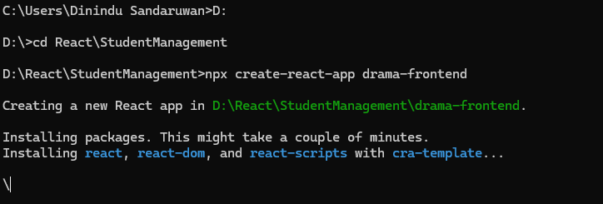
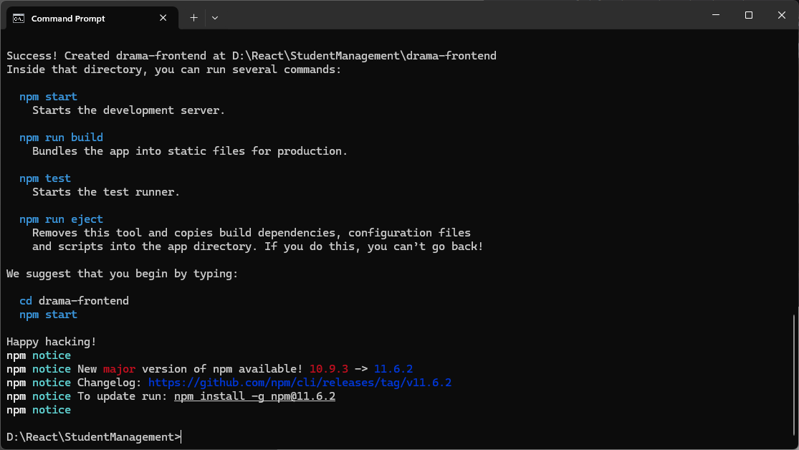
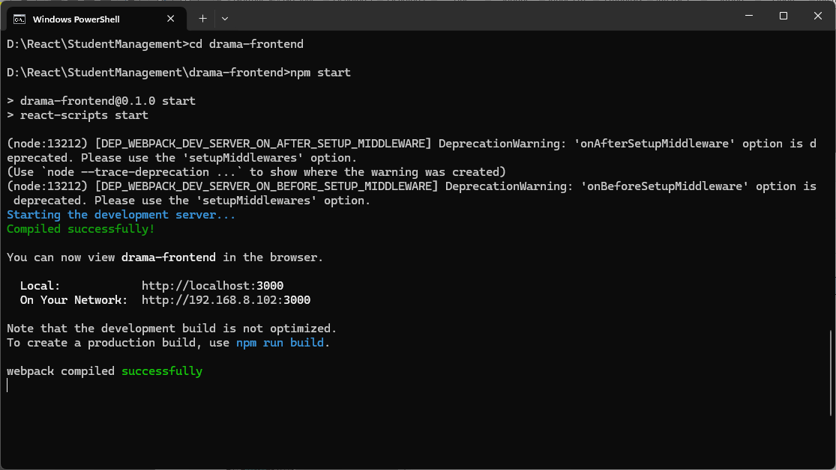

Step 2: Install Axios (for API calls)
Installing Axios in a React.js project for making API calls offers several advantages over using the native fetch API:
- Simplified Syntax and Automatic JSON Parsing:
Axios provides a more concise and readable syntax for making HTTP requests. It automatically parses JSON responses, eliminating the need for manual response.json() calls required with fetch.
- Request and Response Interceptors:
Axios allows you to define interceptors for both requests and responses. This enables global modifications to requests (e.g., adding authentication tokens to headers) and responses (e.g., handling errors uniformly or transforming data) in a centralized location.
- Enhanced Error Handling:
Axios offers a more robust and straightforward way to handle errors. It automatically rejects promises for HTTP status codes in the 4xx and 5xx ranges, making error management more consistent and easier to implement using try-catch blocks.
- Built-in Features:
Axios includes built-in features such as Cross-Site Request Forgery (CSRF) protection, request cancellation, and request timeouts, which can be beneficial for building more secure and robust applications.
- Browser and Node.js Compatibility:
Axios works seamlessly in both browser and Node.js environments, providing a consistent API for making HTTP requests across different parts of your application if you're working with server-side rendering or a full-stack JavaScript setup.
- Centralized Configuration:
You can create custom Axios instances with predefined configurations (e.g., base URLs, default headers), promoting code reusability and maintainability, especially in larger applications with multiple API endpoints.

npm install axios

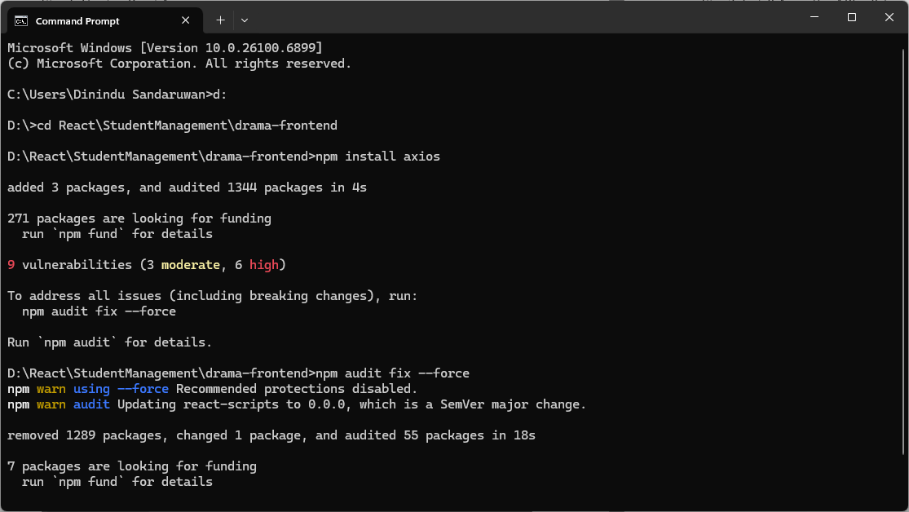

Step 3: Structure the Project
You can keep an api folder for API requests.
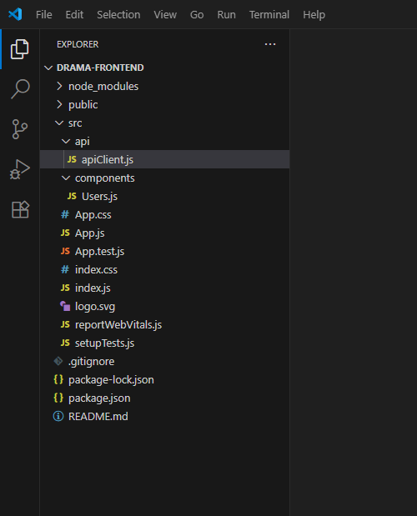
Step 4: Create an Axios Client
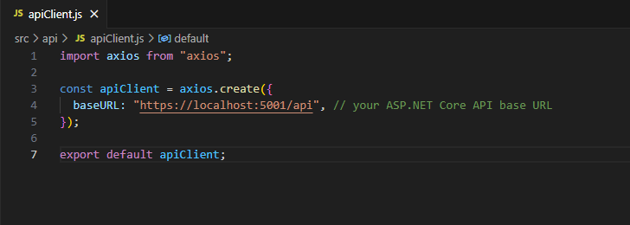

Step 5: Fetch Data in React Component
npm install react-router-dom --save
npm i react-bootstrap –save
npm i react-bootstrap

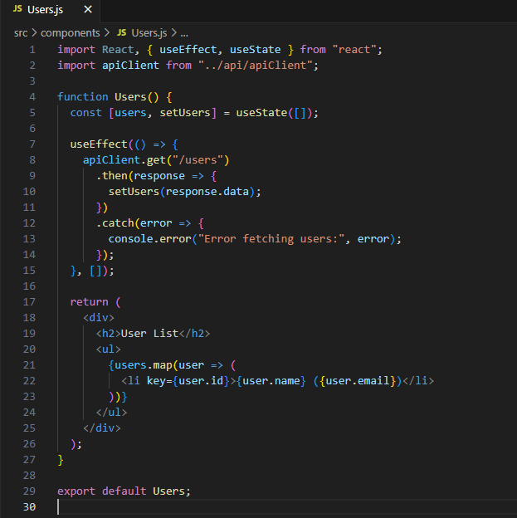
Step 6: Use the Component
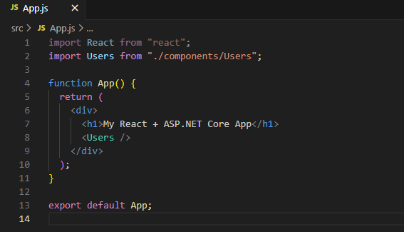

Step 1: Create ASP.NET Core Web API Project
Step 2: Add Entity Framework Core + SQL Server
Install-Package Microsoft.EntityFrameworkCore.SqlServer 9.0.11
Install-Package Microsoft.EntityFrameworkCore.Tools 9.0.11
Step 3: Create the Model
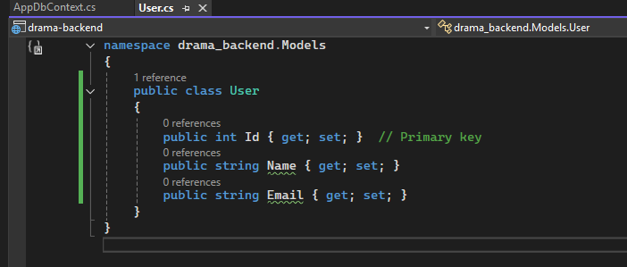
Step 4: Setup the Database Context
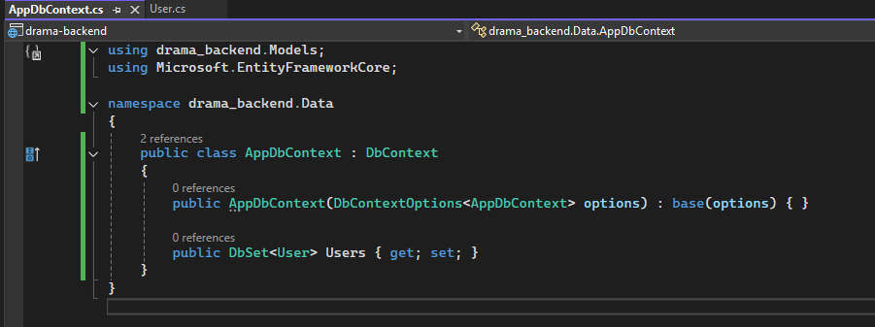
Step 5: Configure Connection String
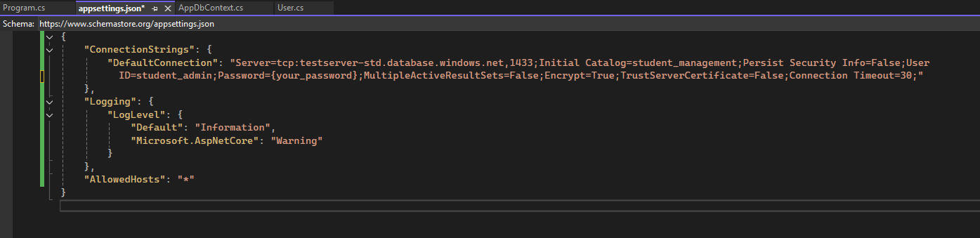

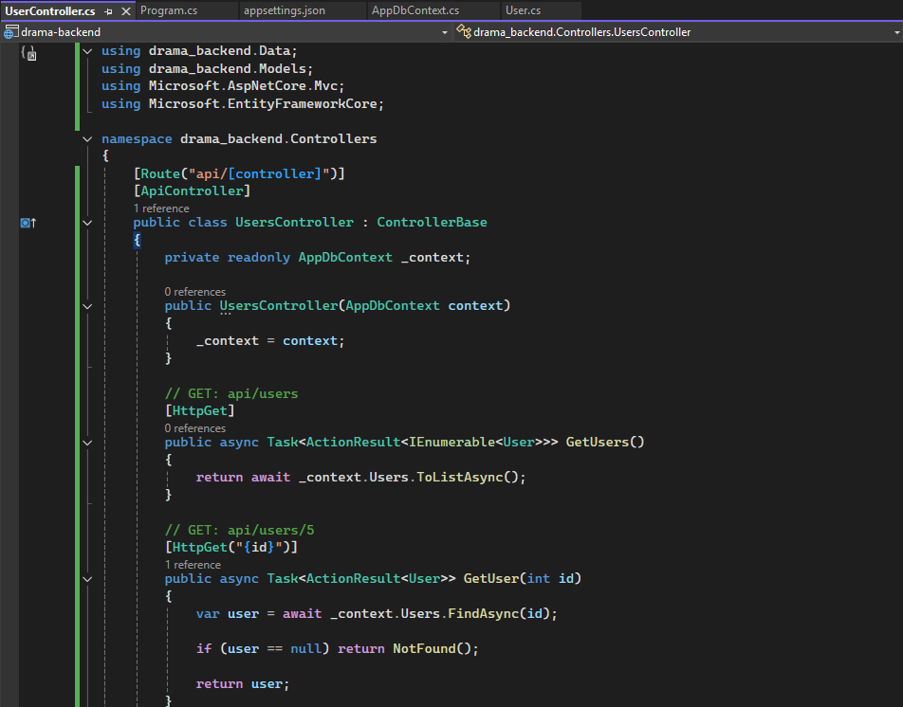
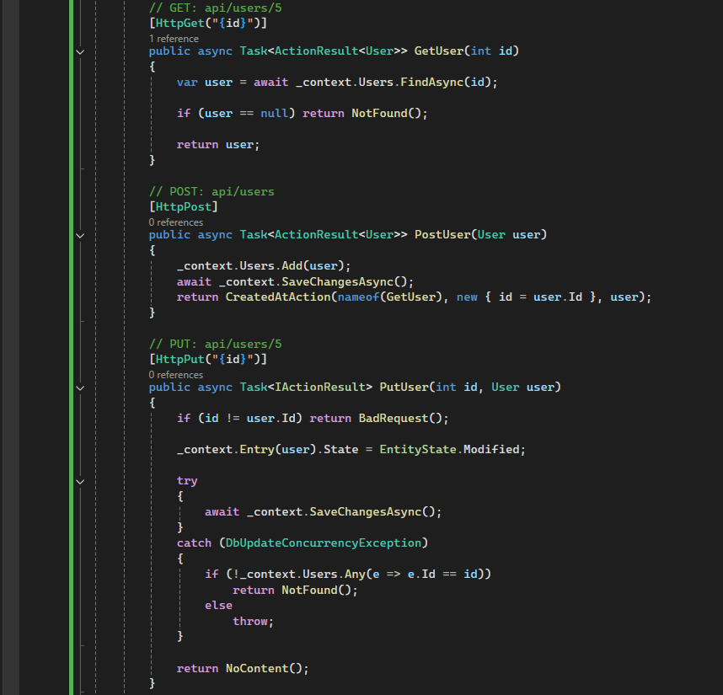
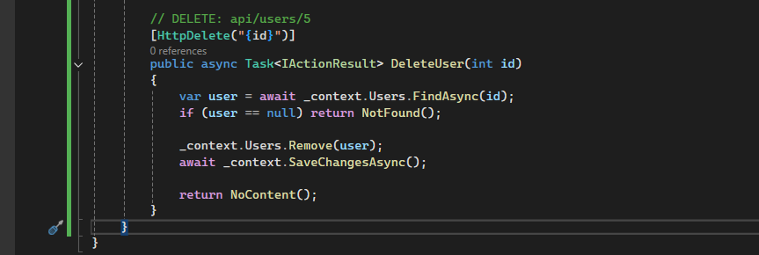

Step 8: Apply Migrations & Create Database
Add-Migration InitialCreate
Update-Database

