Report

Name: Dinis Dimitris
Reached Implementation band : B3 – B1

CGS D3-D1

Block 0: Using the diskblock provided , I initialise it by setting it to ‘\0’ , then write the text "CS3026 Operating Systems Assessment" to it. FAT[0] is set to ENDOFCHAIN.

Block 1,2: I initialise the FAT array by setting its entries to UNUSED. FAT[1] will point to 2 and FAT[2] will point to ENDOFCHAIN, providing the FAT chain. I then call updateFAT() which will copy the first 512 entries of the FAT array into a fatblock, then write that block into VD[1]. Similarly, the next 512 entries are overriden into the fatblock, and then write the block into VD[2]. UpdateFAT() is used every time a FAT block is being allocated.

Block 3: The same diskblock used to initialise Block 0 is reinitialised ( overriden with’\0’) . In order to avoid clogging in the virtual disk. I then create a dirblock that is equal to block.dir, and initialise its attributes (isDir, nextEntry). I write the name “root” into entrylist[0] and then write the block into VD[3].
RootDirIndex and currDirIndex are set to 3.

Functions used:
format();
writeDir();
writeFAT();
writeBlock();
updateFAT();
writedisk();

CGS C3-C1
My approach to this band is described in the following two pages
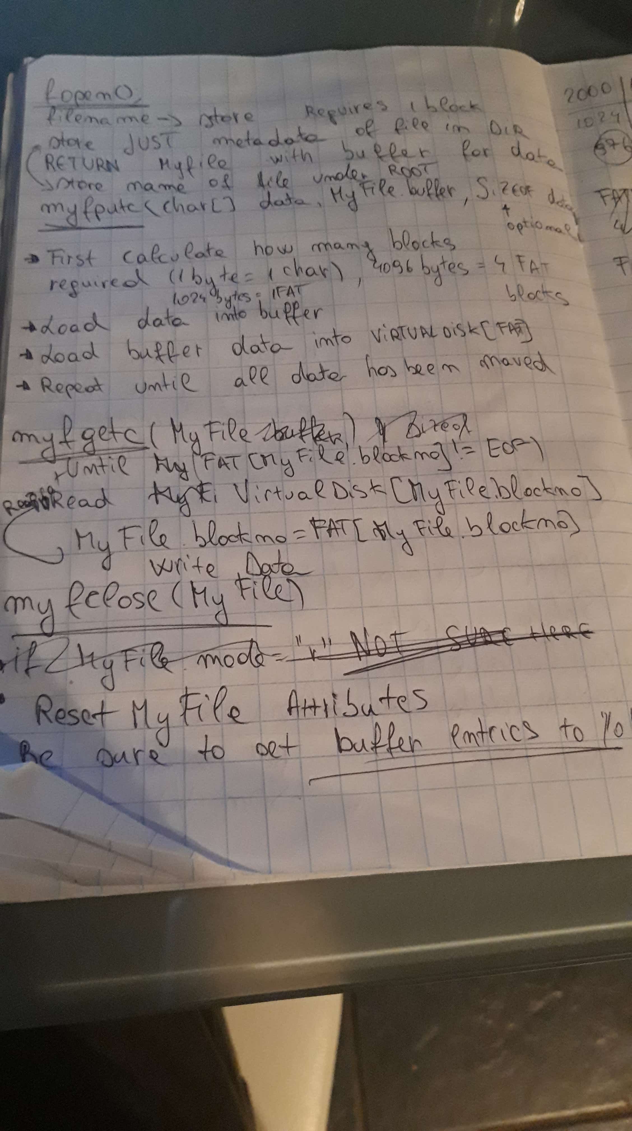
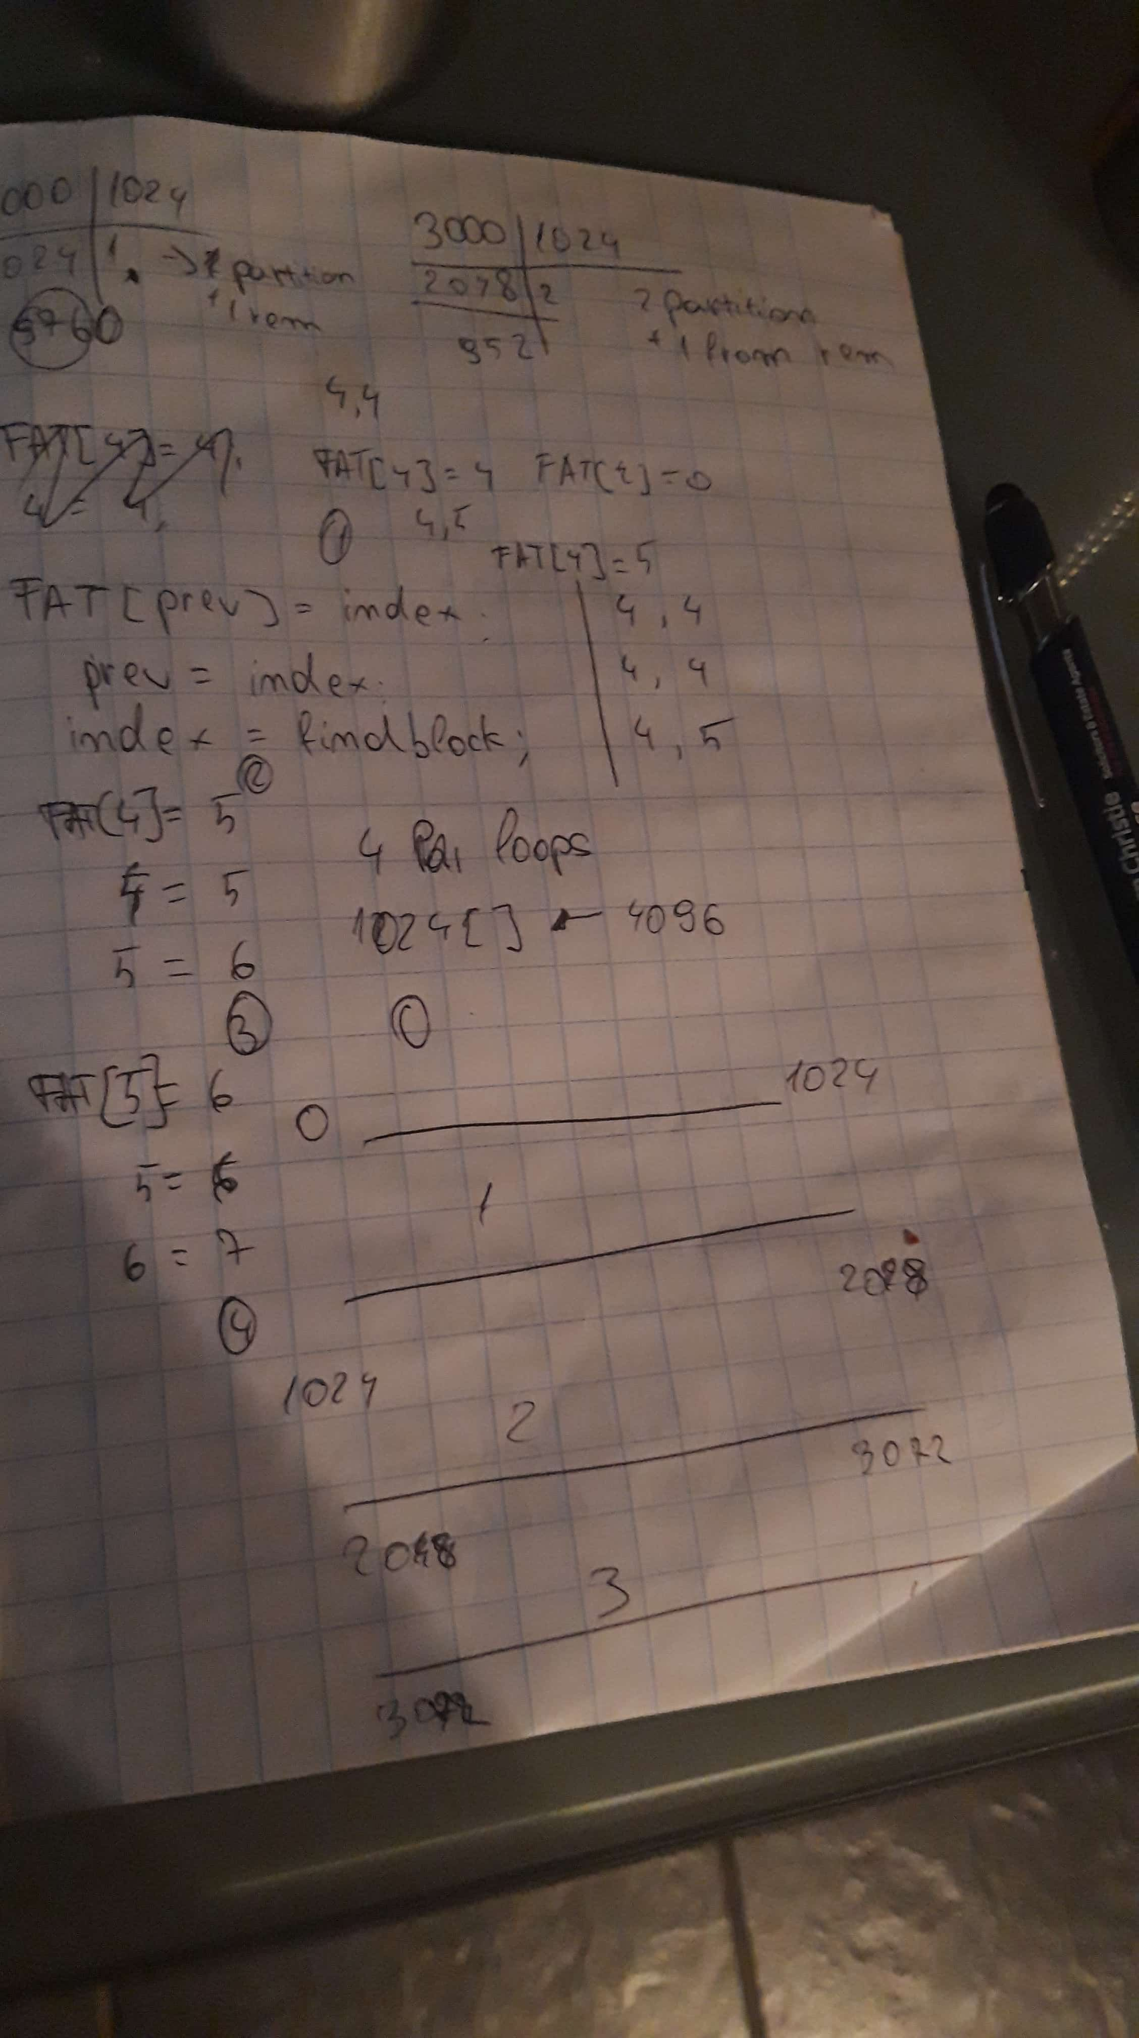
Implementation of myfopen()

myfopen takes as parameters a pointer to a char, and a char mode and returns a MyFILE
First, the function checks the mode. If mode is ‘w’, then we check whether the file has been opened already by searching through the entrylist of our root block. If it was, then we get the index of the file’s block chain (which points to the first block) and iterate through the block chain until ENDOFCHAIN. At ENDOFCHAIN, we create a new block by searching for UNUSED in the FAT array and link them together and call updateFAT(). Then a MyFILE is created , setting the blockno to our new FAT block, mode to ‘w’ .

If Filename does not exist in the entrylist , we allocate a FAT entry, we create a new direntry_t , setting the attributes to our files ( size ,entrylength, firstblock, name). Then we find a free entry in the entrylist ( For this, I just check if entrylength == 0 , since both a dir and a file in a entrylist would have entrylength == 1). A MyFILE fileManager is created , setting the blockno to our fat entry, and the mode to ‘w’.

If mode is ‘r’ then we know that a file already exists in our entrylist, so we just have to search for it. If no file is found, return stderr , file not found. If it is found, return a MyFILE fileManager with mode = ‘r’ and blockno to the first block of the file.

Implementation of myfputc()

myfputc is a void function that takes a pointer to data , a MyFILE fileManager , and size of data.
The way I do this is to dynamically allocate blocks for data by computing how many blocks are needed. First, I divide the data into partitions of 1024 ( size / 1024) . That will return me the amount of blocks needed if size is divisible by 1024. Then, I check if the remainder of (size % 1024) > 0. If it is , that means that our size needs 1 more block ( size = 1025, 1025 / 1024 = 1 , 1025 % 1024 = 1,
In total 2 blocks, one for the first 1024 bytes, second block for the last 1 byte. Based on the clusters I computed, I allocate the FAT block chain. Then I search for our file in the entrylist ( which was created in myFopen() ) and increment its size by the size of our data. I then call updateFAT() and begin to allocate the data into the fileManager.buffer . Since I know how many blocks I will be using, I iterate through the data using 2 loops, allocating the data into the buffer by segments ( 0...1024, 1024… 2048, 2048...3072, 3072… 4096 -> N * Blocksize.. (N * Blocksize) + Blocksize where N is the clustersCount in the outer loop. After each segment allocation, I load the buffer into VD[index]. Index is then set to FAT[index]. Also, I check if data[j] at any point is NULL which means that im loading a block that contains a number of chars which is not divisible by 1024. In that case, I break out of the loop.

Implementation of myfgetc()

myfgetc is a void function that takes a MyFILE fileManager. Here, I get the index of the fileManager which points to the first block, read the data , open a file into ‘a’ mode and put the data into it. Next block is loaded and the proccess is rinse and repeat until index hits ENDOFCHAIN.

Implementation of myfclose()
myfclose is also a void function that takes a MyFILE fileManager and simply resets all its entries.

** Further Improvements **
Since I did not have too much time to work on this , I would like to specify further improvements that could have been made. First, MyFILE could have in the params of these functions could have been a MyFILE * , however I was getting a segmentation error and I by running it with flags and gdb, I would get a stderr inside a C library which I could not debug. In shell, I am using the same srcfile to open and close files to write for data. Also more modes could be added.

CGS B3 – B1

Implementation of mymkdir()

mymkdir() is a void function that takes a pointer to char which is our path. First, I check if path[0] is a ‘/’ . If it is, then path is relative so we start allocating the path from the currentDirIndex. If it is not, we find a free fatblock and start allocating from there. I am using strtok to tokenize the path, and for every token, I store the path in the previous directory’s entrylist, then write the path in its allocated VD[index] where index is our allocated fat block. Rinse and repeat, until token is NULL.

Implementation of mylistDir()

mylistDir() is a function that returns an arrray of strings , and takes a char * path as parameter. Similar proccess is done here, first we tokenize the path, and for each token, we check it with the name of the path in our currentDir.entrylist[] . Since we only want to list the data from the last token of our path, I simply override the values in our string array on each iteration. The last iteration will return the data from the last token in our path.

** Further Improvements **
I did not have time to implement opening the file in different paths. Though I was able to implement it, by using strtok and returning a string of arrays with the last index having the filename, and index -1 the last path, it was very unstable and I decided it’s better to scrap it since it may cause other errors. Also, I have noticed that every function that uses strtok on the char * specified in the parameter , will returrn a seg error unless path is initialized first and then passed as a parameter. I could have researched more into that as well , given more time. I have created a function checkPath() that is able to tokenize the path without using strtok. However this was done one night before the submission and I decided its better to finalise the report.

Explanation of Shell.c

In shell.c, I first call format() to format the virtualdisk. Then I create data to be read which consists of a string of alphabet letters looped . DataSize sets the size of the data , which is currently set to 4 * 1024 → 4096. I create some other strings just to test the re opening of the file and writing again.
I call mymkdir(/root/subdir1/subdir2) open a file ‘testfile.txt’ , write the data to it and close it. I then call mylistDir(path2) to list the contents of the root directory( I create a path2 because path was modified by strtok in mymkdir() ) . I call myfopen again on the same testfile, and write some other data to it. Then I call myfread() to read the file and write the data to the actual hard disk. I then call writedisk to create the virtualdiskB3_B1. I did not submit a testfile_copy.txt since it is created on compile.

Explanation of hexdump

00000000 43 53 33 30 32 36 20 4f 70 65 72 61 74 69 6e 67 |CS3026 Operating|
00000010 20 53 79 73 74 65 6d 73 20 41 73 73 65 73 73 6d | Systems Assessm|
00000020 65 6e 74 00 00 00 00 00 00 00 00 00 00 00 00 00 |ent.............|
00000030 00 00 00 00 00 00 00 00 00 00 00 00 00 00 00 00 |................|

This is block 0 which contains the block allocated for our OS.

00000400 00 00 02 00 00 00 00 00 00 00 00 00 07 00 08 00 |................|
00000410 09 00 0a 00 00 00 ff ff ff ff ff ff ff ff ff ff |................|
00000420 ff ff ff ff ff ff ff ff ff ff ff ff ff ff ff ff |................|

This is block 1 and 2, which contain the FAT entries.

00000400 00 00 02 00 00 00 00 00 contains in order → Block 0 OS, Block 1, 2 FAT , Block 3 , Root

00 00 00 00 07 00 08 00 → first 4 groups of 00’s are for the subdir1 , subdir2 . Starting from 07,
00000410 09 00 0a 00 00 00 we have the block chain for our file , which is extended by 1 block (0a) when file is opened the second time for write. ENDOFCHAIN is marked by the last two 0’s

This is the Root block, containing subdir1, and testfile.txt
00000c00 01 00 00 00 00 00 00 00 01 00 00 00 00 00 00 00 |................|
00000c10 00 00 00 00 00 00 00 00 00 00 00 00 00 00 72 6f |..............ro|
00000c20 6f 74 00 00 00 00 00 00 00 00 00 00 00 00 00 00 |ot..............|
00000c30 00 00 00 00 00 00 00 00 00 00 00 00 00 00 00 00 |................|
*
00000d20 01 00 00 00 01 00 00 00 00 00 00 00 00 00 00 00 |................|
00000d30 00 00 00 00 04 00 73 75 62 64 69 72 31 00 00 00 |......subdir1...|
00000d40 00 00 00 00 00 00 00 00 00 00 00 00 00 00 00 00 |................|
*
00000e30 00 00 00 00 00 00 00 00 01 00 00 00 00 00 00 00 |................|
00000e40 00 00 00 00 00 00 00 00 1e 10 00 00 06 00 74 65 |..............te|
00000e50 73 74 66 69 6c 65 2e 74 78 74 00 00 00 00 00 00 |stfile.txt......|
00000e60 00 00 00 00 00 00 00 00 00 00 00 00 00 00 00 00 |................|

This is subdir1 block, containing subdir2
00001000 01 00 00 00 00 00 00 00 01 00 00 00 00 00 00 00 |................|
00001010 00 00 00 00 00 00 00 00 00 00 00 00 00 00 73 75 |..............su|
00001020 62 64 69 72 31 00 00 00 00 00 00 00 00 00 00 00 |bdir1...........|
00001030 00 00 00 00 00 00 00 00 00 00 00 00 00 00 00 00 |................|
*
00001120 01 00 00 00 01 00 00 00 00 00 00 00 00 00 00 00 |................|
00001130 00 00 00 00 05 00 73 75 62 64 69 72 32 00 00 00 |......subdir2...|
00001140 00 00 00 00 00 00 00 00 00 00 00 00 00 00 00 00 |................|

This is subdir2 block
00001400 01 00 00 00 00 00 00 00 01 00 00 00 00 00 00 00 |................|
00001410 00 00 00 00 00 00 00 00 00 00 00 00 00 00 73 75 |..............su|
00001420 62 64 69 72 32 00 00 00 00 00 00 00 00 00 00 00 |bdir2...........|
00001430 00 00 00 00 00 00 00 00 00 00 00 00 00 00 00 00 |................|

After this block we have the data in our file.

