Dan Annis

MGD Week 1

GITHUB LINK (the plan was to have it here, but it seems to not want to push)

<https://github.com/DinkyDetailsLLC/MGD>

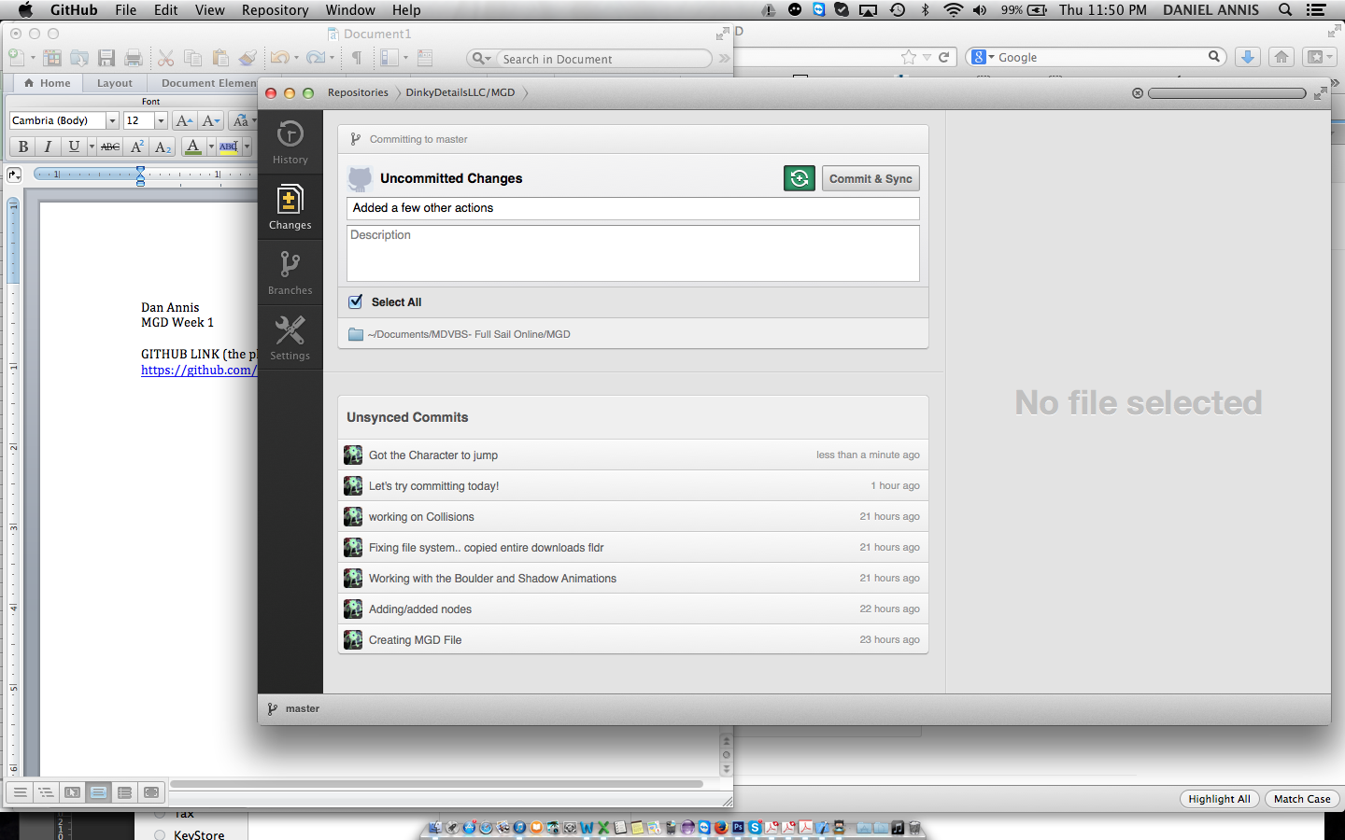

This has been going on for about 1 day!!! Not sure why it isn’t pushing!??!!!

I am linking my xcode project in here too!