Group Project – Communications App
Software Design Specification
Revision History

Date | Revision | Description | Author
03/07/2026 | 1.1 | First Three Use Case Diagrams (CA01-03) | Darien D. Chau
03/13/2026 | 1.11 | Use Case Diagrams (CA04-05) | Darien, Victor

Table of Contents
1. Purpose 4
1.1. Scope 4
1.2. Definitions, Acronyms, Abbreviations 4
1.3. References 4
1.4. Overview 4
2. Actors and Use-Cases 5
2.1. Actors 5
2.2. Use-Cases 5
3. Use-Case Diagram 12
3.1. Communications App Use Case Diagram 12
3.2. Send Message (Individual) Use Case Diagram 13
3.3. Create Group Use Case Diagram 13
3.4. Log In Use Case Diagram 14
3.5. Log out Use Case Diagram 15
3.6. Search Users Use Case Diagram 16
4. Object Candidates and Class Diagrams 20
4.1. Object Candidates 20
4.2. Class Diagrams 20
5. UML Sequence Diagrams 21
5.1. User Actor and the Communication Application 21
5.2. IT User Actor and the Communication Application 21
5.3. Application 23

Purpose
This document outlines the requirements for a Java Communications Client and Server Application.

Scope
This document will catalog the user, system, and hardware requirements for the Java Communications Client and Server Application system. It will not, however, document how these requirements will be implemented.

Definitions, Acronyms, Abbreviations
Communications App: A private text-messaging app that allows for asynchronous and synchronous communication manageable by IT.
TCP/IP: This stands for Transmission Control Protocol/Internet Protocol, which is a set of communication protocols used to connect devices on the internet and private networks.
Synchronous/Asynchronous: Chat history between users is persistent regardless of whether users are online or offline.
Help Page: The user manual for utilizing the Java GUI Client.

User: An established actor that has the privileges to engage or request communication between other actors.

IT User: An elevated actor with system privileges that is able to monitor conversations, help users establish credentials, and interact with server-side interfaces.

References
Specific Requirements
Actors and Use-Cases
UML Use Case Diagrams Documentation
UML Class Diagram Documentation
Sequence Diagram Documentation

Overview
We are creating a Java Client and Server Communications Application that allows for synchronous and asynchronous text-based communication between several employees over TCP/IP, manageable by IT.

Actors and Use-Cases

Actors

2.1.1
Users : General individuals who use the system to communicate with other individuals over the network.

2.1.2
IT Users: Specialized individuals who also use the system to communicate with other individuals over the network, but are also capable of system management level access.

Use-Cases

2.2.1 - Send Message (Individual)

Use Case ID: CA01-SMI
Use Case Name: Send Message to another User
Relevant Requirements: 3.1.1.4, 3.1.1.5, 3.1.1.12, 3.1.1.14, 3.1.2.3, 3.2.3, 3.3.10
Primary Actor: User, IT Users
Pre-conditions:
Both users should have established accounts. Recipient can be on or offline
Post-Conditions:
The user will have their message sent to the intended recipient
Basic Flow or Main Scenario:
- User logs in
- User finds the intended recipient and opens their existing chat
- User types in a message and hits send
- The recipient will be able to receive and view the message
Extensions or Alternate Flows:
- User logs in
- User searches for a new user with no previous chat history, thus initiating a new private chat
- User types in a message and hits send
- The recipient will be able to receive and view the message.
Exception:
- A server error occurs, thus making the action of the sending the message halt. A message will be sent showing message was not sent.
Related Use Case:
View Chat History
Read Message
Log In

2.2.2 - Use Case: Create Group

Use Case ID: CA02-CG
Use Case Name: User creates a Group Chat
Primary Actor: User, IT Users
Relevant requirements: 3.1.3.6 , 3.1.1.13, 3.1.2.4, 3.1.2.5, 3.1.3.6, 3.3.6
Pre-conditions:
All Users should have an established account. New added users shouldn’t exist in the group chat.
Post-Conditions:
The user will have a new group chat of at least 2 different users
Basic Flow or Main Scenario:
- User logs in
- User clicks the create a group button
- User will write in usernames to create a list of people to add
- Each recipient will receive an invite to the chat
- Each recipient will be successfully added
- Each user will now be able to message or view each other's messages.
Extensions or Alternate Flows:
- User has an already existing group chat
- Main User of the group chat decides to add more users
- Main User searches for any extra recipients and adds them via the add button
- Those users are now added to the group
Exception:
- If the Main user adds an already existing user that is in the group, then it will simply avoid repetition and prompt a message that lets the user know they are already added
- User tries to add a non-existing user. Thus, will fail to add to the group and prompt an error message that says, “user does not exist”.
- If the user tries to create a duplicate group with the exact same name and members, the system may notify: "Similar group already exists"
- If the user attempts to create a group with no members, the system prevents creation and prompts: "Group must have at least one member"
- If the server reaches maximum capacity for storing group information, the system displays: "Cannot create more groups. Server storage limit reached"
- If the group name exceeds the maximum character limit, the system rejects it and prompts: "Group name too long"

Related Use Case:
Login
Logout
Create group
Send message
View chat history
Receive messages

2.2.3 - Use Case: Log In

Use Case ID: CA03-LI
Use Case: User Log In
Relevant Requirements: 3.1.2.1, 3.1.3.3
Primary Actor: User
Pre-conditions:
- Must be an existing user registered by IT
- Server must be running and accessible
- Client Application must be launched with a successful network connection
Post-conditions:
- User is authenticated
- New session is established
- Login attempt logged (successful)
- Messaging features accessible
Basic Flow / Main Scenario:
- User launches client application
- User enters username and password
- User submits login request
- Request is validated and sent to Server.
- Server sends authentication result to Client.
- Authentication success is displayed to user.
- Messaging features now accessible, new session established.
Alternate Flows:
- Invalid Credentials
  - Server rejects authentication, attempt logged as failed, error displayed to user
- Server Unavailable / Disrupted
  - Client cannot establish connection
- Duplicate Session
  - Server detects user is already logged in, error displayed to user, attempt logged as failed (or closes existing session and accepts new attempt?)
Exceptions: n/a
Related Use Case: Log Out

2.2.4 - Use Case: Log Out

Use Case ID: CA04-LO
Use Case: User Log Out
Relevant Requirements: 3.1.2.1, 3.1.3.3
Primary Actor: User
Pre-conditions:
- User must be authenticated
- Server must be running and accessible
- User must be in an existing session
Post-conditions:
- Session is terminated
- Connection is terminated
- Chats sent and received during session are logged
- Log out is logged

Basic Flow / Main Scenario:
- User selects Log Out option
- Client sends a request to Server
- Server terminates session
- Client returns to home/log in screen

Alternate Flows:
- Network Interruption
  - Session automatically terminated
Exceptions: n/a
Related Use Cases: Log In

2.2.5 - Use Case: Search Users
Use Case ID: CA05-SU
Use Case Name: Search Users
Relevant Requirements: 2.3.11, 3.1.2.5
Primary Actor: Users, IT Users
Pre-conditions: User is a currently logged into the Client Interface.
Post-Conditions: A listing of existing users, given their search term is returned.
Basic Flow or Main Scenario:
- User opens the Client Interface/GUI, and is presented with the login page.
- They enter their credentials correctly, bringing them to the Chat Interface.
- They enter a search term into a search bar and hit enter.
- The user is then provided with a listing of all registered users that match their specific search query.
Extensions or Alternate Flows:
- The user may try the search again with a different keyword, as many times as they choose.
Exceptions:
- When the user enters a term, but nothing is returned, this is treated as an “exception”, giving an error message that displays nothing was found.
Related Use Case:
Log In

2.2.6 - Use Case: Register User

Use Case ID: CA06-RU
Use Case Name: Register Users
Relevant Requirements: 2.3.4, 2.3.6, 3.1.1.9, 3.2.10, 3.3.8.
Primary Actor: IT Users
Pre-conditions: User is an IT User, and is currently accessing the Client Interface.
Post-Conditions: Upon successful entry of user credentials, the user is registered and their information logged to the system.
Basic Flow or Main Scenario:
- The IT user logs in, and has access to the Server Console CLI, which possesses their elevated actions, logs or registering users.
- Upon the command of register users, they are prompted to either load this information, or manually input it.
- Once the information is received, log the information to the server, and return it to the main Console UI, awaiting more information.
Extensions or Alternate Flows:
- If the IT user loads the information, the format of “username, password” should be followed.
- If the IT user simply enters it manually, the format takes in username first, then the password. It will also prompt them to either add more or stop.
Exceptions:
- If the loading process fails, loading is truncated and an error should be outputted, with the Console returning to an idle state.
- If the username already exists the username should not be added and should return an error message.
Related Use Cases:
Log In

2.2.7 - Use Case: Send Message (Group)

Use Case ID: CA07-SMG
Relevant Requirements: 3.1.1.2, 3.1.1.3, 3.1.1.8, 3.1.3.2, 3.1.3.3, 3.1.3.3.1, 3.1.3.3.2, 3.1.3.4, 3.1.3.5, 3.1.4.1.2, 3.1.4.1.1, 3.2.2, 3.3.3.1, 3.3.4
Use case: Send group chat
Primary Actor: User
Pre-conditions:
- The user is logged into the system
- The user is a member of at least one existing group chat
- The user has selected a group chat to message
Post-conditions:
- The message is delivered to all online group members in real-time
- The message is queued for any offline group members
- The message is permanently stored in the group's history file
- The message appears in the sender's conversation view with a timestamp
Main Scenario:
- User selects a group chat
- User types a message and clicks send
- Client sends a message to the server with the group ID, sender, timestamp, and content
- Server validates the message is plain text
- Server retrieves group member list
- The server delivers the message to online members immediately
- Server queues a message for offline members
- Server appends message to group history file
- Message appears in sender's conversation history

Extensions:
- If the user is not a member of the selected group, the server rejects the message and notifies the sender
- If the message contains only whitespace or is empty, the client prevents sending and prompts the user to enter a message
- If the group has no members, the server notifies the sender that delivery is not possible

Exceptions:
- The server fails to validate the message as plain text, allowing non-text content
- The server fails to append the message to the group history file
- The client disconnects before receiving confirmation of message delivery
- The group data cannot be found or has been corrupted

Related Use Cases:
Create Group

2.2.8 - View Chat History

Use Case ID: CA08-VCH
Use Case Name: View Chat History
Relevant Requirements: 2.3.12, 2.4.2, 2.2.17, 3.1.1.6, 3.1.1.7, 3.1.2.2, 3.2.8, 3.3.3, 3.3.10, 4.1.1
Primary Actor: Users, IT Users
Pre-conditions: User is a currently logged into the Client Interface.
Post-Conditions: In the GUI, the chat history is displayed, letting the user show their chats with the related members in the group.
Basic Flow or Main Scenario:
- User opens the Client Interface/GUI, and is presented with the login page.
- They enter their credentials correctly, bringing them to the Chat Interface.
- The chat history is displayed to them, letting them scroll up/down to the oldest or latest message sent.
Extensions or Alternate Flows:
- The user may send a new message, and will update the chat history, both what is currently stored and what is currently displayed.
Exceptions:
- Messages are not displayed in the chronological order in which they weren’t sent.
- Messages are missing, meaning that something went wrong with the storing of chat history.
Related Use Case:
Send Message (Individual)

2.2.9 – Read Chat Logs

Use Case ID: CA09-RCL
Use Case Name: Read Chat Logs
Relevant Requirements: 3.1.4.10, 3.3.4, 4.1.1
Primary Actor: IT Users
Pre-conditions:
- Server must be running and accessible.
- User must be IT user.
- Chat log files must be stored in server storage.

Post-Conditions:
- Requested chat logs are displayed for IT user.
- Log retrieval is logged.
- Chat log files must be stored in server storage.
Basic Flow / Main Scenario:
- IT User selects “View Chat Logs”.
- System prompts for specific chat log information.
- IT User sends request.
- Server validates request and locates corresponding logs.
Server retrieves and displays stored messages for the user.
- System logs log request.
Alternate Flows:
- Log does not exist
  - Server cannot find corresponding file.
Exceptions:
- Unauthorized attempt
  - Non-IT User attempts to access chat logs, access denied.
Related Use Case: n/a

2.2.10 - Use Case: Receive Message (Group and Individual)

Use Case ID: CA10-RM
Use Case: Receive message (Group and Individual)
Relevant Requirements:
3.1.1.2, 3.1.1.3, 3.1.1.4, 3.1.1.5, 3.1.1.11, 3.1.1.12, 3.1.1.13, 3.1.4.5
Primary Actor: User
Pre-conditions:
- The user is logged into the system
- The user has an active connection to the server
- A message has been sent to the user (either private or group)
Post-conditions:
- The message is displayed in the user's conversation history
- The user sees the sender and timestamp
- The message is saved in chat history
Basic Flow / Main Scenario:
- Server receives a message intended for the user
- Server identifies the user as online
- Server forwards the message to the user's client
- Client displays the message in the appropriate chat window
- Client shows the sender's name and timestamp
- User is notified of the new message
- Message is added to conversation history

Alternate Flows:
- If the message is private, it appears in the individual chat window with the sender
- If the message is group, it appears in the group chat window for all members
- If multiple messages arrive, they are displayed in chronological order

Exceptions:
- The server fails to forward the message due to network issues
- The client disconnects before receiving the message
- The message arrives corrupted and cannot be displayed
- The chat window cannot be found or opened

Related Use Case:
- Login
- Send message
- View Chat History

Use-Case Diagram

Communications App Use Case Diagram

The Main Diagram that combines all available use-case diagrams to represent the communication application system as a whole. Currently a WIP. We used PlantUML to draw these diagrams. Using the online editor, inserting the encoding will automatically draw what we worked on. Images are also provided for convenience.

Things to address regarding Use Cases Diagrams:
Server and Client actors? They perform actions that may need to be looked into more.
Extensions of use cases, those should be appended to in the larger application as a whole.
i.e. Log In Use-Case is the specifics of what happens on a deeper level, the Send Message use case is just abstracting it. When all cases are compiled we put the pieces together to one cohesive use-case diagram that represents the communication application system.
Answer:
- Something we can come back to later if need be, but we’ll get what we come up with, and keep moving forward with making class diagrams.

Encoding for the Diagram:
bLPDRnen4BtxLqo9LBK7KYL74aL9ILIj1A5AGa-vcDrPiBfhKzjBoh_lZ6sMZwKqvH3OzRmtRpwTM-UbzKrT2V6CTeKMhg_lbijAvT8heszkG3fuVdWImqgXziTEXwFinAdn2xHi8dDlx1UOkk23lwB1z69pTAU3STVYKWWwGkWDJLqtEl73ZY-cxG-bGxXNScvbtGkwnmdtjMeGxdAsT20jWfmvRsLySHviNoRt4o4-FQCkO8pEoJb-ZXoP-3GoSvWqFhmOJU9pfkDZnY1fymKqfDX5q5JmPte1_HlE3vnLIkFvp5G5368Ab5usdiG4b9OrmgkMv7ifdNipjX22SGIdlmC8iYWvP9IRUgPqY5g8Q4BrsV5mvV6t7ymuv07yGAlAzJ4eWtRL3ImMLmSaz8euChsIbIfWI8zKPIKhrqNFBQ8-n8UNhAA3tqH7AVg7ztlbbfLSmuErnfAMqdIm9tsFqCUCP_gm8AU1twOPo9LKbPnL-9y1F-8Rl2miocBJ1maxW0VjgKt0nPwXttMg_49HFo2VfknmPQUf-2tWLVzgqAu5dVHJwGVmtPgSUlRG9efkhMAReWEBS-N83-Ktz2m1IifjBNs-K7eE1-XtjCYZYMWYBqsZYoFOa_bwGjzOcirMGjHLaSnjCjxTAmvwl4gOvqqcHJseurHtwKugQobP2pEQifE_jiOfuCsCqrRCVxemV4xDDPZ6mwpndiSlgk3vda1ROsOZTig_yrGKRw2YJKCmGLRzRhtfb3bVTS9iMG-2smifBXC32qDRPyafIULA_72skq4SxMOggzHhqCXUfLtJzYeDVAH-evQb6yGtZWbDMRBFBTj-v-mKAWb7dkbZviTKDpbxBvigeJziWQUY7LR68HSXJcFA48SwplOZvRnG_bqeHRe3E2mUpt0pnVgib0mbJNSUhGdAtxXbvLsypngkLOkvmXK9KNh6_KYigI6XjAPEpeNOt9T_evi48SbtYN7cMYwt8MEVRLc9fwKzfes6_qtQOe-7udwAahkYffTXP7Er32hQq3OJ9cuf6FwVuWy0

Image:
https://img.plantuml.biz/plantuml/svg/bLPDRnen4BtxLqo9LBK7KYL74aL9ILIj1A5AGa-vcDrPiBfhKzjBoh_lZ6sMZwKqvH3OzRmtRpwTM-UbzKrT2V6CTeKMhg_lbijAvT8heszkG3fuVdWImqgXziTEXwFinAdn2xHi8dDlx1UOkk23lwB1z69pTAU3STVYKWWwGkWDJLqtEl73ZY-cxG-bGxXNScvbtGkwnmdtjMeGxdAsT20jWfmvRsLySHviNoRt4o4-FQCkO8pEoJb-ZXoP-3GoSvWqFhmOJU9pfkDZnY1fymKqfDX5q5JmPte1_HlE3vnLIkFvp5G5368Ab5usdiG4b9OrmgkMv7ifdNipjX22SGIdlmC8iYWvP9IRUgPqY5g8Q4BrsV5mvV6t7ymuv07yGAlAzJ4eWtRL3ImMLmSaz8euChsIbIfWI8zKPIKhrqNFBQ8-n8UNhAA3tqH7AVg7ztlbbfLSmuErnfAMqdIm9tsFqCUCP_gm8AU1twOPo9LKbPnL-9y1F-8Rl2miocBJ1maxW0VjgKt0nPwXttMg_49HFo2VfknmPQUf-2tWLVzgqAu5dVHJwGVmtPgSUlRG9efkhMAReWEBS-N83-Ktz2m1IifjBNs-K7eE1-XtjCYZYMWYBqsZYoFOa_bwGjzOcirMGjHLaSnjCjxTAmvwl4gOvqqcHJseurHtwKugQobP2pEQifE_jiOfuCsCqrRCVxemV4xDDPZ6mwpndiSlgk3vda1ROsOZTig_yrGKRw2YJKCmGLRzRhtfb3bVTS9iMG-2smifBXC32qDRPyafIULA_72skq4SxMOggzHhqCXUfLtJzYeDVAH-evQb6yGtZWbDMRBFBTj-v-mKAWb7dkbZviTKDpbxBvigeJziWQUY7LR68HSXJcFA48SwplOZvRnG_bqeHRe3E2mUpt0pnVgib0mbJNSUhGdAtxXbvLsypngkLOkvmXK9KNh6_KYigI6XjAPEpeNOt9T_evi48SbtYN7cMYwt8MEVRLc9fwKzfes6_qtQOe-7udwAahkYffTXP7Er32hQq3OJ9cuf6FwVuWy0

Send Message (Individual) Use Case Diagram
Encoding for the Use Case:
VP91Qy9048Nlyok6dlGGg_PIYeWX3IAO5hBa1spZg07Dokvg_tvdDXkrL7f90llUzzxCPk6yjlvyF00eiXUoE9kbfzEXgRLlJ3kVetQeyXAoGqEjVtIQhLV_d1g_9oiINNjZdr5HkmafbIFRIQf9VrXItPmYwUvy2j0QJ_XKgHopb1zltEdZ7OjSgNIPuo1BnvD45SEdKBU8SaM4ZC5CooCTloJhLL1mdSUArwGiWg8i00RI5GjoJkzes95N051DS3GI1dyaoLmM88MwmTPcvx1flK4U7EDUbfNuH2TwfjpqZb-k3q6swJQi3CyyFruQ_OSZze39ou09jsPvStGXYVuoPwvzZCIjDSUO1T1Vnft_CuH5_fPylMT8DBlUBH4Sp0OnNYdNzAsntzfkxemyIDbLOkCjb_V6c_rLeveovtRnrq4Y2c31vUK7_G40

Image:
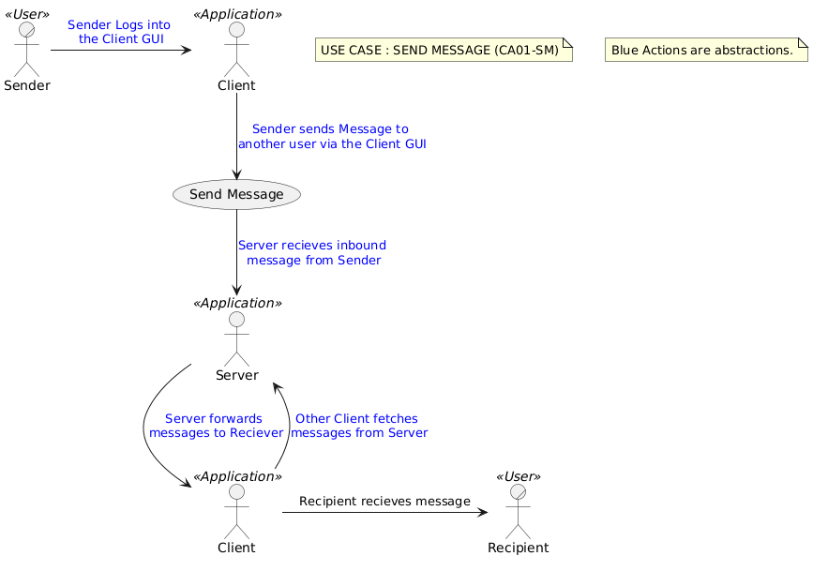

Create Group Use Case Diagram

Encoding for the Use Case: RLBTQi8m5Bu_Jt7mIc6owQM8M69N1aAtrZv0rXmqq2KbIIVkwNSQTTfjDmd9ztj2rZv85xgF1g0azqaEbykaRHjTow2jMQrGUYpJ0aIZoOJ_KB5z0La7wnwnyj6WtyvODRj29KbN7uGqIYiPo0zfSm1Z0-6eAbCK2IyB54MQx5BCYhnwnR58dkPJaKr6CP8F5q7oxeFZ359zEWhfoIykQR6FVy2jtQCsKRdBDpd0M3ZY4fWvsxMJw9W1L3ESJbVzF9mUHs6XPoL0VnUnx0hLqS6VBL0SP61MXipXryAV1dS31ujIAOwPHwiphQ3GESFbtpfo9-WlRnqsshUDF5smWVspDhBHNpJ8Z-gRyrxxm4qD7UzPaQJiqVo9-KK4M9DH_TVu1W00

Image:
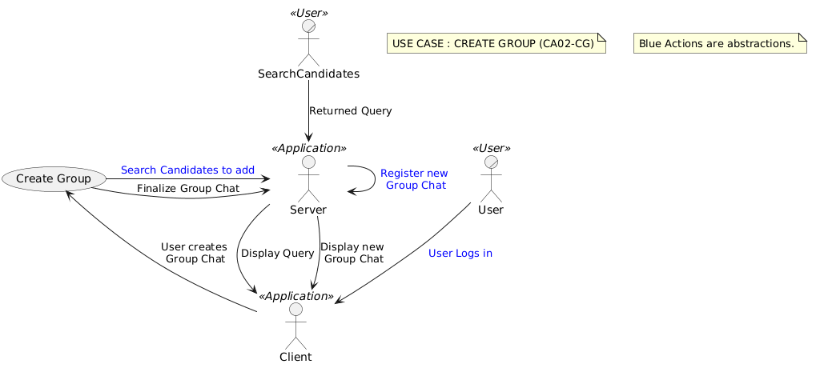

Log In Use Case Diagram

Encoding for the Use Case:
ZPB1Ri8m38RlUGeBBjk1RMWtG0ZKLQXInQInxhIBIys8b3fLai9u-pb5cxQ1nYvDdVZ__Dl9p0TqeQsDKYjoEt8mcSoRnkWr1crvEWNqi4gVL68qSJXtckIPmdMmxXOAtm7YSZmhXagn3GIzOfL2CfVF2FB71MHBk4hcT_U3FBlkTHG9b2g6C1XC8rBoEfhcfWqU45g966k2LqQke47lzzPLIiNaA1ANq0_q7aQbQKdqB-JqvW1XIx2sTQcvCosDIk9dbRxHJ2D7rJZ-t9JMLEEE8Lk2o7Y7HbUGI2ZjQpJ-ZFpD4V5lGBSPNPm0lXnBjnVgFsZV63n0wfnrucPZJyL_Liyf7EUOyVVX_aEvA3B07Mg3fQ6VGxuiNj8UdhUEKEvdHbp51_O1

Image:
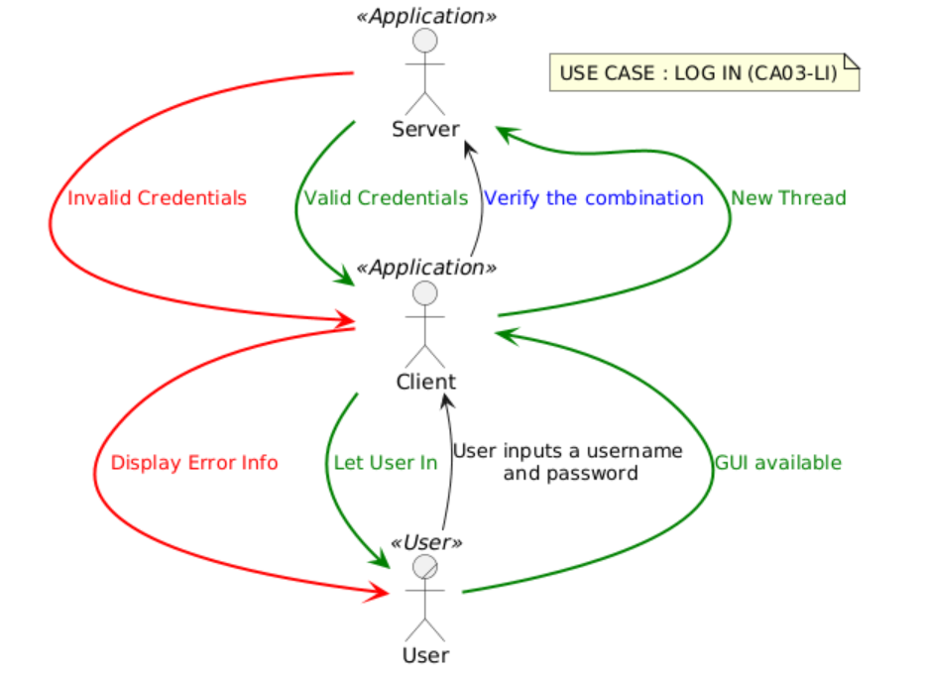

Log out Use Case Diagram

Encoding for the Use Case:
RP31QiCm38RlVWgjWztAo3KhOIMKCIWKbkK1t4H9Grqxi-InllsaP0ihx68Rw_FdNtecjf7JnHbJOVp429lDTXpTq5WUWYyAi0JLxisKRa3F_rNB_Qkn3OVu28acWMvphSwCyO4HLdMrWt8hImxxmmiSwdTOJKG9njGPhDU5ck2UyOlpeqief0izmU3_rdEezHE9qvm9-8H0G-yX98PZOWxU6CKKbzY2L-XRcfD5_4X831pKh6yMjivcKckdS44OROyo4r7ygcwZaJIC1DPVmME3H3PU9MeNu048cGImd4XzeUlSu76HJMtgJHwnVPgaSfZRrJumnX1lQCcM6lsaI-w7kbi06SviwoEYdttJKPwLBX3gc2BQrdm3

Image:
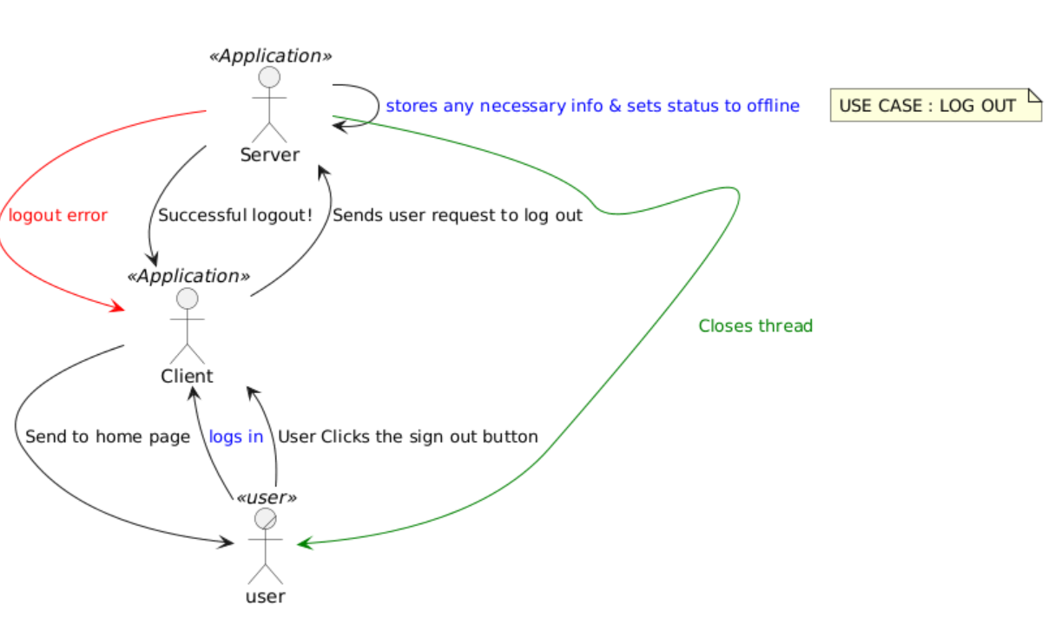

Search Users Use Case Diagram

Encoding for the Use Case:
XP91QyCm38NlWVm7aPsxqMjQIajMs63ia91RBswYfWP7xYndM__zf7HqfIlR9HZflKzFTfOSJOX3xz8aJIeCxnXWFbyT3ius9bfFYmKOXcfTfadXB5AyrIvUdjF4DD671wXP45Ahfuea7n6okbf3iP9FBgHLMJo1LCeg6tM5wkefJ2OB1S5TnC-ORzs08Xzfbi7vhiCMB5s9SrXJnC30Q4Ap1pdti253BUnjP43jgaV5QfAvcWAfFNlU1Wp7SN_fNMgqYmm1Eyk2aVa3wwmDxNo0tiHcRwdxxH-tS9Om5yzC3_TRxzhPk9XYSdZr9x_WTtwWzfQv2uXqRH-B0YWn3e7u9yKfcfEab-lALVsJvD7omPaZGoPlDP8-p7Ue37faDXtUuFqPxipKE8hqkr-tg2cNyWpoxtq1

Image:
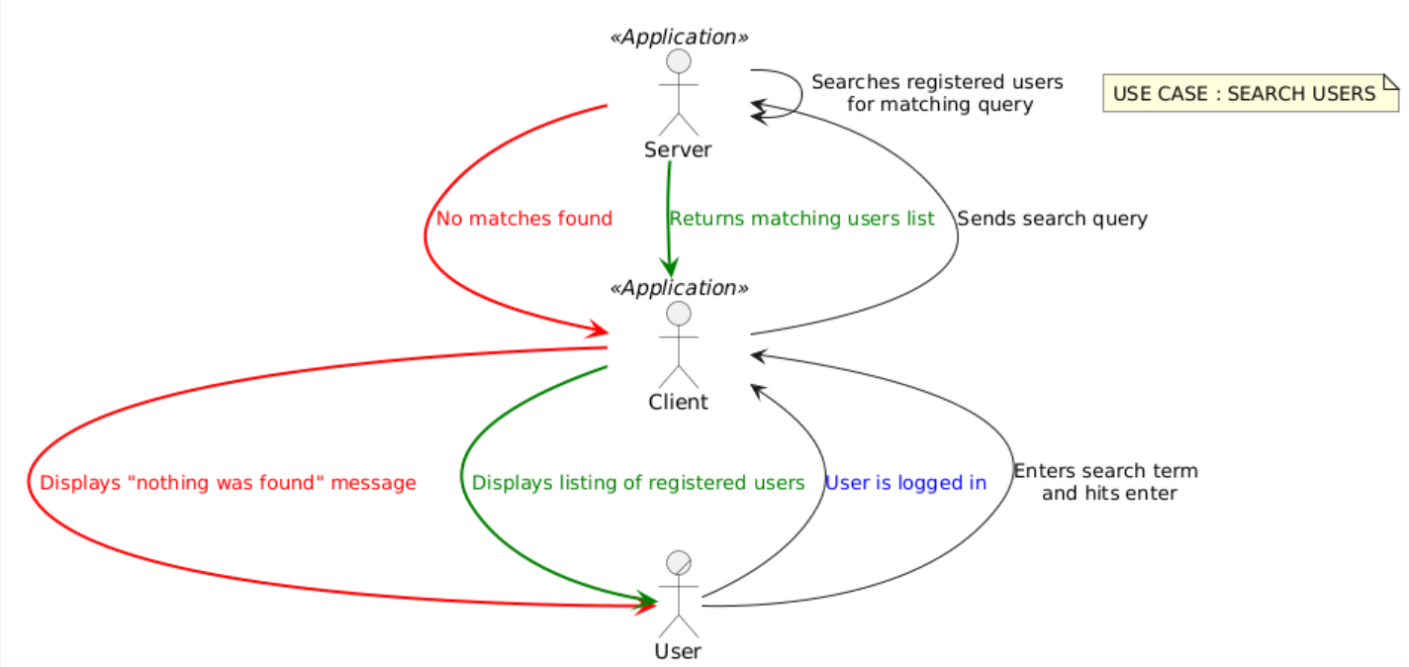
CLASS PLANTUML EXAMPLE
ENCODING:
hLVDSgD64Bxp59mIj6khaciEgIK8swfeaGhGkZPRgHI6jZG9FzJC89UTvDtJGoE65budXrpCg7zwkh_-fcVyGUbCwgugdH8UjQiRLuh3KRk5a91hqTJEj-xrzRKRHlkFYLavK7ULwmV1TX-bloMfd-uJzqzdkmiZ9zXiat3b9Fi4VwrmTRFnRs_n-xV3tTBFkn2TWhim-7aTtJg9_ma_YHF4uMgTZkPfx4U97wJhRNHskL-dTwlOlzyugt2tJT2uDxe9OoUCustiRDCxN6C4odkz2gDqdNvslt5tOPni8oeYBpEbNBye92Y5OQzTfIM0Zhhg0QJxWojgZSAiHN0ggAqyqLBK1_VBTylbzx-ERgC29RdGpzFVBw8Tuo7O6gpIUNzEmLlWkaMXzXQZ7aK7qCaaiLw9HgJnUNPVyPo90qnm9ln5j3nuObBbPkeYcNe2bZ4yDQ8WCvlPsvPZZXSmCXjAcC7AzIRt4MMkeYeOxDOPIK8ys85KJTtJeCugc7Ole_wWQEYKQHhPUmkxP6vNSw-5IwX6MKMW6WSIZGomrfIxiMM1MTdMSRxPhC2WKxgfGFOb_jw8UaM0c0zAq4QdK9OWFmabD5VuwSSBQQT0HXSujQ8c_16VSRiUeVoOrGVO2GG9ddPdiuLDhj-PKfDm44g378du9FInaDcJbrLDLviSYgPxA64nhj280dWBU-g7EJCzwdbk0lIxPBHEdriiWSyagpNCwGoeVDGPWquV6obUeDWZ46XYuVtopio4XwpCwXniYWGaMbiCqVD40wLV86hd53qzp-lApSzRsDqCk48bdMgXBg3e2VJGD2MA7oN02qmbNJsNvMMZuBphI1eY9Q_HQ7cLxmt7kPNNAPuVY_WJWUAnpfcTR3DGnyl-hmGee6sKq7CRljM6ce3RK1jGggoqi4U2PquTMkzcmv0f-85BiXEQgIdhaD0WGUaODx29OIHkwv42BQOE_VMGFPz1n6K5aqhvO5XF7BqXogks1sRBUcD7nn7oFp2_IIbZKygDg8IUydpen8NSSCs6OLKoZmNbj9g8E5_KXNBg_BMktzjav_58lRBgLs9ecTNg4MGWeK2BOJwW1Gc6Ybvr6LexyL6S62nfZhmDJxYRsPGR4I_tBMQn25CcS6hDINE98GMQ0VWcW-mJBBg9_IIDzq6wZqDyY6ssjxVut9jCPpf9T4pQwRLIDWSpO3VDuK13yfILmfnKb61TvlgZwM_7cibfTbX9n9YF4MYkuO96cjajF46jvmUwDpBf5TEBa_gSzUzakarcJrRJjAQYmshBOeEAUeKRUFyUxceMxUeosEHcnQkxJphFr75wIXypKKBXQmrLgvLzdM8NH0v1KxKbQ2Wif1Z8KyEqiw-H_t4yqtmOnjlRmOHgo-mvQEf78QlCO3Msowf3AHivogcrelP4GSLUsVSAjnamyN19p9WomLBXG6Irz2G6lKOinYimVtbWUqxYSEERHYTtwntzbpBUkEzGFHnZP_Ywo-NvxN0nej7rhnz7Spv5cCfUF5p7Ts4tCfEpXz6OBCMXTx53XvE9w8C1njSkee4MxmPW-v_B_h_GvVmuKSa8IDTUdnq-G5rqLVaF

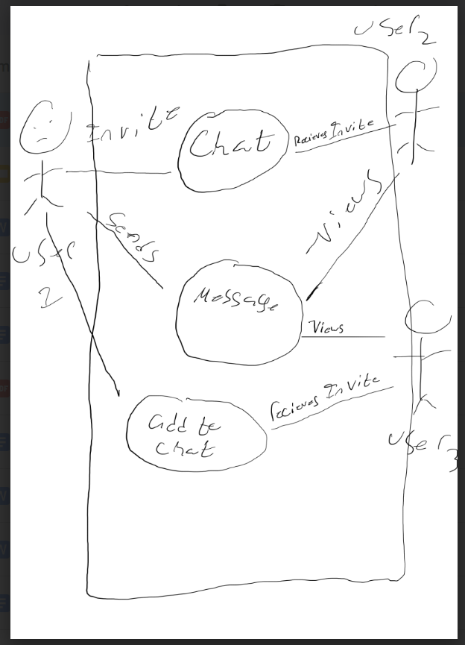
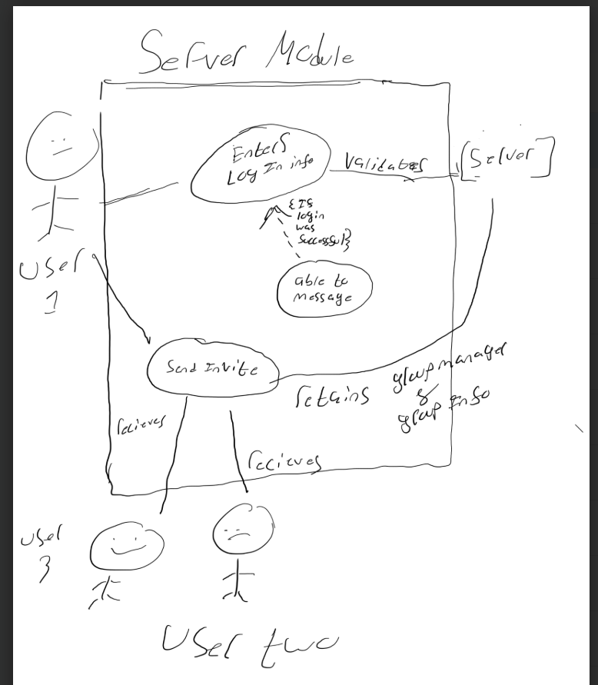

Object Candidates and Class Diagrams

Object Candidates

Class Diagrams

UML Sequence Diagrams

User Actor and the Communication Application

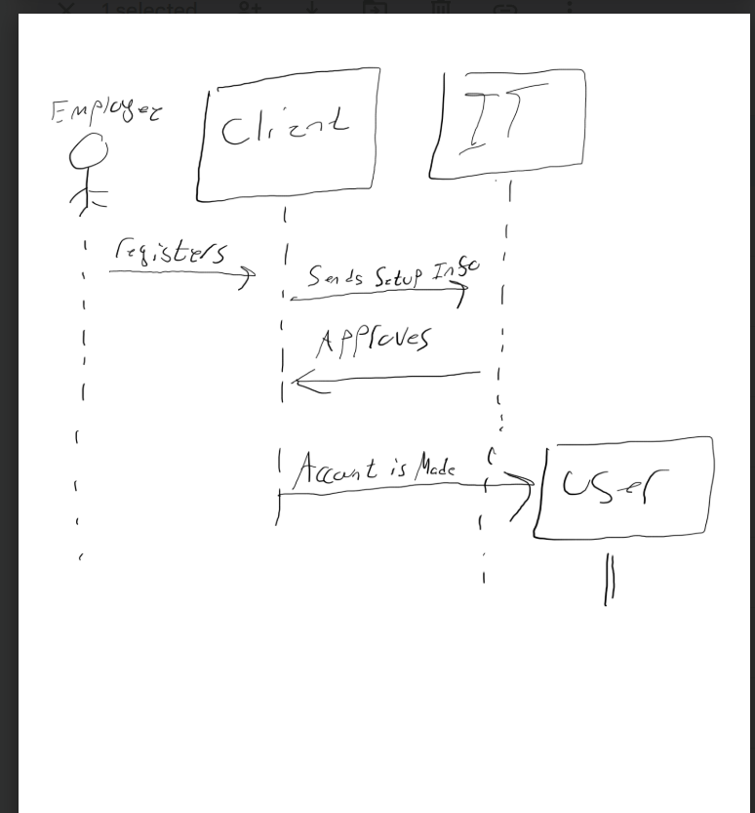

IT User Actor and the Communication Application

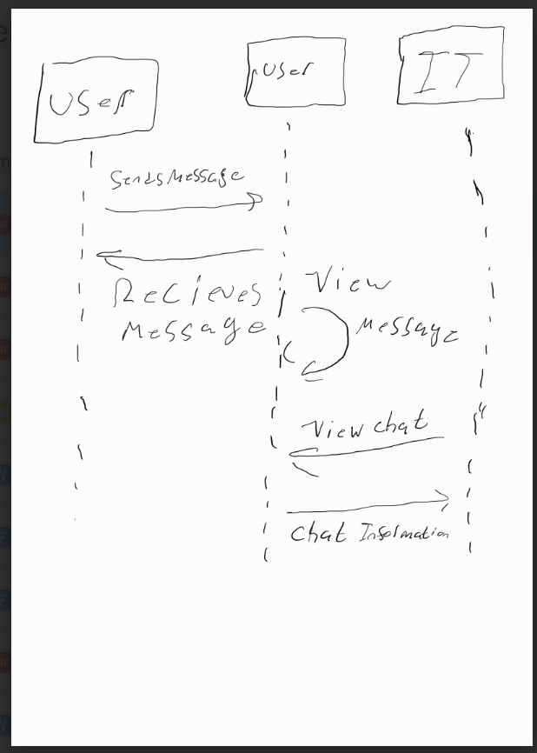

Application
