Group Project – Communications App
Software Requirements Specification
Revision History

Date | Revision | Description | Author
02/10/2026 | 1.0 | Document Init + Project Purpose | Darien D. Chau
02/21/2026 | 1.1 | Overall Description | Darien C., Victor R.
02/25/2026 | 1.2 | Specific Requirements (3.1, 3.2) | Andrea Clarize N.
02/26/2026 | 1.21 | Non-functional Requirements | Darien C.
02/26/2026 | 1.22 | Specific Requirements (3.1.2, 3.1.3,3.1.4) and Internal Interface Requirements | Olalekan Faniran-Ajiwe

Table of Contents
1. Purpose 4
1.1. Scope 4
1.2. Definitions, Acronyms, Abbreviations 4
1.3. References 4
1.4. Overview 4
2. Overall Description 5
2.1. Product Perspective 5
2.2. Product Architecture 5
2.3. Product Functionality/Features 5
2.4. Constraints 5
2.5. Assumptions and Dependencies 5
3. Specific Requirements 6
3.1. Functional Requirements 6
3.2. External Interface Requirements 6
3.3. Internal Interface Requirements 7
4. Non-Functional Requirements 8
4.1. Security and Privacy Requirements 8
4.2. Environmental Requirements 8
4.3. Performance Requirements 8

Purpose
This document outlines the requirements for a Java Communications Client and Server Application.

Scope
This document will catalog the user, system, and hardware requirements for the Java Communications Client and Server Application system. It will not, however, document how these requirements will be implemented.

Definitions, Acronyms, Abbreviations
Communications App: A private text-messaging app that allows for asynchronous and synchronous communication manageable by IT.
TCP/IP: This stands for Transmission Control Protocol/Internet Protocol, which is a set of communication protocols used to connect devices on the internet and private networks.
Synchronous/Asynchronous: Chat history between users is persistent regardless of whether users are online or offline.
Help Page: The user manual for utilizing the Java GUI Client.

User: An established actor that has the privileges to engage or request communication between other actors.

IT User: An elevated actor with system privileges that is able to monitor conversations, help users establish credentials, and interact with server-side interfaces.

References
Use Case Specification Document – Step 2 in assignment description
UML Use Case Diagrams Document – Step 3 in assignment description
Class Diagrams – Step 5 in assignment description
Sequence Diagrams – Step 6 in assignment description

Overview
We are creating a Java Client and Server Communications Application that allows for synchronous and asynchronous text-based communication between several employees over TCP/IP, manageable by IT.

Overall Description

Product Perspective
Our multi-system communication application will provide ap platform that is suitable not just for large enterprise companies to use but for small ambitious teams as well. These applications offer the flexibility of one-on-one communication in addition to group conversations, which brings that flexibility that other company communications lack. In addition to help boost the productivity, communication, and engagement of the team. All of this is created through the power of Java, which has been a strong leader in overall sheer resource management compared to other used languages like C++ and Python.

Product Architecture
The system will be organized into 2 major modules: the Client module and the Server module. These modules may have sub-systems, some of which may be recognized later as potential class candidates later in design.

- Client Module:
  - User, user of the system.
  - IT, superuser of the system.
  - GUI, interactive user interface for clients.
  - Networking, to handle Inbound/Outbound traffic.
  - Help Page, a short page to explain the basic usages of the GUI.
  - ...
- Server Module:
  - ConsoleUI, to interact with any server-side processes.
  - Networking, to handle Inbound/Outbound traffic.
  - Logging, a record of all user chats.
  - Registration, logical processing of new users.
  - Verification, logical determination of existing users.
  - …

Product Functionality/Features
The high-level features of the system are as follows (see section 3 of this document for more detailed requirements that address these features):

2.3.1
Communication is strictly text-based. No images nor videos.

2.3.2
Communication is both asynchronous and synchronous.

2.3.3
Privacy between users and IT is negligible.

2.3.4
IT users must register any new users to the system.

2.3.5
Users need to have a way to log in and log out of the client.

2.3.6
Log ins must be verified, so that only registered users can use the client.

2.3.7
Help Page will cover the different client capabilities.

2.3.8
Client and Server are capable of two-way communication.

2.3.9
Users are allowed to converse with another user or several at once.

2.3.10
The message box supports conventional text modification, i.e., copy and paste, redo and undo.

2.3.11
Users will be able to search for other users to either chat individually or form a group with.

Constraints

2.4.1
Since users will directly interact with system by an application, the system must not contain browser specific code

2.4.2
Chat logs should be saved and stored by some means

2.4.3
Any new or additional users of the applications must be created by the IT

2.4.4
The application may only be programmed in Java.

2.4.5
The application’s soft deadline is 04/30/2026.

2.4.6
The application’s hard deadline is 05/05/2026.

2.4.7
The application cannot use databases.

2.4.8
The application cannot use encryption.

2.4.9
The application must use TCP/IP for network connections.

2.4.10
No code should be AI-generated or “vibe-coded”.

2.4.11
Built-in data structures, unless otherwise stated or asked about beforehand, are not allowed.
Exceptions are: …

2.4.12
Developers may only use the Eclipse IDE for Java Developers.

2.4.13
Developers are expected to maintain standard coding conventions, including but not limited to: Good comments, “Clean code”, Naming conventions, or Pre-conditions/Post-conditions for methods/function calls.

2.4.14
Users cannot have any access to logs.

2.4.15
All developers must use JDK 25 when working on this application.

2.4.16
All developers must use Eclipse IDE for Java Developers for development.

Assumptions and Dependencies

2.5.1
It is assumed that the application will handle several thousand users at any given time.

2.5.2
We can assume that the network when the application will be used is established on each user’s device.

2.5.3
In addition, we must assume that the company will provide computers that are capable of running the communication applications, thus reducing the need for compatibility comparison.

2.5.4
The help page is assumed to not cover every last aspect of Client GUI. Instead it functions as an onboarding for new users to become familiar enough to use the application comfortably and efficiently.

2.5.5
It is assumed that the existing infrastructure within the company supports basic electronic devices.

2.5.6
It is assumed that since there is no encryption, the users of the system are completely perfect at keeping their credentials to themselves, and that there are never any cybercrimes or attacks committed against this software.

2.5.7
Both the server and client application will be dependent on the Eclipse IDE for Java Developers for their development.
2.5.8 It is assumed that the group chat will have a reasonable number of participants to maintain performance

2.5.9 It is assumed that the system will be used during business hours, with the best storage during workdays

2.5.10 it is assumed that usernames in the system will not be reused after an employee leaves the company, due to chat history integrity

Specific Requirements

Functional Requirements

Common Requirements:

3.1.1.1
The system must support TCP/IP-based communication between both modules.

3.1.1.2
The system must ensure two-way connection between both modules, allowing both to send and receive data.

3.1.1.3
The system must gracefully handle network interruptions and notify users of disconnection.

3.1.1.4
The system must support and maintain both synchronous and asynchronous messaging.

3.1.1.5
The system must ensure that messages are properly stored and delivered to its intended recipient in chronological order.

3.1.1.6
The system must store all chat history on the server to be made accessible after the user disconnects or logs out.

3.1.1.7
The system must ensure that all logs and chat history is not accessible to non-IT users.

3.1.1.8
The system must maintain and enforce user authentication through a unique username and password before accessing messaging features.

3.1.1.9
The system must restrict access from unregistered users.

3.1.1.10
The system must log all login attempts, both successful and unsuccessful.

3.1.1.11
The system must allow multiple users to be connected simultaneously.

3.1.1.12
The system must associate each message with a sender identifier, a recipient identifier, and a timestamp.

3.1.1.13
The system must support both private messaging and group messaging between users.

3.1.1.14
The system must support and validate strictly text-based communication and reject any attempt otherwise.

Client Module Requirements:

3.1.2.1
Users must log in using a unique username and password, both of which are alphanumeric strings between 3 and 20 characters in length.

3.1.2.2
Must display a scrollable conversation history showing all sent and received messages with timestamps and sender labels for each message.

3.1.2.3
The client must provide a text input field and send a button for composing and transmitting text-based messages to selected recipients.

3.1.2.4
The client must display a contact's panel showing available users and existing chats, allowing users to select contacts for private messaging or group invitations.

3.1.2.5
Include a search feature allowing users to find other registered users by entering partial usernames, with matching results displayed for selection.

3.1.2.6
The client must provide an accessible Help Page from the main menu describing login procedures, sending messages, group chat management, and application restrictions.

3.1.2.7
The client must support conventional text editing features, including copy, paste, undo, and redo within the message area.

Server Module Requirements:

3.1.3.1
The server must log all login attempts, with timestamps and usernames for security monitoring.

3.1.3.2
The server must process user registration requests from IT clients by creating new user records with unique usernames and storing them persistently in the user database.

3.1.3.3
The server must authenticate users by validating credentials against the stored user database before granting access to messaging features.
3.1.3.4
The server must process user registration requests from IT clients and create new user accounts with unique usernames.

3.1.3.5
The server must provide a console interface for server administrators to monitor active connections and system status.

3.1.3.6
The server must maintain group chat functionality, including group creation, member management, and message broadcasting to all group members.

IT Module Requirements:

3.1.4.1
IT must provide an administrative interface accessible only after authentication with IT role privileges for user registration and history access.

3.1.4.2
IT must include a user registration form with fields for username, password, full name, and role selection for creating new user accounts.

3.1.4.3
IT must validate that passwords are between 6-30 characters before submitting registration requests to the server.

3.1.4.4
IT must display success or error messages after each registration attempt, confirming new user records or reporting issues such as duplicate usernames.

3.1.4.5
The IT module must provide access to view any user's complete chat history upon request, displaying all messages with timestamps and participant information.

3.1.4.6
The IT module must display real-time server status information including active user connections and system health indicators.

External Interface Requirements

3.2.1
The system must support TCP/IP based communication to maintain authentication, messaging, and session management.

3.2.2
The Client must initiate a socket connection to the Server while the Server must continuously listen to incoming connection requests.

3.2.3
The system must maintain an active connection for the duration of each session and close upon logout. In the event of network failure or disconnection, the system must terminate the session, notify the Client, and detect the loss of disconnection.

3.2.4
The system must transmit authentication requests upon each user login before allowing access to messaging features.

3.2.5
All communication must follow a protocol consisting of a message identifier, a sender and recipient identifier, and timestamp. Messages must be encoded as plain text.
3.2.6
The system must provide a Java-based UI as the external interaction layer between the user and Client module.

3.2.7
The login interface must take input for a unique username and password. Upon submission, the interface must validate completion, verify authentication, and display a success or failure response. Messaging features are only accessible upon success.

3.2.8
The messaging interface must display the user’s scrollable conversation history, a text input field for sending messages including a send action, and a messaging panel of users and existing chats.

3.2.9
The interface must provide an accessible Help Page that describes the functionality of the application, including login procedure, group chat behavior, messaging procedure, and general restrictions.

3.2.10
The system must provide an administrative interface for IT users to interact with Server-side processes. This must allow IT users to register new users with a unique username and password, creating and storing a new user record.

Internal Interface Requirements

3.3.1
The system must enforce immutable message storage by ensuring all file write operations use append mode only. No user, including IT, will have the ability to update or delete any stored messages.

3.3.2
The server must permanently store every text message by appending user specific history files. Each message record must include the timestamp, sender, recipient, and plain text messages. Storage will be done without any modification or deletion.

3.3.3
The server must maintain a text message queue for each offline user when offline. When users reconnect and log in, all queued text messages are delivered in the order they were received and remain permanently stored in the user's history
3.3.4
Only IT users have access to view text message history. The server must verify the role of the user’s from the active session before granting access to the history file. Regular users requesting a history record will receive an access denied response

3.3.5
The server module must provide a shutdown that saves all offline text messages, closes all client connections, and releases all file handles before terminating

3.3.6
The Group management subsystem must maintain group data for each text-based group chat created in the system, including group name, admin username, and each member in the group username for each group chat created in the system

3.3.7
The server must reject any non-text-based communication. Any messages attempting to include binary data, images, or media files must be rejected and the sender must receive an error notification

3.3.8
The user must maintain user database that stores all registered usernames, password, and roles( admin, IT, etc.)

3.3.9
The server must track and store the online/offline status of all registered users in real time. When connected or disconnected the server must update its status

3.3.10
Server must maintain separate history files for private conversations and group conversations. Private chat history will store user specific files, while group char history must store group specific file containing all messages sent to the group with participant information

Non-Functional Requirements

Security and Privacy Requirements

4.1.1
Privacy of user chats regarding the IT role is fully minimized, meaning that IT users are able to view chat logs without any restriction to the information that they see. Specifically, they will view all outgoing messages, people who sent those messages, and all associated users/recipients.

4.1.2
Security-wise, only the most minimum level of security will be provided for the application. As per the functional requirements, all users have passwords, but these passwords are not hashed/encrypted under any existing sequence. Additionally, it is expected that any actions restricted to say, the IT user, is not accessible to any normal user of the system.

4.1.3
As a general rule of thumb, there is no encryption of any kind present within the program. Nor is there advocation for user privacy. The primary focus is the service itself.

4.1.4
…

Environmental Requirements

4.2.1
The Communications Application must run on Java, specifically using the Java Development Kit (JDK 25).

4.2.2
The Communications Application must be able to communicate utilizing a Java Server Application and a Java Client Application.

4.2.3
The Communications Application should only use tools built from the ground-up, unless otherwise specified for built-ins that should be allowed.

4.2.4
The Communications Server Application should use a console command line to perform any user interaction.

4.2.5
The Communications Client Application should use a GUI and optionally a console command line to perform any user interactions.

4.2.6
…

Performance Requirements

4.3.1
Loading User Chats take no longer than 3 seconds.

4.3.2
Loading a specified chat log takes no longer than 3 seconds.

4.3.3
Client Application boot takes no longer than 5 seconds.

4.3.4
Client Application render takes no longer than 3 seconds.

4.3.5
…

Actors and Use-Cases

Actors
5.1.1
Operator is an actor that interacts with the MPC system. They are able to turn on or off the pump systems given water levels are between the sensors, read logs, examine methane readings no older than 24 hours old, and log-in and out of the system.

5.1.2
Supervisor is an actor that interacts with the MPC system. They are able to turn on or off the pump systems freely, reset the automatic pump systems, read logs, examine methane readings up to 30 days old, and log-in and out of the system.

5.1.3
Automatic is an actor that interacts with the MPC system. It is able to turn on or off the pumps, according to information read by the sensors.

Use-Cases
5.2.1 - Turn on the pump system:
Use Case ID: MPC-01-TON
Use Case Name: Automatic or manual activation of the MPC System.
Relevant Requirements: 3.1.1.2, 3.1.1.3, 3.1.1.8, 3.1.3.2, 3.1.3.3, 3.1.3.3.1, 3.1.3.3.2, 3.1.3.4, 3.1.3.5, 3.1.4.1.2, 3.1.4.1.1, 3.2.2, 3.3.3.1, 3.3.4
Primary Actor: Operator, Supervisor, Automatic
Pre-conditions:
High Water Sensor detects water (Automatic) || Water Level is between both sensors (Operator) || User is a Supervisor (Supervisor)
Post-conditions: The pump system will begin pumping out water of the cave until the water reaches the desired level for the actor that initiated the pump. The log will also be updated with the specific action, time, and which entity did it.
Basic Flow or Main Scenario:
- The actor initiates the pump action, whether manually or automatically.
- The action is performed until its specific termination.
  - If done manually, an Operator/Supervisor will need to shut it off.
  - If done automatically, when water drops below the low sensor it will shut off.
- The action, if successful, logs the information of the action, the user, and the time.
- Then the system will wait for further instructions and continue monitoring the state of the cave.
Extensions or Alternate Flows:
- If the action is done manually by a supervisor, then the automatic system will be turned off.
- If done automatically, the automatic system will remain in place.
Exceptions:
- The system fails to start the pump, whether automatically or manually.
- The system fails to shut off the pump, whether automatically or manually.
- The system fails to log the action, such as missing or incorrect information.
- The system fails to return to a waiting/monitoring state.
- The system fails to disengage automatically when a supervisor action is issued, OR fails to stay automatic when actions are performed autonomously.
Related Use Cases:
Turn off the pump system
Reset the Automatic Pump System
Update Logs

5.2.2 - Turn off the pump system:

Use Case ID: MPC-02-TOF
Use Case Name: Automatic or Manual shutoff of the MPC System.
Relevant Requirements: 3.1.1.2, 3.1.1.3, 3.1.1.5, 3.1.1.8, 3.1.3.1, 3.1.3.3.1, 3.1.3.3.2, 3.1.3.4, 3.1.3.5, 3.1.4.1.1, 3.1.4.1.2, 3.3.3.1, 3.3.4
Primary Actor: Operator, Supervisor, Automatic
Pre-conditions: Low Water Sensor no longer detects water || Water Levels are Safe and User is an Operator || User is a Supervisor.
Post-conditions: The pump system will immediately stop pumping out water of the cave once the command is received. The log will also be updated with the specific action, time, and which entity did it.
Basic Flow or Main Scenario:
- The actor initiates the shutoff action, whether manually or automatically.
- The action is performed immediately, halting any further draining.
  - If done manually, an Operator/Supervisor will need to manually start it back up again if needed..
  - If done automatically, when water rises above the high sensor again it will resume draining by itself.
- The action, if successful, logs the information of the action, the user, and the time.
- Then the system will wait for further instructions and continue monitoring the state of the cave.
Extensions or Alternate Flows:
- If shut off is manually done by a supervisor, then the automatic system will disengage.
- If shut off is done automatically, the automatic system will stay as is.
Exceptions:
- The system fails to properly shut off, whether manually or automatically.
- The automatic system fails prematurely, shutting off before reaching below the low water sensor.
- The system fails to log the action, whether incorrectly or insufficiently.
- The system fails to return to its waiting/monitoring state.
- The system fails to maintain or improperly maintains its automation state.
Related Use Cases:
Turn on the Pump System
Reset the Automatic Pump System
Update Logs

5.2.3 - Log in to the pump system:

Use Case ID: MPC-03-LI
Use Case Name: User login to the pump control system.
Relevant Requirements: 3.1.1.1, 3.1.2.1, 3.1.2.4, 3.1.2.5, 3.1.3.3, 3.3.5, 3.3.6, 3.3.7
Primary Actor: Operator, Supervisor
Pre-conditions: No user is currently logged into the system, and the user attempting to login has credentials currently in the system.
Post-conditions: The user is logged in upon successfully entering their credentials, and their access to the control system is mandated by their role in the system.
Basic Flow or Main Scenario:
- At the login interface, the user is prompted to enter their username and password.
- Upon successful entry and validation of the username and password, the user (depending on the role of their account from the creation process), is let into the system with their specific permission level.
Extensions or Alternate Flows:
- If the user cannot enter a valid username or password, the system will never let them in.
Exceptions:
- The user enters a valid username and password, but the system does not recognize it- likely a result of failing to update the registered data.
- The user enters an incorrect username or password, but the system still allows the user. Possibly due to validation failures.
Related Use Cases:
Log out of the Pump system
Registering Users

5.2.4 - Log out of the pump system:

Use Case ID: MPC-04-LO
Use Case Name: User logout for the pump control system.
Relevant Requirements: 3.1.1.1, 3.1.2.4, 3.1.2.5, 3.1.3.3, 3.3.5, 3.3.6, 3.3.7
Primary Actor: Operator, Supervisor
Pre-conditions: The user is already logged into the system.
Post-conditions: The user will be logged out of the system, and the system will await a new log-in, whilst its automatic system will either stall or be active, depending on its state.
Basic Flow or Main Scenario:
- The user clicks the option to logout.
- The user is then logged out.
- The system will wait for another user to log in.
Extensions or Alternate Flows:
- In the background, the system will continue its automatic processes if the state allows so. Otherwise, it will remain inactive. Do note that inactivity for prolonged periods can be dangerous.
Exceptions:
- Users failing to log out, despite logout appearing to have worked. Possibly as a result of some persistent data that was not flushed out properly.
- The automatic system failing to maintain its state upon user log out; Either becoming active when originally inactive, or vice versa.
- The system not returning back to a log in state after a user log out, leaving the control panel wide open for anyone to use.
Related Use Cases:
Log in to the pump system
Registering Users

5.2.5 - Registering Users

Use Case ID: MPC-05-REG
Use Case Name: User registration for the pump control system.
Relevant Requirements: 3.1.1.5, 3.1.2.1, 3.1.2.2, 3.1.2.4, 3.1.2.5, 3.3.5, 3.3.7
Primary Actor: Supervisor
Pre-conditions: User is logged in as a supervisor, and has data of users to register on hand.
Post-conditions: Users are registered as the data provides and each newly registered user is saved so the people that correspond to those credentials may log in to the system later.
Basic Flow or Main Scenario:
- User logs in as a supervisor.
- User either creates or has existing data to use for user registration.
- The system will take in the data, registering users according to the stream.
- The system then saves the newly registered credentials so that the corresponding people may log in with their information.
Extensions or Alternate Flows:

Exceptions:
- Entered data is not in the correct format, causing the initialization of user registrations to terminate prematurely.
- Data is not saved or stored properly after users are registered, preventing the credentials that should work from properly allowing users to log in.
- A user other than a supervisor successfully adding users presents a security hazard.
Related Use Cases:
Log in to the pump system
Log out of the pump system

5.2.6 - Reset the automatic pump system:

Use Case ID: MPC-06-RES
Use Case Name: Reengagement of the automatic pump system.
Relevant Requirements: 3.1.1.4, 3.1.3.4, 3.3.3.3
Primary Actor: Supervisor
Pre-conditions: User is a supervisor and the automatic pump system is currently disengaged.
Post-conditions: The automatic pump system is reengaged.
Basic Flow or Main Scenario:
- The user logs in as a supervisor.
- The user requests a pump reset, given that the automatic system is currently disengaged.
- The pump reset is processed by the system, and the automatic system is reengaged.
Extensions or Alternate Flows:
- Pump resets may potentially be a candidate for a log entry, but is not mandatory by federal standards.
Exceptions:
- Other roles other than supervisor being able to perform pump resets is a hazard to the security of the system.
- The automatic system, not reengaging after what appears to be a proper reset may lead to dangerous consequences for the mining crew.
- The automatic system, if already engaged, a reset should not do anything.
Related Use Cases:
Turn on the pump system
Turn off the pump system

5.2.7 - Update Logs:

Use Case ID: MPC-07-UPD
Use Case Name: Updates the existing log data with a new event.
Relevant Requirements: 3.1.1.6, 3.1.1.7, 3.1.1.8, 3.1.4, 3.3.1
Primary Actor: Operator, Supervisor, Automatic
Pre-conditions: An action is taken that can be logged.
Post-conditions: The log data is updated with the most recent action taken.
Basic Flow or Main Scenario:
- An action is performed, whether automatically or manually
- The system records the action with the time and details of the task completed to the log.
- After the action is processed, the updated data log overwrites the old data log.
Extensions or Alternate Flows:
- The system records the following actions:
  - Turning on/off the pump both automatically and manually
  - Evacuation Alarm Triggering
  - Methane Readings
Exceptions:
- The system fails to record the most recent action to the log, whether that be incorrectly overwriting existing log information, incorrect action or time details, or generally failing to write.
Related Use Cases:
Read Logs and Methane Readings
Turn on the pump system
Turn off the pump system

5.2.8 - Read Logs and Methane Readings:

Use Case ID: MPC-08-LOG
Use Case Name: User reads a display of logs and readings based on security level.
Relevant Requirements: 3.1.1.7, 3.1.1.8, 3.1.4, 3.3.2, 3.3.3.2
Primary Actor: Operator, Supervisor
Pre-conditions: The user is logged in as either an operator or supervisor and there is existing log data to read from.
Post-conditions: The entries of the log are displayed to the user, varying on security level.
Basic Flow or Main Scenario:
- A user logs in as an either an operator or supervisor.
- They choose to view the logs.
- The system will load the most current version of the logs, formatting it into a readable format: i.e. date/time, event, notes.
- The system outputs the read stream into an interface that the user may interact with, mainly reading or scrolling.
- From here, the user is free to close the interface and return to the control panel.
Extensions or Alternate Flows:
- Operators specifically may only view methane readings that are 24 hours old.
- Supervisors are allowed to view log entries up to 30 days old.
- Supervisors can append notes to any event that is under 24 hours old. Meaning that Supervisors have permissions to edit only the notes section for those events.
Exceptions:
- Operators viewing logs that are older than 24 hours old.
- Supervisors viewing logs that are older than 30 days old.
- Supervisors being able to append notes to events older than 24 hours old.
- The system reads an old version of the logs, possibly due to a fault with Update Logs not overwriting old versions correctly.
- The system reads a broken version of the logs, possibly due to a fault with Update Logs not saving or writing correctly.

Related Use Cases:
Update Logs

5.2.9 - Read Sensors

Use Case ID: MPC-09-SEN
Use Case Name: Automation System reads information provided by either the water or methane sensors.
Relevant Requirements: 3.1.1.9, 3.1.1.10, 3.1.3.1, 3.1.3.2, 3.1.3.5, 3.1.3.6, 3.1.4.3, 3.1.4.4, 3.2.3, 3.3.4
Primary Actor: Automatic
Pre-conditions: Sensors are detected by the Automatic System and are functioning properly.
Post-conditions: Information, specifically water level or methane amounts for the current state of the cave are taken account of, which will determine the next set of actions.
Basic Flow or Main Scenario:
- Given the sensors are detected and function correctly, they will retrieve the information specified in the postconditions.
- From there the system can make multiple decisions. See alternate flows.
Extensions or Alternate Flows:
- For the water sensors:
  - If water is detected by the low-term level sensor, but not the high-water level sensor, no action is needed.
  - If water is detected by the low water level sensor and the high-water level sensor, the system will turn on the pump system.
  - If water is detected by neither the low water level sensor nor the high-water level sensor, the system will turn off the pump system.
- For the methane sensors:
  - If methane levels in PPM are below the danger threshold, no action is needed.
  - If methane levels in PPM are at or above the danger threshold, raise the alarm.
Exceptions:
- If the sensors are reading incorrectly, this is a fatal impairment to the system, as it prevents it from making any decisions, let alone correct ones.
- If the alarm does not raise even when PPM is at or above the danger threshold.
- If water is detected by high and low sensors, but no action is taken.
- The automatic system prematurely shutting off due to a misread of the sensors should reverify that the low water sensor is not reading any water as a backup.
- If water is no longer detected by the high and low sensors, but shut off does not happen. Not particularly dangerous, but may unnecessarily consume power.
Related Use Cases:
Turn on Pump System
Turn off Pump System
Trigger Alarm

5.2.10 - Trigger Alarm

Use Case ID: MPC-10-ARM
Use Case Name: Raising the alarm when methane levels are too high.
Relevant Requirements: 3.1.1.3, 3.1.1.10, 3.1.3.3, 3.1.4.1.3, 3.1.4.4, 3.3.4
Primary Actor: Automatic
Pre-conditions: When Methane Sensors readings are higher than what is determined to be safe.
Post-conditions: The alarm is raised, prompting immediate evacuation of all personnel.
Basic Flow or Main Scenario:
- Provided Methane Sensors are in working order and detected by the Automatic System, the read information will be sent to the system.
- From here, the system will make two choices.
Extensions or Alternate Flows:
- If methane levels are below the danger level, do nothing and continue to monitor.
- If methane levels are at or above the danger level, raise the alarm.
Exceptions:
- The sensors are malfunctioning, and are providing incorrect information to the system; This can cause the alarm to not be triggered when it needs to be, or the alarm to be triggered when it does not need to be.
Related Use Cases:
Read Sensors

Use-Case Diagram

MPC Use Case Diagram

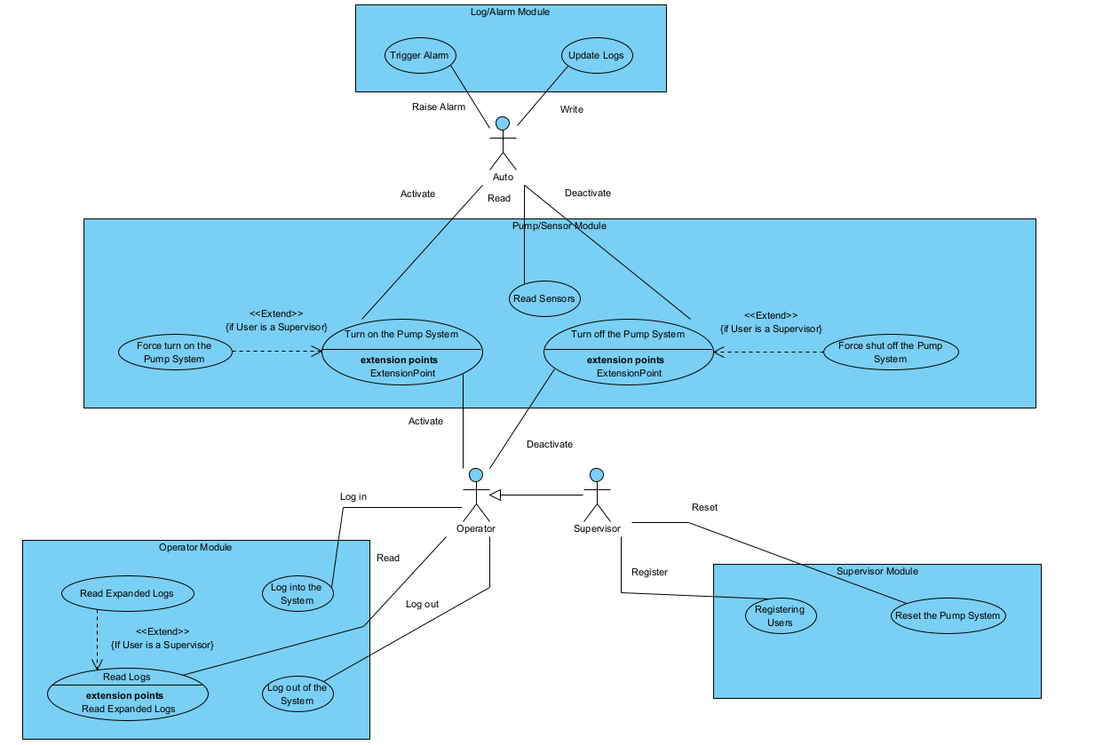

In the MPC Use Case Diagram presented above, we have four (three) major modules discussed from before. Top to bottom, there is the Log/Alarm Module, which contains the use-cases of “Trigger Alarm” and “Update Logs”. These use-cases pertain mainly to the Auto/Automatic actor, as they will be in charge of updating the log as new actions are received, and raising the alarm if necessary after Read Sensors fires. Next, there is the Pump/Sensor Module, which contains the main use-cases of “Turn on the Pump System”, “Read Sensors”, and “Turn off the Pump System”. There are extended use-cases, which pertain mainly to the Supervisor actor, who can forcefully turn on or off the pump system regardless of water level as the problem scenario described. Read Sensors is exclusive to the Auto/Automatic actor, as that is how the automation system receives information on the outside in order to decide internally. Last but not least, are the Operator/Supervisor modules. These contain the use-cases of logging in and out of the system, reading logs. The Supervisor is an inheritance/generalization of the Operator, meaning it possesses the same abilities, but with also the exclusive use-cases of being able to Register Users, and Reset the Pump System. Likewise, supervisor also has the extended ability to read expanded logs, addressing the 30-day old entries versus the 24-hour old entries regularly.

Object Candidates and Class Diagrams

Object Candidates

7.1.1
Operator

Data Encapsulation: UID, Username, Password, Account Type, count
Methods Supported: Operator (Constructor) Log In, Log Out, Read Logs, Turn on Pump, Turn off Pump

getUID
getUser
getPass
getType

7.1.2
Supervisor (Child of the Parent Operator)

Data Encapsulation:
Provided: UID, Username, Password, Account Type

Methods Supported:
Provided: Log In, Log Out, Read Logs, Turn on Pump, Turn off Pump

Extension: Read Logs, Force on Pump, Force off Pump (Potential Overrides)

Supervisor (Constructor), Registering Users, Restart Pump, doAppendNote

7.1.3
Auto/Automatic

Data Encapsulation:

isActive
lastReset

Methods Supported:

Automatic (Constructor)
doTurnOnPump
doTurnOffPump
doReadSensors
doRaiseAlarm
doUpdateLog
getLastReset
setLastReset

7.1.4
Pump

Data Encapsulation:

isActive
isAuto
currentWaterLevel

Methods Supported:

Pump (Constructor)
readWaterSensor
getCurrWaterLevel
getActive
getAuto
turnOnPump
turnOffPump

7.1.5
Water Sensor

Data Encapsulation:

isActive
sensorType (Low or High)
installDate
lastReading
minLevel
maxLevel

Methods Supported:

WaterSensor (Constructor)
setMin
setMax
setLastReading
getInstallDate
getType
getActive
doRead
Activate
Deactivate

7.1.6
Methane Sensor

Data Encapsulation:

isActive
installDate
lastReading
maxLevel

Methods Supported:

MethaneSensor (Constructor)
getInstallDate
getActive
getLastReading
doRead
setMax
getMax
Activate
Deactivate

7.1.7
Alarm

Data Encapsulation:
isActive
isArmed
timesActive
installDate

Methods Supported:

Alarm (Constructor)
Activate
Arm
Disarm
getInstallDate
getTimesActive
getArmed

7.1.8
Log

Data Encapsulation:

lastModified
modified

Methods Supported:

Log (Constructor)
writeToLog
readLog
appendNote
saveLog

Class Diagrams

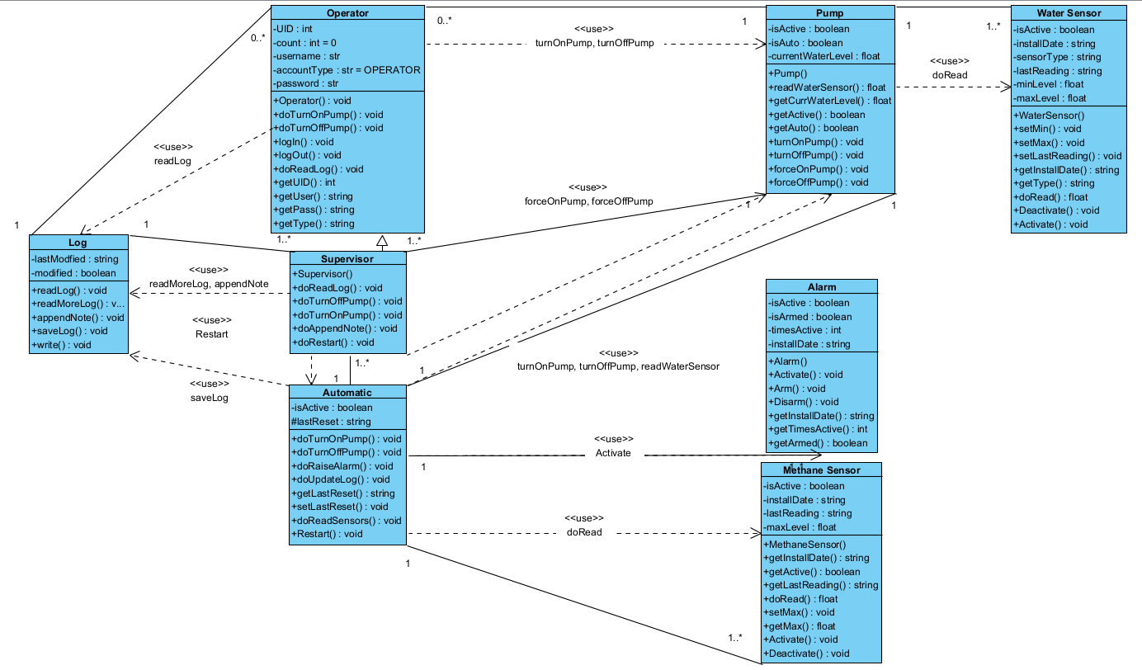

In the MPC Class Diagram shown above, there are 8 different abstract data types. They are as follows: Operator, Supervisor, Automatic, Log, Pump, Alarm, Methane Sensor, Water Sensor. The listed will function as the class breakdown of the full application. From the list, Operator will pertain to general user controls, such as Pump Controls (turnOnPump, turnOffPump), but also being able to log in and out, or examine logs (readLog). Supervisors will inherit those general controls from the Operator class, overriding some existing methods to perform them at an elevated security level (forceOnPump, forceOffPump, readMoreLog, appendNote, and Restart for the pumps). Automatic is similar in the way Operator works, with the difference being that there are no human controls and there is only ever one at any given point. It is in charge of the same pump controls as an Operator, but also holds full authority over the methane system (doRead, Activate). Additionally, it will keep the log up-to-date (saveLog) and requires restarts after supervisor pump actions. Conveniently, the Log is next, and there will only ever be one instance of a log, even though many Operators or Supervisors may interact with the features it provides. Following this is the Pump class, which possesses a very wide public interface for other classes to interact with, which is the whole MPC system as a whole. To perform as intended, it does need to obtain precise readings of the current water level (doRead). Next, is the alarm, there can be many of these tied to one automatic system, and each of them have their own different attributes. The date of installation, whether it is active or armed, and times it was activated. Additionally, it comes with methods to help both obtain information about those attributes but arm or disarm the alarm. Finally, the last two, but arguably most important, are the sensors. The methane sensor frequently uses the doRead method for the Automatic class, to constantly keep track of how much methane is present in the mine. Meanwhile, the water sensor which is implicitly used by the Automatic class through the Pump class, helps the Automatic class determine if it needs to run the pump system or not. Both sensor types have differing attributes to keep track of information that may prove useful to the actors, or the MPC system as a whole, and have getters or setters to accomplish that task to the fullest.

UML Sequence Diagrams

Auto Actor and the MPC System
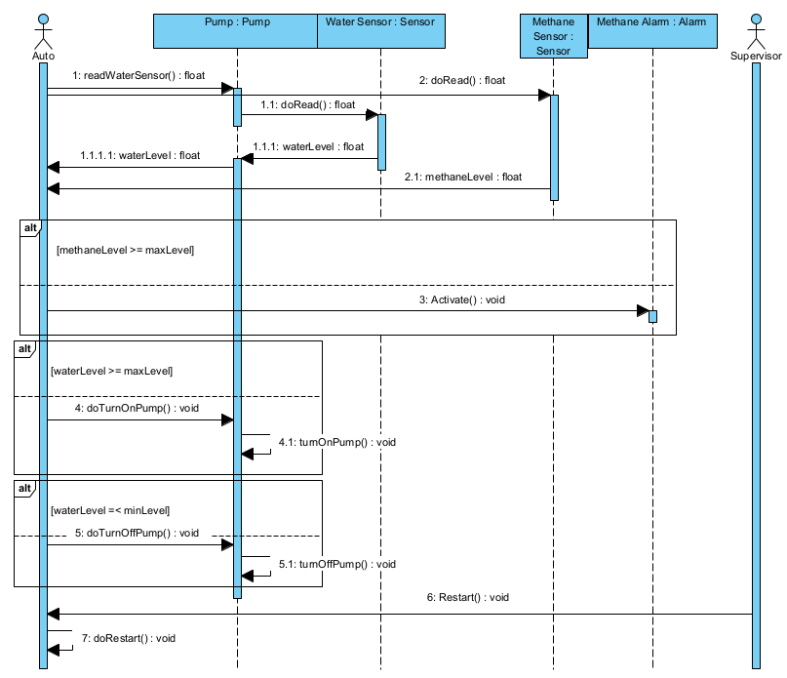
The above diagram showcases the Automatic System actor performing its execution of methods. It is expected to retrieve information regarding the water and methane sensors, determining whether it should: activate the alarms, starting the pump, disable the pump, or simply do nothing. It can also receive an incoming message by a supervisor to issue a restart which will reengage its systems.

Operator Actor and the MPC System
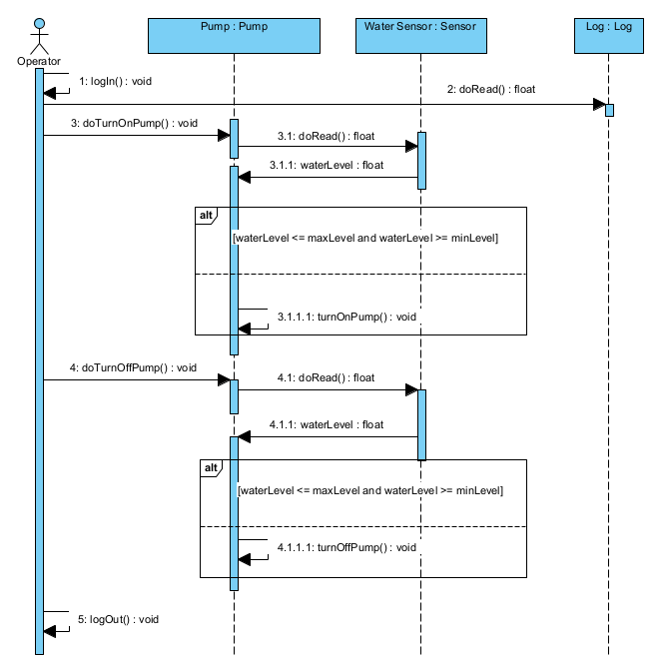
The above diagram represents the Operator actor and its relation to the MPC system. The operator role logs into the system, regularly reads logs, and may choose to turn on the pump to keep water levels from reaching the dangerous levels. They may also turn off the pump if its in safe enough levels to do so. When they are done managing the system, they log out.

Supervisor Actor and the MPC System

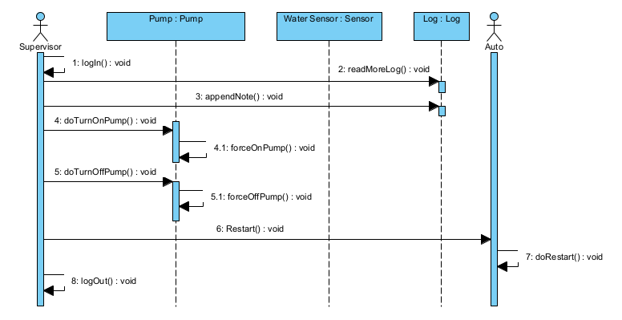
Finally, there is the Supervisor Actor’s relation to the MPC system and the additional Auto actor. Supervisors will log in, regularly check logs, and possibly add notes to specific events. Then, they can issue a control that overrides the system protections and automatic flow to either switch on the pumps or shut them off. When they are done, they should consider restarting the automatic system in place before logging out.

