Logistics Management System
Data Flow Documentation
Laravel web application with a read-only link to the Inventory System
Version 4 · 9 October 2026
Document control
Item | Details
Document | Logistics Management System – Data Flow Documentation
Version | 4.0
Date | 9 October 2026
Status | Current
Companion document | Logistics-System-Documentation (modules and user guide with screenshots)

Contents
1. Purpose and Scope 3
1.1 Revision history 3
1.2 What changed in version 4 3
1.3 Changes in version 3 4
1.4 Changes in version 2 4
2. System Components 4
3. Level 0: Context Diagram 6
4. Level 1: Main Processes 7
4.1 Processes 7
4.2 Data Stores 8
4.3 Process and Store Matrix 10
5. Detailed Data Flows 10
5.1 Signing In 10
5.2 Creating a Shipment and Reserving Stock 10
5.3 Crew Assignment and Availability 11
5.4 Status Changes by Office Staff 11
5.5 Delivery Updates from the Field 12
5.6 Live Vehicle Tracking 12
5.7 Shipment Notes 12
5.8 Alerts 12
5.9 Managing Vehicles, Leases, Drivers and Helpers 13
5.10 Users, Passwords and Images 13
5.11 Dashboard, Calendar, Printing and Reports 13
5.12 Emergency and SOS 14
5.13 Driver Dashboard Content and Language 14
6. Who Can Access Which Data 15
7. Data Handling Rules 15
8. Glossary 16

1. Purpose and Scope
This document describes how data moves through the Logistics Management System: where it comes from, which part of the system processes it, where it is stored, and what is shown back to users.
It is written from the system as it is currently built, and table names match the database so it can be used alongside the code.

1.1 Revision history
Version | Date | Summary of changes
1.0 | September 2026 | First release: sign-in, shipments, dispatch, fleet, users, images, dashboard and reports.
2.0 | 23 September 2026 | Stock reservations, field delivery updates, live vehicle tracking, shipment notes and alerts, sign-in security.
3.0 | 29 September 2026 | Emergency and SOS, emergency contacts, driver dashboard content, English/Tagalog language, driver and helper positions, live notes, management dashboard upgrade.
4.0 | 9 October 2026 | Access by role, multi-pickup shipments, required crew with availability checks, truck / cargo helpers, calendar, printing, more delivery statuses, reminder banner, ended lease contracts, installable app. Automatic dispatch and the dashboard CSV export were removed.

1.2 What changed in version 4
- Access by role. Each role now opens only its own part of the system. A Super Admin looks after accounts, reports and site content and no longer works with shipments or the fleet. Managers and Logistics Coordinators run operations and the fleet. Field Personnel see only the shipments they are on. Section 6 has the full table.
- Multi-pickup shipments. One shipment can collect from up to five places. Each stop has its own pickup time and its own items, and is ticked off when collected.
- Required crew and availability. Every shipment is created with a driver and a vehicle, and optionally a truck / cargo helper. A vehicle, driver or helper on an unfinished shipment cannot be put on another. Automatic dispatch was removed.
- Truck / cargo helpers. Helpers are kept as their own records beside drivers and can be linked to a sign-in account.
- More delivery statuses. Ready for pickup, Picked up, Out for delivery, Delivery attempted, Held for pickup and Returned to sender were added to Pending, In transit, Delayed, Delivered and Cancelled.
- Calendar and printing. A calendar shows pickups and deliveries by day. A shipment, and the shipment list, can be printed or saved as PDF. The list is filtered by status, search and Weekly / Monthly / Yearly.
- Reminder banner. Every page reminds office staff and the assigned driver of shipments that are not delivered yet, until they are finished.
- Leased vehicles. A leased vehicle whose contract has ended is shown as Unavailable and cannot be put on a shipment. A vehicle on an unfinished shipment is shown as On road automatically.
- Installable app. The system can be added to a phone's home screen and shows an offline page when there is no connection.
- Removed. The dashboard's shipment CSV export. The activity log export remains.

1.3 Changes in version 3
- Emergency and SOS. An Emergency button for field personnel with tap-to-call contacts and a Send SOS alert to the office, including the driver's last shared location.
- Emergency contacts. Managers and Super Admins keep the list of numbers drivers can call, checked against Philippine phone formats.
- Driver dashboard. Field personnel get their own dashboard: next delivery, other deliveries, their week, and a guide, safety guidelines and company profile written by the Super Admin.
- Language. Each user chooses English or Tagalog; the choice is saved on their account.
- Driver or helper. Field Personnel accounts record whether the person is a driver or a helper.
- Live notes and dashboard. Notes appear without reloading and show exact times; the management dashboard has a 7/30-day period, a Needs attention list and CSV export.

1.4 Changes in version 2
- Stock reservations. Stock promised to open shipments is subtracted from what can be booked, so the same units cannot go on two shipments.
- Field delivery updates. Drivers mark their own deliveries In transit, Delayed or Delivered, with a photo and the receiver's name as proof of delivery.
- Live vehicle tracking. Drivers can share their phone's location during a delivery; the office sees it on a live map.
- Shipment notes and alerts. A notes thread on every shipment, and a bell with alerts for new notes, delays, deliveries and assignments.
- Security. Limits on failed sign-in attempts; sessions end when a password is changed; Super Admins add users and set passwords.
- Screens. The route map is shown only on a shipment's own page; the sidebar is grouped into Operations, Fleet, Insights and Administration.

2. System Components
Component | Technology | Role in the data flow
Logistics web app | Laravel (PHP), Blade pages | Receives every request, checks permissions, validates input, and reads and writes the data stores.
Logistics database | Microsoft SQL Server (logistics) | Stores users, shipments and their pickup stops, fleet (vehicles, leases, drivers, helpers), allocations, images, activity log, location pings, notes and alerts (D1 to D6, D8 to D12).
Inventory database | Microsoft SQL Server (inventory_DB) | Owned by the Inventory System. Logistics only reads products, stock, locations and suppliers from it.
File storage | Laravel "public" disk (storage/app/public) | Site images, profile pictures, proof-of-delivery photos and lease contracts. The database stores only their paths.
City dataset | resources/data/ph_locations.json (D7) | Philippine cities with province and postal code, used by the location search.
OpenStreetMap | External web services | Nominatim turns addresses into map coordinates. The browser also loads map tiles and road routes (OSRM) directly.
Drivers' phones | Web browser, or the app installed to the home screen | Send delivery updates, pickup ticks, photos and, when the driver opts in, the phone's location.
Translations | lang/tl.json | Tagalog wording for every page; English is the default. Each user's choice is stored in users.locale.
Scheduler | Laravel scheduler (php artisan schedule:run) | Runs daily clean-up, including deleting location data older than 90 days.

3. Level 0: Context Diagram
The whole system as a single process, and the outside parties it exchanges data with.
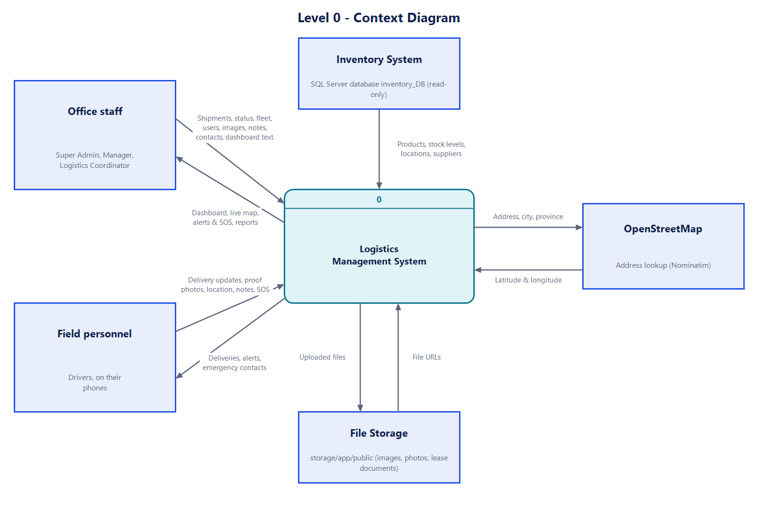
Figure 1. Context diagram
External party | Data sent to the system | Data received from the system
Office staff | Sign-in details, shipments with pickup stops and crew, status changes, vehicle, driver and helper records, user accounts, images, notes | Dashboard, shipment pages, calendar, printable shipments, live tracking map, alerts, activity reports and their CSV export
Field personnel | Delivery updates, pickup ticks, proof-of-delivery photos and receiver names, phone location (opt-in), notes, SOS | Only the deliveries assigned to them, their calendar, alerts and emergency contacts
Inventory System | Products, stock per location, warehouse and store locations, suppliers | Nothing. The link is read-only.
OpenStreetMap | Latitude and longitude for an address | Address, city and province to look up
File storage | Stored files, served back by their URL | Uploaded images, photos and documents

4. Level 1: Main Processes
Level 1 splits the system into ten processes and shows the data stores each one mainly uses.
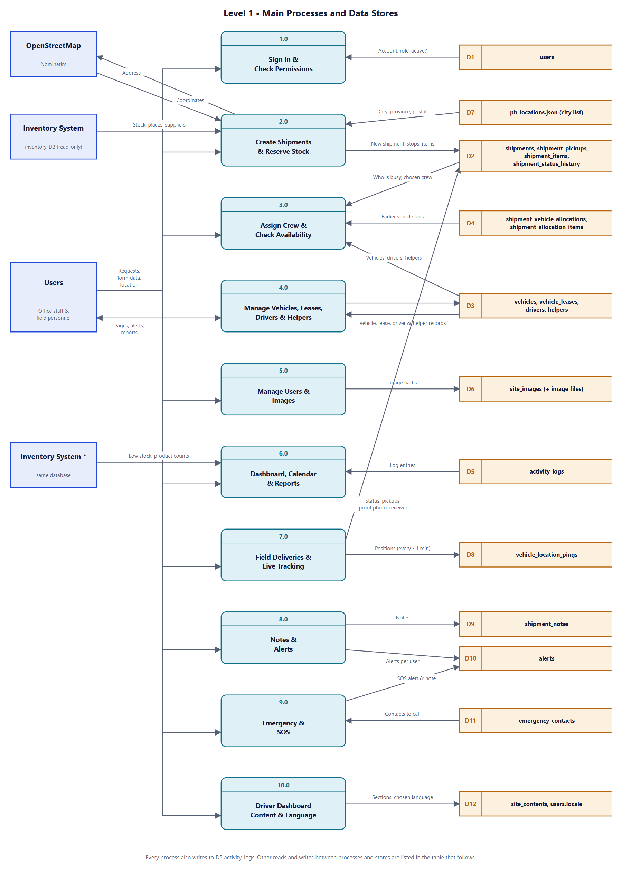
Figure 2. Level 1 data flow diagram

4.1 Processes
No. | Process | What it does with data
1.0 | Sign In & Check Permissions | Checks email and password against D1, allows only active accounts, limits failed attempts, and on every request lets in only the roles named for that page. A session ends if the account's password is changed.
2.0 | Create Shipments & Reserve Stock | Builds a shipment from the form, with up to five pickup stops and the items collected at each. Reads stock from Inventory and subtracts what open shipments already hold, so only free stock can be booked. Fills city details from D7, looks up map coordinates, and saves to D2.
3.0 | Assign Crew & Check Availability | Every shipment needs a driver and a vehicle from D3, and may have a helper. Anyone still on an unfinished shipment in D2 is refused, as is a leased vehicle whose contract has ended. Managers and Logistics Coordinators can change the crew of an unfinished shipment.
4.0 | Manage Vehicles, Leases, Drivers & Helpers | Adds, edits and deletes vehicles, leases, drivers and helpers in D3, including which Field Personnel account each driver or helper signs in with. Works out which vehicles are On road or Unavailable.
5.0 | Manage Users & Images | Super Admins manage every account in D1; Managers add and manage Field Personnel accounts only. Super Admins manage background images and profile pictures in D6.
6.0 | Dashboard, Calendar & Reports | Combines shipment figures from D2 with live Inventory stock figures, shows pickups and deliveries by day, prints shipments, and reads D5 for the activity report, its print view and CSV export.
7.0 | Field Deliveries & Live Tracking | Drivers tick off pickup stops and update their own deliveries in D2 (with proof photo and receiver on delivery) and, if they opt in, send positions to D8. The office reads D8 for the live map.
8.0 | Notes & Alerts | Saves notes to D9 and creates alerts in D10 for the people involved when a note is posted, a shipment is delayed or delivered, or a driver is assigned.
9.0 | Emergency & SOS | Shows drivers the contacts in D11 to call. A Send SOS creates an urgent alert in D10 for all Managers and the people on the delivery, adds a note to D9 with the last position from D8, and logs it in D5.
10.0 | Driver Dashboard Content & Language | Super Admins edit the guide, guidelines and company profile in D12; field personnel read them on their dashboard. Each user's language choice is saved on their account and used on every page.

4.2 Data Stores
ID | Store (tables) | Holds | Written by / read by
D1 | users | Accounts, hashed passwords, roles, driver or helper position, active flag | Written by 5.0; read by 1.0 and every page
D2 | shipments, shipment_pickups, shipment_items, shipment_status_history | Shipment details and crew, pickup stops and when each was collected, item lines copied from Inventory, every status change, proof of delivery | Written by 2.0, 3.0 and 7.0; read by 2.0, 3.0, 4.0, 6.0, 7.0 and 8.0
D3 | vehicles, vehicle_leases, drivers, helpers | Fleet, capacity, rental terms and contract dates, drivers and helpers and their linked accounts | Written by 4.0; read by 2.0, 3.0, 4.0, 6.0, 7.0 and 8.0
D4 | shipment_vehicle_allocations, shipment_allocation_items | Vehicle legs of shipments that were dispatched automatically before version 4. Kept for those shipments; no longer written. | Read by 3.0, 7.0 and 8.0
D5 | activity_logs | Who did what and when, with IP address | Written by every process; read by 6.0
D6 | site_images (+ files) | Login and sidebar backgrounds, and each user's profile picture | Written by 5.0 and the profile menu; read by every page
D7 | ph_locations.json | City, province and postal code list | Read-only; read by 2.0
D8 | vehicle_location_pings | Positions from drivers' phones during deliveries | Written by 7.0; read by 7.0. Deleted after 90 days
D9 | shipment_notes | The notes thread on each shipment | Written and read by 8.0
D10 | alerts | Each user's alerts, read or unread | Written by 8.0 and 9.0 (triggered by 2.0, 3.0, 7.0, notes and SOS); read by the bell
D11 | emergency_contacts | Names and phone numbers drivers can call, in display order | Written by Super Admins and Managers; read by 9.0
D12 | site_contents, users.locale | Driver dashboard sections, and each user's language | Written by 10.0; read by the driver dashboard and every page

4.3 Process and Store Matrix
R = reads, W = writes. This includes links left out of Figure 2 to keep it readable.
Process | D1 | D2 | D3 | D4 | D5 | D6 | D7 | D8 | D9 | D10 | D11 | D12 | Inv.
1.0 Sign in | R |  |  |  | W | R |  |  |  |  |  | R
2.0 Shipments | R | R/W | R | R | W |  | R | R |  | W |  |  | R
3.0 Crew |  | R | R | R | W |  |  |  |  | W
4.0 Fleet | R |  | R/W |  | W
5.0 Users & images | R/W |  |  |  | W | R/W
6.0 Dashboard & reports | R | R |  |  | R/W |  |  |  |  |  |  | R | R
7.0 Field & tracking | R | R/W | R | R | W |  |  | R/W |  | W
8.0 Notes & alerts | R | R | R | R |  | R |  |  | R/W | R/W
9.0 Emergency & SOS | R | R | R | R | W |  |  | R | W | W | R/W
10.0 Content & language | R/W |  |  |  | W |  |  |  |  |  |  | R/W

5. Detailed Data Flows
Each flow lists the steps in order, from the user's action to what is saved and shown.

5.1 Signing In
- The user opens the login page. The background images are loaded from D6.
- The user enters an email and password and agrees to the Terms and Privacy Policy.
- The system checks the details against D1. Only active accounts can sign in.
- After 5 wrong passwords for one account from one address, that account is blocked from that address for 60 seconds. One address is limited to 20 failed attempts a minute across all accounts. Blocked attempts are logged as "Sign-in blocked".
- On success the session is renewed and a "login" entry is written to D5. A failed attempt writes "login_failed" with the email tried, never the password.
- On every later request the system checks that the account is still active and that its password has not changed since the session began. Otherwise the user is signed out.

5.2 Creating a Shipment and Reserving Stock
- A Manager or Logistics Coordinator opens New shipment. The system reads stock, locations and suppliers from the Inventory System.
- For each product, the free quantity is Inventory's quantity minus what is reserved: the total on shipments that are not finished yet (every status except Delivered, Returned to sender and Cancelled). Only products with free stock are offered, with that number shown.
- Origin and destination cities are searched in D7, with province and postal code filled in. Anything not in the list can be entered manually.
- More pickup stops can be added, up to five places including the origin. Each stop has a name, address, pickup date and time, and its own items; the same place cannot be used twice, and the same product cannot be added twice at one stop.
- A driver and a vehicle must be chosen, and a helper may be. Anyone still out on an unfinished shipment is shown as busy and cannot be picked (see 5.3). The delivery time cannot be before the pickup time.
- On submit, the system validates every field and re-reads product names, SKUs and stock from Inventory instead of trusting the browser.
- Addresses without stored coordinates are sent to OpenStreetMap; results are cached for 30 days.
- Under a lock, so two people cannot book the last units at the same moment, the free quantity is checked again across every stop together, and the shipment, its pickup stops, its items and its first history entry are saved in one transaction.
- A "created" entry goes to D5, and the driver's account gets an "assigned" alert in D10.

5.3 Crew Assignment and Availability
- Nothing is stored about who is busy. A vehicle, driver or helper is busy while any shipment they are on in D2 is unfinished, and free again the moment it is Delivered, Returned to sender or Cancelled.
- When a shipment is created or its crew is changed, the system refuses anyone who is busy on another shipment and names that shipment in the message.
- A leased vehicle whose contract has ended (see 5.9) is not offered and is refused if submitted. A shipment that already has it keeps it.
- Managers and Logistics Coordinators can change the driver, vehicle or helper of an unfinished shipment from its page. The change is logged in D5 and a newly assigned driver gets an "assigned" alert in D10.
- On the Vehicles and Drivers pages each busy vehicle, driver and helper is marked with the shipment it is on.

5.4 Status Changes by Office Staff
- Office staff pick a new status on the shipment page, with an optional note.
- Only valid next steps are offered. In order, a shipment goes from Pending to Ready for pickup, Picked up, In transit and Out for delivery, and ends as Delivered, Returned to sender or Cancelled. Delivery attempted, Held for pickup and Delayed can be recorded along the way. A shipment with pickup stops cannot move on until every stop is collected.
- Only a Manager can cancel a shipment. Logistics Coordinators are not offered Cancelled and are refused if they submit it.
- The status, dispatch or delivery time and a history row are saved in D2, and "status_changed" is written to D5.
- Delivered, Returned and Cancelled shipments release their reserved stock and free their vehicle, driver and helper. Delayed and delivered shipments trigger alerts (see 5.8).

5.5 Delivery Updates from the Field
- Office staff link each driver or helper in D3 to a Field Personnel account. That person then sees only the shipments they are on: as the driver, on one of the vehicle legs, or as the helper. Opening any other shipment, its notes or its print page is refused.
- On a shipment with pickup stops, the driver ticks off each stop as it is collected. The time and the person are saved on the stop in D2.
- On a shipment assigned to them, the driver chooses what happened from the steps allowed next. The form has no default choice, so a delivery cannot be finished by accident. The dashboard explains what each status means.
- Delivered requires a photo (JPG, PNG or WebP, up to 5 MB, stored under a random name) and the receiver's name. Delayed and Delivery attempted require a reason. Drivers cannot cancel a shipment or return it to the sender; the office decides those.
- The change is saved to D2 exactly as an office change would be, with the history note (for example "Received by Ana Reyes."), and logged in D5.
- The proof photo and receiver appear on the shipment page for everyone. Marking Delivered releases the reserved stock and ends location sharing.

5.6 Live Vehicle Tracking
- On an In-transit or Delayed shipment assigned to them, the driver presses Start sharing, and the phone asks for location permission. Starting and stopping are logged in D5 as a record of consent.
- While that page is open, the phone sends its position about once a minute. The system accepts it only from the assigned driver while the shipment is on the road, ignores positions less than 20 seconds apart, and saves it in D8 with the vehicle and accuracy.
- The Live tracking page (office roles only) shows the latest position of each active shipment on a map, green if seen in the last 5 minutes and grey otherwise, refreshing every minute. The shipment's route map shows the same marker.
- Sharing stops when the driver presses Stop, closes the page, or the shipment is delivered or cancelled; further positions are refused.
- A daily scheduled job deletes positions older than 90 days.

5.7 Shipment Notes
- Everyone who can open a shipment can read its notes. Managers and Logistics Coordinators can post on any shipment; Field Personnel only on shipments assigned to them.
- A note of up to 1,000 characters is saved in D9 with its author and time (at most 20 notes a minute per person).
- An alert is created for everyone involved except the author (see 5.8).

5.8 Alerts
- "Involved" people are the shipment's creator, the accounts of its drivers, and anyone who has posted a note on it. The person who caused an event is never alerted about it.
- A new note, a delivery and a driver assignment alert those people (assignment alerts the driver). A delay alerts them and every Manager, with the reason.
- Alerts are stored per user in D10. The bell checks for new ones every 10 seconds and whenever the tab regains focus, shows the unread count, and pops up new alerts in the corner.
- Opening an alert marks it read and goes to the shipment (to its notes for note alerts). A user can only open their own alerts.

5.9 Managing Vehicles, Leases, Drivers and Helpers
- Managers and Logistics Coordinators add and edit vehicles, drivers and helpers; only Managers can delete them.
- Plate numbers, mobile numbers and LTO licence numbers are checked against Philippine formats.
- Lease contracts are stored under lease-contracts/ and only their path is saved. Each change is logged in D5.
- A vehicle on an unfinished shipment is shown as On road with the shipment's number, and as Available again when the shipment ends. This is worked out each time from D2; the saved status is not changed.
- A leased vehicle is Unavailable once its lease end date has passed or its contract is marked Expired or Terminated. The Vehicles page shows a warning listing these vehicles, which the user can close, and the vehicle cannot be put on a shipment until the contract is renewed.

5.10 Users, Passwords and Images
- Super Admins and Managers can open Users & Roles; only a Super Admin can open Site Images. Both the route and the controller check this.
- A Super Admin can add a user (name, email, role, password) and change any user's name, email, role, status and password. A Manager sees only Field Personnel accounts: they can add, edit, activate and deactivate them and set driver or helper, but cannot change a role or open any other account. Passwords need at least 8 characters with letters and numbers and are stored only as a hash.
- Changing a password signs that user out of every other session and ends their "remember me" logins. A Super Admin changing their own password stays signed in.
- At least one active Super Admin always remains, and nobody can change their own role or deactivate themselves.
- Background images and profile pictures are stored under random names with their paths in D6. Replacing one deletes the old file. Users can change their own name, email and photo, but not their password.

5.11 Dashboard, Calendar, Printing and Reports
- Managers and Logistics Coordinators choose a 7- or 30-day period. The dashboard counts shipments by status from D2, lists overdue and delayed shipments under Needs attention, and reads low-stock items and product counts from Inventory (cached for 60 seconds; the page still loads if Inventory is unavailable). A Super Admin has no shipment dashboard and lands on Reports.
- Super Admins and Managers filter the activity log in D5 by user, action and date. Only a Super Admin can print it or export it to CSV. Export values are protected from running as spreadsheet formulas, and printing and exporting are themselves logged.
- Field personnel instead see their own dashboard: next delivery, other deliveries and their week, from D2. An account linked to a driver or helper is greeted by that person's first name.
- The calendar reads D2 and shows each day's pickups and deliveries by their scheduled times, by month or week, with filters by driver and vehicle for office staff. Field personnel see only their own.
- The shipment list is filtered by status, by a search, and by Weekly, Monthly or Yearly on the scheduled delivery date. A single shipment and the filtered list each have a printable page (which can be saved as PDF); printing is logged in D5.
- On every page a banner counts the shipments that are not delivered yet and lists them, most urgent first, for office staff and for the assigned driver. It disappears when they are finished. A Super Admin does not see it, or the alert bell.

5.12 Emergency and SOS
- Super Admins and Managers keep the emergency contacts in D11. Mobile and landline numbers are checked against Philippine formats as they are typed.
- Field personnel open the Emergency panel from the button at the bottom of the menu. It shows the 911 hotline and the contacts from D11 as tap-to-call buttons; calls are made by the phone, not the system.
- Send SOS, with an optional message of up to 300 characters, finds the driver's open delivery and their last position in D8 from the past 12 hours. At most 3 SOS a minute are accepted.
- An urgent alert goes to D10 for every active Manager and everyone on that delivery; a note with the location is added to D9; the event is logged in D5. SOS does not call 911.

5.13 Driver Dashboard Content and Language
- A Super Admin edits the driver dashboard sections (guide, safety guidelines, company profile) in D12. Lines starting with "-" become lists; the text is shown as plain text, never as HTML.
- Any user can switch between English and Tagalog. The choice is saved to users.locale and applied on every page, including dates and greetings; the sign-in page remembers it for the browser.

6. Who Can Access Which Data
Function | Super Admin | Manager | Logistics Coord. | Field Personnel
View shipments, calendar and notes | No | Yes | Yes | Own only
Shipment dashboard; create shipments, change status, change crew | No | Yes | Yes | No
Cancel a shipment | No | Yes | No | No
Update own deliveries, tick pickups, share location | No | No | No | Own only
Post notes | No | Yes | Yes | Own only
Live tracking map | No | Yes | Yes | No
Add and edit vehicles, drivers and helpers | No | Yes | Yes | No
Delete vehicles, drivers and helpers | No | Yes | No | No
Activity reports (read) | Yes | Yes | No | No
Activity reports: print and CSV export | Yes | No | No | No
Users & Roles (add users, set passwords) | All accounts | Field Personnel accounts only | No | No
Site Images (backgrounds, all profile pictures) | Yes | No | No | No
Emergency contacts (manage) | Yes | Yes | No | No
Emergency panel and Send SOS | No | No | No | Yes
Receive SOS alerts | No | Yes | If on the delivery | If on the delivery
Edit driver dashboard content | Yes | No | No | No
Edit own profile and photo; language | Yes | Yes | Yes | Yes
Alert bell and the undelivered-shipments banner | No | Yes | Yes | Yes

7. Data Handling Rules
- Inventory is read-only. The code blocks any change to Inventory data. The connection currently uses a Windows administrator login; a script is ready (database/sql/inventory_readonly_login.sql) to switch it to the read-only login inv_reader, which would also protect Inventory at the database level.
- Stock is reserved, not deducted. Logistics does not change Inventory quantities. Reserved stock is worked out from open shipments. Once a shipment is delivered it no longer holds stock, so the stock-out still has to be recorded in Inventory.
- Inventory data is copied at the time of use. A shipment keeps the SKU and name it was created with.
- Location is personal data (RA 10173). It is collected only when the driver opts in, only for their own active deliveries, with every start and stop logged, and it is deleted after 90 days. Phones only share location with a secure (https://) site, so the system must be served over HTTPS for drivers to use it.
- Files are stored by path. Images, photos and documents are kept under random names; old files are deleted when replaced. Anyone with a file's exact link can open it.
- Multi-step saves are transactions. Creating a shipment with its stops, changing its crew and changing its status are saved in full or not at all.
- Availability is worked out, not stored. Whether a vehicle, driver or helper is busy, and whether a leased vehicle is unavailable, is read from open shipments and contract dates each time, so it cannot go out of date.
- Everything is audited. Sign-ins, changes, exports and location sharing are written to the activity log. Passwords are never logged.
- SOS supports, not replaces, emergency services. SOS only alerts staff inside the system; the panel tells drivers to call 911 first.
- Failures degrade gracefully. If Inventory or OpenStreetMap is unavailable, pages still load and only the affected feature is disabled or hidden.

8. Glossary
Term | Meaning
DFD | Data flow diagram: shows how data moves between people, processes and stored data.
External entity | A person or system outside the application that sends or receives data (square boxes).
Process | Part of the system that changes or moves data (rounded boxes, numbered 1.0 to 10.0).
Data store | Where data is kept, usually database tables (open boxes, D1 to D12).
Reservation | Stock held by an open shipment, subtracted from what can be booked.
Allocation | One vehicle and driver's share of a shipment that was dispatched automatically before version 4.
Pickup stop | One place a shipment collects from. A shipment has up to five, the origin included.
Crew | The driver, vehicle and optional helper assigned to a shipment.
Open shipment | A shipment that is not yet Delivered, Returned to sender or Cancelled.
Ping | One position sent from a driver's phone.
SOS | An urgent alert from a driver to the office.

