Logistics Management System
System Documentation — Modules and User Guide
Version 2.0 · October 2026

Contents
1. Introduction 4
1.1 User roles 4
1.2 Technology 4
2. Authentication (Sign in) 5
2.1 Purpose 5
2.2 Features 5
2.3 How to use 5
2.4 Screenshots 5
3. Dashboard 6
3.1 Purpose 6
3.2 Features 6
3.3 Screenshots 6
4. Shipments 8
4.1 Purpose 8
4.2 Features 8
4.3 How to use 8
4.4 Screenshots 8
5. Calendar 13
5.1 Purpose 13
5.2 Features 13
5.3 Screenshots 13
6. Live Tracking and Delivery Updates 14
6.1 Purpose 14
6.2 Features 14
6.3 Screenshots 14
7. Fleet: Vehicles, Drivers and Helpers 15
7.1 Purpose 15
7.2 Features 15
7.3 Screenshots 15
8. Notes and Alerts 17
8.1 Purpose 17
8.2 Features 17
9. Emergency (SOS) 18
9.1 Purpose 18
9.2 Features 18
9.3 How to use 18
9.4 Screenshots 18
10. Administration 20
10.1 Purpose 20
10.2 Features 20
10.3 Screenshots 20
11. Reports 23
11.1 Purpose 23
11.2 Features 23
11.3 Screenshots 23
12. Language and Navigation 24
12.1 Purpose 24
12.2 Features 24

1. Introduction
The Logistics Management System plans and follows deliveries from the warehouse to the customer. It works together with the Inventory System: products, stock and locations are read from inventory, while shipments, fleet, tracking, notes and alerts are managed here.
This document describes each module of the system — its purpose, who can use it, its main features and how to use it — with screenshots taken from the running system. Version 2.0 covers the access rules by role, shipments with several pickup stops, the calendar, truck / cargo helpers, printing, and how leased vehicles are handled.

1.1 User roles
Access depends on the role given to each account. Each role sees only its own part of the menu, and a page that is not listed for a role is refused even when its address is typed in.
Module | Super Admin | Manager | Logistics Coordinator | Field Personnel
Dashboard | Opens Reports instead | Management | Management | Field version
Shipments | — | Full | Full, except cancelling | Own deliveries
Calendar | — | Yes | Yes | Own deliveries
Live tracking | — | Yes | Yes | Shares location
Vehicles / Drivers / Helpers | — | Yes | Yes, except deleting | —
Reports | Yes | Read only | — | —
Emergency | Manages contacts | Receives SOS, manages contacts | Receives SOS if on the delivery | Sends SOS
Administration | Yes | Field Personnel accounts | — | —

1.2 Technology
- Application — Laravel 13 (PHP 8.5), web browser on computers and phones. It can be added to a phone's home screen like an app.
- Database — SQL Server: the logistics database, plus read-only access to the Inventory System database.
- Maps — OpenStreetMap with Leaflet; routes by OSRM.

2. Authentication (Sign in)
Who can use it: Everyone

2.1 Purpose
Controls who can enter the system. Every user signs in with their email and password; what they see afterwards depends on their role.

2.2 Features
- Language switch — English or Tagalog can be chosen right on the sign-in page.
- Attempt limit — repeated wrong passwords are temporarily blocked to stop guessing.
- Deactivated accounts — a user switched off by an administrator sees a clear message and cannot sign in.
- Forgot password — explains that passwords are reset from Users & Roles by a Super Admin (or by a Manager, for Field Personnel accounts).
- Session security — signing out, or a password change, ends the session on every device.

2.3 How to use
- Open the system address in a browser.
- Enter your email and password.
- Click Sign in. Managers and Logistics Coordinators land on the management dashboard, Field Personnel on their own dashboard, and a Super Admin on Reports.

2.4 Screenshots
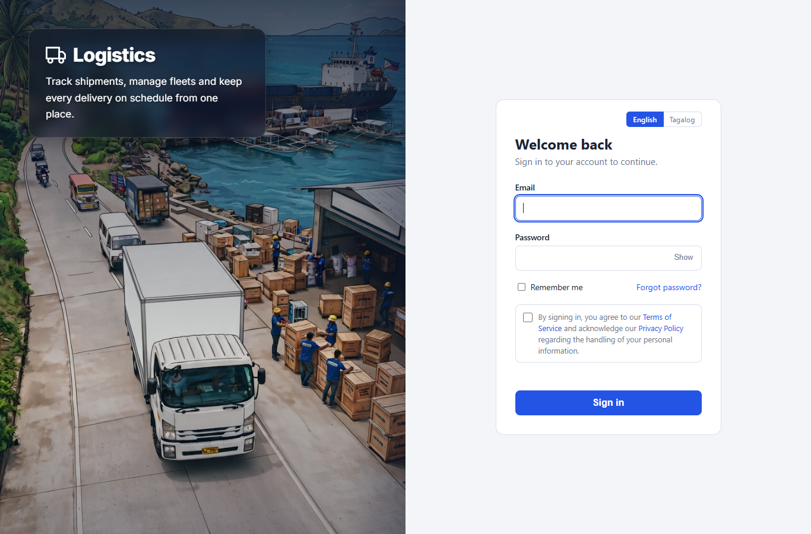
Figure 1. Sign-in page

3. Dashboard
Who can use it: Manager, Logistics Coordinator and Field Personnel (two versions)

3.1 Purpose
The first page after signing in. Managers and Logistics Coordinators see a management overview of the whole operation; drivers and helpers see a simple page about their own deliveries. A Super Admin does not work with shipments and is taken to Reports instead.

3.2 Features
- Period switch — shows figures for the last 7 or 30 days.
- Shipment figures — active, in transit, delivered today, delayed and on-time rate.
- Deliveries chart — delivered shipments per day.
- Needs attention — overdue or delayed shipments to follow up.
- Inventory — low stock, pending transfers and active products, read from the Inventory System.
- Recent shipments, with Live tracking and + New shipment shortcuts.
- Field version — a greeting by first name, the next delivery, other deliveries, "My week" figures, unread alerts, what each delivery status means, and the guide, safety guidelines and company profile written by the Super Admin.
- Reminder banner — shown on every page while shipments are not delivered yet, with the most urgent first; it can be opened into a list. It disappears once they are finished.

3.3 Screenshots
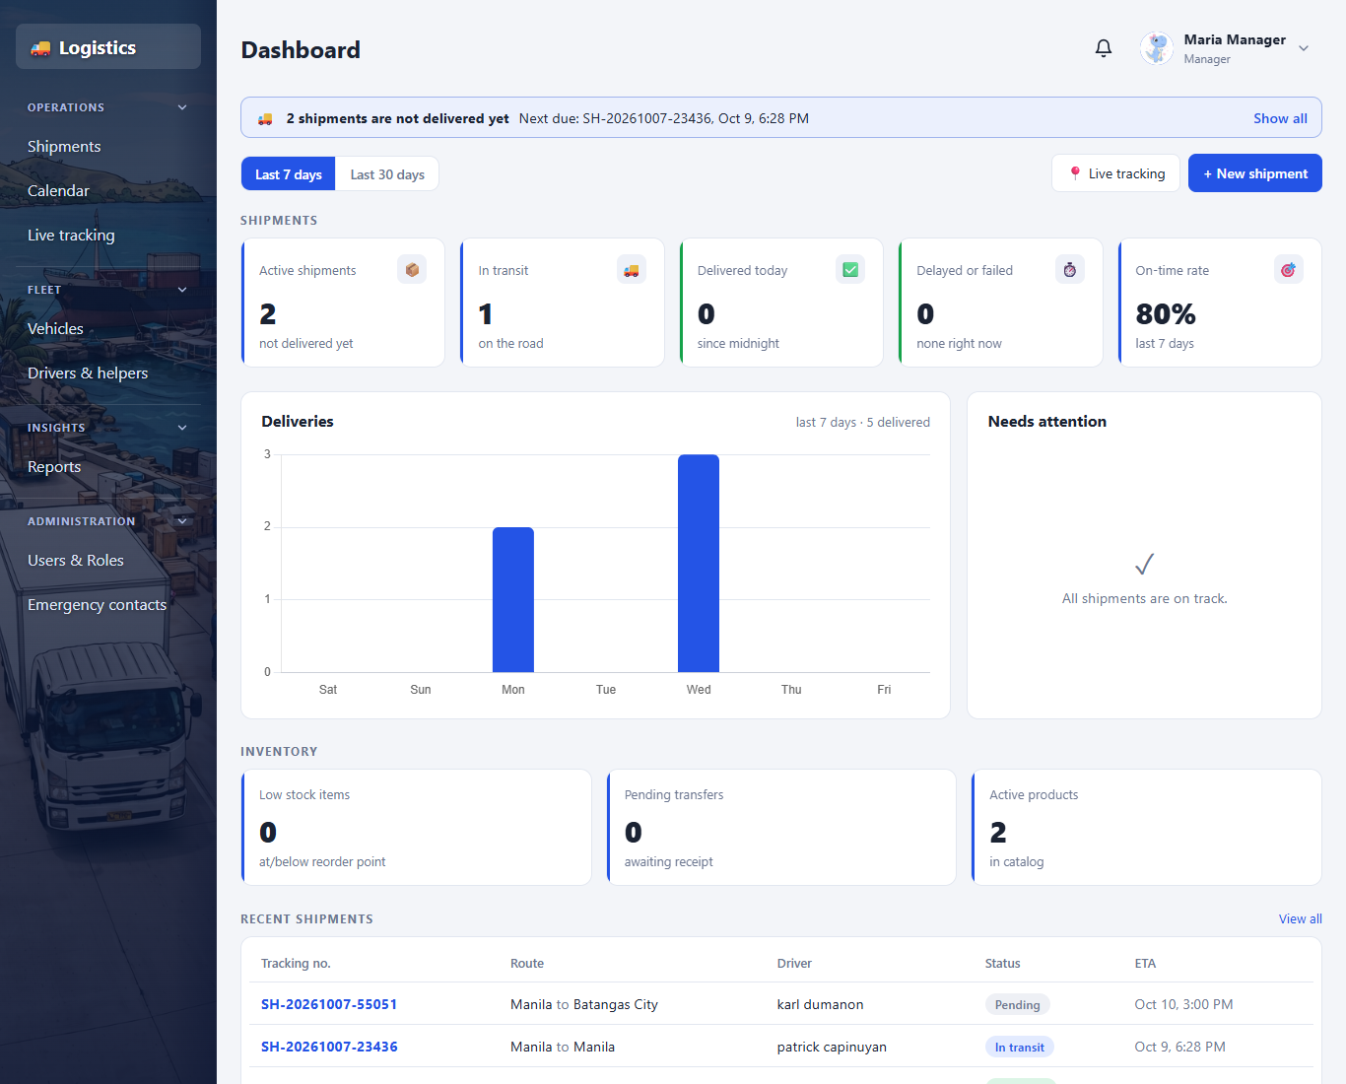
Figure 2. Management dashboard (Manager, Logistics Coordinator)
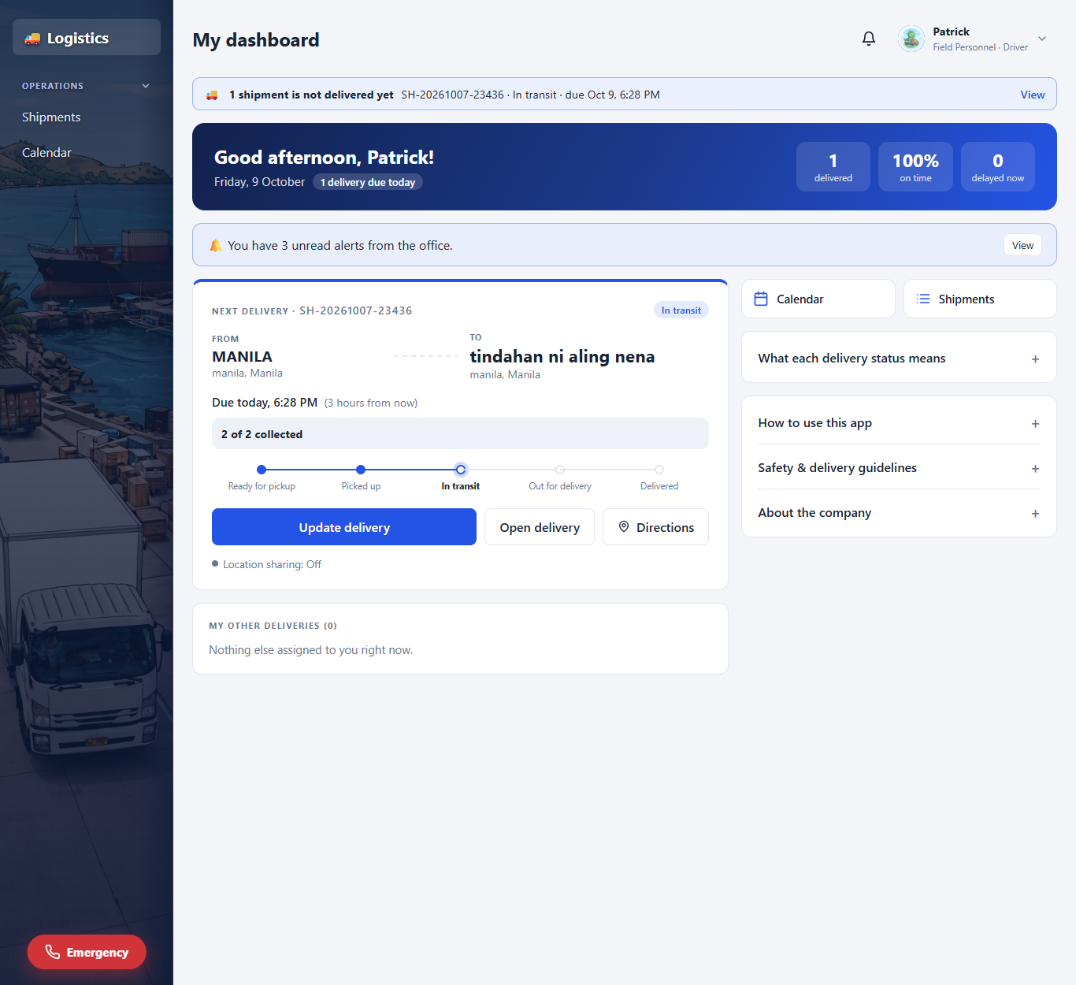
Figure 3. Field Personnel dashboard (driver)

4. Shipments
Who can use it: Managers and Logistics Coordinators create and manage; Field Personnel see only their own

4.1 Purpose
The core of the system. A shipment records where goods are collected, where they go and when, the driver, vehicle and helper taking them, and which inventory items it carries.

4.2 Features
- Shipment list — search, filter by status, and filter by Weekly, Monthly or Yearly on the scheduled delivery date. A whole row can be clicked. Field Personnel see only the shipments they are on.
- Create shipment — a three-step form with a summary that stays in view: pickup, destination, then schedule and assignment. Places are picked from the Inventory System or typed, with a city search that fills the province and postal code.
- Several pickup stops — one shipment can collect from up to five places. Each stop has its own pickup date and time and its own items; the same place cannot be added twice.
- Stock check — requested items are checked against inventory stock when saving and reserved for the shipment.
- Driver, vehicle and helper — a driver and a vehicle are required on every shipment, and a helper is optional. Anyone still on an unfinished shipment, and any leased vehicle whose contract has ended, cannot be chosen.
- Dates and times — a date box with a typed time and AM/PM. The delivery cannot be scheduled before the pickup.
- Shipment page — summary header, pickup stops with their items, route map through every stop with the truck's live position, status update panel, and tabs for Notes, Items and Tracking history.
- Statuses — Pending, Ready for pickup, Picked up, In transit, Out for delivery, Delivery attempted, Held for pickup, Delayed, Delivered, Returned to sender and Cancelled. Only the next valid steps are offered. Only a Manager can cancel a shipment.
- Edit assignment — Managers and Logistics Coordinators can change the driver, vehicle or helper of a shipment that is not finished.
- Proof of delivery — the driver marks the delivery as delivered with a photo and the receiver's name, or records a problem with a reason. Photos open in a pop-up.
- Print / PDF — a single shipment, or the filtered shipment list, opens as a clean page that can be printed or saved as PDF.

4.3 How to use
- Open Operations → Shipments and click + New shipment.
- Step 1, Pickup: choose or type where the goods are collected, set the pickup date and time, and add the items collected there. Use + Add another pickup for more stops.
- Step 2, Destination: choose or type where the goods are going.
- Step 3, Schedule and assignment: set the delivery date and time, then choose the driver and vehicle (and a helper if needed).
- Check the summary on the right and click Create shipment.
- Follow the shipment from its page; the driver ticks off each pickup stop and updates the status, or the office does.

4.4 Screenshots
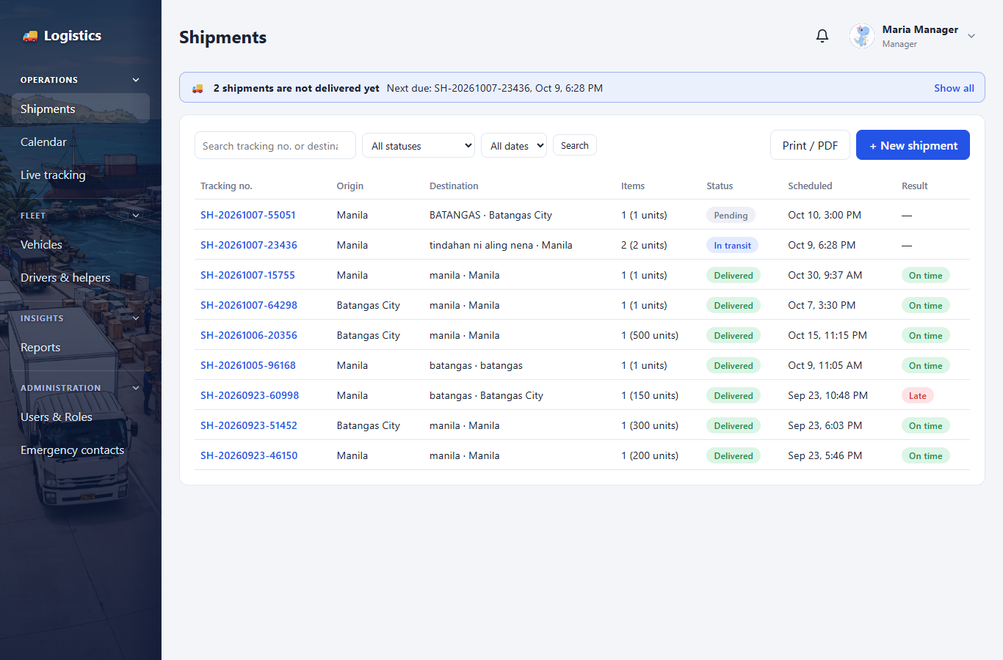
Figure 4. Shipment list
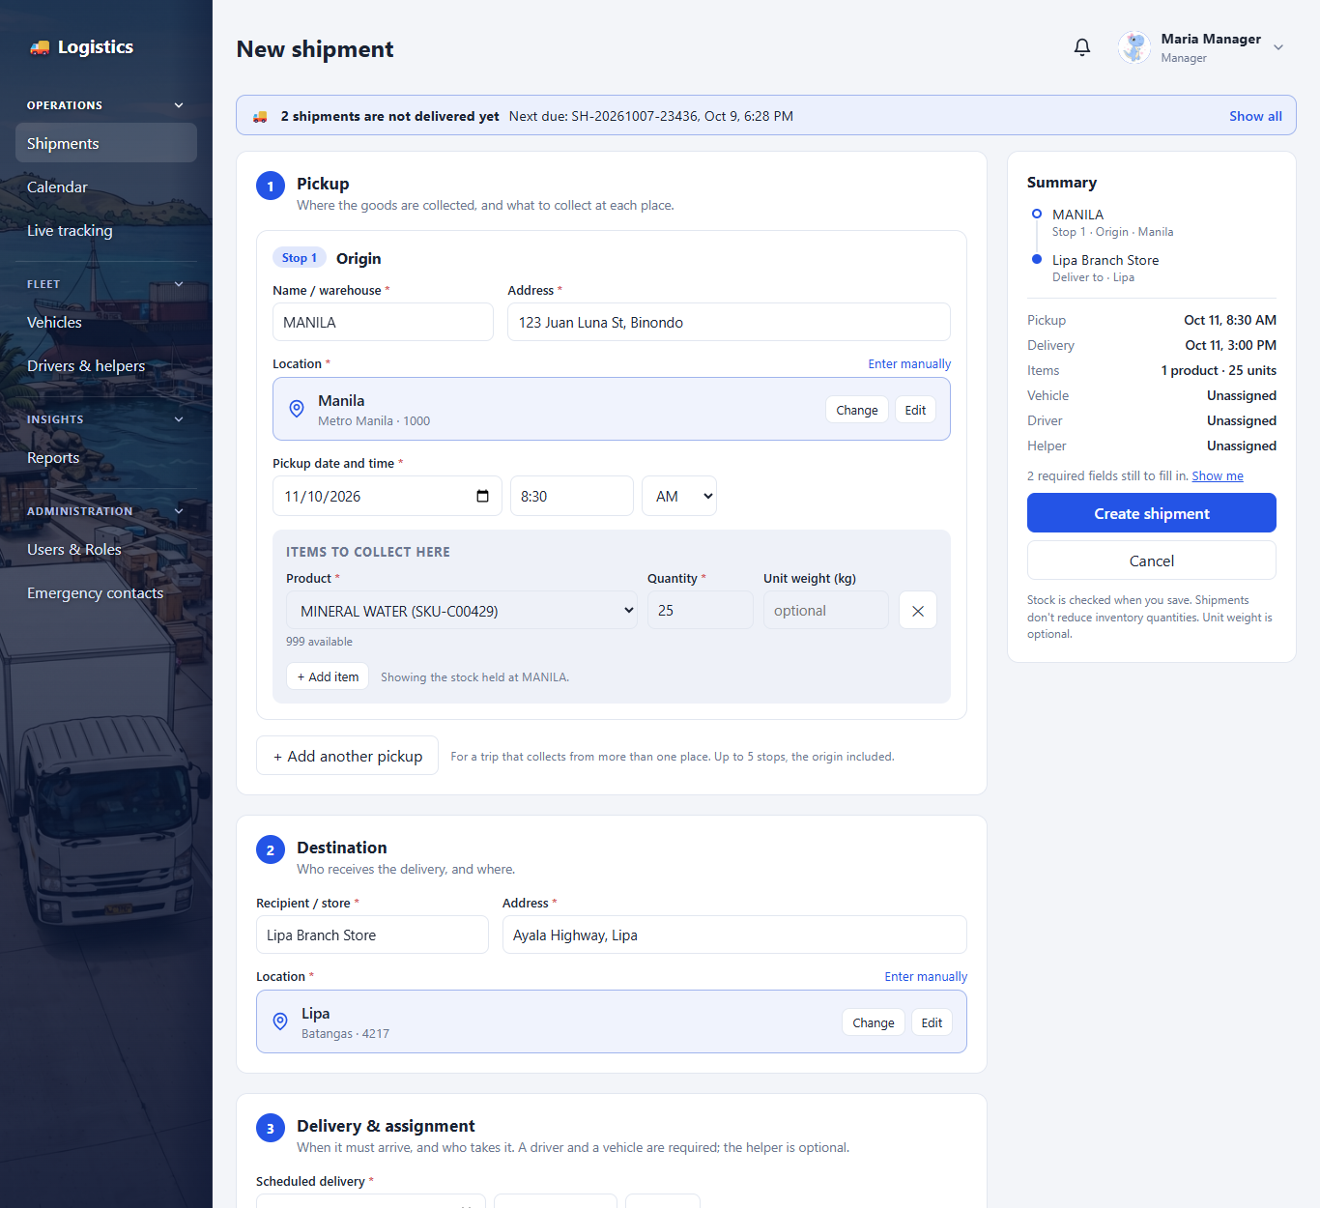
Figure 5. Creating a new shipment
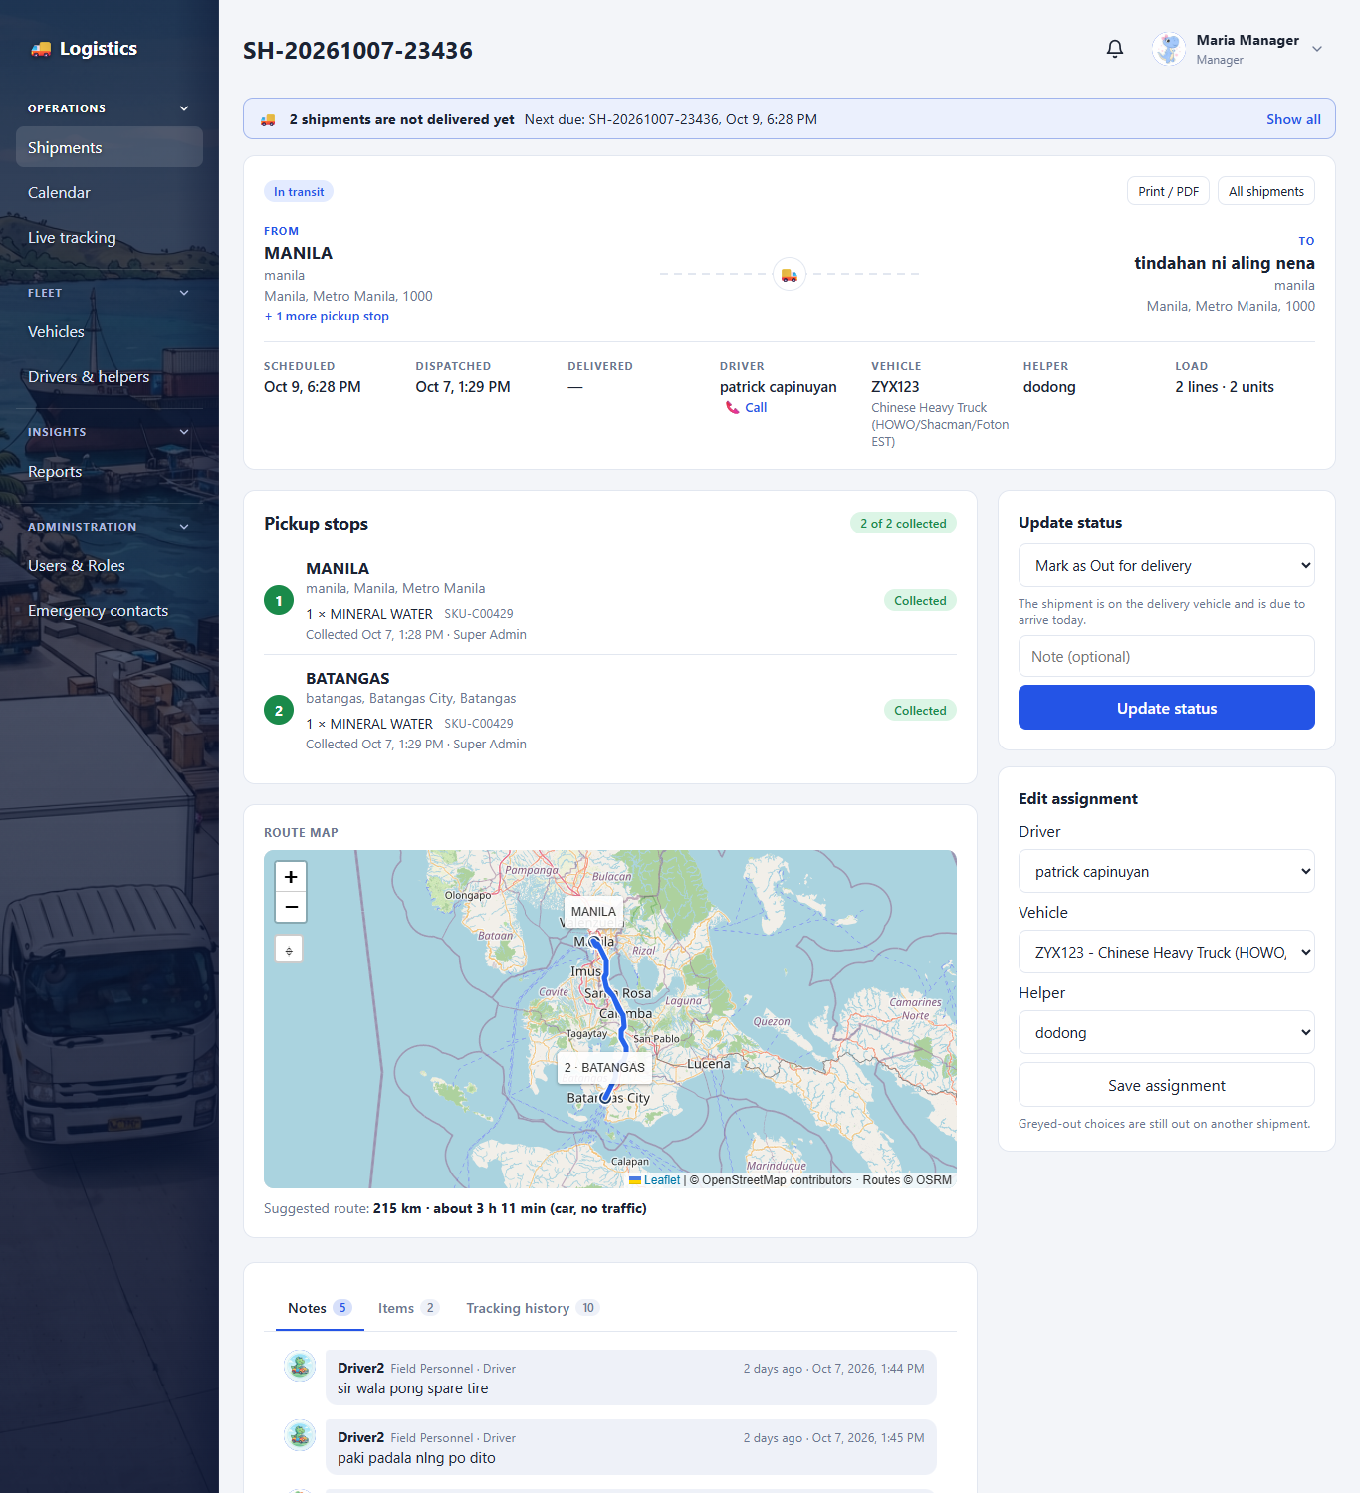
Figure 6. Shipment page (office view)
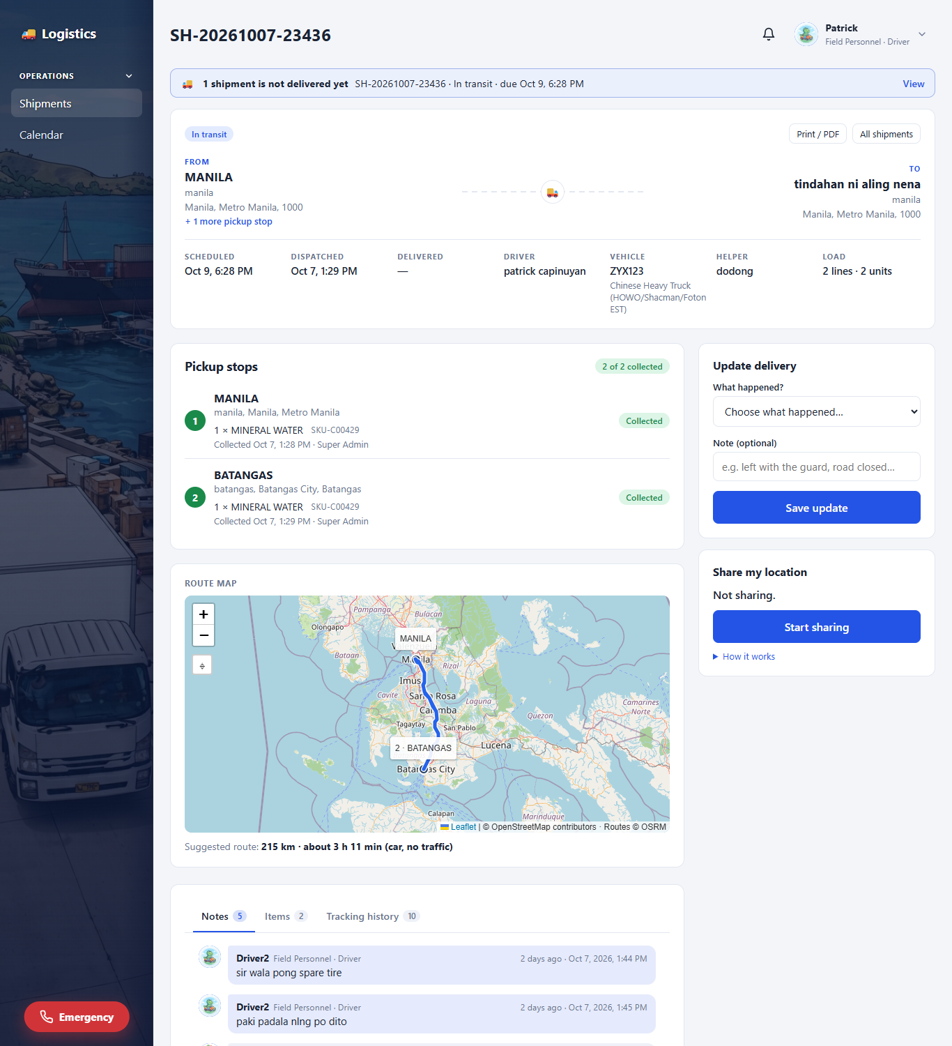
Figure 7. Shipment page (driver view)
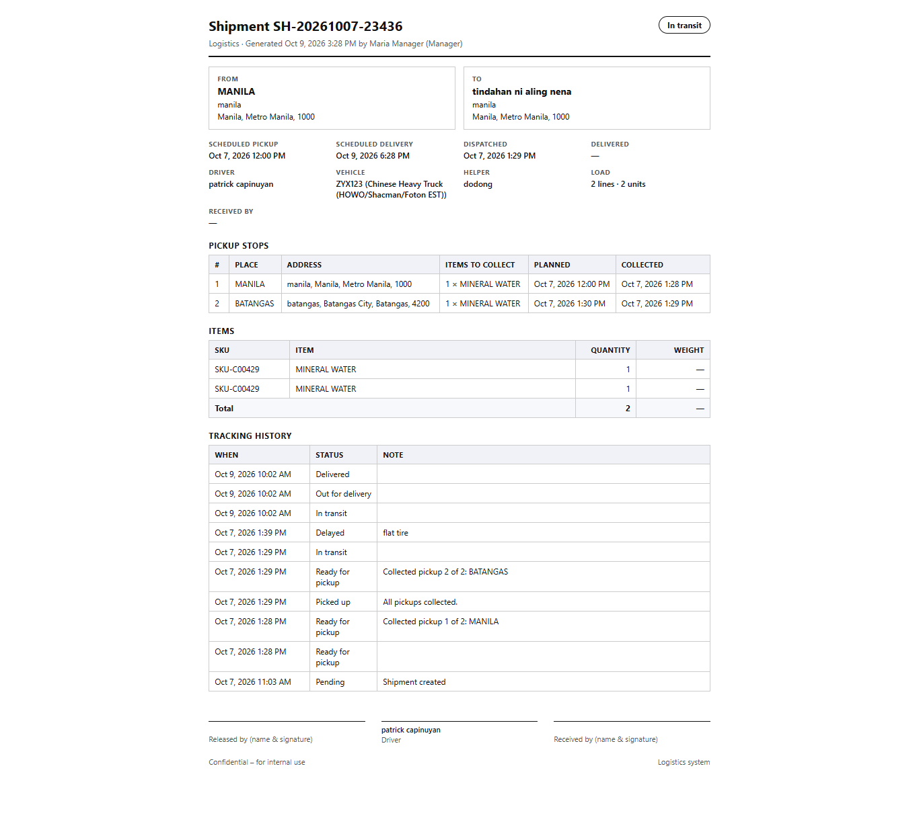
Figure 8. Printable shipment (Print / PDF)

5. Calendar
Who can use it: Managers and Logistics Coordinators see everything; Field Personnel see their own

5.1 Purpose
Shows what is collected and delivered on each day, so the office can plan and drivers can see what is coming.

5.2 Features
- Month and week views — each day shows its pickups and deliveries, coloured by status.
- Times from the schedule — the pickup and the expected delivery come from the scheduled pickup and delivery times entered on the shipment.
- Day list — clicking a day lists its shipments with place, time, driver and vehicle; a whole row can be clicked to open the shipment.
- Filters — office staff can narrow the calendar to one driver or one vehicle.

5.3 Screenshots
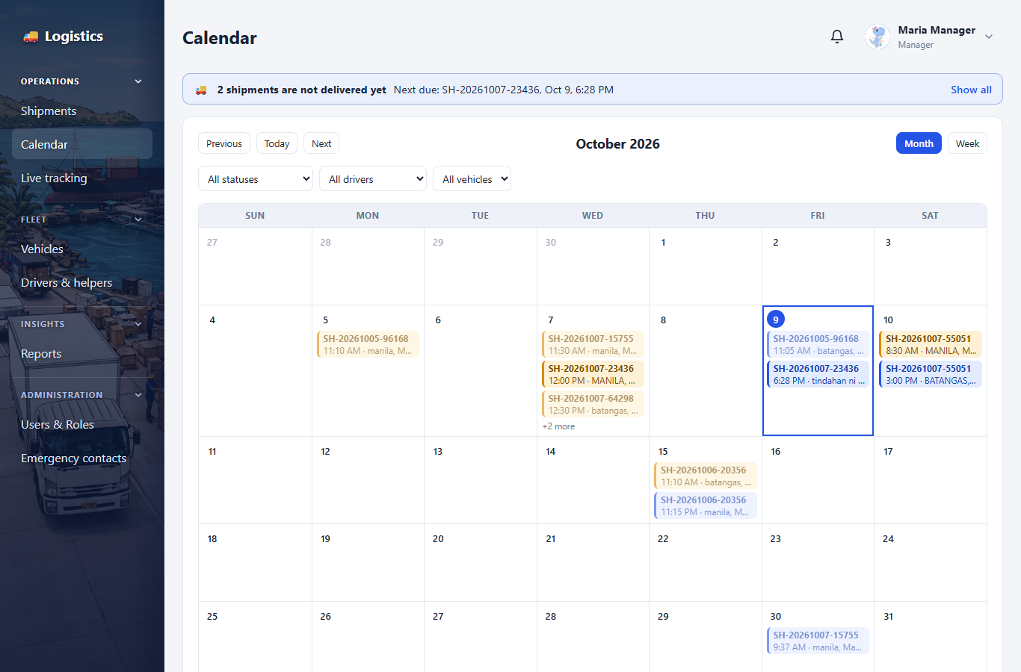
Figure 9. Calendar

6. Live Tracking and Delivery Updates
Who can use it: Managers and Logistics Coordinators view; drivers share their location

6.1 Purpose
Shows where each truck is during a delivery. While a delivery is in progress, the driver's phone shares its location with the office.

6.2 Features
- Location sharing — starts when the driver opens an active delivery and agrees to share; shown as "Location sharing: On". Phones only share location over a secure (https) address.
- Live map — green markers are trucks seen in the last 5 minutes, grey is the last known position. Updates every minute.
- On the road — table of vehicle, driver (with tap-to-call), shipment, destination and last seen time.
- Tracking history — every status change is recorded on the shipment with the time and who made it.

6.3 Screenshots
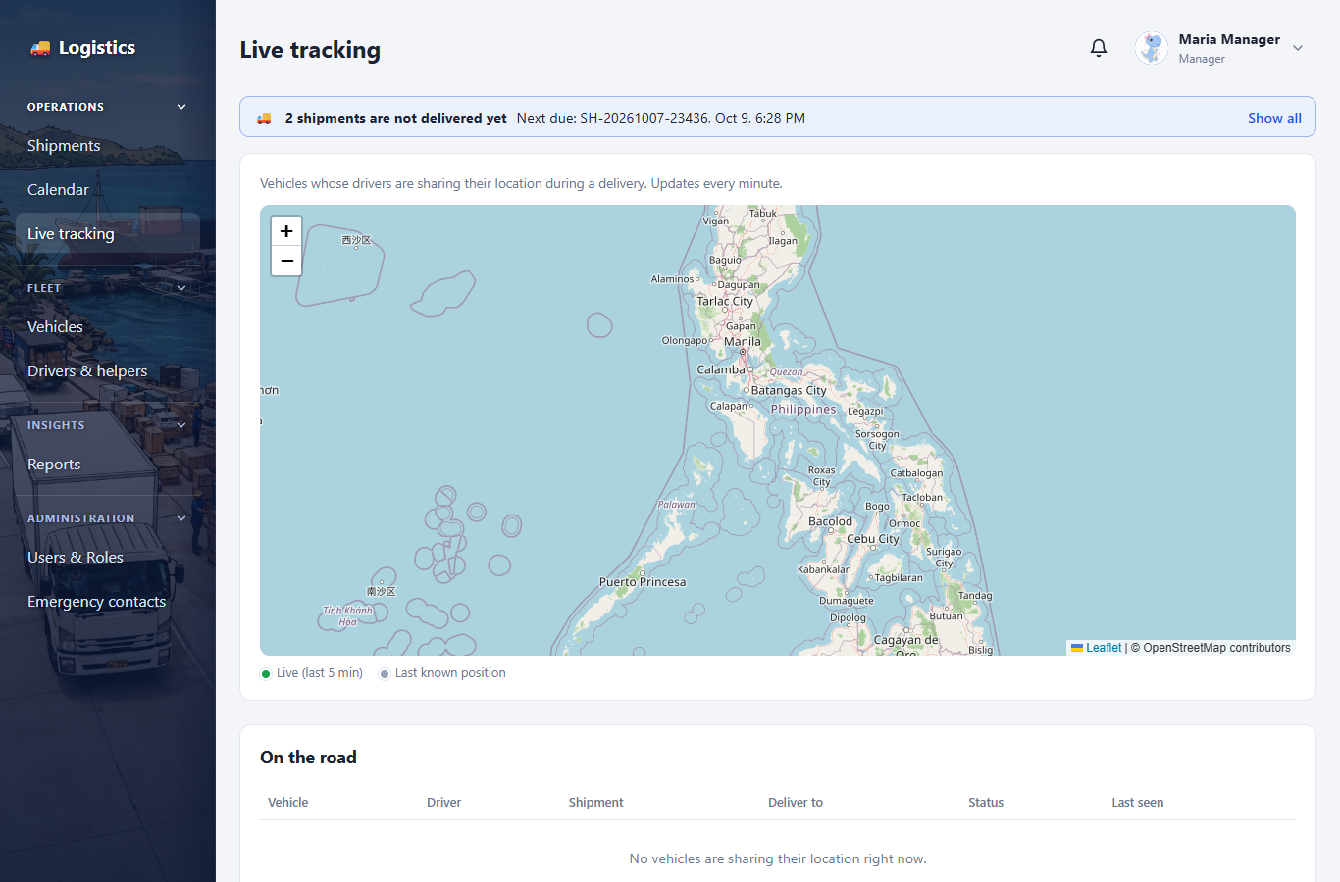
Figure 10. Live tracking page

7. Fleet: Vehicles, Drivers and Helpers
Who can use it: Manager, Logistics Coordinator (only a Manager can delete)

7.1 Purpose
Keeps the list of trucks, drivers and truck / cargo helpers that can be assigned to shipments, and shows which of them are free.

7.2 Features
- Vehicles — plate number, type, capacity, status and lease details for leased trucks.
- On road — a vehicle on an unfinished shipment is shown as On road with the shipment's number, and goes back to Available by itself when the shipment ends.
- Ended lease — a leased vehicle whose contract end date has passed (or whose contract is Expired or Terminated) is shown as Unavailable and cannot be put on a shipment. A warning at the top of the page lists these vehicles and can be closed with its × button. Renew the contract by setting a new lease end date.
- Drivers — name, phone, licence number and status. A driver is linked to a sign-in account so their deliveries appear on their dashboard, and the account is then greeted by the driver's first name.
- Truck / cargo helpers — listed on the same page as drivers, with the truck they usually ride and an optional sign-in account.
- On delivery — drivers and helpers on an unfinished shipment are marked with its number and cannot be assigned to another.
- Managers and Logistics Coordinators add and edit vehicles, drivers and helpers. Only a Manager can delete one, and a vehicle already used by shipments is set to Maintenance instead.

7.3 Screenshots
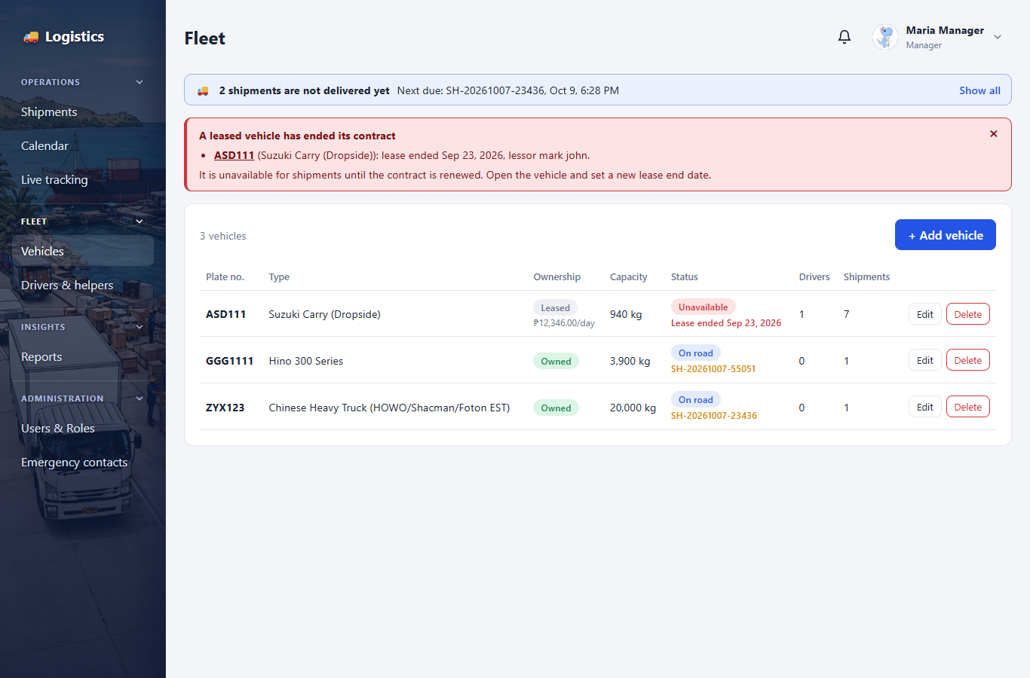
Figure 11. Vehicles, with a leased vehicle whose contract has ended
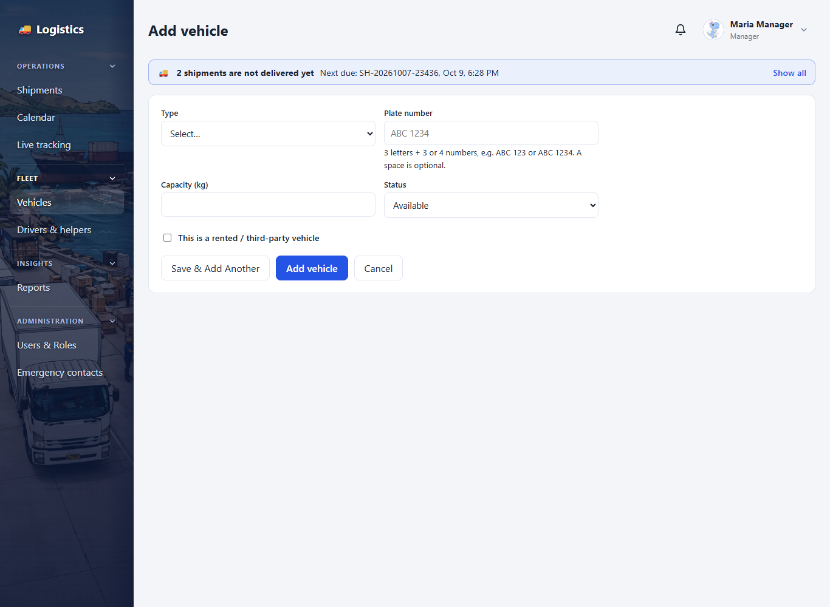
Figure 12. Adding a vehicle
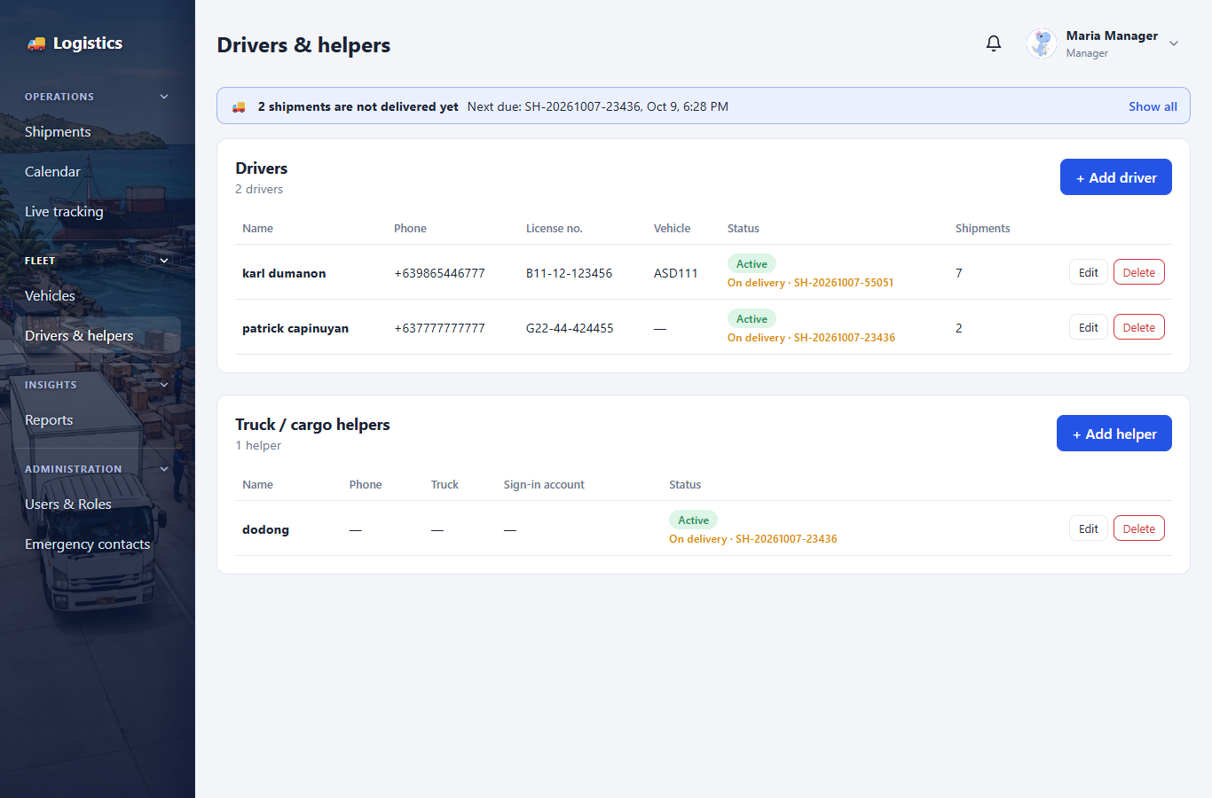
Figure 13. Drivers and truck / cargo helpers

8. Notes and Alerts
Who can use it: Everyone involved in a shipment

8.1 Purpose
Lets the office and drivers talk about a delivery, and makes sure important events are noticed.

8.2 Features
- Shipment notes — posted on the Notes tab of a shipment, with the writer's name, role and exact time. New notes appear without reloading. Field Personnel read and post only on shipments assigned to them.
- Bell — the top bar bell shows unread alerts and checks for new ones every 10 seconds. A Super Admin has no bell, because alerts are about shipments.
- Pop-ups — a new alert (new assignment, note, delay, SOS) briefly appears on screen.
- Clicking an alert opens the shipment it is about.

9. Emergency (SOS)
Who can use it: Field Personnel send; Managers receive

9.1 Purpose
Gives drivers a quick way to get help on the road.

9.2 Features
- Emergency button — always at the bottom of the menu (bottom centre of the screen on phones).
- Tap-to-call — the national hotline 911 and the company emergency contacts.
- Send SOS — alerts every Manager and the people on that delivery with the driver's name, delivery and last shared location. It does not call 911.
- Emergency contacts — maintained by the Super Admin and Managers; Philippine phone numbers are checked as they are typed.

9.3 How to use
- Tap Emergency.
- If anyone is hurt or in danger, call 911 first.
- Optionally type what is happening, then tap Send SOS.

9.4 Screenshots
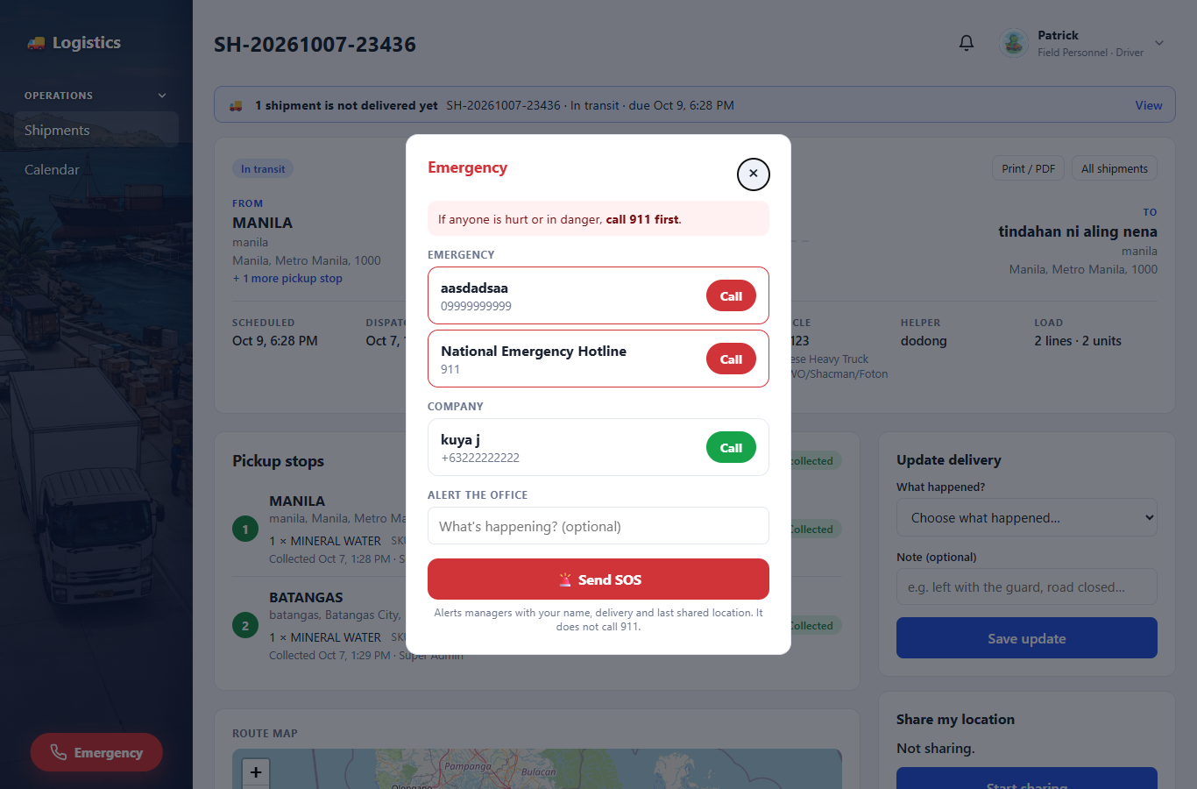
Figure 14. Emergency panel
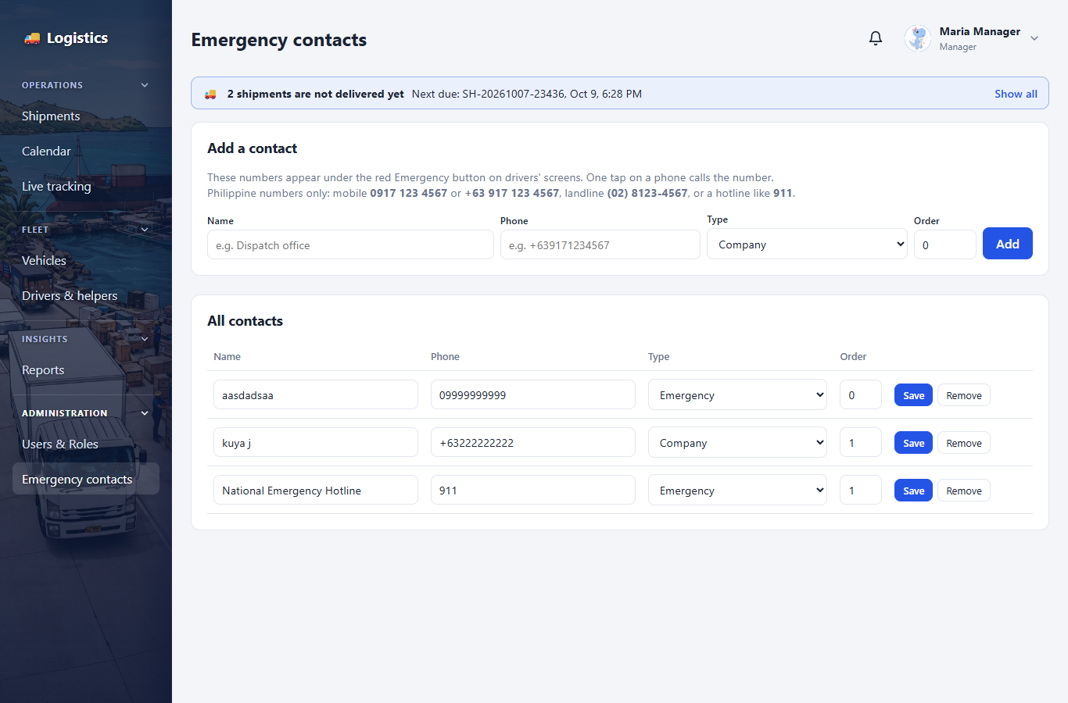
Figure 15. Emergency contacts (Super Admin, Manager)

10. Administration
Who can use it: Super Admin; Managers for Field Personnel accounts and emergency contacts

10.1 Purpose
Settings that control who uses the system and what drivers see.

10.2 Features
- Users & Roles — a Super Admin adds users, sets their role, resets passwords, deactivates accounts, and sets a field worker's position (driver or helper). The list can be sorted A–Z and filtered by role and by active or inactive.
- Managers — see only Field Personnel accounts. They can add, edit, activate and deactivate them and set driver or helper, but cannot change a role or open any other account. Logistics Coordinators have no Administration pages.
- Driver dashboard — Super Admin only. Edit the "How to use this app", safety guidelines and company profile shown to drivers. Simple lists with "-" are supported.
- Site Images — Super Admin only. Change the background pictures and profile pictures.

10.3 Screenshots
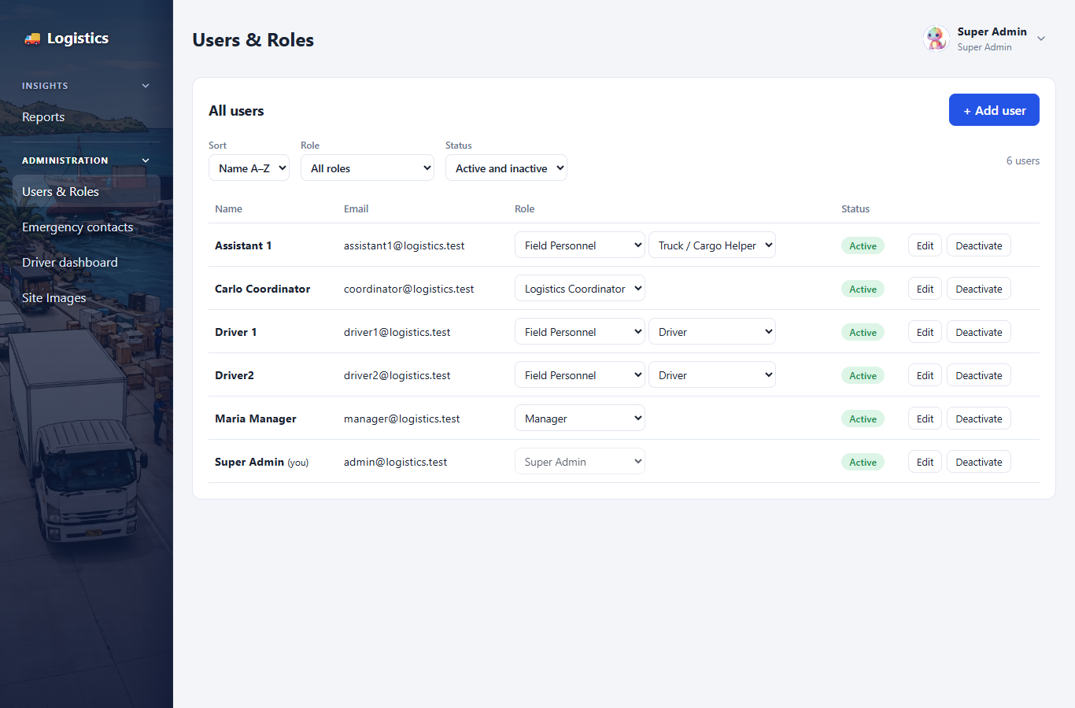
Figure 16. Users & Roles
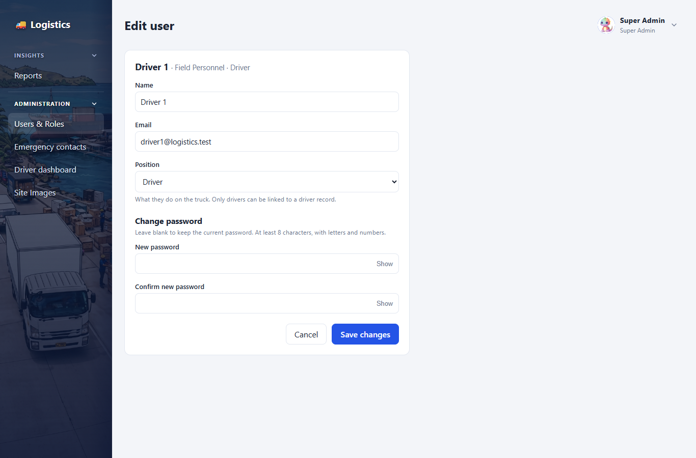
Figure 17. Editing a user
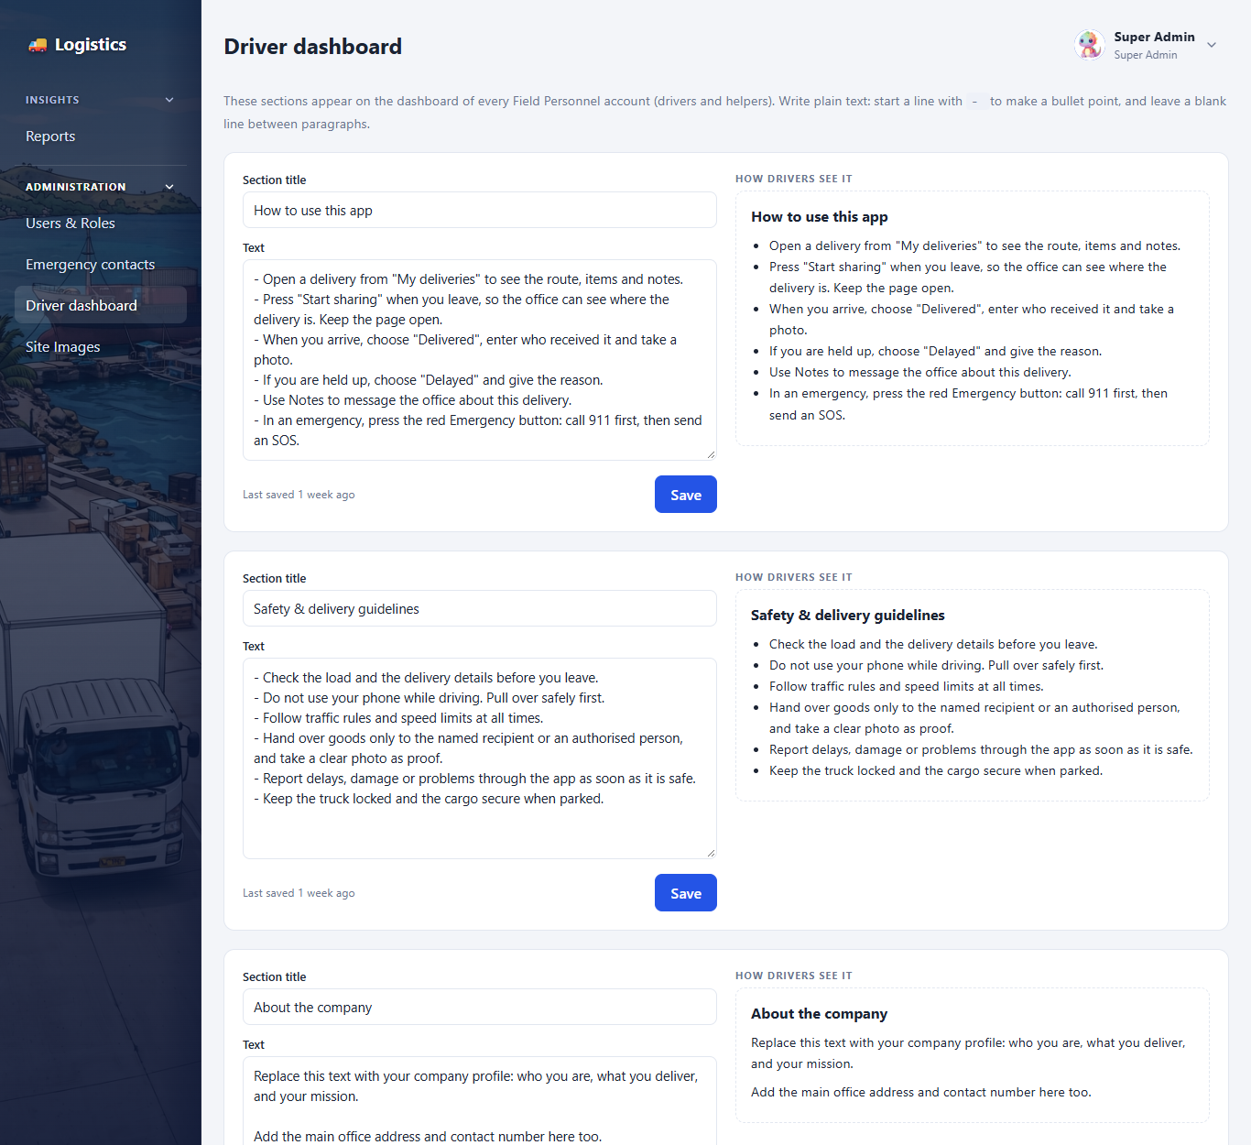
Figure 18. Editing the driver dashboard
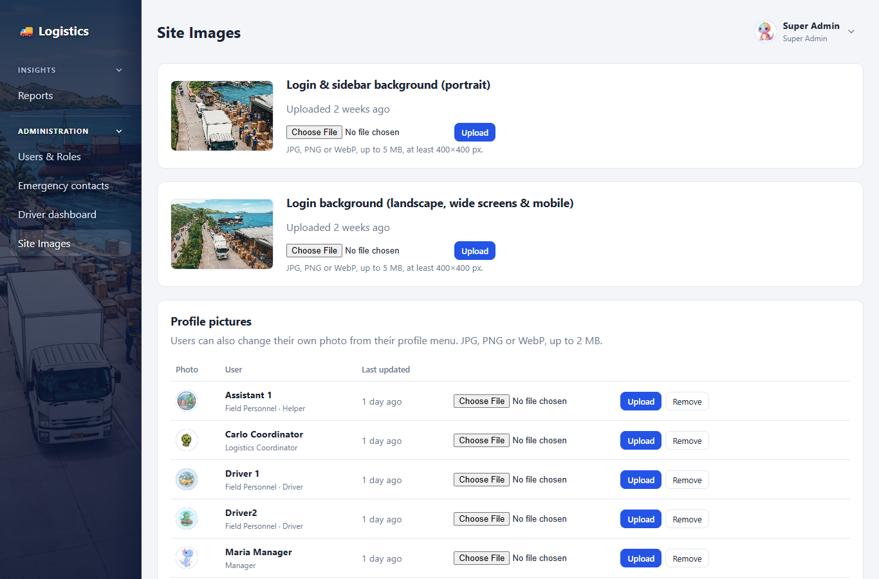
Figure 19. Site Images

11. Reports
Who can use it: Super Admin; Managers can read

11.1 Purpose
An activity log of what happened in the system: who did what, and when.

11.2 Features
- Filters — by date range, user, and type of action.
- Print — a clean printable page. Super Admin only.
- Export CSV — download the filtered log for Excel. Super Admin only.

11.3 Screenshots
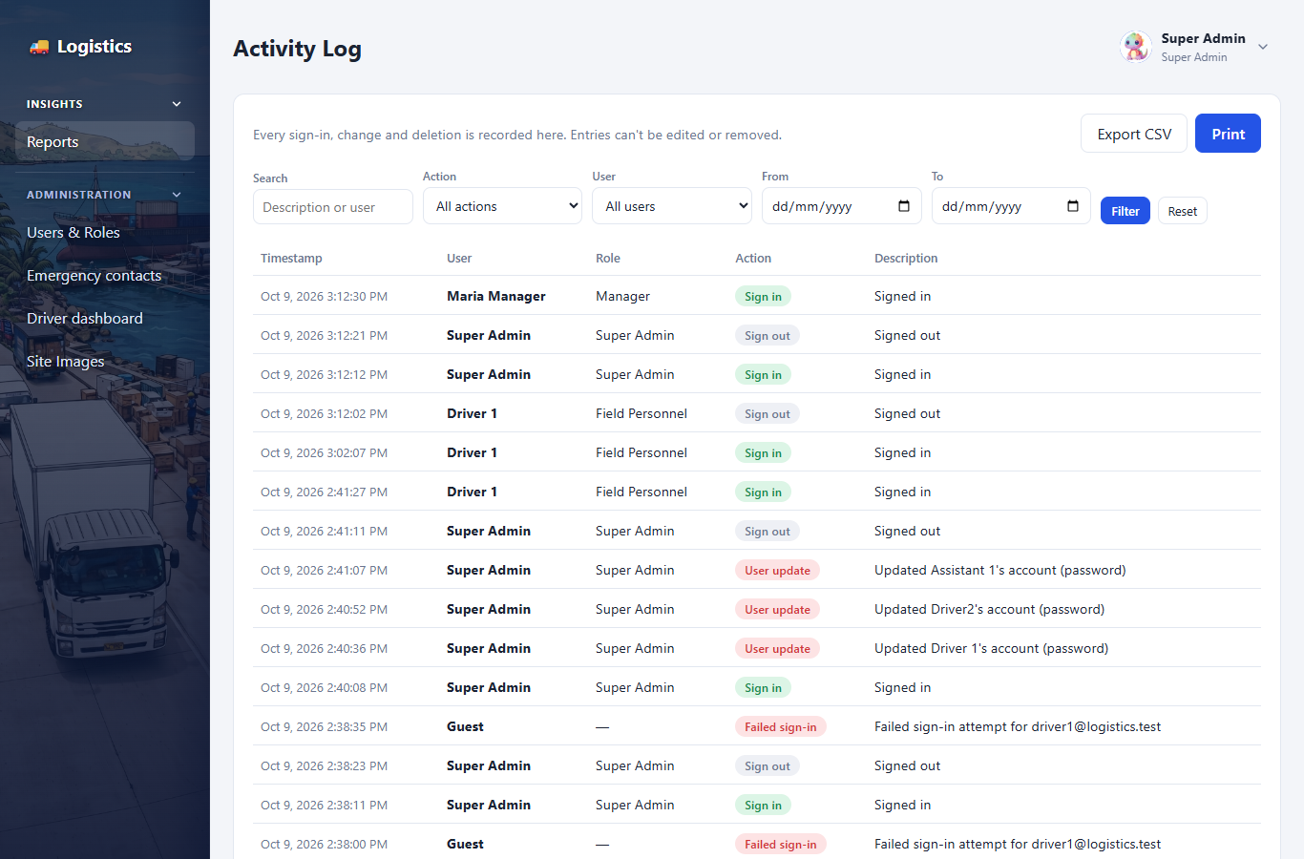
Figure 20. Activity log report

12. Language and Navigation
Who can use it: Everyone

12.1 Purpose
Makes the system easy to use for every role.

12.2 Features
- Language — each user chooses English or Tagalog from the profile menu; the choice is saved on the account.
- Sidebar groups — Operations, Fleet, Insights and Administration can be collapsed; the menu remembers what was open.
- Role-based menu — each role only sees the pages they are allowed to use: Super Admin sees Insights and Administration; Managers see Operations, Fleet, Insights and Administration; Logistics Coordinators see Operations and Fleet; Field Personnel see Shipments and Calendar.
- Dark mode and phone layout — the pages adapt to dark mode and to small screens.
- Install as an app — on a phone, the browser's "Add to Home screen" puts the system on the home screen. It opens full screen and shows a friendly page when there is no connection.

