XPathVisualizer Help
This is the help document for Ionic’s XPathVisualizer.

Basic Operation
Use the application to perform XPath queries on XML documents, and view the results. To do this, load an XML document into the application, or create a new, blank document. The XML is automatically syntax-highlighted. For large documents it takes a few seconds after loading for the highlighting to complete. No worries: you can still edit the XML while highlighting is happening.
Key in your XPath query in the space provided. When you’ve stopped typing, the xpath query will be evaluated against the displayed document. (If for some reason this doesn’t happen, just press <RETURN> while the cursor is in the textbox.) The query results will be highlighted in the XML document. You can scroll through the matches using the arrow bar.
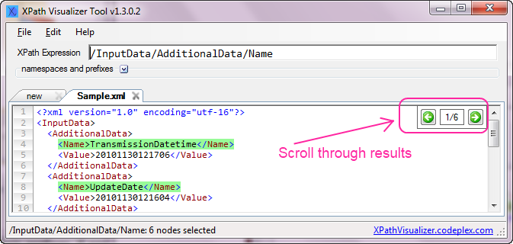
Any XML namespaces present in the document are automatically detected and listed in the form, with their prefixes, if any. If there's no prefix assigned to a particular namespace, then one is assigned. All the prefixes, either detected or assigned, are then available for use in xpath expressions that you can apply to the document.
That’s the basic operation. Very simple.

The Menus
The application is a traditional Windows app. You’ll find the menu strip at the top, very familiar and similar to other applications.

The File Menu
File…New creates a new, blank XML document. You can paste XML into the box to fill it in, or just type. You can also create a new document at any time with the ctrl-N shortcut.
File…Open opens an XML document from the file system. The shortcut for File…Open is ctrl-O.
You can also use File…Get to retrieve one from an HTTP location (shortcut: ctrl-G), or use the Recent Files option to quickly go to a previously opened file.
File…Save saves the document into its backing file. If the file has never been saved, and has not been loaded from a file system XML file, then the application will prompt you for a filename. The shortcut for File…Save is ctrl-S.
File…Save As saves the XML document into a new document that you specify.

The Edit Menu
Edit…Reindent re-indents the XML document, preserving whitespace. The shortcut: ctrl-F.
Edit…Line Numbers allows you to toggle the display of line numbers in the user interface. Shortcut: ctrl-L.
Edit…Strip Namespaces removes all namespaces from the XML document. This can make for simpler queries.
Edit…Extract Highlighted extracts the highlighted elements – those selected by the current XPath query – into a new XML document, on a new tab. Shortcut: ctrl-E.
Edit…Remove Highlighted simply deletes the selected elements. Shortcut: ctrl-R.

XPath Queries
To perform an XPath query, just type in your XPath string in the box, and it will auto-evaluate on the displayed XML document. You can also paste text into the box.
The application will highlight errors in the query, in red text.
If you right-click in the xPath box, you’ll see a dropdown list of recent successful xPath queries you performed. You can select one of these to place it into the box.
As you flip between one tab and the next, the xpath query you used most recently during this session with the document displayed in that tab, is placed into the xpath textbox and evaluated.
The most recent 10? successful xpath queries are stored upon exit from the program, and reloaded when you restart. So the next time you right-click in the box, you’ll get those queries.

Closing Tabs
You can close a tab by clicking the X. Be careful: if you have unsaved changes, you will lose them with no warning.

