INTEGRATIVE PROGRAMMING
ACTIVITY COMPILATION
Activities 1 to 13 - Visual Basic .NET Windows Forms and Console Programs
Submitted by : Sonajo, Christian Paolo
Course, Year and Section : BSIT 3B
Subject : Integrative Programming
Submitted to : ________________________
School Year : School Year 2026 - 2027
Date Submitted : October 26, 2026

This compilation contains the thirteen activities of the semester. The form designs of Activities 4, 5, 6, 8, 10 and 12 were newly drawn and their program code was rewritten, while the names of the author, the course and the program titles were updated in every project.

Contents
Activity 1 Console Basics and Data Types (Act1_Activity202606241600)
Activity 2 Name Input and Celsius - Fahrenheit Converter (Act2 Celcius-Fahrenheit Converter)
Activity 3 Sum, Difference, Product, Quotient and Average (Console with Retry) (Activity3_20260629)
Activity 4 Arithmetic Machine (Windows Form) (Activity4_20260703)
Activity 5 Ternary Remarks (If Operator) (Act5 - Ternary2)
Activity 6 Select Case Grade Evaluation (Act6_IntegProg1_20260715)
Activity 7 Integrative Program 1 - Interest, Square and Class Average (Act7_IntegProg1_SW20260720)
Activity 8 The Message (MessageBox Options) (Act8_SW20260805)
Activity 9 ListView File Explorer (SW202609301600)
Activity 10 Panel and SplitContainer Laboratory (SW20261002 - PanelSplitPanelDemo)
Activity 11 Windows Forms Controls Collection (TabControl, TreeView, ListView, Dialogs) (SW202610021600)
Activity 12 File Explorer Clone (PanelSplitDemo) (FileExplorerClone - PanelSplitDemo)
Activity 13 Integrative Project - School Records with MDI Forms (IntegProgProject2026)

Appendix A - Project file list
Appendix B - What changed in this compilation

How to open and run the projects
Every project in the submitted archive was made with Visual Studio 2010. The solution files use Format Version 11.00 and # Visual Studio 2010, the project files use MSBuild ToolsVersion 4.0, and the target framework is .NET Framework 4.0 (Client Profile).
To run an activity: open its .sln file in Visual Studio 2010 (or a newer Visual Studio that still supports .NET Framework 4.0), wait for the designer to load, then press F5. Activities 1, 2 and 3 open a console window; the other activities open a Windows Form.
No NuGet package and no third party library is used. The code stays inside the Visual Basic 2010 language level: there is no string interpolation, no async or Await, no iterator method and no multiline lambda, so the projects compile in Visual Studio 2010 without any change.
The bin, obj and .suo files of the original uploads are not included. Visual Studio creates them again the first time a project is built.

Activity 1
Console Basics and Data Types
Project : Act1_Activity202606241600 Author : Sonajo, Christian Paolo BSIT 3B
Description
The first activity is a console application that prints a short greeting and declares one variable of every basic data type (String, Integer, Double, Boolean and Char). The program ends with Console.ReadKey() so the console window stays open until a key is pressed.
The output starts with the activity name, the author (Sonajo, Christian Paolo) and the course and section (BSIT 3B), and it ends with a closing line that repeats the name of the author, so the printed screen already carries the complete identity of the student.
Objectives
- Create a Visual Basic .NET console application and identify the Module and Sub Main entry point.
- Declare variables with the correct data type and assign initial values.
- Print output with Console.WriteLine and pause the console with Console.ReadKey.
Source Code
Module1.vb
' ============================================================
' Activity 1 - Act1_Activity202606241600
' Console basics and data types
' Author : Sonajo, Christian Paolo | BSIT 3B
' ============================================================
Module Module1

Sub Main()
' program header
Console.WriteLine("Activity202606241600")
Console.WriteLine("Author: Sonajo, Christian Paolo")
Console.WriteLine("Course Year Section: BSIT 3B")
Console.WriteLine()

' String variable
Dim theName As String = "Sonajo, Christian Paolo"
Console.WriteLine("Hello " + theName)

' one variable for every basic data type
Dim n1 As Integer = 0
Dim n2 As Double = 0.0
Dim isValid As Boolean = True
Dim character As Char = "A"c
Dim number1 As Integer = 12
Dim number2 As Double = 12.12

Console.WriteLine("n1 = " & n1.ToString())
Console.WriteLine("n2 = " & n2.ToString())
Console.WriteLine("isValid = " & isValid.ToString())
Console.WriteLine("character = " & character.ToString())
Console.WriteLine("number1 = " & number1.ToString())
Console.WriteLine("number2 = " & number2.ToString())
Console.WriteLine()

' closing line with the name of the author
Console.WriteLine("Prepared by: Sonajo, Christian Paolo | BSIT 3B")
Console.ReadKey()
End Sub

End Module

Sample Output
Activity202606241600
Author: Sonajo, Christian Paolo
Course Year Section: BSIT 3B

Hello Sonajo, Christian Paolo
n1 = 0
n2 = 0
isValid = True
character = A
number1 = 12
number2 = 12.12

Prepared by: Sonajo, Christian Paolo | BSIT 3B

Activity 2
Name Input and Celsius - Fahrenheit Converter
Project : Act2 Celcius-Fahrenheit Converter Author : Sonajo, Christian Paolo BSIT 3B
Description
This console program asks for the last name and the first name of the user, prints them back, and then performs two temperature conversions. The first conversion changes Celsius into Fahrenheit using the formula (C x 1.8) + 32, and the second conversion changes Fahrenheit into Celsius using (F - 32) / 1.8.
Objectives
- Read input from the user with Console.ReadLine.
- Convert text input into numbers with Convert.ToDecimal.
- Apply arithmetic formulas and display the computed results.
Source Code
Module1.vb
' ============================================================
' Activity 2 - Act2 Celcius-Fahrenheit Converter
' Name input and temperature conversion
' Author : Sonajo, Christian Paolo | BSIT 3B
' ============================================================
Module Module1

Sub Main()
' program header
Console.WriteLine("Act2 Celcius-Fahrenheit Converter")
Console.WriteLine("Author: Sonajo, Christian Paolo")
Console.WriteLine("Course Year Section: BSIT 3B")
Console.WriteLine()

Console.Write("Hello world")
Console.ReadLine()

Dim lastName As String = ""
Dim firstName As String = ""

Console.Write("Enter Lastname: ")
lastName = Console.ReadLine()
Console.Write("Enter Firstname: ")
firstName = Console.ReadLine()

Console.WriteLine("Your Lastname is " + lastName)
Console.WriteLine("Your Firstname is " + firstName)
Console.ReadLine()

' Converter 1: Celsius to Fahrenheit
Console.WriteLine("--- Celsius to Fahrenheit Converter ---" & vbNewLine)
Console.Write("Enter Celsius: ")
Dim celsiusInput As Decimal = Convert.ToDecimal(Console.ReadLine())
Dim fahrenheitResult As Decimal = (celsiusInput * 1.8) + 32
Console.WriteLine("Result in Fahrenheit: " & fahrenheitResult)
Console.ReadLine()

' Converter 2: Fahrenheit to Celsius
Console.WriteLine("--- Fahrenheit to Celsius Converter ---" & vbNewLine)
Console.Write("Enter Fahrenheit: ")
Dim fahrenheitInput As Decimal = Convert.ToDecimal(Console.ReadLine())
Dim celsiusResult As Decimal = (fahrenheitInput - 32) / 1.8
Console.WriteLine("Result in Celsius: " & celsiusResult)

' closing line with the name of the author
Console.WriteLine()
Console.WriteLine("Activity 2 completed by: Sonajo, Christian Paolo | BSIT 3B")
Console.ReadLine()

End Sub

End Module

Sample Output
Act2 Celcius-Fahrenheit Converter
Author: Sonajo, Christian Paolo
Course Year Section: BSIT 3B

Hello world
Enter Lastname: Sonajo
Enter Firstname: Christian Paolo
Your Lastname is Sonajo
Your Firstname is Christian Paolo
--- Celsius to Fahrenheit Converter ---
Enter Celsius: 37
Result in Fahrenheit: 98.6
--- Fahrenheit to Celsius Converter ---
Enter Fahrenheit: 98.6
Result in Celsius: 37.0

Activity 2 completed by: Sonajo, Christian Paolo | BSIT 3B

Activity 3
Sum, Difference, Product, Quotient and Average (Console with Retry)
Project : Activity3_20260629 Author : Sonajo, Christian Paolo BSIT 3B
Description
The program accepts three whole numbers and displays their sum, difference, product, quotient and average. A Try - Catch block with the label ulit traps a FormatException, so when the user types a letter instead of a number the program prints the error message and asks for the three numbers again instead of closing.
Objectives
- Use Convert.ToInt16 to read three numbers.
- Compute the five required results and display them with labels.
- Handle invalid input with Try - Catch and a GoTo label so the program repeats.
Source Code
Module1.vb
Module Module1
Sub Main()

'Activity3_20260629'
'Create a vb.net console app that will accept 3 numbers, and display the sum, difference,
product, quotient, and ave of the 3 numbers'

Try
ulit:
Console.WriteLine("Activity3_20260629")
Console.WriteLine("Author: Sonajo, Christian Paolo")
Console.WriteLine("Course Year Section: BSIT 3B")

Console.Write("Enter number 1: ")
Dim n1 As Integer = Convert.ToInt16(Console.ReadLine())
Console.Write("Enter number 2: ")
Dim n2 As Integer = Convert.ToInt16(Console.ReadLine())
Console.Write("Enter number 3: ")
Dim n3 As Integer = Convert.ToInt16(Console.ReadLine())

Console.Write("The sum is: ")
Dim sum As Double = n1 + n2 + n3
Console.WriteLine(sum)

Console.Write("The difference is: ")
Dim difference As Double = n1 - n2 - n3
Console.WriteLine(difference)

Console.Write("The product is: ")
Dim product As Double = n1 * n2 * n3
Console.WriteLine(product)

Console.Write("The quotient is: ")
Dim quotient As Double = n1 / n2 / n3
Console.WriteLine(quotient)

Console.Write("The average is: ")
Dim ave As Double = sum / 3
Console.WriteLine(ave)

Catch ex As FormatException
Console.WriteLine("Error: " & ex.Message)
GoTo ulit
End Try

Console.ReadKey()

'Iti nasursurwak ditoy nga taraon ket iti makuna nga "convertion method" iti agduduma nga
datatypes.'
'ken syak ket na gwapo'
End Sub
End Module

Sample Output
Activity3_20260629
Author: Sonajo, Christian Paolo
Course Year Section: BSIT 3B
Enter number 1: 10
Enter number 2: 5
Enter number 3: 2
The sum is: 17
The difference is: 3
The product is: 100
The quotient is: 1
The average is: 5.666666666666667

Activity 4
Arithmetic Machine (Windows Form)
Project : Activity4_20260703 Author : Sonajo, Christian Paolo BSIT 3B
Description
Activity 4 converts the console computation of Activity 3 into a Windows Form application. The form is divided into an input card, a result card and a row of action buttons. The three numbers are read once by a shared function, and every operation button writes its answer in its own result box.
The interface of this activity was redesigned for this compilation: the old free-floating labels and text boxes were replaced by two bordered panels, a dark banner that carries the activity number and the author, and colour coded buttons. The program logic was rewritten as well: a single ReadInputs() function validates the entries, a ShowResult() routine formats every answer to four decimal places, and the quotient button checks for division by zero before it computes.
Objectives
- Design a Windows Form with Panel containers, Labels, TextBoxes and Buttons.
- Declare module level variables and use a Function that returns Boolean for validation.
- Trap conversion errors with Try - Catch and guard the quotient against division by zero.

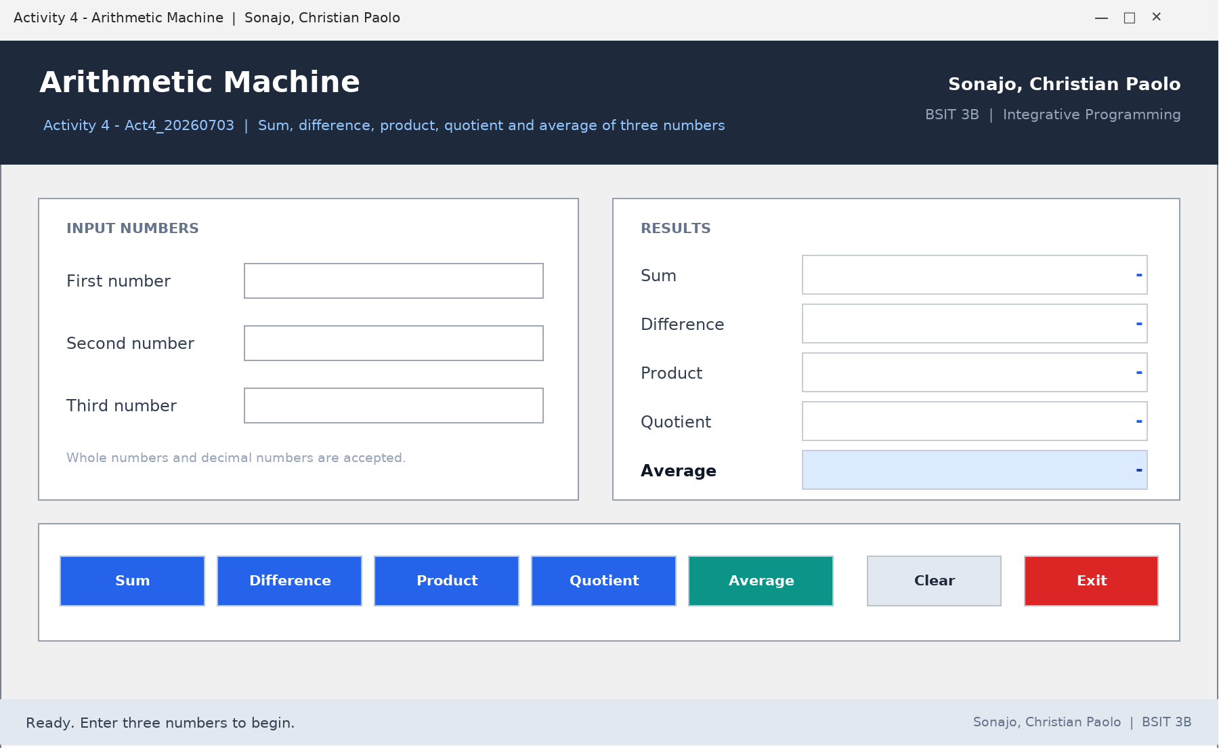
Figure 4.1 - Form design of Activity 4 - Arithmetic Machine
Source Code
Form1.vb
' ============================================================
' Activity 4 - Act4_20260703
' Arithmetic Machine : sum, difference, product, quotient and
' average of three numbers entered by the user.
' Author : Sonajo, Christian Paolo | BSIT 3B
' ============================================================
Public Class Form1

Private number1 As Double
Private number2 As Double
Private number3 As Double
Private inputsAreValid As Boolean

Private Sub Form1_Load(ByVal sender As System.Object, ByVal e As System.EventArgs) Handles
MyBase.Load
ResetForm()
txtN1.Focus()
End Sub

' Reads the three text boxes and stores the values in the
' module level variables. Returns False when an entry is not a number.
Private Function ReadInputs() As Boolean
Try
number1 = Convert.ToDouble(txtN1.Text.Trim())
number2 = Convert.ToDouble(txtN2.Text.Trim())
number3 = Convert.ToDouble(txtN3.Text.Trim())
inputsAreValid = True
Catch ex As Exception
inputsAreValid = False
ClearResults()
lblStatus.Text = "Invalid entry. Please type numbers only (for example 12 or 12.5)."
End Try
Return inputsAreValid
End Function

Private Sub ShowResult(ByVal target As Label, ByVal value As Double, ByVal operation As String)
target.Text = value.ToString("N4")
lblStatus.Text = operation & " = " & value.ToString("N4")
End Sub

Private Sub ClearResults()
lblSumValue.Text = "-"
lblDiffValue.Text = "-"
lblProdValue.Text = "-"
lblQuotValue.Text = "-"
lblAveValue.Text = "-"
End Sub

Private Sub ResetForm()
txtN1.Clear()
txtN2.Clear()
txtN3.Clear()
ClearResults()
lblStatus.Text = "Ready. Enter three numbers to begin."
txtN1.Focus()
End Sub

Private Sub btnSum_Click(ByVal sender As System.Object, ByVal e As System.EventArgs) Handles
btnSum.Click
If Not ReadInputs() Then Return
ShowResult(lblSumValue, number1 + number2 + number3, "Sum")
End Sub

Private Sub btnDifference_Click(ByVal sender As System.Object, ByVal e As System.EventArgs)
Handles btnDifference.Click
If Not ReadInputs() Then Return
ShowResult(lblDiffValue, number1 - number2 - number3, "Difference")
End Sub

Private Sub btnProduct_Click(ByVal sender As System.Object, ByVal e As System.EventArgs) Handles
btnProduct.Click
If Not ReadInputs() Then Return
ShowResult(lblProdValue, number1 * number2 * number3, "Product")
End Sub

Private Sub btnQuotient_Click(ByVal sender As System.Object, ByVal e As System.EventArgs)
Handles btnQuotient.Click
If Not ReadInputs() Then Return
If number2 = 0 OrElse number3 = 0 Then
lblQuotValue.Text = "undefined"
lblStatus.Text = "Quotient is undefined because the second or third number is zero."
Return
End If
ShowResult(lblQuotValue, number1 / number2 / number3, "Quotient")
End Sub

Private Sub btnAverage_Click(ByVal sender As System.Object, ByVal e As System.EventArgs) Handles
btnAverage.Click
If Not ReadInputs() Then Return
ShowResult(lblAveValue, (number1 + number2 + number3) / 3, "Average")
End Sub

Private Sub btnClear_Click(ByVal sender As System.Object, ByVal e As System.EventArgs) Handles
btnClear.Click
ResetForm()
End Sub

Private Sub btnExit_Click(ByVal sender As System.Object, ByVal e As System.EventArgs) Handles
btnExit.Click
If MessageBox.Show("Close the Arithmetic Machine?", "Exit", _
MessageBoxButtons.YesNo, MessageBoxIcon.Question) = DialogResult.Yes Then
Application.Exit()
End If
End Sub
End Class

Sample Output
Banner : Arithmetic Machine
Author : Sonajo, Christian Paolo | BSIT 3B | Integrative Programming

First number : 10
Second number : 5
Third number : 2

Sum = 17.0000
Difference = 3.0000
Product = 100.0000
Quotient = 1.0000
Average = 5.6667

Status bar : Average = 5.6667
Footer : Sonajo, Christian Paolo | BSIT 3B

Notes
Average is highlighted in blue because it is the summary value of the three operations above it. Clear returns the form to its start-up state, and Exit asks for confirmation before the application closes.

Activity 5
Ternary Remarks (If Operator)
Project : Act5 - Ternary2 Author : Sonajo, Christian Paolo BSIT 3B
Description
The user types one average grade and the program displays three different remarks: the pass or fail remark, the letter grade and the numeric rating. Every result is produced by one nested ternary If expression instead of a long If - ElseIf block.
For this compilation the form was rebuilt as a two-column layout. The dark side rail holds the title and the name of the author, while the right side contains the entry box and three result cards. The code was reorganised into small procedures (ClearOutputs, ApplyCardColor), the Enter key inside the text box runs the evaluation, and the first card changes colour depending on the result.
Objectives
- Use the ternary If(condition, truePart, falsePart) operator.
- Nest several If operators to build a grading scale.
- Validate numeric input with Try - Catch and guide the user with status messages.

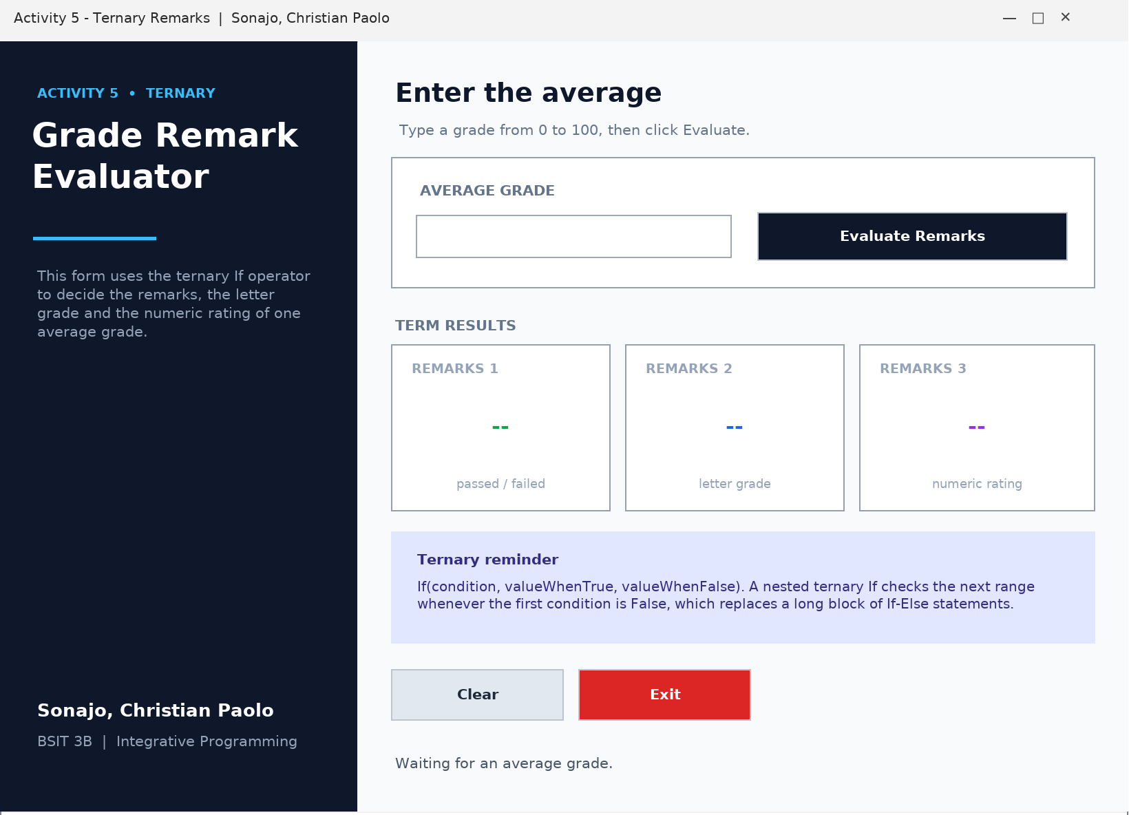
Figure 5.1 - Form design of Activity 5 - Ternary Remarks
Source Code
Form1.vb
' ============================================================
' Activity 5 - Ternary2
' Displays the remarks, the letter grade and the numeric rating
' of an average grade using nested ternary (If) operators.
' Author : Sonajo, Christian Paolo | BSIT 3B
' ============================================================
Public Class Form1

Private averageGrade As Double

Private Sub Form1_Load(ByVal sender As System.Object, ByVal e As System.EventArgs) Handles
MyBase.Load
ClearOutputs()
lblStatus.Text = "Waiting for an average grade."
txtAverage.Focus()
End Sub

Private Sub ClearOutputs()
lblCard1Value.Text = "--"
lblCard2Value.Text = "--"
lblCard3Value.Text = "--"
End Sub

Private Sub txtAverage_KeyPress(ByVal sender As Object, ByVal e As
System.Windows.Forms.KeyPressEventArgs) Handles txtAverage.KeyPress
' Enter key inside the textbox works like clicking the Evaluate button
If e.KeyChar = Microsoft.VisualBasic.ChrW(13) Then
btnEvaluate.PerformClick()
e.Handled = True
End If
End Sub

Private Sub btnEvaluate_Click(ByVal sender As System.Object, ByVal e As System.EventArgs)
Handles btnEvaluate.Click
Try
averageGrade = Convert.ToDouble(txtAverage.Text.Trim())

' Remarks 1 : passed / conditional / failed
lblCard1Value.Text = If(averageGrade >= 75, "Passed",
If(averageGrade >= 70, "Conditional", "Failed"))

' Remarks 2 : letter grade
lblCard2Value.Text = If(averageGrade >= 94, "A",
If(averageGrade >= 89, "B",
If(averageGrade >= 84, "C",
If(averageGrade >= 80, "D",
If(averageGrade >= 75, "E", "F")))))

' Remarks 3 : numeric rating
lblCard3Value.Text = If(averageGrade >= 98, "1.00",
If(averageGrade >= 95, "1.25",
If(averageGrade >= 92, "1.50",
If(averageGrade >= 89, "1.75",
If(averageGrade >= 86, "2.00",
If(averageGrade >= 83, "2.25",
If(averageGrade >= 80, "2.50",
If(averageGrade >= 77, "2.75",
If(averageGrade >= 75, "3.00",
If(averageGrade >= 70, "5.00", "Invalid Grade..."))))))))))

If averageGrade > 100 OrElse averageGrade < 0 Then
lblStatus.Text = "The grade " & averageGrade.ToString("0.##") & " is outside the 0
to 100 range."
Else
lblStatus.Text = "Average " & averageGrade.ToString("0.##") & " evaluated using
nested ternary If operators."
End If

ApplyCardColor(averageGrade)
Catch ex As Exception
ClearOutputs()
lblCard1Value.Text = "Invalid"
lblCard2Value.Text = "Invalid"
lblCard3Value.Text = "Invalid"
lblStatus.Text = "Please type a valid number, for example 88.5"
txtAverage.SelectAll()
txtAverage.Focus()
End Try
End Sub

' Small extra touch : the first card changes color with the result
Private Sub ApplyCardColor(ByVal grade As Double)
If grade >= 75 Then
lblCard1Value.ForeColor = System.Drawing.Color.FromArgb(22, 163, 74)
ElseIf grade >= 70 Then
lblCard1Value.ForeColor = System.Drawing.Color.FromArgb(217, 119, 6)
Else
lblCard1Value.ForeColor = System.Drawing.Color.FromArgb(220, 38, 38)
End If
End Sub

Private Sub btnClear_Click(ByVal sender As System.Object, ByVal e As System.EventArgs) Handles
btnClear.Click
txtAverage.Clear()
ClearOutputs()
lblStatus.Text = "Cleared. Type another average grade."
txtAverage.Focus()
End Sub

Private Sub btnExit_Click(ByVal sender As System.Object, ByVal e As System.EventArgs) Handles
btnExit.Click
Application.Exit()
End Sub
End Class

Sample Output
Activity 5 - Ternary
Author : Sonajo, Christian Paolo | BSIT 3B | Integrative Programming

Average grade : 88
Remarks 1 : Passed (shown in green)
Remarks 2 : C
Remarks 3 : 2.00
Status : Average 88 evaluated using nested ternary If operators.

Other tests
Average grade : 74 -> Conditional | F | 5.00 (amber)
Average grade : 60 -> Failed | F | 5.00 (red)

Notes
Test values that show the boundaries: 75 (Passed / E / 3.00), 74 (Conditional / F / 5.00) and 98 (Passed / A / 1.00).

Activity 6
Select Case Grade Evaluation
Project : Act6_IntegProg1_20260715 Author : Sonajo, Christian Paolo BSIT 3B
Description
Three grades are entered and the program computes their average. Three separate Select Case blocks then convert the average into the pass or fail remark, the letter grade and the numeric rating.
The form was redesigned for this compilation. The three grade boxes are grouped in one card on the left, the average is shown in a large dark badge on the right with three remark rows below it, and the badge changes colour (green, amber or red) depending on the result. The code was cleaned up so that the old duplicated button handlers are gone, validation is done by one ReadGrades() function, and grades outside the 0 to 100 range are rejected.
Objectives
- Compute the average of three grades.
- Use Select Case with relational cases (Case Is >=) and ranges (Case 70 To 74).
- Present the result with colour coded feedback.

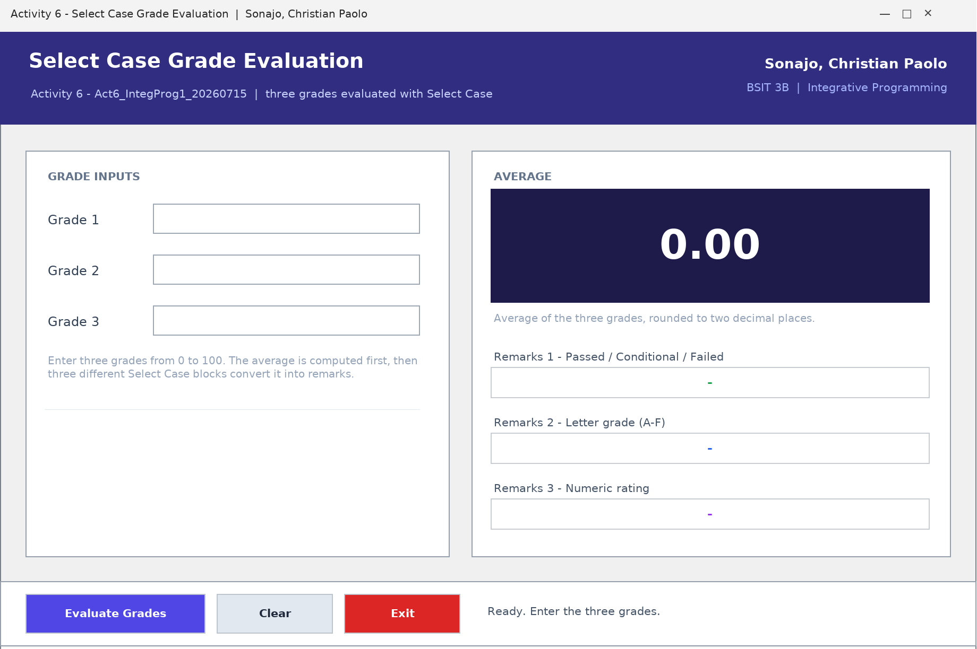
Figure 6.1 - Form design of Activity 6 - Select Case Grade Evaluation
Source Code
Form1.vb
' ============================================================
' Activity 6 - Act6_IntegProg1_20260715
' Reads three grades, computes the average and displays three
' different remarks using Select Case.
' Author : Sonajo, Christian Paolo | BSIT 3B
' ============================================================
Public Class Form1

Private grade1 As Double
Private grade2 As Double
Private grade3 As Double
Private averageGrade As Double

Private Sub Form1_Load(ByVal sender As System.Object, ByVal e As System.EventArgs) Handles
MyBase.Load
ResetScreen()
End Sub

Private Sub ResetScreen()
txtG1.Clear()
txtG2.Clear()
txtG3.Clear()
lblAverage.Text = "0.00"
lblRemarks1.Text = "-"
lblRemarks2.Text = "-"
lblRemarks3.Text = "-"
lblRemarks1.ForeColor = System.Drawing.Color.FromArgb(22, 163, 74)
pnlAveBadge.BackColor = System.Drawing.Color.FromArgb(30, 27, 75)
lblStatus.Text = "Ready. Enter the three grades."
txtG1.Focus()
End Sub

Private Function ReadGrades() As Boolean
Try
grade1 = Convert.ToDouble(txtG1.Text.Trim())
grade2 = Convert.ToDouble(txtG2.Text.Trim())
grade3 = Convert.ToDouble(txtG3.Text.Trim())
Catch ex As Exception
lblAverage.Text = "0.00"
lblRemarks1.Text = "Invalid entry"
lblRemarks2.Text = "Numbers only"
lblRemarks3.Text = "Numbers only"
lblStatus.Text = "Only numeric grades are accepted. Example : 88 or 91.5"
Return False
End Try

If grade1 < 0 OrElse grade2 < 0 OrElse grade3 < 0 OrElse _
grade1 > 100 OrElse grade2 > 100 OrElse grade3 > 100 Then
lblStatus.Text = "Each grade must be from 0 to 100 only."
lblRemarks1.Text = "Out of range"
lblRemarks2.Text = "Out of range"
lblRemarks3.Text = "Out of range"
lblAverage.Text = "0.00"
Return False
End If

Return True
End Function

Private Sub btnEvaluate_Click(ByVal sender As System.Object, ByVal e As System.EventArgs)
Handles btnEvaluate.Click
If Not ReadGrades() Then Return

' Average of the three grades (Double so decimals are kept)
averageGrade = (grade1 + grade2 + grade3) / 3
lblAverage.Text = averageGrade.ToString("0.00")

' Remarks 1 : passed / conditional / failed
Select Case averageGrade
Case Is >= 75
lblRemarks1.Text = "Passed!"
Case Is >= 70
lblRemarks1.Text = "Conditional!"
Case Else
lblRemarks1.Text = "Failed!"
End Select

' Remarks 2 : letter grade
Select Case averageGrade
Case Is >= 95
lblRemarks2.Text = "A"
Case Is >= 89
lblRemarks2.Text = "B"
Case Is >= 80
lblRemarks2.Text = "C"
Case Is >= 75
lblRemarks2.Text = "D"
Case Is >= 70
lblRemarks2.Text = "E"
Case Else
lblRemarks2.Text = "F"
End Select

' Remarks 3 : numeric rating
Select Case averageGrade
Case Is >= 98
lblRemarks3.Text = "1.00"
Case Is >= 95
lblRemarks3.Text = "1.25"
Case Is >= 92
lblRemarks3.Text = "1.50"
Case Is >= 89
lblRemarks3.Text = "1.75"
Case Is >= 86
lblRemarks3.Text = "2.00"
Case Is >= 83
lblRemarks3.Text = "2.25"
Case Is >= 80
lblRemarks3.Text = "2.50"
Case Is >= 77
lblRemarks3.Text = "2.75"
Case Is >= 75
lblRemarks3.Text = "3.00"
Case Is >= 70
lblRemarks3.Text = "4.00"
Case Else
lblRemarks3.Text = "5.00"
End Select

ShowBadgeColor()
lblStatus.Text = "Average " & averageGrade.ToString("0.00") & " evaluated with three Select
Case blocks."
End Sub

Private Sub ShowBadgeColor()
If averageGrade >= 75 Then
pnlAveBadge.BackColor = System.Drawing.Color.FromArgb(6, 78, 59)
lblRemarks1.ForeColor = System.Drawing.Color.FromArgb(22, 163, 74)
ElseIf averageGrade >= 70 Then
pnlAveBadge.BackColor = System.Drawing.Color.FromArgb(120, 53, 15)
lblRemarks1.ForeColor = System.Drawing.Color.FromArgb(217, 119, 6)
Else
pnlAveBadge.BackColor = System.Drawing.Color.FromArgb(127, 29, 29)
lblRemarks1.ForeColor = System.Drawing.Color.FromArgb(220, 38, 38)
End If
End Sub

Private Sub btnClear_Click(ByVal sender As System.Object, ByVal e As System.EventArgs) Handles
btnClear.Click
ResetScreen()
End Sub

Private Sub btnExit_Click(ByVal sender As System.Object, ByVal e As System.EventArgs) Handles
btnExit.Click
Application.Exit()
End Sub
End Class

Sample Output
Banner : Select Case Grade Evaluation
Author : Sonajo, Christian Paolo | BSIT 3B

Grade 1 : 88
Grade 2 : 92
Grade 3 : 85

Average : 88.33 (dark badge)
Remarks 1 : Passed!
Remarks 2 : B
Remarks 3 : 2.00
Status : Average 88.33 evaluated with three Select Case blocks.

Activity 7
Integrative Program 1 - Interest, Square and Class Average
Project : Act7_IntegProg1_SW20260720 Author : Sonajo, Christian Paolo BSIT 3B
Description
Activity 7 is a multi-tab integrative exercise. One tab computes compound interest with a For loop and a NumericUpDown for the number of years, one tab draws a square out of a fill character using nested For loops, one tab collects grades in a ListBox and counts the letter grade distribution with Select Case, and one tab converts the numbers 1 to 255 into octal, hexadecimal and binary.
Objectives
- Use For loops, Do While loops and NumericUpDown values.
- Apply Select Case for tallying grades.
- Use Convert.ToString(number, base) for number system conversion.

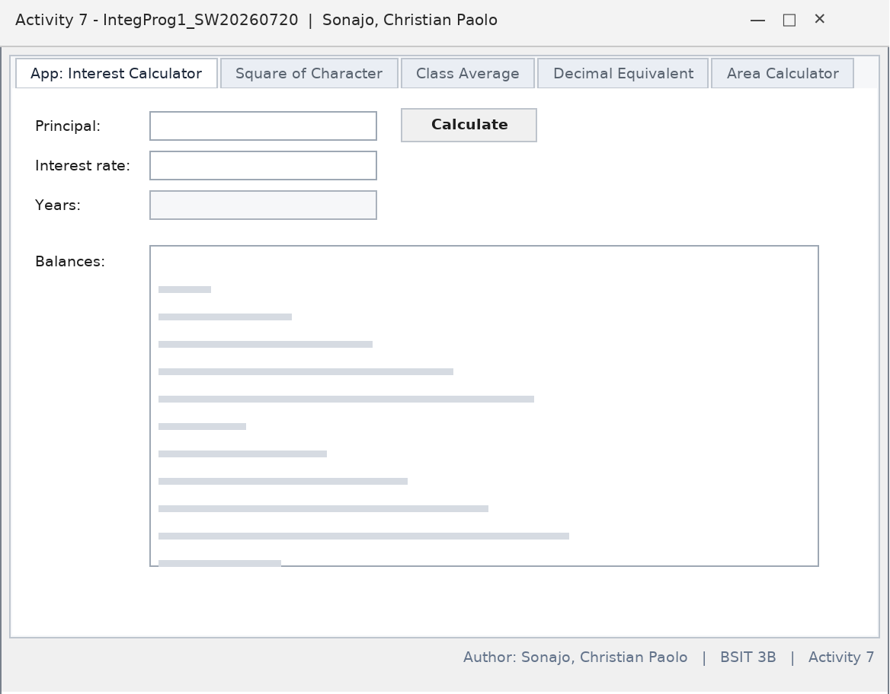
Figure 7.1 - Form design of Activity 7 - the author label is at the bottom right
Source Code
Form1.vb
Public Class Form1

Private Sub calculateButton_Click(ByVal sender As Object,
ByVal e As EventArgs) Handles calculateButton.Click

Dim principal As Decimal = Val(principalTextBox.Text)
Dim rate As Decimal = Val(interestRateTextBox.Text)
Dim amount As Decimal

resultsListBox.Items.Add(
"Year" & vbTab & "Amount on Deposit")

For yearCounter As Integer = 1 To yearsNumericUpDown.Value
amount = principal * ((1 + rate / 100) ^ yearCounter)
resultsListBox.Items.Add(yearCounter & vbTab &
String.Format("{0:C}", amount))
Next
End Sub

Private Sub principalTextBox_TextChanged(ByVal sender As Object,
ByVal e As EventArgs) Handles principalTextBox.TextChanged
resultsListBox.Items.Clear()
End Sub

Private Sub interestRateTextBox_TextChanged(ByVal sender As Object,
ByVal e As EventArgs) Handles interestRateTextBox.TextChanged
resultsListBox.Items.Clear()
End Sub

Private Sub yearsNumericUpDown_ValueChanged(ByVal sender As Object,
ByVal e As EventArgs) Handles yearsNumericUpDown.ValueChanged
resultsListBox.Items.Clear()
End Sub

Private Sub displaySquareButton_Click(ByVal sender As Object,
ByVal e As EventArgs) Handles displaySquareButton.Click

outputTextBox.Clear()

Dim fillCharacter As String = fillCharacterTextBox.Text
Dim sideLength As Integer = sideLengthNumericUpDown.Value

For row As Integer = 1 To sideLength
For column As Integer = 1 To sideLength
outputTextBox.AppendText(fillCharacter & " ")
Next column

outputTextBox.AppendText(vbCrLf)
Next row
End Sub

Private Sub fillCharacterTextBox_TextChanged(ByVal sender As Object,
ByVal e As EventArgs) Handles fillCharacterTextBox.TextChanged
outputTextBox.Clear()
End Sub

Private Sub sideLengthNumericUpDown_ValueChanged(ByVal sender As Object,
ByVal e As EventArgs) Handles sideLengthNumericUpDown.ValueChanged
outputTextBox.Clear()
End Sub

Dim aCount As Integer
Dim bCount As Integer
Dim cCount As Integer
Dim dCount As Integer
Dim fCount As Integer
Dim perfectScoreCount As Integer

Private Sub submitGradeButton_Click(ByVal sender As Object,
ByVal e As EventArgs) Handles submitGradeButton.Click

Dim grade As Integer = Val(gradeTextBox.Text)

gradesListBox.Items.Add(grade)
gradeTextBox.Clear()

Select Case grade
Case 100
perfectScoreCount += 1
aCount += 1
Case 90 To 99
aCount += 1
Case 80 To 89
bCount += 1
Case 70 To 79
cCount += 1
Case 60 To 69
dCount += 1
Case Else
fCount += 1
End Select

gradeTextBox.Focus()
End Sub

Private Sub calculateAverageButton_Click(ByVal sender As Object,
ByVal e As EventArgs) Handles calculateAverageButton.Click

Dim total As Integer
Dim gradeCounter As Integer
Dim grade As Integer
Dim average As Double

total = 0
gradeCounter = 0

Do While gradeCounter < gradesListBox.Items.Count
grade = gradesListBox.Items(gradeCounter)
total += grade
gradeCounter += 1
Loop

If gradeCounter <> 0 Then
average = total / gradeCounter

classAverageLabel.Text = "Total of the " & gradeCounter &
" grade(s) is " & total & vbCrLf & "Class average is " &
String.Format("{0:F}", average) & vbCrLf & vbCrLf

classAverageLabel.Text &=
"Letter grade summary:" & vbCrLf & "A: " & aCount &
vbCrLf & "B: " & bCount & vbCrLf & "C: " & cCount &
vbCrLf & "D: " & dCount & vbCrLf & "F: " & fCount &
vbCrLf & "Perfect scores: " & perfectScoreCount
Else
classAverageLabel.Text = "No grades were entered"
End If
End Sub

Private Sub clearGradesButton_Click(ByVal sender As Object,
ByVal e As EventArgs) Handles clearGradesButton.Click

gradesListBox.Items.Clear()
classAverageLabel.Text = String.Empty
End Sub

Private Sub Form1_Load(ByVal sender As Object,
ByVal e As EventArgs) Handles MyBase.Load

decimalOutputTextBox.AppendText("Decimal" & vbTab & "Octal" &
vbTab & "Hexadecimal" & vbTab & "Binary" & vbCrLf)

For number As Integer = 1 To 255
decimalOutputTextBox.AppendText(number & vbTab &
Convert.ToString(number, 8) & vbTab &
Convert.ToString(number, 16).ToUpper() & vbTab & vbTab &
Convert.ToString(number, 2) & vbCrLf)
Next number
End Sub

Private Sub decimalOutputTextBox_TextChanged(ByVal sender As System.Object, ByVal e As
System.EventArgs) Handles decimalOutputTextBox.TextChanged

End Sub

Private Sub tabClassAverage_Click(ByVal sender As System.Object, ByVal e As System.EventArgs)
Handles tabClassAverage.Click

End Sub

Private Sub TabPage1_Click(ByVal sender As System.Object, ByVal e As System.EventArgs) Handles
TabPage1.Click
'square, rectangle, trapesoid, triangle, circle
End Sub

Private Sub TabPage2_Click(ByVal sender As System.Object, ByVal e As System.EventArgs) Handles
TabPage2.Click

End Sub
End Class

Sample Output
Title : Activity 7 - IntegProg1_SW20260720 | Sonajo, Christian Paolo
Label : Author: Sonajo, Christian Paolo | BSIT 3B | Activity 7

Tab App: Interest Calculator
Principal : 1000 Interest rate : 5 Years : 3
Year Amount on Deposit
1 P1,050.00
2 P1,102.50
3 P1,157.63

Tab Decimal Equivalent : 1 1 1 1 ... up to 255

Activity 8
The Message (MessageBox Options)
Project : Act8_SW20260805 Author : Sonajo, Christian Paolo BSIT 3B
Description
The Message activity collects everything that a MessageBox needs: a title, a message body, one icon, one button set and one default button. When Display is clicked the program validates the five groups and then shows the message box with the selected options. The answer of the user is reported back in another message box.
The form was redesigned for this compilation from four overlapping GroupBoxes into a two-column dashboard: a compose card on the left and three option cards on the right. The code was rewritten with small helper functions - ValidateEntry, ChosenIcon, ChosenButtons, ChosenDefaultButton and DescribeResult - so that the long chain of If statements in the original version is no longer needed.
Objectives
- Use MessageBox.Show with a title, message, buttons, icon and default button.
- Read DialogResult values and describe the answer of the user.
- Validate user entries before showing a dialog.

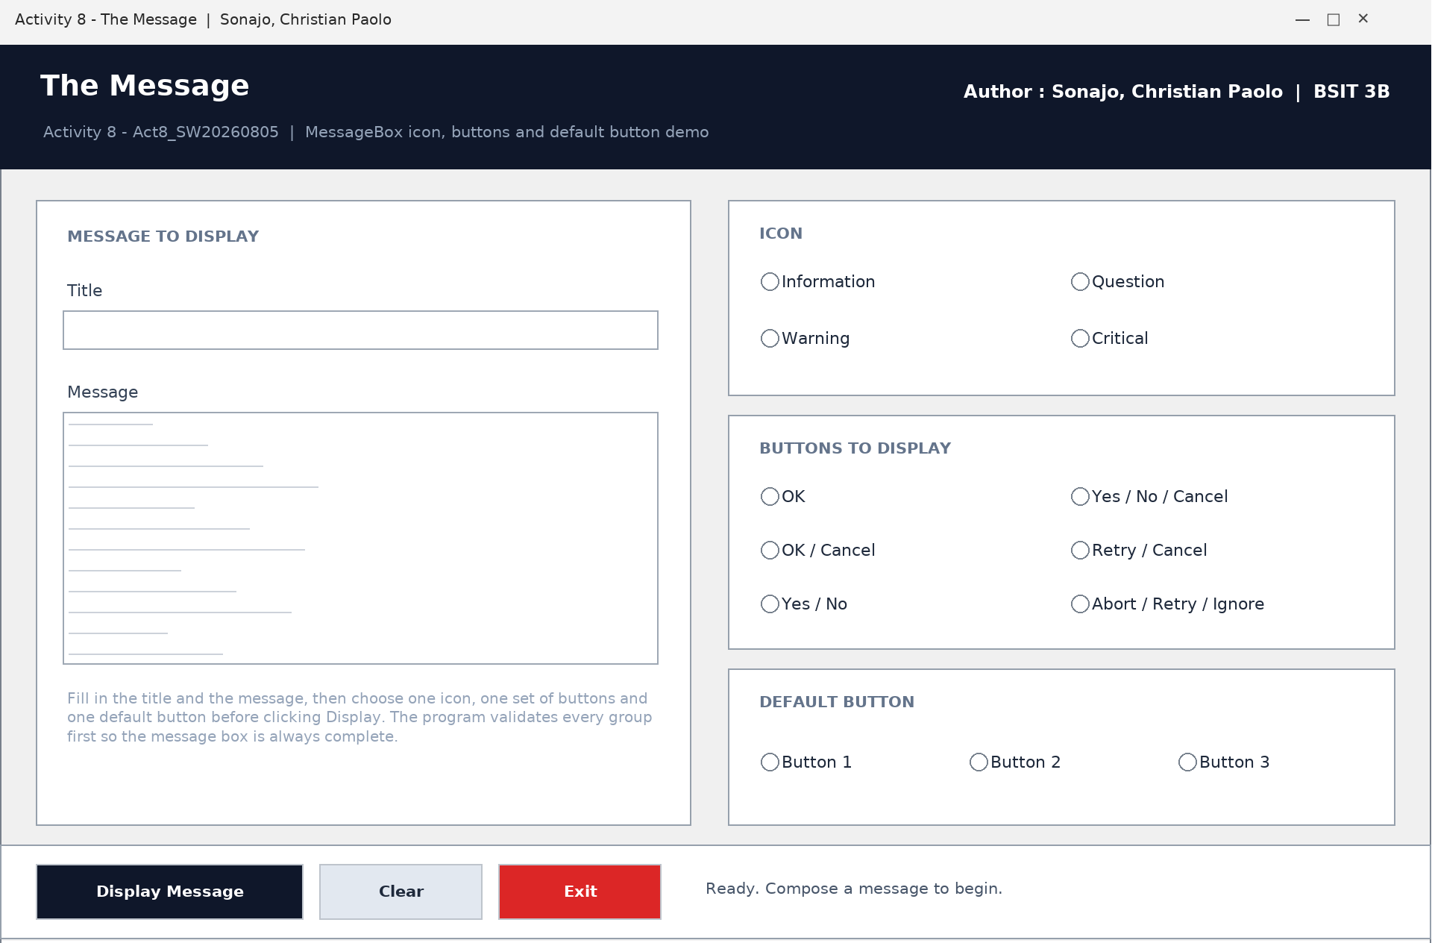
Figure 8.1 - Form design of Activity 8 - The Message
Source Code
Form1.vb
' ============================================================
' Activity 8 - Act8_SW20260805
' The Message : composes a MessageBox with a title, a message,
' an icon, a button set and a default button.
' Author : Sonajo, Christian Paolo | BSIT 3B
' ============================================================
Public Class Form1

Private Sub Form1_Load(ByVal sender As System.Object, ByVal e As System.EventArgs) Handles
MyBase.Load
PrepareForm()
End Sub

Private Sub PrepareForm()
txtTitle.Clear()
txtMessage.Clear()
ClearRadioButtons(pnlIcons)
ClearRadioButtons(pnlButtons)
ClearRadioButtons(pnlDefault)
lblStatus.Text = "Ready. Compose a message to begin."
txtTitle.Focus()
End Sub

Private Sub ClearRadioButtons(ByVal host As Control)
For Each child As Control In host.Controls
If TypeOf child Is RadioButton Then
CType(child, RadioButton).Checked = False
End If
Next
End Sub

' ------------------------- validation -------------------------
Private Function ValidateEntry() As Boolean
If txtTitle.Text.Trim() = "" Then
MessageBox.Show("Please enter a title.", "Missing Title", _
MessageBoxButtons.OK, MessageBoxIcon.Warning)
txtTitle.Focus()
Return False
End If

If txtMessage.Text.Trim() = "" Then
MessageBox.Show("Please enter a message.", "Missing Message", _
MessageBoxButtons.OK, MessageBoxIcon.Warning)
txtMessage.Focus()
Return False
End If

If Not (rbInfo.Checked OrElse rbWarning.Checked OrElse rbQuestion.Checked OrElse
rbCritical.Checked) Then
MessageBox.Show("Please select one icon.", "Icon Required", _
MessageBoxButtons.OK, MessageBoxIcon.Warning)
Return False
End If

If Not (rbOk.Checked OrElse rbOkCancel.Checked OrElse rbYesNo.Checked OrElse _
rbYesNoCancel.Checked OrElse rbRetryCancel.Checked OrElse
rbAbortRetryIgnore.Checked) Then
MessageBox.Show("Please select the buttons to display.", "Buttons Required", _
MessageBoxButtons.OK, MessageBoxIcon.Warning)
Return False
End If

If Not (rbDefault1.Checked OrElse rbDefault2.Checked OrElse rbDefault3.Checked) Then
MessageBox.Show("Please select the default button.", "Default Button Required", _
MessageBoxButtons.OK, MessageBoxIcon.Warning)
Return False
End If

Return True
End Function

' --------------------- selected MessageBox parts ---------------------
Private Function ChosenIcon() As MessageBoxIcon
If rbInfo.Checked Then Return MessageBoxIcon.Information
If rbWarning.Checked Then Return MessageBoxIcon.Warning
If rbQuestion.Checked Then Return MessageBoxIcon.Question
Return MessageBoxIcon.Error
End Function

Private Function ChosenButtons() As MessageBoxButtons
If rbOk.Checked Then Return MessageBoxButtons.OK
If rbOkCancel.Checked Then Return MessageBoxButtons.OKCancel
If rbYesNo.Checked Then Return MessageBoxButtons.YesNo
If rbYesNoCancel.Checked Then Return MessageBoxButtons.YesNoCancel
If rbRetryCancel.Checked Then Return MessageBoxButtons.RetryCancel
Return MessageBoxButtons.AbortRetryIgnore
End Function

Private Function ChosenDefaultButton() As MessageBoxDefaultButton
If rbDefault2.Checked Then Return MessageBoxDefaultButton.Button2
If rbDefault3.Checked Then Return MessageBoxDefaultButton.Button3
Return MessageBoxDefaultButton.Button1
End Function

Private Function DescribeResult(ByVal answer As DialogResult) As String
Select Case answer
Case DialogResult.OK
Return "OK was clicked."
Case DialogResult.Cancel
Return "Cancel was clicked."
Case DialogResult.Yes
Return "Yes was clicked."
Case DialogResult.No
Return "No was clicked."
Case DialogResult.Retry
Return "Retry was clicked."
Case DialogResult.Abort
Return "Abort was clicked."
Case DialogResult.Ignore
Return "Ignore was clicked."
Case Else
Return "The message box was closed without a button answer."
End Select
End Function

Private Sub btnDisplay_Click(ByVal sender As System.Object, ByVal e As System.EventArgs) Handles
btnDisplay.Click
If Not ValidateEntry() Then Return

Try
Dim answer As DialogResult = MessageBox.Show(txtMessage.Text, txtTitle.Text, _
ChosenButtons(), ChosenIcon(), _
ChosenDefaultButton())

lblStatus.Text = DescribeResult(answer)

MessageBox.Show(DescribeResult(answer), "Result", _
MessageBoxButtons.OK, MessageBoxIcon.Information)
Catch ex As Exception
MessageBox.Show(ex.Message, "There is an error", _
MessageBoxButtons.OK, MessageBoxIcon.Error)
End Try
End Sub

Private Sub btnClear_Click(ByVal sender As System.Object, ByVal e As System.EventArgs) Handles
btnClear.Click
PrepareForm()
End Sub

Private Sub btnExit_Click(ByVal sender As System.Object, ByVal e As System.EventArgs) Handles
btnExit.Click
Application.Exit()
End Sub
End Class

Sample Output
Header : The Message
Author : Sonajo, Christian Paolo | BSIT 3B

Title : Saving the record
Message : Do you want to save this record?
Icon : Question
Buttons : Yes / No / Cancel
Default : Button 1

Message box : [Question] Do you want to save this record? (Yes) (No) (Cancel)
After click : [Information] Yes was clicked.
Status bar : Yes was clicked.

Activity 9
ListView File Explorer
Project : SW202609301600 Author : Sonajo, Christian Paolo BSIT 3B
Description
This activity introduces the ListView control. The form lists the folders and files of the Documents folder with their type and size, and the user can browse another folder through a FolderBrowserDialog. The Details and List buttons switch the view, and the menu opens the same form again.
Objectives
- Fill a ListView with folders and files using Directory.GetDirectories and Directory.GetFiles.
- Add columns to a ListView and switch between the Details and List views.
- Use FolderBrowserDialog to choose a folder.

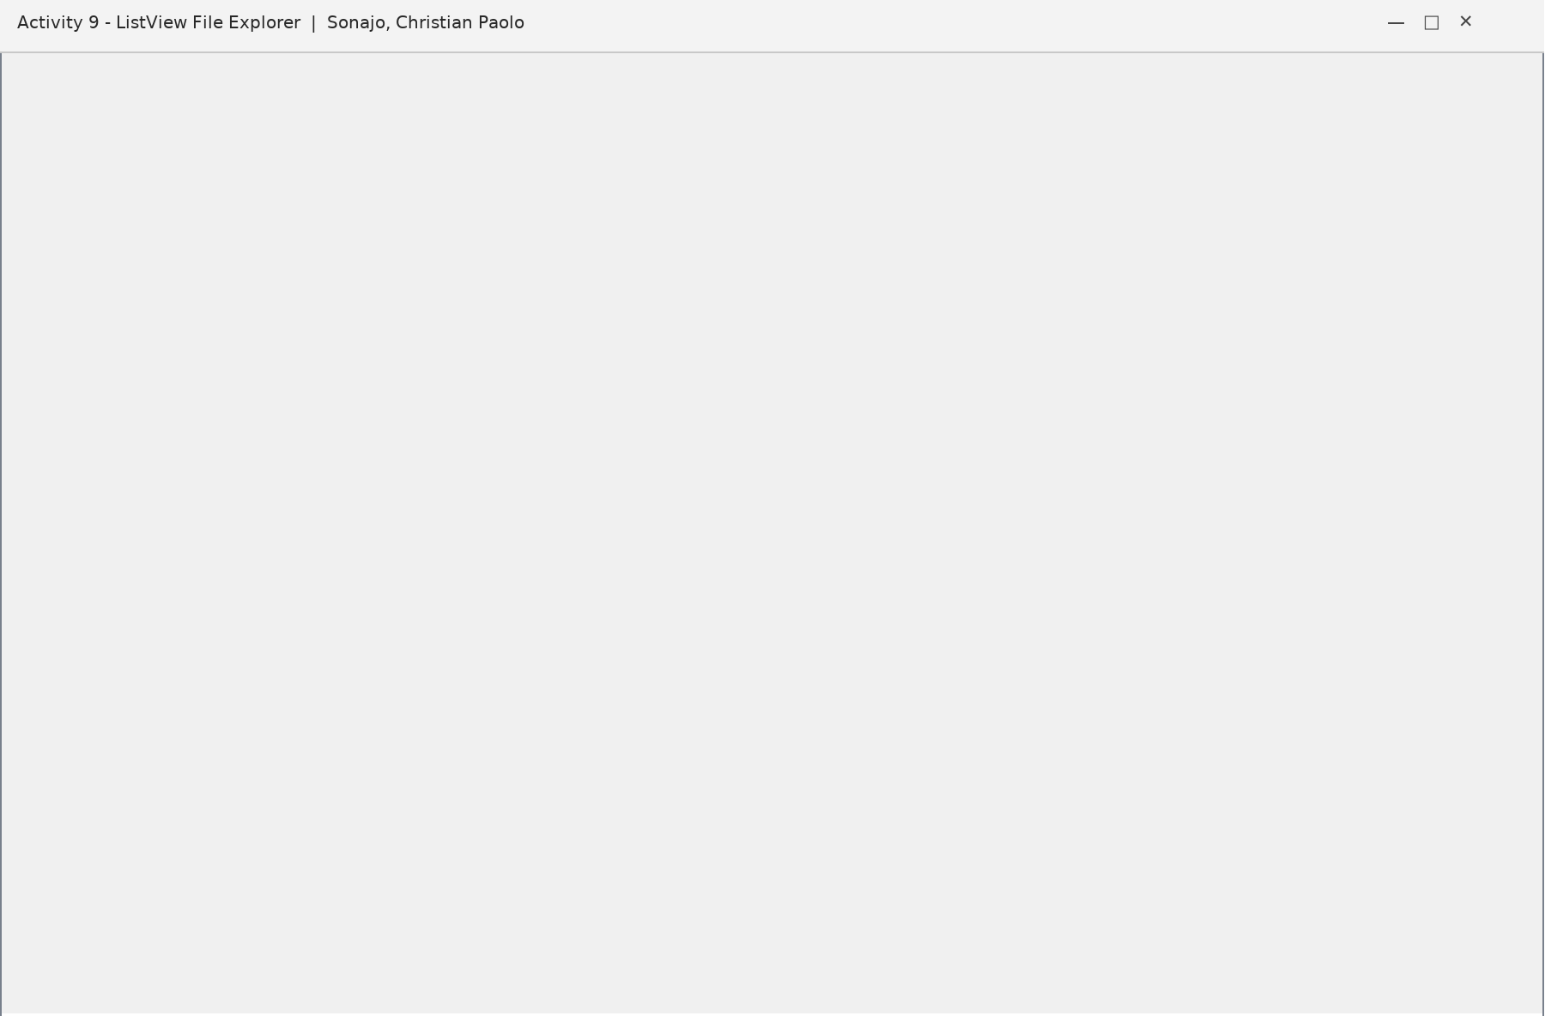
Figure 9.1 - Form design of Activity 9 - the author label shares the status line
Source Code
ListViewSample.vb
Imports System
Imports System.IO
Imports System.Diagnostics
Imports System.Windows.Forms

Public Class ListViewSample
Private currentFolder As String =
Environment.GetFolderPath(Environment.SpecialFolder.MyDocuments)

Public Sub New()
InitializeComponent()
AddHandler menuList.Click, AddressOf OpenListForm

AddHandler menuExit.Click, AddressOf ExitApplication
End Sub

Private Sub OpenListForm(ByVal sender As Object, ByVal e As EventArgs)
Using form As New ListViewSample()
form.ShowDialog()
End Using
End Sub

Private Sub ExitApplication(ByVal sender As Object, ByVal e As EventArgs)
Me.Close()
End Sub

Private Sub Form1_Load(ByVal sender As Object, ByVal e As EventArgs) Handles MyBase.Load
LoadFolder(currentFolder)
End Sub

Private Sub LoadFolder(ByVal folder As String)
If Not Directory.Exists(folder) Then Return
currentFolder = folder
txtPath.Text = folder
lv.Items.Clear()
Try
For Each directoryName As String In Directory.GetDirectories(folder)
Dim item As New ListViewItem(Path.GetFileName(directoryName))
item.SubItems.Add("Folder")
item.SubItems.Add(Directory.GetLastWriteTime(directoryName).ToString())
item.Tag = directoryName
lv.Items.Add(item)
Next
For Each fileName As String In Directory.GetFiles(folder)
Dim info As New FileInfo(fileName)
Dim item As New ListViewItem(info.Name)
item.SubItems.Add(info.Extension)
item.SubItems.Add(info.Length.ToString() & " bytes")
item.Tag = fileName
lv.Items.Add(item)
Next
lbl.Text = lv.Items.Count.ToString() & " item(s)"
Catch ex As Exception
lbl.Text = ex.Message
End Try
End Sub

Private Sub browse_Click(ByVal sender As Object, ByVal e As EventArgs) Handles browse.Click
Using dialog As New FolderBrowserDialog()
dialog.SelectedPath = currentFolder
dialog.Description = "Select a folder"
If dialog.ShowDialog() = DialogResult.OK Then
LoadFolder(dialog.SelectedPath)
End If
End Using
End Sub

Private Sub btnRefresh_Click(ByVal sender As Object, ByVal e As EventArgs) Handles
btnRefresh.Click
LoadFolder(currentFolder)
End Sub

Private Sub details_Click(ByVal sender As Object, ByVal e As EventArgs) Handles details.Click
lv.View = View.Details
End Sub

Private Sub list_Click(ByVal sender As Object, ByVal e As EventArgs) Handles list.Click
lv.View = View.List
End Sub

Private Sub lv_DoubleClick(ByVal sender As Object, ByVal e As EventArgs) Handles lv.DoubleClick
If lv.SelectedItems.Count = 0 Then Return
Dim selectedPath As String = CStr(lv.SelectedItems(0).Tag)
If Directory.Exists(selectedPath) Then
LoadFolder(selectedPath)
ElseIf File.Exists(selectedPath) Then
Process.Start(selectedPath)
End If
End Sub

Private Sub lv_ColumnClick(ByVal sender As Object, ByVal e As ColumnClickEventArgs) Handles
lv.ColumnClick
lv.ListViewItemSorter = New ListViewComparer(e.Column)
lv.Sort()
End Sub

Private Class ListViewComparer
Implements System.Collections.IComparer
Private ReadOnly columnNumber As Integer

Public Sub New(ByVal column As Integer)
columnNumber = column
End Sub

Public Function Compare(ByVal first As Object, ByVal second As Object) As Integer Implements
System.Collections.IComparer.Compare
Dim a As ListViewItem = DirectCast(first, ListViewItem)
Dim b As ListViewItem = DirectCast(second, ListViewItem)
Return String.Compare(a.SubItems(columnNumber).Text, b.SubItems(columnNumber).Text,
True)
End Function
End Class
End Class

ListViewSample.Designer.vb
Imports System.Windows.Forms
Imports System.Drawing

<Global.Microsoft.VisualBasic.CompilerServices.DesignerGenerated()> _
Partial Class ListViewSample
Inherits System.Windows.Forms.Form
Private components As System.ComponentModel.IContainer
Friend WithEvents txtPath As TextBox
Friend WithEvents browse As Button
Friend WithEvents btnRefresh As Button
Friend WithEvents details As Button
Friend WithEvents list As Button
Friend WithEvents lv As ListView
Friend WithEvents lbl As Label
Friend WithEvents lblAuthor As Label
Friend WithEvents menuStrip1 As MenuStrip
Friend WithEvents menuForms As ToolStripMenuItem
Friend WithEvents menuList As ToolStripMenuItem
Friend WithEvents menuTree As ToolStripMenuItem
Friend WithEvents menuOpen As ToolStripMenuItem
Friend WithEvents menuCombined As ToolStripMenuItem
Friend WithEvents menuExit As ToolStripMenuItem
<System.Diagnostics.DebuggerNonUserCode()> Protected Overrides Sub Dispose(ByVal disposing As
Boolean)
If disposing AndAlso components IsNot Nothing Then components.Dispose()
MyBase.Dispose(disposing)
End Sub
<System.Diagnostics.DebuggerStepThrough()> Private Sub InitializeComponent()
Me.components = New System.ComponentModel.Container()
Me.txtPath=New TextBox() : Me.browse=New Button() : Me.btnRefresh=New Button() : Me.details=New
Button() : Me.list=New Button() : Me.lv=New ListView() : Me.lbl=New Label() : Me.lblAuthor=New
Label()
Me.menuStrip1=New MenuStrip() : Me.menuForms=New ToolStripMenuItem() : Me.menuList=New
ToolStripMenuItem() : Me.menuTree=New ToolStripMenuItem() : Me.menuOpen=New ToolStripMenuItem()
: Me.menuCombined=New ToolStripMenuItem() : Me.menuExit=New ToolStripMenuItem()
Me.SuspendLayout()
Me.menuForms.Text="Forms"
Me.menuList.Text="ListView File Explorer"
Me.menuTree.Text="TreeView File Explorer"
Me.menuOpen.Text="OpenFileDialog File Explorer"
Me.menuCombined.Text="Combined File Explorer"
Me.menuExit.Text="Exit"
Me.menuForms.DropDownItems.AddRange(New ToolStripItem()
{Me.menuList,Me.menuTree,Me.menuOpen,Me.menuCombined,Me.menuExit})
Me.menuStrip1.Items.Add(Me.menuForms)
Me.menuStrip1.Dock=DockStyle.Top
Me.txtPath.SetBounds(10,38,560,25) : Me.browse.SetBounds(580,36,85,28) :
Me.browse.Text="Browse..." : Me.btnRefresh.Se ...
' [very long data line omitted in this document]
Me.ClientSize = New System.Drawing.Size(900, 560)
Me.Text = "Activity 9 - ListView File Explorer | Sonajo, Christian Paolo"
Me.StartPosition = FormStartPosition.CenterScreen
Me.ResumeLayout(False)
End Sub
End Class

Sample Output
Title : Activity 9 - ListView File Explorer | Sonajo, Christian Paolo
Path : C:\Users\Sonajo\Documents
Name Type Modified/Size
Documents Folder ...
notes.txt .txt 1.2 KB
Activity1.docx .docx 24.6 KB
Status : 3 item(s) Author: Sonajo, Christian Paolo | BSIT 3B

Notes
The form title now reads Activity 9 - ListView File Explorer | Sonajo, Christian Paolo and the author label at the bottom right of the form shows Sonajo, Christian Paolo | BSIT 3B.

Activity 10
Panel and SplitContainer Laboratory
Project : SW20261002 - PanelSplitPanelDemo Author : Sonajo, Christian Paolo BSIT 3B
Description
Activity 10 is a laboratory for two container controls. Form1 shows the members of the Panel control - Visible, BackColor, BorderStyle, BringToFront, SendToBack, Contains, Focus, Refresh, Invalidate and Dispose - while Form2 shows two nested SplitContainer controls with collapsing, orientation switching and splitter locking.
Both forms and both code files were completely rebuilt for this compilation. Instead of the old plain buttons that only changed a status label, Form1 now has a navigation rail, a workspace with a parent panel and two child panels, an API inspector and an event log that records every action with a counter. Form2 was replaced by a Split Container Lab with a category list, a record list, a details pane, a reset layout button and a ratio based SetRatioDistance helper that keeps the splitter inside the allowed minimum sizes.
Objectives
- Demonstrate the properties and methods of the Panel control.
- Use a vertical and a horizontal SplitContainer, including nested panels.
- Collapse, expand, re-orient and lock splitters at run time.

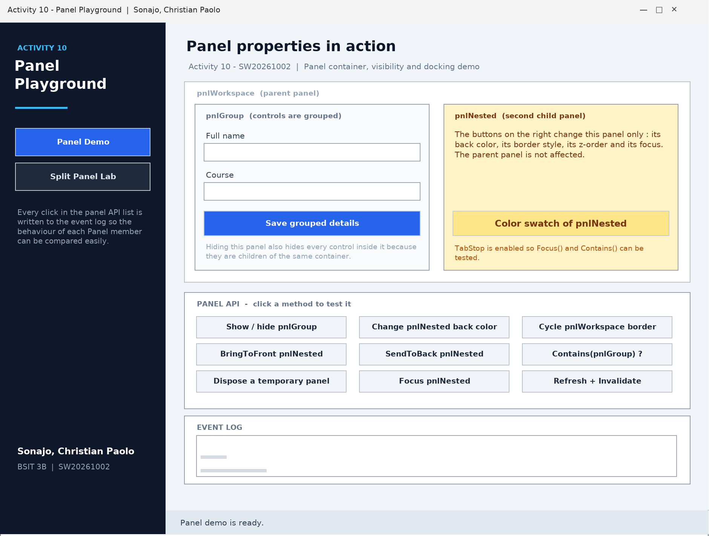
Figure 10.1 - Form design of Activity 10 - Panel Playground

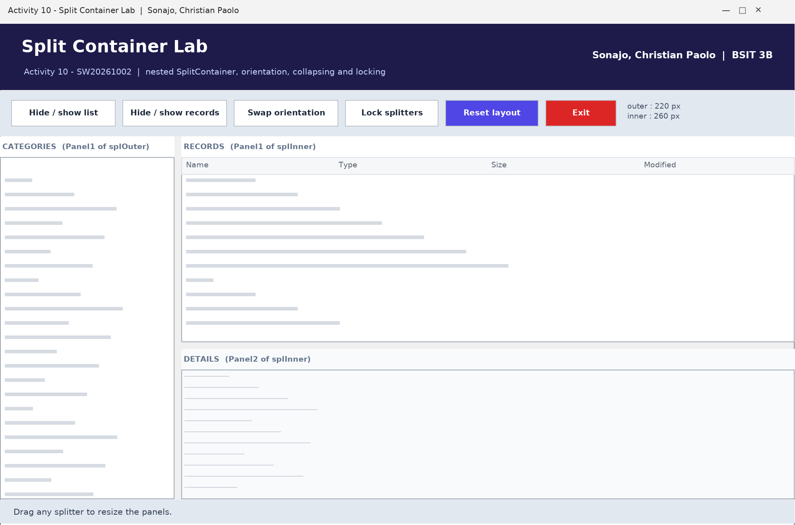
Figure 10.2 - Form design of Activity 10 - Split Container Lab
Source Code
Form1.vb (Panel Playground)
' ============================================================
' Activity 10 - SW20261002 (Panel Demo)
' Demonstrates the most common members of the Panel control :
' Visible, BackColor, BorderStyle, BringToFront, SendToBack,
' Contains, Focus, Refresh, Invalidate and Dispose.
' Author : Sonajo, Christian Paolo | BSIT 3B
' ============================================================
Option Strict On
Option Explicit On

Public Class Form1

Private actionCounter As Integer = 0
Private colorIndex As Integer = 0
Private borderIndex As Integer = 0

Private ReadOnly palette As Color() = { _
Color.FromArgb(254, 243, 199), _
Color.FromArgb(219, 234, 254), _
Color.FromArgb(220, 252, 231)}

Private Sub Form1_Load(ByVal sender As Object, ByVal e As EventArgs) Handles MyBase.Load
WriteLog("Form1 loaded - Panel Playground is ready.")
WriteLog("pnlWorkspace contains " & pnlWorkspace.Controls.Count.ToString() & " child
control(s).")
pnlNested.TabStop = True
lblStatus.Text = "Panel demo is ready."
End Sub

' ---------------------------------------------------------
' helper routines
' ---------------------------------------------------------
Private Sub WriteLog(ByVal message As String)
actionCounter += 1
lstLog.Items.Insert(0, actionCounter.ToString("00") & " " & message)
lblStatus.Text = message
lblCounter.Text = actionCounter.ToString() & " action(s) performed"
End Sub

Private Sub OpenSplitLab()
Dim lab As New Form2()
lab.Owner = Me
AddHandler lab.FormClosed, AddressOf SplitLabClosed
lab.Show()
Me.Hide()
End Sub

Private Sub SplitLabClosed(ByVal sender As Object, ByVal e As FormClosedEventArgs)
If Not Me.IsDisposed Then
Me.Show()
WriteLog("Split Panel Lab was closed, Panel Playground is shown again.")
End If
End Sub

' ---------------------------------------------------------
' navigation
' ---------------------------------------------------------
Private Sub btnNavSplit_Click(ByVal sender As Object, ByVal e As EventArgs) Handles
btnNavSplit.Click
OpenSplitLab()
End Sub

Private Sub mnuSplitLab_Click(ByVal sender As Object, ByVal e As EventArgs) Handles
mnuSplitLab.Click
OpenSplitLab()
End Sub

Private Sub btnNavPanel_Click(ByVal sender As Object, ByVal e As EventArgs) Handles
btnNavPanel.Click
WriteLog("You are already on the Panel demo.")
End Sub

Private Sub mnuExit_Click(ByVal sender As Object, ByVal e As EventArgs) Handles mnuExit.Click
Application.Exit()
End Sub

' ---------------------------------------------------------
' grouped controls demo
' ---------------------------------------------------------
Private Sub btnSave_Click(ByVal sender As Object, ByVal e As EventArgs) Handles btnSave.Click
Dim fullName As String = txtName.Text.Trim()
Dim course As String = txtCourse.Text.Trim()

If fullName = "" Then
WriteLog("Nothing saved - the full name box is empty.")
txtName.Focus()
Return
End If

If course = "" Then
course = "no course given"
End If

WriteLog("Saved from pnlGroup : " & fullName & " - " & course)
End Sub

' ---------------------------------------------------------
' Panel API demo buttons
' ---------------------------------------------------------
Private Sub btnToggleGroup_Click(ByVal sender As Object, ByVal e As EventArgs) Handles
btnToggleGroup.Click
pnlGroup.Visible = Not pnlGroup.Visible
btnToggleGroup.Text = If(pnlGroup.Visible, "Show / hide pnlGroup", "pnlGroup is hidden -
click to show")
WriteLog("pnlGroup.Visible = " & pnlGroup.Visible.ToString())
End Sub

Private Sub btnSwapColor_Click(ByVal sender As Object, ByVal e As EventArgs) Handles
btnSwapColor.Click
colorIndex += 1
If colorIndex > palette.Length - 1 Then colorIndex = 0

pnlNested.BackColor = palette(colorIndex)
lblNestedBadge.BackColor = ControlPaint.Light(palette(colorIndex))
WriteLog("pnlNested.BackColor changed to " & ColorName(palette(colorIndex)) & ".")
End Sub

Private Function ColorName(ByVal value As Color) As String
If value = palette(0) Then Return "amber"
If value = palette(1) Then Return "blue"
Return "green"
End Function

Private Sub btnCycleBorder_Click(ByVal sender As Object, ByVal e As EventArgs) Handles
btnCycleBorder.Click
borderIndex += 1
Select Case borderIndex Mod 3
Case 0
pnlWorkspace.BorderStyle = BorderStyle.Fixed3D
Case 1
pnlWorkspace.BorderStyle = BorderStyle.FixedSingle
Case 2
pnlWorkspace.BorderStyle = BorderStyle.None
End Select
WriteLog("pnlWorkspace.BorderStyle = " & pnlWorkspace.BorderStyle.ToString())
End Sub

Private Sub btnBringFront_Click(ByVal sender As Object, ByVal e As EventArgs) Handles
btnBringFront.Click
pnlNested.BringToFront()
WriteLog("pnlNested.BringToFront() - the child panel is now in front of pnlGroup.")
End Sub

Private Sub btnSendBack_Click(ByVal sender As Object, ByVal e As EventArgs) Handles
btnSendBack.Click
pnlNested.SendToBack()
WriteLog("pnlNested.SendToBack() - the child panel moved behind pnlGroup.")
End Sub

Private Sub btnContains_Click(ByVal sender As Object, ByVal e As EventArgs) Handles
btnContains.Click
Dim hasGroup As Boolean = pnlWorkspace.Contains(pnlGroup)
Dim hasNested As Boolean = pnlWorkspace.Contains(pnlNested)
Dim hasOutsider As Boolean = pnlMain.Contains(pnlGroup)
WriteLog("Contains -> pnlGroup : " & hasGroup.ToString() & _
", pnlNested : " & hasNested.ToString() & _
", from pnlMain : " & hasOutsider.ToString())
End Sub

Private Sub btnDisposeDemo_Click(ByVal sender As Object, ByVal e As EventArgs) Handles
btnDisposeDemo.Click
Dim temporary As New Panel()
temporary.Controls.Add(New Label())
temporary.Controls.Add(New TextBox())
Dim childCount As Integer = temporary.Controls.Count
temporary.Dispose()
WriteLog("A temporary panel with " & childCount.ToString() & " child control(s) was disposed
safely.")
End Sub

Private Sub btnFocusPanel_Click(ByVal sender As Object, ByVal e As EventArgs) Handles
btnFocusPanel.Click
Dim gotFocus As Boolean = pnlNested.Focus()
WriteLog("pnlNested.Focus() returned " & gotFocus.ToString() & ".")
End Sub

Private Sub btnRedraw_Click(ByVal sender As Object, ByVal e As EventArgs) Handles
btnRedraw.Click
pnlNested.Refresh()
pnlWorkspace.Invalidate(True)
WriteLog("Refresh() and Invalidate(True) requested a redraw of the child panels.")
End Sub
End Class

Form2.vb (Split Container Lab)
' ============================================================
' Activity 10 - SW20261002 (SplitContainer Demo)
' Nested SplitContainer practice : two panels in the outer
' splitter, two panels in the inner splitter.
' Author : Sonajo, Christian Paolo | BSIT 3B
' ============================================================
Option Strict On
Option Explicit On

Public Class Form2

' one line of sample data
Private Class RecordItem
Public Name As String
Public Category As String
Public Status As String
Public Detail As String

Public Sub New(ByVal recordName As String, ByVal recordCategory As String, _
ByVal recordStatus As String, ByVal recordDetail As String)
Name = recordName
Category = recordCategory
Status = recordStatus
Detail = recordDetail
End Sub
End Class

Private records As New List(Of RecordItem)()
Private splittersLocked As Boolean = False

Private Sub Form2_Load(ByVal sender As Object, ByVal e As EventArgs) Handles MyBase.Load
BuildSampleData()
FillCategories()
ApplyDefaultLayout()

If lstCategories.Items.Count > 0 Then lstCategories.SelectedIndex = 0

lblStatus.Text = "Drag any splitter to resize the panels."
lblCount.Text = records.Count.ToString() & " sample record(s) loaded"
End Sub

' ---------------------------------------------------------
' sample data
' ---------------------------------------------------------
Private Sub BuildSampleData()
records.Add(New RecordItem("Student Masterlist", "Students", "Active", _
"The student masterlist holds the complete list of enrolled students of BSIT 3B." &
vbCrLf & _
"Fields : student number, full name, year level, section and status."))
records.Add(New RecordItem("Grade Sheet", "Students", "Active", _
"The grade sheet stores the midterm and final grades of every student." & vbCrLf & _
"Average and remarks are computed automatically."))
records.Add(New RecordItem("Course Catalog", "Courses", "Active", _
"The course catalog lists every subject with its code, title and unit count."))
records.Add(New RecordItem("Class Schedule", "Courses", "Draft", _
"The class schedule combines a course, a teacher, a day, a time and a room."))
records.Add(New RecordItem("Enrollment Slip", "Enrollments", "Active", _
"The enrollment slip is printed for each student after the subjects are confirmed."))
records.Add(New RecordItem("Subject Load", "Enrollments", "Pending", _
"The subject load shows the subjects and schedules of one student for the term."))
records.Add(New RecordItem("Enrollment Report", "Reports", "Active", _
"A summary of the number of enrolled students per course and per year level."))
records.Add(New RecordItem("Grade Summary", "Reports", "Draft", _
"A report that groups the class by remarks : passed, conditional and failed."))
records.Add(New RecordItem("User Accounts", "Settings", "Active", _
"User accounts control who can add, edit or delete the records of the system."))
records.Add(New RecordItem("Backup Preferences", "Settings", "Pending", _
"Backup preferences decide how often the database file is copied to a safe folder."))
End Sub

Private Sub FillCategories()
lstCategories.Items.Clear()
lstCategories.Items.Add("All records")
lstCategories.Items.Add("Students")
lstCategories.Items.Add("Courses")
lstCategories.Items.Add("Enrollments")
lstCategories.Items.Add("Reports")
lstCategories.Items.Add("Settings")
End Sub

Private Sub lstCategories_SelectedIndexChanged(ByVal sender As Object, ByVal e As EventArgs)
Handles lstCategories.SelectedIndexChanged
ShowRecords(CStr(lstCategories.SelectedItem))
End Sub

Private Sub ShowRecords(ByVal category As String)
lvRecords.BeginUpdate()
lvRecords.Items.Clear()

For Each record As RecordItem In records
If category = "All records" OrElse record.Category = category Then
Dim row As New ListViewItem(record.Name)
row.SubItems.Add(record.Category)
row.SubItems.Add(record.Status)
row.Tag = record
lvRecords.Items.Add(row)
End If
Next

lvRecords.EndUpdate()
txtDetails.Text = "Select a record in the list above to display its details here."
lblStatus.Text = If(category = "All records", "Showing every record", "Showing the " &
category & " records") & _
" - " & lvRecords.Items.Count.ToString() & " item(s)."
lblCount.Text = "outer splitter : " & splOuter.SplitterDistance.ToString() & " px"
End Sub

Private Sub lvRecords_SelectedIndexChanged(ByVal sender As Object, ByVal e As EventArgs) Handles
lvRecords.SelectedIndexChanged
If lvRecords.SelectedItems.Count = 0 Then Return

Dim chosen As RecordItem = CType(lvRecords.SelectedItems(0).Tag, RecordItem)
txtDetails.Text = chosen.Name & vbCrLf & _
"Category : " & chosen.Category & vbCrLf & _
"Status : " & chosen.Status & vbCrLf & vbCrLf & _
chosen.Detail & vbCrLf & vbCrLf & _
"This text is shown inside Panel2 of the inner SplitContainer."
lblStatus.Text = "Selected : " & chosen.Name
End Sub

' ---------------------------------------------------------
' split container layout helpers
' ---------------------------------------------------------
Private Sub ApplyDefaultLayout()
splOuter.Panel1Collapsed = False
splOuter.Panel2Collapsed = False
splInner.Panel1Collapsed = False
splInner.Panel2Collapsed = False
splInner.Orientation = Orientation.Horizontal

SetRatioDistance(splOuter, 0.24)
SetRatioDistance(splInner, 0.62)
ShowSplitInfo()
End Sub

' The distance is given as a ratio of the available space so the
' splitter never goes beyond its minimum sizes.
Private Sub SetRatioDistance(ByVal splitter As SplitContainer, ByVal ratio As Double)
Dim available As Integer
If splitter.Orientation = Orientation.Vertical Then
available = splitter.ClientSize.Width
Else
available = splitter.ClientSize.Height
End If

Dim lowest As Integer = splitter.Panel1MinSize
Dim highest As Integer = available - splitter.Panel2MinSize - splitter.SplitterWidth
If highest <= lowest Then Return

Dim requested As Integer = CInt(available * ratio)
If requested < lowest Then requested = lowest
If requested > highest Then requested = highest
splitter.SplitterDistance = requested
End Sub

Private Sub ShowSplitInfo()
lblSplitInfo.Text = "outer : " & splOuter.SplitterDistance.ToString() & " px" & vbCrLf & _
"inner : " & splInner.SplitterDistance.ToString() & " px"
End Sub

Private Sub btnCollapseLeft_Click(ByVal sender As Object, ByVal e As EventArgs) Handles
btnCollapseLeft.Click
splOuter.Panel1Collapsed = Not splOuter.Panel1Collapsed
lblStatus.Text = "splOuter.Panel1Collapsed = " & splOuter.Panel1Collapsed.ToString()
ShowSplitInfo()
End Sub

Private Sub btnCollapseTop_Click(ByVal sender As Object, ByVal e As EventArgs) Handles
btnCollapseTop.Click
splInner.Panel1Collapsed = Not splInner.Panel1Collapsed
lblStatus.Text = "splInner.Panel1Collapsed = " & splInner.Panel1Collapsed.ToString()
ShowSplitInfo()
End Sub

Private Sub btnSwapOrientation_Click(ByVal sender As Object, ByVal e As EventArgs) Handles
btnSwapOrientation.Click
Try
If splInner.Orientation = Orientation.Horizontal Then
splInner.Orientation = Orientation.Vertical
lblStatus.Text = "Orientation = Vertical, the inner panels are now left and right."
Else
splInner.Orientation = Orientation.Horizontal
lblStatus.Text = "Orientation = Horizontal, the inner panels are now top and
bottom."
End If
SetRatioDistance(splInner, 0.62)
ShowSplitInfo()
Catch ex As Exception
lblStatus.Text = "The orientation could not be changed : " & ex.Message
End Try
End Sub

Private Sub btnLock_Click(ByVal sender As Object, ByVal e As EventArgs) Handles btnLock.Click
splittersLocked = Not splittersLocked
splOuter.IsSplitterFixed = splittersLocked
splInner.IsSplitterFixed = splittersLocked
btnLock.Text = If(splittersLocked, "Unlock splitters", "Lock splitters")
lblStatus.Text = "IsSplitterFixed = " & splittersLocked.ToString()
End Sub

Private Sub btnReset_Click(ByVal sender As Object, ByVal e As EventArgs) Handles btnReset.Click
splittersLocked = False
splOuter.IsSplitterFixed = False
splInner.IsSplitterFixed = False
btnLock.Text = "Lock splitters"
ApplyDefaultLayout()
lblStatus.Text = "The default layout and splitter distances were restored."
End Sub

Private Sub splOuter_SplitterMoved(ByVal sender As Object, ByVal e As SplitterEventArgs) Handles
splOuter.SplitterMoved
ShowSplitInfo()
lblStatus.Text = "Outer splitter moved to " & splOuter.SplitterDistance.ToString() & "
pixels."
End Sub

Private Sub splInner_SplitterMoved(ByVal sender As Object, ByVal e As SplitterEventArgs) Handles
splInner.SplitterMoved
ShowSplitInfo()
lblStatus.Text = "Inner splitter moved to " & splInner.SplitterDistance.ToString() & "
pixels."
End Sub

' ---------------------------------------------------------
' navigation
' ---------------------------------------------------------
Private Sub mnuPanelDemo_Click(ByVal sender As Object, ByVal e As EventArgs) Handles
mnuPanelDemo.Click
Me.Close()
End Sub

Private Sub mnuExit_Click(ByVal sender As Object, ByVal e As EventArgs) Handles mnuExit.Click
Application.Exit()
End Sub

Private Sub btnExit_Click(ByVal sender As Object, ByVal e As EventArgs) Handles btnExit.Click
Application.Exit()
End Sub
End Class

Sample Output
Panel Playground - Author : Sonajo, Christian Paolo | BSIT 3B
01 pnlGroup.Visible = False
02 pnlNested.BackColor changed to blue.
03 Contains -> pnlGroup : True, pnlNested : True, from pnlMain : False
04 pnlNested.Focus() returned True.
Status bar : 4 action(s) performed

Split Container Lab - Author : Sonajo, Christian Paolo | BSIT 3B
outer : 220 px inner : 260 px
splOuter.Panel1Collapsed = True
Orientation = Vertical, the inner panels are now left and right.

Activity 11
Windows Forms Controls Collection (TabControl, TreeView, ListView, Dialogs)
Project : SW202610021600 Author : Sonajo, Christian Paolo BSIT 3B
Description
The eleventh activity collects the answers to questions 6 to 9 in one TabControl based program: a ListView file explorer, a TreeView file explorer, an OpenFileDialog and SaveFileDialog demonstration, and a combined explorer that uses the TreeView, the ListView and both dialogs together. One tab lists the written answers of the assignment.
Objectives
- Build forms completely in code without the designer.
- Embed one form inside a TabPage of another form.
- Combine TreeView, ListView, OpenFileDialog and SaveFileDialog in one application.
Source Code
Application.vb
Imports System
Imports System.Windows.Forms
Module Application
<STAThread()> Public Sub Main()
System.Windows.Forms.Application.EnableVisualStyles()
System.Windows.Forms.Application.SetCompatibleTextRenderingDefault(False)
System.Windows.Forms.Application.Run(New MainForm())
End Sub
End Module

MainForm.vb
Imports System
Imports System.Drawing
Imports System.Windows.Forms

Public Class MainForm
Inherits Form

Private statusBar As Label
Private tabs As TabControl
Private explorerTab As TabPage
Private listTab As TabPage
Private treeTab As TabPage
Private answersTab As TabPage

Public Sub New()
Me.Text = "Activity 11 - SW202610021600 - Windows Forms Controls | Sonajo, Christian
Paolo"
Me.StartPosition = FormStartPosition.CenterScreen
Me.WindowState = FormWindowState.Maximized
Me.MinimumSize = New Size(900, 600)
statusBar = New Label()
statusBar.Dock = DockStyle.Bottom
statusBar.Height = 24
statusBar.TextAlign = ContentAlignment.MiddleRight
statusBar.ForeColor = Color.FromArgb(100, 116, 139)
statusBar.Text = "Author: Sonajo, Christian Paolo | BSIT 3B | Activity 11 -
SW202610021600"
Me.Controls.Add(statusBar)

tabs = New TabControl()
tabs.Dock = DockStyle.Fill
explorerTab = New TabPage("File explorer + dialogs")
listTab = New TabPage("ListView examples")
treeTab = New TabPage("TreeView examples")
answersTab = New TabPage("Assignment answers")
tabs.TabPages.Add(explorerTab)
tabs.TabPages.Add(listTab)
tabs.TabPages.Add(treeTab)
tabs.TabPages.Add(answersTab)
Me.Controls.Add(tabs)
EmbedForm(New CombinedSample(), explorerTab)
EmbedForm(New ListViewSample(), listTab)
EmbedForm(New TreeViewSample(), treeTab)
BuildAnswersTab()
End Sub

Private Sub EmbedForm(ByVal child As Form, ByVal page As TabPage)
child.TopLevel = False
child.FormBorderStyle = FormBorderStyle.None
child.Dock = DockStyle.Fill
page.Controls.Add(child)
child.Show()
End Sub

Private Sub BuildAnswersTab()
Dim text As New RichTextBox()
text.Dock = DockStyle.Fill
text.ReadOnly = True
text.Font = New Font("Segoe UI", 11.0F)
text.Text = "Activity 11 - SW202610021600" & Environment.NewLine & _
"Author : Sonajo, Christian Paolo | Course, Year and Section : BSIT 3B" & _
Environment.NewLine & Environment.NewLine & _
"Question 6 - ListView" & Environment.NewLine & _
"The ListView examples tab imitates File Explorer with folder browsing,
Details/List views, columns, sorting, double-click opening, and a status bar." &
Environment.NewLine & Environment.NewLine & _
"Question 7 - TreeView" & Environment.NewLine & _
"The TreeView examples tab displays drives and directories. Nodes are loaded
when expanded and the selected path is shown." & Environment.NewLine & Environment.NewLine & _
"Question 8 - OpenFileDialog" & Environment.NewLine & _
"The File explorer + dialogs tab demonstrates OpenFileDialog, file filters,
multiple selection, CheckFileExists, and RestoreDirectory." & Environment.NewLine &
Environment.NewLine & _
"Question 9 - Combined form" & Environment.NewLine & _
"The File explorer + dialogs tab combines OpenFileDialog, SaveFileDialog,
TreeView, ListView, folder navigation, and saving a directory listing."
answersTab.Controls.Add(text)
End Sub
End Class

MenuForm.vb
Imports System
Imports System.Drawing
Imports System.Windows.Forms

Public Class MenuForm
Inherits Form

Private menuStrip1 As MenuStrip
Private listMenu As ToolStripMenuItem
Private treeMenu As ToolStripMenuItem
Private openMenu As ToolStripMenuItem
Private combinedMenu As ToolStripMenuItem
Private exitMenu As ToolStripMenuItem

Public Sub New()
Me.Text = "Activity 11 - SW202610021600 | Sonajo, Christian Paolo"
Me.StartPosition = FormStartPosition.CenterScreen
Me.Size = New Size(720, 400)
menuStrip1 = New MenuStrip()
treeMenu = New ToolStripMenuItem("TreeView File Explorer")
openMenu = New ToolStripMenuItem("OpenFileDialog File Explorer")
combinedMenu = New ToolStripMenuItem("Combined File Explorer")
exitMenu = New ToolStripMenuItem("Exit")
menuStrip1.Items.AddRange(New ToolStripItem() {treeMenu, openMenu, combinedMenu, exitMenu})
menuStrip1.Dock = DockStyle.Top
Me.Controls.Add(menuStrip1)
Me.MainMenuStrip = menuStrip1

AddHandler treeMenu.Click, AddressOf OpenTree
AddHandler openMenu.Click, AddressOf OpenDialog
AddHandler combinedMenu.Click, AddressOf OpenCombined
AddHandler exitMenu.Click, AddressOf ExitProgram
End Sub

Private Sub OpenTree(ByVal sender As Object, ByVal e As EventArgs)
Using form As New TreeViewSample()
form.ShowDialog()
End Using
End Sub

Private Sub OpenDialog(ByVal sender As Object, ByVal e As EventArgs)
Using form As New OpenFileDialogSample()
form.ShowDialog()
End Using
End Sub

Private Sub OpenCombined(ByVal sender As Object, ByVal e As EventArgs)
Using form As New CombinedSample()
form.ShowDialog()
End Using
End Sub

Private Sub ExitProgram(ByVal sender As Object, ByVal e As EventArgs)
Me.Close()
End Sub

Private Sub InitializeComponent()
Me.SuspendLayout()
'
'MenuForm
'
Me.ClientSize = New System.Drawing.Size(729, 387)
Me.Name = "MenuForm"
Me.ResumeLayout(False)

End Sub

Private Sub MenuForm_Load(ByVal sender As System.Object, ByVal e As System.EventArgs) Handles
MyBase.Load

End Sub
End Class

ListViewSample.vb
Imports System
Imports System.IO
Imports System.Diagnostics
Imports System.Windows.Forms

Public Class ListViewSample
Private currentFolder As String =
Environment.GetFolderPath(Environment.SpecialFolder.MyDocuments)

Public Sub New()
InitializeComponent()
End Sub

Private Sub Form1_Load(ByVal sender As Object, ByVal e As EventArgs) Handles MyBase.Load
LoadFolder(currentFolder)
End Sub

Private Sub LoadFolder(ByVal folder As String)
If Not Directory.Exists(folder) Then Return
currentFolder = folder
txtPath.Text = folder
lv.Items.Clear()
Try
For Each directoryName As String In Directory.GetDirectories(folder)
Dim item As New ListViewItem(Path.GetFileName(directoryName))
item.SubItems.Add("Folder")
item.SubItems.Add(Directory.GetLastWriteTime(directoryName).ToString())
item.Tag = directoryName
lv.Items.Add(item)
Next
For Each fileName As String In Directory.GetFiles(folder)
Dim info As New FileInfo(fileName)
Dim item As New ListViewItem(info.Name)
item.SubItems.Add(info.Extension)
item.SubItems.Add(info.Length.ToString() & " bytes")
item.Tag = fileName
lv.Items.Add(item)
Next
lbl.Text = lv.Items.Count.ToString() & " item(s)"
Catch ex As Exception
lbl.Text = ex.Message
End Try
End Sub

Private Sub browse_Click(ByVal sender As Object, ByVal e As EventArgs) Handles browse.Click
Using dialog As New FolderBrowserDialog()
dialog.SelectedPath = currentFolder
dialog.Description = "Select a folder"
If dialog.ShowDialog() = DialogResult.OK Then
LoadFolder(dialog.SelectedPath)
End If
End Using
End Sub

Private Sub btnRefresh_Click(ByVal sender As Object, ByVal e As EventArgs) Handles
btnRefresh.Click
LoadFolder(currentFolder)
End Sub

Private Sub details_Click(ByVal sender As Object, ByVal e As EventArgs) Handles details.Click
lv.View = View.Details
End Sub

Private Sub list_Click(ByVal sender As Object, ByVal e As EventArgs) Handles list.Click
lv.View = View.List
End Sub

Private Sub lv_DoubleClick(ByVal sender As Object, ByVal e As EventArgs) Handles lv.DoubleClick
If lv.SelectedItems.Count = 0 Then Return
Dim selectedPath As String = CStr(lv.SelectedItems(0).Tag)
If Directory.Exists(selectedPath) Then
LoadFolder(selectedPath)
ElseIf File.Exists(selectedPath) Then
Process.Start(selectedPath)
End If
End Sub

Private Sub lv_ColumnClick(ByVal sender As Object, ByVal e As ColumnClickEventArgs) Handles
lv.ColumnClick
lv.ListViewItemSorter = New ListViewComparer(e.Column)
lv.Sort()
End Sub

Private Class ListViewComparer
Implements System.Collections.IComparer
Private ReadOnly columnNumber As Integer

Public Sub New(ByVal column As Integer)
columnNumber = column
End Sub

Public Function Compare(ByVal first As Object, ByVal second As Object) As Integer Implements
System.Collections.IComparer.Compare
Dim a As ListViewItem = DirectCast(first, ListViewItem)
Dim b As ListViewItem = DirectCast(second, ListViewItem)
Return String.Compare(a.SubItems(columnNumber).Text, b.SubItems(columnNumber).Text,
True)
End Function
End Class
End Class

TreeViewSample.vb
Imports System
Imports System.IO
Imports System.Windows.Forms

Public Class TreeViewSample
Public Sub New()
InitializeComponent()
End Sub
Private Sub Form1_Load(ByVal sender As Object, ByVal e As EventArgs) Handles MyBase.Load
BuildTree()
End Sub
Private Sub BuildTree()
tree.Nodes.Clear()
For Each drive As DriveInfo In DriveInfo.GetDrives()
If drive.IsReady Then
Dim node As New TreeNode(drive.Name)
node.Tag = drive.RootDirectory.FullName
node.Nodes.Add("Loading...")
tree.Nodes.Add(node)
End If
Next
End Sub
Private Sub tree_BeforeExpand(ByVal sender As Object, ByVal e As TreeViewCancelEventArgs)
Handles tree.BeforeExpand
Dim folder As String = CStr(e.Node.Tag)
e.Node.Nodes.Clear()
Try
For Each directoryName As String In Directory.GetDirectories(folder)
Dim child As New TreeNode(Path.GetFileName(directoryName))
child.Tag = directoryName
Try
If Directory.GetDirectories(directoryName).Length > 0 Then
child.Nodes.Add("Loading...")
Catch
End Try
e.Node.Nodes.Add(child)
Next
Catch
End Try
End Sub
Private Sub tree_AfterSelect(ByVal sender As Object, ByVal e As TreeViewEventArgs) Handles
tree.AfterSelect
selectedPath.Text = CStr(e.Node.Tag)
End Sub
Private Sub btnRefresh_Click(ByVal sender As Object, ByVal e As EventArgs) Handles
btnRefresh.Click
BuildTree()
End Sub
End Class

OpenFileDialogSample.vb
Imports System
Imports System.Windows.Forms

Public Class OpenFileDialogSample
Public Sub New()
InitializeComponent()
End Sub
Private Sub one_Click(ByVal sender As Object, ByVal e As EventArgs) Handles one.Click
Using dialog As New OpenFileDialog()
Configure(dialog, False)
If dialog.ShowDialog() = DialogResult.OK Then ShowFiles(dialog.FileNames)
End Using
End Sub
Private Sub many_Click(ByVal sender As Object, ByVal e As EventArgs) Handles many.Click
Using dialog As New OpenFileDialog()
Configure(dialog, True)
If dialog.ShowDialog() = DialogResult.OK Then ShowFiles(dialog.FileNames)
End Using
End Sub
Private Sub Configure(ByVal dialog As OpenFileDialog, ByVal allowMultiple As Boolean)
dialog.Title = "Select file"
dialog.Filter = "All files (*.*)|*.*|Text files (*.txt)|*.txt|Images
(*.jpg;*.png)|*.jpg;*.png"
dialog.FilterIndex = 1
dialog.Multiselect = allowMultiple
dialog.CheckFileExists = True
dialog.CheckPathExists = True
dialog.RestoreDirectory = True
End Sub
Private Sub ShowFiles(ByVal files() As String)
selected.Items.Clear()
For Each fileName As String In files
selected.Items.Add(fileName)
Next
End Sub
Private Sub clear_Click(ByVal sender As Object, ByVal e As EventArgs) Handles clear.Click
selected.Items.Clear()
End Sub
End Class

CombinedSample.vb
Imports System
Imports System.IO
Imports System.Diagnostics
Imports System.Windows.Forms

Public Class CombinedSample
Private currentFolder As String =
Environment.GetFolderPath(Environment.SpecialFolder.MyDocuments)
Public Sub New()
InitializeComponent()
End Sub
Private Sub Form1_Load(ByVal sender As Object, ByVal e As EventArgs) Handles MyBase.Load
BuildTree()
LoadFolder(currentFolder)
End Sub
Private Sub BuildTree()
tree.Nodes.Clear()
For Each drive As DriveInfo In DriveInfo.GetDrives()
If drive.IsReady Then
Dim node As New TreeNode(drive.Name)
node.Tag = drive.RootDirectory.FullName
node.Nodes.Add("Loading...")
tree.Nodes.Add(node)
End If
Next
End Sub
Private Sub tree_BeforeExpand(ByVal sender As Object, ByVal e As TreeViewCancelEventArgs)
Handles tree.BeforeExpand
Dim folder As String = CStr(e.Node.Tag)
e.Node.Nodes.Clear()
Try
For Each directoryName As String In Directory.GetDirectories(folder)
Dim child As New TreeNode(Path.GetFileName(directoryName))
child.Tag = directoryName
e.Node.Nodes.Add(child)
Next
Catch
End Try
End Sub
Private Sub tree_AfterSelect(ByVal sender As Object, ByVal e As TreeViewEventArgs) Handles
tree.AfterSelect
currentFolder = CStr(e.Node.Tag)
LoadFolder(currentFolder)
End Sub
Private Sub LoadFolder(ByVal folder As String)
If Not Directory.Exists(folder) Then Return
lv.Items.Clear()
Try
For Each directoryName As String In Directory.GetDirectories(folder)
Dim item As New ListViewItem(Path.GetFileName(directoryName))
item.SubItems.Add("Folder")
item.Tag = directoryName
lv.Items.Add(item)
Next
For Each fileName As String In Directory.GetFiles(folder)
Dim item As New ListViewItem(Path.GetFileName(fileName))
item.SubItems.Add("File")
item.Tag = fileName
lv.Items.Add(item)
Next
Catch
End Try
End Sub
Private Sub open_Click(ByVal sender As Object, ByVal e As EventArgs) Handles open.Click
Using dialog As New OpenFileDialog()
dialog.Filter = "All files (*.*)|*.*"
dialog.CheckFileExists = True
If dialog.ShowDialog() = DialogResult.OK Then Process.Start(dialog.FileName)
End Using
End Sub
Private Sub save_Click(ByVal sender As Object, ByVal e As EventArgs) Handles save.Click
Using dialog As New SaveFileDialog()
dialog.Filter = "Text files (*.txt)|*.txt|All files (*.*)|*.*"
If dialog.ShowDialog() = DialogResult.OK Then
Using writer As New StreamWriter(dialog.FileName)
For Each item As ListViewItem In lv.Items
writer.WriteLine(item.Text & Microsoft.VisualBasic.ControlChars.Tab &
item.SubItems(1).Text)
Next
End Using
End If
End Using
End Sub
Private Sub btnRefresh_Click(ByVal sender As Object, ByVal e As EventArgs) Handles
btnRefresh.Click
BuildTree()
LoadFolder(currentFolder)
End Sub
End Class

Sample Output
Title : Activity 11 - SW202610021600 - Windows Forms Controls | Sonajo, Christian Paolo
Status bar : Author: Sonajo, Christian Paolo | BSIT 3B | Activity 11 - SW202610021600

Tab 1 File explorer + dialogs -> OpenFileDialog / SaveFileDialog demo
Tab 2 ListView examples -> folder browsing with Details / List view
Tab 3 TreeView examples -> drives and directories, loaded on expand
Tab 4 Assignment answers -> Activity 11 - SW202610021600
Author : Sonajo, Christian Paolo | BSIT 3B

Notes
The main form has a status line at the bottom that prints Author: Sonajo, Christian Paolo | BSIT 3B, and the same identity is printed at the top of the Assignment answers tab.

Activity 12
File Explorer Clone (PanelSplitDemo)
Project : FileExplorerClone - PanelSplitDemo Author : Sonajo, Christian Paolo BSIT 3B
Description
The last activity of the container chapter is a working file explorer. The folder tree is loaded on demand, the file list shows the name, type, size and date modified of every item, and the preview pane shows the text of a file, the picture of an image or the summary of a folder. The layout is built from two SplitContainer controls: one between the tree and the workspace, and one between the file list and the preview.
The whole activity was rewritten for this compilation so that the design and the code are different from the sample. The new name of the program is Sonajo Explorer. The additions are: a Back and Forward history stack, a Home button, an editable address bar with a Go button, a live filter box, column sorting that compares sizes as numbers, hidden files excluded from the list, an image preview that disposes the previous bitmap before showing a new one, a text preview limited to 6000 characters, and buttons that hide the tree or the preview and swap the orientation of the inner splitter.
Objectives
- Combine TreeView, ListView, PictureBox and TextBox inside nested SplitContainers.
- Navigate the file system with Directory, File, FileInfo and DirectoryInfo.
- Preview text, images and folders safely with error handling.

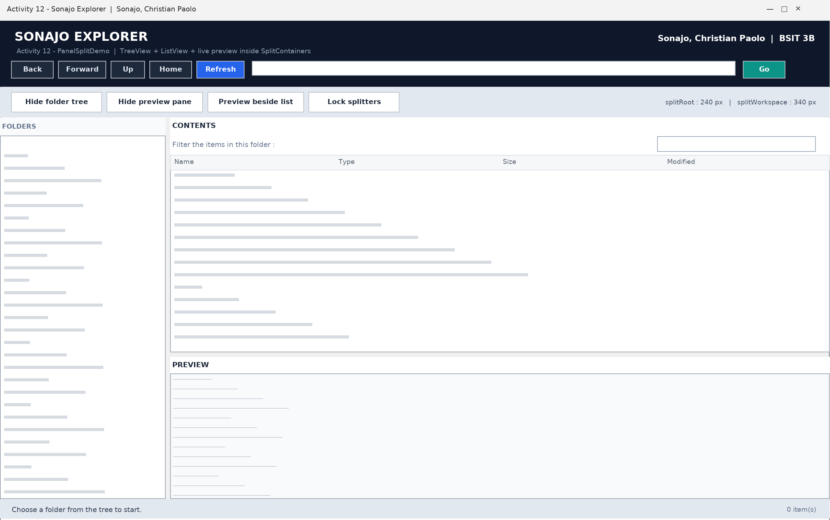
Figure 12.1 - Form design of Activity 12 - Sonajo Explorer
Source Code
Form1.vb
' ============================================================
' Activity 12 - PanelSplitDemo (Sonajo Explorer)
' A small file explorer built with TreeView + ListView + preview
' inside nested SplitContainer controls.
' Author : Sonajo, Christian Paolo | BSIT 3B
' ============================================================
Option Strict On
Option Explicit On

Imports System.IO
Imports System.Text

Public Class Form1

Private currentFolder As String = ""
Private ReadOnly backStack As New Stack(Of String)()
Private ReadOnly forwardStack As New Stack(Of String)()
Private syncingTree As Boolean = False
Private splittersLocked As Boolean = False
Private lastSortColumn As Integer = -1
Private sortAscending As Boolean = True

Private ReadOnly imageTypes As String() = _
{".jpg", ".jpeg", ".png", ".gif", ".bmp", ".ico", ".tif", ".tiff"}

Private ReadOnly textTypes As String() = _
{".txt", ".vb", ".cs", ".xml", ".config", ".csv", ".log", ".md", ".json", _
".ini", ".html", ".htm", ".css", ".js", ".sql", ".bat", ".sln", ".vbproj"}

' ---------------------------------------------------------
' start up
' ---------------------------------------------------------
Private Sub Form1_Load(ByVal sender As Object, ByVal e As EventArgs) Handles MyBase.Load
Try
BuildFolderTree()
ApplyDefaultLayout()
NavigateTo(StartFolder(), False)
Catch ex As Exception
lblStatus.Text = "The explorer could not start : " & ex.Message
End Try
End Sub

Private Function StartFolder() As String
Dim documents As String = Environment.GetFolderPath(Environment.SpecialFolder.MyDocuments)
If Directory.Exists(documents) Then Return documents

Dim desktopFolder As String = Environment.GetFolderPath(Environment.SpecialFolder.Desktop)
If Directory.Exists(desktopFolder) Then Return desktopFolder

Return Environment.CurrentDirectory
End Function

' ---------------------------------------------------------
' folder tree
' ---------------------------------------------------------
Private Sub BuildFolderTree()
tvFolders.BeginUpdate()
tvFolders.Nodes.Clear()

AddRootFolder("Desktop", Environment.GetFolderPath(Environment.SpecialFolder.Desktop))
AddRootFolder("Documents", Environment.GetFolderPath(Environment.SpecialFolder.MyDocuments))
AddRootFolder("Pictures", Environment.GetFolderPath(Environment.SpecialFolder.MyPictures))
AddRootFolder("Downloads",
Path.Combine(Environment.GetFolderPath(Environment.SpecialFolder.UserProfile), "Downloads"))

For Each drive As DriveInfo In DriveInfo.GetDrives()
If drive.IsReady Then
AddRootFolder(drive.Name, drive.RootDirectory.FullName)
End If
Next

tvFolders.EndUpdate()
lblStatus.Text = tvFolders.Nodes.Count.ToString() & " root folder(s) listed."
End Sub

Private Sub AddRootFolder(ByVal title As String, ByVal folderPath As String)
If folderPath = "" OrElse Not Directory.Exists(folderPath) Then Return

Dim node As New TreeNode(title)
node.Tag = folderPath
node.Nodes.Add(New TreeNode("loading"))
tvFolders.Nodes.Add(node)
End Sub

Private Sub tvFolders_BeforeExpand(ByVal sender As Object, ByVal e As TreeViewCancelEventArgs)
Handles tvFolders.BeforeExpand
If e.Node.Tag Is Nothing Then Return
If e.Node.Nodes.Count <> 1 OrElse e.Node.Nodes(0).Text <> "loading" Then Return
If e.Node.Nodes(0).Tag IsNot Nothing Then Return

Dim parentPath As String = CStr(e.Node.Tag)
e.Node.Nodes.Clear()

Try
For Each childPath As String In Directory.GetDirectories(parentPath)
Dim child As New TreeNode(Path.GetFileName(childPath))
If child.Text = "" Then child.Text = childPath
child.Tag = childPath
child.Nodes.Add(New TreeNode("loading"))
e.Node.Nodes.Add(child)
Next
Catch ex As Exception
lblStatus.Text = "Some folders cannot be listed : " & ex.Message
End Try

If e.Node.Nodes.Count = 0 Then e.Node.Nodes.Add(New TreeNode("empty"))
End Sub

Private Sub tvFolders_AfterSelect(ByVal sender As Object, ByVal e As TreeViewEventArgs) Handles
tvFolders.AfterSelect
If syncingTree Then Return
If e.Node.Tag Is Nothing Then Return

Dim folderPath As String = CStr(e.Node.Tag)
If Directory.Exists(folderPath) Then
NavigateTo(folderPath, True)
End If
End Sub

' ---------------------------------------------------------
' navigation
' ---------------------------------------------------------
Private Sub NavigateTo(ByVal folderPath As String, ByVal remember As Boolean)
If folderPath = "" OrElse Not Directory.Exists(folderPath) Then
lblStatus.Text = "Folder not found : " & folderPath
Return
End If

If remember AndAlso currentFolder <> "" AndAlso currentFolder <> folderPath Then
backStack.Push(currentFolder)
forwardStack.Clear()
End If

ShowFolder(folderPath)
End Sub

Private Sub ShowFolder(ByVal folderPath As String)
currentFolder = folderPath
txtPath.Text = folderPath
RefreshFileList()
SyncTreeSelection(folderPath)
ShowPreview("")
lblStatus.Text = "Now browsing : " & folderPath
End Sub

Private Sub SyncTreeSelection(ByVal folderPath As String)
syncingTree = True
Try
Dim node As TreeNode = FindNode(tvFolders.Nodes, folderPath)
If node IsNot Nothing Then
tvFolders.SelectedNode = node
node.EnsureVisible()
End If
Finally
syncingTree = False
End Try
End Sub

Private Function FindNode(ByVal siblings As TreeNodeCollection, ByVal folderPath As String) As
TreeNode
For Each node As TreeNode In siblings
If node.Tag IsNot Nothing AndAlso _
String.Equals(CStr(node.Tag), folderPath, StringComparison.OrdinalIgnoreCase) Then
Return node
End If

If node.IsExpanded AndAlso node.Nodes.Count > 0 Then
Dim found As TreeNode = FindNode(node.Nodes, folderPath)
If found IsNot Nothing Then Return found
End If
Next
Return Nothing
End Function

Private Sub btnBack_Click(ByVal sender As Object, ByVal e As EventArgs) Handles btnBack.Click
If backStack.Count = 0 Then
lblStatus.Text = "There is no previous folder in the history."
Return
End If

forwardStack.Push(currentFolder)
ShowFolder(backStack.Pop())
End Sub

Private Sub btnForward_Click(ByVal sender As Object, ByVal e As EventArgs) Handles
btnForward.Click
If forwardStack.Count = 0 Then
lblStatus.Text = "There is no next folder in the history."
Return
End If

backStack.Push(currentFolder)
ShowFolder(forwardStack.Pop())
End Sub

Private Sub btnUp_Click(ByVal sender As Object, ByVal e As EventArgs) Handles btnUp.Click
If currentFolder = "" Then Return

Dim parent As String = Path.GetDirectoryName(currentFolder)
If parent Is Nothing OrElse parent = "" Then
lblStatus.Text = "This is already the top of the drive."
Return
End If

NavigateTo(parent, True)
End Sub

Private Sub btnHome_Click(ByVal sender As Object, ByVal e As EventArgs) Handles btnHome.Click
NavigateTo(StartFolder(), True)
End Sub

Private Sub btnRefresh_Click(ByVal sender As Object, ByVal e As EventArgs) Handles
btnRefresh.Click
RefreshFileList()
lblStatus.Text = "Folder refreshed."
End Sub

Private Sub btnGo_Click(ByVal sender As Object, ByVal e As EventArgs) Handles btnGo.Click
NavigateTo(txtPath.Text.Trim(), True)
End Sub

Private Sub txtPath_KeyDown(ByVal sender As Object, ByVal e As KeyEventArgs) Handles
txtPath.KeyDown
If e.KeyCode = Keys.Enter Then
e.SuppressKeyPress = True
NavigateTo(txtPath.Text.Trim(), True)
End If
End Sub

' ---------------------------------------------------------
' file list
' ---------------------------------------------------------
Private Sub RefreshFileList()
lvFiles.BeginUpdate()
lvFiles.Items.Clear()

If currentFolder = "" OrElse Not Directory.Exists(currentFolder) Then
lvFiles.EndUpdate()
lblCount.Text = "0 item(s)"
Return
End If

Dim keyword As String = txtFilter.Text.Trim()

Try
For Each folderPath As String In Directory.GetDirectories(currentFolder)
Dim folderInfo As New DirectoryInfo(folderPath)
If IsHidden(folderInfo) Then Continue For
If Not Matches(keyword, folderInfo.Name) Then Continue For
AddRow(folderInfo.Name, "File folder", "", folderInfo.LastWriteTime,
folderInfo.FullName)
Next

For Each filePath As String In Directory.GetFiles(currentFolder)
Dim fileInfo As New FileInfo(filePath)
If IsHidden(fileInfo) Then Continue For
If Not Matches(keyword, fileInfo.Name) Then Continue For
AddRow(fileInfo.Name, TypeLabel(fileInfo), SizeLabel(fileInfo.Length), _
fileInfo.LastWriteTime, fileInfo.FullName)
Next
Catch ex As Exception
lblStatus.Text = "This folder cannot be fully listed : " & ex.Message
Finally
lvFiles.EndUpdate()
End Try

If lastSortColumn >= 0 Then ApplySort(lastSortColumn, False)

lblCount.Text = lvFiles.Items.Count.ToString() & " item(s) | " & currentFolder
End Sub

Private Sub AddRow(ByVal name As String, ByVal kind As String, ByVal size As String, _
ByVal modified As Date, ByVal fullPath As String)
Dim row As New ListViewItem(name)
row.SubItems.Add(kind)
row.SubItems.Add(size)
row.SubItems.Add(modified.ToString("MMM d, yyyy h:mm tt"))
row.Tag = fullPath
lvFiles.Items.Add(row)
End Sub

Private Function IsHidden(ByVal info As FileSystemInfo) As Boolean
Return (info.Attributes And FileAttributes.Hidden) = FileAttributes.Hidden
End Function

Private Function Matches(ByVal keyword As String, ByVal itemName As String) As Boolean
If keyword = "" Then Return True
Return itemName.IndexOf(keyword, StringComparison.OrdinalIgnoreCase) >= 0
End Function

Private Function TypeLabel(ByVal info As FileInfo) As String
If info.Extension = "" Then Return "File"
Return info.Extension.Substring(1).ToUpperInvariant() & " file"
End Function

Private Function SizeLabel(ByVal bytes As Long) As String
If bytes >= 1073741824 Then Return (bytes / 1073741824.0).ToString("0.00") & " GB"
If bytes >= 1048576 Then Return (bytes / 1048576.0).ToString("0.00") & " MB"
If bytes >= 1024 Then Return (bytes / 1024.0).ToString("0.0") & " KB"
Return bytes.ToString() & " B"
End Function

Private Sub txtFilter_TextChanged(ByVal sender As Object, ByVal e As EventArgs) Handles
txtFilter.TextChanged
If currentFolder = "" Then Return
RefreshFileList()
End Sub

' ---------------------------------------------------------
' sorting
' ---------------------------------------------------------
Private Sub lvFiles_ColumnClick(ByVal sender As Object, ByVal e As ColumnClickEventArgs) Handles
lvFiles.ColumnClick
If lastSortColumn = e.Column Then
sortAscending = Not sortAscending
Else
lastSortColumn = e.Column
sortAscending = True
End If

ApplySort(e.Column, sortAscending)
lblStatus.Text = "Sorted by column " & (e.Column + 1).ToString() & If(sortAscending, " (A to
Z)", " (Z to A)")
End Sub

Private Sub ApplySort(ByVal column As Integer, ByVal ascending As Boolean)
lvFiles.ListViewItemSorter = New ItemSorter(column, ascending)
lvFiles.Sort()
End Sub

' Compares two ListView rows; the size column is compared as a number.
Friend Class ItemSorter
Implements System.Collections.IComparer

Private ReadOnly columnIndex As Integer
Private ReadOnly ascendingOrder As Boolean

Public Sub New(ByVal column As Integer, ByVal ascending As Boolean)
columnIndex = column
ascendingOrder = ascending
End Sub

Public Function Compare(ByVal x As Object, ByVal y As Object) As Integer Implements
System.Collections.IComparer.Compare
Dim leftRow As ListViewItem = CType(x, ListViewItem)
Dim rightRow As ListViewItem = CType(y, ListViewItem)

Dim leftText As String = If(leftRow.SubItems.Count > columnIndex,
leftRow.SubItems(columnIndex).Text, "")
Dim rightText As String = If(rightRow.SubItems.Count > columnIndex,
rightRow.SubItems(columnIndex).Text, "")

Dim answer As Integer
If columnIndex = 2 Then
answer = BytesOf(leftText).CompareTo(BytesOf(rightText))
Else
answer = String.Compare(leftText, rightText, StringComparison.OrdinalIgnoreCase)
End If

If Not ascendingOrder Then answer = -answer
Return answer
End Function

Private Function BytesOf(ByVal sizeText As String) As Double
Dim numberPart As String = ""
For Each character As Char In sizeText
If Char.IsDigit(character) OrElse character = "."c Then
numberPart &= character
Else
Exit For
End If
Next

Dim value As Double = 0
Double.TryParse(numberPart, value)

If sizeText.Contains("GB") Then Return value * 1073741824
If sizeText.Contains("MB") Then Return value * 1048576
If sizeText.Contains("KB") Then Return value * 1024
Return value
End Function
End Class

' ---------------------------------------------------------
' preview
' ---------------------------------------------------------
Private Sub lvFiles_SelectedIndexChanged(ByVal sender As Object, ByVal e As EventArgs) Handles
lvFiles.SelectedIndexChanged
If lvFiles.SelectedItems.Count = 0 Then
ShowPreview("")
Return
End If

ShowPreview(CStr(lvFiles.SelectedItems(0).Tag))
End Sub

Private Sub lvFiles_DoubleClick(ByVal sender As Object, ByVal e As EventArgs) Handles
lvFiles.DoubleClick
If lvFiles.SelectedItems.Count = 0 Then Return

Dim chosenPath As String = CStr(lvFiles.SelectedItems(0).Tag)

If Directory.Exists(chosenPath) Then
NavigateTo(chosenPath, True)
Return
End If

Try
Process.Start(chosenPath)
Catch ex As Exception
lblStatus.Text = "This file cannot be opened : " & ex.Message
End Try
End Sub

Private Sub ShowPreview(ByVal chosenPath As String)
ReleasePicture()

If chosenPath = "" Then
lblPreviewTitle.Text = "PREVIEW"
txtPreview.Visible = True
txtPreview.Text = "Select a file or a folder to preview it here."
Return
End If

Dim itemName As String = Path.GetFileName(chosenPath)
If itemName = "" Then itemName = chosenPath
lblPreviewTitle.Text = "PREVIEW - " & itemName

If Directory.Exists(chosenPath) Then
ShowFolderPreview(chosenPath)
Return
End If

If Not File.Exists(chosenPath) Then
txtPreview.Visible = True
txtPreview.Text = "The selected item no longer exists."
Return
End If

Dim info As New FileInfo(chosenPath)
Dim extension As String = info.Extension.ToLowerInvariant()

If IsOneOf(extension, imageTypes) Then
If ShowImagePreview(chosenPath) Then Return
End If

txtPreview.Visible = True

If IsOneOf(extension, textTypes) Then
txtPreview.Text = ReadTextPreview(chosenPath, info)
Else
txtPreview.Text = "Name : " & info.Name & vbCrLf & _
"Type : " & TypeLabel(info) & vbCrLf & _
"Size : " & SizeLabel(info.Length) & vbCrLf & _
"Created : " & info.CreationTime.ToString("MMM d, yyyy h:mm
tt") & vbCrLf & _
"Last modified : " & info.LastWriteTime.ToString("MMM d, yyyy h:mm
tt") & vbCrLf & _
"Attributes : " & info.Attributes.ToString() & vbCrLf & vbCrLf & _
"There is no built-in preview for this file type."
End If
End Sub

Private Function IsOneOf(ByVal value As String, ByVal choices As String()) As Boolean
For Each choice As String In choices
If value = choice Then Return True
Next
Return False
End Function

Private Function ShowImagePreview(ByVal filePath As String) As Boolean
Try
Using stream As New FileStream(filePath, FileMode.Open, FileAccess.Read)
Using source As Image = Image.FromStream(stream)
pbPreview.Image = New Bitmap(source)
End Using
End Using

txtPreview.Visible = False
pbPreview.Visible = True
lblStatus.Text = "Image preview : " & Path.GetFileName(filePath)
Return True
Catch ex As Exception
txtPreview.Visible = True
pbPreview.Visible = False
txtPreview.Text = "The image cannot be previewed." & vbCrLf & ex.Message
Return True
End Try
End Function

Private Sub ShowFolderPreview(ByVal folderPath As String)
Dim summary As New StringBuilder()
Dim folderCount As Integer = 0
Dim fileCount As Integer = 0
Dim totalSize As Long = 0

Try
For Each childFolder As String In Directory.GetDirectories(folderPath)
folderCount += 1
Next

For Each childFile As String In Directory.GetFiles(folderPath)
Dim childInfo As New FileInfo(childFile)
fileCount += 1
totalSize += childInfo.Length
Next
Catch ex As Exception
summary.AppendLine("Some items cannot be counted : " & ex.Message)
End Try

Dim parentPath As String = Path.GetDirectoryName(folderPath)
If parentPath Is Nothing Then parentPath = folderPath

summary.AppendLine("Folder : " & folderPath)
summary.AppendLine("Parent : " & parentPath)
summary.AppendLine("Sub folders : " & folderCount.ToString())
summary.AppendLine("Files : " & fileCount.ToString())
summary.AppendLine("Total size : " & SizeLabel(totalSize))
summary.AppendLine()
summary.AppendLine("CONTENTS (first 40 items)")
summary.AppendLine("-------------------------------------------")

Try
Dim shown As Integer = 0
For Each childFolder As String In Directory.GetDirectories(folderPath)
summary.AppendLine("[folder] " & Path.GetFileName(childFolder))
shown += 1
If shown >= 40 Then Exit For
Next

If shown < 40 Then
For Each childFile As String In Directory.GetFiles(folderPath)
Dim childInfo As New FileInfo(childFile)
summary.AppendLine(" " & childInfo.Name & " (" &
SizeLabel(childInfo.Length) & ")")
shown += 1
If shown >= 40 Then Exit For
Next
End If
Catch ex As Exception
summary.AppendLine(ex.Message)
End Try

txtPreview.Visible = True
txtPreview.Text = summary.ToString()
End Sub

Private Function ReadTextPreview(ByVal filePath As String, ByVal info As FileInfo) As String
Const characterLimit As Integer = 6000

Try
Dim buffer(characterLimit) As Char
Dim text As New StringBuilder()

Using reader As New StreamReader(filePath, Encoding.Default, True)
Dim readNow As Integer = reader.Read(buffer, 0, characterLimit)
While readNow > 0
text.Append(New String(buffer, 0, readNow))
readNow = reader.Read(buffer, 0, characterLimit)
End While
End Using

Dim header As String = "Name : " & info.Name & " Size : " & SizeLabel(info.Length) &
vbCrLf & _
"Modified : " & info.LastWriteTime.ToString("MMM d, yyyy h:mm
tt") & vbCrLf & _
"-------------------------------------------" & vbCrLf

Dim body As String = text.ToString()
If body.Length >= characterLimit Then
body &= vbCrLf & vbCrLf & "... only the first " & characterLimit.ToString() & "
characters are shown."
End If

Return header & body
Catch ex As Exception
Return "The text of this file cannot be shown." & vbCrLf & ex.Message
End Try
End Function

Private Sub ClearPreview(ByVal message As String)
ReleasePicture()
pbPreview.Visible = False
txtPreview.Visible = True
txtPreview.Text = message
End Sub

Private Sub ReleasePicture()
If pbPreview.Image IsNot Nothing Then
Dim oldPicture As Image = pbPreview.Image
pbPreview.Image = Nothing
oldPicture.Dispose()
End If
pbPreview.Visible = False
End Sub

' ---------------------------------------------------------
' split container controls
' ---------------------------------------------------------
Private Sub ApplyDefaultLayout()
splRoot.Panel1Collapsed = False
splRoot.Panel2Collapsed = False
splWorkspace.Panel1Collapsed = False
splWorkspace.Panel2Collapsed = False
splWorkspace.Orientation = Orientation.Horizontal

btnTreeToggle.Text = "Hide folder tree"
btnPreviewToggle.Text = "Hide preview pane"
btnSwapLayout.Text = "Preview beside list"

SetRatioDistance(splRoot, 0.20)
SetRatioDistance(splWorkspace, 0.62)
ShowSplitInfo()
End Sub

Private Sub SetRatioDistance(ByVal splitter As SplitContainer, ByVal ratio As Double)
Dim available As Integer
If splitter.Orientation = Orientation.Vertical Then
available = splitter.ClientSize.Width
Else
available = splitter.ClientSize.Height
End If

Dim lowest As Integer = splitter.Panel1MinSize
Dim highest As Integer = available - splitter.Panel2MinSize - splitter.SplitterWidth
If highest <= lowest Then Return

Dim requested As Integer = CInt(available * ratio)
If requested < lowest Then requested = lowest
If requested > highest Then requested = highest
splitter.SplitterDistance = requested
End Sub

Private Sub ShowSplitInfo()
lblSplitInfo.Text = "splitRoot : " & splRoot.SplitterDistance.ToString() & " px | " & _
"splitWorkspace : " & splWorkspace.SplitterDistance.ToString() & " px"
End Sub

Private Sub btnTreeToggle_Click(ByVal sender As Object, ByVal e As EventArgs) Handles
btnTreeToggle.Click
splRoot.Panel1Collapsed = Not splRoot.Panel1Collapsed
btnTreeToggle.Text = If(splRoot.Panel1Collapsed, "Show folder tree", "Hide folder tree")
lblStatus.Text = "splRoot.Panel1Collapsed = " & splRoot.Panel1Collapsed.ToString()
ShowSplitInfo()
End Sub

Private Sub btnPreviewToggle_Click(ByVal sender As Object, ByVal e As EventArgs) Handles
btnPreviewToggle.Click
splWorkspace.Panel2Collapsed = Not splWorkspace.Panel2Collapsed
btnPreviewToggle.Text = If(splWorkspace.Panel2Collapsed, "Show preview pane", "Hide preview
pane")
lblStatus.Text = "splWorkspace.Panel2Collapsed = " & splWorkspace.Panel2Collapsed.ToString()
ShowSplitInfo()
End Sub

Private Sub btnSwapLayout_Click(ByVal sender As Object, ByVal e As EventArgs) Handles
btnSwapLayout.Click
Try
If splWorkspace.Orientation = Orientation.Horizontal Then
splWorkspace.Orientation = Orientation.Vertical
btnSwapLayout.Text = "Preview below list"
lblStatus.Text = "The preview is now beside the file list."
Else
splWorkspace.Orientation = Orientation.Horizontal
btnSwapLayout.Text = "Preview beside list"
lblStatus.Text = "The preview is now below the file list."
End If

SetRatioDistance(splWorkspace, 0.62)
ShowSplitInfo()
Catch ex As Exception
lblStatus.Text = "The layout cannot be changed : " & ex.Message
End Try
End Sub

Private Sub btnLockSplitters_Click(ByVal sender As Object, ByVal e As EventArgs) Handles
btnLockSplitters.Click
splittersLocked = Not splittersLocked
splRoot.IsSplitterFixed = splittersLocked
splWorkspace.IsSplitterFixed = splittersLocked
btnLockSplitters.Text = If(splittersLocked, "Unlock splitters", "Lock splitters")
lblStatus.Text = "IsSplitterFixed = " & splittersLocked.ToString()
End Sub

Private Sub splRoot_SplitterMoved(ByVal sender As Object, ByVal e As SplitterEventArgs) Handles
splRoot.SplitterMoved
ShowSplitInfo()
lblStatus.Text = "Folder tree width set to " & splRoot.SplitterDistance.ToString() & "
pixels."
End Sub

Private Sub splWorkspace_SplitterMoved(ByVal sender As Object, ByVal e As SplitterEventArgs)
Handles splWorkspace.SplitterMoved
ShowSplitInfo()
lblStatus.Text = "Preview size set to " & splWorkspace.SplitterDistance.ToString() & "
pixels."
End Sub
End Class

Sample Output
SONAJO EXPLORER Author : Sonajo, Christian Paolo | BSIT 3B

Address bar : C:\Users\Sonajo\Documents
Contents : 5 item(s) | C:\Users\Sonajo\Documents
Preview : Name : notes.txt Size : 1.2 KB
Modified : Oct 26, 2026 9:24 AM
Status bar : Now browsing : C:\Users\Sonajo\Documents

Notes
The preview pane keeps the memory safe: every new picture disposes the previous bitmap, and only the first 6000 characters of a text file are read.

Activity 13
Integrative Project - School Records with MDI Forms
Project : IntegProgProject2026 Author : Sonajo, Christian Paolo BSIT 3B
Description
The final activity is the integrative project. A main MDI form holds a menu, a tool strip that shows the name of the user and a live date and time, and a status bar. Four child forms are opened inside the main form: Schedules, Quotes, Bible Verses and About. The record forms read and write their data through a DataTable that is saved to an XML file, and the About form shows the picture of the programmer.
Objectives
- Build an MDI parent form with child forms.
- Store and load records with DataTable, ReadXml and WriteXml.
- Use a MenuStrip, a ToolStrip with a Timer and a StatusStrip.
Source Code
frmMain.vb
Public Class frmMain

Private Sub LogLine(ByVal text As String)
Try
IO.File.AppendAllText(IO.Path.Combine(Application.StartupPath, "forms_log.txt"), _
Date.Now.ToString("HH:mm:ss") & " " & text & vbCrLf)
Catch
End Try
End Sub

Private Sub frmMain_Load(ByVal sender As System.Object, ByVal e As System.EventArgs) Handles
MyBase.Load
Try
toolstripUserInfo.Text = "UserInfo: Sonajo, Christian Paolo | BSIT 3B"
UpdateDateTime()
Timer1.Interval = 1000
Timer1.Start()
lblStatusBar.Text = "Choose a form from the menu."
LogLine("main form loaded")
Catch ex As Exception
LogLine("main load failed: " & ex.Message)
End Try
End Sub

Private Sub Timer1_Tick(ByVal sender As System.Object, ByVal e As System.EventArgs) Handles
Timer1.Tick
Try
UpdateDateTime()
Catch
End Try
End Sub

Private Sub UpdateDateTime()
toolstripCurrentDate.Text = "CurrentDate: " & Date.Now.ToString("dddd, d MMMM yyyy")
toolstripCurrentTime.Text = "Current Time: " & Date.Now.ToString("h:mm:ss tt")
End Sub

Private Sub SchedulesToolStripMenuItem_Click(ByVal sender As System.Object, ByVal e As
System.EventArgs) Handles SchedulesToolStripMenuItem.Click
ShowChild(GetType(frmSchedules))
End Sub

Private Sub AboutToolStripMenuItem_Click(ByVal sender As System.Object, ByVal e As
System.EventArgs) Handles AboutToolStripMenuItem.Click
ShowChild(GetType(frmAbout))
End Sub

Private Sub QuotesToolStripMenuItem_Click(ByVal sender As System.Object, ByVal e As
System.EventArgs) Handles QuotesToolStripMenuItem.Click
ShowChild(GetType(frmQuotes))
End Sub

Private Sub BibleVerseToolStripMenuItem_Click(ByVal sender As System.Object, ByVal e As
System.EventArgs) Handles BibleVerseToolStripMenuItem.Click
ShowChild(GetType(frmBibleVerses))
End Sub

Private Sub ExitToolStripMenuItem_Click(ByVal sender As System.Object, ByVal e As
System.EventArgs) Handles ExitToolStripMenuItem.Click
If MessageBox.Show("Close the program?", "Exit", MessageBoxButtons.YesNo,
MessageBoxIcon.Question) = DialogResult.Yes Then
Me.Close()
End If
End Sub

Private Sub ShowChild(ByVal formType As Type)
LogLine("opening " & formType.Name)
Try
For Each openForm As Form In Me.MdiChildren
If openForm.GetType() Is formType Then
openForm.Activate()
lblStatusBar.Text = "Form: " & openForm.Text
LogLine(formType.Name & " already open - activated")
Return
End If
Next
Dim child As Form = CType(Activator.CreateInstance(formType), Form)
child.MdiParent = Me
child.Show()
child.WindowState = FormWindowState.Maximized
lblStatusBar.Text = "Form: " & child.Text
LogLine(formType.Name & " shown inside main form, Visible=" & child.Visible.ToString())
Catch ex As Exception
LogLine(formType.Name & " FAILED: " & ex.GetType().Name & " - " & ex.Message)
Try
MessageBox.Show("The form could not be opened." & vbCrLf & vbCrLf & _
"Form: " & formType.Name & vbCrLf & vbCrLf & _
"Details: " & ex.Message, "Form Error", MessageBoxButtons.OK,
MessageBoxIcon.Error)
Catch
End Try
End Try
End Sub

End Class

frmSchedules.vb
Imports System.Data.OleDb

Public Class frmSchedules

Private selectedId As Integer = 0
Private isLoading As Boolean = False
Private store As DataTable
Private nextId As Integer = 1

Private Sub LogStep(ByVal text As String)
Try
IO.File.AppendAllText(IO.Path.Combine(Application.StartupPath, "forms_log.txt"), _
Date.Now.ToString("HH:mm:ss") & " [frmSchedules] " & text & vbCrLf)
Catch
End Try
End Sub

Private Function XmlPath() As String
Return IO.Path.Combine(Application.StartupPath, "projectDB.xml")
End Function

Private Function SdfPath() As String
Return IO.Path.Combine(Application.StartupPath, "projectDB.sdf")
End Function

Private Function HasSqlCe() As Boolean
Try
Using key As Microsoft.Win32.RegistryKey = Microsoft.Win32.Registry.LocalMachine.OpenSub
Key("SOFTWARE\Classes\Microsoft.SQLSERVER.CE.OLEDB.3.5")
If key IsNot Nothing Then Return True
End Using
Using key As Microsoft.Win32.RegistryKey = Microsoft.Win32.Registry.LocalMachine.OpenSub
Key("SOFTWARE\Wow6432Node\Classes\Microsoft.SQLSERVER.CE.OLEDB.3.5")
If key IsNot Nothing Then Return True
End Using
Catch
End Try
Return False
End Function

Private Sub frmSchedules_Load(ByVal sender As System.Object, ByVal e As System.EventArgs)
Handles MyBase.Load
LogStep("Load")
Try
SetupStore()
Catch ex As Exception
LogStep("SetupStore failed: " & ex.Message)
End Try
Try
ClearFields()
Catch
End Try
RefreshGrid()
End Sub

Private Sub SetupStore()
store = New DataTable("Schedules")
store.Columns.Add("ScheduleID", GetType(Integer))
store.Columns.Add("CourseID", GetType(String))
store.Columns.Add("TeacherID", GetType(String))
store.Columns.Add("Day", GetType(String))
store.Columns.Add("Time", GetType(String))
store.Columns.Add("Room", GetType(String))
If IO.File.Exists(XmlPath()) Then
Try
store.ReadXml(XmlPath())
LogStep("loaded rows from xml: " & store.Rows.Count.ToString())
Catch ex As Exception
LogStep("xml unreadable, reseeding: " & ex.Message)
store.Clear()
End Try
End If
If store.Rows.Count = 0 Then
SeedSampleData()
SaveStore()
LogStep("seeded sample data")
End If
nextId = 1
For Each row As DataRow In store.Rows
Dim id As Integer = Convert.ToInt32(row.Item("ScheduleID"))
If id >= nextId Then nextId = id + 1
Next
lblDatabase.Text = "Storage: " & XmlPath() & " | " & store.Rows.Count.ToString() & "
record(s)"
End Sub

Private Sub SaveStore()
Try
store.AcceptChanges()
store.WriteXml(XmlPath())
Catch ex As Exception
LogStep("WriteXml failed: " & ex.Message)
End Try
SyncToSdf()
End Sub

Private Sub SyncToSdf()
If Not HasSqlCe() Then Return
Try
If Not IO.File.Exists(SdfPath()) Then
Dim catalog As Object = CreateObject("ADOX.Catalog")
catalog.Create("Provider=Microsoft.SQLSERVER.CE.OLEDB.3.5;Data Source=" & SdfPath())
catalog = Nothing
End If
Using conn As New OleDbConnection("Provider=Microsoft.SQLSERVER.CE.OLEDB.3.5;Data
Source=" & SdfPath() & ";Persist Security Info=False;")
conn.Open()
Using cmd As New OleDbCommand("SELECT COUNT(*) FROM [Schedules]", conn)
cmd.ExecuteScalar()
End Using
Using cmd As New OleDbCommand("DELETE FROM [Schedules]", conn)
cmd.ExecuteNonQuery()
End Using
For Each row As DataRow In store.Rows
Using cmd As New OleDbCommand("INSERT INTO [Schedules] ([CourseID], [TeacherID],
[Day], [Time], [Room]) VALUES (?, ?, ?, ?, ?)", conn)
cmd.Parameters.AddWithValue("?", Convert.ToString(row.Item("CourseID")))
cmd.Parameters.AddWithValue("?", Convert.ToString(row.Item("TeacherID")))
cmd.Parameters.AddWithValue("?", Convert.ToString(row.Item("Day")))
cmd.Parameters.AddWithValue("?", Convert.ToString(row.Item("Time")))
cmd.Parameters.AddWithValue("?", Convert.ToString(row.Item("Room")))
cmd.ExecuteNonQuery()
End Using
Next
End Using
Catch ex As Exception
LogStep("sdf mirror skipped: " & ex.Message)
End Try
End Sub

Private Sub SeedSampleData()
Dim rows As String() = New String() { _
"IT301|T-005|Monday|07:30|Room 205", _
"IT302|T-006|Monday|11:00|Lab 3", _
"CS201|T-007|Tuesday|09:30|Room 206", _
"IT303|T-005|Wednesday|08:00|Lab 4", _
"CS202|T-006|Thursday|13:30|Room 207", _
"IT304|T-007|Friday|10:00|Room 208", _
"CS203|T-005|Saturday|09:00|Lab 5"
}
For Each line As String In rows
Dim parts As String() = line.Split("|"c)
If parts.Length = 5 Then
Dim row As DataRow = store.NewRow()
row.Item("ScheduleID") = nextId
row.Item("CourseID") = parts(0)
row.Item("TeacherID") = parts(1)
row.Item("Day") = parts(2)
row.Item("Time") = parts(3)
row.Item("Room") = parts(4)
store.Rows.Add(row)
nextId += 1
End If
Next
End Sub

Private Sub RefreshGrid()
Try
If store Is Nothing Then Return
Dim view As New DataTable("Schedules")
view = store.Copy()
dataGridView1.DataSource = view
FormatGrid()
lblDatabase.Text = "Storage: " & XmlPath() & " | " & store.Rows.Count.ToString() & "
record(s)"
Catch ex As Exception
LogStep("RefreshGrid failed: " & ex.Message)
End Try
End Sub

Private Sub FormatGrid()
If dataGridView1.Columns.Count = 0 Then Return
With dataGridView1
.Columns("ScheduleID").HeaderText = "ID"
.Columns("CourseID").HeaderText = "Course ID"
.Columns("TeacherID").HeaderText = "Teacher ID"
.Columns("Day").HeaderText = "Day"
.Columns("Time").HeaderText = "Time"
.Columns("Room").HeaderText = "Room"
End With
End Sub

Private Sub addButton_Click(ByVal sender As System.Object, ByVal e As System.EventArgs) Handles
addButton.Click
Try
If Not IsValidInput() Then Return
Dim row As DataRow = store.NewRow()
row.Item("ScheduleID") = nextId
row.Item("CourseID") = txtCourseID.Text.Trim()
row.Item("TeacherID") = txtTeacherID.Text.Trim()
row.Item("Day") = cboDay.Text.Trim()
row.Item("Time") = dtpTime.Value.ToString("HH:mm")
row.Item("Room") = txtRoom.Text.Trim()
store.Rows.Add(row)
nextId += 1
SaveStore()
MessageBox.Show("The record was saved." & vbCrLf & vbCrLf & "New ID: " & (nextId -
1).ToString(), _
"Record Added", MessageBoxButtons.OK, MessageBoxIcon.Information)
ClearFields()
RefreshGrid()
Catch ex As Exception
LogStep("Add failed: " & ex.Message)
MessageBox.Show("The record could not be saved." & vbCrLf & vbCrLf & ex.Message, _
"Save Error", MessageBoxButtons.OK, MessageBoxIcon.Warning)
End Try
End Sub

Private Sub updateButton_Click(ByVal sender As System.Object, ByVal e As System.EventArgs)
Handles updateButton.Click
Try
If selectedId = 0 Then
MessageBox.Show("Select a record in the table first.", "No Record Selected", _
MessageBoxButtons.OK, MessageBoxIcon.Information)
Return
End If
If Not IsValidInput() Then Return
Dim found As DataRow = Nothing
For Each row As DataRow In store.Rows
If Convert.ToInt32(row.Item("ScheduleID")) = selectedId Then
found = row
Exit For
End If
Next
If found Is Nothing Then
MessageBox.Show("That record no longer exists.", "Record Not Found", _
MessageBoxButtons.OK, MessageBoxIcon.Warning)
RefreshGrid()
Return
End If
found.Item("CourseID") = txtCourseID.Text.Trim()
found.Item("TeacherID") = txtTeacherID.Text.Trim()
found.Item("Day") = cboDay.Text.Trim()
found.Item("Time") = dtpTime.Value.ToString("HH:mm")
found.Item("Room") = txtRoom.Text.Trim()
SaveStore()
MessageBox.Show("The record was updated.", "Record Updated", MessageBoxButtons.OK,
MessageBoxIcon.Information)
ClearFields()
RefreshGrid()
Catch ex As Exception
LogStep("Update failed: " & ex.Message)
MessageBox.Show("The record could not be updated." & vbCrLf & vbCrLf & ex.Message, _
"Update Error", MessageBoxButtons.OK, MessageBoxIcon.Warning)
End Try
End Sub

Private Sub deleteButton_Click(ByVal sender As System.Object, ByVal e As System.EventArgs)
Handles deleteButton.Click
Try
If selectedId = 0 Then
MessageBox.Show("Select a record in the table first.", "No Record Selected", _
MessageBoxButtons.OK, MessageBoxIcon.Information)
Return
End If
If MessageBox.Show("Delete this record?" & vbCrLf & vbCrLf & "ID: " &
selectedId.ToString(), _
"Confirm Delete", MessageBoxButtons.YesNo, MessageBoxIcon.Question) <>
DialogResult.Yes Then
Return
End If
For i As Integer = store.Rows.Count - 1 To 0 Step -1
If Convert.ToInt32(store.Rows(i).Item("ScheduleID")) = selectedId Then
store.Rows.RemoveAt(i)
End If
Next
SaveStore()
MessageBox.Show("The record was deleted.", "Record Deleted", MessageBoxButtons.OK,
MessageBoxIcon.Information)
ClearFields()
RefreshGrid()
Catch ex As Exception
LogStep("Delete failed: " & ex.Message)
MessageBox.Show("The record could not be deleted." & vbCrLf & vbCrLf & ex.Message, _
"Delete Error", MessageBoxButtons.OK, MessageBoxIcon.Warning)
End Try
End Sub

Private Sub clearButton_Click(ByVal sender As System.Object, ByVal e As System.EventArgs)
Handles clearButton.Click
ClearFields()
End Sub

Private Sub exitButton_Click(ByVal sender As System.Object, ByVal e As System.EventArgs) Handles
exitButton.Click
Me.Close()
End Sub

Private Sub dataGridView1_SelectionChanged(ByVal sender As System.Object, ByVal e As
System.EventArgs) Handles dataGridView1.SelectionChanged
If isLoading Then Return
If dataGridView1.CurrentRow Is Nothing Then Return
FillFromRow()
End Sub

Private Sub FillFromRow()
Dim row As DataGridViewRow = dataGridView1.CurrentRow
If row Is Nothing Then Return
If row.Cells("ScheduleID").Value Is Nothing Then Return
If row.Cells("ScheduleID").Value Is DBNull.Value Then Return
isLoading = True
Try
selectedId = Convert.ToInt32(row.Cells("ScheduleID").Value)
txtScheduleID.Text = selectedId.ToString()
txtCourseID.Text = Convert.ToString(row.Cells("CourseID").Value)
txtTeacherID.Text = Convert.ToString(row.Cells("TeacherID").Value)
cboDay.Text = Convert.ToString(row.Cells("Day").Value)
Dim TimeText As String = Convert.ToString(row.Cells("Time").Value)
Dim TimeParsed As Date
If Date.TryParse(DateTime.Today.ToShortDateString() & " " & TimeText, TimeParsed) Then
dtpTime.Value = TimeParsed
End If
txtRoom.Text = Convert.ToString(row.Cells("Room").Value)
Catch ex As Exception
LogStep("FillFromRow failed: " & ex.Message)
Finally
isLoading = False
End Try
End Sub

Private Sub ClearFields()
isLoading = True
Try
dataGridView1.CurrentCell = Nothing
Catch
End Try
selectedId = 0
txtScheduleID.Clear()
txtCourseID.Clear()
txtTeacherID.Clear()
cboDay.SelectedIndex = -1
dtpTime.Value = DateTime.Today.AddHours(8)
txtRoom.Clear()
txtCourseID.Focus()
isLoading = False
End Sub

Private Function IsValidInput() As Boolean
If txtCourseID.Text.Trim() = "" Then
MessageBox.Show("Please enter the Course ID.", "Missing Information",
MessageBoxButtons.OK, MessageBoxIcon.Exclamation)
txtCourseID.Focus()
Return False
End If
If txtTeacherID.Text.Trim() = "" Then
MessageBox.Show("Please enter the Teacher ID.", "Missing Information",
MessageBoxButtons.OK, MessageBoxIcon.Exclamation)
txtTeacherID.Focus()
Return False
End If
If cboDay.SelectedIndex < 0 Then
MessageBox.Show("Please choose the Day.", "Missing Information", MessageBoxButtons.OK,
MessageBoxIcon.Exclamation)
cboDay.Focus()
Return False
End If
If txtRoom.Text.Trim() = "" Then
MessageBox.Show("Please enter the Room.", "Missing Information", MessageBoxButtons.OK,
MessageBoxIcon.Exclamation)
txtRoom.Focus()
Return False
End If
Return True
End Function

Private Function IntValue(ByVal text As String) As Integer
Dim value As Integer = 0
If Integer.TryParse(text.Trim(), value) Then Return value
Return 0
End Function

Private Function DateValue(ByVal text As String) As Date
Dim parts As String() = text.Split("-"c)
If parts.Length = 3 Then
Dim y As Integer = 0
Dim m As Integer = 0
Dim d As Integer = 0
If Integer.TryParse(parts(0), y) AndAlso Integer.TryParse(parts(1), m) AndAlso
Integer.TryParse(parts(2), d) Then
If y >= 1 AndAlso m >= 1 AndAlso m <= 12 AndAlso d >= 1 AndAlso d <= 31 Then
Return New Date(y, m, d)
End If
End If
End If
Return Date.Today
End Function

End Class

frmQuotes.vb
Imports System.Data.OleDb

Public Class frmQuotes

Private selectedId As Integer = 0
Private isLoading As Boolean = False
Private store As DataTable
Private nextId As Integer = 1

Private Sub LogStep(ByVal text As String)
Try
IO.File.AppendAllText(IO.Path.Combine(Application.StartupPath, "forms_log.txt"), _
Date.Now.ToString("HH:mm:ss") & " [frmQuotes] " & text & vbCrLf)
Catch
End Try
End Sub

Private Function XmlPath() As String
Return IO.Path.Combine(Application.StartupPath, "projectDB.xml")
End Function

Private Function SdfPath() As String
Return IO.Path.Combine(Application.StartupPath, "projectDB.sdf")
End Function

Private Function HasSqlCe() As Boolean
Try
Using key As Microsoft.Win32.RegistryKey = Microsoft.Win32.Registry.LocalMachine.OpenSub
Key("SOFTWARE\Classes\Microsoft.SQLSERVER.CE.OLEDB.3.5")
If key IsNot Nothing Then Return True
End Using
Using key As Microsoft.Win32.RegistryKey = Microsoft.Win32.Registry.LocalMachine.OpenSub
Key("SOFTWARE\Wow6432Node\Classes\Microsoft.SQLSERVER.CE.OLEDB.3.5")
If key IsNot Nothing Then Return True
End Using
Catch
End Try
Return False
End Function

Private Sub frmQuotes_Load(ByVal sender As System.Object, ByVal e As System.EventArgs) Handles
MyBase.Load
LogStep("Load")
Try
SetupStore()
Catch ex As Exception
LogStep("SetupStore failed: " & ex.Message)
End Try
Try
ClearFields()
Catch
End Try
RefreshGrid()
End Sub

Private Sub SetupStore()
store = New DataTable("Quotes")
store.Columns.Add("QuoteID", GetType(Integer))
store.Columns.Add("Content", GetType(String))
store.Columns.Add("Author", GetType(String))
store.Columns.Add("Source", GetType(String))
store.Columns.Add("QuoteDate", GetType(Date))
If IO.File.Exists(XmlPath()) Then
Try
store.ReadXml(XmlPath())
LogStep("loaded rows from xml: " & store.Rows.Count.ToString())
Catch ex As Exception
LogStep("xml unreadable, reseeding: " & ex.Message)
store.Clear()
End Try
End If
If store.Rows.Count = 0 Then
SeedSampleData()
SaveStore()
LogStep("seeded sample data")
End If
nextId = 1
For Each row As DataRow In store.Rows
Dim id As Integer = Convert.ToInt32(row.Item("QuoteID"))
If id >= nextId Then nextId = id + 1
Next
lblDatabase.Text = "Storage: " & XmlPath() & " | " & store.Rows.Count.ToString() & "
record(s)"
End Sub

Private Sub SaveStore()
Try
store.AcceptChanges()
store.WriteXml(XmlPath())
Catch ex As Exception
LogStep("WriteXml failed: " & ex.Message)
End Try
SyncToSdf()
End Sub

Private Sub SyncToSdf()
If Not HasSqlCe() Then Return
Try
If Not IO.File.Exists(SdfPath()) Then
Dim catalog As Object = CreateObject("ADOX.Catalog")
catalog.Create("Provider=Microsoft.SQLSERVER.CE.OLEDB.3.5;Data Source=" & SdfPath())
catalog = Nothing
End If
Using conn As New OleDbConnection("Provider=Microsoft.SQLSERVER.CE.OLEDB.3.5;Data
Source=" & SdfPath() & ";Persist Security Info=False;")
conn.Open()
Using cmd As New OleDbCommand("SELECT COUNT(*) FROM [Quotes]", conn)
cmd.ExecuteScalar()
End Using
Using cmd As New OleDbCommand("DELETE FROM [Quotes]", conn)
cmd.ExecuteNonQuery()
End Using
For Each row As DataRow In store.Rows
Using cmd As New OleDbCommand("INSERT INTO [Quotes] ([Content], [Author],
[Source], [QuoteDate]) VALUES (?, ?, ?, ?)", conn)
cmd.Parameters.AddWithValue("?", Convert.ToString(row.Item("Content")))
cmd.Parameters.AddWithValue("?", Convert.ToString(row.Item("Author")))
cmd.Parameters.AddWithValue("?", Convert.ToString(row.Item("Source")))
cmd.Parameters.AddWithValue("?", Convert.ToDateTime(row.Item("QuoteDate")))
cmd.ExecuteNonQuery()
End Using
Next
End Using
Catch ex As Exception
LogStep("sdf mirror skipped: " & ex.Message)
End Try
End Sub

Private Sub SeedSampleData()
Dim rows As String() = New String() { _
"Simplicity is the soul of efficiency.|Austin Freeman|The Social Welfare of the
Blind|1912-01-01", _
"First, solve the problem. Then, write the code.|John Johnson|Tech talk|1980-05-20", _
"Experience is the name everyone gives to their mistakes.|Oscar Wilde|Lady Windermere
Fan|1892-02-20", _
"Code is like humor. When you have to explain it, it is bad.|Cory House|Blog
post|2015-03-11", _
"Make it work, make it right, make it fast.|Kent Beck|Extreme Programming|1999-10-05", _
"The best error message is the one that never shows up.|Thomas Fuchs|Conference
talk|2011-07-19"
}
For Each line As String In rows
Dim parts As String() = line.Split("|"c)
If parts.Length = 4 Then
Dim row As DataRow = store.NewRow()
row.Item("QuoteID") = nextId
row.Item("Content") = parts(0)
row.Item("Author") = parts(1)
row.Item("Source") = parts(2)
row.Item("QuoteDate") = DateValue(parts(3))
store.Rows.Add(row)
nextId += 1
End If
Next
End Sub

Private Sub RefreshGrid()
Try
If store Is Nothing Then Return
Dim view As New DataTable("Quotes")
view = store.Copy()
dataGridView1.DataSource = view
FormatGrid()
lblDatabase.Text = "Storage: " & XmlPath() & " | " & store.Rows.Count.ToString() & "
record(s)"
Catch ex As Exception
LogStep("RefreshGrid failed: " & ex.Message)
End Try
End Sub

Private Sub FormatGrid()
If dataGridView1.Columns.Count = 0 Then Return
With dataGridView1
.Columns("QuoteID").HeaderText = "ID"
.Columns("Content").HeaderText = "Content"
.Columns("Author").HeaderText = "Author"
.Columns("Source").HeaderText = "Source"
.Columns("QuoteDate").HeaderText = "Quote Date"
End With
End Sub

Private Sub addButton_Click(ByVal sender As System.Object, ByVal e As System.EventArgs) Handles
addButton.Click
Try
If Not IsValidInput() Then Return
Dim row As DataRow = store.NewRow()
row.Item("QuoteID") = nextId
row.Item("Content") = txtContent.Text.Trim()
row.Item("Author") = txtAuthor.Text.Trim()
row.Item("Source") = txtSource.Text.Trim()
row.Item("QuoteDate") = dtpQuoteDate.Value.Date
store.Rows.Add(row)
nextId += 1
SaveStore()
MessageBox.Show("The record was saved." & vbCrLf & vbCrLf & "New ID: " & (nextId -
1).ToString(), _
"Record Added", MessageBoxButtons.OK, MessageBoxIcon.Information)
ClearFields()
RefreshGrid()
Catch ex As Exception
LogStep("Add failed: " & ex.Message)
MessageBox.Show("The record could not be saved." & vbCrLf & vbCrLf & ex.Message, _
"Save Error", MessageBoxButtons.OK, MessageBoxIcon.Warning)
End Try
End Sub

Private Sub updateButton_Click(ByVal sender As System.Object, ByVal e As System.EventArgs)
Handles updateButton.Click
Try
If selectedId = 0 Then
MessageBox.Show("Select a record in the table first.", "No Record Selected", _
MessageBoxButtons.OK, MessageBoxIcon.Information)
Return
End If
If Not IsValidInput() Then Return
Dim found As DataRow = Nothing
For Each row As DataRow In store.Rows
If Convert.ToInt32(row.Item("QuoteID")) = selectedId Then
found = row
Exit For
End If
Next
If found Is Nothing Then
MessageBox.Show("That record no longer exists.", "Record Not Found", _
MessageBoxButtons.OK, MessageBoxIcon.Warning)
RefreshGrid()
Return
End If
found.Item("Content") = txtContent.Text.Trim()
found.Item("Author") = txtAuthor.Text.Trim()
found.Item("Source") = txtSource.Text.Trim()
found.Item("QuoteDate") = dtpQuoteDate.Value.Date
SaveStore()
MessageBox.Show("The record was updated.", "Record Updated", MessageBoxButtons.OK,
MessageBoxIcon.Information)
ClearFields()
RefreshGrid()
Catch ex As Exception
LogStep("Update failed: " & ex.Message)
MessageBox.Show("The record could not be updated." & vbCrLf & vbCrLf & ex.Message, _
"Update Error", MessageBoxButtons.OK, MessageBoxIcon.Warning)
End Try
End Sub

Private Sub deleteButton_Click(ByVal sender As System.Object, ByVal e As System.EventArgs)
Handles deleteButton.Click
Try
If selectedId = 0 Then
MessageBox.Show("Select a record in the table first.", "No Record Selected", _
MessageBoxButtons.OK, MessageBoxIcon.Information)
Return
End If
If MessageBox.Show("Delete this record?" & vbCrLf & vbCrLf & "ID: " &
selectedId.ToString(), _
"Confirm Delete", MessageBoxButtons.YesNo, MessageBoxIcon.Question) <>
DialogResult.Yes Then
Return
End If
For i As Integer = store.Rows.Count - 1 To 0 Step -1
If Convert.ToInt32(store.Rows(i).Item("QuoteID")) = selectedId Then
store.Rows.RemoveAt(i)
End If
Next
SaveStore()
MessageBox.Show("The record was deleted.", "Record Deleted", MessageBoxButtons.OK,
MessageBoxIcon.Information)
ClearFields()
RefreshGrid()
Catch ex As Exception
LogStep("Delete failed: " & ex.Message)
MessageBox.Show("The record could not be deleted." & vbCrLf & vbCrLf & ex.Message, _
"Delete Error", MessageBoxButtons.OK, MessageBoxIcon.Warning)
End Try
End Sub

Private Sub clearButton_Click(ByVal sender As System.Object, ByVal e As System.EventArgs)
Handles clearButton.Click
ClearFields()
End Sub

Private Sub exitButton_Click(ByVal sender As System.Object, ByVal e As System.EventArgs) Handles
exitButton.Click
Me.Close()
End Sub

Private Sub dataGridView1_SelectionChanged(ByVal sender As System.Object, ByVal e As
System.EventArgs) Handles dataGridView1.SelectionChanged
If isLoading Then Return
If dataGridView1.CurrentRow Is Nothing Then Return
FillFromRow()
End Sub

Private Sub FillFromRow()
Dim row As DataGridViewRow = dataGridView1.CurrentRow
If row Is Nothing Then Return
If row.Cells("QuoteID").Value Is Nothing Then Return
If row.Cells("QuoteID").Value Is DBNull.Value Then Return
isLoading = True
Try
selectedId = Convert.ToInt32(row.Cells("QuoteID").Value)
txtQuoteID.Text = selectedId.ToString()
txtContent.Text = Convert.ToString(row.Cells("Content").Value)
txtAuthor.Text = Convert.ToString(row.Cells("Author").Value)
txtSource.Text = Convert.ToString(row.Cells("Source").Value)
Dim QuoteDateDate As Date
If Date.TryParse(Convert.ToString(row.Cells("QuoteDate").Value), QuoteDateDate) Then
dtpQuoteDate.Value = QuoteDateDate
End If
Catch ex As Exception
LogStep("FillFromRow failed: " & ex.Message)
Finally
isLoading = False
End Try
End Sub

Private Sub ClearFields()
isLoading = True
Try
dataGridView1.CurrentCell = Nothing
Catch
End Try
selectedId = 0
txtQuoteID.Clear()
txtContent.Clear()
txtAuthor.Clear()
txtSource.Clear()
dtpQuoteDate.Value = Date.Today
txtContent.Focus()
isLoading = False
End Sub

Private Function IsValidInput() As Boolean
If txtContent.Text.Trim() = "" Then
MessageBox.Show("Please enter the Content.", "Missing Information",
MessageBoxButtons.OK, MessageBoxIcon.Exclamation)
txtContent.Focus()
Return False
End If
If txtAuthor.Text.Trim() = "" Then
MessageBox.Show("Please enter the Author.", "Missing Information", MessageBoxButtons.OK,
MessageBoxIcon.Exclamation)
txtAuthor.Focus()
Return False
End If
Return True
End Function

Private Function IntValue(ByVal text As String) As Integer
Dim value As Integer = 0
If Integer.TryParse(text.Trim(), value) Then Return value
Return 0
End Function

Private Function DateValue(ByVal text As String) As Date
Dim parts As String() = text.Split("-"c)
If parts.Length = 3 Then
Dim y As Integer = 0
Dim m As Integer = 0
Dim d As Integer = 0
If Integer.TryParse(parts(0), y) AndAlso Integer.TryParse(parts(1), m) AndAlso
Integer.TryParse(parts(2), d) Then
If y >= 1 AndAlso m >= 1 AndAlso m <= 12 AndAlso d >= 1 AndAlso d <= 31 Then
Return New Date(y, m, d)
End If
End If
End If
Return Date.Today
End Function

End Class

frmBibleVerses.vb
Imports System.Data.OleDb

Public Class frmBibleVerses

Private selectedId As Integer = 0
Private isLoading As Boolean = False
Private store As DataTable
Private nextId As Integer = 1

Private Sub LogStep(ByVal text As String)
Try
IO.File.AppendAllText(IO.Path.Combine(Application.StartupPath, "forms_log.txt"), _
Date.Now.ToString("HH:mm:ss") & " [frmBibleVerses] " & text & vbCrLf)
Catch
End Try
End Sub

Private Function XmlPath() As String
Return IO.Path.Combine(Application.StartupPath, "projectDB.xml")
End Function

Private Function SdfPath() As String
Return IO.Path.Combine(Application.StartupPath, "projectDB.sdf")
End Function

Private Function HasSqlCe() As Boolean
Try
Using key As Microsoft.Win32.RegistryKey = Microsoft.Win32.Registry.LocalMachine.OpenSub
Key("SOFTWARE\Classes\Microsoft.SQLSERVER.CE.OLEDB.3.5")
If key IsNot Nothing Then Return True
End Using
Using key As Microsoft.Win32.RegistryKey = Microsoft.Win32.Registry.LocalMachine.OpenSub
Key("SOFTWARE\Wow6432Node\Classes\Microsoft.SQLSERVER.CE.OLEDB.3.5")
If key IsNot Nothing Then Return True
End Using
Catch
End Try
Return False
End Function

Private Sub frmBibleVerses_Load(ByVal sender As System.Object, ByVal e As System.EventArgs)
Handles MyBase.Load
LogStep("Load")
Try
SetupStore()
Catch ex As Exception
LogStep("SetupStore failed: " & ex.Message)
End Try
Try
ClearFields()
Catch
End Try
RefreshGrid()
End Sub

Private Sub SetupStore()
store = New DataTable("BibleVerses")
store.Columns.Add("VerseID", GetType(Integer))
store.Columns.Add("Book", GetType(String))
store.Columns.Add("Chapter", GetType(Integer))
store.Columns.Add("Verse", GetType(Integer))
store.Columns.Add("Content", GetType(String))
store.Columns.Add("Translation", GetType(String))
store.Columns.Add("Remarks", GetType(String))
store.Columns.Add("Category", GetType(String))
If IO.File.Exists(XmlPath()) Then
Try
store.ReadXml(XmlPath())
LogStep("loaded rows from xml: " & store.Rows.Count.ToString())
Catch ex As Exception
LogStep("xml unreadable, reseeding: " & ex.Message)
store.Clear()
End Try
End If
If store.Rows.Count = 0 Then
SeedSampleData()
SaveStore()
LogStep("seeded sample data")
End If
nextId = 1
For Each row As DataRow In store.Rows
Dim id As Integer = Convert.ToInt32(row.Item("VerseID"))
If id >= nextId Then nextId = id + 1
Next
lblDatabase.Text = "Storage: " & XmlPath() & " | " & store.Rows.Count.ToString() & "
record(s)"
End Sub

Private Sub SaveStore()
Try
store.AcceptChanges()
store.WriteXml(XmlPath())
Catch ex As Exception
LogStep("WriteXml failed: " & ex.Message)
End Try
SyncToSdf()
End Sub

Private Sub SyncToSdf()
If Not HasSqlCe() Then Return
Try
If Not IO.File.Exists(SdfPath()) Then
Dim catalog As Object = CreateObject("ADOX.Catalog")
catalog.Create("Provider=Microsoft.SQLSERVER.CE.OLEDB.3.5;Data Source=" & SdfPath())
catalog = Nothing
End If
Using conn As New OleDbConnection("Provider=Microsoft.SQLSERVER.CE.OLEDB.3.5;Data
Source=" & SdfPath() & ";Persist Security Info=False;")
conn.Open()
Using cmd As New OleDbCommand("SELECT COUNT(*) FROM [BibleVerses]", conn)
cmd.ExecuteScalar()
End Using
Using cmd As New OleDbCommand("DELETE FROM [BibleVerses]", conn)
cmd.ExecuteNonQuery()
End Using
For Each row As DataRow In store.Rows
Using cmd As New OleDbCommand("INSERT INTO [BibleVerses] ([Book], [Chapter],
[Verse], [Content], [Translation], [Remarks], [Category]) VALUES (?, ?, ?, ?, ?, ?, ?)", conn)
cmd.Parameters.AddWithValue("?", Convert.ToString(row.Item("Book")))
cmd.Parameters.AddWithValue("?",
IntValue(Convert.ToString(row.Item("Chapter"))))
cmd.Parameters.AddWithValue("?",
IntValue(Convert.ToString(row.Item("Verse"))))
cmd.Parameters.AddWithValue("?", Convert.ToString(row.Item("Content")))
cmd.Parameters.AddWithValue("?", Convert.ToString(row.Item("Translation")))
cmd.Parameters.AddWithValue("?", Convert.ToString(row.Item("Remarks")))
cmd.Parameters.AddWithValue("?", Convert.ToString(row.Item("Category")))
cmd.ExecuteNonQuery()
End Using
Next
End Using
Catch ex As Exception
LogStep("sdf mirror skipped: " & ex.Message)
End Try
End Sub

Private Sub SeedSampleData()
Dim rows As String() = New String() { _
"Genesis|1|1|In the beginning God created the heavens and the earth.|NIV|Creation|Old
Testament", _
"Exodus|20|3|You shall have no other gods before me.|NIV|Commandments|Old Testament", _
"Joshua|1|9|Be strong and courageous. Do not be afraid.|NIV|Courage|History", _
"Isaiah|41|10|So do not fear, for I am with you.|NIV|Comfort|Prophecy", _
"Matthew|5|9|Blessed are the peacemakers.|NIV|Peace|Gospel", _
"James|1|22|Do not merely listen to the word, and so deceive yourselves. Do what it
says.|NIV|Action|Epistle"
}
For Each line As String In rows
Dim parts As String() = line.Split("|"c)
If parts.Length = 7 Then
Dim row As DataRow = store.NewRow()
row.Item("VerseID") = nextId
row.Item("Book") = parts(0)
row.Item("Chapter") = IntValue(parts(1))
row.Item("Verse") = IntValue(parts(2))
row.Item("Content") = parts(3)
row.Item("Translation") = parts(4)
row.Item("Remarks") = parts(5)
row.Item("Category") = parts(6)
store.Rows.Add(row)
nextId += 1
End If
Next
End Sub

Private Sub RefreshGrid()
Try
If store Is Nothing Then Return
Dim view As New DataTable("BibleVerses")
view = store.Copy()
dataGridView1.DataSource = view
FormatGrid()
lblDatabase.Text = "Storage: " & XmlPath() & " | " & store.Rows.Count.ToString() & "
record(s)"
Catch ex As Exception
LogStep("RefreshGrid failed: " & ex.Message)
End Try
End Sub

Private Sub FormatGrid()
If dataGridView1.Columns.Count = 0 Then Return
With dataGridView1
.Columns("VerseID").HeaderText = "ID"
.Columns("Book").HeaderText = "Book"
.Columns("Chapter").HeaderText = "Chapter"
.Columns("Verse").HeaderText = "Verse"
.Columns("Content").HeaderText = "Content"
.Columns("Translation").HeaderText = "Translation"
.Columns("Remarks").HeaderText = "Remarks"
.Columns("Category").HeaderText = "Category"
End With
End Sub

Private Sub addButton_Click(ByVal sender As System.Object, ByVal e As System.EventArgs) Handles
addButton.Click
Try
If Not IsValidInput() Then Return
Dim row As DataRow = store.NewRow()
row.Item("VerseID") = nextId
row.Item("Book") = txtBook.Text.Trim()
row.Item("Chapter") = IntValue(txtChapter.Text)
row.Item("Verse") = IntValue(txtVerse.Text)
row.Item("Content") = txtContent.Text.Trim()
row.Item("Translation") = txtTranslation.Text.Trim()
row.Item("Remarks") = txtRemarks.Text.Trim()
row.Item("Category") = txtCategory.Text.Trim()
store.Rows.Add(row)
nextId += 1
SaveStore()
MessageBox.Show("The record was saved." & vbCrLf & vbCrLf & "New ID: " & (nextId -
1).ToString(), _
"Record Added", MessageBoxButtons.OK, MessageBoxIcon.Information)
ClearFields()
RefreshGrid()
Catch ex As Exception
LogStep("Add failed: " & ex.Message)
MessageBox.Show("The record could not be saved." & vbCrLf & vbCrLf & ex.Message, _
"Save Error", MessageBoxButtons.OK, MessageBoxIcon.Warning)
End Try
End Sub

Private Sub updateButton_Click(ByVal sender As System.Object, ByVal e As System.EventArgs)
Handles updateButton.Click
Try
If selectedId = 0 Then
MessageBox.Show("Select a record in the table first.", "No Record Selected", _
MessageBoxButtons.OK, MessageBoxIcon.Information)
Return
End If
If Not IsValidInput() Then Return
Dim found As DataRow = Nothing
For Each row As DataRow In store.Rows
If Convert.ToInt32(row.Item("VerseID")) = selectedId Then
found = row
Exit For
End If
Next
If found Is Nothing Then
MessageBox.Show("That record no longer exists.", "Record Not Found", _
MessageBoxButtons.OK, MessageBoxIcon.Warning)
RefreshGrid()
Return
End If
found.Item("Book") = txtBook.Text.Trim()
found.Item("Chapter") = IntValue(txtChapter.Text)
found.Item("Verse") = IntValue(txtVerse.Text)
found.Item("Content") = txtContent.Text.Trim()
found.Item("Translation") = txtTranslation.Text.Trim()
found.Item("Remarks") = txtRemarks.Text.Trim()
found.Item("Category") = txtCategory.Text.Trim()
SaveStore()
MessageBox.Show("The record was updated.", "Record Updated", MessageBoxButtons.OK,
MessageBoxIcon.Information)
ClearFields()
RefreshGrid()
Catch ex As Exception
LogStep("Update failed: " & ex.Message)
MessageBox.Show("The record could not be updated." & vbCrLf & vbCrLf & ex.Message, _
"Update Error", MessageBoxButtons.OK, MessageBoxIcon.Warning)
End Try
End Sub

Private Sub deleteButton_Click(ByVal sender As System.Object, ByVal e As System.EventArgs)
Handles deleteButton.Click
Try
If selectedId = 0 Then
MessageBox.Show("Select a record in the table first.", "No Record Selected", _
MessageBoxButtons.OK, MessageBoxIcon.Information)
Return
End If
If MessageBox.Show("Delete this record?" & vbCrLf & vbCrLf & "ID: " &
selectedId.ToString(), _
"Confirm Delete", MessageBoxButtons.YesNo, MessageBoxIcon.Question) <>
DialogResult.Yes Then
Return
End If
For i As Integer = store.Rows.Count - 1 To 0 Step -1
If Convert.ToInt32(store.Rows(i).Item("VerseID")) = selectedId Then
store.Rows.RemoveAt(i)
End If
Next
SaveStore()
MessageBox.Show("The record was deleted.", "Record Deleted", MessageBoxButtons.OK,
MessageBoxIcon.Information)
ClearFields()
RefreshGrid()
Catch ex As Exception
LogStep("Delete failed: " & ex.Message)
MessageBox.Show("The record could not be deleted." & vbCrLf & vbCrLf & ex.Message, _
"Delete Error", MessageBoxButtons.OK, MessageBoxIcon.Warning)
End Try
End Sub

Private Sub clearButton_Click(ByVal sender As System.Object, ByVal e As System.EventArgs)
Handles clearButton.Click
ClearFields()
End Sub

Private Sub exitButton_Click(ByVal sender As System.Object, ByVal e As System.EventArgs) Handles
exitButton.Click
Me.Close()
End Sub

Private Sub dataGridView1_SelectionChanged(ByVal sender As System.Object, ByVal e As
System.EventArgs) Handles dataGridView1.SelectionChanged
If isLoading Then Return
If dataGridView1.CurrentRow Is Nothing Then Return
FillFromRow()
End Sub

Private Sub FillFromRow()
Dim row As DataGridViewRow = dataGridView1.CurrentRow
If row Is Nothing Then Return
If row.Cells("VerseID").Value Is Nothing Then Return
If row.Cells("VerseID").Value Is DBNull.Value Then Return
isLoading = True
Try
selectedId = Convert.ToInt32(row.Cells("VerseID").Value)
txtVerseID.Text = selectedId.ToString()
txtBook.Text = Convert.ToString(row.Cells("Book").Value)
txtChapter.Text = Convert.ToString(row.Cells("Chapter").Value)
txtVerse.Text = Convert.ToString(row.Cells("Verse").Value)
txtContent.Text = Convert.ToString(row.Cells("Content").Value)
txtTranslation.Text = Convert.ToString(row.Cells("Translation").Value)
txtRemarks.Text = Convert.ToString(row.Cells("Remarks").Value)
txtCategory.Text = Convert.ToString(row.Cells("Category").Value)
Catch ex As Exception
LogStep("FillFromRow failed: " & ex.Message)
Finally
isLoading = False
End Try
End Sub

Private Sub ClearFields()
isLoading = True
Try
dataGridView1.CurrentCell = Nothing
Catch
End Try
selectedId = 0
txtVerseID.Clear()
txtBook.Clear()
txtChapter.Clear()
txtVerse.Clear()
txtContent.Clear()
txtTranslation.Clear()
txtRemarks.Clear()
txtCategory.Clear()
txtBook.Focus()
isLoading = False
End Sub

Private Function IsValidInput() As Boolean
If txtBook.Text.Trim() = "" Then
MessageBox.Show("Please enter the Book.", "Missing Information", MessageBoxButtons.OK,
MessageBoxIcon.Exclamation)
txtBook.Focus()
Return False
End If
If txtChapter.Text.Trim() = "" Then
MessageBox.Show("Please enter the Chapter.", "Missing Information",
MessageBoxButtons.OK, MessageBoxIcon.Exclamation)
txtChapter.Focus()
Return False
End If
Dim ChapterNum As Integer = 0
If txtChapter.Text.Trim() <> "" AndAlso Not Integer.TryParse(txtChapter.Text.Trim(),
ChapterNum) Then
MessageBox.Show("The Chapter must be a whole number.", "Invalid Number",
MessageBoxButtons.OK, MessageBoxIcon.Exclamation)
txtChapter.Focus()
Return False
End If
If txtVerse.Text.Trim() = "" Then
MessageBox.Show("Please enter the Verse.", "Missing Information", MessageBoxButtons.OK,
MessageBoxIcon.Exclamation)
txtVerse.Focus()
Return False
End If
Dim VerseNum As Integer = 0
If txtVerse.Text.Trim() <> "" AndAlso Not Integer.TryParse(txtVerse.Text.Trim(), VerseNum)
Then
MessageBox.Show("The Verse must be a whole number.", "Invalid Number",
MessageBoxButtons.OK, MessageBoxIcon.Exclamation)
txtVerse.Focus()
Return False
End If
If txtContent.Text.Trim() = "" Then
MessageBox.Show("Please enter the Content.", "Missing Information",
MessageBoxButtons.OK, MessageBoxIcon.Exclamation)
txtContent.Focus()
Return False
End If
If txtTranslation.Text.Trim() = "" Then
MessageBox.Show("Please enter the Translation.", "Missing Information",
MessageBoxButtons.OK, MessageBoxIcon.Exclamation)
txtTranslation.Focus()
Return False
End If
Return True
End Function

Private Function IntValue(ByVal text As String) As Integer
Dim value As Integer = 0
If Integer.TryParse(text.Trim(), value) Then Return value
Return 0
End Function

Private Function DateValue(ByVal text As String) As Date
Dim parts As String() = text.Split("-"c)
If parts.Length = 3 Then
Dim y As Integer = 0
Dim m As Integer = 0
Dim d As Integer = 0
If Integer.TryParse(parts(0), y) AndAlso Integer.TryParse(parts(1), m) AndAlso
Integer.TryParse(parts(2), d) Then
If y >= 1 AndAlso m >= 1 AndAlso m <= 12 AndAlso d >= 1 AndAlso d <= 31 Then
Return New Date(y, m, d)
End If
End If
End If
Return Date.Today
End Function

End Class

frmAbout.vb
Public Class frmAbout

Private Sub LogStep(ByVal text As String)
Try
IO.File.AppendAllText(IO.Path.Combine(Application.StartupPath, "forms_log.txt"), _
Date.Now.ToString("HH:mm:ss") & " [frmAbout] " & text & vbCrLf)
Catch
End Try
End Sub

Private Const PhotoData As String = _
"/9j/4AAQSkZJRgABAQAAAQABAAD/2wBDAAUDBAQEAwUEBAQFBQUGBwwIBwcHBw8LCwkMEQ8SEhEPERETFhwXExQaFRE
RGCEYGh0dHx8fExciJCI ...
' [very long data line omitted in this document]

Private Sub frmAbout_Load(ByVal sender As System.Object, ByVal e As System.EventArgs) Handles
MyBase.Load
LogStep("Load start")
Try
Dim bytes As Byte() = Convert.FromBase64String(PhotoData)
Using stream As New IO.MemoryStream(bytes)
Using photo As Image = Image.FromStream(stream)
PictureBox1.Image = New Bitmap(photo)
End Using
End Using
Catch ex As Exception
End Try
LogStep("Load end")
End Sub

End Class

Sample Output
Main form : Integrative Project 2026 - Sonajo, Christian Paolo | BSIT 3B
Status strip: UserInfo: Sonajo, Christian Paolo | BSIT 3B
CurrentDate: Monday, 26 October 2026
Current Time: 9:24:41 AM

Menu -> Schedules : opened inside the main form
Menu -> Quotes : opened inside the main form
Menu -> Bible Verse : opened inside the main form
Menu -> About : About - Sonajo, Christian Paolo

Notes
The title of the main form now reads Integrative Project 2026 - Sonajo, Christian Paolo | BSIT 3B and the About form is titled About - Sonajo, Christian Paolo.
The long Base64 picture data inside frmAbout.vb is left out of this document so that the source listing stays readable. The complete file is inside the IntegProgProject2026 folder of the compilation.

Appendix A - Project file list
Every folder below is part of the submitted archive (one folder per activity). The bin, obj and .suo files of the original projects are not included.
Act1_Activity202606241600
Act1_Activity202606241600 / Activity202606241600.sln
Act1_Activity202606241600 / Activity202606241600 / Activity202606241600.vbproj
Act1_Activity202606241600 / Activity202606241600 / Module1.vb
Act2 Celcius-Fahrenheit Converter
Act2 Celcius-Fahrenheit Converter / Act2.sln
Act2 Celcius-Fahrenheit Converter / Act2 / Act2.vbproj
Act2 Celcius-Fahrenheit Converter / Act2 / Module1.vb
Activity3_20260629
Activity3_20260629 / Activity3_20260629.sln
Activity3_20260629 / Activity3_20260629 / Activity3_20260629.vbproj
Activity3_20260629 / Activity3_20260629 / Module1.vb
Activity4_20260703
Activity4_20260703 / Activity4_20260703.sln
Activity4_20260703 / Activity4_20260703 / Activity4_20260703.vbproj
Activity4_20260703 / Activity4_20260703 / Form1.Designer.vb
Activity4_20260703 / Activity4_20260703 / Form1.vb
Act5 - Ternary2
Act5 / Ternary2.sln
Act5 / Ternary2 / Form1.Designer.vb
Act5 / Ternary2 / Form1.vb
Act5 / Ternary2 / Ternary2.vbproj
Act6_IntegProg1_20260715
Act6_IntegProg1_20260715 / IntegrativeProg1_20260715.sln
Act6_IntegProg1_20260715 / IntegrativeProg1_20260715 / Form1.Designer.vb
Act6_IntegProg1_20260715 / IntegrativeProg1_20260715 / Form1.vb
Act6_IntegProg1_20260715 / IntegrativeProg1_20260715 / IntegrativeProg1_20260715.vbproj
Act7_IntegProg1_SW20260720
Act7_IntegProg1_SW20260720 / IntegProg1_SW20260720.sln
Act7_IntegProg1_SW20260720 / IntegProg1_SW20260720 / Form1.Designer.vb
Act7_IntegProg1_SW20260720 / IntegProg1_SW20260720 / Form1.vb
Act7_IntegProg1_SW20260720 / IntegProg1_SW20260720 / IntegProg1_SW20260720.vbproj
Act8_SW20260805
Act8_SW20260805 / TheMessage.sln
Act8_SW20260805 / TheMessage / Form1.Designer.vb
Act8_SW20260805 / TheMessage / Form1.vb
Act8_SW20260805 / TheMessage / TheMessage.vbproj
SW202609301600
SW202609301600 / ListViewSample.Designer.vb
SW202609301600 / ListViewSample.vb
SW202609301600 / SW202609301600.sln
SW202609301600 / SW202609301600.vbproj
SW20261002 - PanelSplitPanelDemo
SW20261002 / PanelSplitPanelDemo.sln
SW20261002 / PanelSplitPanelDemo / Form1.Designer.vb
SW20261002 / PanelSplitPanelDemo / Form1.vb
SW20261002 / PanelSplitPanelDemo / Form2.Designer.vb
SW20261002 / PanelSplitPanelDemo / Form2.vb
SW20261002 / PanelSplitPanelDemo / PanelSplitPanelDemo.vbproj
SW202610021600
SW202610021600 / Application.vb
SW202610021600 / CombinedSample.Designer.vb
SW202610021600 / CombinedSample.vb
SW202610021600 / ListViewSample.Designer.vb
SW202610021600 / ListViewSample.vb
SW202610021600 / MainForm.vb
SW202610021600 / MenuForm.vb
SW202610021600 / OpenFileDialogSample.Designer.vb
SW202610021600 / OpenFileDialogSample.vb
SW202610021600 / SW202610021600.sln
SW202610021600 / SW202610021600.vbproj
SW202610021600 / TreeViewSample.Designer.vb
SW202610021600 / TreeViewSample.vb
FileExplorerClone - PanelSplitDemo
FileExplorerClone / PanelSplitDemo.sln
FileExplorerClone / PanelSplitDemo / Form1.Designer.vb
FileExplorerClone / PanelSplitDemo / Form1.vb
FileExplorerClone / PanelSplitDemo / PanelSplitDemo.vbproj
IntegProgProject2026
IntegProgProject2026 / IntegProgProject2026.sln
IntegProgProject2026 / IntegProgProject2026 / IntegProgProject2026.vbproj
IntegProgProject2026 / IntegProgProject2026 / Forms / frmAbout.Designer.vb
IntegProgProject2026 / IntegProgProject2026 / Forms / frmAbout.vb
IntegProgProject2026 / IntegProgProject2026 / Forms / frmBibleVerses.Designer.vb
IntegProgProject2026 / IntegProgProject2026 / Forms / frmBibleVerses.vb
IntegProgProject2026 / IntegProgProject2026 / Forms / frmMain.Designer.vb
IntegProgProject2026 / IntegProgProject2026 / Forms / frmMain.vb
IntegProgProject2026 / IntegProgProject2026 / Forms / frmQuotes.Designer.vb
IntegProgProject2026 / IntegProgProject2026 / Forms / frmQuotes.vb
IntegProgProject2026 / IntegProgProject2026 / Forms / frmSchedules.Designer.vb
IntegProgProject2026 / IntegProgProject2026 / Forms / frmSchedules.vb

Appendix B - What changed in this compilation
Author and course - The author name and the course line were replaced in every project, every form title, the About form, the application configuration file and the console programs, so the name now reads Sonajo, Christian Paolo and the course reads BSIT 3B.
Activity 4 - New two panel design with a dark banner, a shared ReadInputs() function, four decimal result formatting and a division by zero guard.
Activity 5 - New side rail layout with three result cards, the Enter key runs the evaluation and the first card changes colour with the result.
Activity 6 - New left card and right result layout with a large average badge, one ReadGrades() validation function and a 0 to 100 range check.
Activity 8 - The four overlapping GroupBoxes were replaced by a compose card and three option cards; the long If chain was replaced by helper functions.
Activity 10 - Both forms were rebuilt: Panel Playground with an event log and an API inspector, and Split Container Lab with a category list, a record list, a details pane and a reset layout feature.
Activity 12 - The explorer was rewritten as Sonajo Explorer with history stacks, an address bar, a live filter, numeric column sorting, safe image preview and layout buttons for the nested splitters.
Author shown in every activity - Activities 1 and 2 print the activity name, the author and BSIT 3B at the start of the console output and the author again on the last line. Activities 4, 5, 6, 8, 10 and 12 show the author in the banner or the rail of the form, Activity 7 and Activity 9 have an author label at the bottom of the form, Activity 11 prints the author in the status line and in the answers tab, and Activity 13 prints it in the main form title, the About form and the status strip of the MDI parent.
Visual Studio 2010 - No language feature newer than Visual Basic 2010 is used - no string interpolation, no multiline lambdas, no async or iterator methods - so every project still opens and builds in Visual Studio 2010 with the .NET Framework 4.0.

Prepared by : Sonajo, Christian Paolo Course : BSIT 3B Date : October 26, 2026

