Activity 1 - Act1_Activity202606241600

Source Code
Module Module1
Sub Main()
Console.WriteLine("Activity202606241600")
Console.WriteLine("Author: Alvarez, Rex")
Dim theName = "Alvarez, Rex"
Console.WriteLine("Hello " + theName)
Dim n1 As Integer = 0
Dim n2 As Double = 0.0
Dim isValid As Boolean = True
Dim character As Char = "A"
Dim number1 As Integer = 12
Dim number2 As Double = 12.12
Console.ReadKey()
End Sub
End Module

Sample Run
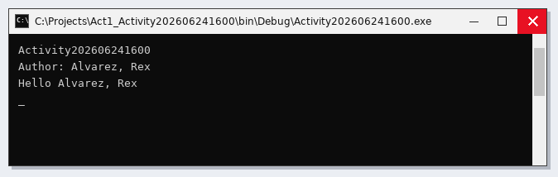

Activity 2 - Act2 Celcius-Fahrenheit Converter

Source Code
Module Module1
Sub Main()
Console.Write("Hello world")
Console.ReadLine()
Dim lastName As String = ""
Dim firstName As String = ""
Console.Write("Enter Lastname: ")
lastName = Console.ReadLine()
Console.Write("Enter Firstname: ")
firstName = Console.ReadLine()
Console.WriteLine("Your Lastname is " + lastName)
Console.WriteLine("Your Firstname is " + firstName)
Console.ReadLine()
' Converter 1: Celsius to Fahrenheit
Console.WriteLine("--- Celsius to Fahrenheit Converter ---" & vbNewLine)
Console.Write("Enter Celsius: ")
Dim celsiusInput As Decimal = Convert.ToDecimal(Console.ReadLine())
Dim fahrenheitResult As Decimal = (celsiusInput * 1.8) + 32
Console.WriteLine("Result in Fahrenheit: " & fahrenheitResult)
Console.ReadLine()
' Converter 2: Fahrenheit to Celsius
Console.WriteLine("--- Fahrenheit to Celsius Converter ---" & vbNewLine)
Console.Write("Enter Fahrenheit: ")
Dim fahrenheitInput As Decimal = Convert.ToDecimal(Console.ReadLine())
Dim celsiusResult As Decimal = (fahrenheitInput - 32) / 1.8
Console.WriteLine("Result in Celsius: " & celsiusResult)
Console.ReadLine()
End Sub
End Module

Sample Run
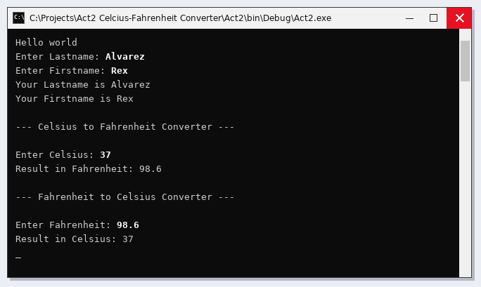

Activity 3 - Activity3_20260629

Source Code
Module Module1
Sub Main()
'Activity3_20260629'
'Create a vb.net console app that will accept 3 numbers, and display the sum, difference, product, quotient, and ave of the 3 numbers'
Try
ulit:
Console.WriteLine("Activity3_20260629")
Console.WriteLine("Author: Alvarez, Rex")
Console.WriteLine("Course Year Section: BSIT 3B")
Console.Write("Enter number 1: ")
Dim n1 As Integer = Convert.ToInt16(Console.ReadLine())
Console.Write("Enter number 2: ")
Dim n2 As Integer = Convert.ToInt16(Console.ReadLine())
Console.Write("Enter number 3: ")
Dim n3 As Integer = Convert.ToInt16(Console.ReadLine())
Console.Write("The sum is: ")
Dim sum As Double = n1 + n2 + n3
Console.WriteLine(sum)
Console.Write("The difference is: ")
Dim difference As Double = n1 - n2 - n3
Console.WriteLine(difference)
Console.Write("The product is: ")
Dim product As Double = n1 * n2 * n3
Console.WriteLine(product)
Console.Write("The quotient is: ")
Dim quotient As Double = n1 / n2 / n3
Console.WriteLine(quotient)
Console.Write("The average is: ")
Dim ave As Double = sum / 3
Console.WriteLine(ave)
Catch ex As FormatException
Console.WriteLine("Error: " & ex.Message)
GoTo ulit
End Try
Console.ReadKey()
'Iti nasursurwak ditoy nga taraon ket iti makuna nga "convertion method" iti agduduma nga datatypes.'
'ken syak ket na gwapo'
End Sub
End Module

Sample Run
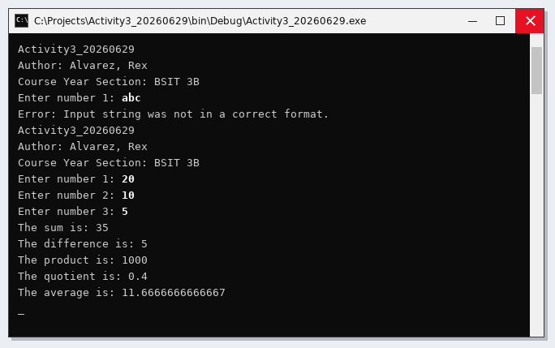

Activity 4 - Activity4_20260703

Source Code
Public Class Form1
Private n1 As Integer
Private n2 As Integer
Private n3 As Integer
Private sum As Integer
Private diff As Integer
Private quot As Integer
Private product As Integer
Private average As Integer
Private Sub Label2_Click(ByVal sender As System.Object, ByVal e As System.EventArgs) Handles Label2.Click
End Sub
Private Sub Form1_Load(ByVal sender As System.Object, ByVal e As System.EventArgs) Handles MyBase.Load
End Sub
Private Sub txtn1_TextChanged(ByVal sender As System.Object, ByVal e As System.EventArgs) Handles txtn1.TextChanged
End Sub
Private Sub txtn2_TextChanged(ByVal sender As System.Object, ByVal e As System.EventArgs) Handles txtn2.TextChanged
End Sub
Private Sub txtn3_TextChanged(ByVal sender As System.Object, ByVal e As System.EventArgs) Handles txtn3.TextChanged
End Sub
Private Sub txtsum_TextChanged(ByVal sender As System.Object, ByVal e As System.EventArgs) Handles txtsum.TextChanged
End Sub
Private Sub txtdiff_TextChanged(ByVal sender As System.Object, ByVal e As System.EventArgs) Handles txtdiff.TextChanged
End Sub
Private Sub txtprod_TextChanged(ByVal sender As System.Object, ByVal e As System.EventArgs) Handles txtprod.TextChanged
End Sub
Private Sub txtquot_TextChanged(ByVal sender As System.Object, ByVal e As System.EventArgs) Handles txtquot.TextChanged
End Sub
Private Sub txtave_TextChanged(ByVal sender As System.Object, ByVal e As System.EventArgs) Handles txtave.TextChanged
End Sub
Private Sub btnAdd_Click(ByVal sender As System.Object, ByVal e As System.EventArgs) Handles btnAdd.Click
Try
n1 = Convert.ToInt32(txtn1.Text())
n2 = Convert.ToInt32(txtn2.Text())
n3 = Convert.ToInt32(txtn3.Text())
sum = n1 + n2 + n3
txtsum.Text() = sum.ToString()
Catch ex As Exception
txtsum.Text = "Error: Maybe Invalid Number..."
End Try
End Sub
Private Sub btnSubtract_Click(ByVal sender As System.Object, ByVal e As System.EventArgs) Handles btnSubtract.Click
Try
n1 = Convert.ToInt32(txtn1.Text())
n2 = Convert.ToInt32(txtn2.Text())
n3 = Convert.ToInt32(txtn3.Text())
diff = n1 - n2 - n3
txtdiff.Text() = diff.ToString()
Catch ex As Exception
txtdiff.Text = "Error: Maybe Invalid Number..."
End Try
End Sub
Private Sub btnMultiply_Click(ByVal sender As System.Object, ByVal e As System.EventArgs) Handles btnMultiply.Click
Try
n1 = Convert.ToInt32(txtn1.Text())
n2 = Convert.ToInt32(txtn2.Text())
n3 = Convert.ToInt32(txtn3.Text())
quot = n1 * n2 * n3
txtquot.Text() = quot.ToString()
Catch ex As Exception
txtquot.Text = "Error: Maybe Invalid Number..."
End Try
End Sub
Private Sub btnDivide_Click(ByVal sender As System.Object, ByVal e As System.EventArgs) Handles btnDivide.Click
Try
n1 = Convert.ToInt32(txtn1.Text())
n2 = Convert.ToInt32(txtn2.Text())
n3 = Convert.ToInt32(txtn3.Text())
product = n1 / n2 / n3
txtprod.Text() = product.ToString()
Catch ex As Exception
txtprod.Text = "Error: Maybe Invalid Number..."
End Try
End Sub
Private Sub btnAverage_Click(ByVal sender As System.Object, ByVal e As System.EventArgs) Handles btnAverage.Click
Try
n1 = Convert.ToInt32(txtn1.Text())
n2 = Convert.ToInt32(txtn2.Text())
n3 = Convert.ToInt32(txtn3.Text())
average = (n1 + n2 + n3) / 3
txtave.Text() = average.ToString()
Catch ex As Exception
txtave.Text = "Error: Maybe Invalid Number..."
End Try
End Sub
Private Sub btnClear_Click(ByVal sender As System.Object, ByVal e As System.EventArgs) Handles btnClear.Click
txtn1.Clear()
txtn2.Clear()
txtn3.Clear()
txtsum.Clear()
txtdiff.Clear()
txtprod.Clear()
txtquot.Clear()
txtave.Clear()
End Sub
Private Sub btnExit_Click(ByVal sender As System.Object, ByVal e As System.EventArgs) Handles btnExit.Click
Application.Exit()
End Sub
End Class

Sample Run
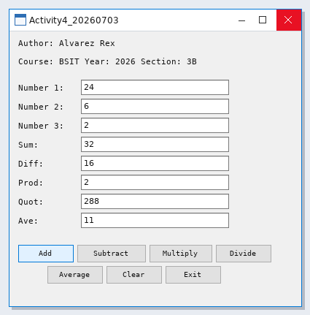

Form Design
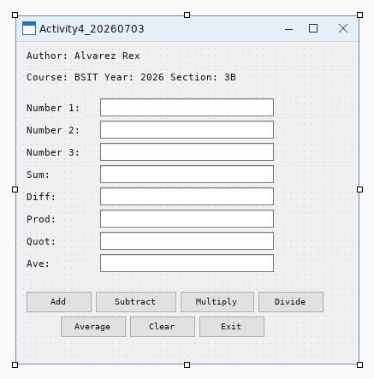

Activity 5

Source Code
Public Class Form1
'todo:
'display passed or failed
'get the value from the textbox
Dim ave As Double
Dim remarks As String
'try to challenge your self
Private Sub txtAverage_TextChanged(ByVal sender As System.Object, ByVal e As System.EventArgs) Handles txtAverage.TextChanged
End Sub
Private Sub Form1_Load(ByVal sender As System.Object, ByVal e As System.EventArgs) Handles MyBase.Load
End Sub
Private Sub txtRemarks_TextChanged(ByVal sender As System.Object, ByVal e As System.EventArgs) Handles txtRemarks.TextChanged
End Sub
Private Sub btnClear_Click(ByVal sender As System.Object, ByVal e As System.EventArgs) Handles btnClear.Click
txtAverage.Clear()
txtRemarks.Clear()
txtRemarks2.Clear()
txtRemarks3.Clear()
End Sub
Private Sub btnRemarks_Click(ByVal sender As System.Object, ByVal e As System.EventArgs) Handles btnRemarks.Click
Try
ave = Convert.ToDouble(txtAverage.Text)
' Remarks 1
txtRemarks.Text = If(ave >= 75, "Passed", If(ave >= 70, "Conditional", "Failed"))
' Remarks 2
txtRemarks2.Text = If(ave >= 94, "A",
If(ave >= 89, "B",
If(ave >= 84, "C",
If(ave >= 80, "D",
If(ave >= 75, "E", "F")))))
' Remarks 3
txtRemarks3.Text = If(ave >= 98, "1.00",
If(ave >= 95, "1.25",
If(ave >= 92, "1.50",
If(ave >= 89, "1.75",
If(ave >= 86, "2.00",
If(ave >= 83, "2.25",
If(ave >= 80, "2.50",
If(ave >= 77, "2.75",
If(ave >= 75, "3.00",
If(ave >= 70, "5.00", "Invalid Grade..."))))))))))
Catch ex As Exception
txtRemarks.Text = "There's something wrong with your code.."
txtRemarks2.Text = "Make sure to enter the right grade number"
txtRemarks3.Text = "Enter only numbers or decimal numbers"
End Try
End Sub
Private Sub btnExit_Click(ByVal sender As System.Object, ByVal e As System.EventArgs) Handles btnExit.Click
Application.Exit()
End Sub
Private Sub txtRemarks2_TextChanged(ByVal sender As System.Object, ByVal e As System.EventArgs) Handles txtRemarks2.TextChanged
End Sub
Private Sub txtRemarks3_TextChanged(ByVal sender As System.Object, ByVal e As System.EventArgs) Handles txtRemarks3.TextChanged
End Sub
End Class

Sample Run
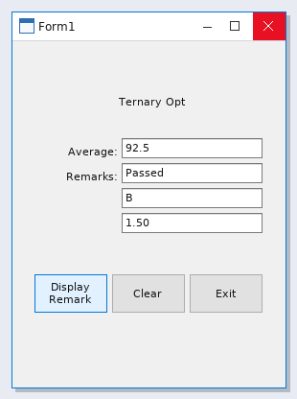

Form Design
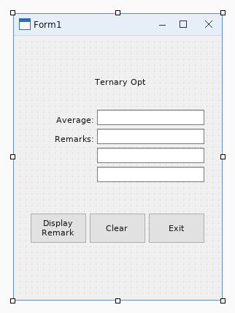

Activity 6 - Act6_IntegProg1_20260715

Source Code
Public Class Form1
Dim g1, g2, g3, sum, ave As Integer
Private Sub Form1_Load(ByVal sender As System.Object, ByVal e As System.EventArgs) Handles MyBase.Load
End Sub
Private Sub txtG1_TextChanged(ByVal sender As System.Object, ByVal e As System.EventArgs)
End Sub
Private Sub txtG2_TextChanged(ByVal sender As System.Object, ByVal e As System.EventArgs)
End Sub
Private Sub txtG3_TextChanged(ByVal sender As System.Object, ByVal e As System.EventArgs)
End Sub
Private Sub txtAve_TextChanged(ByVal sender As System.Object, ByVal e As System.EventArgs)
End Sub
Private Sub txtRemarks1_TextChanged(ByVal sender As System.Object, ByVal e As System.EventArgs)
End Sub
Private Sub txtRemarks2_TextChanged(ByVal sender As System.Object, ByVal e As System.EventArgs)
End Sub
Private Sub txtRemarks3_TextChanged(ByVal sender As System.Object, ByVal e As System.EventArgs)
End Sub
Private Sub btnDisplay_Click(ByVal sender As System.Object, ByVal e As System.EventArgs)
End Sub
Private Sub btnClear_Click(ByVal sender As System.Object, ByVal e As System.EventArgs)
End Sub
Private Sub btnExit_Click(ByVal sender As System.Object, ByVal e As System.EventArgs)
End Sub
Private Sub btnDisplay_Click_1(ByVal sender As System.Object, ByVal e As System.EventArgs)
End Sub
Private Sub btnClear_Click_1(ByVal sender As System.Object, ByVal e As System.EventArgs)
End Sub
Private Sub btnExit_Click_1(ByVal sender As System.Object, ByVal e As System.EventArgs)
Application.Exit()
End Sub
Private Sub btnDisplay_Click_2(ByVal sender As System.Object, ByVal e As System.EventArgs) Handles btnDisplay.Click
Try
'convert to double first
g1 = Convert.ToInt32(txtG1.Text())
g2 = Convert.ToInt32(txtG2.Text())
g3 = Convert.ToInt32(txtG3.Text())
'get the sum and average of the 3 numbers
sum = g1 + g2 + g3
ave = sum / 3.0
'get the value of txtave then convert to string
txtAve.Text = ave.ToString()
'decisions
'remarks 1
Select Case ave
Case Is >= 75
txtRemarks1.Text = "Passed!"
Case 74 To 70
txtRemarks1.Text = "Conditional!"
Case Is < 70
txtRemarks1.Text = "Failed!"
Case Else
txtRemarks1.Text = "Invalid Grade..."
End Select
'remarks 2
Select Case ave
Case 95 To 100
txtRemarks2.Text = "A"
Case 89 To 94
txtRemarks2.Text = "B"
Case 80 To 88
txtRemarks2.Text = "C"
Case 75 To 79
txtRemarks2.Text = "D"
Case 70 To 74
txtRemarks2.Text = "E"
Case Is < 70
txtRemarks2.Text = "F"
Case Else
txtRemarks2.Text = "Invalid Grade..."
End Select
'remarks 3
Select Case ave
Case 98 To 100
txtRemarks3.Text = "1.00"
Case 95 To 97
txtRemarks3.Text = "1.25"
Case 92 To 94
txtRemarks3.Text = "1.50"
Case 89 To 91
txtRemarks3.Text = "1.75"
Case 86 To 88
txtRemarks3.Text = "2.00"
Case 83 To 85
txtRemarks3.Text = "2.25"
Case 80 To 82
txtRemarks3.Text = "2.50"
Case 77 To 79
txtRemarks3.Text = "2.75"
Case 75 To 76
txtRemarks3.Text = "3.00"
Case 70 To 74
txtRemarks3.Text = "4.00"
Case Is < 70
txtRemarks3.Text = "5.00"
Case Else
txtRemarks3.Text = "Invalid Grade..."
End Select
'errror handling
Catch ex As Exception
txtRemarks1.Text = "Theres something wrong with your code.."
txtRemarks2.Text = "Make sure to enter the right grade number"
txtRemarks3.Text = "Enter only number or decimal number"
End Try
End Sub
Private Sub btnExit_Click_2(ByVal sender As System.Object, ByVal e As System.EventArgs) Handles btnExit.Click
'exits the application
Application.Exit()
End Sub
Private Sub btnClear_Click_2(ByVal sender As System.Object, ByVal e As System.EventArgs) Handles btnClear.Click
' Clear all grade inputs and outputs
txtG1.Clear()
txtG2.Clear()
txtG3.Clear()
txtAve.Clear()
txtRemarks1.Clear()
txtRemarks2.Clear()
txtRemarks3.Clear()
End Sub
End Class

Sample Run
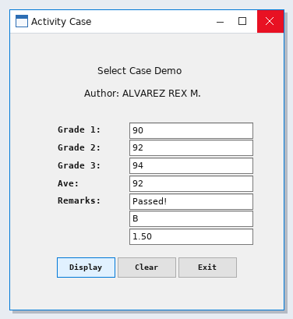

Form Design
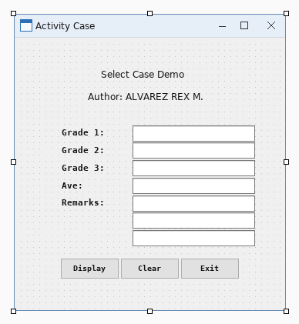

Activity 7 - Act7_IntegProg1_SW20260720

Source Code
Public Class Form1
Private Sub calculateButton_Click(ByVal sender As Object,
ByVal e As EventArgs) Handles calculateButton.Click
Dim principal As Decimal = Val(principalTextBox.Text)
Dim rate As Decimal = Val(interestRateTextBox.Text)
Dim amount As Decimal
resultsListBox.Items.Add(
"Year" & vbTab & "Amount on Deposit")
For yearCounter As Integer = 1 To yearsNumericUpDown.Value
amount = principal * ((1 + rate / 100) ^ yearCounter)
resultsListBox.Items.Add(yearCounter & vbTab &
String.Format("{0:C}", amount))
Next
End Sub
Private Sub principalTextBox_TextChanged(ByVal sender As Object,
ByVal e As EventArgs) Handles principalTextBox.TextChanged
resultsListBox.Items.Clear()
End Sub
Private Sub interestRateTextBox_TextChanged(ByVal sender As Object,
ByVal e As EventArgs) Handles interestRateTextBox.TextChanged
resultsListBox.Items.Clear()
End Sub
Private Sub yearsNumericUpDown_ValueChanged(ByVal sender As Object,
ByVal e As EventArgs) Handles yearsNumericUpDown.ValueChanged
resultsListBox.Items.Clear()
End Sub
Private Sub displaySquareButton_Click(ByVal sender As Object,
ByVal e As EventArgs) Handles displaySquareButton.Click
outputTextBox.Clear()
Dim fillCharacter As String = fillCharacterTextBox.Text
Dim sideLength As Integer = sideLengthNumericUpDown.Value
For row As Integer = 1 To sideLength
For column As Integer = 1 To sideLength
outputTextBox.AppendText(fillCharacter & " ")
Next column
outputTextBox.AppendText(vbCrLf)
Next row
End Sub
Private Sub fillCharacterTextBox_TextChanged(ByVal sender As Object,
ByVal e As EventArgs) Handles fillCharacterTextBox.TextChanged
outputTextBox.Clear()
End Sub
Private Sub sideLengthNumericUpDown_ValueChanged(ByVal sender As Object,
ByVal e As EventArgs) Handles sideLengthNumericUpDown.ValueChanged
outputTextBox.Clear()
End Sub
Dim aCount As Integer
Dim bCount As Integer
Dim cCount As Integer
Dim dCount As Integer
Dim fCount As Integer
Dim perfectScoreCount As Integer
Private Sub submitGradeButton_Click(ByVal sender As Object,
ByVal e As EventArgs) Handles submitGradeButton.Click
Dim grade As Integer = Val(gradeTextBox.Text)
gradesListBox.Items.Add(grade)
gradeTextBox.Clear()
Select Case grade
Case 100
perfectScoreCount += 1
aCount += 1
Case 90 To 99
aCount += 1
Case 80 To 89
bCount += 1
Case 70 To 79
cCount += 1
Case 60 To 69
dCount += 1
Case Else
fCount += 1
End Select
gradeTextBox.Focus()
End Sub
Private Sub calculateAverageButton_Click(ByVal sender As Object,
ByVal e As EventArgs) Handles calculateAverageButton.Click
Dim total As Integer
Dim gradeCounter As Integer
Dim grade As Integer
Dim average As Double
total = 0
gradeCounter = 0
Do While gradeCounter < gradesListBox.Items.Count
grade = gradesListBox.Items(gradeCounter)
total += grade
gradeCounter += 1
Loop
If gradeCounter <> 0 Then
average = total / gradeCounter
classAverageLabel.Text = "Total of the " & gradeCounter &
" grade(s) is " & total & vbCrLf & "Class average is " &
String.Format("{0:F}", average) & vbCrLf & vbCrLf
classAverageLabel.Text &=
"Letter grade summary:" & vbCrLf & "A: " & aCount &
vbCrLf & "B: " & bCount & vbCrLf & "C: " & cCount &
vbCrLf & "D: " & dCount & vbCrLf & "F: " & fCount &
vbCrLf & "Perfect scores: " & perfectScoreCount
Else
classAverageLabel.Text = "No grades were entered"
End If
End Sub
Private Sub clearGradesButton_Click(ByVal sender As Object,
ByVal e As EventArgs) Handles clearGradesButton.Click
gradesListBox.Items.Clear()
classAverageLabel.Text = String.Empty
End Sub
Private Sub Form1_Load(ByVal sender As Object,
ByVal e As EventArgs) Handles MyBase.Load
decimalOutputTextBox.AppendText("Decimal" & vbTab & "Octal" &
vbTab & "Hexadecimal" & vbTab & "Binary" & vbCrLf)
For number As Integer = 1 To 255
decimalOutputTextBox.AppendText(number & vbTab &
Convert.ToString(number, 8) & vbTab &
Convert.ToString(number, 16).ToUpper() & vbTab & vbTab &
Convert.ToString(number, 2) & vbCrLf)
Next number
End Sub
Private Sub decimalOutputTextBox_TextChanged(ByVal sender As System.Object, ByVal e As System.EventArgs) Handles decimalOutputTextBox.TextChanged
End Sub
Private Sub tabClassAverage_Click(ByVal sender As System.Object, ByVal e As System.EventArgs) Handles tabClassAverage.Click
End Sub
Private Sub TabPage1_Click(ByVal sender As System.Object, ByVal e As System.EventArgs) Handles TabPage1.Click
'square, rectangle, trapesoid, triangle, circle
End Sub
Private Sub TabPage2_Click(ByVal sender As System.Object, ByVal e As System.EventArgs) Handles TabPage2.Click
End Sub
End Class

Sample Run
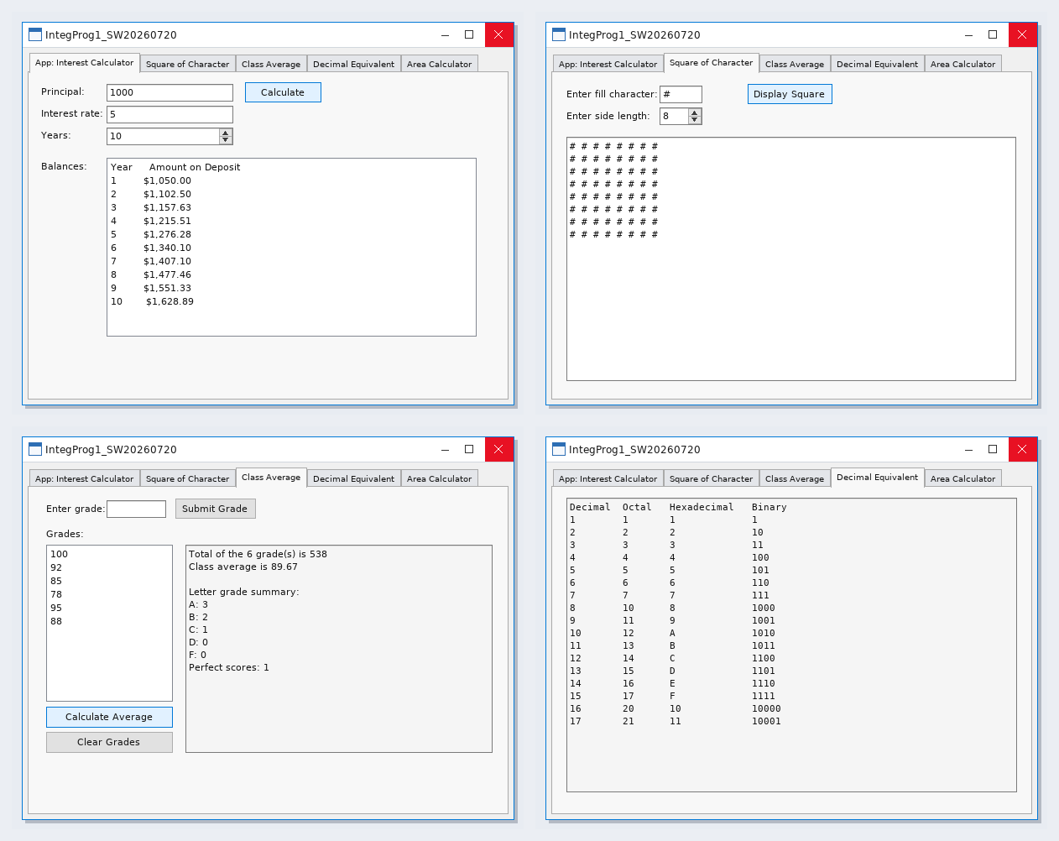

Form Design
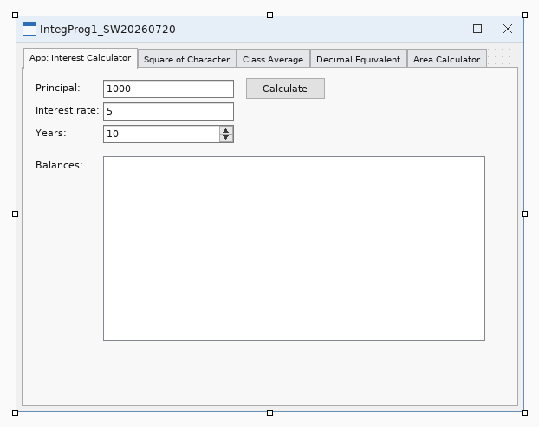

Activity 8 - Act8_SW20260805

Source Code
Public Class Form1
Private Sub Form1_Load(ByVal sender As System.Object, ByVal e As System.EventArgs) Handles MyBase.Load
End Sub
Private Sub messageInfoGroupBox_Enter(ByVal sender As System.Object, ByVal e As System.EventArgs) Handles messageInfoGroupBox.Enter
End Sub
Private Sub titleTextBox_TextChanged(ByVal sender As System.Object, ByVal e As System.EventArgs) Handles titleTextBox.TextChanged
End Sub
Private Sub messageTextBox_TextChanged(ByVal sender As System.Object, ByVal e As System.EventArgs) Handles messageTextBox.TextChanged
End Sub
Private Sub displayButton_Click(ByVal sender As System.Object, ByVal e As System.EventArgs) Handles displayButton.Click
Dim messageDescription As String = messageTextBox.Text
Dim messageTitle As String = titleTextBox.Text
Dim iconType As MessageBoxIcon
Dim buttonType As MessageBoxButtons
Dim defaultButton As MessageBoxDefaultButton
Dim result As DialogResult
Try
If String.IsNullOrWhiteSpace(titleTextBox.Text) Then
MessageBox.Show("Please enter a title.",
"Missing Title",
MessageBoxButtons.OK,
MessageBoxIcon.Warning)
titleTextBox.Focus()
Return
End If
If String.IsNullOrWhiteSpace(messageTextBox.Text) Then
MessageBox.Show("Please enter a message.",
"Missing Message",
MessageBoxButtons.OK,
MessageBoxIcon.Warning)
messageTextBox.Focus()
Return
End If
If Not informationRadioButton.Checked AndAlso
Not warningRadioButton.Checked AndAlso
Not questionRadioButton.Checked AndAlso
Not criticalRadioButton.Checked Then
MessageBox.Show("Please select an icon.",
"Icon Required",
MessageBoxButtons.OK,
MessageBoxIcon.Warning)
Return
End If
If Not okRadioButton.Checked AndAlso
Not okCancelRadioButton.Checked AndAlso
Not yesNoRadioButton.Checked AndAlso
Not yesNoCancelRadioButton.Checked AndAlso
Not retryCancelRadioButton.Checked AndAlso
Not abortRetryIgnoreRadioButton.Checked Then
MessageBox.Show("Please select a button type.",
"Button Required",
MessageBoxButtons.OK,
MessageBoxIcon.Warning)
Return
End If
If Not defaultButton1RadioButton.Checked AndAlso
Not defaultButton2RadioButton.Checked AndAlso
Not defaultButton3RadioButton.Checked Then
MessageBox.Show("Please select a default button.",
"Default Button Required",
MessageBoxButtons.OK,
MessageBoxIcon.Warning)
Return
End If
If informationRadioButton.Checked Then
iconType = MessageBoxIcon.Information
ElseIf warningRadioButton.Checked Then
iconType = MessageBoxIcon.Warning
ElseIf questionRadioButton.Checked Then
iconType = MessageBoxIcon.Question
Else
iconType = MessageBoxIcon.Error
End If
If okRadioButton.Checked Then
buttonType = MessageBoxButtons.OK
ElseIf okCancelRadioButton.Checked Then
buttonType = MessageBoxButtons.OKCancel
ElseIf yesNoRadioButton.Checked Then
buttonType = MessageBoxButtons.YesNo
ElseIf yesNoCancelRadioButton.Checked Then
buttonType = MessageBoxButtons.YesNoCancel
ElseIf retryCancelRadioButton.Checked Then
buttonType = MessageBoxButtons.RetryCancel
Else
buttonType = MessageBoxButtons.AbortRetryIgnore
End If
If defaultButton1RadioButton.Checked Then
defaultButton = MessageBoxDefaultButton.Button1
ElseIf defaultButton2RadioButton.Checked Then
defaultButton = MessageBoxDefaultButton.Button2
Else
defaultButton = MessageBoxDefaultButton.Button3
End If
result = MessageBox.Show(
messageDescription,
messageTitle,
buttonType,
iconType,
defaultButton)
Select Case result
Case DialogResult.OK
MessageBox.Show("OK has been clicked!",
"Result",
MessageBoxButtons.OK,
MessageBoxIcon.Information)
Case DialogResult.Cancel
MessageBox.Show("Cancel has been clicked!",
"Result",
MessageBoxButtons.OK,
MessageBoxIcon.Information)
Case DialogResult.Yes
MessageBox.Show("Yes has been clicked!",
"Result",
MessageBoxButtons.OK,
MessageBoxIcon.Information)
Case DialogResult.No
MessageBox.Show("No has been clicked!",
"Result",
MessageBoxButtons.OK,
MessageBoxIcon.Information)
Case DialogResult.Retry
MessageBox.Show("Retry has been clicked!",
"Result",
MessageBoxButtons.OK,
MessageBoxIcon.Information)
Case DialogResult.Abort
MessageBox.Show("Abort has been clicked!",
"Result",
MessageBoxButtons.OK,
MessageBoxIcon.Information)
Case DialogResult.Ignore
MessageBox.Show("Ignore has been clicked!",
"Result",
MessageBoxButtons.OK,
MessageBoxIcon.Information)
End Select
Catch ex As Exception
MessageBox.Show(ex.Message,
"There is an error",
MessageBoxButtons.OK,
MessageBoxIcon.Error)
End Try
End Sub
Private Sub clearButton_Click(ByVal sender As System.Object, ByVal e As System.EventArgs) Handles clearButton.Click
titleTextBox.Clear()
messageTextBox.Clear()
informationRadioButton.Checked = False
warningRadioButton.Checked = False
questionRadioButton.Checked = False
criticalRadioButton.Checked = False
okRadioButton.Checked = False
okCancelRadioButton.Checked = False
yesNoRadioButton.Checked = False
yesNoCancelRadioButton.Checked = False
retryCancelRadioButton.Checked = False
abortRetryIgnoreRadioButton.Checked = False
defaultButton1RadioButton.Checked = False
defaultButton2RadioButton.Checked = False
defaultButton3RadioButton.Checked = False
titleTextBox.Focus()
End Sub
Private Sub exitButton_Click(ByVal sender As System.Object, ByVal e As System.EventArgs) Handles exitButton.Click
Application.Exit()
End Sub
Private Sub iconsGroupBox_Enter(ByVal sender As System.Object, ByVal e As System.EventArgs) Handles iconsGroupBox.Enter
End Sub
Private Sub informationRadioButton_CheckedChanged(ByVal sender As System.Object, ByVal e As System.EventArgs) Handles informationRadioButton.CheckedChanged
End Sub
Private Sub questionRadioButton_CheckedChanged(ByVal sender As System.Object, ByVal e As System.EventArgs) Handles questionRadioButton.CheckedChanged
End Sub
Private Sub warningRadioButton_CheckedChanged(ByVal sender As System.Object, ByVal e As System.EventArgs) Handles warningRadioButton.CheckedChanged
End Sub
Private Sub criticalRadioButton_CheckedChanged(ByVal sender As System.Object, ByVal e As System.EventArgs) Handles criticalRadioButton.CheckedChanged
End Sub
Private Sub buttonsGroupBox_Enter(ByVal sender As System.Object, ByVal e As System.EventArgs) Handles buttonsGroupBox.Enter
End Sub
Private Sub okRadioButton_CheckedChanged(ByVal sender As System.Object, ByVal e As System.EventArgs) Handles okRadioButton.CheckedChanged
End Sub
Private Sub okCancelRadioButton_CheckedChanged(ByVal sender As System.Object, ByVal e As System.EventArgs) Handles okCancelRadioButton.CheckedChanged
End Sub
Private Sub yesNoRadioButton_CheckedChanged(ByVal sender As System.Object, ByVal e As System.EventArgs) Handles yesNoRadioButton.CheckedChanged
End Sub
Private Sub yesNoCancelRadioButton_CheckedChanged(ByVal sender As System.Object, ByVal e As System.EventArgs) Handles yesNoCancelRadioButton.CheckedChanged
End Sub
Private Sub retryCancelRadioButton_CheckedChanged(ByVal sender As System.Object, ByVal e As System.EventArgs) Handles retryCancelRadioButton.CheckedChanged
End Sub
Private Sub abortRetryIgnoreRadioButton_CheckedChanged(ByVal sender As System.Object, ByVal e As System.EventArgs) Handles abortRetryIgnoreRadioButton.CheckedChanged
End Sub
Private Sub defaultButtonGroupBox_Enter(ByVal sender As System.Object, ByVal e As System.EventArgs) Handles defaultButtonGroupBox.Enter
End Sub
Private Sub defaultButton1RadioButton_CheckedChanged(ByVal sender As System.Object, ByVal e As System.EventArgs) Handles defaultButton1RadioButton.CheckedChanged
End Sub
Private Sub defaultButton2RadioButton_CheckedChanged(ByVal sender As System.Object, ByVal e As System.EventArgs) Handles defaultButton2RadioButton.CheckedChanged
End Sub
Private Sub defaultButton3RadioButton_CheckedChanged(ByVal sender As System.Object, ByVal e As System.EventArgs) Handles defaultButton3RadioButton.CheckedChanged
End Sub
End Class

Sample Run
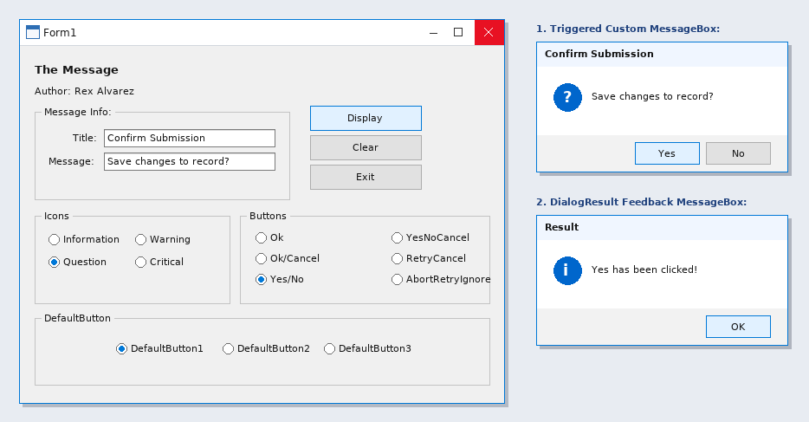

Form Design
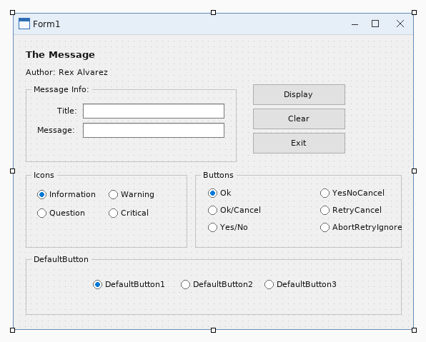

Activity 9 - SW202609301600

Source Code
Imports System
Imports System.IO
Imports System.Diagnostics
Imports System.Windows.Forms
Public Class ListViewSample
Private currentFolder As String = Environment.GetFolderPath(Environment.SpecialFolder.MyDocuments)
Public Sub New()
InitializeComponent()
AddHandler menuList.Click, AddressOf OpenListForm
AddHandler menuExit.Click, AddressOf ExitApplication
End Sub
Private Sub OpenListForm(ByVal sender As Object, ByVal e As EventArgs)
Using form As New ListViewSample()
form.ShowDialog()
End Using
End Sub
Private Sub ExitApplication(ByVal sender As Object, ByVal e As EventArgs)
Me.Close()
End Sub
Private Sub Form1_Load(ByVal sender As Object, ByVal e As EventArgs) Handles MyBase.Load
LoadFolder(currentFolder)
End Sub
Private Sub LoadFolder(ByVal folder As String)
If Not Directory.Exists(folder) Then Return
currentFolder = folder
txtPath.Text = folder
lv.Items.Clear()
Try
For Each directoryName As String In Directory.GetDirectories(folder)
Dim item As New ListViewItem(Path.GetFileName(directoryName))
item.SubItems.Add("Folder")
item.SubItems.Add(Directory.GetLastWriteTime(directoryName).ToString())
item.Tag = directoryName
lv.Items.Add(item)
Next
For Each fileName As String In Directory.GetFiles(folder)
Dim info As New FileInfo(fileName)
Dim item As New ListViewItem(info.Name)
item.SubItems.Add(info.Extension)
item.SubItems.Add(info.Length.ToString() & " bytes")
item.Tag = fileName
lv.Items.Add(item)
Next
lbl.Text = lv.Items.Count.ToString() & " item(s)"
Catch ex As Exception
lbl.Text = ex.Message
End Try
End Sub
Private Sub browse_Click(ByVal sender As Object, ByVal e As EventArgs) Handles browse.Click
Using dialog As New FolderBrowserDialog()
dialog.SelectedPath = currentFolder
dialog.Description = "Select a folder"
If dialog.ShowDialog() = DialogResult.OK Then
LoadFolder(dialog.SelectedPath)
End If
End Using
End Sub
Private Sub btnRefresh_Click(ByVal sender As Object, ByVal e As EventArgs) Handles btnRefresh.Click
LoadFolder(currentFolder)
End Sub
Private Sub details_Click(ByVal sender As Object, ByVal e As EventArgs) Handles details.Click
lv.View = View.Details
End Sub
Private Sub list_Click(ByVal sender As Object, ByVal e As EventArgs) Handles list.Click
lv.View = View.List
End Sub
Private Sub lv_DoubleClick(ByVal sender As Object, ByVal e As EventArgs) Handles lv.DoubleClick
If lv.SelectedItems.Count = 0 Then Return
Dim selectedPath As String = CStr(lv.SelectedItems(0).Tag)
If Directory.Exists(selectedPath) Then
LoadFolder(selectedPath)
ElseIf File.Exists(selectedPath) Then
Process.Start(selectedPath)
End If
End Sub
Private Sub lv_ColumnClick(ByVal sender As Object, ByVal e As ColumnClickEventArgs) Handles lv.ColumnClick
lv.ListViewItemSorter = New ListViewComparer(e.Column)
lv.Sort()
End Sub
Private Class ListViewComparer
Implements System.Collections.IComparer
Private ReadOnly columnNumber As Integer
Public Sub New(ByVal column As Integer)
columnNumber = column
End Sub
Public Function Compare(ByVal first As Object, ByVal second As Object) As Integer Implements System.Collections.IComparer.Compare
Dim a As ListViewItem = DirectCast(first, ListViewItem)
Dim b As ListViewItem = DirectCast(second, ListViewItem)
Return String.Compare(a.SubItems(columnNumber).Text, b.SubItems(columnNumber).Text, True)
End Function
End Class
End Class

Sample Run
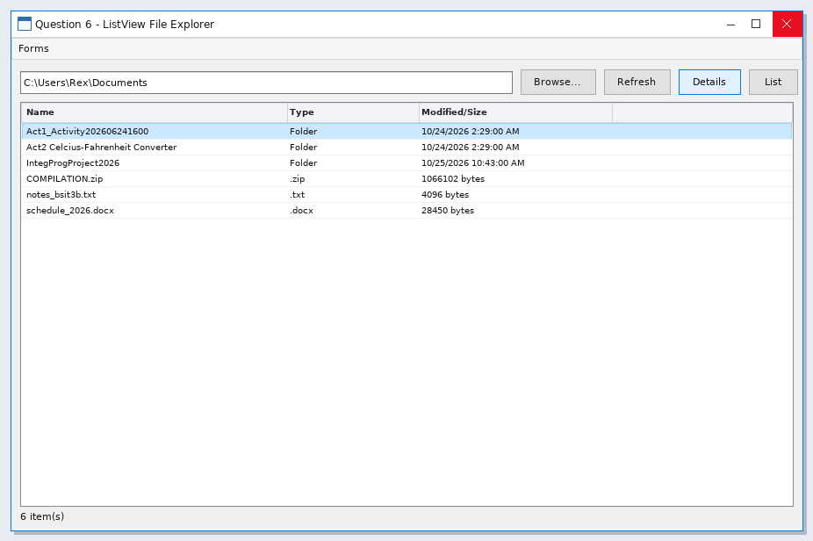

Form Design
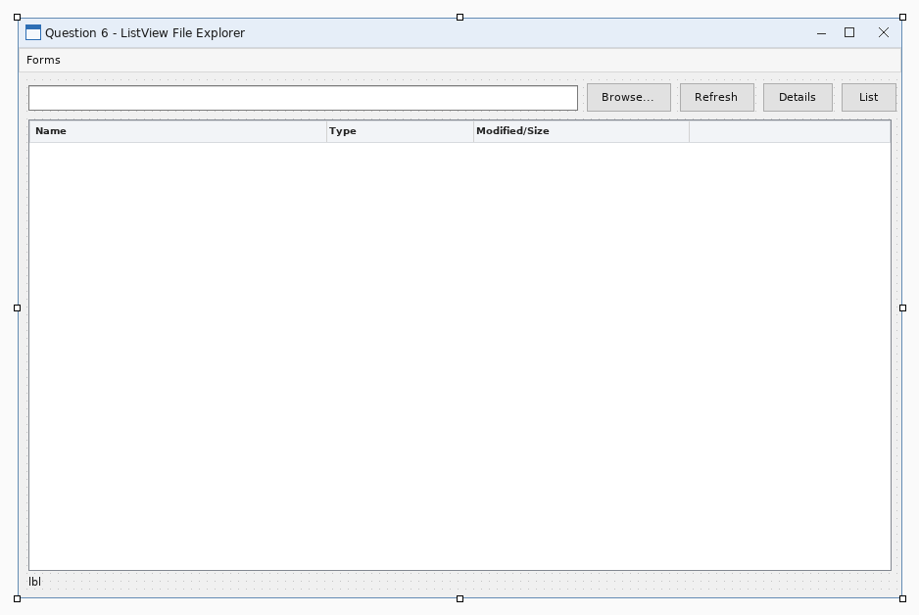

Activity 10 - SW20261002

Source Code
Form1.vb
Option Strict On
Option Explicit On
Public Class Form1
Private colorChanged As Boolean = False
Private Sub menuSplitPanel_Click(ByVal sender As Object, ByVal e As EventArgs) Handles menuSplitPanel.Click
Dim nextForm As New Form2()
nextForm.Owner = Me
AddHandler nextForm.FormClosed, AddressOf SplitFormClosed
nextForm.Show()
Me.Hide()
End Sub
Private Sub SplitFormClosed(ByVal sender As Object, ByVal e As FormClosedEventArgs)
If Not Me.IsDisposed Then Me.Show()
End Sub
Private Sub menuExit_Click(ByVal sender As Object, ByVal e As EventArgs) Handles menuExit.Click
Application.Exit()
End Sub
Private Sub btnVisible_Click(ByVal sender As Object, ByVal e As EventArgs) Handles btnVisible.Click
pnlGroup.Visible = Not pnlGroup.Visible
btnVisible.Text = If(pnlGroup.Visible, "Hide Group", "Show Group")
lblStatus.Text = "Visible = " & pnlGroup.Visible.ToString()
End Sub
Private Sub btnBackColor_Click(ByVal sender As Object, ByVal e As EventArgs) Handles btnBackColor.Click
colorChanged = Not colorChanged
pnlNested.BackColor = If(colorChanged, Color.LightSkyBlue, Color.PaleGreen)
lblStatus.Text = "BackColor changed on the nested panel."
End Sub
Private Sub btnBorder_Click(ByVal sender As Object, ByVal e As EventArgs) Handles btnBorder.Click
If pnlWorkspace.BorderStyle = BorderStyle.Fixed3D Then
pnlWorkspace.BorderStyle = BorderStyle.FixedSingle
Else
pnlWorkspace.BorderStyle = BorderStyle.Fixed3D
End If
lblStatus.Text = "BorderStyle = " & pnlWorkspace.BorderStyle.ToString()
End Sub
Private Sub btnRefresh_Click(ByVal sender As Object, ByVal e As EventArgs) Handles btnRefresh.Click
pnlWorkspace.Refresh()
lblStatus.Text = "Refresh() repainted the workspace panel."
End Sub
Private Sub btnInvalidate_Click(ByVal sender As Object, ByVal e As EventArgs) Handles btnInvalidate.Click
pnlWorkspace.Invalidate(True)
lblStatus.Text = "Invalidate() requested a redraw of the panel and child controls."
End Sub
Private Sub btnFocus_Click(ByVal sender As Object, ByVal e As EventArgs) Handles btnFocus.Click
Dim result As Boolean = pnlWorkspace.Focus()
lblStatus.Text = "Focus() result = " & result.ToString()
End Sub
Private Sub btnContains_Click(ByVal sender As Object, ByVal e As EventArgs) Handles btnContains.Click
Dim result As Boolean = pnlWorkspace.Contains(pnlGroup)
lblStatus.Text = "Contains(pnlGroup) = " & result.ToString()
End Sub
Private Sub btnDispose_Click(ByVal sender As Object, ByVal e As EventArgs) Handles btnDispose.Click
Dim sample As New Panel()
sample.Controls.Add(New Label())
sample.Dispose()
lblStatus.Text = "Dispose() released a temporary panel and its controls."
End Sub
Private Sub btnSave_Click(ByVal sender As Object, ByVal e As EventArgs) Handles btnSave.Click
lblStatus.Text = txtName.Text & " - " & txtCourse.Text & " saved from grouped controls."
End Sub
End Class
Form2.vb
Option Strict On
Option Explicit On
Public Class Form2
Private locked As Boolean = False
Private Sub Form2_Load(ByVal sender As Object, ByVal e As EventArgs) Handles MyBase.Load
SetSafeDistance(splitMain, 210)
SetSafeDistance(splitInner, CInt(splitInner.Height * 0.62))
AddRecord("Student Records", "ListView in Panel1")
AddRecord("Course Information", "Independent content")
AddRecord("Enrollment Report", "Resizable section")
AddRecord("System Settings", "Navigation example")
End Sub
Private Sub AddRecord(ByVal title As String, ByVal category As String)
Dim item As New ListViewItem(title)
item.SubItems.Add(category)
lvRecords.Items.Add(item)
End Sub
Private Sub lvRecords_SelectedIndexChanged(ByVal sender As Object, ByVal e As EventArgs) Handles lvRecords.SelectedIndexChanged
If lvRecords.SelectedItems.Count = 0 Then Return
txtDetails.Text = "Selected record: " & lvRecords.SelectedItems(0).Text & vbCrLf & vbCrLf & _
"This information is displayed independently inside Panel2." & vbCrLf & vbCrLf & _
"Both panels can be resized by dragging the splitter."
End Sub
Private Sub menuPanel_Click(ByVal sender As Object, ByVal e As EventArgs) Handles menuPanel.Click
If Me.Owner IsNot Nothing Then
Me.Owner.Show()
Else
Dim panelForm As New Form1()
panelForm.Show()
End If
Me.Close()
End Sub
Private Sub menuExit_Click(ByVal sender As Object, ByVal e As EventArgs) Handles menuExit.Click
Application.Exit()
End Sub
Private Sub btnCollapse1_Click(ByVal sender As Object, ByVal e As EventArgs) Handles btnCollapse1.Click
CollapsePanel(splitMain, 1)
lblStatus.Text = "CollapsePanel() collapsed Panel1 of the main SplitContainer."
End Sub
Private Sub btnCollapse2_Click(ByVal sender As Object, ByVal e As EventArgs) Handles btnCollapse2.Click
CollapsePanel(splitInner, 2)
lblStatus.Text = "CollapsePanel() collapsed Panel2 of the inner SplitContainer."
End Sub
Private Sub btnExpand_Click(ByVal sender As Object, ByVal e As EventArgs) Handles btnExpand.Click
ExpandPanel(splitMain)
ExpandPanel(splitInner)
SetSafeDistance(splitMain, 210)
If splitInner.Orientation = Orientation.Horizontal Then
SetSafeDistance(splitInner, CInt(splitInner.Height * 0.62))
Else
SetSafeDistance(splitInner, CInt(splitInner.Width * 0.62))
End If
lblStatus.Text = "ExpandPanel() displayed Panel1 and Panel2."
End Sub
Private Sub btnOrientation_Click(ByVal sender As Object, ByVal e As EventArgs) Handles btnOrientation.Click
Try
splitInner.Panel1MinSize = 60
splitInner.Panel2MinSize = 60
SetSafeDistance(splitInner, 150)
If splitInner.Orientation = Orientation.Horizontal Then
splitInner.Orientation = Orientation.Vertical
splitInner.Panel1MinSize = 180
splitInner.Panel2MinSize = 160
SetSafeDistance(splitInner, CInt(splitInner.Width * 0.62))
lblStatus.Text = "Orientation = Vertical, panels are left and right."
Else
splitInner.Orientation = Orientation.Horizontal
splitInner.Panel1MinSize = 120
splitInner.Panel2MinSize = 100
SetSafeDistance(splitInner, CInt(splitInner.Height * 0.62))
lblStatus.Text = "Orientation = Horizontal, panels are top and bottom."
End If
Catch ex As Exception
lblStatus.Text = ex.Message
End Try
End Sub
Private Sub btnLock_Click(ByVal sender As Object, ByVal e As EventArgs) Handles btnLock.Click
locked = Not locked
splitMain.IsSplitterFixed = locked
splitInner.IsSplitterFixed = locked
btnLock.Text = If(locked, "Unlock Splitters", "Lock Splitters")
lblStatus.Text = "IsSplitterFixed = " & locked.ToString()
End Sub
Private Sub btnRefresh_Click(ByVal sender As Object, ByVal e As EventArgs) Handles btnRefresh.Click
splitMain.Refresh()
splitInner.Refresh()
lblStatus.Text = "Refresh() repainted both SplitContainer controls."
End Sub
Private Sub btnInvalidate_Click(ByVal sender As Object, ByVal e As EventArgs) Handles btnInvalidate.Click
splitMain.Invalidate(True)
splitInner.Invalidate(True)
lblStatus.Text = "Invalidate() requested a redraw of every split panel."
End Sub
Private Sub btnDispose_Click(ByVal sender As Object, ByVal e As EventArgs) Handles btnDispose.Click
Dim sample As New SplitContainer()
sample.Panel1.Controls.Add(New Label())
sample.Panel2.Controls.Add(New Button())
sample.Dispose()
lblStatus.Text = "Dispose() released a temporary SplitContainer and both panels."
End Sub
Private Sub CollapsePanel(ByVal target As SplitContainer, ByVal panelNumber As Integer)
If panelNumber = 1 Then
target.Panel1Collapsed = True
Else
target.Panel2Collapsed = True
End If
End Sub
Private Sub ExpandPanel(ByVal target As SplitContainer)
target.Panel1Collapsed = False
target.Panel2Collapsed = False
End Sub
Private Sub SetSafeDistance(ByVal target As SplitContainer, ByVal requested As Integer)
Dim available As Integer
If target.Orientation = Orientation.Vertical Then
available = target.ClientSize.Width
Else
available = target.ClientSize.Height
End If
Dim minimum As Integer = target.Panel1MinSize
Dim maximum As Integer = available - target.Panel2MinSize - target.SplitterWidth
If maximum >= minimum Then target.SplitterDistance = Math.Max(minimum, Math.Min(requested, maximum))
End Sub
Private Sub splitMain_SplitterMoved(ByVal sender As Object, ByVal e As SplitterEventArgs) Handles splitMain.SplitterMoved
lblStatus.Text = "Main SplitterDistance = " & splitMain.SplitterDistance.ToString()
End Sub
Private Sub splitInner_SplitterMoved(ByVal sender As Object, ByVal e As SplitterEventArgs) Handles splitInner.SplitterMoved
lblStatus.Text = "Inner SplitterDistance = " & splitInner.SplitterDistance.ToString()
End Sub
End Class

Sample Run
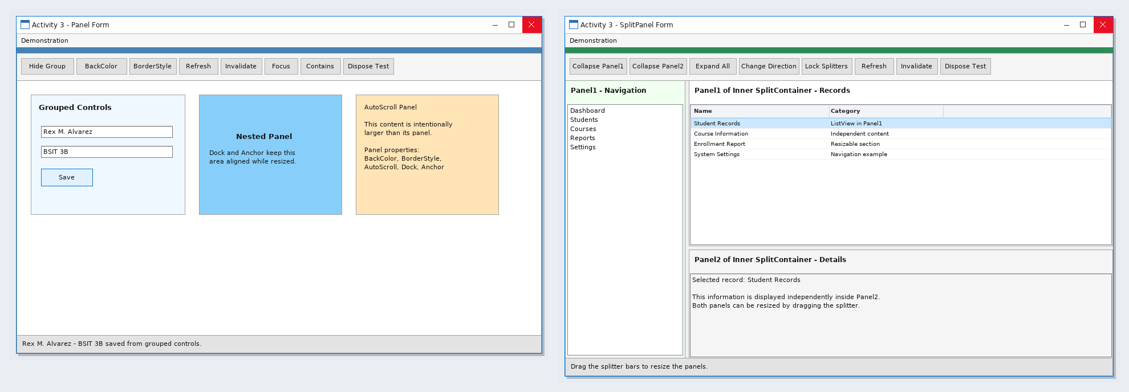

Form Design
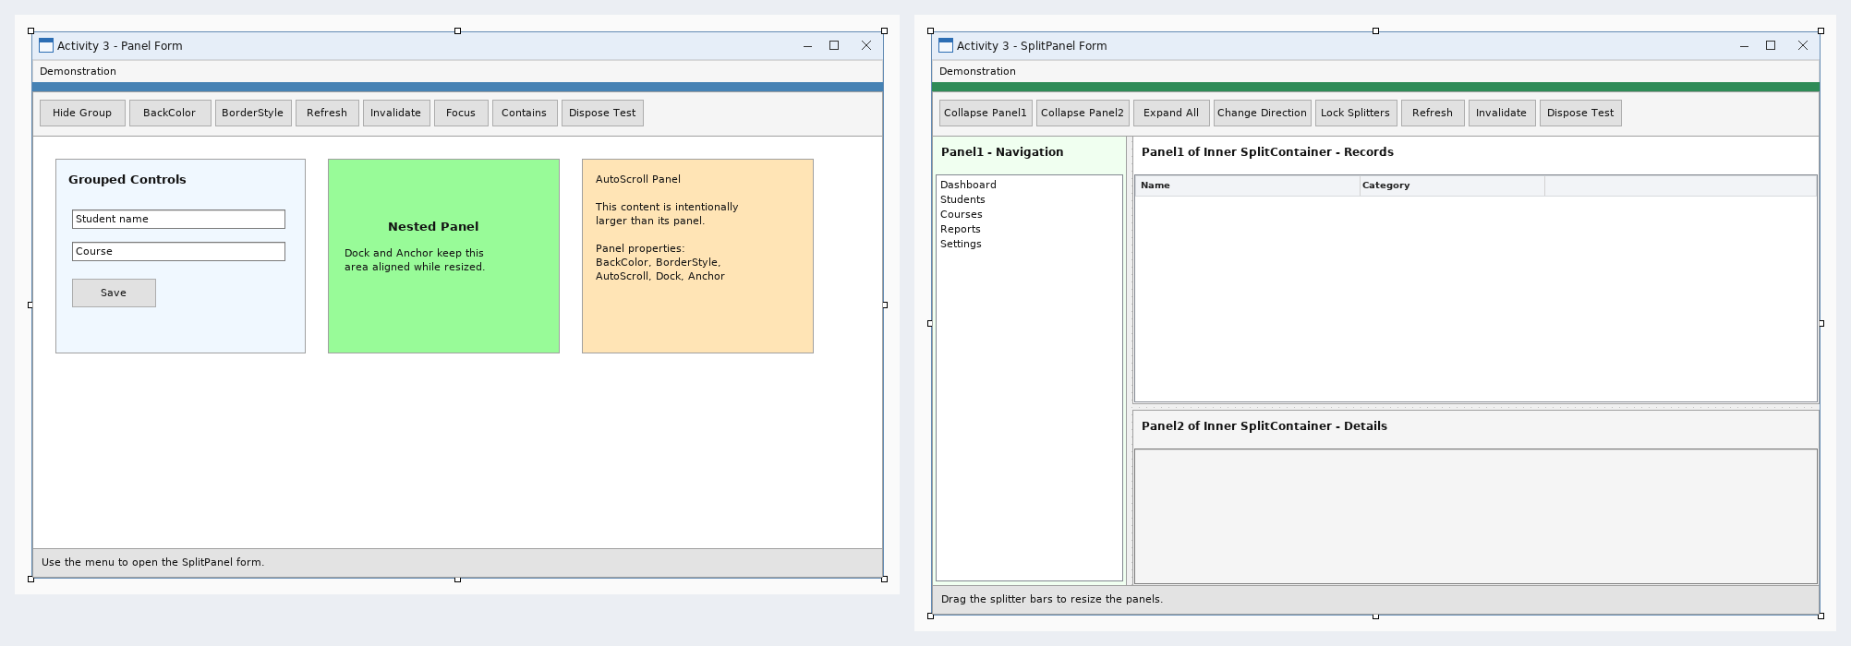

Activity 11 - SW202610021600

Source Code
MenuForm.vb
Imports System
Imports System.Drawing
Imports System.Windows.Forms
Public Class MenuForm
Inherits Form
Private menuStrip1 As MenuStrip
Private listMenu As ToolStripMenuItem
Private treeMenu As ToolStripMenuItem
Private openMenu As ToolStripMenuItem
Private combinedMenu As ToolStripMenuItem
Private exitMenu As ToolStripMenuItem
Public Sub New()
Me.Text = "SW202610021600"
Me.StartPosition = FormStartPosition.CenterScreen
Me.Size = New Size(720, 400)
menuStrip1 = New MenuStrip()
treeMenu = New ToolStripMenuItem("TreeView File Explorer")
openMenu = New ToolStripMenuItem("OpenFileDialog File Explorer")
combinedMenu = New ToolStripMenuItem("Combined File Explorer")
exitMenu = New ToolStripMenuItem("Exit")
menuStrip1.Items.AddRange(New ToolStripItem() {treeMenu, openMenu, combinedMenu, exitMenu})
menuStrip1.Dock = DockStyle.Top
Me.Controls.Add(menuStrip1)
Me.MainMenuStrip = menuStrip1
AddHandler treeMenu.Click, AddressOf OpenTree
AddHandler openMenu.Click, AddressOf OpenDialog
AddHandler combinedMenu.Click, AddressOf OpenCombined
AddHandler exitMenu.Click, AddressOf ExitProgram
End Sub
Private Sub OpenTree(ByVal sender As Object, ByVal e As EventArgs)
Using form As New TreeViewSample()
form.ShowDialog()
End Using
End Sub
Private Sub OpenDialog(ByVal sender As Object, ByVal e As EventArgs)
Using form As New OpenFileDialogSample()
form.ShowDialog()
End Using
End Sub
Private Sub OpenCombined(ByVal sender As Object, ByVal e As EventArgs)
Using form As New CombinedSample()
form.ShowDialog()
End Using
End Sub
Private Sub ExitProgram(ByVal sender As Object, ByVal e As EventArgs)
Me.Close()
End Sub
Private Sub MenuForm_Load(ByVal sender As System.Object, ByVal e As System.EventArgs) Handles MyBase.Load
End Sub
End Class
TreeViewSample.vb
Imports System
Imports System.IO
Imports System.Windows.Forms
Public Class TreeViewSample
Public Sub New()
InitializeComponent()
End Sub
Private Sub Form1_Load(ByVal sender As Object, ByVal e As EventArgs) Handles MyBase.Load
BuildTree()
End Sub
Private Sub BuildTree()
tree.Nodes.Clear()
For Each drive As DriveInfo In DriveInfo.GetDrives()
If drive.IsReady Then
Dim node As New TreeNode(drive.Name)
node.Tag = drive.RootDirectory.FullName
node.Nodes.Add("Loading...")
tree.Nodes.Add(node)
End If
Next
End Sub
Private Sub tree_BeforeExpand(ByVal sender As Object, ByVal e As TreeViewCancelEventArgs) Handles tree.BeforeExpand
Dim folder As String = CStr(e.Node.Tag)
e.Node.Nodes.Clear()
Try
For Each directoryName As String In Directory.GetDirectories(folder)
Dim child As New TreeNode(Path.GetFileName(directoryName))
child.Tag = directoryName
Try
If Directory.GetDirectories(directoryName).Length > 0 Then child.Nodes.Add("Loading...")
Catch
End Try
e.Node.Nodes.Add(child)
Next
Catch
End Try
End Sub
Private Sub tree_AfterSelect(ByVal sender As Object, ByVal e As TreeViewEventArgs) Handles tree.AfterSelect
selectedPath.Text = CStr(e.Node.Tag)
End Sub
Private Sub btnRefresh_Click(ByVal sender As Object, ByVal e As EventArgs) Handles btnRefresh.Click
BuildTree()
End Sub
End Class
OpenFileDialogSample.vb
Imports System
Imports System.Windows.Forms
Public Class OpenFileDialogSample
Public Sub New()
InitializeComponent()
End Sub
Private Sub one_Click(ByVal sender As Object, ByVal e As EventArgs) Handles one.Click
Using dialog As New OpenFileDialog()
Configure(dialog, False)
If dialog.ShowDialog() = DialogResult.OK Then ShowFiles(dialog.FileNames)
End Using
End Sub
Private Sub many_Click(ByVal sender As Object, ByVal e As EventArgs) Handles many.Click
Using dialog As New OpenFileDialog()
Configure(dialog, True)
If dialog.ShowDialog() = DialogResult.OK Then ShowFiles(dialog.FileNames)
End Using
End Sub
Private Sub Configure(ByVal dialog As OpenFileDialog, ByVal allowMultiple As Boolean)
dialog.Title = "Select file"
dialog.Filter = "All files (*.*)|*.*|Text files (*.txt)|*.txt|Images (*.jpg;*.png)|*.jpg;*.png"
dialog.FilterIndex = 1
dialog.Multiselect = allowMultiple
dialog.CheckFileExists = True
dialog.CheckPathExists = True
dialog.RestoreDirectory = True
End Sub
Private Sub ShowFiles(ByVal files() As String)
selected.Items.Clear()
For Each fileName As String In files
selected.Items.Add(fileName)
Next
End Sub
Private Sub clear_Click(ByVal sender As Object, ByVal e As EventArgs) Handles clear.Click
selected.Items.Clear()
End Sub
End Class
CombinedSample.vb
Imports System
Imports System.IO
Imports System.Diagnostics
Imports System.Windows.Forms
Public Class CombinedSample
Private currentFolder As String = Environment.GetFolderPath(Environment.SpecialFolder.MyDocuments)
Public Sub New()
InitializeComponent()
End Sub
Private Sub Form1_Load(ByVal sender As Object, ByVal e As EventArgs) Handles MyBase.Load
BuildTree()
LoadFolder(currentFolder)
End Sub
Private Sub BuildTree()
tree.Nodes.Clear()
For Each drive As DriveInfo In DriveInfo.GetDrives()
If drive.IsReady Then
Dim node As New TreeNode(drive.Name)
node.Tag = drive.RootDirectory.FullName
node.Nodes.Add("Loading...")
tree.Nodes.Add(node)
End If
Next
End Sub
Private Sub tree_BeforeExpand(ByVal sender As Object, ByVal e As TreeViewCancelEventArgs) Handles tree.BeforeExpand
Dim folder As String = CStr(e.Node.Tag)
e.Node.Nodes.Clear()
Try
For Each directoryName As String In Directory.GetDirectories(folder)
Dim child As New TreeNode(Path.GetFileName(directoryName))
child.Tag = directoryName
e.Node.Nodes.Add(child)
Next
Catch
End Try
End Sub
Private Sub tree_AfterSelect(ByVal sender As Object, ByVal e As TreeViewEventArgs) Handles tree.AfterSelect
currentFolder = CStr(e.Node.Tag)
LoadFolder(currentFolder)
End Sub
Private Sub LoadFolder(ByVal folder As String)
If Not Directory.Exists(folder) Then Return
lv.Items.Clear()
Try
For Each directoryName As String In Directory.GetDirectories(folder)
Dim item As New ListViewItem(Path.GetFileName(directoryName))
item.SubItems.Add("Folder")
item.Tag = directoryName
lv.Items.Add(item)
Next
For Each fileName As String In Directory.GetFiles(folder)
Dim item As New ListViewItem(Path.GetFileName(fileName))
item.SubItems.Add("File")
item.Tag = fileName
lv.Items.Add(item)
Next
Catch
End Try
End Sub
Private Sub open_Click(ByVal sender As Object, ByVal e As EventArgs) Handles open.Click
Using dialog As New OpenFileDialog()
dialog.Filter = "All files (*.*)|*.*"
dialog.CheckFileExists = True
If dialog.ShowDialog() = DialogResult.OK Then Process.Start(dialog.FileName)
End Using
End Sub
Private Sub save_Click(ByVal sender As Object, ByVal e As EventArgs) Handles save.Click
Using dialog As New SaveFileDialog()
dialog.Filter = "Text files (*.txt)|*.txt|All files (*.*)|*.*"
If dialog.ShowDialog() = DialogResult.OK Then
Using writer As New StreamWriter(dialog.FileName)
For Each item As ListViewItem In lv.Items
writer.WriteLine(item.Text & Microsoft.VisualBasic.ControlChars.Tab & item.SubItems(1).Text)
Next
End Using
End If
End Using
End Sub
Private Sub btnRefresh_Click(ByVal sender As Object, ByVal e As EventArgs) Handles btnRefresh.Click
BuildTree()
LoadFolder(currentFolder)
End Sub
End Class

Sample Run
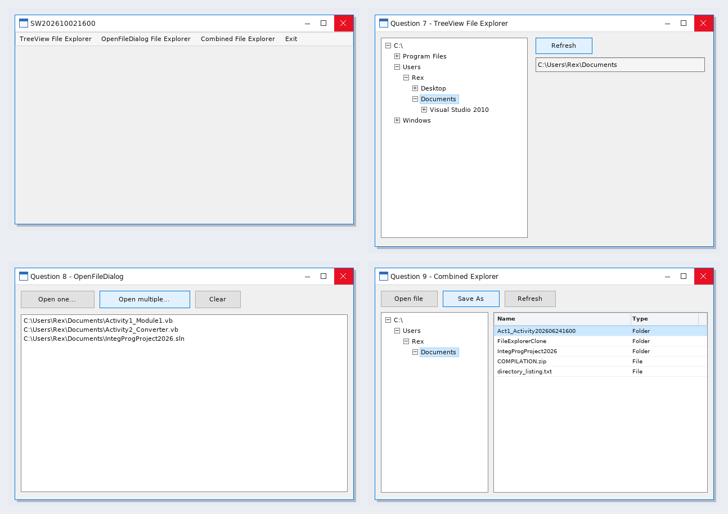

Form Design
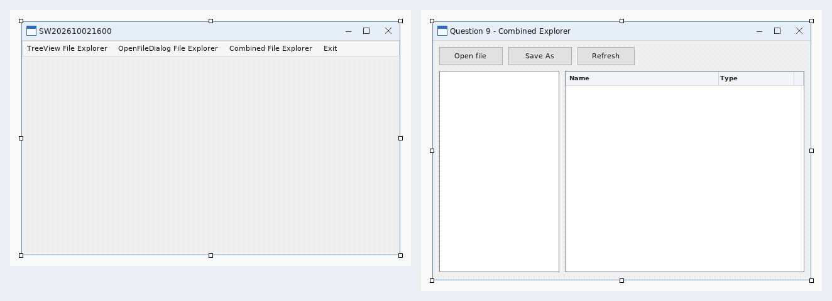

Activity 12

Source Code
Form1.vb
Option Strict On
Option Explicit On
Imports System.IO
Imports System.Text
Public Class Form1
Private currentPath As String = ""
Private history As New List(Of String)()
Private historyPosition As Integer = -1
Private changingFolder As Boolean = False
Private splittersLocked As Boolean = False
Private previewHost As Panel
Private cutPaths As New List(Of String)()
Private Sub Form1_Load(ByVal sender As Object, ByVal e As EventArgs) Handles MyBase.Load
Try
txtSearch.Text = ""
cboShowMode.Items.Clear()
cboShowMode.Items.Add("Details")
cboShowMode.Items.Add("Preview")
cboShowMode.Items.Add("Details + Preview")
cboShowMode.SelectedIndex = 2
SetSafeSplitterDistance(splitMain, 220)
SetSafeSplitterDistance(splitContent, CInt(splitContent.Width * 0.64))
LoadFolderTree()
Dim startFolder As String = Environment.GetFolderPath(Environment.SpecialFolder.MyDocuments)
If Not Directory.Exists(startFolder) Then startFolder = Environment.GetFolderPath(Environment.SpecialFolder.Desktop)
If Not Directory.Exists(startFolder) Then startFolder = Environment.CurrentDirectory
NavigateTo(startFolder, True)
UpdateFileToolState()
Catch ex As Exception
lblStatus.Text = "The explorer could not finish loading: " & ex.Message
End Try
End Sub
Private Sub LoadFolderTree()
tvFolders.Nodes.Clear()
AddRootNode("Desktop", Environment.GetFolderPath(Environment.SpecialFolder.Desktop))
AddRootNode("Documents", Environment.GetFolderPath(Environment.SpecialFolder.MyDocuments))
AddRootNode("Pictures", Environment.GetFolderPath(Environment.SpecialFolder.MyPictures))
AddRootNode("Computer", "")
Dim computer As TreeNode = tvFolders.Nodes(tvFolders.Nodes.Count - 1)
For Each drive As DriveInfo In DriveInfo.GetDrives()
Dim node As New TreeNode(drive.Name)
node.Tag = drive.RootDirectory.FullName
node.Nodes.Add(New TreeNode("Loading"))
computer.Nodes.Add(node)
Next
computer.Expand()
End Sub
Private Sub AddRootNode(ByVal title As String, ByVal folderPath As String)
If folderPath = "" OrElse Not Directory.Exists(folderPath) Then Return
Dim node As New TreeNode(title)
node.Tag = folderPath
node.Nodes.Add(New TreeNode("Loading"))
tvFolders.Nodes.Add(node)
End Sub
Private Sub tvFolders_BeforeExpand(ByVal sender As Object, ByVal e As TreeViewCancelEventArgs) Handles tvFolders.BeforeExpand
If e.Node.Tag Is Nothing Then Return
If e.Node.Nodes.Count = 1 AndAlso e.Node.Nodes(0).Tag Is Nothing Then
e.Node.Nodes.Clear()
Try
For Each folder As String In Directory.GetDirectories(CStr(e.Node.Tag))
Dim info As New DirectoryInfo(folder)
If (info.Attributes And FileAttributes.Hidden) = 0 Then
Dim child As New TreeNode(info.Name)
child.Tag = info.FullName
child.Nodes.Add(New TreeNode("Loading"))
e.Node.Nodes.Add(child)
End If
Next
Catch
End Try
End If
End Sub
Private Sub tvFolders_AfterSelect(ByVal sender As Object, ByVal e As TreeViewEventArgs) Handles tvFolders.AfterSelect
If changingFolder OrElse e.Node.Tag Is Nothing Then Return
NavigateTo(CStr(e.Node.Tag), True)
End Sub
Private Sub NavigateTo(ByVal folderPath As String, ByVal addToHistory As Boolean)
If folderPath = "" OrElse Not Directory.Exists(folderPath) Then
lblStatus.Text = "Folder not found."
Return
End If
Try
currentPath = folderPath
txtAddress.Text = folderPath
lblFiles.Text = IO.Path.GetFileName(folderPath)
If lblFiles.Text = "" Then lblFiles.Text = folderPath
If addToHistory Then
If historyPosition < history.Count - 1 Then
history.RemoveRange(historyPosition + 1, history.Count - historyPosition - 1)
End If
If history.Count = 0 OrElse history(history.Count - 1) <> folderPath Then
history.Add(folderPath)
historyPosition = history.Count - 1
End If
End If
FillFileList(txtSearch.Text.Trim())
SelectTreePath(folderPath)
ClearPreview("Select a file or folder to preview it.")
Catch ex As Exception
lblStatus.Text = ex.Message
End Try
End Sub
Private Sub SelectTreePath(ByVal folderPath As String)
changingFolder = True
Try
Dim found As TreeNode = FindNode(tvFolders.Nodes, folderPath)
If found IsNot Nothing Then tvFolders.SelectedNode = found
Finally
changingFolder = False
End Try
End Sub
Private Function FindNode(ByVal nodes As TreeNodeCollection, ByVal folderPath As String) As TreeNode
For Each node As TreeNode In nodes
If node.Tag IsNot Nothing AndAlso String.Equals(CStr(node.Tag), folderPath, StringComparison.OrdinalIgnoreCase) Then Return node
If node.IsExpanded Then
Dim found As TreeNode = FindNode(node.Nodes, folderPath)
If found IsNot Nothing Then Return found
End If
Next
Return Nothing
End Function
Private Sub FillFileList(ByVal filter As String)
lvFiles.BeginUpdate()
lvFiles.Items.Clear()
Try
For Each folder As String In Directory.GetDirectories(currentPath)
Dim info As New DirectoryInfo(folder)
If (info.Attributes And FileAttributes.Hidden) = 0 AndAlso MatchesFilter(info.Name, filter) Then
Dim item As New ListViewItem(info.Name)
item.SubItems.Add("File folder")
item.SubItems.Add("")
item.SubItems.Add(info.LastWriteTime.ToString("g"))
item.Tag = info.FullName
lvFiles.Items.Add(item)
End If
Next
For Each fileName As String In Directory.GetFiles(currentPath)
Dim info As New FileInfo(fileName)
If MatchesFilter(info.Name, filter) Then
Dim item As New ListViewItem(info.Name)
Dim extension As String = info.Extension.ToUpperInvariant()
If extension = "" Then extension = "File"
item.SubItems.Add(extension & " file")
item.SubItems.Add(FormatSize(info.Length))
item.SubItems.Add(info.LastWriteTime.ToString("g"))
item.Tag = info.FullName
lvFiles.Items.Add(item)
End If
Next
lblStatus.Text = lvFiles.Items.Count.ToString() & " items | " & currentPath
Catch ex As Exception
lblStatus.Text = "Cannot open folder: " & ex.Message
Finally
lvFiles.EndUpdate()
End Try
End Sub
Private Function MatchesFilter(ByVal itemName As String, ByVal filter As String) As Boolean
If filter = "" Then Return True
Return itemName.IndexOf(filter, StringComparison.OrdinalIgnoreCase) >= 0
End Function
Private Function FormatSize(ByVal value As Long) As String
If value >= 1073741824 Then Return (value / 1073741824.0).ToString("0.00") & " GB"
If value >= 1048576 Then Return (value / 1048576.0).ToString("0.00") & " MB"
If value >= 1024 Then Return (value / 1024.0).ToString("0.00") & " KB"
Return value.ToString() & " bytes"
End Function
Private Sub lvFiles_SelectedIndexChanged(ByVal sender As Object, ByVal e As EventArgs) Handles lvFiles.SelectedIndexChanged
UpdateFileToolState()
If lvFiles.SelectedItems.Count = 0 Then
ClearPreview("Select a file or folder to preview it.")
Return
End If
ShowPreview(CStr(lvFiles.SelectedItems(0).Tag))
End Sub
Private Sub lvFiles_DoubleClick(ByVal sender As Object, ByVal e As EventArgs) Handles lvFiles.DoubleClick
If lvFiles.SelectedItems.Count = 0 Then Return
Dim selectedPath As String = CStr(lvFiles.SelectedItems(0).Tag)
If Directory.Exists(selectedPath) Then
NavigateTo(selectedPath, True)
Else
Try
Process.Start(selectedPath)
Catch ex As Exception
lblStatus.Text = ex.Message
End Try
End If
End Sub
Private Sub ShowPreview(ByVal selectedPath As String)
ClearPreview("")
previewHost = New Panel()
previewHost.Dock = DockStyle.Fill
previewHost.AutoScroll = True
previewHost.BackColor = Color.White
previewHost.TabStop = True
pnlPreviewContent.Controls.Add(previewHost)
lblPreviewTitle.Text = IO.Path.GetFileName(selectedPath)
If Directory.Exists(selectedPath) Then
Try
Dim info As New DirectoryInfo(selectedPath)
Dim folderCount As Integer = 0
Dim fileCount As Integer = 0
Try
folderCount = Directory.GetDirectories(selectedPath).Length
fileCount = Directory.GetFiles(selectedPath).Length
Catch
End Try
Dim parentLocation As String = info.FullName
If info.Parent IsNot Nothing Then parentLocation = info.Parent.FullName
txtPreviewDetails.Text = "Type: File folder" & vbCrLf & _
"Location: " & parentLocation & vbCrLf & _
"Modified: " & info.LastWriteTime.ToString("g") & vbCrLf & _
"Contains: " & folderCount.ToString() & " folders, " & fileCount.ToString() & " files"
Dim text As New StringBuilder()
text.AppendLine(info.FullName)
text.AppendLine()
Try
For Each folder As String In Directory.GetDirectories(selectedPath)
text.AppendLine("[Folder] " & IO.Path.GetFileName(folder))
If text.Length > 100000 Then Exit For
Next
For Each fileName As String In Directory.GetFiles(selectedPath)
Dim child As New FileInfo(fileName)
text.AppendLine(" " & child.Name & " " & FormatSize(child.Length))
If text.Length > 200000 Then Exit For
Next
Catch ex As Exception
text.AppendLine(ex.Message)
End Try
AddTextPreview(text.ToString(), False)
Catch ex As Exception
AddTextPreview("Folder preview is not available." & vbCrLf & ex.Message, True)
End Try
Return
End If
Try
If Not File.Exists(selectedPath) Then
ClearPreview("The selected file no longer exists.")
Return
End If
Dim info As New FileInfo(selectedPath)
Dim extension As String = info.Extension.ToLowerInvariant()
txtPreviewDetails.Text = "Type: " & If(extension = "", "File", extension.ToUpperInvariant() & " file") & vbCrLf & _
"Size: " & FormatSize(info.Length) & vbCrLf & _
"Created: " & info.CreationTime.ToString("g") & vbCrLf & _
"Modified: " & info.LastWriteTime.ToString("g") & vbCrLf & _
"Attributes: " & info.Attributes.ToString()
Select Case extension
Case ".jpg", ".jpeg", ".png", ".gif", ".bmp", ".ico", ".tif", ".tiff", ".wmf", ".emf"
If info.Length > 52428800 Then
AddTextPreview("This image is larger than 50 MB. Open it normally to avoid using too much memory.", True)
Return
End If
Dim data As Byte() = File.ReadAllBytes(selectedPath)
Using stream As New MemoryStream(data)
Using source As Image = Image.FromStream(stream)
Dim picture As New PictureBox()
picture.Dock = DockStyle.Fill
picture.SizeMode = PictureBoxSizeMode.Zoom
picture.Image = New Bitmap(source)
previewHost.Controls.Add(picture)
txtPreviewDetails.Text &= vbCrLf & "Dimensions: " & source.Width.ToString() & " x " & source.Height.ToString()
End Using
End Using
Case ".rtf"
AddRtfPreview(selectedPath)
Case ".htm", ".html", ".mht", ".mhtml", ".xhtml", ".svg"
AddWebPreview(selectedPath)
Case ".pdf"
AddTextPreview(PreviewEngine.GetPdfText(selectedPath), True)
Case ".docx", ".docm", ".dotx"
AddTextPreview(PreviewEngine.GetDocxText(selectedPath), True)
Case ".xlsx", ".xltx"
AddTextPreview(PreviewEngine.GetXlsxText(selectedPath), False)
Case ".pptx", ".ppsx", ".potx"
AddTextPreview(PreviewEngine.GetPptxText(selectedPath), True)
Case ".doc", ".dot", ".xls", ".xlsm", ".xlsb", ".ppt", ".pps"
Dim officeText As String = PreviewEngine.GetLegacyOfficeText(selectedPath)
If String.IsNullOrEmpty(officeText) Then
officeText = "Microsoft Office is not available for a full preview." & vbCrLf & vbCrLf & PreviewEngine.ScrapeText(selectedPath, 1048576)
End If
AddTextPreview(officeText, True)
Case ".csv"
AddTextPreview(PreviewEngine.FormatDelimited(ReadText(selectedPath), ","c), False)
Case ".tsv"
AddTextPreview(PreviewEngine.FormatDelimited(ReadText(selectedPath), CChar(vbTab)), False)
Case ".zip", ".jar", ".apk", ".vsix", ".nupkg", ".epub"
AddTextPreview(PreviewEngine.GetZipListing(selectedPath), False)
Case ".exe", ".dll", ".ocx", ".sys"
AddTextPreview(PreviewEngine.GetVersionText(selectedPath) & vbCrLf & GetHexPreview(selectedPath, 512), False)
Case ".mp3", ".wav", ".wma", ".m4a", ".flac", ".ogg", ".aac", ".mp4", ".avi", ".mkv", ".wmv", ".mov", ".flv", ".3gp", ".webm"
AddTextPreview(PreviewEngine.GetMediaText(selectedPath), True)
Case ".txt", ".log", ".ini", ".xml", ".vb", ".cs", ".cpp", ".c", ".h", ".json", ".sql", ".bat", ".cmd", ".ps1", ".py", ".java", ".js", ".css", ".config", ".md"
AddTextPreview(ReadText(selectedPath), False)
Case Else
If LooksLikeText(selectedPath) Then
AddTextPreview(ReadText(selectedPath), False)
Else
AddTextPreview("This format has no visual preview. The first bytes are shown below." & vbCrLf & vbCrLf & GetHexPreview(selectedPath, 2048), False)
End If
End Select
previewHost.Focus()
pnlPreviewContent.Refresh()
Catch ex As OutOfMemoryException
AddTextPreview("The file is too large or damaged to preview safely.", True)
Catch ex As UnauthorizedAccessException
AddTextPreview("Access to this file was denied.", True)
Catch ex As IOException
AddTextPreview("The file is unavailable or is being used by another program." & vbCrLf & ex.Message, True)
Catch ex As Exception
AddTextPreview("Preview is not available." & vbCrLf & vbCrLf & ex.Message, True)
End Try
End Sub
Private Sub AddRtfPreview(ByVal fileName As String)
Dim box As New RichTextBox()
box.BackColor = Color.White
box.BorderStyle = BorderStyle.None
box.Dock = DockStyle.Fill
box.ReadOnly = True
box.ScrollBars = RichTextBoxScrollBars.Both
box.LoadFile(fileName)
previewHost.Controls.Add(box)
End Sub
Private Sub AddWebPreview(ByVal fileName As String)
Dim browser As New WebBrowser()
browser.AllowWebBrowserDrop = False
browser.Dock = DockStyle.Fill
browser.IsWebBrowserContextMenuEnabled = False
browser.ScriptErrorsSuppressed = True
previewHost.Controls.Add(browser)
browser.Navigate(New Uri(fileName))
End Sub
Private Function LooksLikeText(ByVal fileName As String) As Boolean
Try
Using stream As New FileStream(fileName, FileMode.Open, FileAccess.Read, FileShare.ReadWrite)
Dim size As Integer = CInt(Math.Min(stream.Length, 1024))
If size = 0 Then Return True
Dim data(size - 1) As Byte
stream.Read(data, 0, size)
Dim unusual As Integer = 0
For Each value As Byte In data
If value = 0 Then Return False
If value < 9 OrElse (value > 13 AndAlso value < 32) Then unusual += 1
Next
Return unusual * 100 \ size < 5
End Using
Catch
Return False
End Try
End Function
Private Function GetHexPreview(ByVal fileName As String, ByVal maximum As Integer) As String
Dim data() As Byte
Using stream As New FileStream(fileName, FileMode.Open, FileAccess.Read, FileShare.ReadWrite)
Dim size As Integer = CInt(Math.Min(stream.Length, maximum))
If size = 0 Then Return "Empty file"
ReDim data(size - 1)
stream.Read(data, 0, size)
End Using
Dim result As New StringBuilder()
Dim offset As Integer = 0
While offset < data.Length
Dim hexText As New StringBuilder()
Dim normalText As New StringBuilder()
For column As Integer = 0 To 15
If offset + column < data.Length Then
Dim value As Byte = data(offset + column)
hexText.Append(value.ToString("X2") & " ")
If value >= 32 AndAlso value <= 126 Then
normalText.Append(Chr(value))
Else
normalText.Append("."c)
End If
Else
hexText.Append(" ")
End If
Next
result.AppendLine(offset.ToString("X8") & " " & hexText.ToString() & " " & normalText.ToString())
offset += 16
End While
Return result.ToString()
End Function
Private Function ReadText(ByVal fileName As String) As String
Using stream As New FileStream(fileName, FileMode.Open, FileAccess.Read, FileShare.ReadWrite)
Dim size As Integer = CInt(Math.Min(stream.Length, 262144))
If size = 0 Then Return ""
Dim data(size - 1) As Byte
stream.Read(data, 0, size)
Dim text As String = Encoding.Default.GetString(data)
If stream.Length > size Then text &= vbCrLf & vbCrLf & "Preview shortened."
Return text
End Using
End Function
Private Sub AddTextPreview(ByVal value As String, ByVal wrapText As Boolean)
Dim box As New TextBox()
box.BackColor = Color.White
box.BorderStyle = BorderStyle.None
box.Dock = DockStyle.Fill
box.Font = New Font("Consolas", 9.0!)
box.Multiline = True
box.ReadOnly = True
box.ScrollBars = ScrollBars.Both
box.WordWrap = wrapText
box.Text = value
previewHost.Controls.Add(box)
End Sub
Private Sub ClearPreview(ByVal message As String)
If previewHost IsNot Nothing Then
If pnlPreviewContent.Contains(previewHost) Then pnlPreviewContent.Controls.Remove(previewHost)
previewHost.Dispose()
previewHost = Nothing
End If
lblPreviewTitle.Text = "Preview"
txtPreviewDetails.Text = If(message = "", "", "No file selected")
If message <> "" Then
previewHost = New Panel()
previewHost.Dock = DockStyle.Fill
previewHost.BackColor = Color.White
pnlPreviewContent.Controls.Add(previewHost)
Dim label As New Label()
label.Dock = DockStyle.Fill
label.ForeColor = SystemColors.GrayText
label.Text = message
label.TextAlign = ContentAlignment.MiddleCenter
previewHost.Controls.Add(label)
End If
End Sub
Private Function GetSelectedPath() As String
If lvFiles.SelectedItems.Count = 0 Then Return ""
Return CStr(lvFiles.SelectedItems(0).Tag)
End Function
Private Sub UpdateFileToolState()
Dim hasSelection As Boolean = lvFiles.SelectedItems.Count > 0
toolCut.Enabled = hasSelection
toolCopy.Enabled = hasSelection
toolRename.Enabled = hasSelection
toolDelete.Enabled = hasSelection
Try
toolPaste.Enabled = Clipboard.ContainsFileDropList()
Catch
toolPaste.Enabled = False
End Try
End Sub
Private Sub toolNewFolder_Click(ByVal sender As Object, ByVal e As EventArgs) Handles toolNewFolder.Click
Try
Dim folderName As String = GetUniqueDestination(currentPath, "New folder")
Directory.CreateDirectory(folderName)
FillFileList(txtSearch.Text.Trim())
For Each item As ListViewItem In lvFiles.Items
If String.Equals(CStr(item.Tag), folderName, StringComparison.OrdinalIgnoreCase) Then
item.Selected = True
item.BeginEdit()
Exit For
End If
Next
lblStatus.Text = "A new folder was created."
Catch ex As Exception
MessageBox.Show(ex.Message, "New Folder", MessageBoxButtons.OK, MessageBoxIcon.Error)
End Try
End Sub
Private Sub toolCopy_Click(ByVal sender As Object, ByVal e As EventArgs) Handles toolCopy.Click
CopySelection(False)
End Sub
Private Sub toolCut_Click(ByVal sender As Object, ByVal e As EventArgs) Handles toolCut.Click
CopySelection(True)
End Sub
Private Sub CopySelection(ByVal cut As Boolean)
Dim selectedPath As String = GetSelectedPath()
If selectedPath = "" Then Return
Try
Dim files As New System.Collections.Specialized.StringCollection()
files.Add(selectedPath)
Clipboard.SetFileDropList(files)
cutPaths.Clear()
If cut Then cutPaths.Add(selectedPath)
toolPaste.Enabled = True
lblStatus.Text = If(cut, "Item ready to move.", "Item copied to the Clipboard.")
Catch ex As Exception
MessageBox.Show(ex.Message, "Clipboard", MessageBoxButtons.OK, MessageBoxIcon.Error)
End Try
End Sub
Private Sub toolPaste_Click(ByVal sender As Object, ByVal e As EventArgs) Handles toolPaste.Click
If currentPath = "" Then Return
Try
If Not Clipboard.ContainsFileDropList() Then Return
Dim clipboardItems As System.Collections.Specialized.StringCollection = Clipboard.GetFileDropList()
For Each source As String In clipboardItems
If Not File.Exists(source) AndAlso Not Directory.Exists(source) Then Continue For
If Directory.Exists(source) AndAlso currentPath.StartsWith(source.TrimEnd(IO.Path.DirectorySeparatorChar) & IO.Path.DirectorySeparatorChar, StringComparison.OrdinalIgnoreCase) Then
Throw New IOException("A folder cannot be pasted inside itself.")
End If
Dim destination As String = GetUniqueDestination(currentPath, IO.Path.GetFileName(source.TrimEnd(IO.Path.DirectorySeparatorChar)))
Dim moveItem As Boolean = cutPaths.Exists(Function(value As String) String.Equals(value, source, StringComparison.OrdinalIgnoreCase))
If moveItem Then
If Directory.Exists(source) Then
Directory.Move(source, destination)
Else
File.Move(source, destination)
End If
ElseIf Directory.Exists(source) Then
CopyDirectory(source, destination)
Else
File.Copy(source, destination, False)
End If
Next
cutPaths.Clear()
FillFileList(txtSearch.Text.Trim())
lblStatus.Text = "Paste completed."
Catch ex As Exception
MessageBox.Show(ex.Message, "Paste", MessageBoxButtons.OK, MessageBoxIcon.Error)
End Try
UpdateFileToolState()
End Sub
Private Sub CopyDirectory(ByVal source As String, ByVal destination As String)
Directory.CreateDirectory(destination)
For Each fileName As String In Directory.GetFiles(source)
File.Copy(fileName, IO.Path.Combine(destination, IO.Path.GetFileName(fileName)), False)
Next
For Each folder As String In Directory.GetDirectories(source)
CopyDirectory(folder, IO.Path.Combine(destination, IO.Path.GetFileName(folder)))
Next
End Sub
Private Function GetUniqueDestination(ByVal parentFolder As String, ByVal itemName As String) As String
Dim destination As String = IO.Path.Combine(parentFolder, itemName)
If Not File.Exists(destination) AndAlso Not Directory.Exists(destination) Then Return destination
Dim baseName As String = IO.Path.GetFileNameWithoutExtension(itemName)
Dim extension As String = IO.Path.GetExtension(itemName)
Dim number As Integer = 2
Do
destination = IO.Path.Combine(parentFolder, baseName & " (" & number.ToString() & ")" & extension)
number += 1
Loop While File.Exists(destination) OrElse Directory.Exists(destination)
Return destination
End Function
Private Sub toolRename_Click(ByVal sender As Object, ByVal e As EventArgs) Handles toolRename.Click
If lvFiles.SelectedItems.Count > 0 Then lvFiles.SelectedItems(0).BeginEdit()
End Sub
Private Sub lvFiles_AfterLabelEdit(ByVal sender As Object, ByVal e As LabelEditEventArgs) Handles lvFiles.AfterLabelEdit
If e.Label Is Nothing Then Return
If e.Label.Trim() = "" OrElse e.Label.IndexOfAny(IO.Path.GetInvalidFileNameChars()) >= 0 Then
e.CancelEdit = True
MessageBox.Show("Enter a valid name.", "Rename", MessageBoxButtons.OK, MessageBoxIcon.Warning)
Return
End If
Dim source As String = CStr(lvFiles.Items(e.Item).Tag)
Dim destination As String = IO.Path.Combine(IO.Path.GetDirectoryName(source), e.Label.Trim())
Try
If File.Exists(destination) OrElse Directory.Exists(destination) Then Throw New IOException("An item with that name already exists.")
If Directory.Exists(source) Then
Directory.Move(source, destination)
Else
File.Move(source, destination)
End If
lvFiles.Items(e.Item).Tag = destination
lblStatus.Text = "Item renamed."
Catch ex As Exception
e.CancelEdit = True
MessageBox.Show(ex.Message, "Rename", MessageBoxButtons.OK, MessageBoxIcon.Error)
End Try
End Sub
Private Sub toolDelete_Click(ByVal sender As Object, ByVal e As EventArgs) Handles toolDelete.Click
Dim selectedPath As String = GetSelectedPath()
If selectedPath = "" Then Return
If MessageBox.Show("Delete " & IO.Path.GetFileName(selectedPath) & "?", "Delete", MessageBoxButtons.YesNo, MessageBoxIcon.Warning) <> DialogResult.Yes Then Return
Try
ClearPreview("Select a file or folder to preview it.")
If Directory.Exists(selectedPath) Then
Directory.Delete(selectedPath, True)
Else
File.Delete(selectedPath)
End If
FillFileList(txtSearch.Text.Trim())
lblStatus.Text = "Item deleted."
Catch ex As Exception
MessageBox.Show(ex.Message, "Delete", MessageBoxButtons.OK, MessageBoxIcon.Error)
End Try
End Sub
Private Sub Sort_Click(ByVal sender As Object, ByVal e As EventArgs) Handles sortName.Click, sortDate.Click, sortType.Click, sortSize.Click
Dim mode As Integer = 0
If sender Is sortDate Then mode = 1
If sender Is sortType Then mode = 2
If sender Is sortSize Then mode = 3
lvFiles.ListViewItemSorter = New ExplorerItemComparer(mode)
lvFiles.Sort()
lblStatus.Text = "Items sorted by " & DirectCast(sender, ToolStripMenuItem).Text & "."
End Sub
Private Class ExplorerItemComparer
Implements System.Collections.IComparer
Private mode As Integer
Public Sub New(ByVal sortMode As Integer)
mode = sortMode
End Sub
Public Function Compare(ByVal x As Object, ByVal y As Object) As Integer Implements System.Collections.IComparer.Compare
Dim first As ListViewItem = DirectCast(x, ListViewItem)
Dim second As ListViewItem = DirectCast(y, ListViewItem)
Dim firstPath As String = CStr(first.Tag)
Dim secondPath As String = CStr(second.Tag)
Dim firstFolder As Boolean = Directory.Exists(firstPath)
Dim secondFolder As Boolean = Directory.Exists(secondPath)
If firstFolder AndAlso Not secondFolder Then Return -1
If secondFolder AndAlso Not firstFolder Then Return 1
Try
Select Case mode
Case 1
Return DateTime.Compare(File.GetLastWriteTime(firstPath), File.GetLastWriteTime(secondPath))
Case 2
Return String.Compare(IO.Path.GetExtension(firstPath), IO.Path.GetExtension(secondPath), True)
Case 3
Dim firstSize As Long = If(firstFolder, 0, New FileInfo(firstPath).Length)
Dim secondSize As Long = If(secondFolder, 0, New FileInfo(secondPath).Length)
Return firstSize.CompareTo(secondSize)
Case Else
Return String.Compare(first.Text, second.Text, True)
End Select
Catch
Return String.Compare(first.Text, second.Text, True)
End Try
End Function
End Class
Private Sub viewDetails_Click(ByVal sender As Object, ByVal e As EventArgs) Handles viewDetails.Click
lvFiles.View = View.Details
End Sub
Private Sub viewList_Click(ByVal sender As Object, ByVal e As EventArgs) Handles viewList.Click
lvFiles.View = View.List
End Sub
Private Sub viewLarge_Click(ByVal sender As Object, ByVal e As EventArgs) Handles viewLarge.Click
lvFiles.View = View.LargeIcon
End Sub
Private Sub toolDetailsPane_Click(ByVal sender As Object, ByVal e As EventArgs) Handles toolDetailsPane.Click
If toolDetailsPane.Checked Then
ExpandPanel(splitContent)
pnlPreview.Visible = True
btnPreview.Text = "Hide Preview"
Else
pnlPreview.Visible = False
CollapsePanel(splitContent, 2)
btnPreview.Text = "Show Preview"
End If
End Sub
Private Sub btnBack_Click(ByVal sender As Object, ByVal e As EventArgs) Handles btnBack.Click
If historyPosition > 0 Then
historyPosition -= 1
NavigateTo(history(historyPosition), False)
End If
End Sub
Private Sub btnUp_Click(ByVal sender As Object, ByVal e As EventArgs) Handles btnUp.Click
If currentPath = "" Then Return
Dim parent As DirectoryInfo = Directory.GetParent(currentPath)
If parent IsNot Nothing Then NavigateTo(parent.FullName, True)
End Sub
Private Sub btnRefresh_Click(ByVal sender As Object, ByVal e As EventArgs) Handles btnRefresh.Click
FillFileList(txtSearch.Text.Trim())
pnlFiles.Refresh()
splitContent.Refresh()
lblStatus.Text = "Refresh() updated the folder and repainted the panels."
End Sub
Private Sub txtAddress_KeyDown(ByVal sender As Object, ByVal e As KeyEventArgs) Handles txtAddress.KeyDown
If e.KeyCode = Keys.Enter Then
NavigateTo(txtAddress.Text.Trim(), True)
e.SuppressKeyPress = True
End If
End Sub
Private Sub txtSearch_TextChanged(ByVal sender As Object, ByVal e As EventArgs) Handles txtSearch.TextChanged
If currentPath <> "" Then FillFileList(txtSearch.Text.Trim())
End Sub
Private Sub cboShowMode_SelectedIndexChanged(ByVal sender As Object, ByVal e As EventArgs) Handles cboShowMode.SelectedIndexChanged
ApplyPreviewMode()
If Me.Visible AndAlso splitContent.Panel2Collapsed Then
ExpandPanel(splitContent)
pnlPreview.Visible = True
btnPreview.Text = "Hide Preview"
End If
End Sub
Private Sub ApplyPreviewMode()
Select Case cboShowMode.SelectedIndex
Case 0
txtPreviewDetails.Visible = True
txtPreviewDetails.Dock = DockStyle.Fill
pnlPreviewContent.Visible = False
lblStatus.Text = "The right pane is showing file details."
Case 1
txtPreviewDetails.Visible = False
pnlPreviewContent.Visible = True
pnlPreviewContent.Dock = DockStyle.Fill
lblStatus.Text = "The right pane is showing the file preview."
Case Else
txtPreviewDetails.Dock = DockStyle.Top
txtPreviewDetails.Height = 112
txtPreviewDetails.Visible = True
pnlPreviewContent.Visible = True
pnlPreviewContent.Dock = DockStyle.Fill
lblStatus.Text = "The right pane is showing details and preview."
End Select
pnlPreview.PerformLayout()
pnlPreview.Invalidate(True)
End Sub
Private Sub btnFolders_Click(ByVal sender As Object, ByVal e As EventArgs) Handles btnFolders.Click
If splitMain.Panel1Collapsed Then
ExpandPanel(splitMain)
pnlFolders.Visible = True
btnFolders.Text = "Hide Folders"
lblStatus.Text = "ExpandPanel() displayed the folder panel."
Else
pnlFolders.Visible = False
CollapsePanel(splitMain, 1)
btnFolders.Text = "Show Folders"
lblStatus.Text = "CollapsePanel() hid the folder panel."
End If
End Sub
Private Sub btnPreview_Click(ByVal sender As Object, ByVal e As EventArgs) Handles btnPreview.Click
If splitContent.Panel2Collapsed Then
ExpandPanel(splitContent)
pnlPreview.Visible = True
btnPreview.Text = "Hide Preview"
toolDetailsPane.Checked = True
lblStatus.Text = "ExpandPanel() displayed the preview panel."
Else
pnlPreview.Visible = False
CollapsePanel(splitContent, 2)
btnPreview.Text = "Show Preview"
toolDetailsPane.Checked = False
lblStatus.Text = "CollapsePanel() hid the preview panel."
End If
End Sub
Private Sub btnOrientation_Click(ByVal sender As Object, ByVal e As EventArgs) Handles btnOrientation.Click
Try
splitContent.Panel1MinSize = 60
splitContent.Panel2MinSize = 60
SetSafeSplitterDistance(splitContent, 180)
If splitContent.Orientation = Orientation.Vertical Then
splitContent.Orientation = Orientation.Horizontal
splitContent.Panel1MinSize = 100
splitContent.Panel2MinSize = 100
SetSafeSplitterDistance(splitContent, CInt(splitContent.Height * 0.62))
btnOrientation.Text = "Preview Right"
lblStatus.Text = "Orientation changed to horizontal."
Else
splitContent.Orientation = Orientation.Vertical
splitContent.Panel1MinSize = 220
splitContent.Panel2MinSize = 180
SetSafeSplitterDistance(splitContent, CInt(splitContent.Width * 0.64))
btnOrientation.Text = "Preview Below"
lblStatus.Text = "Orientation changed to vertical."
End If
Catch ex As Exception
lblStatus.Text = "The preview direction could not be changed: " & ex.Message
End Try
End Sub
Private Sub SetSafeSplitterDistance(ByVal target As SplitContainer, ByVal requested As Integer)
Dim available As Integer
If target.Orientation = Orientation.Vertical Then
available = target.ClientSize.Width
Else
available = target.ClientSize.Height
End If
Dim lowest As Integer = target.Panel1MinSize
Dim highest As Integer = available - target.Panel2MinSize - target.SplitterWidth
If highest < lowest Then Return
target.SplitterDistance = Math.Max(lowest, Math.Min(requested, highest))
End Sub
Private Sub btnLock_Click(ByVal sender As Object, ByVal e As EventArgs) Handles btnLock.Click
splittersLocked = Not splittersLocked
splitMain.IsSplitterFixed = splittersLocked
splitContent.IsSplitterFixed = splittersLocked
btnLock.Text = If(splittersLocked, "Unlock Panes", "Lock Panes")
lblStatus.Text = "IsSplitterFixed = " & splittersLocked.ToString()
End Sub
Private Sub btnCheck_Click(ByVal sender As Object, ByVal e As EventArgs) Handles btnCheck.Click
Dim containsList As Boolean = pnlFiles.Contains(lvFiles)
Dim focused As Boolean = pnlFiles.Focus()
lblStatus.Text = "Contains(ListView) = " & containsList.ToString() & " Focus() = " & focused.ToString()
End Sub
Private Sub btnRedraw_Click(ByVal sender As Object, ByVal e As EventArgs) Handles btnRedraw.Click
pnlFolders.Invalidate(True)
pnlFiles.Invalidate(True)
pnlPreview.Invalidate(True)
splitMain.Invalidate(True)
splitContent.Invalidate(True)
lblStatus.Text = "Invalidate() requested a redraw of all panels."
End Sub
Private Sub CollapsePanel(ByVal target As SplitContainer, ByVal panelNumber As Integer)
If panelNumber = 1 Then
target.Panel1Collapsed = True
Else
target.Panel2Collapsed = True
End If
End Sub
Private Sub ExpandPanel(ByVal target As SplitContainer)
target.Panel1Collapsed = False
target.Panel2Collapsed = False
End Sub
Private Sub splitMain_SplitterMoved(ByVal sender As Object, ByVal e As SplitterEventArgs) Handles splitMain.SplitterMoved
lblStatus.Text = "Folder pane width: " & splitMain.SplitterDistance.ToString() & " pixels"
End Sub
Private Sub splitContent_SplitterMoved(ByVal sender As Object, ByVal e As SplitterEventArgs) Handles splitContent.SplitterMoved
lblStatus.Text = "SplitterDistance: " & splitContent.SplitterDistance.ToString() & " pixels"
End Sub
Private Sub Form1_FormClosed(ByVal sender As Object, ByVal e As FormClosedEventArgs) Handles MyBase.FormClosed
Try
If previewHost IsNot Nothing Then
previewHost.Dispose()
previewHost = Nothing
End If
splitContent.Dispose()
splitMain.Dispose()
Catch
End Try
End Sub
End Class
PreviewEngine.vb
Option Strict Off
Option Explicit On
Imports System.IO
Imports System.IO.Compression
Imports System.Text
Imports System.Text.RegularExpressions
Public Module PreviewEngine
#Region "Word"
Public Function GetDocxText(ByVal file As String) As String
Try
Using pkg As Packaging.Package = Packaging.Package.Open(file, FileMode.Open, FileAccess.Read)
Dim uri As New Uri("/word/document.xml", UriKind.Relative)
If Not pkg.PartExists(uri) Then Return "(No readable document part inside this file.)"
Dim xml As String
Using sr As New StreamReader(pkg.GetPart(uri).GetStream())
xml = sr.ReadToEnd()
End Using
xml = xml.Replace("<w:br/>", vbCrLf).Replace("<w:br />", vbCrLf)
xml = xml.Replace("<w:tab/>", vbTab).Replace("<w:tab />", vbTab)
xml = xml.Replace("</w:p>", vbCrLf)
xml = xml.Replace("</w:tc>", vbTab)
xml = xml.Replace("</w:tr>", vbCrLf)
Return CleanXmlText(xml)
End Using
Catch ex As Exception
Return "Cannot read this Word document." & vbCrLf & ex.Message
End Try
End Function
#End Region
#Region "Excel"
Public Function GetXlsxText(ByVal file As String) As String
Try
Using pkg As Packaging.Package = Packaging.Package.Open(file, FileMode.Open, FileAccess.Read)
Dim shared_ As New List(Of String)
Dim ssUri As New Uri("/xl/sharedStrings.xml", UriKind.Relative)
If pkg.PartExists(ssUri) Then
Dim xml As String
Using sr As New StreamReader(pkg.GetPart(ssUri).GetStream())
xml = sr.ReadToEnd()
End Using
For Each m As Match In Regex.Matches(xml, "<si>(.*?)</si>", RegexOptions.Singleline)
shared_.Add(CleanXmlText(m.Groups(1).Value).Replace(vbCrLf, " ").Trim())
Next
End If
Dim sb As New StringBuilder()
Dim sheet As Integer = 0
For Each part As Packaging.PackagePart In pkg.GetParts()
If Not part.Uri.ToString().StartsWith("/xl/worksheets/sheet") Then Continue For
sheet += 1
sb.AppendLine("=== Sheet " & sheet & " (" & IO.Path.GetFileName(part.Uri.ToString()) & ") ===")
sb.AppendLine()
Dim xml As String
Using sr As New StreamReader(part.GetStream())
xml = sr.ReadToEnd()
End Using
Dim rows As Integer = 0
For Each rm As Match In Regex.Matches(xml, "<row[^>]*>(.*?)</row>", RegexOptions.Singleline)
Dim line As New StringBuilder()
For Each cm As Match In Regex.Matches(rm.Groups(1).Value, "<c([^>]*)>(.*?)</c>", RegexOptions.Singleline)
Dim attrs As String = cm.Groups(1).Value
Dim inner As String = cm.Groups(2).Value
Dim vm As Match = Regex.Match(inner, "<v>(.*?)</v>", RegexOptions.Singleline)
Dim val As String = ""
If vm.Success Then
val = vm.Groups(1).Value
If attrs.Contains("t=""s""") Then
Dim idx As Integer
If Integer.TryParse(val, idx) AndAlso idx >= 0 AndAlso idx < shared_.Count Then
val = shared_(idx)
End If
End If
Else
val = CleanXmlText(inner).Trim()
End If
line.Append(PadCell(val))
Next
If line.ToString().Trim() <> "" Then
sb.AppendLine(line.ToString().TrimEnd())
rows += 1
End If
If rows >= 400 Then
sb.AppendLine("... (only the first 400 rows are previewed) ...")
Exit For
End If
Next
sb.AppendLine()
Next
If sb.Length = 0 Then Return "(This workbook has no readable sheet.)"
Return sb.ToString()
End Using
Catch ex As Exception
Return "Cannot read this Excel workbook." & vbCrLf & ex.Message
End Try
End Function
Private Function PadCell(ByVal v As String) As String
If v Is Nothing Then v = ""
If v.Length > 16 Then v = v.Substring(0, 15) & Chr(133)
Return v.PadRight(18)
End Function
#End Region
#Region "PowerPoint"
Public Function GetPptxText(ByVal file As String) As String
Try
Using pkg As Packaging.Package = Packaging.Package.Open(file, FileMode.Open, FileAccess.Read)
Dim slides As New List(Of String)
For Each part As Packaging.PackagePart In pkg.GetParts()
Dim u As String = part.Uri.ToString()
If Regex.IsMatch(u, "^/ppt/slides/slide\d+\.xml$") Then slides.Add(u)
Next
slides.Sort(New SlideComparer())
Dim sb As New StringBuilder()
Dim n As Integer = 0
For Each u As String In slides
n += 1
Dim xml As String
Using sr As New StreamReader(pkg.GetPart(New Uri(u, UriKind.Relative)).GetStream())
xml = sr.ReadToEnd()
End Using
xml = xml.Replace("</a:p>", vbCrLf).Replace("<a:br/>", vbCrLf)
sb.AppendLine("----- Slide " & n & " -----")
sb.AppendLine(CleanXmlText(xml).Trim())
sb.AppendLine()
Next
If n = 0 Then Return "(No slides found in this presentation.)"
Return sb.ToString()
End Using
Catch ex As Exception
Return "Cannot read this PowerPoint file." & vbCrLf & ex.Message
End Try
End Function
Private Class SlideComparer
Implements IComparer(Of String)
Public Function Compare(ByVal a As String, ByVal b As String) As Integer _
Implements IComparer(Of String).Compare
Return Num(a).CompareTo(Num(b))
End Function
Private Function Num(ByVal s As String) As Integer
Dim m As Match = Regex.Match(s, "(\d+)")
If m.Success Then Return CInt(m.Groups(1).Value)
Return 0
End Function
End Class
#End Region
#Region "Legacy Office (.doc .xls .ppt) - late bound automation + fallback"
Public Function GetLegacyOfficeText(ByVal file As String) As String
Dim ext As String = IO.Path.GetExtension(file).ToLowerInvariant()
Dim app As Object = Nothing
Try
Select Case ext
Case ".doc", ".dot", ".rtf"
app = CreateObject("Word.Application")
app.Visible = False
Dim doc As Object = app.Documents.Open(file, , True)
Dim t As String = doc.Content.Text
doc.Close(False)
Return t
Case ".xls", ".xlsm", ".xlsb"
app = CreateObject("Excel.Application")
app.Visible = False
Dim wb As Object = app.Workbooks.Open(file, , True)
Dim sb As New StringBuilder()
For s As Integer = 1 To wb.Sheets.Count
Dim ws As Object = wb.Sheets(s)
sb.AppendLine("=== " & ws.Name & " ===")
Dim used As Object = ws.UsedRange
Dim rows As Integer = Math.Min(CInt(used.Rows.Count), 200)
Dim cols As Integer = Math.Min(CInt(used.Columns.Count), 20)
For r As Integer = 1 To rows
Dim line As New StringBuilder()
For c As Integer = 1 To cols
Dim v As Object = used.Cells(r, c).Text
line.Append(PadCell(CStr(v)))
Next
sb.AppendLine(line.ToString().TrimEnd())
Next
sb.AppendLine()
Next
wb.Close(False)
Return sb.ToString()
Case ".ppt"
app = CreateObject("PowerPoint.Application")
Dim pres As Object = app.Presentations.Open(file, True, False, False)
Dim sb As New StringBuilder()
For i As Integer = 1 To pres.Slides.Count
sb.AppendLine("----- Slide " & i & " -----")
For Each shp As Object In pres.Slides(i).Shapes
Try
If shp.HasTextFrame Then
If shp.TextFrame.HasText Then sb.AppendLine(shp.TextFrame.TextRange.Text)
End If
Catch
End Try
Next
sb.AppendLine()
Next
pres.Close()
Return sb.ToString()
End Select
Catch
Return Nothing
Finally
Try
If app IsNot Nothing Then
app.Quit()
Runtime.InteropServices.Marshal.ReleaseComObject(app)
End If
Catch
End Try
End Try
Return Nothing
End Function
Public Function ScrapeText(ByVal file As String, ByVal maxBytes As Integer) As String
Dim buf() As Byte
Using fs As New FileStream(file, FileMode.Open, FileAccess.Read, FileShare.ReadWrite)
Dim take As Integer = CInt(Math.Min(fs.Length, maxBytes))
ReDim buf(Math.Max(take - 1, 0))
fs.Read(buf, 0, take)
End Using
Dim sb As New StringBuilder()
Dim run As New StringBuilder()
Dim i As Integer = 0
While i < buf.Length
Dim b As Byte = buf(i)
Dim isUni As Boolean = (i + 1 < buf.Length AndAlso buf(i + 1) = 0 AndAlso b >= 32 AndAlso b <= 126)
If b >= 32 AndAlso b <= 126 Then
run.Append(Chr(b))
i += IIf(isUni, 2, 1)
ElseIf b = 13 OrElse b = 10 Then
run.Append(vbLf) : i += 1
Else
If run.Length >= 4 Then sb.AppendLine(run.ToString().Trim())
run.Length = 0
i += 1
End If
End While
If run.Length >= 4 Then sb.AppendLine(run.ToString().Trim())
Dim res As String = Regex.Replace(sb.ToString(), "(\r?\n){3,}", vbCrLf & vbCrLf)
If res.Trim() = "" Then Return "(No readable text found in this file.)"
Return res
End Function
#End Region
#Region "PDF"
Public Function GetPdfText(ByVal file As String) As String
Try
Dim data As Byte() = IO.File.ReadAllBytes(file)
Dim latin As Encoding = Encoding.GetEncoding(28591)
Dim raw As String = latin.GetString(data)
If raw.IndexOf("/Encrypt") >= 0 Then
Return "This PDF is encrypted / password protected, text cannot be previewed."
End If
Dim text As New StringBuilder()
Dim pos As Integer = 0
Dim streams As Integer = 0
While True
Dim s As Integer = raw.IndexOf("stream", pos, StringComparison.Ordinal)
If s < 0 Then Exit While
Dim e As Integer = raw.IndexOf("endstream", s, StringComparison.Ordinal)
If e < 0 Then Exit While
Dim start As Integer = s + 6
If start < raw.Length AndAlso raw(start) = vbCr Then start += 1
If start < raw.Length AndAlso raw(start) = vbLf Then start += 1
Dim len As Integer = e - start
If len > 0 Then
Dim chunk(len - 1) As Byte
Array.Copy(data, start, chunk, 0, len)
Dim plain As String = Inflate(chunk)
If plain IsNot Nothing Then
text.Append(ExtractPdfOperators(plain))
streams += 1
End If
End If
pos = e + 9
If streams > 400 Then Exit While
End While
Dim result As String = text.ToString()
result = Regex.Replace(result, "[ \t]{2,}", " ")
result = Regex.Replace(result, "(\r?\n){3,}", vbCrLf & vbCrLf)
If result.Trim() = "" Then
Return "No extractable text in this PDF (it is probably a scanned image)." & vbCrLf & _
"Double-click the file to open it in your PDF reader."
End If
Return result.Trim()
Catch ex As Exception
Return "Cannot read this PDF." & vbCrLf & ex.Message
End Try
End Function
Private Function Inflate(ByVal data As Byte()) As String
Try
If data.Length < 3 Then Return Nothing
Dim skip As Integer = 0
If data(0) = &H78 Then skip = 2
Using ms As New MemoryStream(data, skip, data.Length - skip)
Using ds As New DeflateStream(ms, CompressionMode.Decompress)
Using outMs As New MemoryStream()
Dim buf(8191) As Byte
Dim n As Integer = ds.Read(buf, 0, buf.Length)
While n > 0
outMs.Write(buf, 0, n)
If outMs.Length > 4 * 1024 * 1024 Then Exit While
n = ds.Read(buf, 0, buf.Length)
End While
Return Encoding.GetEncoding(28591).GetString(outMs.ToArray())
End Using
End Using
End Using
Catch
Return Nothing
End Try
End Function
Private Function ExtractPdfOperators(ByVal content As String) As String
Dim sb As New StringBuilder()
For Each m As Match In Regex.Matches(content, "\((?:\\.|[^\\()])*\)\s*(Tj|TJ|')|\[(?:[^\[\]]*)\]\s*TJ", _
RegexOptions.Singleline)
Dim piece As String = m.Value
For Each sm As Match In Regex.Matches(piece, "\((?:\\.|[^\\()])*\)", RegexOptions.Singleline)
Dim t As String = sm.Value.Substring(1, sm.Value.Length - 2)
t = t.Replace("\(", "(").Replace("\)", ")").Replace("\\", "\")
t = t.Replace("\n", vbLf).Replace("\r", vbCr).Replace("\t", vbTab)
sb.Append(t)
Next
If piece.TrimEnd().EndsWith("'") OrElse piece.TrimEnd().EndsWith("TJ") Then sb.Append(" ")
Next
If Regex.IsMatch(content, "\bTD\b|\bTd\b|\bT\*\b") Then sb.AppendLine()
Return sb.ToString()
End Function
#End Region
#Region "ZIP archives"
Public Function GetZipListing(ByVal file As String) As String
Try
Dim d As Byte() = IO.File.ReadAllBytes(file)
Dim eocd As Integer = -1
For i As Integer = d.Length - 22 To Math.Max(0, d.Length - 65557) Step -1
If i < 0 Then Exit For
If d(i) = &H50 AndAlso d(i + 1) = &H4B AndAlso d(i + 2) = 5 AndAlso d(i + 3) = 6 Then
eocd = i : Exit For
End If
Next
If eocd < 0 Then Return "(Not a readable ZIP archive.)"
Dim count As Integer = BitConverter.ToUInt16(d, eocd + 10)
Dim cdOff As Integer = CInt(BitConverter.ToUInt32(d, eocd + 16))
Dim sb As New StringBuilder()
sb.AppendLine("Archive contents - " & count & " entries")
sb.AppendLine(New String("-"c, 70))
sb.AppendLine("Size".PadLeft(12) & " " & "Packed".PadLeft(12) & " Name")
Dim p As Integer = cdOff
Dim shown As Integer = 0
While shown < count AndAlso p + 46 <= d.Length
If Not (d(p) = &H50 AndAlso d(p + 1) = &H4B AndAlso d(p + 2) = 1 AndAlso d(p + 3) = 2) Then Exit While
Dim comp As UInteger = BitConverter.ToUInt32(d, p + 20)
Dim uncomp As UInteger = BitConverter.ToUInt32(d, p + 24)
Dim nameLen As Integer = BitConverter.ToUInt16(d, p + 28)
Dim extraLen As Integer = BitConverter.ToUInt16(d, p + 30)
Dim cmtLen As Integer = BitConverter.ToUInt16(d, p + 32)
Dim name As String = Encoding.UTF8.GetString(d, p + 46, nameLen)
sb.AppendLine(Format(uncomp, "#,##0").PadLeft(12) & " " & _
Format(comp, "#,##0").PadLeft(12) & " " & name)
p += 46 + nameLen + extraLen + cmtLen
shown += 1
If shown >= 500 Then
sb.AppendLine("... (only the first 500 entries are listed) ...")
Exit While
End If
End While
Return sb.ToString()
Catch ex As Exception
Return "Cannot read this archive." & vbCrLf & ex.Message
End Try
End Function
#End Region
#Region "Helpers"
Public Function CleanXmlText(ByVal xml As String) As String
Dim t As String = Regex.Replace(xml, "<[^>]+>", "")
t = t.Replace("&amp;", "&").Replace("&lt;", "<").Replace("&gt;", ">")
t = t.Replace("&quot;", """").Replace("&apos;", "'").Replace("&#10;", vbCrLf)
t = Regex.Replace(t, "(\r?\n){3,}", vbCrLf & vbCrLf)
Return t
End Function
Public Function FormatDelimited(ByVal text As String, ByVal sep As Char) As String
Dim lines() As String = text.Replace(vbCrLf, vbLf).Split(CChar(vbLf))
Dim sb As New StringBuilder()
Dim max As Integer = Math.Min(lines.Length, 500)
For i As Integer = 0 To max - 1
Dim cells() As String = lines(i).Split(sep)
Dim line As New StringBuilder()
For Each c As String In cells
line.Append(PadCell(c.Trim(""""c)))
Next
sb.AppendLine(line.ToString().TrimEnd())
If i = 0 Then sb.AppendLine(New String("-"c, Math.Min(line.Length, 100)))
Next
If lines.Length > max Then sb.AppendLine("... (" & (lines.Length - max) & " more rows) ...")
Return sb.ToString()
End Function
Public Function GetVersionText(ByVal file As String) As String
Try
Dim fv As FileVersionInfo = FileVersionInfo.GetVersionInfo(file)
Dim sb As New StringBuilder()
sb.AppendLine("Program information")
sb.AppendLine(New String("-"c, 40))
sb.AppendLine("Product name : " & fv.ProductName)
sb.AppendLine("Description : " & fv.FileDescription)
sb.AppendLine("Company : " & fv.CompanyName)
sb.AppendLine("File version : " & fv.FileVersion)
sb.AppendLine("Product version: " & fv.ProductVersion)
sb.AppendLine("Copyright : " & fv.LegalCopyright)
sb.AppendLine("Language : " & fv.Language)
Return sb.ToString()
Catch ex As Exception
Return "No version information available."
End Try
End Function
Public Function GetMediaText(ByVal file As String) As String
Dim fi As New FileInfo(file)
Dim sb As New StringBuilder()
sb.AppendLine("Media file")
sb.AppendLine(New String("-"c, 40))
sb.AppendLine("Name : " & fi.Name)
sb.AppendLine("Type : " & IO.Path.GetExtension(file).ToUpperInvariant() & " file")
sb.AppendLine("Size : " & Format(fi.Length / 1048576.0, "#,##0.00") & " MB")
sb.AppendLine("Created : " & fi.CreationTime.ToString("g"))
sb.AppendLine("Modified : " & fi.LastWriteTime.ToString("g"))
sb.AppendLine()
sb.AppendLine("Double-click the file to play it in your default player.")
Return sb.ToString()
End Function
#End Region
End Module

Sample Run
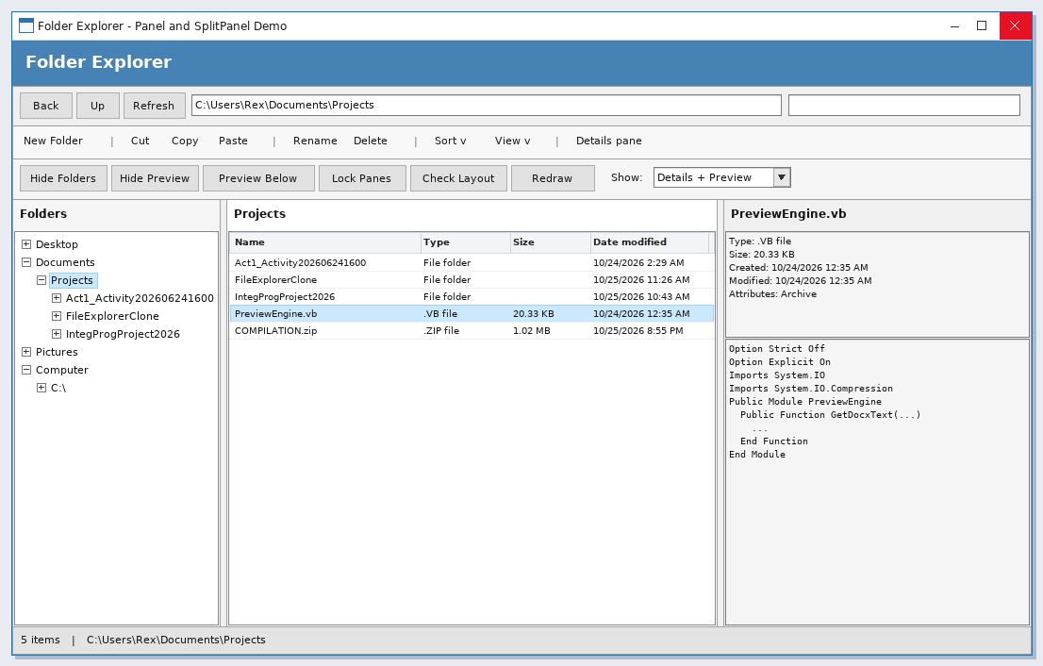

Form Design
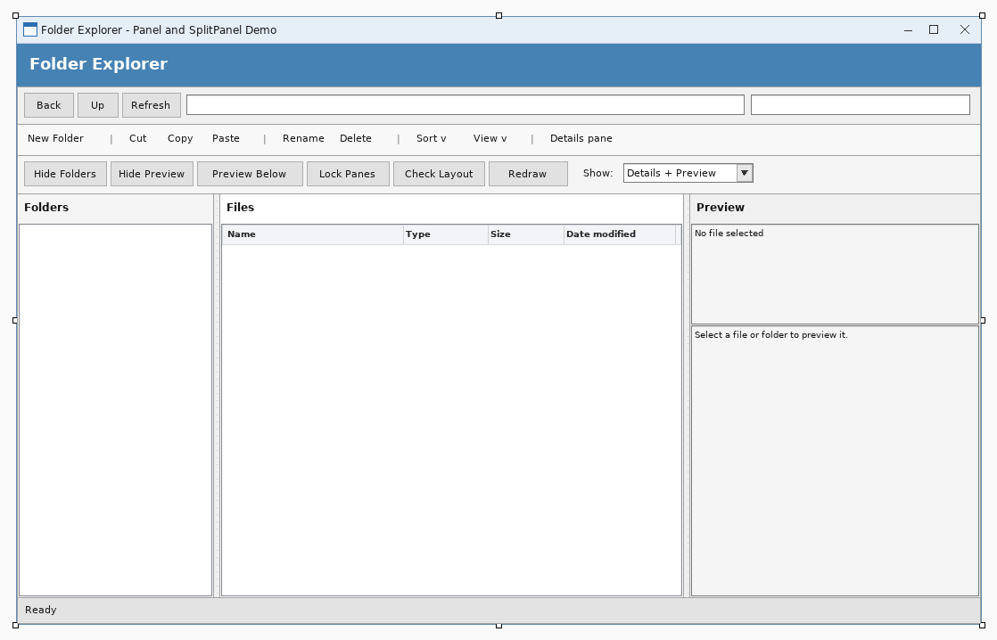

Activity 13

Source Code
frmMain.vb
Public Class frmMain
Private Sub LogLine(ByVal text As String)
Try
IO.File.AppendAllText(IO.Path.Combine(Application.StartupPath, "forms_log.txt"), _
Date.Now.ToString("HH:mm:ss") & " " & text & vbCrLf)
Catch
End Try
End Sub
Private Sub frmMain_Load(ByVal sender As System.Object, ByVal e As System.EventArgs) Handles MyBase.Load
Try
toolstripUserInfo.Text = "UserInfo: Rex M. Alvarez | BSIT 3B"
UpdateDateTime()
Timer1.Interval = 1000
Timer1.Start()
lblStatusBar.Text = "Choose a form from the menu."
LogLine("main form loaded")
Catch ex As Exception
LogLine("main load failed: " & ex.Message)
End Try
End Sub
Private Sub Timer1_Tick(ByVal sender As System.Object, ByVal e As System.EventArgs) Handles Timer1.Tick
Try
UpdateDateTime()
Catch
End Try
End Sub
Private Sub UpdateDateTime()
toolstripCurrentDate.Text = "CurrentDate: " & Date.Now.ToString("dddd, d MMMM yyyy")
toolstripCurrentTime.Text = "Current Time: " & Date.Now.ToString("h:mm:ss tt")
End Sub
Private Sub SchedulesToolStripMenuItem_Click(ByVal sender As System.Object, ByVal e As System.EventArgs) Handles SchedulesToolStripMenuItem.Click
ShowChild(GetType(frmSchedules))
End Sub
Private Sub AboutToolStripMenuItem_Click(ByVal sender As System.Object, ByVal e As System.EventArgs) Handles AboutToolStripMenuItem.Click
ShowChild(GetType(frmAbout))
End Sub
Private Sub QuotesToolStripMenuItem_Click(ByVal sender As System.Object, ByVal e As System.EventArgs) Handles QuotesToolStripMenuItem.Click
ShowChild(GetType(frmQuotes))
End Sub
Private Sub BibleVerseToolStripMenuItem_Click(ByVal sender As System.Object, ByVal e As System.EventArgs) Handles BibleVerseToolStripMenuItem.Click
ShowChild(GetType(frmBibleVerses))
End Sub
Private Sub ExitToolStripMenuItem_Click(ByVal sender As System.Object, ByVal e As System.EventArgs) Handles ExitToolStripMenuItem.Click
If MessageBox.Show("Close the program?", "Exit", MessageBoxButtons.YesNo, MessageBoxIcon.Question) = DialogResult.Yes Then
Me.Close()
End If
End Sub
Private Sub ShowChild(ByVal formType As Type)
LogLine("opening " & formType.Name)
Try
For Each openForm As Form In Me.MdiChildren
If openForm.GetType() Is formType Then
openForm.Activate()
lblStatusBar.Text = "Form: " & openForm.Text
LogLine(formType.Name & " already open - activated")
Return
End If
Next
Dim child As Form = CType(Activator.CreateInstance(formType), Form)
child.MdiParent = Me
child.Show()
child.WindowState = FormWindowState.Maximized
lblStatusBar.Text = "Form: " & child.Text
LogLine(formType.Name & " shown inside main form, Visible=" & child.Visible.ToString())
Catch ex As Exception
LogLine(formType.Name & " FAILED: " & ex.GetType().Name & " - " & ex.Message)
Try
MessageBox.Show("The form could not be opened." & vbCrLf & vbCrLf & _
"Form: " & formType.Name & vbCrLf & vbCrLf & _
"Details: " & ex.Message, "Form Error", MessageBoxButtons.OK, MessageBoxIcon.Error)
Catch
End Try
End Try
End Sub
End Class
frmSchedules.vb
Imports System.Data.OleDb
Public Class frmSchedules
Private selectedId As Integer = 0
Private isLoading As Boolean = False
Private store As DataTable
Private nextId As Integer = 1
Private Sub LogStep(ByVal text As String)
Try
IO.File.AppendAllText(IO.Path.Combine(Application.StartupPath, "forms_log.txt"), _
Date.Now.ToString("HH:mm:ss") & " [frmSchedules] " & text & vbCrLf)
Catch
End Try
End Sub
Private Function XmlPath() As String
Return IO.Path.Combine(Application.StartupPath, "projectDB.xml")
End Function
Private Function SdfPath() As String
Return IO.Path.Combine(Application.StartupPath, "projectDB.sdf")
End Function
Private Function HasSqlCe() As Boolean
Try
Using key As Microsoft.Win32.RegistryKey = Microsoft.Win32.Registry.LocalMachine.OpenSubKey("SOFTWARE\Classes\Microsoft.SQLSERVER.CE.OLEDB.3.5")
If key IsNot Nothing Then Return True
End Using
Using key As Microsoft.Win32.RegistryKey = Microsoft.Win32.Registry.LocalMachine.OpenSubKey("SOFTWARE\Wow6432Node\Classes\Microsoft.SQLSERVER.CE.OLEDB.3.5")
If key IsNot Nothing Then Return True
End Using
Catch
End Try
Return False
End Function
Private Sub frmSchedules_Load(ByVal sender As System.Object, ByVal e As System.EventArgs) Handles MyBase.Load
LogStep("Load")
Try
SetupStore()
Catch ex As Exception
LogStep("SetupStore failed: " & ex.Message)
End Try
Try
ClearFields()
Catch
End Try
RefreshGrid()
End Sub
Private Sub SetupStore()
store = New DataTable("Schedules")
store.Columns.Add("ScheduleID", GetType(Integer))
store.Columns.Add("CourseID", GetType(String))
store.Columns.Add("TeacherID", GetType(String))
store.Columns.Add("Day", GetType(String))
store.Columns.Add("Time", GetType(String))
store.Columns.Add("Room", GetType(String))
If IO.File.Exists(XmlPath()) Then
Try
store.ReadXml(XmlPath())
LogStep("loaded rows from xml: " & store.Rows.Count.ToString())
Catch ex As Exception
LogStep("xml unreadable, reseeding: " & ex.Message)
store.Clear()
End Try
End If
If store.Rows.Count = 0 Then
SeedSampleData()
SaveStore()
LogStep("seeded sample data")
End If
nextId = 1
For Each row As DataRow In store.Rows
Dim id As Integer = Convert.ToInt32(row.Item("ScheduleID"))
If id >= nextId Then nextId = id + 1
Next
lblDatabase.Text = "Storage: " & XmlPath() & " | " & store.Rows.Count.ToString() & " record(s)"
End Sub
Private Sub SaveStore()
Try
store.AcceptChanges()
store.WriteXml(XmlPath())
Catch ex As Exception
LogStep("WriteXml failed: " & ex.Message)
End Try
SyncToSdf()
End Sub
Private Sub SyncToSdf()
If Not HasSqlCe() Then Return
Try
If Not IO.File.Exists(SdfPath()) Then
Dim catalog As Object = CreateObject("ADOX.Catalog")
catalog.Create("Provider=Microsoft.SQLSERVER.CE.OLEDB.3.5;Data Source=" & SdfPath())
catalog = Nothing
End If
Using conn As New OleDbConnection("Provider=Microsoft.SQLSERVER.CE.OLEDB.3.5;Data Source=" & SdfPath() & ";Persist Security Info=False;")
conn.Open()
Using cmd As New OleDbCommand("SELECT COUNT(*) FROM [Schedules]", conn)
cmd.ExecuteScalar()
End Using
Using cmd As New OleDbCommand("DELETE FROM [Schedules]", conn)
cmd.ExecuteNonQuery()
End Using
For Each row As DataRow In store.Rows
Using cmd As New OleDbCommand("INSERT INTO [Schedules] ([CourseID], [TeacherID], [Day], [Time], [Room]) VALUES (?, ?, ?, ?, ?)", conn)
cmd.Parameters.AddWithValue("?", Convert.ToString(row.Item("CourseID")))
cmd.Parameters.AddWithValue("?", Convert.ToString(row.Item("TeacherID")))
cmd.Parameters.AddWithValue("?", Convert.ToString(row.Item("Day")))
cmd.Parameters.AddWithValue("?", Convert.ToString(row.Item("Time")))
cmd.Parameters.AddWithValue("?", Convert.ToString(row.Item("Room")))
cmd.ExecuteNonQuery()
End Using
Next
End Using
Catch ex As Exception
LogStep("sdf mirror skipped: " & ex.Message)
End Try
End Sub
Private Sub SeedSampleData()
Dim rows As String() = New String() { _
"IT301|T-005|Monday|07:30|Room 205", _
"IT302|T-006|Monday|11:00|Lab 3", _
"CS201|T-007|Tuesday|09:30|Room 206", _
"IT303|T-005|Wednesday|08:00|Lab 4", _
"CS202|T-006|Thursday|13:30|Room 207", _
"IT304|T-007|Friday|10:00|Room 208", _
"CS203|T-005|Saturday|09:00|Lab 5"
}
For Each line As String In rows
Dim parts As String() = line.Split("|"c)
If parts.Length = 5 Then
Dim row As DataRow = store.NewRow()
row.Item("ScheduleID") = nextId
row.Item("CourseID") = parts(0)
row.Item("TeacherID") = parts(1)
row.Item("Day") = parts(2)
row.Item("Time") = parts(3)
row.Item("Room") = parts(4)
store.Rows.Add(row)
nextId += 1
End If
Next
End Sub
Private Sub RefreshGrid()
Try
If store Is Nothing Then Return
Dim view As New DataTable("Schedules")
view = store.Copy()
dataGridView1.DataSource = view
FormatGrid()
lblDatabase.Text = "Storage: " & XmlPath() & " | " & store.Rows.Count.ToString() & " record(s)"
Catch ex As Exception
LogStep("RefreshGrid failed: " & ex.Message)
End Try
End Sub
Private Sub FormatGrid()
If dataGridView1.Columns.Count = 0 Then Return
With dataGridView1
.Columns("ScheduleID").HeaderText = "ID"
.Columns("CourseID").HeaderText = "Course ID"
.Columns("TeacherID").HeaderText = "Teacher ID"
.Columns("Day").HeaderText = "Day"
.Columns("Time").HeaderText = "Time"
.Columns("Room").HeaderText = "Room"
End With
End Sub
Private Sub addButton_Click(ByVal sender As System.Object, ByVal e As System.EventArgs) Handles addButton.Click
Try
If Not IsValidInput() Then Return
Dim row As DataRow = store.NewRow()
row.Item("ScheduleID") = nextId
row.Item("CourseID") = txtCourseID.Text.Trim()
row.Item("TeacherID") = txtTeacherID.Text.Trim()
row.Item("Day") = cboDay.Text.Trim()
row.Item("Time") = dtpTime.Value.ToString("HH:mm")
row.Item("Room") = txtRoom.Text.Trim()
store.Rows.Add(row)
nextId += 1
SaveStore()
MessageBox.Show("The record was saved." & vbCrLf & vbCrLf & "New ID: " & (nextId - 1).ToString(), _
"Record Added", MessageBoxButtons.OK, MessageBoxIcon.Information)
ClearFields()
RefreshGrid()
Catch ex As Exception
LogStep("Add failed: " & ex.Message)
MessageBox.Show("The record could not be saved." & vbCrLf & vbCrLf & ex.Message, _
"Save Error", MessageBoxButtons.OK, MessageBoxIcon.Warning)
End Try
End Sub
Private Sub updateButton_Click(ByVal sender As System.Object, ByVal e As System.EventArgs) Handles updateButton.Click
Try
If selectedId = 0 Then
MessageBox.Show("Select a record in the table first.", "No Record Selected", _
MessageBoxButtons.OK, MessageBoxIcon.Information)
Return
End If
If Not IsValidInput() Then Return
Dim found As DataRow = Nothing
For Each row As DataRow In store.Rows
If Convert.ToInt32(row.Item("ScheduleID")) = selectedId Then
found = row
Exit For
End If
Next
If found Is Nothing Then
MessageBox.Show("That record no longer exists.", "Record Not Found", _
MessageBoxButtons.OK, MessageBoxIcon.Warning)
RefreshGrid()
Return
End If
found.Item("CourseID") = txtCourseID.Text.Trim()
found.Item("TeacherID") = txtTeacherID.Text.Trim()
found.Item("Day") = cboDay.Text.Trim()
found.Item("Time") = dtpTime.Value.ToString("HH:mm")
found.Item("Room") = txtRoom.Text.Trim()
SaveStore()
MessageBox.Show("The record was updated.", "Record Updated", MessageBoxButtons.OK, MessageBoxIcon.Information)
ClearFields()
RefreshGrid()
Catch ex As Exception
LogStep("Update failed: " & ex.Message)
MessageBox.Show("The record could not be updated." & vbCrLf & vbCrLf & ex.Message, _
"Update Error", MessageBoxButtons.OK, MessageBoxIcon.Warning)
End Try
End Sub
Private Sub deleteButton_Click(ByVal sender As System.Object, ByVal e As System.EventArgs) Handles deleteButton.Click
Try
If selectedId = 0 Then
MessageBox.Show("Select a record in the table first.", "No Record Selected", _
MessageBoxButtons.OK, MessageBoxIcon.Information)
Return
End If
If MessageBox.Show("Delete this record?" & vbCrLf & vbCrLf & "ID: " & selectedId.ToString(), _
"Confirm Delete", MessageBoxButtons.YesNo, MessageBoxIcon.Question) <> DialogResult.Yes Then
Return
End If
For i As Integer = store.Rows.Count - 1 To 0 Step -1
If Convert.ToInt32(store.Rows(i).Item("ScheduleID")) = selectedId Then
store.Rows.RemoveAt(i)
End If
Next
SaveStore()
MessageBox.Show("The record was deleted.", "Record Deleted", MessageBoxButtons.OK, MessageBoxIcon.Information)
ClearFields()
RefreshGrid()
Catch ex As Exception
LogStep("Delete failed: " & ex.Message)
MessageBox.Show("The record could not be deleted." & vbCrLf & vbCrLf & ex.Message, _
"Delete Error", MessageBoxButtons.OK, MessageBoxIcon.Warning)
End Try
End Sub
Private Sub clearButton_Click(ByVal sender As System.Object, ByVal e As System.EventArgs) Handles clearButton.Click
ClearFields()
End Sub
Private Sub exitButton_Click(ByVal sender As System.Object, ByVal e As System.EventArgs) Handles exitButton.Click
Me.Close()
End Sub
Private Sub dataGridView1_SelectionChanged(ByVal sender As System.Object, ByVal e As System.EventArgs) Handles dataGridView1.SelectionChanged
If isLoading Then Return
If dataGridView1.CurrentRow Is Nothing Then Return
FillFromRow()
End Sub
Private Sub FillFromRow()
Dim row As DataGridViewRow = dataGridView1.CurrentRow
If row Is Nothing Then Return
If row.Cells("ScheduleID").Value Is Nothing Then Return
If row.Cells("ScheduleID").Value Is DBNull.Value Then Return
isLoading = True
Try
selectedId = Convert.ToInt32(row.Cells("ScheduleID").Value)
txtScheduleID.Text = selectedId.ToString()
txtCourseID.Text = Convert.ToString(row.Cells("CourseID").Value)
txtTeacherID.Text = Convert.ToString(row.Cells("TeacherID").Value)
cboDay.Text = Convert.ToString(row.Cells("Day").Value)
Dim TimeText As String = Convert.ToString(row.Cells("Time").Value)
Dim TimeParsed As Date
If Date.TryParse(DateTime.Today.ToShortDateString() & " " & TimeText, TimeParsed) Then
dtpTime.Value = TimeParsed
End If
txtRoom.Text = Convert.ToString(row.Cells("Room").Value)
Catch ex As Exception
LogStep("FillFromRow failed: " & ex.Message)
Finally
isLoading = False
End Try
End Sub
Private Sub ClearFields()
isLoading = True
Try
dataGridView1.CurrentCell = Nothing
Catch
End Try
selectedId = 0
txtScheduleID.Clear()
txtCourseID.Clear()
txtTeacherID.Clear()
cboDay.SelectedIndex = -1
dtpTime.Value = DateTime.Today.AddHours(8)
txtRoom.Clear()
txtCourseID.Focus()
isLoading = False
End Sub
Private Function IsValidInput() As Boolean
If txtCourseID.Text.Trim() = "" Then
MessageBox.Show("Please enter the Course ID.", "Missing Information", MessageBoxButtons.OK, MessageBoxIcon.Exclamation)
txtCourseID.Focus()
Return False
End If
If txtTeacherID.Text.Trim() = "" Then
MessageBox.Show("Please enter the Teacher ID.", "Missing Information", MessageBoxButtons.OK, MessageBoxIcon.Exclamation)
txtTeacherID.Focus()
Return False
End If
If cboDay.SelectedIndex < 0 Then
MessageBox.Show("Please choose the Day.", "Missing Information", MessageBoxButtons.OK, MessageBoxIcon.Exclamation)
cboDay.Focus()
Return False
End If
If txtRoom.Text.Trim() = "" Then
MessageBox.Show("Please enter the Room.", "Missing Information", MessageBoxButtons.OK, MessageBoxIcon.Exclamation)
txtRoom.Focus()
Return False
End If
Return True
End Function
Private Function IntValue(ByVal text As String) As Integer
Dim value As Integer = 0
If Integer.TryParse(text.Trim(), value) Then Return value
Return 0
End Function
Private Function DateValue(ByVal text As String) As Date
Dim parts As String() = text.Split("-"c)
If parts.Length = 3 Then
Dim y As Integer = 0
Dim m As Integer = 0
Dim d As Integer = 0
If Integer.TryParse(parts(0), y) AndAlso Integer.TryParse(parts(1), m) AndAlso Integer.TryParse(parts(2), d) Then
If y >= 1 AndAlso m >= 1 AndAlso m <= 12 AndAlso d >= 1 AndAlso d <= 31 Then
Return New Date(y, m, d)
End If
End If
End If
Return Date.Today
End Function
End Class
frmQuotes.vb
Imports System.Data.OleDb
Public Class frmQuotes
Private selectedId As Integer = 0
Private isLoading As Boolean = False
Private store As DataTable
Private nextId As Integer = 1
Private Sub LogStep(ByVal text As String)
Try
IO.File.AppendAllText(IO.Path.Combine(Application.StartupPath, "forms_log.txt"), _
Date.Now.ToString("HH:mm:ss") & " [frmQuotes] " & text & vbCrLf)
Catch
End Try
End Sub
Private Function XmlPath() As String
Return IO.Path.Combine(Application.StartupPath, "projectDB.xml")
End Function
Private Function SdfPath() As String
Return IO.Path.Combine(Application.StartupPath, "projectDB.sdf")
End Function
Private Function HasSqlCe() As Boolean
Try
Using key As Microsoft.Win32.RegistryKey = Microsoft.Win32.Registry.LocalMachine.OpenSubKey("SOFTWARE\Classes\Microsoft.SQLSERVER.CE.OLEDB.3.5")
If key IsNot Nothing Then Return True
End Using
Using key As Microsoft.Win32.RegistryKey = Microsoft.Win32.Registry.LocalMachine.OpenSubKey("SOFTWARE\Wow6432Node\Classes\Microsoft.SQLSERVER.CE.OLEDB.3.5")
If key IsNot Nothing Then Return True
End Using
Catch
End Try
Return False
End Function
Private Sub frmQuotes_Load(ByVal sender As System.Object, ByVal e As System.EventArgs) Handles MyBase.Load
LogStep("Load")
Try
SetupStore()
Catch ex As Exception
LogStep("SetupStore failed: " & ex.Message)
End Try
Try
ClearFields()
Catch
End Try
RefreshGrid()
End Sub
Private Sub SetupStore()
store = New DataTable("Quotes")
store.Columns.Add("QuoteID", GetType(Integer))
store.Columns.Add("Content", GetType(String))
store.Columns.Add("Author", GetType(String))
store.Columns.Add("Source", GetType(String))
store.Columns.Add("QuoteDate", GetType(Date))
If IO.File.Exists(XmlPath()) Then
Try
store.ReadXml(XmlPath())
LogStep("loaded rows from xml: " & store.Rows.Count.ToString())
Catch ex As Exception
LogStep("xml unreadable, reseeding: " & ex.Message)
store.Clear()
End Try
End If
If store.Rows.Count = 0 Then
SeedSampleData()
SaveStore()
LogStep("seeded sample data")
End If
nextId = 1
For Each row As DataRow In store.Rows
Dim id As Integer = Convert.ToInt32(row.Item("QuoteID"))
If id >= nextId Then nextId = id + 1
Next
lblDatabase.Text = "Storage: " & XmlPath() & " | " & store.Rows.Count.ToString() & " record(s)"
End Sub
Private Sub SaveStore()
Try
store.AcceptChanges()
store.WriteXml(XmlPath())
Catch ex As Exception
LogStep("WriteXml failed: " & ex.Message)
End Try
SyncToSdf()
End Sub
Private Sub SyncToSdf()
If Not HasSqlCe() Then Return
Try
If Not IO.File.Exists(SdfPath()) Then
Dim catalog As Object = CreateObject("ADOX.Catalog")
catalog.Create("Provider=Microsoft.SQLSERVER.CE.OLEDB.3.5;Data Source=" & SdfPath())
catalog = Nothing
End If
Using conn As New OleDbConnection("Provider=Microsoft.SQLSERVER.CE.OLEDB.3.5;Data Source=" & SdfPath() & ";Persist Security Info=False;")
conn.Open()
Using cmd As New OleDbCommand("SELECT COUNT(*) FROM [Quotes]", conn)
cmd.ExecuteScalar()
End Using
Using cmd As New OleDbCommand("DELETE FROM [Quotes]", conn)
cmd.ExecuteNonQuery()
End Using
For Each row As DataRow In store.Rows
Using cmd As New OleDbCommand("INSERT INTO [Quotes] ([Content], [Author], [Source], [QuoteDate]) VALUES (?, ?, ?, ?)", conn)
cmd.Parameters.AddWithValue("?", Convert.ToString(row.Item("Content")))
cmd.Parameters.AddWithValue("?", Convert.ToString(row.Item("Author")))
cmd.Parameters.AddWithValue("?", Convert.ToString(row.Item("Source")))
cmd.Parameters.AddWithValue("?", Convert.ToDateTime(row.Item("QuoteDate")))
cmd.ExecuteNonQuery()
End Using
Next
End Using
Catch ex As Exception
LogStep("sdf mirror skipped: " & ex.Message)
End Try
End Sub
Private Sub SeedSampleData()
Dim rows As String() = New String() { _
"Simplicity is the soul of efficiency.|Austin Freeman|The Social Welfare of the Blind|1912-01-01", _
"First, solve the problem. Then, write the code.|John Johnson|Tech talk|1980-05-20", _
"Experience is the name everyone gives to their mistakes.|Oscar Wilde|Lady Windermere Fan|1892-02-20", _
"Code is like humor. When you have to explain it, it is bad.|Cory House|Blog post|2015-03-11", _
"Make it work, make it right, make it fast.|Kent Beck|Extreme Programming|1999-10-05", _
"The best error message is the one that never shows up.|Thomas Fuchs|Conference talk|2011-07-19"
}
For Each line As String In rows
Dim parts As String() = line.Split("|"c)
If parts.Length = 4 Then
Dim row As DataRow = store.NewRow()
row.Item("QuoteID") = nextId
row.Item("Content") = parts(0)
row.Item("Author") = parts(1)
row.Item("Source") = parts(2)
row.Item("QuoteDate") = DateValue(parts(3))
store.Rows.Add(row)
nextId += 1
End If
Next
End Sub
Private Sub RefreshGrid()
Try
If store Is Nothing Then Return
Dim view As New DataTable("Quotes")
view = store.Copy()
dataGridView1.DataSource = view
FormatGrid()
lblDatabase.Text = "Storage: " & XmlPath() & " | " & store.Rows.Count.ToString() & " record(s)"
Catch ex As Exception
LogStep("RefreshGrid failed: " & ex.Message)
End Try
End Sub
Private Sub FormatGrid()
If dataGridView1.Columns.Count = 0 Then Return
With dataGridView1
.Columns("QuoteID").HeaderText = "ID"
.Columns("Content").HeaderText = "Content"
.Columns("Author").HeaderText = "Author"
.Columns("Source").HeaderText = "Source"
.Columns("QuoteDate").HeaderText = "Quote Date"
End With
End Sub
Private Sub addButton_Click(ByVal sender As System.Object, ByVal e As System.EventArgs) Handles addButton.Click
Try
If Not IsValidInput() Then Return
Dim row As DataRow = store.NewRow()
row.Item("QuoteID") = nextId
row.Item("Content") = txtContent.Text.Trim()
row.Item("Author") = txtAuthor.Text.Trim()
row.Item("Source") = txtSource.Text.Trim()
row.Item("QuoteDate") = dtpQuoteDate.Value.Date
store.Rows.Add(row)
nextId += 1
SaveStore()
MessageBox.Show("The record was saved." & vbCrLf & vbCrLf & "New ID: " & (nextId - 1).ToString(), _
"Record Added", MessageBoxButtons.OK, MessageBoxIcon.Information)
ClearFields()
RefreshGrid()
Catch ex As Exception
LogStep("Add failed: " & ex.Message)
MessageBox.Show("The record could not be saved." & vbCrLf & vbCrLf & ex.Message, _
"Save Error", MessageBoxButtons.OK, MessageBoxIcon.Warning)
End Try
End Sub
Private Sub updateButton_Click(ByVal sender As System.Object, ByVal e As System.EventArgs) Handles updateButton.Click
Try
If selectedId = 0 Then
MessageBox.Show("Select a record in the table first.", "No Record Selected", _
MessageBoxButtons.OK, MessageBoxIcon.Information)
Return
End If
If Not IsValidInput() Then Return
Dim found As DataRow = Nothing
For Each row As DataRow In store.Rows
If Convert.ToInt32(row.Item("QuoteID")) = selectedId Then
found = row
Exit For
End If
Next
If found Is Nothing Then
MessageBox.Show("That record no longer exists.", "Record Not Found", _
MessageBoxButtons.OK, MessageBoxIcon.Warning)
RefreshGrid()
Return
End If
found.Item("Content") = txtContent.Text.Trim()
found.Item("Author") = txtAuthor.Text.Trim()
found.Item("Source") = txtSource.Text.Trim()
found.Item("QuoteDate") = dtpQuoteDate.Value.Date
SaveStore()
MessageBox.Show("The record was updated.", "Record Updated", MessageBoxButtons.OK, MessageBoxIcon.Information)
ClearFields()
RefreshGrid()
Catch ex As Exception
LogStep("Update failed: " & ex.Message)
MessageBox.Show("The record could not be updated." & vbCrLf & vbCrLf & ex.Message, _
"Update Error", MessageBoxButtons.OK, MessageBoxIcon.Warning)
End Try
End Sub
Private Sub deleteButton_Click(ByVal sender As System.Object, ByVal e As System.EventArgs) Handles deleteButton.Click
Try
If selectedId = 0 Then
MessageBox.Show("Select a record in the table first.", "No Record Selected", _
MessageBoxButtons.OK, MessageBoxIcon.Information)
Return
End If
If MessageBox.Show("Delete this record?" & vbCrLf & vbCrLf & "ID: " & selectedId.ToString(), _
"Confirm Delete", MessageBoxButtons.YesNo, MessageBoxIcon.Question) <> DialogResult.Yes Then
Return
End If
For i As Integer = store.Rows.Count - 1 To 0 Step -1
If Convert.ToInt32(store.Rows(i).Item("QuoteID")) = selectedId Then
store.Rows.RemoveAt(i)
End If
Next
SaveStore()
MessageBox.Show("The record was deleted.", "Record Deleted", MessageBoxButtons.OK, MessageBoxIcon.Information)
ClearFields()
RefreshGrid()
Catch ex As Exception
LogStep("Delete failed: " & ex.Message)
MessageBox.Show("The record could not be deleted." & vbCrLf & vbCrLf & ex.Message, _
"Delete Error", MessageBoxButtons.OK, MessageBoxIcon.Warning)
End Try
End Sub
Private Sub clearButton_Click(ByVal sender As System.Object, ByVal e As System.EventArgs) Handles clearButton.Click
ClearFields()
End Sub
Private Sub exitButton_Click(ByVal sender As System.Object, ByVal e As System.EventArgs) Handles exitButton.Click
Me.Close()
End Sub
Private Sub dataGridView1_SelectionChanged(ByVal sender As System.Object, ByVal e As System.EventArgs) Handles dataGridView1.SelectionChanged
If isLoading Then Return
If dataGridView1.CurrentRow Is Nothing Then Return
FillFromRow()
End Sub
Private Sub FillFromRow()
Dim row As DataGridViewRow = dataGridView1.CurrentRow
If row Is Nothing Then Return
If row.Cells("QuoteID").Value Is Nothing Then Return
If row.Cells("QuoteID").Value Is DBNull.Value Then Return
isLoading = True
Try
selectedId = Convert.ToInt32(row.Cells("QuoteID").Value)
txtQuoteID.Text = selectedId.ToString()
txtContent.Text = Convert.ToString(row.Cells("Content").Value)
txtAuthor.Text = Convert.ToString(row.Cells("Author").Value)
txtSource.Text = Convert.ToString(row.Cells("Source").Value)
Dim QuoteDateDate As Date
If Date.TryParse(Convert.ToString(row.Cells("QuoteDate").Value), QuoteDateDate) Then
dtpQuoteDate.Value = QuoteDateDate
End If
Catch ex As Exception
LogStep("FillFromRow failed: " & ex.Message)
Finally
isLoading = False
End Try
End Sub
Private Sub ClearFields()
isLoading = True
Try
dataGridView1.CurrentCell = Nothing
Catch
End Try
selectedId = 0
txtQuoteID.Clear()
txtContent.Clear()
txtAuthor.Clear()
txtSource.Clear()
dtpQuoteDate.Value = Date.Today
txtContent.Focus()
isLoading = False
End Sub
Private Function IsValidInput() As Boolean
If txtContent.Text.Trim() = "" Then
MessageBox.Show("Please enter the Content.", "Missing Information", MessageBoxButtons.OK, MessageBoxIcon.Exclamation)
txtContent.Focus()
Return False
End If
If txtAuthor.Text.Trim() = "" Then
MessageBox.Show("Please enter the Author.", "Missing Information", MessageBoxButtons.OK, MessageBoxIcon.Exclamation)
txtAuthor.Focus()
Return False
End If
Return True
End Function
Private Function IntValue(ByVal text As String) As Integer
Dim value As Integer = 0
If Integer.TryParse(text.Trim(), value) Then Return value
Return 0
End Function
Private Function DateValue(ByVal text As String) As Date
Dim parts As String() = text.Split("-"c)
If parts.Length = 3 Then
Dim y As Integer = 0
Dim m As Integer = 0
Dim d As Integer = 0
If Integer.TryParse(parts(0), y) AndAlso Integer.TryParse(parts(1), m) AndAlso Integer.TryParse(parts(2), d) Then
If y >= 1 AndAlso m >= 1 AndAlso m <= 12 AndAlso d >= 1 AndAlso d <= 31 Then
Return New Date(y, m, d)
End If
End If
End If
Return Date.Today
End Function
End Class
frmBibleVerses.vb
Imports System.Data.OleDb
Public Class frmBibleVerses
Private selectedId As Integer = 0
Private isLoading As Boolean = False
Private store As DataTable
Private nextId As Integer = 1
Private Sub LogStep(ByVal text As String)
Try
IO.File.AppendAllText(IO.Path.Combine(Application.StartupPath, "forms_log.txt"), _
Date.Now.ToString("HH:mm:ss") & " [frmBibleVerses] " & text & vbCrLf)
Catch
End Try
End Sub
Private Function XmlPath() As String
Return IO.Path.Combine(Application.StartupPath, "projectDB.xml")
End Function
Private Function SdfPath() As String
Return IO.Path.Combine(Application.StartupPath, "projectDB.sdf")
End Function
Private Function HasSqlCe() As Boolean
Try
Using key As Microsoft.Win32.RegistryKey = Microsoft.Win32.Registry.LocalMachine.OpenSubKey("SOFTWARE\Classes\Microsoft.SQLSERVER.CE.OLEDB.3.5")
If key IsNot Nothing Then Return True
End Using
Using key As Microsoft.Win32.RegistryKey = Microsoft.Win32.Registry.LocalMachine.OpenSubKey("SOFTWARE\Wow6432Node\Classes\Microsoft.SQLSERVER.CE.OLEDB.3.5")
If key IsNot Nothing Then Return True
End Using
Catch
End Try
Return False
End Function
Private Sub frmBibleVerses_Load(ByVal sender As System.Object, ByVal e As System.EventArgs) Handles MyBase.Load
LogStep("Load")
Try
SetupStore()
Catch ex As Exception
LogStep("SetupStore failed: " & ex.Message)
End Try
Try
ClearFields()
Catch
End Try
RefreshGrid()
End Sub
Private Sub SetupStore()
store = New DataTable("BibleVerses")
store.Columns.Add("VerseID", GetType(Integer))
store.Columns.Add("Book", GetType(String))
store.Columns.Add("Chapter", GetType(Integer))
store.Columns.Add("Verse", GetType(Integer))
store.Columns.Add("Content", GetType(String))
store.Columns.Add("Translation", GetType(String))
store.Columns.Add("Remarks", GetType(String))
store.Columns.Add("Category", GetType(String))
If IO.File.Exists(XmlPath()) Then
Try
store.ReadXml(XmlPath())
LogStep("loaded rows from xml: " & store.Rows.Count.ToString())
Catch ex As Exception
LogStep("xml unreadable, reseeding: " & ex.Message)
store.Clear()
End Try
End If
If store.Rows.Count = 0 Then
SeedSampleData()
SaveStore()
LogStep("seeded sample data")
End If
nextId = 1
For Each row As DataRow In store.Rows
Dim id As Integer = Convert.ToInt32(row.Item("VerseID"))
If id >= nextId Then nextId = id + 1
Next
lblDatabase.Text = "Storage: " & XmlPath() & " | " & store.Rows.Count.ToString() & " record(s)"
End Sub
Private Sub SaveStore()
Try
store.AcceptChanges()
store.WriteXml(XmlPath())
Catch ex As Exception
LogStep("WriteXml failed: " & ex.Message)
End Try
SyncToSdf()
End Sub
Private Sub SyncToSdf()
If Not HasSqlCe() Then Return
Try
If Not IO.File.Exists(SdfPath()) Then
Dim catalog As Object = CreateObject("ADOX.Catalog")
catalog.Create("Provider=Microsoft.SQLSERVER.CE.OLEDB.3.5;Data Source=" & SdfPath())
catalog = Nothing
End If
Using conn As New OleDbConnection("Provider=Microsoft.SQLSERVER.CE.OLEDB.3.5;Data Source=" & SdfPath() & ";Persist Security Info=False;")
conn.Open()
Using cmd As New OleDbCommand("SELECT COUNT(*) FROM [BibleVerses]", conn)
cmd.ExecuteScalar()
End Using
Using cmd As New OleDbCommand("DELETE FROM [BibleVerses]", conn)
cmd.ExecuteNonQuery()
End Using
For Each row As DataRow In store.Rows
Using cmd As New OleDbCommand("INSERT INTO [BibleVerses] ([Book], [Chapter], [Verse], [Content], [Translation], [Remarks], [Category]) VALUES (?, ?, ?, ?, ?, ?, ?)", conn)
cmd.Parameters.AddWithValue("?", Convert.ToString(row.Item("Book")))
cmd.Parameters.AddWithValue("?", IntValue(Convert.ToString(row.Item("Chapter"))))
cmd.Parameters.AddWithValue("?", IntValue(Convert.ToString(row.Item("Verse"))))
cmd.Parameters.AddWithValue("?", Convert.ToString(row.Item("Content")))
cmd.Parameters.AddWithValue("?", Convert.ToString(row.Item("Translation")))
cmd.Parameters.AddWithValue("?", Convert.ToString(row.Item("Remarks")))
cmd.Parameters.AddWithValue("?", Convert.ToString(row.Item("Category")))
cmd.ExecuteNonQuery()
End Using
Next
End Using
Catch ex As Exception
LogStep("sdf mirror skipped: " & ex.Message)
End Try
End Sub
Private Sub SeedSampleData()
Dim rows As String() = New String() { _
"Genesis|1|1|In the beginning God created the heavens and the earth.|NIV|Creation|Old Testament", _
"Exodus|20|3|You shall have no other gods before me.|NIV|Commandments|Old Testament", _
"Joshua|1|9|Be strong and courageous. Do not be afraid.|NIV|Courage|History", _
"Isaiah|41|10|So do not fear, for I am with you.|NIV|Comfort|Prophecy", _
"Matthew|5|9|Blessed are the peacemakers.|NIV|Peace|Gospel", _
"James|1|22|Do not merely listen to the word, and so deceive yourselves. Do what it says.|NIV|Action|Epistle"
}
For Each line As String In rows
Dim parts As String() = line.Split("|"c)
If parts.Length = 7 Then
Dim row As DataRow = store.NewRow()
row.Item("VerseID") = nextId
row.Item("Book") = parts(0)
row.Item("Chapter") = IntValue(parts(1))
row.Item("Verse") = IntValue(parts(2))
row.Item("Content") = parts(3)
row.Item("Translation") = parts(4)
row.Item("Remarks") = parts(5)
row.Item("Category") = parts(6)
store.Rows.Add(row)
nextId += 1
End If
Next
End Sub
Private Sub RefreshGrid()
Try
If store Is Nothing Then Return
Dim view As New DataTable("BibleVerses")
view = store.Copy()
dataGridView1.DataSource = view
FormatGrid()
lblDatabase.Text = "Storage: " & XmlPath() & " | " & store.Rows.Count.ToString() & " record(s)"
Catch ex As Exception
LogStep("RefreshGrid failed: " & ex.Message)
End Try
End Sub
Private Sub FormatGrid()
If dataGridView1.Columns.Count = 0 Then Return
With dataGridView1
.Columns("VerseID").HeaderText = "ID"
.Columns("Book").HeaderText = "Book"
.Columns("Chapter").HeaderText = "Chapter"
.Columns("Verse").HeaderText = "Verse"
.Columns("Content").HeaderText = "Content"
.Columns("Translation").HeaderText = "Translation"
.Columns("Remarks").HeaderText = "Remarks"
.Columns("Category").HeaderText = "Category"
End With
End Sub
Private Sub addButton_Click(ByVal sender As System.Object, ByVal e As System.EventArgs) Handles addButton.Click
Try
If Not IsValidInput() Then Return
Dim row As DataRow = store.NewRow()
row.Item("VerseID") = nextId
row.Item("Book") = txtBook.Text.Trim()
row.Item("Chapter") = IntValue(txtChapter.Text)
row.Item("Verse") = IntValue(txtVerse.Text)
row.Item("Content") = txtContent.Text.Trim()
row.Item("Translation") = txtTranslation.Text.Trim()
row.Item("Remarks") = txtRemarks.Text.Trim()
row.Item("Category") = txtCategory.Text.Trim()
store.Rows.Add(row)
nextId += 1
SaveStore()
MessageBox.Show("The record was saved." & vbCrLf & vbCrLf & "New ID: " & (nextId - 1).ToString(), _
"Record Added", MessageBoxButtons.OK, MessageBoxIcon.Information)
ClearFields()
RefreshGrid()
Catch ex As Exception
LogStep("Add failed: " & ex.Message)
MessageBox.Show("The record could not be saved." & vbCrLf & vbCrLf & ex.Message, _
"Save Error", MessageBoxButtons.OK, MessageBoxIcon.Warning)
End Try
End Sub
Private Sub updateButton_Click(ByVal sender As System.Object, ByVal e As System.EventArgs) Handles updateButton.Click
Try
If selectedId = 0 Then
MessageBox.Show("Select a record in the table first.", "No Record Selected", _
MessageBoxButtons.OK, MessageBoxIcon.Information)
Return
End If
If Not IsValidInput() Then Return
Dim found As DataRow = Nothing
For Each row As DataRow In store.Rows
If Convert.ToInt32(row.Item("VerseID")) = selectedId Then
found = row
Exit For
End If
Next
If found Is Nothing Then
MessageBox.Show("That record no longer exists.", "Record Not Found", _
MessageBoxButtons.OK, MessageBoxIcon.Warning)
RefreshGrid()
Return
End If
found.Item("Book") = txtBook.Text.Trim()
found.Item("Chapter") = IntValue(txtChapter.Text)
found.Item("Verse") = IntValue(txtVerse.Text)
found.Item("Content") = txtContent.Text.Trim()
found.Item("Translation") = txtTranslation.Text.Trim()
found.Item("Remarks") = txtRemarks.Text.Trim()
found.Item("Category") = txtCategory.Text.Trim()
SaveStore()
MessageBox.Show("The record was updated.", "Record Updated", MessageBoxButtons.OK, MessageBoxIcon.Information)
ClearFields()
RefreshGrid()
Catch ex As Exception
LogStep("Update failed: " & ex.Message)
MessageBox.Show("The record could not be updated." & vbCrLf & vbCrLf & ex.Message, _
"Update Error", MessageBoxButtons.OK, MessageBoxIcon.Warning)
End Try
End Sub
Private Sub deleteButton_Click(ByVal sender As System.Object, ByVal e As System.EventArgs) Handles deleteButton.Click
Try
If selectedId = 0 Then
MessageBox.Show("Select a record in the table first.", "No Record Selected", _
MessageBoxButtons.OK, MessageBoxIcon.Information)
Return
End If
If MessageBox.Show("Delete this record?" & vbCrLf & vbCrLf & "ID: " & selectedId.ToString(), _
"Confirm Delete", MessageBoxButtons.YesNo, MessageBoxIcon.Question) <> DialogResult.Yes Then
Return
End If
For i As Integer = store.Rows.Count - 1 To 0 Step -1
If Convert.ToInt32(store.Rows(i).Item("VerseID")) = selectedId Then
store.Rows.RemoveAt(i)
End If
Next
SaveStore()
MessageBox.Show("The record was deleted.", "Record Deleted", MessageBoxButtons.OK, MessageBoxIcon.Information)
ClearFields()
RefreshGrid()
Catch ex As Exception
LogStep("Delete failed: " & ex.Message)
MessageBox.Show("The record could not be deleted." & vbCrLf & vbCrLf & ex.Message, _
"Delete Error", MessageBoxButtons.OK, MessageBoxIcon.Warning)
End Try
End Sub
Private Sub clearButton_Click(ByVal sender As System.Object, ByVal e As System.EventArgs) Handles clearButton.Click
ClearFields()
End Sub
Private Sub exitButton_Click(ByVal sender As System.Object, ByVal e As System.EventArgs) Handles exitButton.Click
Me.Close()
End Sub
Private Sub dataGridView1_SelectionChanged(ByVal sender As System.Object, ByVal e As System.EventArgs) Handles dataGridView1.SelectionChanged
If isLoading Then Return
If dataGridView1.CurrentRow Is Nothing Then Return
FillFromRow()
End Sub
Private Sub FillFromRow()
Dim row As DataGridViewRow = dataGridView1.CurrentRow
If row Is Nothing Then Return
If row.Cells("VerseID").Value Is Nothing Then Return
If row.Cells("VerseID").Value Is DBNull.Value Then Return
isLoading = True
Try
selectedId = Convert.ToInt32(row.Cells("VerseID").Value)
txtVerseID.Text = selectedId.ToString()
txtBook.Text = Convert.ToString(row.Cells("Book").Value)
txtChapter.Text = Convert.ToString(row.Cells("Chapter").Value)
txtVerse.Text = Convert.ToString(row.Cells("Verse").Value)
txtContent.Text = Convert.ToString(row.Cells("Content").Value)
txtTranslation.Text = Convert.ToString(row.Cells("Translation").Value)
txtRemarks.Text = Convert.ToString(row.Cells("Remarks").Value)
txtCategory.Text = Convert.ToString(row.Cells("Category").Value)
Catch ex As Exception
LogStep("FillFromRow failed: " & ex.Message)
Finally
isLoading = False
End Try
End Sub
Private Sub ClearFields()
isLoading = True
Try
dataGridView1.CurrentCell = Nothing
Catch
End Try
selectedId = 0
txtVerseID.Clear()
txtBook.Clear()
txtChapter.Clear()
txtVerse.Clear()
txtContent.Clear()
txtTranslation.Clear()
txtRemarks.Clear()
txtCategory.Clear()
txtBook.Focus()
isLoading = False
End Sub
Private Function IsValidInput() As Boolean
If txtBook.Text.Trim() = "" Then
MessageBox.Show("Please enter the Book.", "Missing Information", MessageBoxButtons.OK, MessageBoxIcon.Exclamation)
txtBook.Focus()
Return False
End If
If txtChapter.Text.Trim() = "" Then
MessageBox.Show("Please enter the Chapter.", "Missing Information", MessageBoxButtons.OK, MessageBoxIcon.Exclamation)
txtChapter.Focus()
Return False
End If
Dim ChapterNum As Integer = 0
If txtChapter.Text.Trim() <> "" AndAlso Not Integer.TryParse(txtChapter.Text.Trim(), ChapterNum) Then
MessageBox.Show("The Chapter must be a whole number.", "Invalid Number", MessageBoxButtons.OK, MessageBoxIcon.Exclamation)
txtChapter.Focus()
Return False
End If
If txtVerse.Text.Trim() = "" Then
MessageBox.Show("Please enter the Verse.", "Missing Information", MessageBoxButtons.OK, MessageBoxIcon.Exclamation)
txtVerse.Focus()
Return False
End If
Dim VerseNum As Integer = 0
If txtVerse.Text.Trim() <> "" AndAlso Not Integer.TryParse(txtVerse.Text.Trim(), VerseNum) Then
MessageBox.Show("The Verse must be a whole number.", "Invalid Number", MessageBoxButtons.OK, MessageBoxIcon.Exclamation)
txtVerse.Focus()
Return False
End If
If txtContent.Text.Trim() = "" Then
MessageBox.Show("Please enter the Content.", "Missing Information", MessageBoxButtons.OK, MessageBoxIcon.Exclamation)
txtContent.Focus()
Return False
End If
If txtTranslation.Text.Trim() = "" Then
MessageBox.Show("Please enter the Translation.", "Missing Information", MessageBoxButtons.OK, MessageBoxIcon.Exclamation)
txtTranslation.Focus()
Return False
End If
Return True
End Function
Private Function IntValue(ByVal text As String) As Integer
Dim value As Integer = 0
If Integer.TryParse(text.Trim(), value) Then Return value
Return 0
End Function
Private Function DateValue(ByVal text As String) As Date
Dim parts As String() = text.Split("-"c)
If parts.Length = 3 Then
Dim y As Integer = 0
Dim m As Integer = 0
Dim d As Integer = 0
If Integer.TryParse(parts(0), y) AndAlso Integer.TryParse(parts(1), m) AndAlso Integer.TryParse(parts(2), d) Then
If y >= 1 AndAlso m >= 1 AndAlso m <= 12 AndAlso d >= 1 AndAlso d <= 31 Then
Return New Date(y, m, d)
End If
End If
End If
Return Date.Today
End Function
End Class
frmAbout.vb
Public Class frmAbout
Private Sub LogStep(ByVal text As String)
Try
IO.File.AppendAllText(IO.Path.Combine(Application.StartupPath, "forms_log.txt"), _
Date.Now.ToString("HH:mm:ss") & " [frmAbout] " & text & vbCrLf)
Catch
End Try
End Sub
Private Const PhotoData As String = ""
Private Sub frmAbout_Load(ByVal sender As System.Object, ByVal e As System.EventArgs) Handles MyBase.Load
LogStep("Load start")
Try
Dim bytes As Byte() = Convert.FromBase64String(PhotoData)
Using stream As New IO.MemoryStream(bytes)
Using photo As Image = Image.FromStream(stream)
PictureBox1.Image = New Bitmap(photo)
End Using
End Using
Catch ex As Exception
End Try
LogStep("Load end")
End Sub
End Class

Sample Run
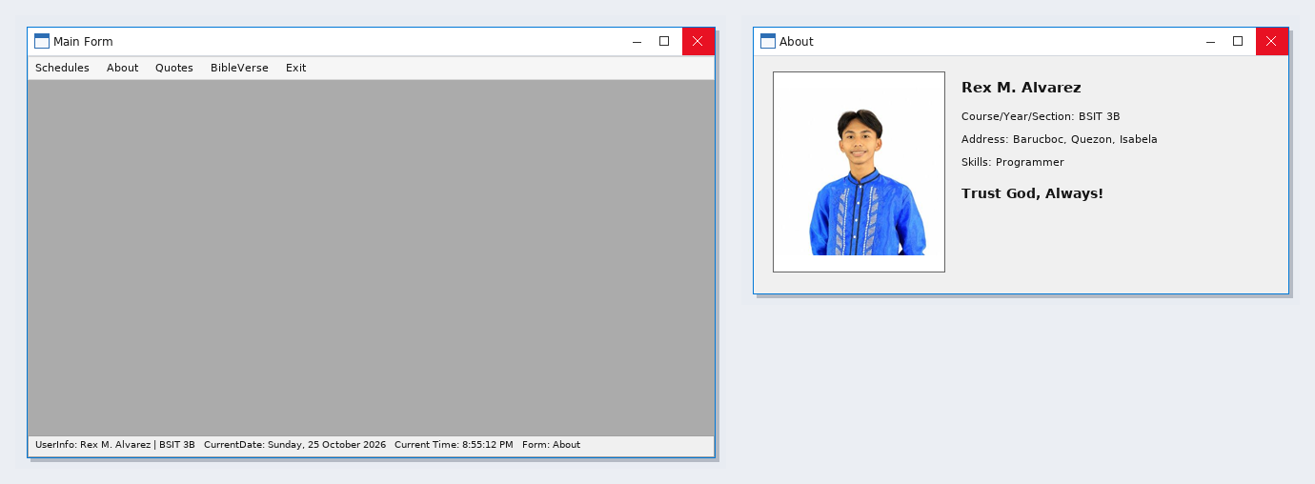
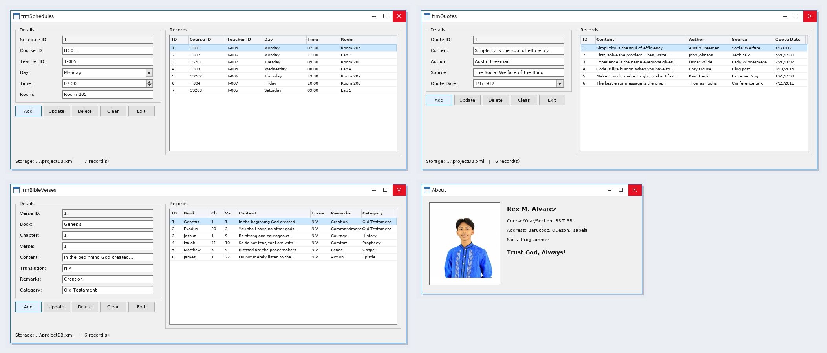

Form Design
