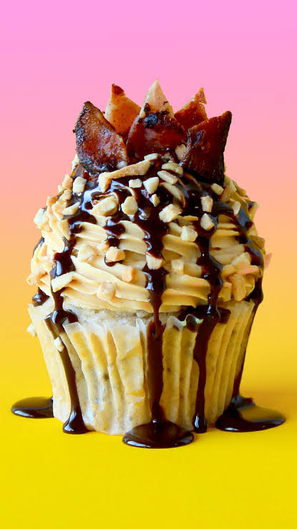
Elvis Cupcakes
Elvis was famous for his heart-stopping love of bacon, peanut butter and banana sandwiches. This cupcake is taken to the next level with a cheeky splash of chocolate!

INGREDIENTS
Makes 20

429 grams all-purpose flour

265 grams caster (superfine) sugar

1/2 teaspoon salt

3 teaspoons baking powder

375 milliliters of milk

125 milliliters vegetable oil

125 grams unsalted butter, softened

2 tablespoons Greek yogurt (can substitute with sour cream)

1 teaspoon vanilla extract

2 large eggs

American Bacon strips (Aussies: you can get these from Woolworths)

Chocolate sauce (recipe: www.thescranline.com)

Crushed peanuts to sprinkle

Mini Toasts

10 slices white bread (sandwich slice. This is completely optional)

Cinnamon sugar

Vegetable oil spray

Caramelized Bananas

3 ripe bananas

3-4 tablespoons brown sugar

Frosting

1 batch fluffy buttercream frosting (recipe: www.thescranline.com)

4 tablespoons smooth peanut butter

INSTRUCTIONS
- Preheat your oven to 180C (356F) or 160C (320F) for a fan forced oven. Line a cupcake tin with cupcake liners.

- To prepare bacon add bacon to a hot fry pan and grill until crispy and golden on both sides. Set aside on paper towels to let fat drain. Once they've cooled, cut into shards.

- To prepare caramelized bananas: slice bananas and add to a baking tray lined with baking paper. Sprinkle with brown sugar and bake on 160C (320F) for 25 min, mixing each 5 min to allow bananas to cook evenly. Set aside to cool.

- To prepare cinnamon toast, (and guys this is completely optional, see notes): Use a round cookie cutter (60mm) to cut out discs of bread. Place discs on a baking tray lined with baking paper. Spray with cooking oil and sprinkle a generous amount of cinnamon sugar. Set aside to add to your cupcakes later on before you bake them.

- In the bowl of a stand mixer fitted with the paddle attachment, add the flour, baking powder, caster sugar and salt. Turn mixer on low speed and allow it to mix for a couple minutes to help everything combine well (alternatively you may do this by sifting the ingredients together). Add the softened butter and let it mix until it resembles a fine sand like texture.

- Next, add milk, eggs, yogurt, oil and vanilla extract in a large jug and whisk well.

- Add wet ingredients to dry ingredients in a slow and steady stream until no dry ingredients are visible. Scrape down the bowl, add caramelized banana and mix for another 20 seconds.

- Fill each cupcake liner 3/4 of the way (using an ice cream scoop to transfer the batter into the cupcake liners makes this a quick and easy process otherwise you can use two tablespoons). Place a cinnamon toast disc on top of each cupcake and press it in slightly. Bake for 20-25 min or until a toothpick inserted comes out clean. Allow them to cool completely on a wire cooling rack before frosting.

- To prepare buttercream frosting, add peanuts butter to frosting and mix until well combined. Fit the end of a piping bag with an open star tip and frost in a swirl. Drizzle with chocolate sauce and sprinkle with crushed nuts. To finish off place a crown of crispy bacon shards on top.

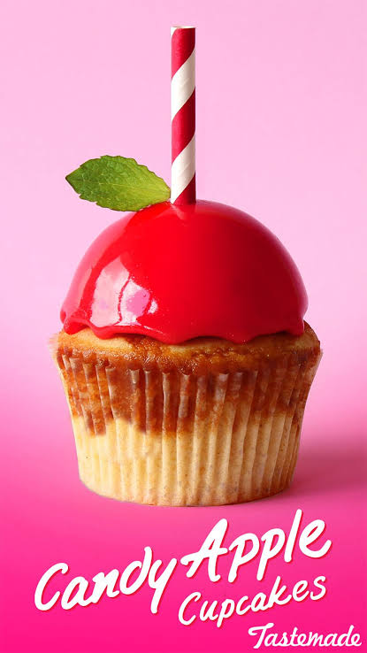
Candy Apple Cupcakes

Made with white chocolate and dulce de leche, this is one candy apple worth trying.
30 ingredients
Produce
1 Apples, Stewed
1 Mint leaves to decorate
Refrigerated
1 Egg
Condiments
1 Caramel sauce to drizzle, Salted
3 tbsp Dulce de leche
1 tsp Lemon juice
Baking & Spices
1 1/2 tsp Baking powder
2 tbsp Brown sugar
1 Caramel mousse
1 tsp Cinnamon
215 g Flour
300 g Granulated sugar
1 Mirror glaze, Red
1 Pinch Salt
132 g Sugar
2 1/2 tsp Vanilla
250 g White chocolate
350 g White chocolate chips
Oils & Vinegars
65 ml Oil
Bread & Baked Goods
1 Cupcakes
Dairy
60 g Butter
200 g Condensed milk, sweetened
250 ml Cream
187 ml Milk
1 tbsp Yogurt
Desserts
3 tsp Gelatin, unflavored powdered
19 g Gelatin
Liquids
2 tbsp Water
150 g Water
Other
4 -6 drops red red Americolour food gel (liquid food dye will not work in this recipe)
These devilishly good chocolate cupcakes with a cherry coconut centre and whipped chocolate ganache frosting are just too good to miss!

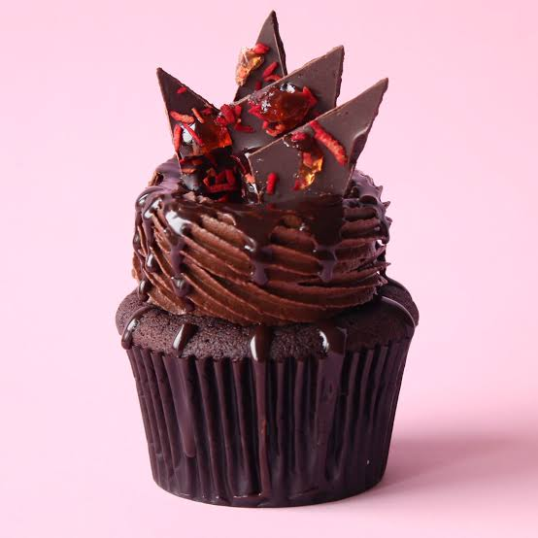
Cherry Coconut Cupcakes
INGREDIENTS
50 grams cocoa powder

175 grams plain flour

2 large eggs, at room temperature

1 teaspoon vanilla extract

1/2 teaspoon salt

1/2 teaspoon bicarbonate of soda

225 grams caster sugar

175 grams unsalted butter, softened

80 milliliters milk

80 milliliters cherry wine or liqueur

Chocolate Sauce

1 batch of chocolate ganache frosting

INSTRUCTIONS
- Preheat your oven to 180C (356F) or 160C (320F) for a fan forced oven

- Add all of the dry ingredients in a large mixing bowl, and mix on low speed for about 20 seconds before you add your softened butter. Let it mix until it reaches a crumbly, sand like texture.

- Add eggs, cherry wine/liqueur and milk into a jug and whisk together well. Add milk/egg mixture to dry ingredients in a slow steady stream while mixer is on low. Make sure you scrape down the bowl each time you add an ingredient to make sure everything's mixing well. Scoop into cupcake pan, filling about 3/4 way. Bake for 20 min. To check if they're done simply pierce the cupcake with a skewer and if they come out clean they're done. Once they're done, let them cool down completely.

- To assemble your cupcakes core them in the centre using an apple corer and fill with cherry coconut mixture. Fit the end of your piping bag with a wilton 6b star tip and frost your cupcakes in a donut swirl as demonstrated in the video. Top with shards of cherry coconut bark.

Cherry Filling
INGREDIENTS
1/4 sweetened condensed milk

1 cup desiccated coconut

1/2 cup of chopped glacé cherries

2 tablespoons cherry essence, wine or liqueur

INSTRUCTIONS
Combine all ingredients in a large mixing bowl until well combined. Cover and set aside.

Red Coconut Sprinkles
INGREDIENTS
1/2 cup shredded coconut

1 teaspoon red food dye

INSTRUCTIONS
To make coconut sprinkles simply add shredded coconut into a zip lock bag and shake around to coat and colour the coconut. Spread out onto a baking tray and bake on a low temp for 10 min or until they appear dryer than when they went in.

Chocolate Cherry Coconut Bark
INGREDIENTS
400 grams dark cooking chocolate (melted)

Coconut Spinkles

1/2 cup of chopped Glacé cherries

INSTRUCTIONS
To make cherry coconut bark simply melt your chocolate in the microwave for 20seconds at a time, mixing each time until chocolate is smooth. Line a baking tray with baking paper and use a knife or offset spatula to spread chocolate as thin as you can get it. Sprinkle with chopped glacé cherries and coconut sprinkles. Pop it in the fridge for 20 min to set and harden.

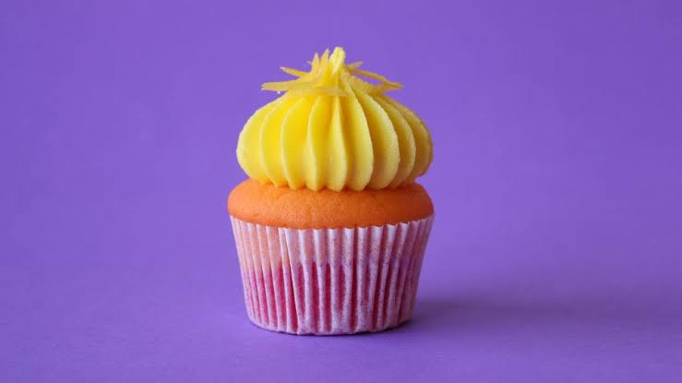
Silver Bullet Cupcakes
Flavored with Whisky and Gin, this Silver Bullet Cupcake is like taking a shot.
16 ingredients
Produce
1 tsp Lemon essence
1 Lemon for cake and top of cake, Zest of
Refrigerated
1 Egg
Baking & Spices
1 1/2 tsp Baking powder
215 g Flour
132 g Sugar
1/2 tsp Vanilla extract
Oils & Vinegars
65 ml Oil
Dairy
60 g Butter
187 ml Milk
1 tbsp Yogurt
Beer, Wine & Liquor
20 ml Gin
20 ml Whiskey
Other
2 drops Of orange food dye
4 drops Yellow food dye
2 drop Pink food dye

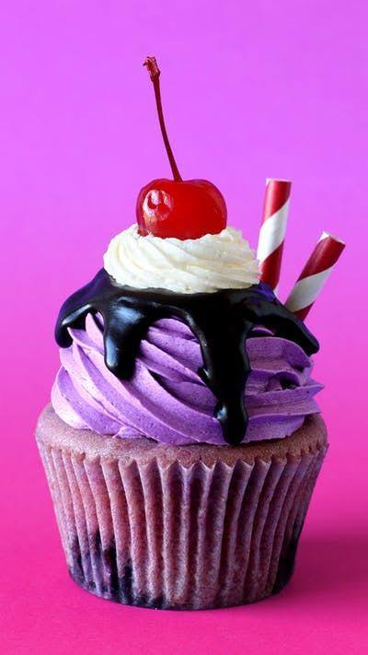
cherry Malt Milkshake Cupcakes
Why settle for just a cherry on top when you can also enjoy the fruit baked right into the cake?
21 ingredients
Serves 20
Produce
250 g Cherries, canned
200 ml Cherry
Refrigerated
2 Eggs, large
Condiments
1 Chocolate sauce
Baking & Spices
429 g All-purpose flour
3 tsp Baking powder
265 g Caster (superfine) sugar
1 batch Fluffy vanilla buttercream frosting
1 Frosting
1/2 tsp Salt
1 tsp Vanilla extract
Oils & Vinegars
125 ml Vegetable oil
Dairy
125 g Butter, unsalted
2 tbsp Greek yogurt
175 ml Milk
Desserts
1 Maraschino cherries
Beer, Wine & Liquor
1 tsp Cherry brandy essence
Other
2 drops Purple food dye
1 drop Purple food gel
2 drops Pink food dye
2 drops Pink food gel

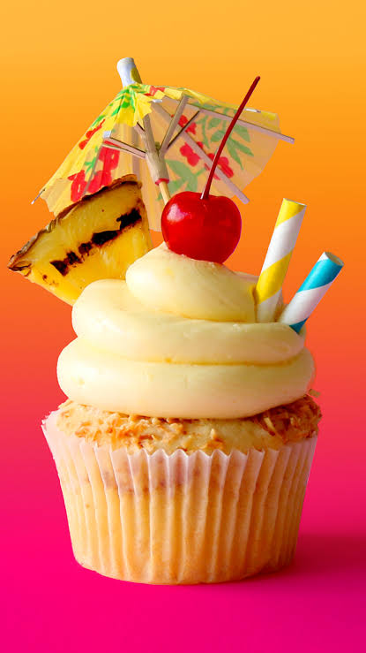
Piña Colada Cupcakes
Piña coladas are sweet as cocktails, but even sweeter in cupcake form.

INGREDIENTS
429 grams all-purpose flour

265 grams caster (superfine) sugar

1/2 teaspoon salt

3 teaspoons baking powder

375 milliliters of coconut milk

125 milliliters vegetable oil

125 grams unsalted butter, softened

2 tablespoons Greek yogurt (can substitute with sour cream)

1 teaspoon vanilla extract

2 large eggs

Fresh Pineapple (sliced and cut into wedges as demonstrated)

Shredded coconut (toasted)

24 Maraschino Cherries

2 tablespoons rum (optional)

Frosting

1 batch of fluffy vanilla buttercream frosting (recipe on www.thescranline.com)

2 tablespoons rum (you may use rum essence or coconut essence instead.)

INSTRUCTIONS
- Preheat your oven to 180C (356F) or 160C (320F) for a fan forced oven. Line a cupcake tin with cupcake liners.

- In the bowl of a stand mixer fitted with the paddle attachment, add the flour, baking powder, caster sugar and salt. Turn mixer on low speed and allow it to mix for a couple minutes to help everything combine well (alternatively you may do this by sifting the ingredients together). Add the softened butter and let it mix until it resembles a fine sand like texture.

- Next, add coconut milk, eggs, yogurt, oil and vanilla extract in a large jug and whisk well.

- Add wet ingredients to dry ingredients in a slow and steady stream until no dry ingredients are visible. Scrape down the bowl and mix for another 20 seconds.

- Fill each cupcake liner 3/4 of the way (using an ice cream scoop to transfer the batter into the cupcake liners makes this a quick and easy process otherwise you can use two tablespoons). Sprinkle with shredded coconut. Bake for 20-25 min or until a toothpick inserted comes out clean. Allow them to cool completely on a wire cooling rack before frosting.

- To prepare your grilled pineapple, simply cut your pineapple in half. Slice 1 centimeter thick slice from it and cut into 8 wedges per slice, Grill on a griddle for about 3 min on each side on high heat. Set aside to cool completely.

- To prepare your buttercream frosting. Add rum and mix until well combined.

- To decorate your cupcakes fit the end of a piping bag with a round tip and frost your cupcakes in a swirl. Add a pineapple wedge on the side, a cherry on top and decorate with some paper straws and a fancy little cocktail umbrella!

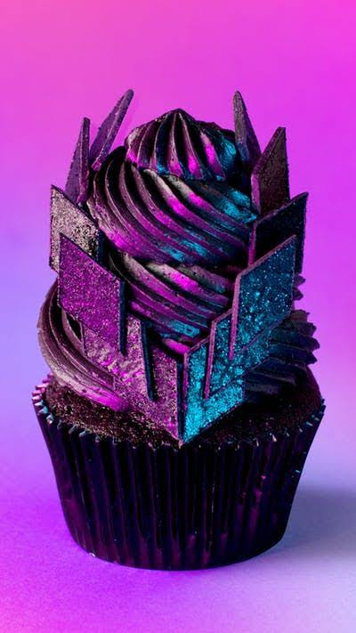
In His Kiss (Cher Inspired) Cupcakes

These triple-chocolate cupcakes are inspired by pop icon Cher and a certain signature leather outfit...
15 ingredients
Serves 12
Refrigerated
2 Eggs, large
Baking & Spices
175 g All-purpose flour
1/2 tsp Bicarbonate of soda
225 g Caster sugar
1 Chocolate shards
1 batch Chocolate swiss meringue buttercream frosting
50 g Cocoa powder
1 Frosting
1/2 tsp Salt
300 g Wilton black choc melts
Bread & Baked Goods
1 Cupcakes
Dairy
175 g Butter, unsalted
175 ml Milk
Other
edible black shimmer
1 tbsp food safe activated charcoal

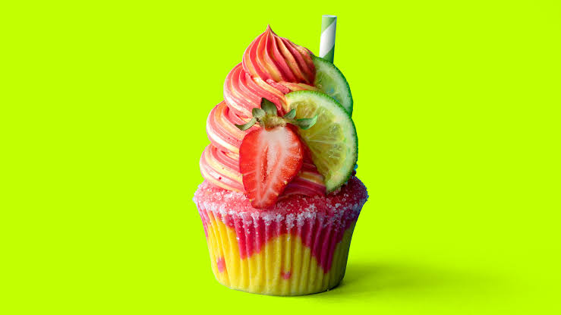
Strawberry Mango Margarita Cupcakes
Now you can have your cupcake & margarita too! 🍹

SERVINGS:
serving time15

INGREDIENTS
Cupcakes

430g (15 oz) plain (all-purpose) flour

265 g (91/2 oz) caster (superfine) sugar

3 teaspoons baking powder

1/2 teaspoon fine salt

125 g (41/2 oz/1/2 cup) unsalted butter, softened

2 large eggs

375 ml (121/2 fl oz/11/2 cups) full-cream (whole) milk

125 ml (4 fl oz/1/2 cup) vegetable oil

2 tablespoons Greek yoghurt (or sour cream)

1 teaspoon vanilla extract or vanilla bean paste

4 drops pink food gel + 3 drops red food gel

1 tsp strawberry flavouring

30ml tequila

1 lime, juiced

4 drops yellow food gel

1 tsp mango flavouring

30ml tequila

1 lime, juiced

Decorations

1 cup granulated sugar

40 small lime wedges

10 strawberries, washed & halved

Frosting

1 batch American buttercream frosting or Swiss meringue buttercream frosting

5 drops pink food gel + 3 drops red food gel

1 tsp strawberry flavouring

5 drops yellow food gel

1 tsp mango flavouring

INSTRUCTIONS
- Cupcakes

- Preheat a fan-forced oven to 140°C (275°F) or a conventional oven to 160°C (320°F). Line two cupcake tins with the cupcake liners.

- Add the flour, sugar, baking powder and salt to a large mixing bowl and mix with a hand mixer until well combined.

- Next, add the softened butter and mix on low speed until the mixture reaches a crumbly, sand-like texture.

- Add the eggs, milk, oil, yoghurt and vanilla, and mix on low speed until all the dry ingredients are incorporated. Scrape down the side of the bowl and mix for a final 20 seconds.

- Split the batter into two separate mixing bowls. Add pink and red food gel to one bowl along with the strawberry flavouring, lime juice and tequila and mix until well combined. Add yellow food gel and mango flavouring, lime juice and tequila to the other bowl and mix.

- Add both batters to two separate piping bags. Begin by piping yellow batter into your cupcake liners, then pipe swirls of red batter on top.

- Bake for 40–50 minutes, or until a toothpick inserted in the middle of a cupcake comes out clean. Allow the cupcakes to cool completely on a wire rack before frosting.

- To prepare the frosting, split into two mixing bowls. Add pink and red food gel to one bowl along with the strawberry flavouring and mix until well combined. Add yellow food gel and mango flavouring to the other bowl and mix.

- Lightly brush the rim of each baked cupcake with a little bit of water. Gently roll the cupcake in sugar to give it the illusion of a salt rimmed glass.

- Fit the end of a piping bag with an open star tip and frosting a swirl of frosting on top of each cupcake. Add two wedges of lime on the side along with a strawberry cut in half at the front of each cupcake. Finish each cupcake with a paper straw before serving to complete the drink illusion.

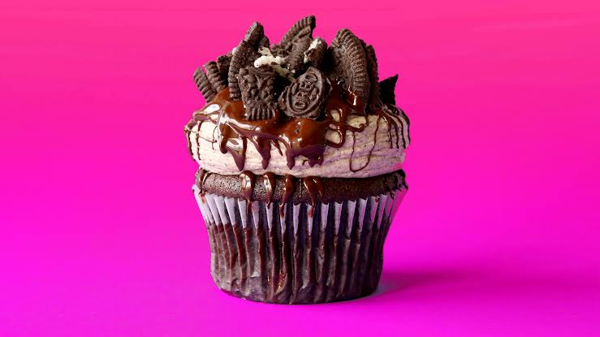
Vegan Cookies & Cream Cupcakes
Vegan or not, you are going to want this.

INGREDIENTS
400 milliliters coconut milk

165 grams cup sugar

80 milliliters cup canola oil

1 1/2 teaspoon Apple cider vinegar

1 teaspoon vanilla extract

240 grams cup all purpose flour

3 tablespoons Cocoa powder

3/4 teaspoon baking soda

1/2 teaspoon baking powder

1/4 teaspoon salt

1 cup roughly chopped Oreo cookies (or a vegan alternative. Oreo cookies in Australia are 100 percent vegan. Check the ingredients list on the back of the box at your local store)

Dairy free chocolate (melted, to drizzle)

Frosting

1 batch of fluffy vegan vanilla buttercream frosting

4 tablespoons unsweetened cocoa powder

INSTRUCTIONS
- Preheat your oven to 180C (356F) or 160C (320F) for a fan forced oven. Line a cupcake tin with cupcake liners.

- In the bowl of a stand mixer fitted with the paddle attachment, add the cocoa powder, plain flour, salt, bicarb soda, baking powder and sugar. Turn mixer on low speed and allow it to mix for a couple minutes to help everything combine well (alternatively you may do this by sifting the ingredients together).

- Next, add coconut milk, canola oil, apple cider vinegar in a jug and whisk until well combined.

- Add wet ingredients to dry ingredients in a slow and steady stream until no dry ingredients are visible. Scrape down the bowl, add chopped oreo cookies and mix for another 20 seconds.

- Fill each paper 3/4 of the way (using an ice cream scoop to transfer the batter into the cupcake liners makes this a quick and easy process otherwise you can use two tablespoons). Bake for 20-25 min or until a toothpick inserted comes out clean. Allow them to cool completely on a wire cooling rack before frosting.

- While your cupcakes are baking and cooling prepare your vegan chocolate frosting by adding the cocoa powder to the vanilla frosting and mix until well combined.

- Fit the end of a piping bag with a large round tip and frost a large blob of

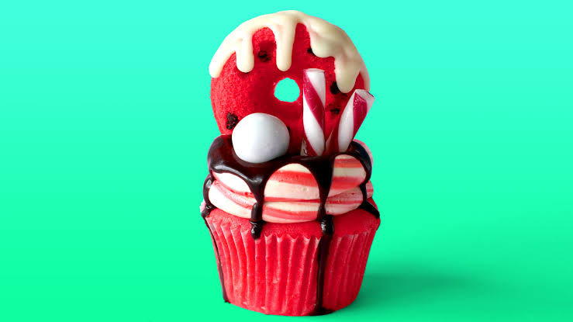
Candy Cane Freakshake Cupcake

This giant peppermint cupcake is filled with chocolate, covered in peppermint frosting and topped with a peppermint donut drizzled with white chocolate.

SERVINGS:
serving time10

INGREDIENTS
Cupcakes

429g all-purpose flour

265g caster (superfine) sugar

3 tsp baking powder

1/2 tsp salt

125g unsalted butter, softened

375ml of milk

125ml vegetable oil

2 tbsp Greek yogurt (can substitute with sour cream)

1 tsp vanilla extract

2 large eggs

4 drops red food gel

2 tsp peppermint extract or essence

200g mini choc chips

chocolate sauce

x10 candy canes

x 10 white chocolate ball candy

Frosting

1 batch Swiss meringue buttercream frosting

2 tsp peppermint extract/essence

4 drops red food gel

White choc ganache

290g white chocolate

¼ cup thickened cream

INSTRUCTIONS
- Cupcakes

- Preheat a fan-forced oven to 160C (320F) or 180C (356F) for a conventional oven. Line a 12 hole cupcake tin with cupcake liners. Spray a 12 hole donut tin with oil spray. Use a brush to spread around. Set aside.

- In the bowl of a stand mixer fitted with the paddle attachment, add the flour, baking powder, caster sugar and salt. Turn mixer on low speed and allow it to mix for a couple minutes to help everything combine well (alternatively you may do this by sifting the ingredients together). Add the softened butter and let it mix until it resembles a fine sand like texture.

- Next, add milk, eggs, yogurt. Peppermint extract, red food gel, oil and vanilla extract in a large jug and whisk well.

- Add wet ingredients to dry ingredients in a slow and steady stream until no dry ingredients are visible. Scrape down the bowl and mix for another 20 seconds.

- Add mini choc chips to the bottom of the donut holes and add batter using a piping bag. Fill to just above half way.

- Fill each cupcake liner 3/4 of the way (using an ice cream scoop to transfer the batter into the cupcake liners makes this a quick and easy process otherwise you can use two tablespoons).

- Bake donuts for 20 min and cupcakes for 40-45 min or until a toothpick inserted comes out clean. Allow them to cool completely on a wire cooling rack before frosting.

- White chocolate ganache

- Add white chocolate and ganache into a microwave safe bowl and microwave for 20 seconds at a time mixing each time until smooth. Set aside to cool slightly before using

- Frosting

- Add peppermint extract to all of the frosting and mix until well combined. Set aside ¼ of the frosting in a bowl. Add red food gel and mix until well combined. Add white frosting and red frosting in two separate frosting bags.

- Lay out a sheet of plastic wrap on your work bench and frost lines of the red and white frosting. Roll up and twist each end. Add to a piping bag fitted with a medium round tip.

- Core each cupcake and fill with chocolate sauce. Frost a double donut swirl on top. Drizzle with chocolate sauce. Add donut on top and drizzle with white ganache. Add candy cane straws and finish with white chocolate ball candy.

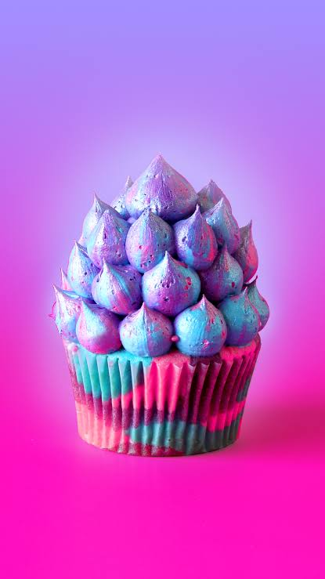
Unicorn Cupcakes
What's more enchanting than a pretty cupcake filled with colorful sprinkles?

INGREDIENTS
429 grams all-purpose flour

265 grams caster (superfine) sugar

1/2 teaspoon salt

3 teaspoons baking powder

375 milliliters of milk

125 milliliters vegetable oil

125 grams unsalted butter, softened

2 tablespoons Greek yogurt (can substitute with sour cream)

1 teaspoon vanilla extract

2 large eggs

4 drops pink food gel

2 blue pink food gel

2 drop purple food dye

Pink and purple sprinkles

Frosting

1 batch vanilla buttercream frosting

2 drops pink food gel

2 blue pink food gel

1 drop purple food dye

INSTRUCTIONS
- Preheat a fan-forced oven to 180C (356F) or 160C (320F) for a fan forced oven. Line a cupcake tin with cupcake liners.

- In the bowl of a stand mixer fitted with the paddle attachment, add the flour, baking powder, caster sugar and salt. Turn mixer on low speed and allow it to mix for a couple minutes to help everything combine well (alternatively you may do this by sifting the ingredients together). Add the softened butter and let it mix until it resembles a fine sand like texture.

- Next, add milk, eggs, yogurt, oil and vanilla extract in a large jug and whisk well.

- Add wet ingredients to dry ingredients in a slow and steady stream until no dry ingredients are visible. Scrape down the bowl and mix for another 20 seconds.

- Split the batter between three bowls. Colour one blue, one pink and the other with 2 drops of pink and two drops of purple. Transfer batter to three separate piping bags and pipe little blobs of each colour in the cupcake liners until it's filled 3/4 of the way.

- Bake for 20-25 min or until a toothpick inserted comes out clean. Allow them to cool completely on a wire cooling rack before frosting.

- To prepare frosting colour each one blue, purple and pink (same as the batter). Fit the end of a piping bag with a round tip and add a teaspoon of each coloured frosting in the bag (just randomly)

- Core the centre of each cupcake and fill with sprinkles.

- Frost three blobs of frosting on the cupcake. The bottom one being the biggest and the top one being smaller. Continue piping little blobs around each blob finishing with one final blob on top.

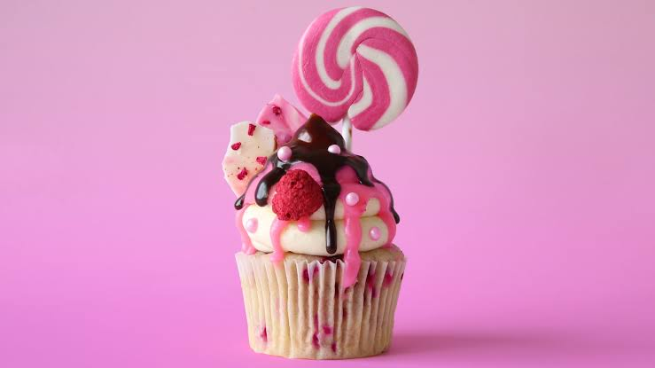
Candy Meadow Cupcakes

A chocolate and raspberry cupcake to satisfy any sweet tooth.

INGREDIENTS
429 grams all-purpose flour

265 grams caster (superfine) sugar

1/2 teaspoon salt

3 teaspoons baking powder

375 milliliters of milk

125 milliliters vegetable oil

125 grams unsalted butter, softened

2 tablespoons Greek yogurt (can substitute with sour cream)

1 teaspoon vanilla extract

2 large eggs

20 candy striped lollipops

1 teaspoon strawberry essence

3 cups crushed frozen raspberries

Freeze dried raspberries (whole x 20 and some crushed to sprinkle)

Pink sugar pearls

Chocolate sauce

Chocolate bark:

300 grams white chocolate

1 tablespoon vegetable oil

1 drop pink food dye

Pink chocolate sauce:

200 grams white chocolate

150 milliliters cream (at least 35 percent fat content)

1 drop pink food dye

Frosting

2 batches of fluffy white choc ganache frosting (recipe: thescranline.com)

INSTRUCTIONS
- Pink chocolate sauce:

- Combine white choc and cream in a microwave safe bowl and microwave for 20 seconds at a time until smooth. Add pink food dye and mix until well combined. Cover with plastic wrap and set aside.

- Chocolate Bark

- Add white chocolate to a microwave safe bowl and microwave for 20 seconds at a time, mixing each time until smooth. Transfer about 1/3 of it to a small mixing bowl. Add oil and food dye and mix until well combined.

- Pour white choc on to a large piece of baking paper and spread evenly. Drizzle pink chocolate on to the white and use a tooth pick or the back of a fork and swirl it around to create a tie dye like effect. Sprinkle for freeze dried raspberries and chill in the fridge for 20 min. Once it's set chop up with a large knife or break up with your hands.

- Cupcakes:

- Preheat a fan-forced oven to 180C (356F) or 160C (320F) for a fan forced oven. Line a cupcake tin with cupcake liners.

- In the bowl of a stand mixer fitted with the paddle attachment, add the flour, baking powder, caster sugar and salt. Turn mixer on low speed and allow it to mix for a couple minutes to help everything combine well (alternatively you may do this by sifting the ingredients together). Add the softened butter and let it mix until it resembles a fine sand like texture.

- Next, add milk, eggs, yogurt, oil, strawberry essence and vanilla extract in a large jug and whisk well.

- Add wet ingredients to dry ingredients in a slow and steady stream until no dry ingredients are visible. Scrape down the bowl, add 2 cups frozen raspberries and mix for another 20 seconds.

- Fill each cupcake liner 3/4 of the way (using an ice cream scoop to transfer the batter into the cupcake liners makes this a quick and easy process otherwise you can use two tablespoons). Sprinkle with more crushed frozen raspberries.

- Bake for 20-25 min or until a toothpick inserted comes out clean. Allow them to cool completely on a wire cooling rack before frosting.

- To finish cupcakes, core each cupcake, insert one freeze dried raspberry in each one and fill with chocolate sauce.

- Fit the end of a piping bag with a round tip and frost in a swirl with white chocolate ganache.

- Drizzle with pink chocolate sauce, then with chocolate sauce. Decorate with freeze dried raspberry, pink sugar pearls, chocolate bark and a candy striped lollipop.

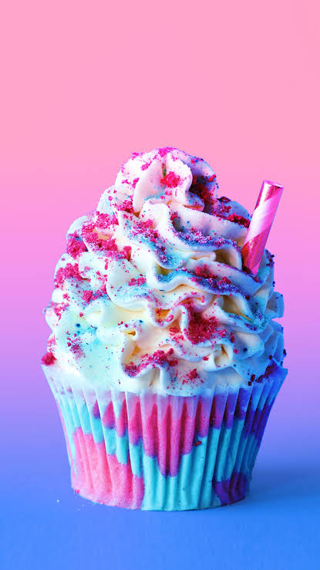
Unicorn Frappuccino Cupcakes
This is what rainbows and sunshine would taste like if they came in cupcake form.

SERVINGS:
serving time20

INGREDIENTS
Cupcakes

429 grams all-purpose flour

265 grams caster (superfine) sugar

1/2 teaspoon salt

3 teaspoons baking powder

375 milliliters of milk

125 milliliters vegetable oil

125 grams unsalted butter, softened

1 teaspoon vanilla extract

2 large eggs

2 drops blue food gel

2 drops pink food gel

3 tablespoons blue jello powder + extra to sprinkle

3 tablespoons raspberry jello powder

Freeze dried raspberry to sprinkle (crushed to a powder)

Pink filling

250 milliliters sweetened condensed milk

1 teaspoon raspberry essence

2 drops pink food gel

Frosting

600 milliliters thickened cream (for whipping)

3 tablespoons sweetened condensed milk

1 teaspoon vanilla extract

INSTRUCTIONS
- Pink filling

- Combine sweetened condensed milk, raspberry essence and pink food gel in a bowl. Mix until well combined and then transfer to a piping bag. Set aside.

- Cupcakes

- Preheat a fan-forced oven to 160C (320F) or 180C (356F) for a conventional oven. Line a cupcake tin with cupcake liners.

- In the bowl of a stand mixer fitted with the paddle attachment, add the flour, baking powder, caster sugar and salt. Turn mixer on low speed and allow it to mix for a couple minutes to help everything combine well (alternatively you may do this by sifting the ingredients together). Add the softened butter and let it mix until it resembles a fine sand like texture.

- Next, add milk, eggs, yogurt, oil and vanilla extract in a large jug and whisk well.

- Add wet ingredients to dry ingredients in a slow and steady stream until no dry ingredients are visible. Scrape down the bowl and mix for another 20 seconds.

- Split batter into two bowls. One with 1/3 and the other with 2/3. Add blue food dye and blue jelly powder to the bowl with 1/3 and mix until well combined. Add pink food dye and raspberry jelly powder to the other and mix until well combined.

- Add the blue batter to a piping bag and pipe zig zags on the inside of white cupcake liners.

- Fill each cupcake liner 3/4 of the way (using an ice cream scoop to transfer the batter into the cupcake liners makes this a quick and easy process otherwise you can use two tablespoons).

- Bake for 20-25 min or until a toothpick inserted comes out clean. Allow them to cool completely on a wire cooling rack before frosting.

- Frosting

- Add cream, condensed milk and vanilla extract into a large mixing bowl and whip to stiff peaks using a hand mixer.

- To finish cupcakes core the centre and fill with strawberry filling. Next, fit the end of a piping bag with a Wilton 1M piping tip and frost a swirl on top.

- Finish off with a sprinkle of blue jelly and crushed, freeze dried raspberries.

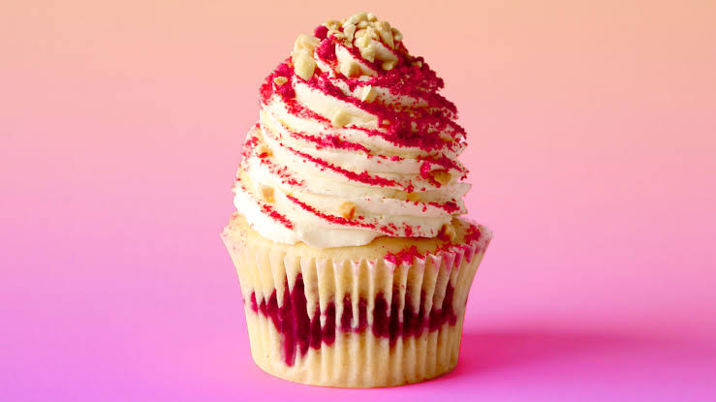
Raspberry Trifle Cupcakes
With mascarpone frosting and a custard center, this treat is full of creamy, berry goodness.

INGREDIENTS
429 grams all-purpose flour

265 grams caster (superfine) sugar

1/2 teaspoon salt

3 teaspoons baking powder

375 milliliters of milk

125 milliliters vegetable oil

125 grams unsalted butter, softened

2 tablespoons Greek yogurt (can substitute with sour cream)

1 teaspoon vanilla extract

2 large eggs

400 grams frozen raspberries (you can use fresh of you like!)

100 grams crushed, freeze dried raspberries

100 grams crushed peanuts

Custard

250 milliliters cup milk

250 milliliters cream (35 grams fat per 100g)

4 tablespoons custard powder

3 tablespoons sugar

1 teaspoon vanilla extract

2 tablespoons butter

Frosting

300 milliliters cream (35 grams fat per 100g)

1 teaspoon vanilla extract

3 tablespoons mascarpone cheese

INSTRUCTIONS
- Preheat a fan-forced oven to 180C (356F) or 160C (320F) for a fan forced oven. Line a cupcake tin with cupcake liners.

- In the bowl of a stand mixer fitted with the paddle attachment, add the flour, baking powder, caster sugar and salt. Turn mixer on low speed and allow it to mix for a couple minutes to help everything combine well (alternatively you may do this by sifting the ingredients together). Add the softened butter and let it mix until it resembles a fine sand like texture.

- Next, add milk, eggs, yogurt, oil and vanilla extract in a large jug and whisk well.

- Add wet ingredients to dry ingredients in a slow and steady stream until no dry ingredients are visible. Scrape down the bowl and mix for another 20 seconds.

- Fill each cupcake liner with about 1 1/2 tablespoon of batter. Fill with one layer of frozen raspberries and then top with more batter until the liners are filled 3/4 of the way.

- Bake for 30-35 min or until a toothpick inserted comes out clean. Allow them to cool completely on a wire cooling rack before frosting.

- Custard

- Add cream, vanilla extract and milk to a large microwave safe bowl or jug. Microwave for 2 min. Add custard powder and sugar to a large microwave safe bowl and mix with a whisk. Add 1/4 of the hot milk mixture to the custard powder mixture and whisk until well combined. Add the rest of the milk and repeat.

- Microwave for 1 min and mix. If it thickens as shown in the video then add the butter and whisk until combined. If it's still thin, continue microwaving for 30 seconds at a time, mixing each time until thickened. Cover with cling wrap and set aside in the fridge.

- Frosting

- Add cream to a large mixing bowl along with vanilla extract and whisk until you reach soft peaks. Add mascarpone and continue whisking until you reach stiff peaks.

- To finish cupcakes, core each one and fill with cooled custard. Fit the end of a piping bag with an open star tip and frost in a swirl. Finish with a sprinkle of crushed freeze dried raspberries and crushed peanuts.

