Insert your name, centre number and candidate number into the header above.
Save this evidence document as evidence_ followed by your centre number_ candidate number. For example: evidence_ zz999_9999.doc
Screenshots or program listings must be copied into appropriate cells in the following tables.
Examiners must be able to read the contents including any screenshots without the use of a magnifying glass. Answers that are not readable or missing will not be awarded any marks.
Save this evidence document at regular intervals, for example every 10 minutes.
Question 1
Part 1(a)(i)
{Copy and paste program code listing for question 1(a)(i) here}
class Bird:
def __init__(self,dph,s):
self.__DistancePerHour = dph #real,private
self.__Species = s #string,private
self.__XPosition = 500.0 #real,private
self.__YPosition = 500.0 #real,private

Part 1(a)(ii)
{Copy and paste program code listing for question 1(a)(ii) here}
def GetSpecies(self):
return self.__Species

Part 1(a)(iii)
{Copy and paste program code listing for question 1(a)(iii) here}
def GetPosition(self):
return "X = " + str(self.__XPosition) + " Y = " + str(self.__YPosition)

Part 1(a)(iv)
{Copy and paste program code listing for question 1(a)(iv) here}
def Move(self,direction,time):
distance = self.__DistancePerHour / 60 * time
if direction == "N":
self.__YPosition += distance
elif direction == "S":
self.__YPosition -= distance
elif direction == "E":
self.__XPosition += distance
elif direction == "W":
self.__XPosition -= distance

Part 1(b)
{Copy and paste program code listing for question 1(b) here}
b1 = Bird(71.0,"Cockatiel")
b2 = Bird(56.0,"Macaw")

Part 1(c)(i)
{Copy and paste program code listing for question 1(c)(i) here}

print("Bird 1: " + b1.GetSpecies() + " " + b1.GetPosition())
print("Bird 2: " + b2.GetSpecies() + " " + b2.GetPosition())

bird = input("Select a bird to move (1/2): ")
while bird != "1" and bird != "2":
print("Invalid input. Try again.")
bird = input("Select a bird to move (1/2): ")

direction = input("Enter the direction the bird has been travelling (N/S/E/W): ").upper()
while not direction in ["N","S","E","W"]:
print("Invalid input. Try again.")
direction = input("Enter the direction the bird has been travelling (N/S/E/W): ").upper()

time = int(input("Enter the time to the nearest minute that the bird has been travelling: "))
while time < 0 or time > 500:
print("Invalid input. Try again.")
time = int(input("Enter the time to the nearest minute that the bird has been travelling: "))
if bird == "1":
b1.Move(direction,time)

elif bird == "2":
b2.Move(direction,time)

print(b1.GetSpecies() + " is now at " + b1.GetPosition())
print(b2.GetSpecies() + " is now at " + b2.GetPosition())

Part 1(c)(ii)
{Copy and paste screenshot(s) for question 1(c)(ii) here}

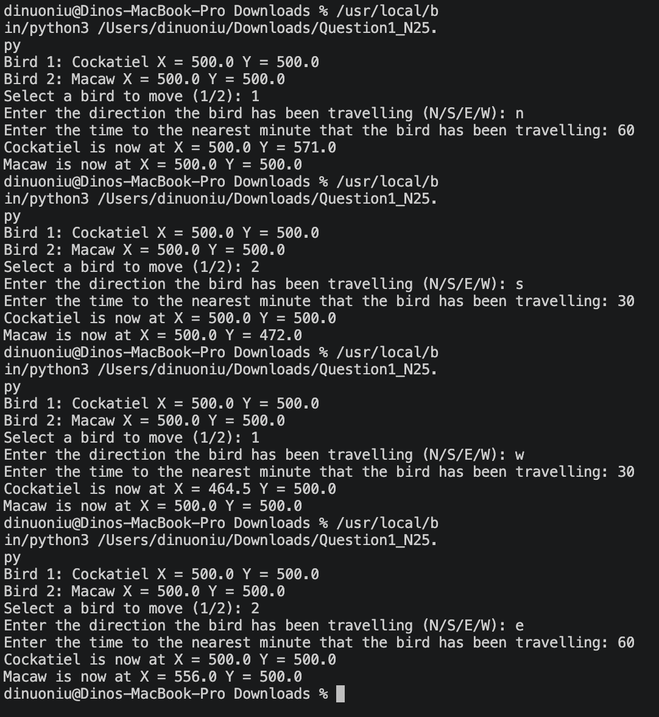

Question 2
Part 2(a)
{Copy and paste program code listing for question 2(a) here}
import random
array = [None] * 20
for i in range(20):
randnum = random.randrange(0,101)
while randnum in array:
randnum = random.randrange(0,101)
array[i] = randnum

Part 2(b)
{Copy and paste program code listing for question 2(b) here}
def PrintArray(par):
string = ""
for item in par:
string += " " + str(item)
print(string.strip())

Part 2(c)
{Copy and paste program code listing for question 2(c) here}
def BubbleSort(par):
for i in range(len(par) - 1):
swapped = False
for j in range(len(par) - i - 1):
if par[j] > par[j + 1]:
temp = par[j]
par[j] = par[j + 1]
par[j + 1] = temp
swapped = True
if not swapped:
break
return par

Part 2(d)(i)
{Copy and paste program code listing for question 2(d)(i) here}
PrintArray(array)
SortedArray = BubbleSort(array)
print("Sorted")
PrintArray(SortedArray)

Part 2(d)(ii)
{Copy and paste screenshot(s) for question 2(d)(ii) here}
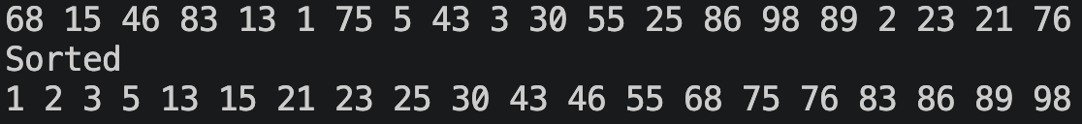

Part 2(e)
{Copy and paste program code listing for question 2(e) here}
def RecursiveBinarySearch(array,lb,ub,searchValue):
mid = (lb + ub) // 2

if lb + 1 == ub:
if searchValue == array[ub]:
return ub
elif searchValue == array[lb]:
return lb
else:
return -1
if searchValue < array[mid]:
return RecursiveBinarySearch(array,lb,mid,searchValue)
elif searchValue > array[mid]:
return RecursiveBinarySearch(array,mid,ub,searchValue)
elif searchValue == array[mid]:
return mid

Part 2(f)(i)
{Copy and paste program code listing for question 2(f)(i) here}
try:
searchValue = int(input("Enter an integer to search: "))
returnValue = RecursiveBinarySearch(SortedArray,0,19,searchValue)
if returnValue == -1:
print("Not Found")
else:
print(f"Found at position {returnValue}")
except:
print("Error. Input should be an integer.")

Part 2(f)(ii)
{Copy and paste screenshot(s) for question 2(f)(ii) here}
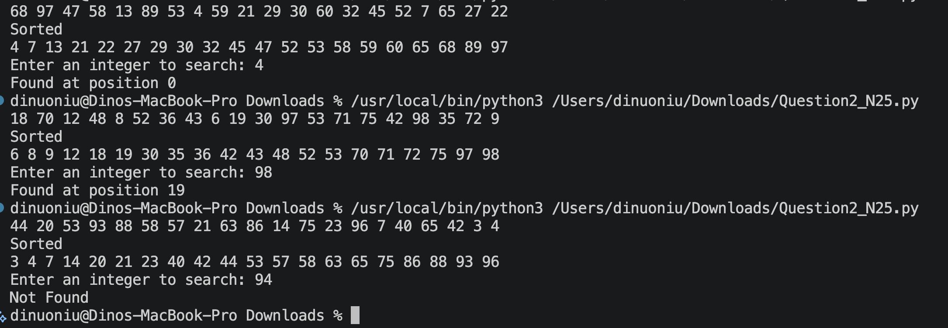

Question 3
Part 3(a)
{Copy and paste program code listing for question 3(a) here}
TreeArray = []
for i in range(50):
TreeArray.append([-1,-1,-1])
RootPointer = -1
FreeNode = 0

Part 3(b)
{Copy and paste program code listing for question 3(b) here}
def AddNode(newNode):
global RootPointer,FreeNode
if FreeNode > 49:
print("The tree is full")
elif FreeNode == 0:
TreeArray[0][1] = newNode
RootPointer = 0
FreeNode += 1
else:
current = RootPointer
previous = -1
isLeft = False
while current != -1:
if newNode < TreeArray[current][1]:
isLeft = True
previous = current
current = TreeArray[current][0]
elif newNode > TreeArray[current][1]:
isLeft = False
previous = current
current = TreeArray[current][2]

TreeArray[FreeNode][1] = newNode
if isLeft:
TreeArray[previous][0] = FreeNode
else:
TreeArray[previous][2] = FreeNode
FreeNode += 1

Part 3(c)
{Copy and paste program code listing for question 3(c) here}

try:
f = open("TreeData.txt","r")
for line in f:
AddNode(int(line.strip()))
f.close()
except FileNotFoundError:
print("Error. File does not exist.")

Part 3(d)
{Copy and paste program code listing for question 3(d) here}
def WriteAllToFile():
try:
f = open("Tree.txt","w")
string = ""
for i in range(50):
string += str(TreeArray[i][0]) + "," + str(TreeArray[i][1]) + "," + str(TreeArray[i][2]) + "\n"
f.write(string.strip())
f.close()
except:
print("Error cannot open file")

Part 3(e)(i)
{Copy and paste program code listing for question 3(e)(i) here}

WriteAllToFile()

Part 3(e)(ii)
{Copy and paste screenshot(s) for question 3(e)(ii) here}



