Insert your name, centre number and candidate number into the header above.
Save this evidence document as evidence_ followed by your centre number_ candidate number. For example: evidence_ zz999_9999.doc
Screenshots or program listings must be copied into appropriate cells in the following tables.
Examiners must be able to read the contents including any screenshots without the use of a magnifying glass. Answers that are not readable or missing will not be awarded any marks.
Save this evidence document at regular intervals, for example, every 10 minutes.
Question 1
Part 1(a)
{Copy and paste program code listing for question 1(a) here}
Stack = []
for i in range(20):
Stack.append("-1")
TopOfStack = -1

Part 1(b)
{Copy and paste program code listing for question 1(b) here}
def Push(item):
global Stack,TopOfStack
if TopOfStack >= 20:
return -1
else:
TopOfStack += 1
Stack[TopOfStack] = item
return 1

Part 1(c)
{Copy and paste program code listing for question 1(c) here}
def Pop():
global Stack,TopOfStack
if TopOfStack == -1:
return "-1"
else:
item = Stack[TopOfStack]
TopOfStack -= 1
return item

Part 1(d)
{Copy and paste program code listing for question 1(d) here}
def ReadData(filename):
try:
f = open(filename,"r")
for line in f:
returnValue = Push(line.strip())
if returnValue == -1:
print("Stack full")
break
f.close()
except FileNotFoundError:
print("Error. File not found.")

Part 1(e)
{Copy and paste program code listing for question 1(e) here}
def Calculate():
total = int(Pop())
while TopOfStack != -1:
operator = Pop()
num = int(Pop())
if operator == "+":
total += num
elif operator == "-":
total -= num
elif operator == "*":
total *= num
elif operator == "/":
total /= num
elif operator == "^":
total **= num
return total

Part 1(f)(i)
{Copy and paste program code listing for question 1(f)(i) here}
file = input("Enter filename:")
ReadData(file)
result = Calculate()
print(result)

Part 1(f)(ii)
{Copy and paste screenshot for question 1(f)(ii) here}

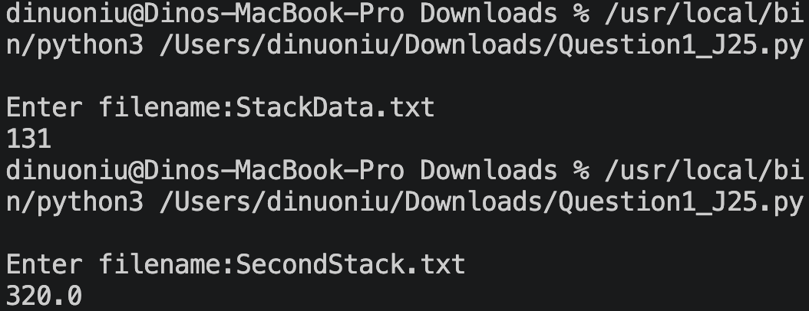

Question 2
Part 2(a)
{Copy and paste program code listing for question 2(a) here}
class NewRecord:
def __init__(self,k,I1,I2):
self.Key = k #integer,public
self.Item1 = I1 #integer,public
self.Item2 = I2 #integer,public

Part 2(b)(i)
{Copy and paste program code listing for question 2(b)(i) here}
HashTable = []
Spare = []

Part 2(b)(ii)
{Copy and paste program code listing for question 2(b)(ii) here}
def Initialise():
for i in range(200):
HashTable.append(NewRecord(-1,-1,-1))
for i in range(100):
Spare.append(NewRecord(-1,-1,-1))

Part 2(c)
{Copy and paste program code listing for question 2(c) here}
def CalculateHash(key):
return key % 200

Part 2(d)
{Copy and paste program code listing for question 2(d) here}
def InsertIntoHash(record):
HashValue = CalculateHash(record.Key)
if HashTable[HashValue].Key == -1:
HashTable[HashValue] = record
else:
i = 0
while Spare[i].Key != -1:
i += 1
Spare[i] = record

Part 2(e)
{Copy and paste program code listing for question 2(e) here}
def CreateHashTable():
try:
f = open("HashData.txt","r")
for line in f:
key,item1,item2 = line.strip().split(",")
InsertIntoHash(NewRecord(int(key),int(item1),int(item2)))
f.close()
except FileNotFoundError:
print("Error. File does not exist.")

Part 2(f)(i)
{Copy and paste program code listing for question 2(f)(i) here}
def PrintSpare():
i = 0
while Spare[i].Key != -1:
print(Spare[i].Key)
i += 1

Part 2(f)(ii)
{Copy and paste program code listing for question 2(f)(ii) here}
Initialise()
CreateHashTable()
PrintSpare()

Part 2(f)(iii)
{Copy and paste screenshot for question 2(f)(iii) here}

Question 3
Part 3(a)(i)
{Copy and paste program code listing for question 3(a)(i) here}
class Animal:
def __init__(self,n,sd,sz,i):
self.__Name = n #string,private
self.__Sound = sd #string,private
self.__Size = sz #integer,private
self.__Intelligence = i #integer,private

Part 3(a)(ii)
{Copy and paste program code listing for question 3(a)(ii) here}
def Description(self):
string = f"The animal's name is {self.__Name}, it makes a {self.__Sound} sound, its size is {self.__Size} and its intelligence level is {self.__Intelligence}"
return string

Part 3(b)(i)
{Copy and paste program code listing for question 3(b)(i) here}
class Parrot(Animal):
def __init__(self,n,sd,sz,i,ws,nw):
super().__init__(n,sd,sz,i)
self.__WingSpan = ws #integer,private
self.__NumberWords = nw #integer,private

def ChangeNumberWords(self,addValue):
self.__NumberWords += addValue

Part 3(b)(ii)
{Copy and paste program code listing for question 3(b)(ii) here}
def Description(self):
string = super().Description()
string += f". It has a wingspan of {self.__WingSpan}cm and can say {self.__NumberWords} words."
return string

Part 3(c)(i)
{Copy and paste program code listing for question 3(c)(i) here}
class Wolf(Animal):
def __init__(self,n,sd,sz,i,ts):
super().__init__(n,sd,sz,i)
self.__TerritorySize = ts #integer,private

def SetTerritorySize(self,addValue):
self.__TerritorySize += addValue

Part 3(c)(ii)
{Copy and paste program code listing for question 3(c)(ii) here}
def Description(self):
string = super().Description()
string += f". Its territory is {self.__TerritorySize} square miles."
return string

Part 3(d)(i)
{Copy and paste program code listing for question 3(d)(i) here}
a1 = Parrot("Chewie","Squawk",1,10,30,29)
a2 = Wolf("Nighteyes","Howl",8,7,100)
a3 = Animal("Copper","Neigh",10,6)

Part 3(d)(ii)
{Copy and paste program code listing for question 3(d)(ii) here}
a2.SetTerritorySize(-20)
a1.ChangeNumberWords(2)
print(a1.Description())
print(a2.Description())
print(a3.Description())

Part 3(d)(iii)
{Copy and paste screenshot for question 3(d)(iii) here}


