Tutorial

# How to Load Text into CAR

to select a Word Doc on your computer,

Drag and drop a Word Doc into CAR



Paste text from clipboard

Open as many Word Docs or paste as much text into CAR as you like. Navigate between documents and clips on the tabs at the top of the window.

# Playback

Press the start button to begin playback.

Press stop to stop playback.

--OR--

Press the spacebar to start or end playback

## Speech Rate

You can change the rate of speech as CAR reads. Press the "Rate" button in the upper right-hand corner of the window to reveal the rate slider.

# CAR Bar



## General Settings

* Adjust rate, volume, and pause length
* Select from TTS voices on your computer
* Change math discipline
* Change how images and alternative text are handled

## Highlight, Color, and Font Settings

* Change the colors of the background and text in the document
* Enable highlighting by word and sentence as it is read
* Change the font type
* Change the color theme of CAR

## Save to MP3

## Adjusting Text Size Zoom inZoom out or reset zoom

## Show/Hide Navigation Window

# Selecting Where to Begin Reading

## Using Your Keyboard

CAR highlights the word where it will begin reading

* Left and right arrow keys move the highlight forward and backward
* Up and down arrow keys move the highlight to the previous or next paragraph
* Home and End keys move the highlight to the beginning or the end of the paragraph
* Page Up and Page Down keys move the highlight between headings

Press the spacebar to begin reading at highlighted location.

## Using Your Mouse

* Double Click a word and press the spacebar, or
* Highlight a passage and press the spacebar

## Navigation Pane

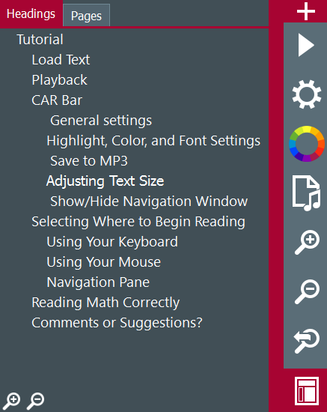

If headings have been enabled in your document, click the heading and press the spacebar to begin reading from that heading.

If pages have been enabled in your document, click the page number and press the spacebar to begin reading from that page.

# Advanced Settings Menu The Advanced Settings Menu is located in the upper right-hand corner of the window.

# Reading Math Correctly

 If there are math equations in your document, make sure to select the correct math discipline in the general settings.

CAR can read math:



.

# Comments or Suggestions?

If you have suggestions on how CAR can better drive the reading experience, then please let us know!

<http://www.cwu.edu/central-access/car-comments-and-suggestions>