Tutorial!

Welcome to the Nifty Prose Articulator! Here you will find how easy it is read your book in flawless prose.

# Player Functions

Here are the player functions in the toolbar:

Click on the Play button to start playback. Then, to stop playback, click on the Stop button.

To speak a certain passage, select the text using your mouse by clicking and dragging, and click the Play button. Try it out on a passage from Herman Melville’s Moby Dick below:

Call me Ishmael. Some years ago- never mind how long precisely- having little or no money in my purse, and nothing particular to interest me on shore, I thought I would sail about a little and see the watery part of the world. It is a way I have of driving off the spleen and regulating the circulation. Whenever I find myself growing grim about the mouth; whenever it is a damp, drizzly November in my soul; whenever I find myself involuntarily pausing before coffin warehouses, and bringing up the rear of every funeral I meet; and especially whenever my hypos get such an upper hand of me, that it requires a strong moral principle to prevent me from deliberately stepping into the street, and methodically knocking people's hats off- then, I account it high time to get to sea as soon as I can. This is my substitute for pistol and ball. With a philosophical flourish Cato throws himself upon his sword; I quietly take to the ship. There is nothing surprising in this. If they but knew it, almost all men in their degree, some time or other, cherish very nearly the same feelings towards the ocean with me.

# Settings

## Speech

The speech settings affect the quality of the voice, such as the speaking rate, the volume, and the actual voice. To access these settings, click on the  button. You will see a window that looks like the following:

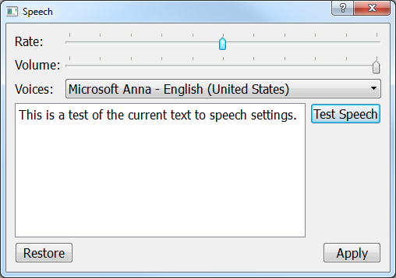

To adjust the rate and volume, slide the sliders accordingly.

For rate, the more left the slider is dragged, the slower the speech will sound. Likewise, the more the slider is dragged right, the faster the speech will sound. Also, for any slider in the program, you can simply click on the slider and use your mouse wheel to move the slider.

For the volume slider, the leftmost position is quieter while the rightmost position is louder.

To change the speaker, click on the button that is to the right of the Voices label. The button will show a list of voices currently installed on your computer. Click on the voice you want to select it.

To test out the speech settings, click on the Test Speech button. Then, to save your settings, click on the Apply button.

If you don’t like your settings and want to revert back to your last settings, click on the Restore button.

## Highlighting, Colors, and Fonts

To change the appearance of the program, such as the background colors, text colors, fonts, and highlighting behavior, click on the Paint Bucket button. This will reveal a window that looks like the following:

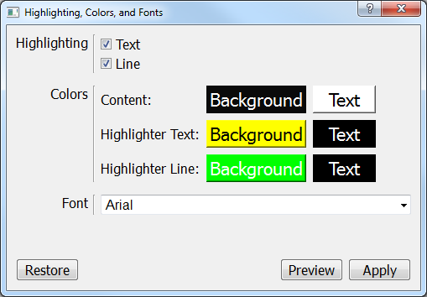

To turn off certain aspects of the highlighting (or everything entirely), click on the checkboxes next to “Text” and “Line.” A checkmark means that setting is active.

To change colors, click on the colored button of the setting you want to change. You will see a window that looks like this:

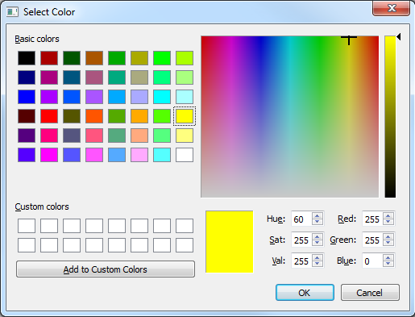

You can choose colors either by clicking on the preset colors on the left side of the window, or by clicking on the colored image on the right side of the window to choose a custom color. You can also drag the slider next to it to make the color darker or lighter.

To save your new choice, click on the OK button. To revert back to the color before, click on the Cancel button.

To change the font, you can either type in the font you want and press the “Enter” key, or click on the Small Arrow button that is at the end of the box and choose from one of the available fonts.

Finally, to preview your changes without saving them, click on the Preview button. To save and apply your changes, click on the Apply button. To restore your settings to what they were before, click on the Restore button.

# Making Text Larger

There are a couple ways to make text larger and easier to see. You can either click on the Zoom In button and Zoom Out button to make the text larger and smaller, or you can hold the “Control” key and use your mouse wheel.

For the Navigation items, click on the smaller Zoom In button and Zoom Out button that is above the navigation items to the right of the “Navigation:” label.

# Navigating the Document

On the left side of the window, you will see a navigation panel that looks like the following:

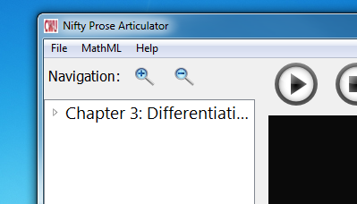

The items you see are the headings that correspond to the headings in your document. For headings that have subheadings, you will see an arrow to the left of it that when clicked will reveal or hide the subheadings.

To navigate to that heading in the document, click on the item. The document view will automatically scroll to where the heading is located in the document.