Baleka Spine V1 Assembly Guide

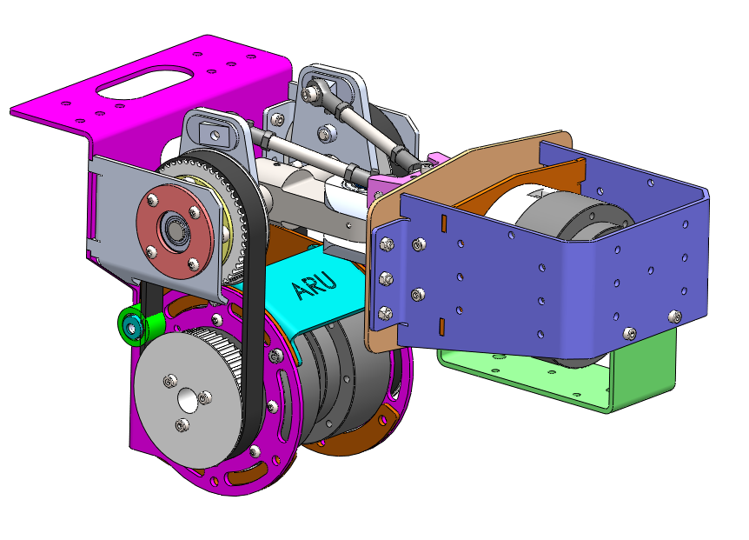

*Updated by Dino Claro (26 August 2025)*

All parts for the Spine, including the wiring harness, can be found in the project box. This guide aids with assembling the Spine and attaching it to Baleka and the frame. A brief explanation of the wiring harness is also provided. The guide primarily shows the order of assembly, and it is recommended to have the Solidworks model open alongside.

The procedure for assembling the parts that require press fits, such as the universal joint and bearings seats, is not shown here since they are already assembled and should not be taken apart unless a part has failed.

Assembly Tips:

* Washers are not shown in this guide. The general rule of thumb is to put the washer on the side that is turning. Depending on the access to the part this may either be the nut or the bolt head.
* When there are multiple screws/bolts, first tighten gently by hand and then tighten each bolt/screw by alternating to opposite sides.
* Nylock nuts are to be used throughout the assembly

## Differential Drive

### Control Arm Assembly

There are two Control-arm assemblies for the left and right Heim-rods, respectively.

Left and Right Control Assembly

1. A close-up of a gear

   AI-generated content may be incorrect.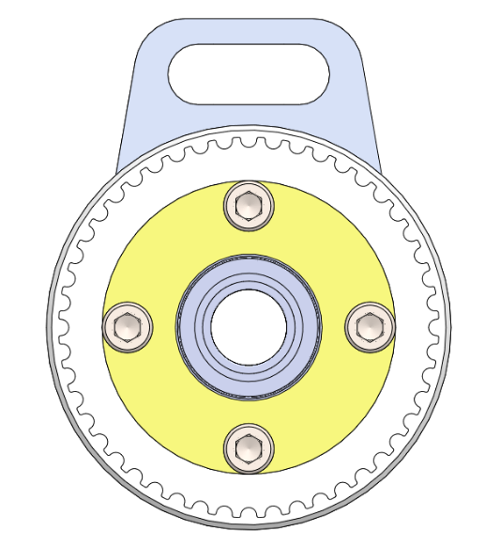The 6002-Bearing Seat (BLKS-M004) slots into the cavity of the Differential Shaft Pulley (BLKS-P001) and is fastened with M6x30 shoulder screws and 3D printed washers (BLKS-P007).
2. Repeat for the other side.

### Differential Shaft

1. Fix the left and right control assemblies with 15mm circlips.

## A close-up of a gear AI-generated content may be incorrect.Differential Drive Body

1. A close-up of a metal object

   AI-generated content may be incorrect.Attach the 6001-Bearing seat (BLKS-M001) to the side plates (BLKS-SM002 and BLKS-SM003) using M4x8 Button head screws. These screw directly into the side plates.
2. Fix the right-side Differential plate (BLKS-SM003) to the Differential back plate (BLKS-SM001) using M4x12 socket head cap screws.
3. 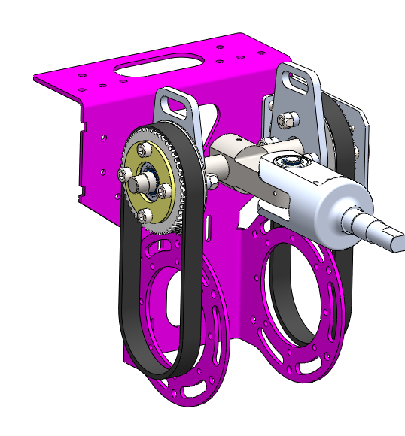Manoeuvre the complete Differential Shaft assembly into the bearing of the right-side Differential plate.  
   **N.B. Timing belts should be placed on the pulleys at this point.**
4. A purple box with white circles

   AI-generated content may be incorrect.A purple and silver machine

   AI-generated content may be incorrect.Slide the left-side Differential plate (BLKS-SM002) onto Differential Shaft and fix using M4x12 bolts.   
   **Take note of the bolt orientation for the left-side Differential plate in the image below. You should use a spanner to hold the nut and then tighten using the head of the bolt. The right-side bolt and nut can be in any orientation.**
5. Place the Differential rib (BLKS-SM009) in-between the side plates of the Differential back plate (BLKS-SM001). The Differential Rib is fixed to the sides of Back-plate with M6x8 shoulder bolts.

Can included now for alignment but will have to be removed at a later stage when attaching Spine to Baleka

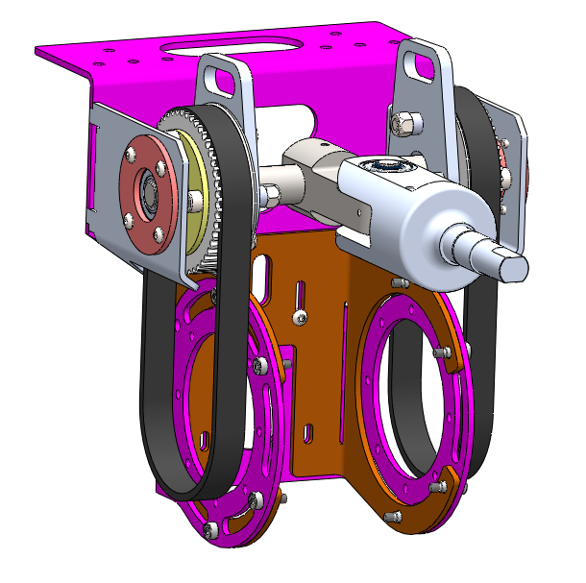

1. The Eccentric Belt Pulley tensioners are put together using various 3D printed parts (BLKS-P008, BLKS-P009 and BLKS-P010) as well as a 6800 DGBB. The tensioner assembly is attached to the Differential body using M6x35mm bolt and nut.  
   **Note:** **There may not be a hole in the Differential Rib. This is because the hole is too close to the bend line and must be drilled after receiving from Vulcan Steel. Insert the other shoulder bolts and mark the position with a drill punch to achieve correct hole location.**

## Roll Body

1. 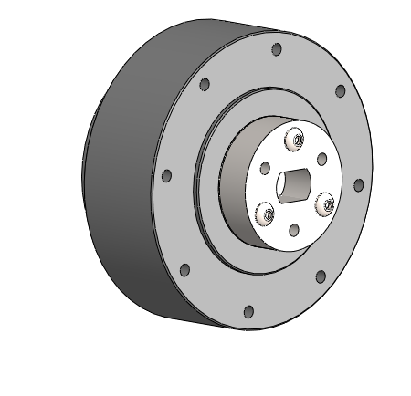Attach Roll Motor Couple (BLKS-M007) to the GIM8115-6 Roll motor using M4x16 button head screws.
2. A green and gold metal piece

   AI-generated content may be incorrect.6002 Bearing seat (BLKS-M006) attaches to Roll support plate (BLKS-SM007)with M4x12 button head bolts.

1. Attach the GIM8115-6 Motor to the Roll Support Plate using the Roll Motor Spacer (BLKS-P006) with M4x35 bolts.
2. 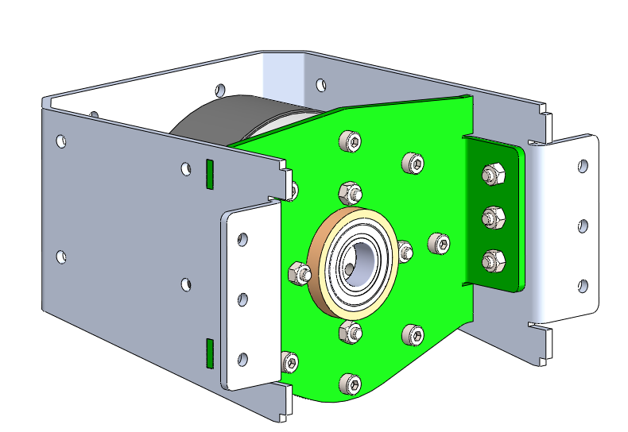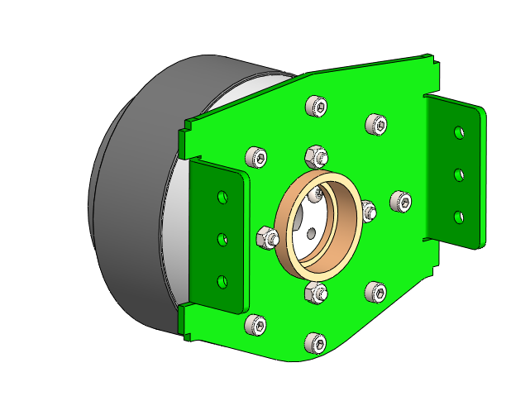Slightly bend the Roll-U-Plate (BLKS-SM006) outwards for the tabs of the Roll support plateto slot in and attach the two sheet metal parts with M4x12mm bolts.

Roll Assembly

1. A white metal plate with holes

   AI-generated content may be incorrect.Slot the 6003 Bearing seat (BLKS-M005) into the Frame roll plate (BLKS-SM010) and fasten with M4x12 bolts.
2. A blue and white metal object with a metal tape in it

   AI-generated content may be incorrect.Align the Roll-U plate tabs with the slots of the Frame roll plate. This may require a bit of force. Use a rubber mallet at the back side of the U-plate. The sheet metal parts are fastened using M4x12 bolts.

## Spine Assembly

Roll Shaft

1. A close-up of a nut and bolt

   AI-generated content may be incorrect.A colorful machine with metal parts

   AI-generated content may be incorrect. Slide the Universal-Joint female shaft into the Roll assembly. **N.B.: Ensure that the 17 mm circlip is placed on the shaft before inserting it into the roll assembly. Initially, the circlip will slide along the smaller-diameter section of the shaft as it is inserted. Eventually, the circlip will need to be manually shifted along the shaft until it locates in the cavity.  
   Tip: Check the orientation of the roll couple before sliding the shaft in.**

17mm Circlip

## 

## Frame

1. The spine attaches to two vertical extrusion profiles using 40x40 T-nuts (two for each side).

**N.B. The extrusion that should be used is different from the CAD model. Use the 40x40 extrusion profiles from the experimental space to assemble the frame shown below.**

## Baleka

**It is recommended to remove Baleka’s legs.**

1. 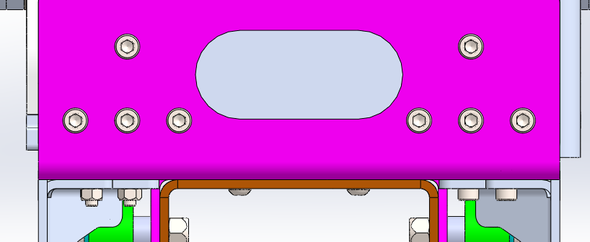The Spine attaches to Baleka on the top plate using eight M5 bolts. Four of these are shared with the bolts that secure the two half-Balekas, two have dedicated threads in the top plate, and the remaining two fasten only the spine.

**Top Side**

**To access the nut side of the bolts, the 20 × 20 mm extrusion profile must be removed. The nuts can then be tightened using a ratchet with an extension bar. If reaching the bolts proves difficult, a magnetic pen can help position the nuts.**

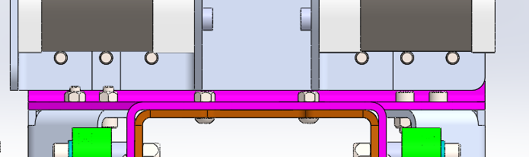

**Bottom Side**

### Back Support

1. 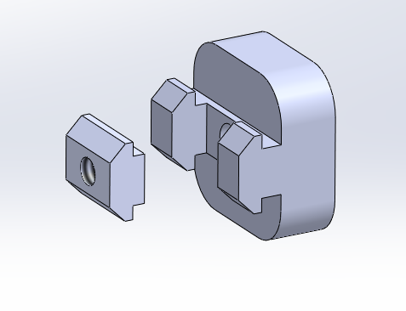The Back plate of the spine is secured to the extrusion profile using a two custom 3D printed spacers (BLKS-P011). Parts are designed to interface with the 20x20 extrusion T-nuts that can be found in the experimental space supplies.  
   **N.B. These parts may not have been 3D printed yet.**
2. A close up of a metal object

   AI-generated content may be incorrect.A close-up of a machine

   AI-generated content may be incorrect.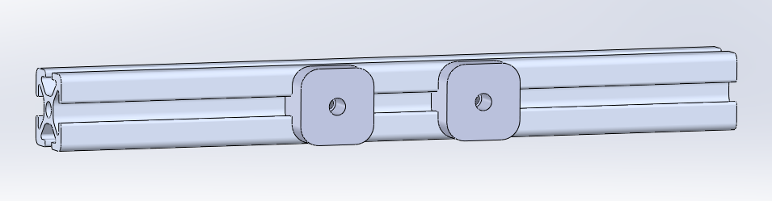Slide the 3D-printed spacers and T-nuts into the extrusion profile. Reinstall the extrusion profile and secure the back plate to the extrusion profile with an M4 bolt running through the two vertical slots of the back plate, through the spacer, and into the T-nut.

## Control Arms

1. A purple object with holes

   AI-generated content may be incorrect.A purple object with holes

   AI-generated content may be incorrect.A close-up of a metal object

   AI-generated content may be incorrect.Slide the Universal Joint Rod End (BLKS-P003) over the two roll pins and secure with a M4x20 bolt.
2. A close-up of a metal object

   AI-generated content may be incorrect.On each control arm, clip in the Control Rod End front and back (BLKS-P004 and BLKS-P005)
3. **Note: The Heim-rod assembly looks different from the CAD model due to the decision to use turnbuckles.**The Heim-rods are constructed with a turnbuckle, a left-hand thread, and a right-hand-thread rod-end bearing. The turnbuckle has a left-hand thread on one end and a right-hand thread on the other, allowing for easy adjustment. The rod-end bearings are attached to the 3D-printed parts (BLKS-P003/4/5) using M5×30 bolts.  
   **The 3D-printed rod-end parts are a work in progress, and further development is encouraged to improve the design for increased mobility and durability.**

## Differential Motors

1. A close-up of a machine

   AI-generated content may be incorrect.Attach the two Differential GIM8115-6 motors to the Differential back plate using M4x8 button head screws.   
   **N.B: Make sure the IO ports of the motors are facing up**
2. A close-up of a machine

   AI-generated content may be incorrect.Align and slot the two Differential Motor Pulley (BLKS-P012) onto the Differential motors. This can be finicky ;(
3. **N.B: Only complete this step are wiring is complete**.   
   Attach the two Motor guard (BLKS-SM011) using the M6 shoulder bolts.   
   **Note: The original design only has the top Motor guard. The updated design uses the** A colorful machine with metal parts

   AI-generated content may be incorrect.**second bottom motor guard.**

## Wiring

**As of latest update of this document, the wiring harness has not been fully completed.**   
  
The existing wiring harness has the following power connections:

* XT90 to four XT30s: Baleka motors
* XT90 to two XT60s and a single XT30: Differential drive motors, tail motors, and roll motor
* XT90 to two XT90s: supplies the above adapters from the 3-phase 10 kW or single-phase 1.2 kW power supplies

To accommodate the nine CAN lines, a Veroboard is used, interfacing with the M16 connector running to the Speedgoat. The CAN lines from the various motors slot into the Veroboard as shown below:

CAN Channel 1 (M16)

CAN Channel 2 (M16)

Tail Motors (2 lines)

Roll Motor

Differential Motors (2 lines)

Baleka Motors 1-4