CONSTITUTION
Of the National Online and OnDemand Workers Union
(NOODWU)

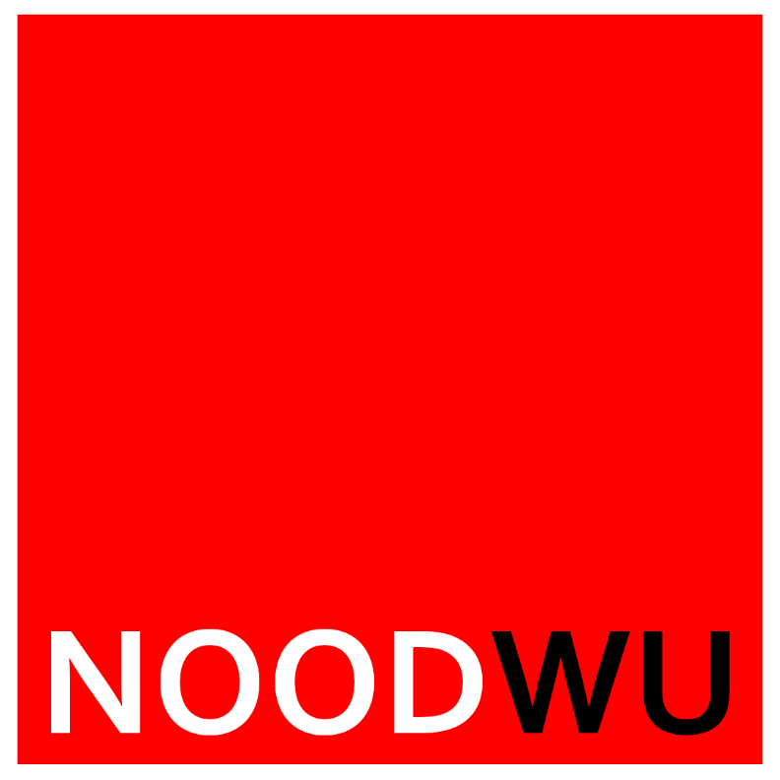

As constructed at the first National Congress of NOODWU in 2021

TABLE OF CONTENTS
PREAMBLE……………………………………………………………………………………………………………5
CHAPTER 1……………………………………………………………………………………………………………6
- CHARACTER OF THE UNION
- Name
- Scope
- Legal Status
- Location of head office
- Aims and objects
- Organisational structures
CHAPTER 2……………………………………………………………………………………………………………………………….

