**University of Witwatersrand**

**School of Electrical and Information Engineering**

**ELEN3020: Professional Practice & Software Engineering**

**10 June 2022**

**Group Technical Report**

**Contributors: Kiaan Moodley**

**Dinolan Naidoo**

**Ashley Jurisich**

**Abstract**

This document details the process that took place during the production of the website and accompanying documents. The project requirements and constraints were stated in the ELEN3020 project brief. The group consisted of three members, Dinolan Naidoo, Ashley Jurisich, and Kiaan Moodley. These three, known as the development team, worked together to successfully meet the brief demands, and named their fictional start-up company NES.

**Introduction**

The project required a website be created that allows users to understand and analyze the energy they are currently using for transport purposes, and see how this usage compares against a scenario where electric vehicles are used as an alternative. A prototype is set to be launched on 10th June 2022, whilst full deployment is set for 1st May 2023. Besides submitting the source code for a working prototype of the website, the project brief also requires several key documents. The process and reasoning behind the production of these project components are found in this document.

1. **The Requirements**

The documents that have to be submitted included a business plan, user documentation, timesheets, list of contributions, a slide deck for the presentation and also the source codes used for the website. The website needs to be a functioning prototype of what NES plans to launch at full deployment, so this prototype is required to at least show proof of concept. The website construction is split into two sub-systems, client-side technologies – HTML, JavaScript, CSS, and back-end technology - MySQL. These two systems working in tandem would result in a fully operational prototype of an energy tracker website. For full deployment of the website, Cloudflare will be used for the launch; however, for proof of concept, the prototype is launched using GitHub. The business plan needs to show that there has been thorough research done in regards to the industry climate and what the current situation of the market is in South Africa, as these are all fundamentals when starting a new business. The user documentation is required to give new users to the website an overview of it, and assist them in learning and understanding how the website operates, by giving them the necessary learning tools. The timesheet is meant to track the team members contribution to this project by having them input their time spent working on the project. The list of contributors gives a rough idea of the project component each team member is responsible for. The presentation slides are meant for a pitch the company is required to make, where a brief overview of the prototype, business strategies and practices, and financial pan is set to be spoken about.

1. **The Website**

**2.1 Client-side Technology**

**2.1.1 Sub-System Overview**

The flow diagram, labeled ***A*** and found in the Appendix, shows an overview of the design of the website and what each technology is used for.

**2.1.2 Sub-System Design**

The developer made use of Visual Studio as the Integrated Development Studio.

* HTML(Hypertext Markup Language):

The navigation bar is structured using HTML. The navigation bar includes the company name, the company logo, and hyperlink headings to the other pages. This navigation bar remains the same for all the pages. Furthermore, there are social media links at the bottom of the page that remain the same for all the pages.

Home Page:

The basic structuring and layout of the home page content is done using HTML. The home page consists of a description box. The name of the software designed (Energy Tracking System) is the heading of the description box. Below the heading there is a short description of the company mission statement. After the mission statement there is a demonstration button that will allow the user to navigate to a demonstration video on how to use the software. Lastly, there is a copyright free image used of a truck to unify the idea of tracking transport energy usage. The image was downloaded from *Unsplash* (<https://unsplash.com/>), which provides a variety of copyright free images.

Demo Page:

The structuring of the demonstration page is done by HTML. The demo page also consists of a navigation bar at the top to allows users to navigate between pages. Furthermore, there is an embedded video on the page that provides insight into how to use the software and how to analyze the data calculated.

Calculator Page:

The calculator page uses HTML for the layout of the input fields, results obtained in the form of numbers and the results obtained in the form of bar graphs. The user is also provided with a navigation bar at the top to navigate between pages. The styling is left to the CSS script.

Log-In Page:

The Log-In page uses HTML to create an input box. This input box allows the user to either sign up or log-in to their account. The sign-up box consists of a user email address, user password and a confirmation section for the user password. The log-in box consists of the user email address and the user password input field. Furthermore, there is another option for the user to reset their password if they forgot their password. The user is also provided with a navigation bar at the top. Lastly, the user can submit or login by clicking the relevant buttons at the bottom of the input box.

Help Page:

The help page uses HTML for the navigation bar and the context box below it. The user is given a description stating that signing up for the website will allow them to save and track their energy usage over any time period. Furthermore, the user is given the contact information of the company. The contact information includes a telephone number and our company e-mail address.

* CSS (Cascading Style Sheets):

The navigation bar’s font size, type of font, colour scheme and hovering effects are handled by CSS. This navigation bar styling remains the same for all the pages. Furthermore, the styling of the social media links remains the same for all the pages.

Home Page:

The home page styling is handled by CSS. The description box is also designed using CSS. The software heading is displayed much larger than the description text. The description text size is adjusted to be aesthetically pleasing to the user. Furthermore, the image used is adjusted and given a border-edge radius to improve the overall aesthetics. Lastly, the Demo button is styled to change the text colour and border colour when the user hovers over it. This gives the user an indication that it is a button that can be clicked.

Demo Page:

The demo page consists of mainly a demonstration video (besides the navigation bar). The video size, layout, and options are all handled by CSS. This page is not added in the navigation bar since the user will most likely watch the demonstration only once.

Calculator Page:

The calculator page uses CSS for the styling of the input fields, results, and graphing. The input fields are positioned in the center of the page. The results obtained are positioned on the left of the page. Furthermore, the results colour scheme is designed to match the graphs below. The ‘Calculate’ button is designed to have hovering effects and to match the colour scheme of the website. Lastly, the graphs are plotted on an invisible canvas. The canvas width and height are designed by using CSS.

Log-In Page:

The log in page consists of only a navigation bar and an input text box. The styling of this text box is handled by CSS. This includes the font sizes, font layout, button layout, headings and the colour scheme of each of these components.

Help Page:

The help page styling consists of the information layout, size, colour scheme and hovering effects. The description text size is considerably larger than the contact information. Furthermore, the contact information lies in text boxes to make it stand out. The border colour of the contact boxes change to green when the user hovers over it.

Responsiveness:

The responsive screen design is handled by CSS. This is done by compensating for different screen sizes by changing the font size, image size and overall layout of the website. Furthermore, the navigation bar disappears on smaller screens and an options bar is displayed on the top right corner. The user can click this options bar to display the pages that the user wants to navigate to.

* JavaScript:

JavaScript is used for only the calculator page and the log-in page.

Log-In Page:

The log-in page uses JavaScript for the animation effects when a user clicks on either sign-up or log-in. Furthermore, when a user logs in or signs up the JavaScript code is integrated with MySQL in order to store that information in a database.

Calculator page:

The calculator page needs JavaScript for event handling, function calling, calculations and linking the results to the HTML page. The flow chart named ***B***, found in the Appendix, illustrates how the calculations are done and displayed for the user to view. The user inputs data in HTML, this data is used for calculations in JavaScript and the results are displayed in HTML.

**2.1.3 Testing**

* Unit Testing:

Unit test is a key concept in software design to ensure that the functions used, and the results obtained are indeed correct. Unit testing is performed and it showed that the unit tests proved the validity of the functions used in the calculations. This is vital to the entire website, since our website is designed to receive input data, calculate results, and display these results correctly. This concludes the unit testing section.

* Functionality Testing:

Functionality testing refers to the user interface being tested.

Buttons:

All the buttons used on the website have been tested thoroughly. This includes the demo button, calculate button, log-in button, and sign-up button.

Navigation:

All the navigation links in the navigation bar have been tested and work flawlessly.

User input fields:

It was found that even though the distance and fuel economy fields have been limited to a number greater than 0, the user could still input a negative number manually. This was not a required result due to the fact that the calculations would yield a negative answer. As a result, an error checking prompt was implemented:

**2.2 Back-end Technology**

1. **The Documentation**

**3.1 The Business Plan**

The first thing that has to be done is drawing up a detailed business plan. This helps create a skeleton path of what direction the developers should head in, and what the project should look like going forward. It also would involve researching possible solutions and software architecture that could be used when designing the website. It helps developers obtain a clear picture of the vehicle energy market and how to present the solution in such a way that it may innovate the industry as a whole. Through minimum experience and multiple professional examples, found through online research, afforded the document master the ability to skillfully flesh out a detailed business plan. Online research also allows for the document master to devise business strategies which encourage the deployment of the start-up company, NES. Through some research, it was established that South Africa cannot support a large number electric vehicles on the road. For that reason, NES decided to target large businesses that rely on transport vehicles. This also affects the marketing strategy for the project. Since large businesses are targeted, it was decided that they be contacted directly and offered premium service for a fee, to add an income stream into the business. The business plan also helps devise an implementation strategy that fills in the gaps in the current market, as well as identify potential limitations that may prevent the growth of the web service. To solve this issue, there should be a second phase, after full deployment, that would target everyday individuals.

**3.2 User Documentation**

The user documentation is a simple and easy to design. It is basically a user manual for the website, and since the website is not complicated, the user documentation is also straight forward. The document briefly explains how the user can navigate the web page, and also what can be done on each page. The document master also edited the tutorial video that is played whenever the user clicks on the demo button the website. This means that the writer of this document has covered all bases in providing new users with the tools to fully make use of the service provided by NES. The document also contains visual cues which make it easier for readers to understand.

**3.3 Presentation**

Since the business plan had the business strategy, and website is at the prototype phase, by combining these two elements, the document master is able to create an intricate presentation about the new start-up company, NES. The presentation contains a demonstration of the of the website, as well as a short overview of the business plan and approach that NES plan to adopt when full deployment approaches. It also takes into consideration the financial plan up until the full deployment of the project.

**3.4 Timesheet**

The timesheet is a single complete document that has been compiled by adding the individual timesheets of each of the members of the development team. It tracks the team member’s contribution to the project by having them input the day and total time spent working on their individual responsibilities related to this project. It includes team meetings and any work the member might have done by themselves.

**3.5 Contribution List**

The contributions list is an informal document which verifies the contribution each team member has made towards the production of this project. The contribution of each member has been planned from the beginning of the project preparation phase.

**Conclusion**

The website is functional, as seen from the testing that took place. This is proof of concept, with the website prototype being launched using GitHub, and the full deployment is set to be launched using Cloudflare. The website has no apparent bugs or errors, and it is able to provide an energy tracking service, which is the requirement set in the project brief. There are also plans to improve and build upon this website by the time full deployment of the website is set, this being the database. The documentation covers all the required information stated in the project brief. It also covers details the process that took place to produce the submitted products. The business plan shows a clear business strategy and intricate implementation of this strategy. It also plans for the marketing and financial elements of this new start-up company. The user document assists new users in navigating the website. The timesheet and contributors list support the fact that each team member has spent a lot of time an effort in meeting all the project conditions. Therefore, the project is seen as successful because it meets all the project brief requirements.

**Appendix**

***A***

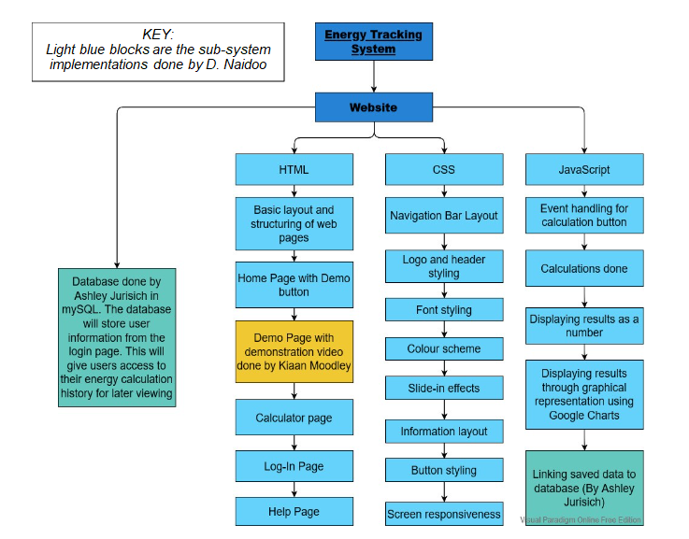

***B***

