**University of Witwatersrand**

**School of Electrical and Information Engineering**

**ELEN3020: Professional Practice & Software Engineering**

**User Documentation**

***Getting Started***

Once the webpage has loaded, the user should find themselves on the home page. It should appear as seen below:

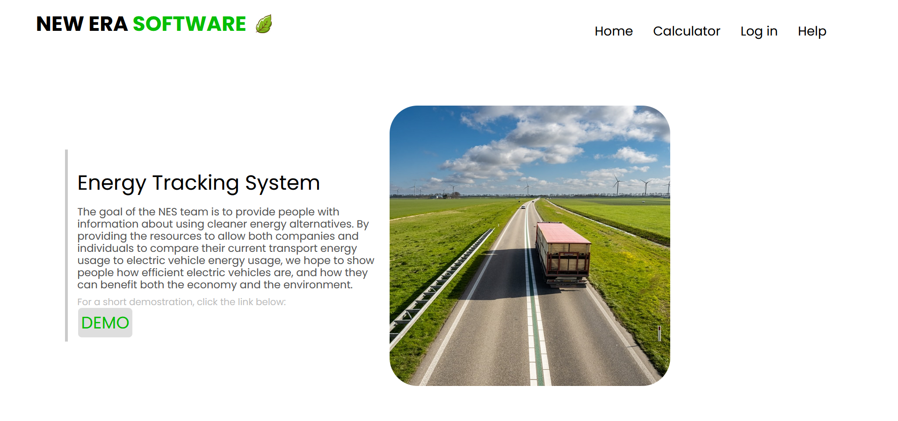

The bar at the top is constant in all pages. The left side displays the company’s name and logo. The right side shows the different pages the user may navigate to. These are:



The user is able to navigate to any one of these pages whenever they want.

***Home Page***

The home page is filled with a brief overview of what the goal of the company is, as well as the service the website provides – *Energy Tracking System*.

There is also a demo button found on the page. When this button is clicked, a video is played that shows the user a demonstration of how the calculator operates, and how to input data into the required fields.

***Calculator Page***

This is the main page of the site. The calculator page is where the energy tracking service is provided. It required the user to input their distance covered in kilometers in the first empty field. The second empty field is where the user inputs their fuel economy in liters per 100 kilometers. Then the user must select what energy source their vehicle uses from the drop-down list. They can then press the large green calculate button, which performs all the calculations. What is then displayed is the values for:

* Liters used – how much petrol/diesel their car has consumed
* Energy used – how much energy their car would consume if it was electrical and over the same distance and fuel economy the user previously inputted
* Cost – how much the petrol/diesel consumed has cost the user
* Cost for electricity – how much the user would have to pay for the electricity they would consume if the vehicle was electrical and over the same distance and fuel economy the user previously inputted

The Energy used, Cost and Cost for electricity are all displayed in a bar graph below to help the user better understand the comparison being made. Up to 4 calculations and comparisons can be made.

***Log in***

This page allows the user to either sign up or log in. Signing up requires the user to pay a subscription fee. Logging in means that they have already signed up, and are currently paying members of the service. It gives the users access to their history comparisons, as well as store any future calculations that the user may make.

***Help***

This page provides the user with company contact information should be user require it to report any issues with errors or bugs, or if the user has any queries and needs further assistance.