|  |  |
| --- | --- |
|  | **Plentoon Games** |

**Design Document for:**

# Grid Grunts

**FPS with Grid design in cute style world**

**“Grunt, and have fun in the cute grid world!”™**

**All work Copyright ©2017 by Plentoon Games**

**Written by Chengyu Yang, Kin Pan Mak, Liam Goerke and Jayden Grant**

**Version # 1.0**

**March 31, 2017**

**Table of Contents**

**Grid Grunts** **1**

**Game Overview** **5**

Philosophy 5

Philosophical point #1 5

Philosophical point #2 5

Common Questions 5

What is the game ? 5

Why create this game? 5

Where does the game take place? 5

What do I control? 6

What is the main focus? 6

What’s different? 6

**Feature Set** **7**

General Features 7

Gameplay 7

**The Demo World** **8**

Overview 8

World Feature #1 8

World Feature #2 8

World Feature #3 8

The Physical World 8

Overview 8

Key Locations 8

Travel 9

Scale 9

Objects 9

Weather 9

Day and Night 9

Time 10

**The Game World** **10**

Overview 10

World Feature #1 10

World Feature #2 10

World Feature #3 10

The Physical World 10

Overview 10

Key Locations 11

Travel 11

Scale 11

Objects 11

Weather 12

Day and Night 12

Time 12

Rendering System 12

Overview 12

2D/3D Rendering 12

Camera 12

Overview 12

Camera Detail #1 12

Game Engine 12

Overview 12

Game Engine Detail #1 13

Physical 13

**Game Characters** **14**

Overview 14

Enemies and Monsters 14

**User Interface** **14**

Overview 15

User Interface Detail #1 15

User Interface Detail #2 15

**Weapons** **15**

Overview 16

Weapons Details 16

**Sound** **16**

Overview 17

3D Sound 17

Sound Design 17

**Single-Player Game** **18**

Overview 18

Story 18

Hours of Gameplay 18

Victory Conditions 18

**Multiplayer Game** **19**

Overview 19

Max Players 19

Servers 19

Customization 19

Internet 19

Persistence 19

Saving and Loading 19

# 

# 

# Game Overview

## Philosophy

### Philosophical point #1

This game is trying to build up a First-Person Shooter (FPS) in a cute style world that is constantly changing around the player. Fundamentally we are trying to build up our own game engine to implement the game models, physics and sounds.

### Philosophical point #2

Our game will be designed to run on any machine, being compatible with most of the Operating Systems current users often use, such as Windows and PlayStation, so that every user can play this game.

## Common Questions

### What is the game ?

This game is using FPS gerner as a base, and playing shooting game dealing with monster and players as a match, in a cute style dynamic terrain.

### Why create this game?

This kind of semi-platform type game would appeal to retro gamers who enjoy older platforming games mixed in with new first person FPS feel. It is aimed to be a fun competitive game to play locally with friends, in a similar way to mariokart from Nintendo. The game concept sounds very fun and it would be a great game for all ages.

### Where does the game take place?

The game would take place on a floating sky block built of many squares, in a grid like fashion. Each individual grid square would be able to move up and down creating impassable terrain and opening and closing different areas in the world. Falling of the world would result in the death of the player and forcing them to restart.

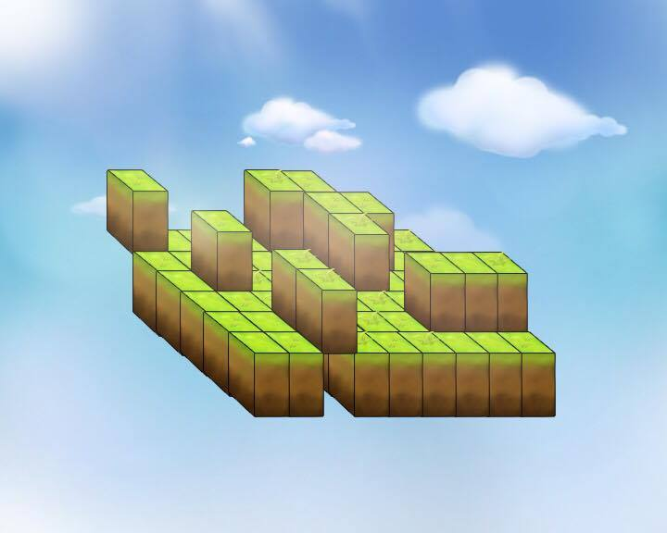

### What do I control?

The player will control one character and will be able to move throughout the world. They will be able to shoot and interact with other players and monsters throughout the world.

### What is the main focus?

The main focus of the game is to shoot the monsters in the world with your portal gun, sending them back to their home dimension that they escaped from. The game will have a time constraint and in the single player component the player will try to shoot as many monsters before the time runs out. In the multiplayer component the players will race against each other to shoot the most monsters before the time runs out.

### What’s different?

As far as we can tell there are no other games like this on the market. There are games that involve shooting but this game’s dynamic terrain would make it extremely unique in comparison to other shooting/puzzle games.

# Feature Set

## General Features

Cute style view of world

Dynamic terrain design

First Person Shooter with 3D graphics

**Particle effects**

Particles used to simulate fire, water or explosions.

## Gameplay

Peek in and out of dynamic cover and out maneuver your opponent.

Shoot your opponent to down them for a short period, trap the creatures while your competition is down.

Collect monsters while maneuvering through constantly changing terrain.

Knock your opponents off the map with special abilities.

# The Demo World

## Overview

This game occurs on a grid world where each individual grid chunks Can be at a different height. In future versions these chunks will be able to move up and down so that the whole battle scene will be changing all the time. It looks like a chessboard floating in the sky.

## World Feature #1

Agile, various terrain design. Different height in the landscape based on the grid chunks vertical location. A total of 1 square kilometer built of 20 metre chunks. The chunks that are elevated are impassable.

## World Feature #2

Particle effects can be implemented to represent fire, smoke or water.

## The Physical World

### Overview

**Two levels:**

1. Ground:

The base height that the players start on and will spend the majority of their time on.

1. Level 1:

The higher level based on the moving chunks. As the chunks are not moving this location is out of reach.

**Each grid has its own physical abilities:**

1. physical plane(players can stand up on).
2. as a boundary box when raised up(restrict the range of players moving, defense attack).

**Sky box:**

1. the boundary of the whole terrain
2. can kill when players when they step off of the world.

### Key Locations

**Two main locations:**

1. Grid world: where the battle would take place.
2. Sky box: contain the grid world where players can fall off the world to their death, simulated by respawning the player back on the skyblock if they step off.

### Travel

As the game is a normal first person shooting game, the basic movement are handled by 2 sections：

**Horizontal：**

4 keys for moving forward, backward, left, and right.

**Vertical:**

1 key for jumping..

All the moving function can be reached under mouse moving.

### Scale

**Initial scale:**

World scale: 1000 * 1000 grid (total is 1 000 000 m2 or 1 square kilometer)

Grid scale: 20m x 20m

(Players scale: 1 m, Monster scale: 1 m or less)

### Objects

1. Trees
2. Mushrooms
3. World Chunks
4. Particles
5. Grunts( not implemented in the demo world)

### Weather

The initial weather will be set to be always sunny day. (further design: the game levels could be represented by different weather such as sunny day lv1, raining day lv2). Potentially even introducing fog or a reduced FOV to give a more exciting gameplay experience.

### Day and Night

N/A

### Time

**Initial battle time:** 20 minutes each term.

During the gaming period, the world will be leveled up in each 5 mins (such as speed up the frequency of changing grids). No timer implemented into the demo world.

## Rendering System

### Overview

The game will initially be supported by openGL rendering, other graphics rendering libraries can be implemented into the graphics engine at later stages.

### 2D/3D Rendering

The main game will be rendered in 3D, the world the player is in, whilst UI elements will be rendered over the 3D scene in 2D.

## Camera

### Overview

The camera will be locked on to the player in a first person view, they will have full control only bounded by the physics of the world.

### Camera Detail #1

The camera’s position will be moved through the use of the WASD keys and the angle or perspective of the world will be altered through the use of the mouse

## Game Engine

### 

### Overview

The game engine will control everything that is going on, the physics, rendering, graphics and interactions between AI and characters.

### Game Engine Detail #1

The game engine will keep track of everything in the world such as impassable terrain and locations of AI and players to detect collisions. It would implement gravity and other physics into the world.

### Physical

Our game will use the Bullet physics engine to simulate the physics and collision detection in our game, This will prevent players and monsters from walking through walls and falling through floors. The engine will also provide the hit detection when players shoot their weapons.

# 

# 

# Game Characters

## Overview

There will be two main characters in our game, the player and the grunts. The players will be some kind of human form and the grunts will be from an alternate universe somehow slipping into our world and threatening our way of life.

## Enemies and Monsters

The main enemies in the world will be the grunts, these enemies will start of small and may get bigger or faster depending on the difficulty of the game. The player will attempt to catch these grunts and either send them back to the dimension they came from with some kind of portal weapon or eliminating them.

# User Interface

## Overview

The user interface will provide vital information to the player about their current game, such as how long the current match has remaining, their current score and the status of their weapon.

## User Interface Detail #1

The user interface will contain a map of the world. Based on difficulty this map may show the world in its entirety or only the parts of the world the player has explored.

## User Interface Detail #2

The user interface will inform the user of necessary information to the game. This would be things like weapon status, ammo left in their clip or total ammo remaining. It will also show the player what power ups the player has available at that point in time if any.

# Weapons

## Overview

The player will have a ‘Portal’ weapon, this weapons will shoot a projectile which, when it comes in contact with an enemy, will send them back to their original dimension/world.

As the other human players in the game are already in their original world/dimension, the weapon will stun them preventing them from taking any actions for a short time.

## Weapons Details

The players also have access to a special ability, players may be able to pick this special ability off of the ground, this ability will allow the player to push other players from a distance around the game world and of the edge ot the world.

# Sound

### 

## Overview

The game will play basic sound for many interactions with the game, such as when navigating the menu, when shooting, being attacked, or moving their character.

## 3D Sound

The OpenAL audio library will allow implementation of 3D audio in our game, this will allow players the hear when and where other players shoot their weapons and allow them to hear when and where an enemy spawns, this will be crucial to the games clarity and allowing the player to understand what is happening around them in the game world.

## Sound Design

Many of the games sound will be created using free only tools such as BFXR and SFB Games’ Chiptone, Both these tools are designed for making simple 8/16-bit like sound effects intended for video games.

Others sounds may be sampled where appropriate, such as footsteps sounds.

# 

# 

# Single-Player Game

## Overview

The single player experience will involve a hero (the player) fighting the grid grunts who have managed to break through into our world and who are now threatening our way of life. The player will rush around the world eliminating and sending the grunts back from where they came before they overrun the planet.

## Story

You are humankind's last hope for survival, an interdimensional rift has allowed evil grunts to pass into our world. Humans before you have created a battle environment best suited to defeat these enemies with ever changing environments giving you the best possible chance to defend humanity. A special set of armour and weapon have been designed for you to fight these Grid Grunts allowing you to send them back from where they came.

## Hours of Gameplay

The game will be like a challenge sort of game with slight variations allowing the player to battle themselves to attempt to achieve the highest score possible. Each level will be more difficult and fast paced allowing all players to be challenged and have fun. The single player game experience should be something like an old arcade game where although each playthrough would be very similar it never stops being fun.

## Victory Conditions

After completing all possible levels the player would have successfully defended Earth from the Grunt invasion winning the game and having their score saved within the game.

# Multiplayer Game

## Overview

The multiplayer gamemode will involve at most probably 4 players interacting in the world. The players will either race against each other to eliminate as many grunts in the time limit or work there way through the world together.

## Max Players

The game will support up to 4 players. This may be altered depending on demand.

## 

## Servers

Our server will be peer-to-peer, with the host also being one of the players.

## Customization

Host is able to choose the difficulty of the match.

## Internet

The client players enter the host’s game world and start looping until disconnected. Client players keep sending the device input action (like wasd for moving and left click for shooting) to the host. Then, the host update all the components in the game world, including monsters action and other player’s action etc. The host upload the updated contents to the client players (other players’ actions, monsters’ actions) so that the client players can receive the updated game world.

## Persistence

The game finishes when all the monsters have been sent back through portal.

## Saving and Loading

It is not suitable to pause, save and load the Grid Grunt match in multiple gameplay. The reason is that Grid Grunt match is a real time FPS genre, which runs continuously and synchronous with each player. If there is a player disconnected, every player has to be disconnected, and wait for everyone be connected again to be able to save and load, which is inconvenient.