

Kazakh-British Technical University
School of Information Technologies and Engineering

Laboratory work №1

Prepared by: Gainullin D.
Checked by: Abildayeva T.

Almaty, 2025
CONTENT

Introduction 3
Task 1: Formatting Excel Sheet 4
Task 2: Automation of financial data analysis using macros 7
Step 1: Data Preparation 7
Step 2: Automated Analysis 9
Step 3: Forecasting and Scenario Analysis 10
Step 4: Conclusions and recommendations 12
Conclusion 13

INTRODUCTION

In this lab work, we focused on applying Excel tools and macros to analyze financial data in a structured and automated way. The tasks included formatting the sheet, calculating key metrics, using filters and sorting, and identifying quarters for better organization of information. Special attention was given to automation with macros to save time, avoid errors, and make the analysis more effective.

Part №1

Task №1

Figure 1 – Bold Style

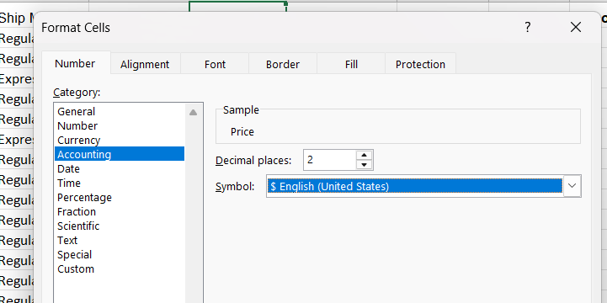

Figure 2 – Format cells

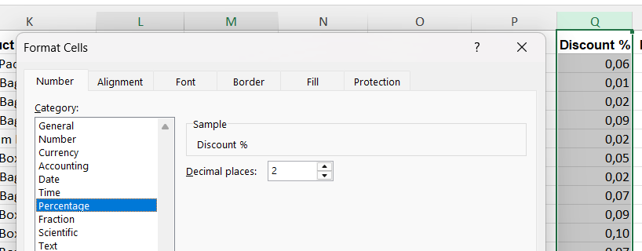

Figure 3 – Percentage format

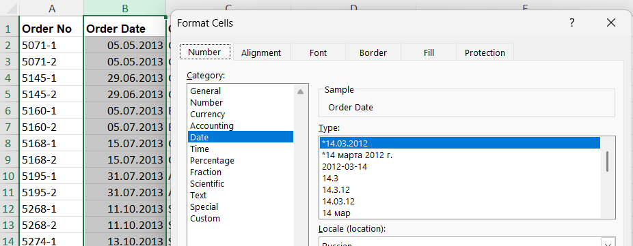

Figure 4 – Date format

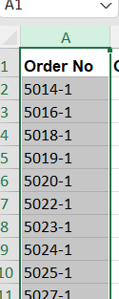

Figure 5 – Result of date

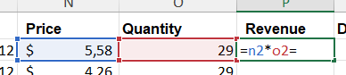

Figure 6 – Revenue column

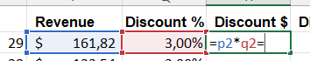

Figure 7 – Discount column

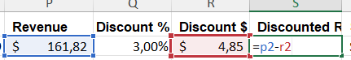

Figure 8 – Discount revenue column

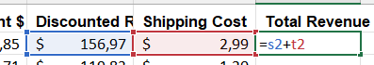

Figure 9 – Total revenue column

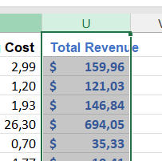

Figure 10 – Result of Total revenue column

Figure 11 – Summary of column

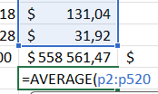

Figure 12 – Average value

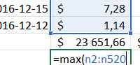

Figure 13 – Max value

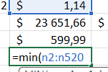

Figure 14 – Min value

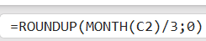

Figure 15 – Formula for quarter column

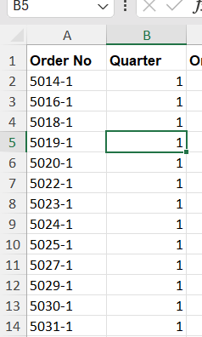

Figure 16 – Quarter column

Task 2: Automation of financial data analysis using macros

Step 1: Data Preparation

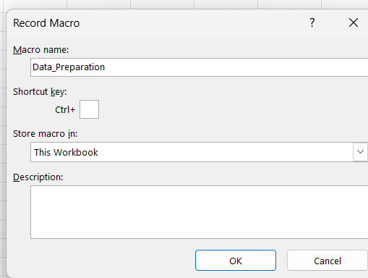

Figure 17 – Macros №1

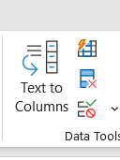

Figure 18 – Remove duplicates
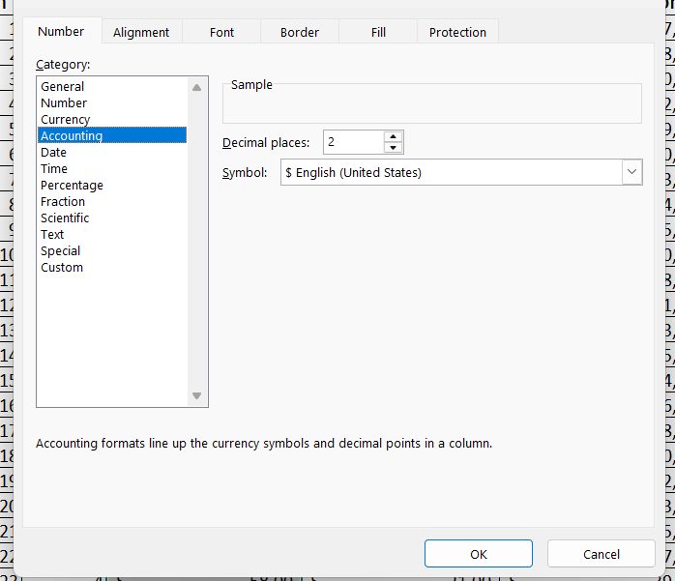

Figure 19 – Format cells

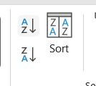

Figure 20 - Sort
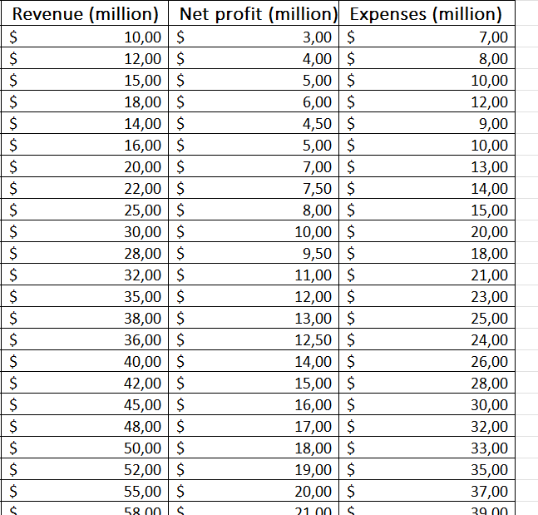

Figure 21 – Result of all column

Step 2: Automated Analysis

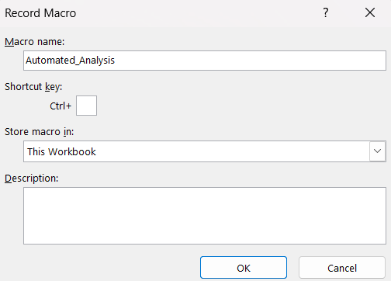

Figure 22 – Macros №2

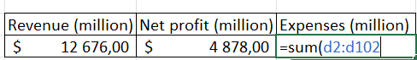

Figure 23 – Sum column

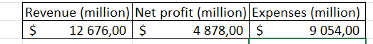

Figure 24 – Results of sum

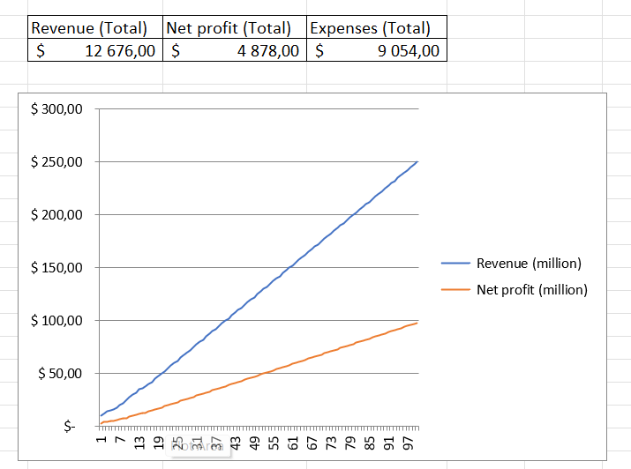

Figure 25 - Graph

Step 3: Forecasting and Scenario Analysis

Figure 26 – Data tab

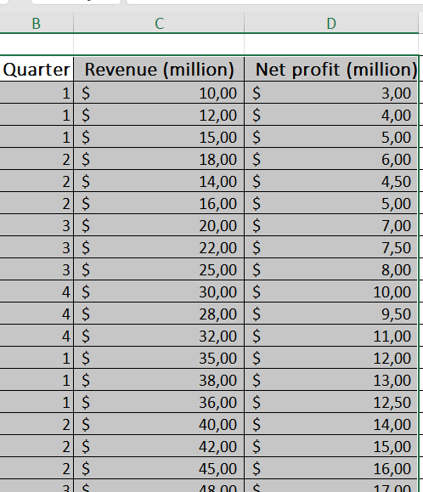

Figure 27 – Copy for Forecast Sheet

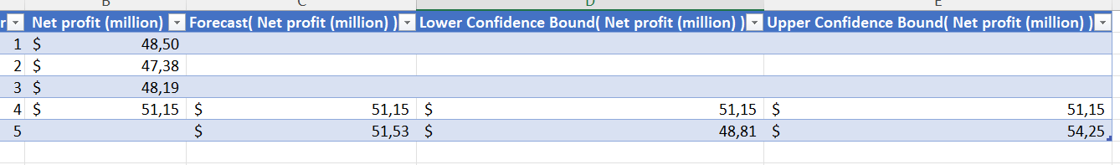

Figure 28 – Forecast Sheet

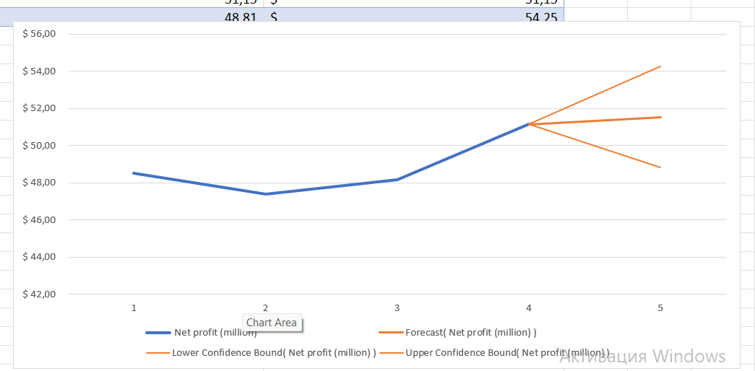

Figure 29 – Graph of Forecast Sheet

Step 4: Conclusions and recommendations

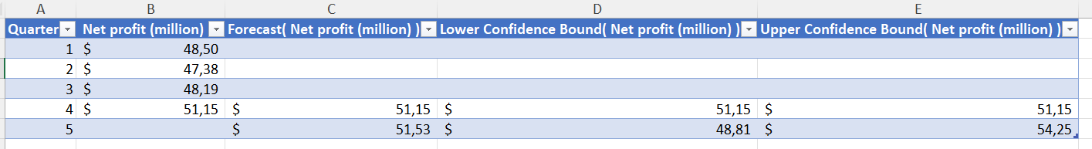

Figure 30 – Result of Forecast Sheet

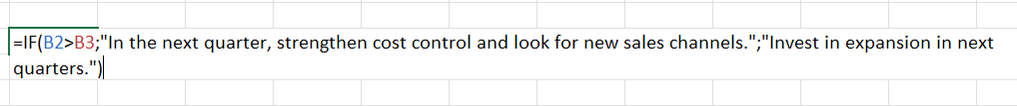

Figure 31 - Сomparison
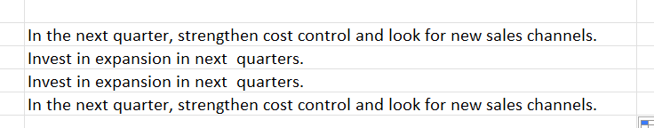

Figure 32 – Answer of comparison

CONCLUSION

In this lab work, the results showed that financial data can be managed more clearly and efficiently with proper formatting, formulas, and automated tools. The use of macros allowed us to prepare data, create summaries, visualize trends, and even forecast future performance. Overall, this approach supports better decision-making and provides useful recommendations for improving financial outcomes.

