

Kazakh-British Technical University
School of Information Technologies and Engineering

Laboratory work №6
POWER BI

Prepared by: Gainullin D.
Checked by: Abildayeva T.

Almaty, 2025
CONTENT

Introduction 3
Part A 4
1.1 Creating an interactive dashboard 4
1.2 Creating complex dashboards 6
1.3 Interactive filters 7
Part B 8
2.1 Data analysis using Power BI 8
Conclusion 11

INRODUCTION

In this laboratory work, we explore the capabilities of Microsoft Power BI as a modern tool for data visualization and interactive analytics. The primary objective of this lab is to learn how to design dashboards that provide meaningful insights through various graphical representations. Throughout the tasks, we focus on creating interactive reports, applying filters, linking visualizations, and analyzing real data sets. By completing these steps, we develop essential skills for transforming raw information into clear, structured, and easy-to-interpret analytical dashboards.

Part A

1.1 Creating an interactive dashboard

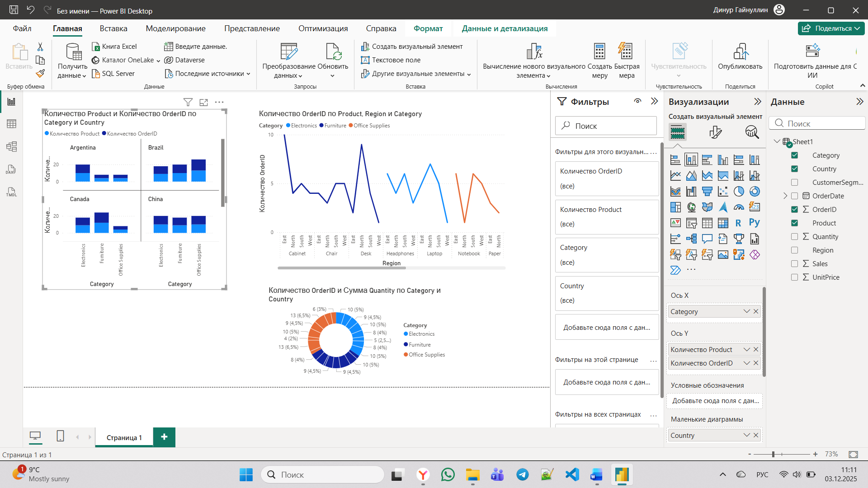

Figure 1 – The histogram

As shown in Figure 1, this looks like a table or matrix visualization in Power BI, showing data such as "Quantity of Products" and "Quantity of Order IDs," broken down by categories like Argentina, Brazil, Canada, and China, and likely by product types (e.g., Electronics, Furniture). It appears to be part of a dashboard summarizing sales or orders by region and product category. This type of visual is used for comparing metrics across different dimensions.

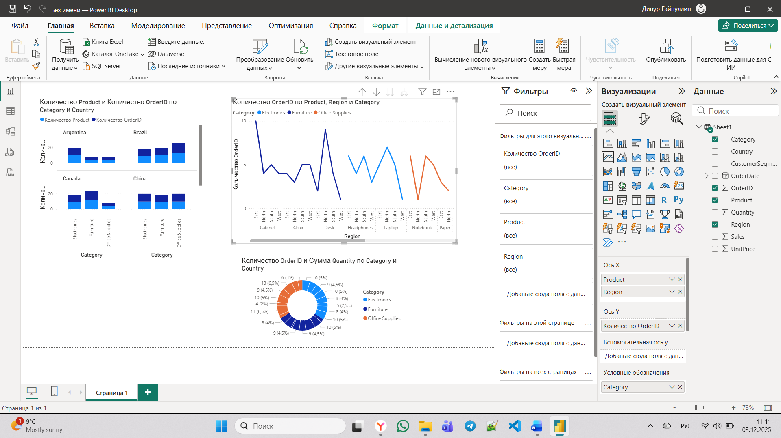

Figure 2 – The Graph

As presented in Figure 2, the interface displays a Power BI visualization with cross-tabulated data. It appears to be a matrix showing the count of Order IDs broken down by Product, Region, and Category (such as Electronics, Furniture). The view allows for analyzing order distribution across different product types and geographical areas like East, West, North, and South.

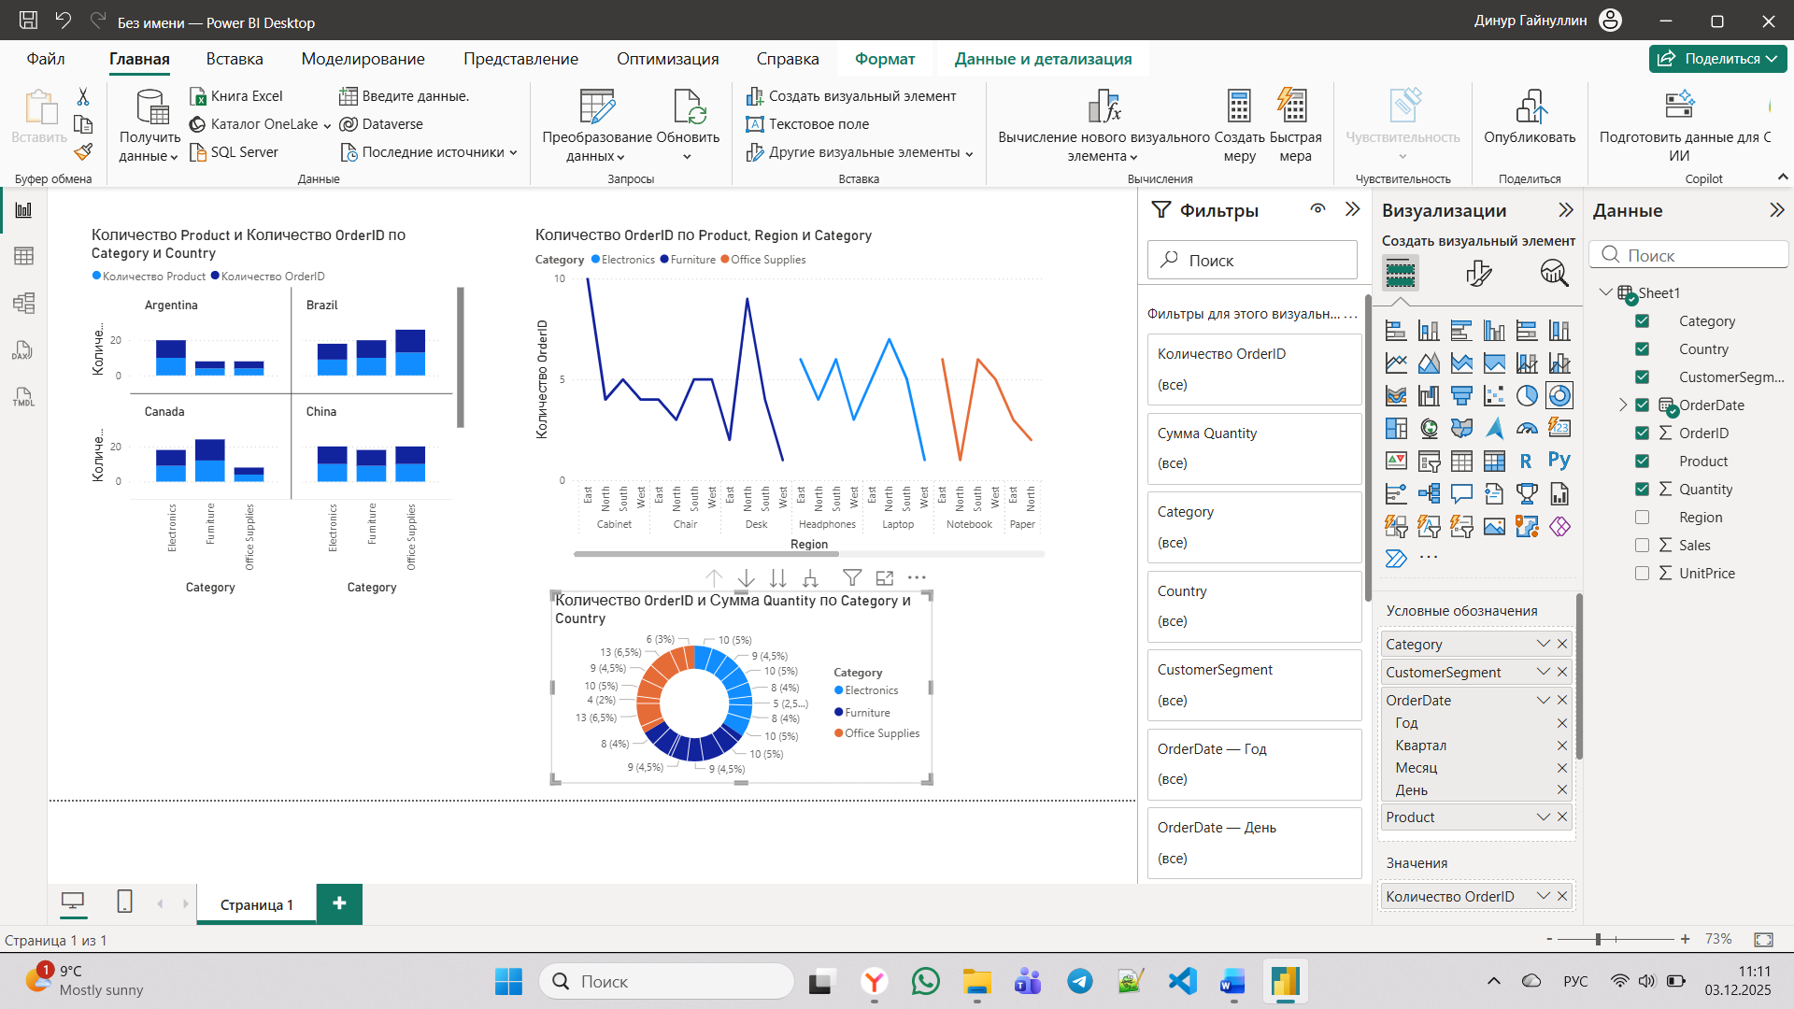

Figure 3 - The ring graph

As shown in the Figure 3, this is a data summary panel from Power BI, likely part of a filter or tooltip. It displays the count of Order IDs and the sum of Quantity segmented by Category and Country, with percentages shown next to each value (e.g., 13 orders representing 6.5%). This panel helps users quickly understand the proportion of orders and quantities for categories like Electronics, Furniture, and Office Supplies across different countries.

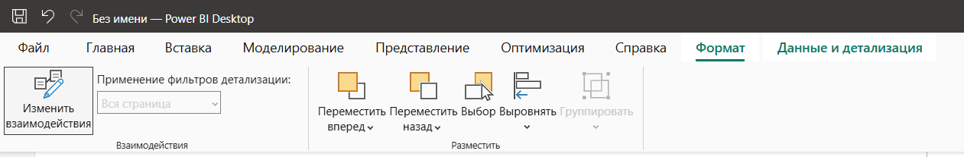

Figure 4 - Interactions between graphs

This interface in Power BI is used to set up and manage interactions between different visualizations on a report page, go to Format → Edit interactions. Click on other visuals to choose how they react: Filter, Highlight, or No effect. This allows clicking on one chart to filter or highlight related data in other visuals on the same report page.

1.2 Creating complex dashboards

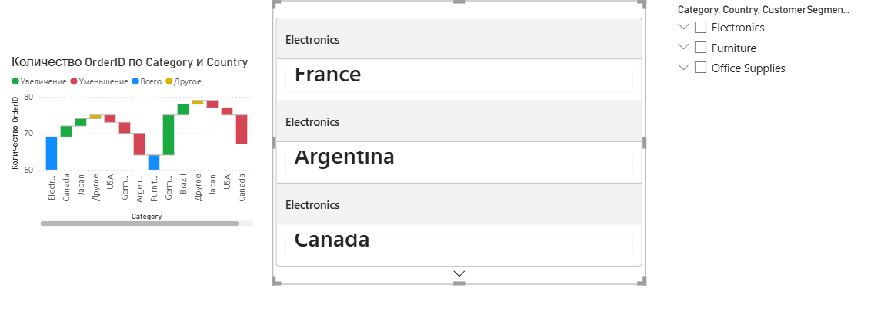

Figure 5 – Complex dashboards

This appears to be a Power BI dashboard view displaying Order ID Count by Category and Country, likely using a bar chart and a table. The visual allows interaction, such as filtering by category (Electronics, Furniture, Office Supplies) and country (USA, Canada, Japan, etc.), to show the corresponding order quantities. The panel on the right may include additional filters or a legend for dynamic data exploration.

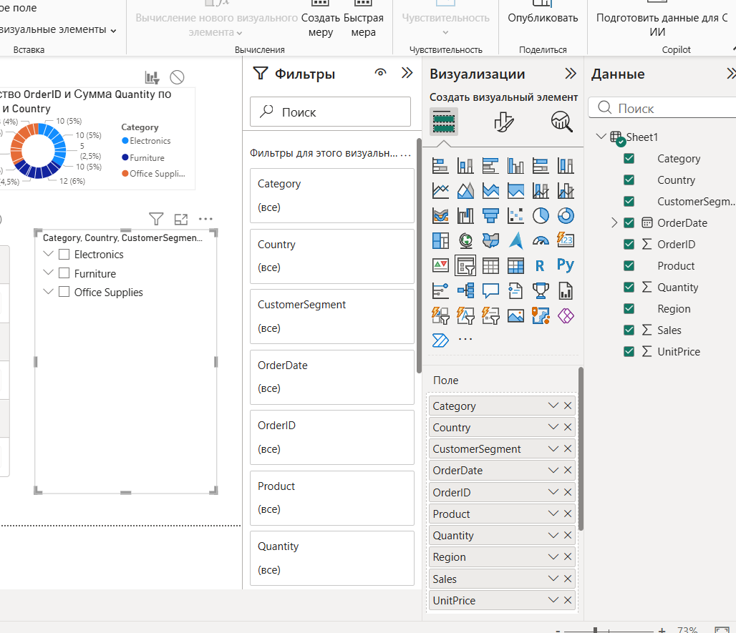

Figure 6 – Filter and visualization
As presented in Figure 6, This is the Filters pane in Power BI, showing all available data fields (like Category, Country, OrderDate, etc.) that can be used to filter visuals. Below it, the Data pane lists the same fields from the dataset (e.g., Sheet1), which can be dragged into visualizations. This panel is where you control which data dimensions are applied as filters to limit or focus what is displayed in your charts and tables.

1.3 Interactive filters

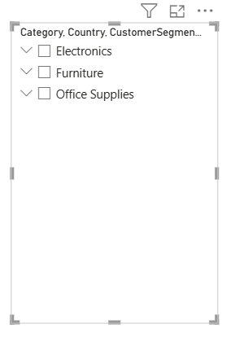

Figure 7 – Slicer

This is a filter selection window in Power BI showing the available categories in the data: Electronics, Furniture, and Office Supplies. The checkboxes allow the user to include or exclude specific categories from the visualization or report. This filter helps to dynamically control which data is displayed based on the selected categories.

Part B

2.1 Data analysis using Power BI

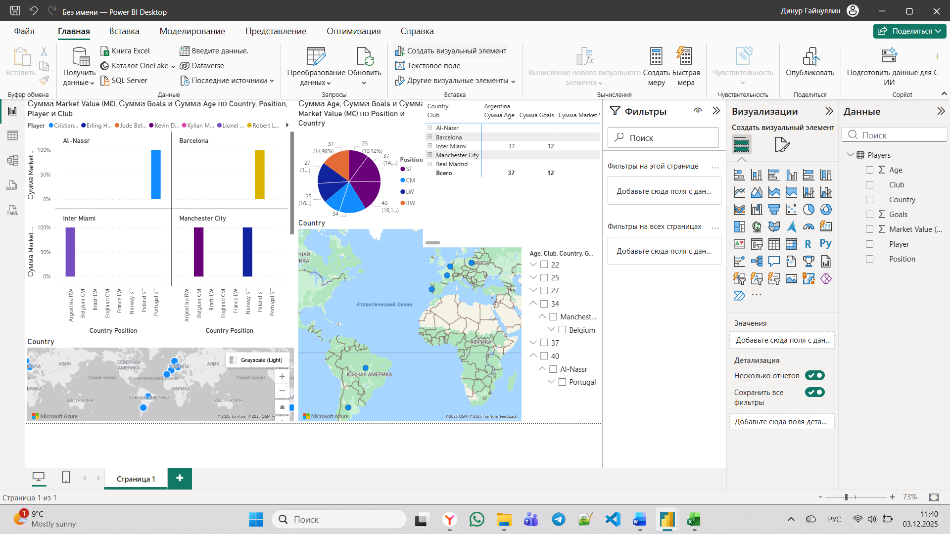

Figure 8 – Charts for part B

Here are the types of visualizations (graphs and charts) present in the Power BI dashboard image: bar charts, pie chart, 2 map visualizations, matrix visualization, slicer pane.

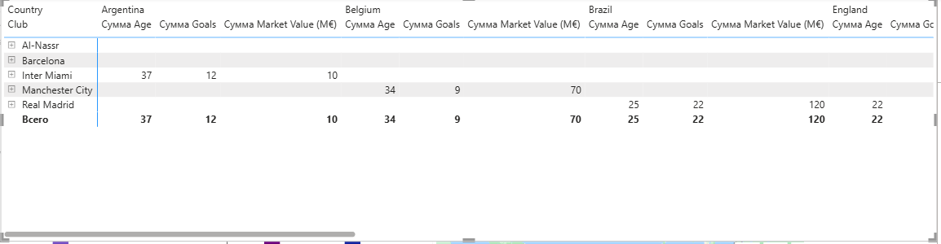

Figure 9 - The matrix graph

The matrix visual presents aggregated football data, summarizing the sum of age, sum of goals, and sum of market value for various clubs (listed vertically) across different countries (listed horizontally) in a pivot-table format. This structure allows for a quick, comparative view of key metrics for each Club within its represented national context.
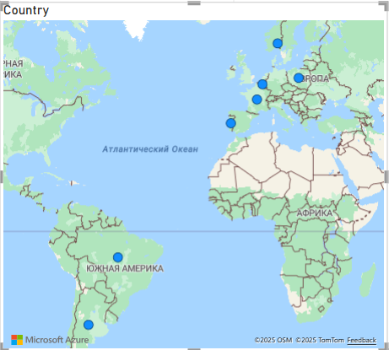

Figure 10 – Map

This is a map visualization in Power BI showing country data, likely with metrics plotted geographically over regions like Europe and South America.

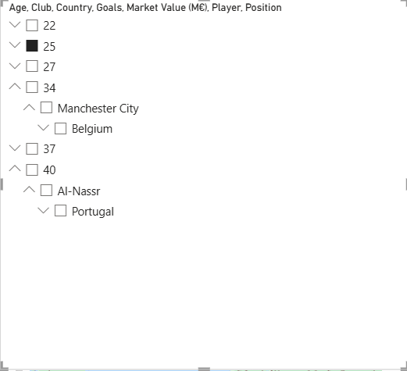

Figure 11 – Filter

As shown in Figure 11, this appears to be a data table or list in Power BI displaying football (soccer) player information, with columns such as Age, Club, Country, Goals, Market Value, Player, and Position. It shows example rows, likely with filters applied, including players from clubs like Manchester City (Belgium) and Al-Nassr (Portugal), used for analysis and visualization in a sports-related dashboard.

CONCLUSION

In conclusion, the laboratory work allowed us to gain practical experience with Power BI and its powerful features for data visualization and analysis. We successfully created interactive dashboards, integrated different types of visualizations, and applied user-driven filters to enhance data exploration. Additionally, the analysis of imported datasets demonstrated how Power BI can simplify complex data and support informed decision-making. The completed work highlights the effectiveness of Power BI as a tool for building dynamic, flexible, and visually compelling analytical solutions.

