RAILGUARD AI
Railway Safety Intelligence, Predictive Maintenance
& Collision-Risk Monitoring Platform
PROJECT MASTER DOCUMENT | VERSION 1.0
01 November 2026
A practical, research-oriented engineering blueprint
Prepared as the central planning and implementation reference
for an academic / portfolio engineering prototype.

Document control
Item | Definition
Project name | RailGuard AI
Document purpose | Single source of truth for project scope, datasets, system design, ML methodology, implementation, testing and delivery.
Version | 1.0 – initial implementation baseline
Project type | Academic / portfolio engineering prototype; not a certified railway safety product.
Primary implementation principle | Use ML for predictive monitoring and anomaly discovery; use deterministic, explicitly tested logic for simulated operational safety constraints.
Intended outcome | A reproducible ML engineering platform with data pipelines, experiments, APIs, dashboard, deployment and documented limitations.

How to use this document
- Treat Sections 1–8 as the project specification. Avoid expanding scope before the first end-to-end milestone works.
- Treat Section 9 onward as the implementation playbook. Complete phases in order and record decisions in docs/decisions/.
- Do not interpret example labels, thresholds or simulated scenarios as validated railway operating rules.
- Keep a clear distinction between observed public datasets, derived labels, synthetic simulator data and model-generated predictions.
- Update the dataset register, experiment register and risk register whenever the project changes.

1. Executive summary
RailGuard AI is a modular railway safety intelligence prototype that combines equipment predictive maintenance, track-condition anomaly monitoring, historical accident analysis and simulated train-operation conflict detection. It is designed to demonstrate an end-to-end ML engineering workflow rather than a single model or dashboard.
The system has four complementary capabilities:
- Equipment health intelligence: analyse compressor / air-production-unit sensor time series and identify abnormal behaviour that may precede documented failures.
- Track-condition intelligence: process onboard vibration and environmental measurements, identify unusual signal patterns and associate them with GPS locations where data quality permits.
- Historical safety analytics: explore FRA Form 54 accident/incident records to understand accident patterns and build descriptive risk-analysis features. This is not a real-time collision prediction dataset.
- Operational conflict monitor: simulate train movements and evaluate explicit rules for occupancy conflicts, movement-authority violations, overspeed and unsafe separation. ML may flag unusual operating patterns, but the rule engine remains authoritative within the prototype.
The central dashboard brings alerts, evidence, model outputs, explanations and historical events into one place. The system should be deployable locally with Docker and optionally hosted when the core workflow is stable.

2. Problem statement and motivation
Railway systems contain multiple interacting sources of operational risk: mechanical equipment degradation, changing track conditions, train movement conflicts, signalling constraints and delayed maintenance response. Data-driven monitoring can help surface unusual patterns earlier and make operational information easier to investigate.
A practical prototype can demonstrate how sensor analytics, interpretable ML, simulation and software engineering fit together. However, public datasets do not provide a unified view of all railway subsystems. RailGuard AI therefore combines separate public datasets for bounded tasks and a clearly labelled simulator for train-operation scenarios.

2.1 Problem statement
How can a modular railway intelligence platform combine real sensor data, historical incident records and controlled train-operation simulations to detect equipment and track anomalies, analyse historical safety patterns, and identify simulated operational conflicts while preserving a strict boundary between ML predictions and safety-critical rule enforcement?

2.2 Objectives
- Build reproducible data ingestion and quality-validation pipelines for each selected dataset.
- Develop and compare baseline and advanced anomaly-detection models for equipment time series.
- Develop signal-processing and anomaly-detection workflows for onboard track-environment sensor data.
- Analyse historical FRA Form 54 records using descriptive statistics and carefully scoped predictive experiments only where labels and sampling support them.
- Build a configurable train-operation simulator with documented scenarios and expected outcomes.
- Implement a deterministic operational conflict rule engine with automated tests.
- Expose results through a FastAPI backend and a responsive web dashboard.
- Track experiments and model versions, containerise services and implement CI checks.
- Document data limitations, model limitations, safety boundaries and reproducibility steps.

3. Scope and non-goals
In scope | Out of scope / not claimed
Offline analysis of public equipment sensor data. | Direct access to live railway infrastructure or operational control systems.
Vibration anomaly monitoring with GPS context. | Declaring a track defect from vibration alone without inspection ground truth.
Historical accident/incident trend analysis. | Claiming historical accidents can directly predict an imminent collision.
Synthetic train movement and signalling scenarios. | Presenting simulated records as real railway telemetry.
Deterministic rule checks within a transparent simulator. | Replacing interlocking, ATP/ETCS, signalling or certified train-protection systems.
ML-based anomaly scores and maintenance prioritisation research. | Safety certification, guaranteed collision avoidance or deployment authority.

Safety statement: RailGuard AI is a decision-support research prototype. It must not connect to or issue commands to real railway control equipment. Any operational use would require railway-domain experts, validated requirements, hazard analysis, independent verification, applicable standards and formal certification.

4. System overview and architecture

4.1 High-level logical architecture
- Data sources: MetroPT-3; railway track environmental dataset; FRA Form 54; synthetic train-operation simulator.
- Ingestion and data quality: source-specific loaders, schema checks, timestamp validation, missingness checks, provenance metadata and immutable raw-data storage.
- Processing: cleaning, resampling where justified, feature engineering, window generation, geospatial checks and label construction with documented assumptions.
- Intelligence services: equipment anomaly model; track vibration anomaly model; historical incident analytics; deterministic operational safety rules; optional operational anomaly model.
- Backend: FastAPI endpoints, PostgreSQL persistence, background jobs and WebSocket updates for simulator/demo streams.
- Frontend: Next.js / TypeScript dashboard for fleet overview, equipment, track, operational simulation, alert investigation and model monitoring.
- MLOps: MLflow experiments, model artefacts, versioned configurations, Docker, automated tests and CI/CD.

4.2 Recommended technology stack
Layer | Initial choice | Reason / when to add alternatives
Language & analysis | Python, pandas, NumPy, SciPy | Core data and ML work.
Classical ML | scikit-learn, XGBoost | Strong baselines; avoid deep learning until baselines and labels justify it.
Explainability | SHAP | Use with supported supervised models; explanations are not causal proof.
API | FastAPI + Pydantic | Typed, testable Python API.
Database | PostgreSQL | Start with relational storage; add TimescaleDB only if time-series query needs justify it.
Frontend | Next.js + TypeScript | Dashboard and investigation views.
Visualisation | Plotly; MapLibre if GPS map is useful | Time series, feature distributions and location context.
Experiment tracking | MLflow | Parameters, metrics, artefacts and model versions.
Streaming | WebSockets first; MQTT / Redis Streams later | Start with simulator updates; introduce broker only when needed.
Packaging & CI | Docker, Docker Compose, GitHub Actions | Reproducible local environment and automated quality gates.
Deployment | Local Docker first; cloud VM for demo later | Do not spend early time on cloud operations.

5. Data sources and dataset strategy
Each dataset answers a different question. Do not merge them into one training table or imply that they share a common time base, route, train or operating context.

5.1 Dataset A – MetroPT-3 (equipment predictive maintenance)
Official source: https://archive.ics.uci.edu/dataset/791/metropt%2B3%2B
MetroPT-3 contains approximately 1.52 million observations and 15 features collected from a train air-production-unit compressor. The UCI description identifies 1 Hz logging, multivariate time-series data, sensor signals such as pressure, oil temperature and motor current, and four documented air-leak failure periods. The dataset is described as unlabeled at row level; failure reports provide event windows rather than exhaustive labels. Cite the UCI dataset page and its associated paper in project publications.
Core signals listed by UCI include timestamp, TP2, TP3, H1, DV_pressure, Reservoirs, Oil_temperature, Motor_current, COMP, DV_eletric, Towers, MPG, LPS, Pressure_switch, Oil_level and Caudal_impulses. Validate the downloaded file's actual schema before writing production code.
- Primary task: unsupervised / semi-supervised anomaly detection on compressor behaviour.
- Secondary task: investigate whether documented failure windows exhibit detectable precursors. Treat this as a limited retrospective experiment, not a general failure predictor.
- Possible rolling windows: 10 s, 30 s, 60 s and 300 s; compare rather than assume one is optimal.
- Features: rolling mean/std/min/max, range, slope, first difference, rate of pressure change, signal ratios where physically meaningful, and state-transition counts for digital signals.
- Do not label all timestamps outside the four reports as confirmed healthy. Use labels such as documented_failure_window, pre_event_window, and unlabelled_or_unknown.
- Use chronological and event-aware splits. Avoid random row-level splitting because adjacent time points leak temporal information.
Useful starting point:
pip install ucimlrepo
from ucimlrepo import fetch_ucirepo
dataset = fetch_ucirepo(id=791)
X = dataset.data.features
print(X.shape, X.columns.tolist())
Download the CSV and description PDF from the UCI page if you prefer manual, reproducible file storage.

5.2 Dataset B – Train track environmental data
Official source: https://zenodo.org/records/17607068
This dataset describes onboard multimodal measurements collected on a running train, including 40 Hz accelerometer, gyroscope, magnetometer, heading, environmental variables and GPS-tagged samples from a Madrid–Barcelona test route. The published record lists a 65.6 MB CSV named vibration_raw.csv. Inspect the record, file schema and licence before use.
- Primary task: vibration signal exploration, window-based signal features and unsupervised anomaly scoring.
- Potential features: per-axis mean, standard deviation, RMS, peak, peak-to-peak, kurtosis, skewness, crest factor and frequency-domain energy bands, subject to sample quality and correct axis units.
- Preserve original sample timestamps and sample rate. Do not assume every interval is perfectly sampled at 40 Hz; measure gaps and duplicates.
- Map anomaly windows to GPS only after checking coordinate validity, timestamp alignment and GPS sampling behaviour.
- An unusual vibration segment is not automatically a track defect. Without independent inspection labels, describe outputs as vibration anomalies or candidate locations for review.
- If multiple trips are not present, do not claim repeated-traversal confirmation.

5.3 Dataset C – FRA Form 54 historical accident/incident records
Human-readable dataset: https://data.transportation.gov/Railroads/Rail-Equipment-Accident-Incident-Data-Form-54-/85tf-25kj
Raw source dataset: https://data.transportation.gov/dataset/Form-54-Source-Table/aqxq-n5hy
Data dictionary (PDF): https://datahub.transportation.gov/api/views/aqxq-n5hy/files/ea00a728-94b0-43e7-8c11-8481f13170a7?download=true&filename=accfile_EFFECTIVE_060111%20(8).pdf
The FRA Form 54 dataset covers reportable rail equipment accidents/incidents, including collisions, derailments, fires, explosions and other reportable events involving on-track equipment. The human-readable dataset is intended for easier interpretation; the separate Source Table is explicitly described as raw source values. The FRA catalogue notes reporting thresholds and provides a data dictionary. Review the current metadata, download guide and release schedule before downloading. See the official Data.gov catalogue entry: https://catalog.data.gov/dataset/rail-equipment-accident-incident-data-form-54.
- Primary task: descriptive historical safety analysis: incident types, trends over time, geography, railroad / equipment groupings and severity fields where present.
- Secondary task: only attempt a supervised model if a well-defined target, adequate sample size, feature availability before the event and defensible sampling design exist.
- Do not use post-incident fields (e.g. damage, cause determinations or investigation outcomes) as predictors for a purported pre-incident risk model.
- Do not equate number of reports with exposure-adjusted risk. Exposure denominators such as train-miles, track-miles or operating hours may be needed.
- Records may have multiple railroad reports for one accident. Understand whether the selected view contains one row per report or one row per unique accident before aggregating.
- This is US historical incident data; it is not representative ground truth for Sri Lankan railway operations.

5.4 Dataset D – synthetic train-operation simulator
There is no verified public dataset in this project that supplies synchronized train positions, speeds, track occupancy, signals and movement authorities for the required collision-conflict experiments. Build a transparent simulator and label every generated record as synthetic.
- Train state: train_id, timestamp, route_id, track_section_id, position_m, speed_mps, acceleration_mps2, direction, train_length_m, status.
- Infrastructure state: track_section_id, occupancy, signal_aspect, permitted_speed_mps, block boundaries, route reservation / movement authority.
- Communication state: heartbeat age, communication status, telemetry freshness.
- Scenario metadata: scenario_id, scenario_type, seed, expected_rule_outcome, simulator_version.
- Store units explicitly. Use SI units internally: metres, seconds, metres per second and metres per second squared.

5.5 Dataset register and provenance
Dataset | Role | Important caveat | Required metadata
MetroPT-3 | Equipment time series | Few event reports; not row-labelled ground truth. | UCI ID/DOI, download date, checksum, schema, licence, event-window assumptions.
Track environmental | Vibration/GPS anomaly exploration | Anomaly does not equal inspected defect. | Zenodo DOI/version, file checksum, sample rate checks, GPS quality, licence.
FRA Form 54 | Historical accident analysis | Reporting threshold, reporting duplication, US context, post-event fields. | View ID, download date, dictionary version, filters, row granularity, licence/terms.
Simulator | Operational conflict tests | Synthetic, not operational evidence. | Code commit, config, random seed, scenario version, expected outcomes.

Never commit large raw datasets to Git. Store them locally or in appropriate external storage, keep dataset acquisition scripts and metadata in the repository, and record checksums for reproducibility.

6. Data engineering and preprocessing

6.1 Common ingestion contract
- Every loader must return a documented schema and a dataset metadata record.
- Keep raw files immutable. Write cleaned and feature-engineered data to separate processed locations.
- Validate required columns, types, timestamp parse rate, duplicates, missing values, impossible ranges and sampling intervals.
- Log row counts before and after each transformation.
- Make preprocessing deterministic and configurable; avoid hidden notebook-only transformations.

6.2 MetroPT-3 preprocessing
- Load timestamp as datetime and sort chronologically.
- Check duplicate timestamps, missing samples, irregular intervals and sensor value ranges.
- Inspect digital/state signals separately from continuous analogue measurements.
- Plot each sensor over the full period and around documented event windows.
- Build time-based rolling features only after defining window semantics and handling warm-up rows.
- Create event-window annotations from the UCI failure reports in a separate label table.
- Preserve original timestamps and never interpolate across long gaps without an explicit policy.

6.3 Track signal preprocessing
- Inspect columns, units, timestamp representation, coordinate reference and sampling regularity.
- Check missing values, sensor saturation, impossible coordinates and discontinuities.
- Segment the data into fixed-duration windows (initially compare 1 s, 2 s and 5 s windows).
- Compute per-axis and vector-magnitude features; retain axis-specific information.
- Explore FFT / power spectral density features only after confirming sampling rate and anti-aliasing assumptions.
- Align GPS to sensor windows with a documented method; flag low-confidence location assignments.

6.4 FRA preprocessing
- Download the current source table and dictionary; save the exact extraction date and filter criteria.
- Determine record grain: report, railroad filing, incident or unique accident.
- Parse dates, codes, categorical values and numeric amounts according to the dictionary.
- Profile missingness and changes in reporting schemas over time.
- Separate event outcome fields from any potential pre-event predictors.
- Build reproducible aggregation tables and document any exclusions.

7. Machine learning and analytics methodology

7.1 Equipment anomaly detection
Experiment | Candidate method | Purpose
E0 | Physical/statistical thresholds | Simple interpretable baseline; thresholds must be learned or justified from data, not invented as safety limits.
E1 | Isolation Forest | Unsupervised multivariate anomaly baseline.
E2 | Robust covariance / One-Class SVM | Optional comparison; assess scalability and distribution assumptions.
E3 | Autoencoder | Only after simpler methods and adequate validation; compare reconstruction-error stability.

Evaluate anomaly scores against documented event windows using event-level detection rate, false alerts per operating hour, detection lead time and qualitative event plots. Row-level precision/recall is misleading when labels are sparse and event windows are approximate. Do not tune and evaluate on the same event windows.

7.2 Failure-risk experiment
Only build a supervised failure-risk model if label construction is defensible. Define candidate pre-event horizons (for example 10, 30 and 60 minutes) as experiments, not facts. Compare logistic regression and tree-based baselines such as Random Forest / XGBoost. Use event-aware chronological validation and report uncertainty caused by the small number of failure episodes. Avoid reporting a production-ready probability.

7.3 Track vibration anomaly detection
- Start with statistical baselines and visual inspection; then Isolation Forest or a robust unsupervised baseline.
- Compare anomaly windows with GPS only where alignment confidence is sufficient.
- If there are no inspection labels, evaluate stability, repeatability and plausibility, not defect-classification accuracy.
- Avoid training a neural network merely to make the project look advanced.

7.4 FRA historical analysis
- Prioritise descriptive analytics and careful data quality work.
- Possible outputs: yearly event counts, event type distributions, severity/damage distributions, geographic summaries and trends with reporting caveats.
- If predictive modelling is attempted, formulate a clearly defined target and prediction time, exclude post-event leakage and consider exposure denominators.
- Do not interpret correlations as causes or compare raw counts between railroads without exposure and reporting context.

7.5 Operational conflict detection
The operational monitor should be a deterministic rule engine operating on simulator state. ML may separately score unusual patterns, but a model score must never suppress a rule violation.
Rule family | Illustrative check | Expected response
Track occupancy | Two trains occupy the same exclusive block at overlapping times. | Raise critical simulated conflict event.
Movement authority | Train position exceeds its simulated authority boundary. | Raise authority-violation event.
Signal compliance | Train passes a restrictive signal in the simulated scenario. | Raise rule violation; do not infer real-world signalling semantics.
Separation | Predicted stopping/separation margin falls below configured simulation threshold. | Raise proximity warning with assumptions shown.
Speed | Train speed exceeds scenario permitted speed. | Raise overspeed event.
Telemetry freshness | Position/heartbeat exceeds configured age limit. | Raise stale-data warning; do not treat stale data as safe.
Occupancy inconsistency | Sensor / simulator occupancy state contradicts train position. | Raise data-integrity conflict.

Simplified same-direction time-to-collision (TTC): TTC = gap / (v_following - v_leading), only when the closing speed is positive and both values use consistent units. For head-on motion, relative speed is the sum of speeds. TTC alone is not a safety criterion. A more realistic simulation may consider braking deceleration, reaction / system delay, train length, gradient, curvature and permitted speed. Keep all assumptions configurable and clearly visible.

7.6 Evaluation metrics
Problem | Useful metrics | Avoid / caveat
Anomaly detection | Event-level recall, false alerts per hour, detection delay, precision where labels support it. | Accuracy on mostly normal rows.
Supervised failure classification | PR-AUC, recall, precision, F1, calibration, event-level lead time. | Random row split; leakage; overclaiming with few events.
Track anomaly | Window score stability, anomaly density, location consistency, expert review if available. | Calling anomalies confirmed defects.
Historical incident analysis | Data completeness, trend sensitivity, counts/rates with denominator caveats. | Causal claims from correlations.
Rule engine | Scenario pass/fail, invariant coverage, false positives/negatives against known synthetic expected outcomes. | Treating simulator tests as railway certification.

8. Simulator design

8.1 Core simulator objects
- Train: ID, length, route, direction, position, speed, acceleration and timestamp.
- Track section: ID, start/end coordinate, occupancy state, allowed direction and speed limit.
- Signal: ID, associated block, aspect/state and simulated authority relationship.
- Movement authority: train ID, permitted end position, issue time, expiry / freshness and source.
- Scenario: configuration, random seed, initial state, event schedule and expected rule-engine output.

8.2 Required scenarios
Scenario | Setup | Expected detection
S01 Normal operation | Trains separated and within configured limits. | No conflict; normal telemetry.
S02 Following train closes gap | Follower speed exceeds leader speed. | TTC / separation warning if configured margin crossed.
S03 Same-block conflict | Two trains assigned to same exclusive block concurrently. | Occupancy conflict.
S04 Authority overrun | Train crosses simulated movement-authority endpoint. | Authority violation.
S05 Restrictive signal pass | Train passes a restrictive simulated signal. | Signal rule violation.
S06 Overspeed | Train speed exceeds scenario speed limit. | Overspeed warning.
S07 Stale telemetry | Position updates stop or exceed freshness limit. | Stale-data warning.
S08 Occupancy mismatch | Reported occupancy disagrees with simulated train location. | Data-integrity alert.
S09 Head-on approach | Opposing trains approach on a shared conflict segment. | Conflict / relative-closing-speed warning.
S10 Recovery | Conflict condition clears after a simulated state change. | Alert transitions to resolved; history retained.

8.3 Simulator validation
- Use deterministic random seeds for repeatable tests.
- Keep scenario generation separate from rule evaluation.
- Write unit tests for every rule and integration tests for scenario outcomes.
- Test boundary conditions: exact block boundary, zero closing speed, negative / missing speed, stale timestamps, duplicate train IDs and conflicting authorities.
- Store expected outcomes alongside each scenario; fail CI when behaviour changes unexpectedly.

9. Backend and database design

9.1 Suggested service structure
backend/
app/main.py
app/api/routes/
app/schemas/
app/services/
app/repositories/
app/core/config.py
app/db/
tests/
Use Pydantic request/response models, service-layer business logic and repository-layer database access. Keep ML inference separate from HTTP route functions.

9.2 Initial API endpoints
Method / path | Purpose
GET /api/health | Service and database health.
GET /api/equipment | List monitored equipment.
GET /api/equipment/{id}/readings | Time-bounded sensor history.
GET /api/equipment/{id}/anomalies | Equipment anomaly events and scores.
GET /api/track/anomalies | Track anomaly windows with location confidence.
GET /api/incidents/summary | FRA historical analytics aggregates.
GET /api/trains | Current simulator train states.
GET /api/safety/events | Rule-engine events and status.
POST /api/simulator/scenarios/{id}/run | Run a named synthetic scenario.
GET /api/alerts | Unified alert list with filters.
GET /api/models | Model versions, status and evaluation summary.
WS /api/stream | Optional simulator / alert live updates.

9.3 Initial database entities
Table | Important fields (illustrative)
datasets | id, name, source_uri, version, downloaded_at, checksum, licence, notes
equipment | id, name, type, dataset_id, description
sensor_readings | id, equipment_id, timestamp, signal_name, value, unit, quality_flag
model_versions | id, model_name, version, artifact_uri, created_at, metrics_json, status
model_predictions | id, model_version_id, entity_id, timestamp, score, label, explanation_json
track_segments | id, route_id, segment_key, geometry / location metadata
track_anomalies | id, timestamp_start, timestamp_end, score, location, confidence, model_version_id
historical_incidents | id, source_record_id, event_date, event_type, geography, severity fields, source metadata
trains | id, scenario_id, train_code, length_m, direction, state
simulator_snapshots | id, scenario_id, timestamp, state_json
safety_events | id, scenario_id, rule_id, severity, detected_at, evidence_json, status
alerts | id, source_type, source_id, severity, title, created_at, acknowledged_at, resolved_at

For an MVP, it is acceptable to keep some complex simulator snapshots as JSONB while retaining searchable event fields in normal columns. Add TimescaleDB only if measured query performance or retention needs justify it.

10. Frontend experience
Page | Content
Operations overview | System status, open alerts by severity, equipment health summary, latest simulator state and recent events.
Equipment monitoring | Sensor trend charts, anomaly timeline, model score, feature context and maintenance investigation notes.
Track intelligence | GPS route / sample map, vibration feature plots, anomaly windows and location-confidence indicator.
Historical incidents | FRA filters, time trends, event-type breakdowns and data-quality caveats.
Collision-risk simulator | Scenario selector, train positions, track blocks, signals, movement authority visualisation and detected rule events.
Alert investigation | Evidence, source dataset, timestamp, rule/model version, explanation, acknowledgement and resolution history.
Model intelligence | Model versions, metrics, experiment links, data drift / score distribution and limitations.

Use clear status language: 'anomaly detected', 'simulated rule conflict', 'historical incident statistic', 'unlabelled data' and 'location confidence'. Avoid labels such as 'collision prevented' or 'track defect confirmed' unless supported by independent evidence.

11. MLOps, reproducibility and deployment

11.1 Experiment tracking
- Track dataset version/checksum, time range, feature set, preprocessing version, split strategy, model parameters, random seed and code commit.
- Log evaluation metrics, plots, model artefacts and configuration files to MLflow.
- Register model artefacts with explicit task and limitations in their names / metadata.
- Never promote a model solely because one metric improved; inspect event-level performance and false-alert burden.

11.2 Model lifecycle
- Data validation
- Preprocessing and feature generation
- Baseline training
- Chronological / event-aware evaluation
- Error analysis and threshold selection
- Model artefact registration
- Offline API integration
- Monitoring of input quality and score distributions
- Retraining only when new representative data and evaluation criteria exist

11.3 Deployment plan
- Phase 1: local Python environment and notebooks.
- Phase 2: Docker Compose for PostgreSQL, API and frontend.
- Phase 3: CI with formatting, linting, unit tests and API tests.
- Phase 4: optional cloud deployment after secrets, logging, backups and access controls are designed.
- Do not expose simulator or experimental safety endpoints as real operational interfaces.

12. Testing and quality assurance
Test layer | Examples
Data tests | Required columns, valid timestamps, uniqueness rules, range checks, expected row counts, schema drift.
Feature tests | No future data in rolling features; correct window boundaries; stable output on fixed sample.
Model tests | Artefact loads; expected input schema; deterministic inference where configured; threshold behaviour.
Rule tests | Each scenario and boundary case has expected outcome; rule precedence is explicit.
API tests | Validation errors, pagination, filters, database failure handling and response schemas.
UI tests | Empty states, loading/errors, alert filters, charts with gaps and simulator state changes.
Integration tests | Dataset-to-feature-to-model-to-API-to-dashboard path works end to end.
Security checks | Secrets outside source control, dependency audit, input validation and restricted admin actions.

A passing test suite validates the implementation against the tests you wrote. It does not establish railway safety integrity or certify the design.

13. Repository structure
RailGuard-AI/
├── README.md
├── pyproject.toml (or requirements.txt initially)
├── .env.example
├── docker-compose.yml
├── datasets/
│ ├── raw/ (gitignored)
│ ├── processed/ (gitignored or external storage)
│ └── metadata/
├── notebooks/
│ ├── 01_metropt3_eda.ipynb
│ ├── 02_track_dataset_eda.ipynb
│ └── 03_fra_form54_eda.ipynb
├── src/railguard/
│ ├── data/
│ ├── preprocessing/
│ ├── features/
│ ├── models/
│ ├── evaluation/
│ ├── simulation/
│ └── safety_rules/
├── backend/
├── frontend/
├── configs/
├── tests/
├── docs/
│ ├── architecture/
│ ├── datasets/
│ ├── experiments/
│ ├── decisions/
│ └── risk-register.md
└── .github/workflows/

14. Development roadmap and milestones
Phase | Work | Exit criteria
0 – Project setup | Repository, environment, package management, README, data folders and task board. | Fresh clone can install dependencies; raw data ignored by Git.
1 – MetroPT EDA | Acquire dataset, schema and timestamp checks, sensor plots, event-window documentation. | EDA report and dataset card committed.
2 – Equipment baselines | Statistical thresholds and Isolation Forest; event-aware evaluation. | Reproducible experiment with false-alert and event-level metrics.
3 – Track EDA | Download Zenodo CSV, inspect schema/rate/GPS, build window features. | Data-quality report and initial anomaly baseline.
4 – FRA analytics | Acquire raw Form 54, dictionary, record-grain analysis and descriptive dashboard dataset. | Documented clean analytical extract and caveats.
5 – Simulator | Train/block/signal state, scenarios and deterministic rule engine. | All scenario tests pass with repeatable seeds.
6 – Backend | Schemas, database, model inference and rule event APIs. | API tests pass and returns persisted evidence.
7 – Frontend | Overview, equipment, track, incidents, simulator and alert investigation. | User can trace an alert to source evidence.
8 – MLOps & deployment | MLflow, Docker, CI, model metadata and demo hosting. | Reproducible local deployment and documented demo.
9 – Final validation | End-to-end tests, limitations, architecture diagrams, demo script and report. | Release candidate with reproducibility instructions.

A realistic solo build can take roughly 10–12 weeks for a strong prototype, depending on available weekly hours, data quality and frontend polish. Treat this as a planning estimate, not a guaranteed deadline. Deliver a working vertical slice early rather than waiting until every subsystem is complete.

15. First 7 days – exact starting plan
- Create a GitHub repository named RailGuard-AI and add the README, .gitignore, licence decision and this project document.
- Create a Python virtual environment and pin the initial dependencies.
- Create datasets/raw, datasets/processed and datasets/metadata; add raw data paths to .gitignore.
- Download MetroPT-3 from the official UCI page. Record source URL, download date, file size and checksum.
- Run a schema inspection script. Print shape, columns, dtypes, timestamp parse rate, duplicate count and sampling-interval summary.
- Create notebook 01_metropt3_eda.ipynb. Plot each continuous signal over time and inspect all documented failure windows.
- Write a short dataset card explaining the 1 Hz source, unlabeled row-level status, four reported air-leak windows and limits on evaluation.
- Do not train a deep model in week one. Finish data understanding and a reliable baseline first.

15.1 Initial environment
python -m venv .venv
# Windows PowerShell
.venv\Scripts\Activate.ps1
python -m pip install --upgrade pip
pip install pandas numpy scipy matplotlib seaborn scikit-learn xgboost shap
pip install jupyterlab ucimlrepo pyarrow pydantic
pip freeze > requirements-lock.txt
Add FastAPI, SQLAlchemy, PostgreSQL driver, MLflow, frontend and streaming dependencies when their phases begin. Avoid installing every possible framework on day one.

15.2 First inspection script
from ucimlrepo import fetch_ucirepo
import pandas as pd

ds = fetch_ucirepo(id=791)
X = ds.data.features.copy()
print('Shape:', X.shape)
print('Columns:', X.columns.tolist())
print(X.dtypes)

# Inspect the raw feature table; confirm timestamp column before further processing.
if 'timestamp' in X.columns:
ts = pd.to_datetime(X['timestamp'], errors='coerce')
print('Timestamp parse rate:', ts.notna().mean())
print('Time range:', ts.min(), 'to', ts.max())
print('Duplicate timestamps:', ts.duplicated().sum())
print('Interval summary:')
print(ts.sort_values().diff().dt.total_seconds().describe())

16. Project governance and documentation
- README: purpose, safety disclaimer, architecture, setup, data sources, demo and limitations.
- Dataset cards: provenance, licence, schema, quality, known labels, intended use and prohibited claims.
- Experiment cards: hypothesis, dataset version, split, baseline, metrics, plots, result and decision.
- Architecture decision records: why a technology or design was selected and alternatives considered.
- Risk register: data leakage, label uncertainty, sample bias, sensor quality, model drift, false alerts and safety misinterpretation.
- Release notes: changes to data, features, models, APIs and simulator scenarios.

16.1 Key project risks
Risk | Mitigation
Sparse / incomplete failure labels | Use anomaly detection, event-level evaluation and explicit uncertainty.
Time leakage | Chronological and event-aware splits; test feature windows for future leakage.
Vibration anomaly misinterpreted as track defect | Use neutral wording; seek inspection labels before defect classification.
FRA post-event leakage | Define prediction time and exclude fields unavailable before an event.
Historical data bias | Document reporting thresholds, changes over time and exposure denominator limitations.
Synthetic data mistaken for real | Mark simulator records synthetic in UI, database and exported files.
ML mistaken for safety authority | Separate rule engine and ML services; no model override of rules; prominent disclaimer.
Scope expansion | Complete the first end-to-end equipment anomaly slice before adding advanced subsystems.

17. Definition of done
- A new developer can clone the repository and follow the README to run the local system.
- Dataset acquisition and preprocessing steps are documented and reproducible.
- At least one equipment anomaly baseline is evaluated with event-aware metrics and limitations.
- Track dataset quality and anomaly exploration are documented; no unsupported defect claims are made.
- FRA Form 54 descriptive analysis is reproducible and respects the data dictionary and record granularity.
- The simulator includes repeatable normal and conflict scenarios.
- The deterministic rule engine has unit and integration tests.
- The backend exposes results with traceable model / rule versions and evidence.
- The dashboard supports alert investigation and clearly labels synthetic versus observed data.
- MLflow or equivalent experiment records, Docker setup and CI checks are included.
- The final report includes architecture, methods, evaluation, limitations, ethical/safety boundaries and future work.

18. Final project positioning
The strongest version of RailGuard AI is not the one with the largest number of algorithms. It is the one that demonstrates sound data reasoning, careful label construction, realistic evaluation, reliable software interfaces, reproducible experiments and responsible safety boundaries. A well-tested classical anomaly detector plus a transparent simulator and complete deployment pipeline is more valuable than an unvalidated deep-learning model presented as a collision predictor.

19. Official dataset references and useful links
- UCI MetroPT-3 dataset: https://archive.ics.uci.edu/dataset/791/metropt%2B3%2B
- MetroPT-3 associated research paper: https://doi.org/10.1109/DSAA53316.2021.9564201
- Zenodo train track environmental dataset: https://zenodo.org/records/17607068
- FRA Form 54 human-readable dataset: https://data.transportation.gov/Railroads/Rail-Equipment-Accident-Incident-Data-Form-54-/85tf-25kj
- FRA Form 54 raw source table: https://data.transportation.gov/dataset/Form-54-Source-Table/aqxq-n5hy
- FRA Form 54 data dictionary: https://datahub.transportation.gov/api/views/aqxq-n5hy/files/ea00a728-94b0-43e7-8c11-8481f13170a7?download=true&filename=accfile_EFFECTIVE_060111%20(8).pdf
- FRA Form 54 Data.gov catalogue: https://catalog.data.gov/dataset/rail-equipment-accident-incident-data-form-54
- FRA download/export guide: https://data.transportation.gov/stories/s/Download-Export-and-Print-User-Guide/s8hj-vns8/
- FRA safety data landing page: https://data.transportation.gov/stories/s/FRA-Safety-Data-Landing-Page/dakf-i7zd/
Dataset facts in this document were checked against the official UCI MetroPT-3 page, the Zenodo record and the FRA / Data.gov Form 54 catalogue metadata as of 01 November 2026. Always re-check the live source metadata and terms when downloading a new version.

Appendix A – System and engineering diagrams
These diagrams are conceptual implementation diagrams. They show the intended separation of observed datasets, synthetic simulation, ML services, deterministic safety rules, persistence and user interfaces. Adjust them as the actual schema and implementation evolve.

A1. High-level system architecture
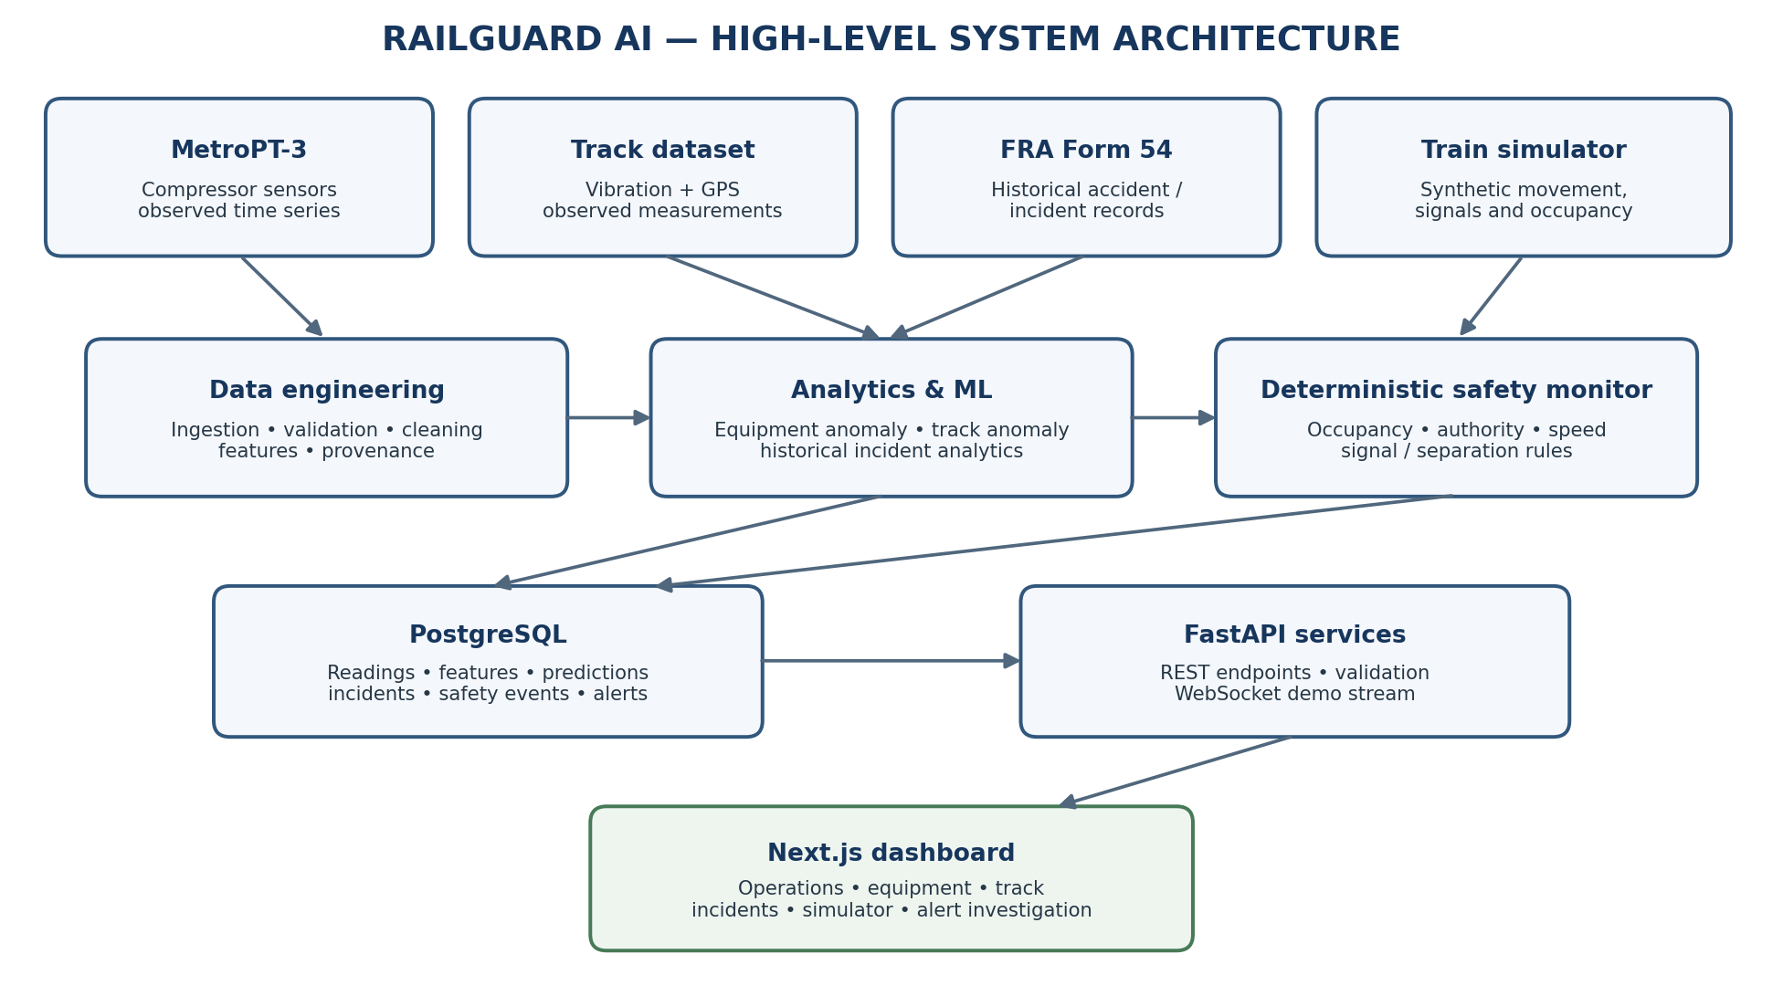
Observed public datasets and synthetic simulator feed separate processing paths. ML services and deterministic safety monitoring remain distinct before results are persisted and presented.

A2. ML engineering lifecycle
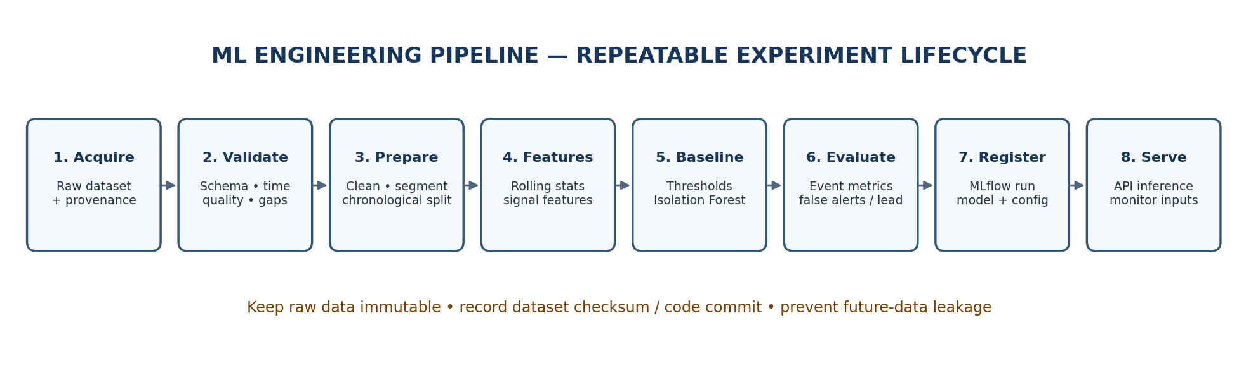
This is the repeatable workflow for each ML task. Use chronological / event-aware splits and preserve dataset, feature and code provenance.

A3. Simulator and rule-engine flow
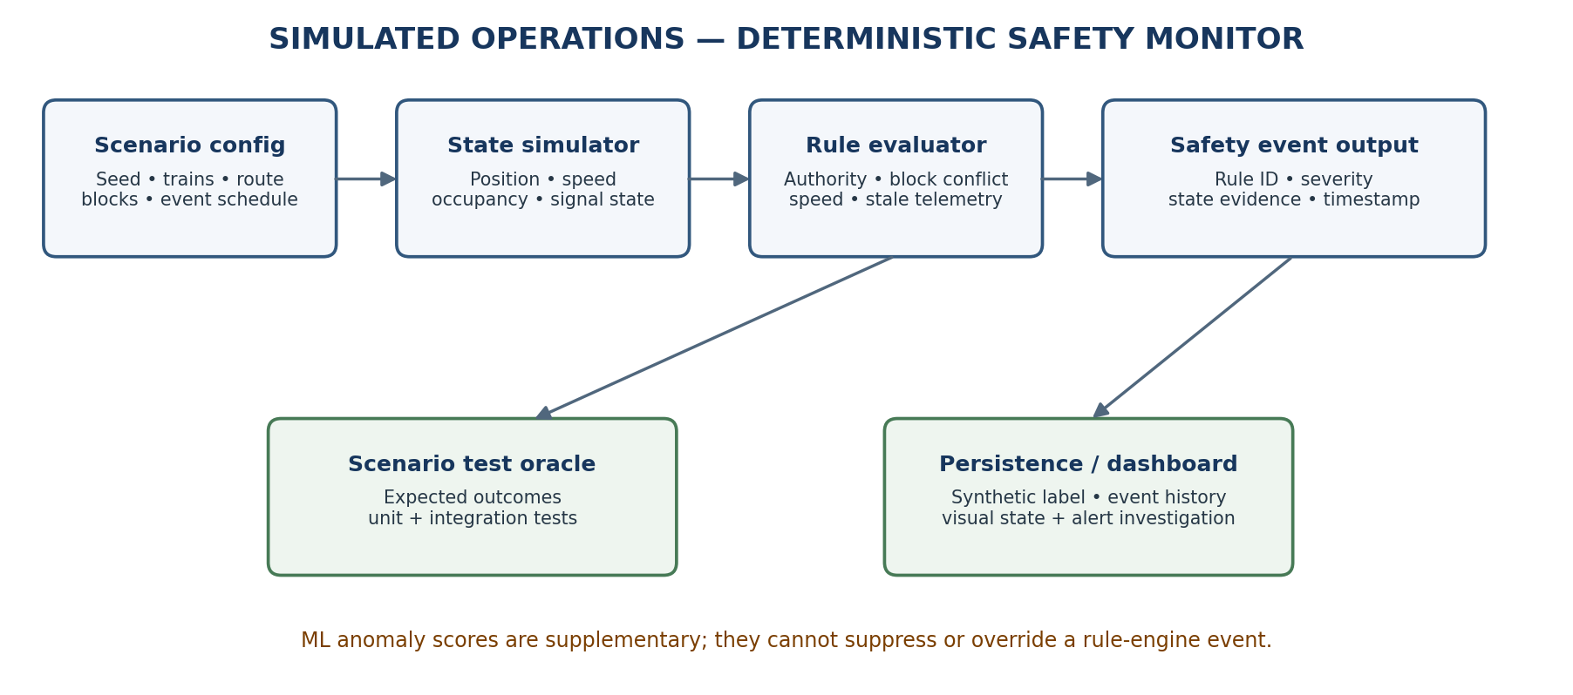
Scenario generation, state simulation, deterministic rule evaluation and expected-outcome testing are separate components. ML does not override rules.

A4. Deployment view
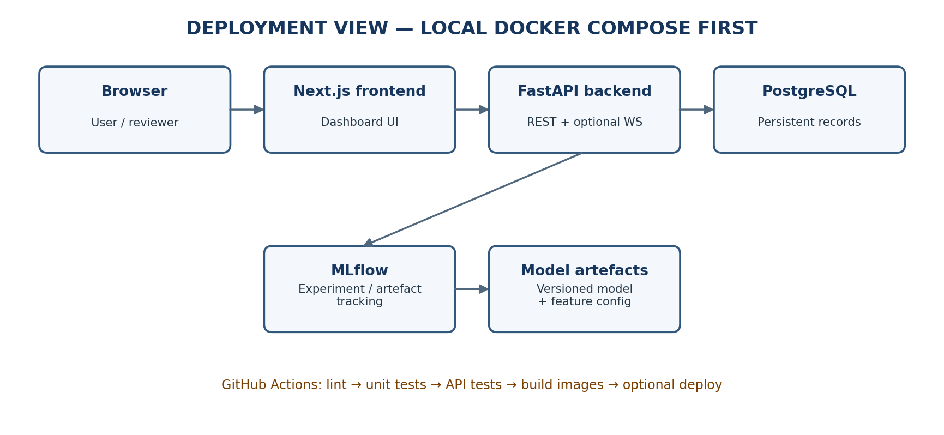
Start with a local Docker Compose environment. Add hosted deployment only after the API, database, frontend and model artefacts work reproducibly.

A5. Initial database entity relationship view
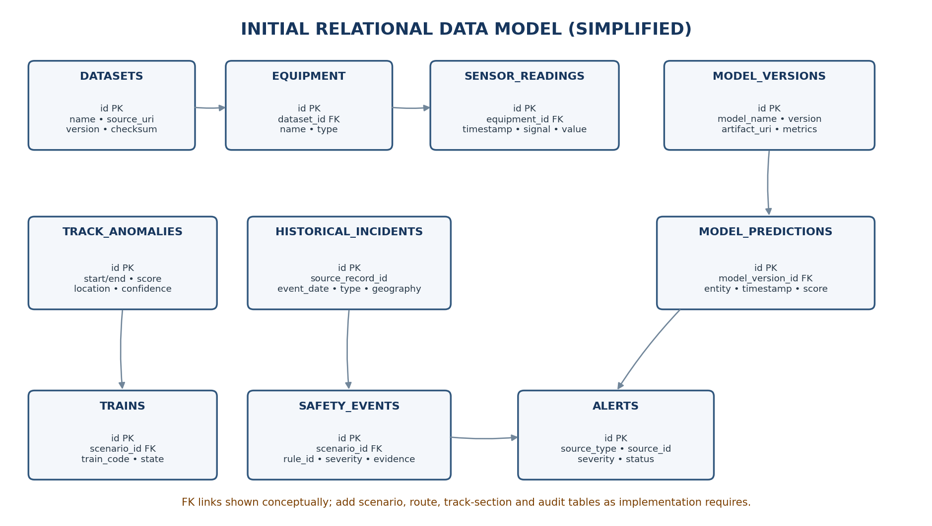
This is a starting logical data model, not a final migration specification. Refine keys, constraints, indexes and cardinalities during implementation.

