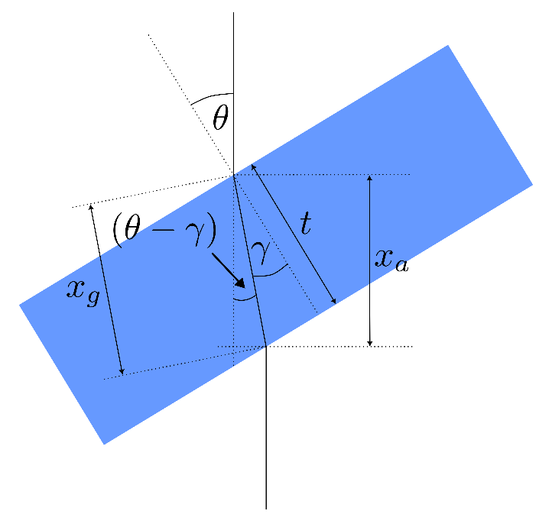
Figure 1: schematic diagram of the BK7 glass delay block
In Figure 1, the incident angle ($θ$) is related to the refracted angle ($γ$) and refractive index of the BK7 glass ($n$) using Snell’s law:
$$\sin{θ}=n\sin{γ}$$
$x_{a}$ defines the length of the beam through air if there was no glass block exists and $x_{g}$ represents the length of the beam through glass block and can be represented by following:
$$x_{g}=\frac{t}{\cos{γ}}=\frac{t}{\cos\left(\sin^{-1}\left[\frac{\sin{θ}}{n}\right]\right)}$$
$$x_{a}=x_{g}\cos{(θ-γ)}=\frac{t\cos\left(θ-\sin^{-1}\left[\frac{\sin{θ}}{n}\right]\right)}{\cos\left(\sin^{-1}\left[\frac{\sin{θ}}{n}\right]\right)}$$

Where $t$ is the thickness of the BK7 glass block. Let $θ_{0}$ be the incident angle where relative delay between the two pulses reaches 0 (shows maximum autocorrelation amplitude). Corresponding beam lengths through air and glass are, $x_{a0}$ and $x_{g0}$ respectively.
Time delay ($Δt$) between the maximum and any arbitrary angle is:
$$Δt=\frac{2}{c}\left[x_{a0}-x_{a}+n\left(x_{g}-x_{g0}\right)\right]$$
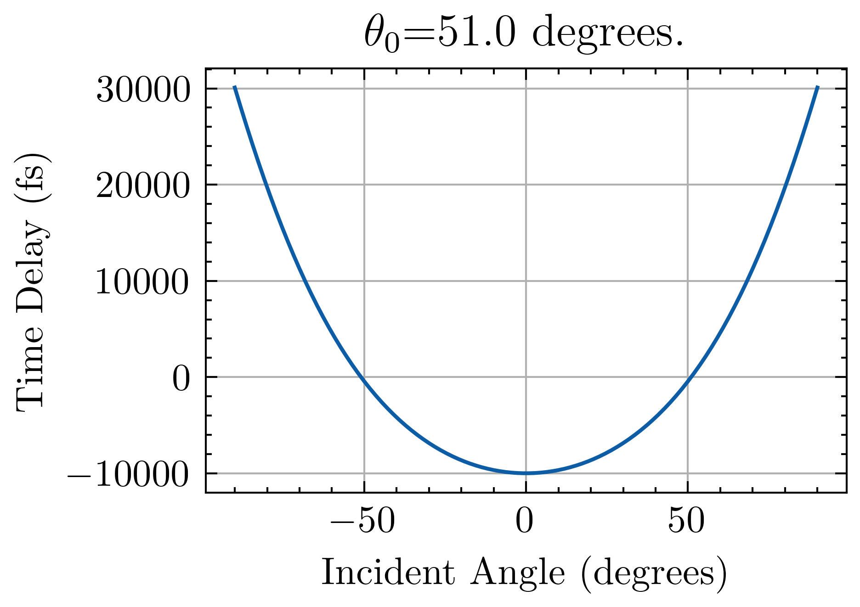
Figure 2: Simulated time delay vs incident angle where maximum is considered at 50 degrees.
When the glass block is allowed to rotate at a frequency of $f$, the angle $θ$ is represented by:
$$θ=θ_{0}+2πft$$
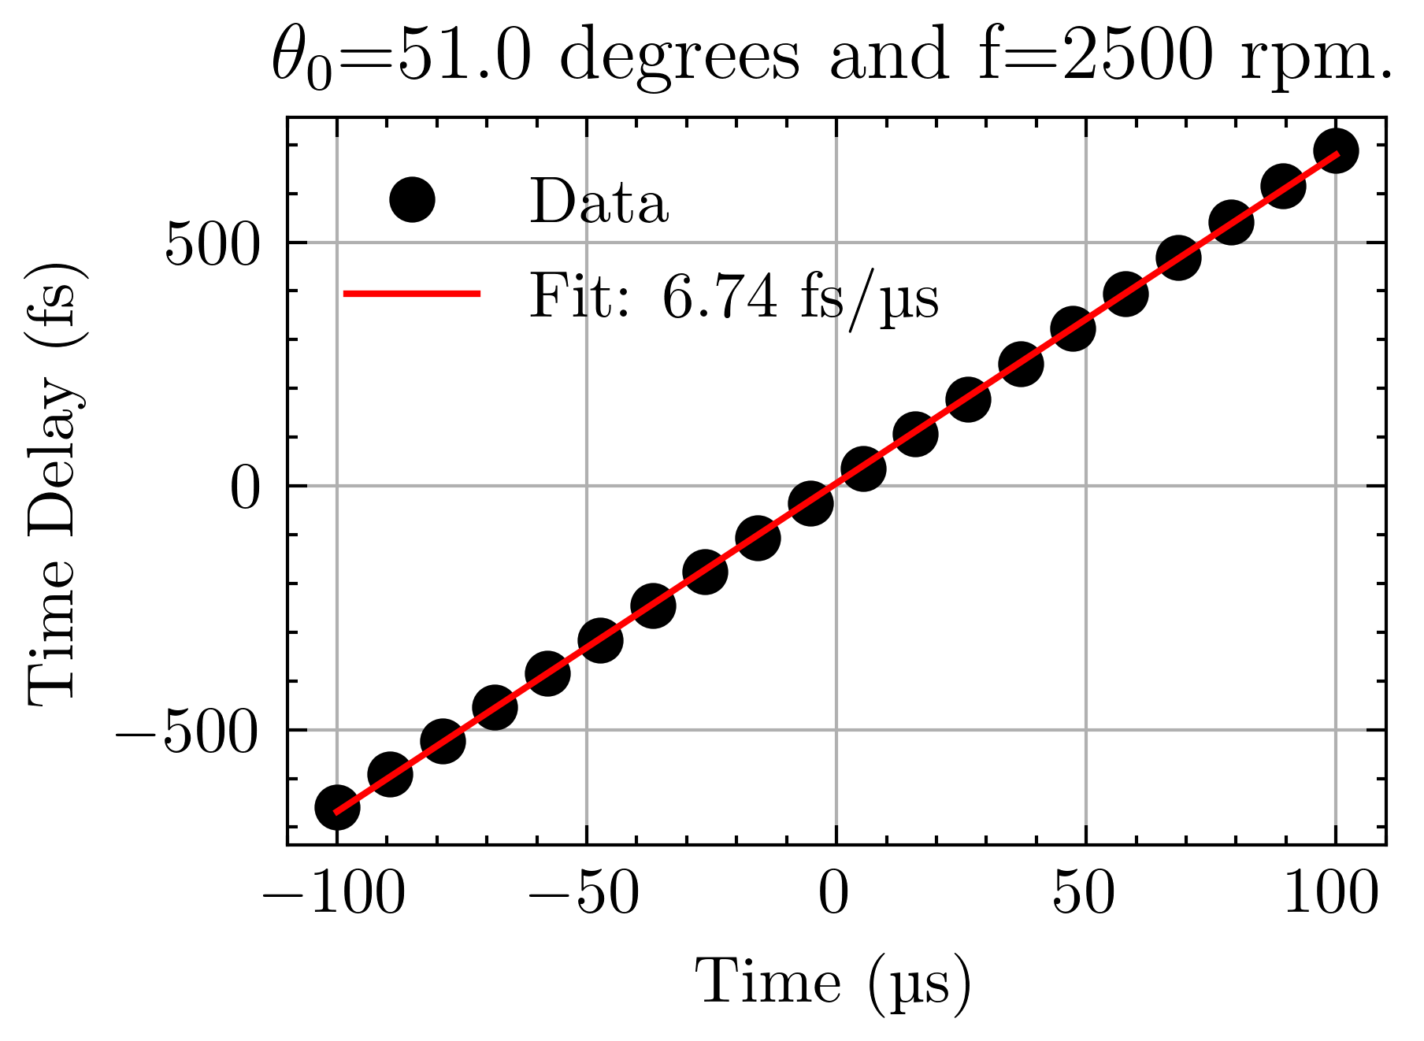
Final conversion factor with deconvolution factor for gaussian pulses: $\frac{6.74}{1.414}=4.76 fs μs^{-1}$

